|  |  |
| --- | --- |
| **Grade:** | X / 100 |
| **Instructor’s Comments:** | To be filled by the instructor |

**ITS 46200 – Application Integration**

**Lab 8**

**Submitted on 3/26/2018**

**Ravali Pothepalli**

Contents

Problem 1. 2

Problem 2. 4

**Solution**

# Problem 1.

***8.1 Jenna’s DVD library.***   
Jenna has been working on creating a DVD library where she can list all of the DVDs that she has. Some she bought herself, others were gifts from her mom, dad, sister, grandpa, and grandma. The root element for her library is dvdlibrary with one or more dvd elements. Each dvd has a title, description, year, company, favorite characters, favorite bonus features, and purchase information. Her characters’ elements each have one or more character elements. Her bonus elements each have one or more features. Her purchased elements each have price, location, and date. The dvd element has two attributes, bonus element has one attribute, and the purchased element has no attributes.

Jenna wishes to create an XSLT style sheet to use to display the DVD collection information attractively.She would like the price value to be clearly formatted as currency with a dollar sign. She would like the result document to show how many years it has been since each movie was released. Lastly, she would like to display a small chart illustrating her own review rating for each movie, based on a number from 1 to 10.

**Solution (source code):**

XML Document created :

dvdlibrary.xml

<?xml version="1.0" encoding="UTF-8" standalone="no" ?>

<!--

New Perspectives on XML, 3rd Edition

Tutorial 8

Tutorial Project

DVD Library XSLT Style Sheet

Author: Ravali Pothepalli

Date: 3/22/2018

Filename: dvdlibrary.xml

-->

<?xml-stylesheet type="text/xsl" href="dvdlibrarytxt.xsl" ?>

<dvdlibrary>

<dvd isbn="1-4157-4399-0" from="mom" >

<title>Kung Fu Lizard</title>

<description>Jo defends his training academy against the evil Mighty Moose, Benny.</description>

<year>2011</year>

<company>Cloud Nine Productions</company>

<characters>

<character>Jo, the Kung Fu Lizard</character>

<character>Lisa, the Fighting Kricket</character>

<character>Benny, the Evil Mangler Moose</character>

</characters>

<bonus num="2">

<feature>Kung Fu Academy</feature>

<feature>Cast Commentary</feature>

</bonus>

<purchased>

<price>19.94</price>

<location>Best DVDs in Town</location>

<date>2012-10-03</date>

</purchased>

<rating>6</rating>

</dvd>

<dvd isbn="1-5158-4399-0" from="mom">

<title>Planet of the Ogres</title>

<description>Bilbo had always dreamt he was from another planet. Now he finds out that he is. Join him as he meets his destiny to save his homeworld.</description>

<year>2012</year>

<company>MGM</company>

<characters>

<character>Bilbo, future leader of the Ogres</character>

<character>Kilnary, leader of the invading Tigres</character>

<character>Wicket, leader of the Morkian army</character>

</characters>

<bonus num="3">

<feature>Making Of Featurette</feature>

<feature>Theatre Trailers</feature>

<feature>PC downloadable version</feature>

</bonus>

<purchased>

<price>17.99</price>

<location>Mallmart</location>

<date>2013-10-06</date>

</purchased>

<rating>9</rating>

</dvd>

<dvd isbn="1-9955-8745-0" from="mom">

<title>Mountain King</title>

<description>Freda is the daughter of the Mountain King. As the only heir, will she break with tradition and be the first Mountain Queen?</description>

<year>2014</year>

<company>Sunny Entertainment</company>

<characters>

<character>Freda, daughter of the Mountain King</character>

<character>Toru, the Mountain King</character>

<character>Ella, the Enchanted Advisor</character>

<character>Bopo, the Monkey Bone Wizard</character>

</characters>

<bonus num="2">

<feature>Cast Commentary</feature>

<feature>Mountain King Music Video</feature>

</bonus>

<purchased>

<price>14.99</price>

<location>Movies For Everyone</location>

<date>2015-11-07</date>

</purchased>

<rating>4</rating>

</dvd>

</dvdlibrary>

**dvdlibrarytxt.xsl :**

<?xml version="1.0" encoding="UTF-8" ?>

<!--

Denison Public Library XSLT Style Sheet

Author: Ravali Pothepalli

Date: 3/21/2018

Filename: library.xsl

-->

<xsl:stylesheet version="1.0"

xmlns:xsl="http://www.w3.org/1999/XSL/Transform">

<xsl:output method="html"

doctype-system="about:legacy-compat"

encoding="UTF-8"

indent="yes" />

<xsl:template match="/">

<html>

<head>

<title>Denison Public Library</title>

<link href="libstyles.css" rel="stylesheet" type="text/css" />

</head>

<body>

<header>

<h1>Denison Public Library</h1>

<h2>Ennis, Montana</h2>

</header>

<section>

<h1>Item List</h1>

<xsl:apply-templates select="itemlist/item">

</xsl:apply-templates>

</section>

</body>

</html>

</xsl:template>

<xsl:template match="item">

<article>

<h1>

<xsl:value-of select="title" />

</h1>

<h2>

by:

<xsl:for-each select="authors/author">

[<xsl:value-of select="."/>]

</xsl:for-each>

</h2>

<p>

Type:

<span>

<xsl:value-of select="type"/>

</span>

</p>

<p>

Tags:

<xsl:for-each select="subjects">

<span>

<xsl:value-of select="subject"/>

</span>

</xsl:for-each>

</p>

<p>

Publisher:

<span>

<xsl:value-of select="publisher" />

</span>

</p>

<p>

ISBN:

<span>

<xsl:value-of select="isbn" />

</span>

</p>

<table>

<tr>

<th>Location</th>

<th>Collection</th>

<th>Call No.</th>

<th>Status</th>

</tr>

<tr>

<td><xsl:value-of select="location" /></td>

<td><xsl:value-of select="collection" /></td>

<td><xsl:value-of select="callno" /></td>

<td> <xsl:value-of select="status" />

<xsl:if test="status/@return">

(due:<xsl:value-of select="status/@return" />)

</xsl:if>

<!--(due: return) -->

</td>

</tr>

</table>

</article>

</xsl:template>

</xsl:stylesheet>

**Result of Execution:**

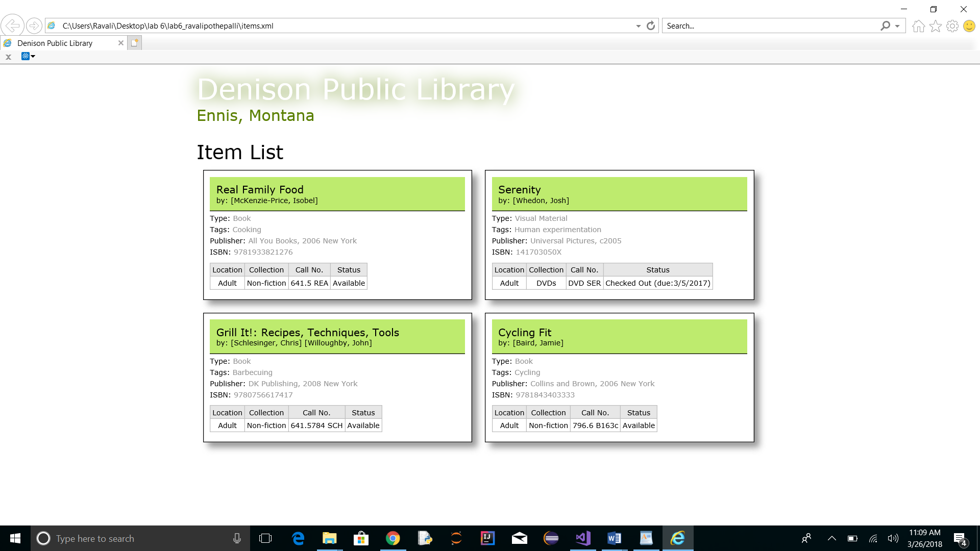

**Comments**

This assignment has helped me learn how to write XSL document and I have faced few difficulties while coding as it involves combing two different xml files. Overall it helped me a lot.