Templates

- Repetition - I2OOP[16, chap. 1-3][3]
  - En måde at skrive en generel klasse på som ikke afhænging type.
  - Implementationen forgår i header filen
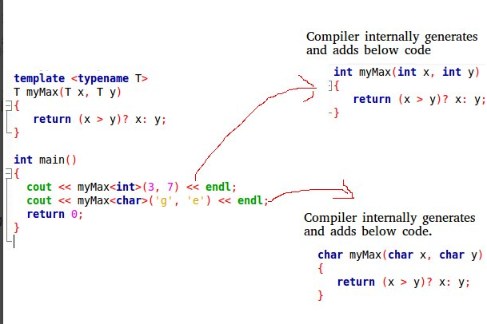
  - Der findes to typer template:
    - Funktions template
      - We write a generic function that can be used for different data types. Examples of function templates are sort(), max(), min(), printArray().
    - Klasse template
      - Like function templates, class templates are useful when a class defines something that is independent of the data type. Can be useful for classes like LinkedList, BinaryTree, Stack, Queue, Array, etc.

- What is the rational for using templates
  - At undgå at skrive den samme kode om igen?
  - Ønsker at have en function eller klasse der kan bruges til flere ting/typer end bare en.

- How do you actually write one and use it - exactly how does it differentiate from an ordinary class
  - Implementers i header filen
  - Se billede ovenfor. (Functions template)
  - Se billede nedenfor (Klasse template)
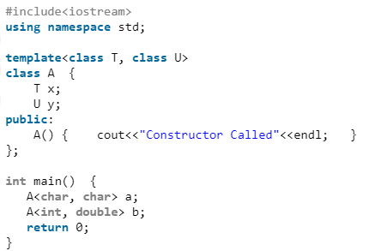

- Which function in a template class do actually get instantiated
  - Hvis man ved at en template klasse kun kommer til at arbejde med en type variable kan det være effektivt at fortælle templaten at den kun skal arbejde med den type.
  - Når en template klasse bliver instantieret bliver der oprettet versioner af templaten til hver af de anvendte typer implicit.
  - Ved man at templaten kun skal arbejde med en type variable kan man explicit fortælle templaten at den kun skal arbejde med den type.

- What is a template function
  - A function template works in a similar to a normal function, with one key difference.
A single function template can work with different data types at once but, a single normal function can only work with one set of data types.
Normally, if you need to perform identical operations on two or more types of data, you use function overloading to create two functions with the required function declaration.
However, a better approach would be to use function templates because you can perform the same task writing less and maintainable code.
  - Er en function som kan anvende forskellige variable typer med den samme function.

- What is a template class specialization
  - Generelt for template klasse:
    - Like function templates, you can also create class templates for generic class operations.
Sometimes, you need a class implementation that is same for all classes, only the data types used are different.
Normally, you would need to create a different class for each data type OR create different member variables and functions within a single class.
This will unnecessarily bloat your code base and will be hard to maintain, as a change is one class/function should be performed on all classes/functions.
However, class templates make it easy to reuse the same code for all data types.

  - Template klasse specialation:
    - Når man ønsker at en template klasse skal gøre noget specielt hvis det er en bestemt variable type der bliver anvendt.

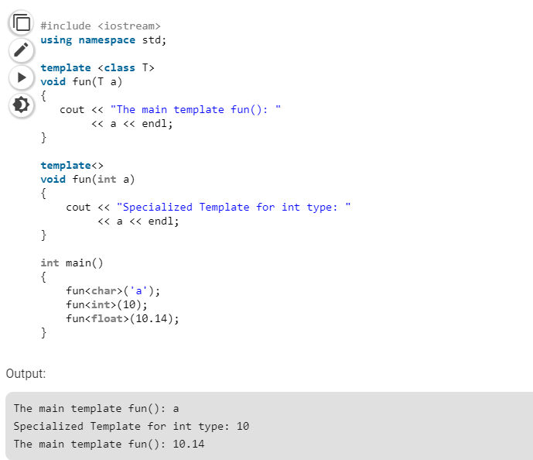

- Can you have template functions in a template class
  - Ja det kan du godt!

- Should template function overload or specialize or both
  - Det er bedre at bruge overloads til funktioner da specialiceringer kan fejl eller blive overset.

- What is 2 phase lookup and why is it important to understand
  - Templates are compiled (atleast) twice:
    - Without Instantiation the template code itself is checked for syntax. (Non-dependencies)
Eg: Any syntax errors such as ; etc.
    - At the time of instantiation(when the exact type is known), the template code is checked again to ensure all calls are valid for that particular type. (Dependencies)
Eg: The template might in turn call to functions which might not be present for that particular type.

- How is a template parsed and what does this mean from a users perspective
  - how is a template parsed:
    - 2 phase lookup
  - Hvad betyder det for en bruger:
    - At man skal være meget opmærksom på den syntax man anvender, da den godt kan blive godkendt I første phase men det ikke er sikkert at det giver mening I forhold til den variable type der bliver anvendt. (så hold tungen lige I munden!)

