Exercise 1
Shared_Ptr template class
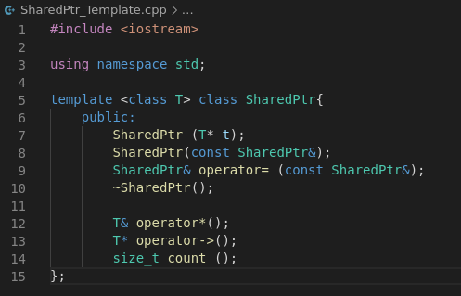

Exercise 2
Exercise 2.1 – The explicit constructor
Inspect your SharedPtr<> template class and discuss which of the constructors, if any, should be explicit and why/why not. A code snippet for or against should be included in your answer.
- Ikke sikker på at jeg forstår?
Exercise 2.2 – Overloading
Exercise 2.2.1 - Which overloads are used
Which overloads have been implemented and why? Are there any other overloads that might be useful?
- Vi overloader “Assignment operator(=)”, “member select operator (→)” og “Dereference operator(*)”.
- Andre brugbare: “comparison operator(==)”
Exercise 2.2.2 – “Implicit” conversion to bool

