1. What do these "new" C++11++ fundamentals entail?
- New Initialization syntax
  - The initialization is more uniform (Use common syntax (Braces {}))

- Delegating Constructors
  - The ability to call another constructor from the same class
    - Has to be done in the initialiser list

- Strongly Typed Enums
  - Strongly typed enums har deres egen scope.

- NullPTR
  - No need to use NULL or 0 anymore
  - nullptr is a constant of type std::nulptr_t
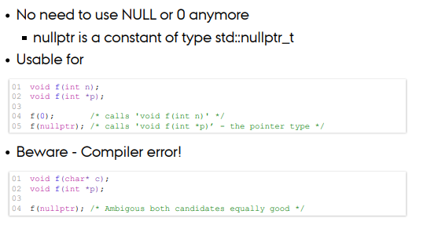

- Declare Type
  - You don't need to declare types of objects
  - Auto can only find the original type, but decltype(auto) will find the exact typecast.
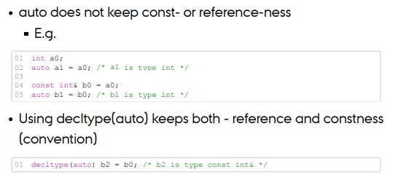
2. What is overloading and how does it work – why bother?
- When you want to make an operator/function/Functor do a specialized task instead of the default setting when used in your scope.
- It tailors the operator/function/functor to your need and reduced the changes of failure when using a standardized operator/function/functor.

3. Implicit and Explicit Conversions
- What do they do and what to be aware of?
  - Implicit
    - Implicit conversion are automatically performed when a value is copied to a compatible type
    - Performed when a value or const reference is required
    - Implicit is questionable
      - Includes narrowing conversion
        - Removes part of the value if converting from double to int
      - Conversions from double to int
      - Often this is best done Explicitly
  - Explicitly
    - Cast are used for explicit conversions
    - The two forms are traditional (typecasting) and functions
    - Explicit (visual) and required
      - No implicit conversion supported
        - Example: converting ints to enums or converting between imcompatible pointer types
      - Potentially very unsafe

4. The different flavours of const and static – how do they influence the language?
- Const is used to make sure that the object cannot be changed
  - Depending on the usage it is the value of the object of the object itself which may not be changed
  - A const object cannot be called by a “non” const method, the method has to be const as well.
- Static makes an object local and not accessible from other compilation units
  - Used in a function – Created upon first used and dies at program death
  - Used in class declaration – Makes it a class wide accessible attribute.
    - When you have a static variable declared it will only be allocated once and shared by all objects of the given class

5. Lambda, what is it? Argue why this construct is desirable
- Are an unnamedd function object capable of capturing variables in scope
  - Basic idea
    - [ Capture ] ( params ) → return { statements }
  - Terms
    - capture - values from scope are available in statements
    - [] - Captures nothing
    - [a, &b] - a by value, b by reference
    - [this] - Captures this pointer by value
    - [&] - Captures all automatic variables by reference
    - [=] - Captures all automatic variables by value
    - [&ra = a, y = y*y] - Renaming or special initialisation
    - ra & y are local vars - ra is a reference, y is y squared

- Terms
  - params - Ordinary input parameters to a function
  - ret - The return type. Auto discovers via return, otherwise can be hardcoded
  - statements - Ordinary statements in a function body

6. What is the great thing about RAII?
- Resource acquisition is initialization. (RAII)
  - Wrap up all resources in their own object that handles their lifetime and put object on stack

7. What is a resource?
- The general description of a resource is the concept of an object that is provided by an outside source that is used by the code user (think resources in real life)

8. What differntiates a SmartPointer from RAII
- A smart-pointer that deallocates the memory used automatically
- You don’t have to pay as much attention to the smart-pointer.

9. What differentiates Counted Smart Pointer from simple SmartPointer?

10. What is Rule of 3?
- If you implement one of the following three, then all of them needs to be implemented:
  - Destructor
  - Copy constructor
  - Assignment Operator

