[NAME OF THE COLLEGE / INSTITUTION]
Department of Artificial Intelligence and Data Science
[University / Affiliation Details]
MINI PROJECT REPORT
on
WEATHER PATTERN ANALYSIS AND CLASSIFICATION USING UNSUPERVISED CLUSTERING ALGORITHMS
Subject: Unsupervised Learning Algorithms
B.Tech – Artificial Intelligence and Data Science
Submitted by
[Student Name] – [Register / Roll Number]
[Year / Semester]
Under the guidance of
[Faculty Name, Designation]
Academic Year: [20XX – 20XX]

Certificate
This is to certify that the mini project report entitled “Weather Pattern Analysis and Classification Using Unsupervised Clustering Algorithms” is a bonafide record of the work carried out by [Student Name] (Register No. [XXXXXXXX]) in partial fulfilment of the requirements of the subject Unsupervised Learning Algorithms for the degree of Bachelor of Technology in Artificial Intelligence and Data Science during the academic year [20XX – 20XX].
The work embodied in this report has not been submitted to any other institution or university for the award of any degree or diploma.

Project Guide Head of the Department
[Faculty Name] [HOD Name]

Internal Examiner: ______________________ External Examiner: ______________________

Declaration
I hereby declare that the mini project report entitled “Weather Pattern Analysis and Classification Using Unsupervised Clustering Algorithms” submitted to [College Name] is a record of original work done by me under the guidance of [Faculty Name]. The dataset used is a publicly available weather dataset whose source is cited in this report, and all results reported here were produced by running the accompanying Python notebook. No supervised learning algorithm has been used. To the best of my knowledge, this work has not been submitted to any other institution for any degree or diploma.

Place: [City]
Date: [DD/MM/YYYY] [Student Name]

Acknowledgement
I express my sincere gratitude to my project guide, [Faculty Name], Department of Artificial Intelligence and Data Science, for the guidance, encouragement and valuable suggestions throughout this mini project.
I am thankful to the Head of the Department, [HOD Name], and the management of [College Name] for providing the facilities needed to complete this work. I also thank the Australian Bureau of Meteorology for collecting the weather observations, the Kaggle and GitHub communities for making the data publicly accessible, and the developers of the open-source Python libraries used in this project. Finally, I thank my family and friends for their constant support.
[Student Name]

Abstract
Weather varies from day to day, but days with similar temperature, humidity, rainfall, wind and pressure tend to form natural groups. This project applies three unsupervised learning algorithms – K-Means, Agglomerative Hierarchical Clustering and DBSCAN – to discover such groups from real daily weather observations of the Australian Bureau of Meteorology (the “Rain in Australia” data, 142,193 records from 49 stations). Six numerical features were used: minimum temperature, maximum temperature, rainfall, humidity at 3 pm, wind speed at 3 pm and pressure at 3 pm.
After removing 45 duplicate rows and rows with missing feature values, 124,426 days remained. Rainfall was log-transformed, all features were standardised, and a random sample of 5,000 days was clustered by all three algorithms. K-Means (k = 3) obtained a Silhouette Score of 0.249 and a Davies-Bouldin Index of 1.355. Agglomerative clustering with Ward linkage (k = 3) obtained 0.192 and 1.580. DBSCAN (eps = 1.2, min_samples = 5) found 2 clusters and 85 noise points, with 0.310 and 0.796 computed on non-noise points.
Interpretation of the K-Means clusters shows three natural weather types: a hot and dry group, a cool and calm high-pressure group, and a rainy, humid group with low pressure. The hierarchical result agrees closely on the rainy group, while DBSCAN mainly separates a few extreme storm-like days as noise. The project shows that clustering can reveal meaningful weather regimes without any labels.
Keywords: Unsupervised learning, clustering, K-Means, hierarchical clustering, DBSCAN, weather patterns, Silhouette Score.

Table of Contents

(If the page numbers appear blank, right-click the table in Microsoft Word and choose “Update Field” → “Update entire table”.)

1. Introduction
Weather affects agriculture, transport, energy use, health and daily life. Meteorologists record many variables every day, such as temperature, humidity, rainfall, wind speed and atmospheric pressure. Looking at these numbers one by one is difficult. A better way is to ask: which days resemble each other, and what kinds of weather exist in the data?
Clustering is a branch of unsupervised learning that answers this question. It groups data points so that points in the same group are similar and points in different groups are different, without using any ready-made labels. In this project, clustering is used to find natural weather patterns from real observations and to describe each pattern in plain language such as “hot and dry” or “rainy and humid”.
Three popular algorithms are studied: K-Means (centre-based), Agglomerative Hierarchical Clustering (tree-based) and DBSCAN (density-based). They are compared with internal evaluation measures because no true labels are available.

2. Problem Statement
Daily weather data contain several related measurements, and there is no official label that tells which “type” of weather a day belongs to. The problem is therefore to automatically discover groups of similar weather days from multi-variable observations using unsupervised clustering, to evaluate the quality of the groups produced by different algorithms, and to interpret the groups in terms of real weather characteristics.

3. Objectives
- To obtain a genuine, publicly available weather dataset and load it automatically in Python.
- To clean the data: remove duplicates, handle missing values and select numerical features.
- To explore the data with statistical summaries, distributions, a correlation heatmap and scatter plots.
- To apply K-Means (with the Elbow method), Agglomerative Hierarchical Clustering (with a dendrogram) and DBSCAN (with tuned eps and min_samples).
- To evaluate the algorithms using Silhouette Score, Davies-Bouldin Index, number of clusters and DBSCAN noise count.
- To interpret the clusters as natural weather groups from their actual average values, without using predefined labels.
- To compare the algorithms and discuss their advantages, limitations and applications.

4. Literature Review

4.1 Clustering in general
Clustering has a long history. MacQueen (1967) introduced the name K-Means for a method that assigns points to the nearest of k centres and updates the centres; Lloyd (1982) described the iterative algorithm now commonly implemented. Jain (2010) reviewed fifty years of clustering research and noted that K-Means remains popular because it is simple and fast, even though it needs k in advance and prefers round clusters.

4.2 Hierarchical clustering
Hierarchical methods build a tree of clusters. Ward (1963) proposed merging, at every step, the two clusters that cause the smallest increase in total within-cluster variance. Kaufman and Rousseeuw (1990) describe agglomerative and other clustering methods in detail. A dendrogram lets the analyst choose the number of clusters after seeing the merge structure, but the method needs memory that grows with the square of the number of points.

4.3 Density-based clustering
Ester et al. (1996) proposed DBSCAN, which finds clusters as dense regions separated by sparse regions and labels isolated points as noise. It can find clusters of arbitrary shape and does not need k, but it is sensitive to the neighbourhood radius (eps) and minimum points (min_samples). Schubert et al. (2017) revisited DBSCAN and discussed practical ways to choose these parameters.

4.4 Cluster evaluation
Without true labels, internal indices are used. Rousseeuw (1987) introduced the Silhouette coefficient, which compares how close a point is to its own cluster against the nearest other cluster (higher is better). Davies and Bouldin (1979) proposed an index based on the ratio of within-cluster scatter to between-cluster separation (lower is better).

4.5 Relevance to weather analysis
Weather and climate data are multi-variable and have no natural class labels, so grouping similar days or regions is a common use of clustering in climate science. This project follows the standard methods above and applies them to a public multi-station dataset, concentrating on a clear workflow, honest evaluation and interpretation of the resulting groups.

5. Dataset Description

5.1 Source
The dataset is the “Rain in Australia” (weatherAUS) dataset, which contains daily weather observations from many Australian weather stations. The observations were originally collected by the Australian Bureau of Meteorology (BoM) and compiled on Kaggle. The copy used in this project is downloaded directly from a public GitHub repository, so no login or manual upload is needed:
- Original data owner: Australian Bureau of Meteorology – http://www.bom.gov.au/climate/data
- Kaggle page: https://www.kaggle.com/datasets/jsphyg/weather-dataset-rattle-package
- Direct download URL used in the notebook: https://raw.githubusercontent.com/tvdboom/ATOM/master/examples/datasets/weatherAUS.csv
The file contains 142,193 rows and 22 columns from 49 locations. This copy has no Date column and stores RainTomorrow as 0/1. The BoM data are used for educational purposes with acknowledgement of the Bureau as the source; because redistribution terms are not clearly stated, the dataset file itself is not bundled with the project and is downloaded by the notebook.

5.2 Columns
Column | Meaning | Unit
Location | Weather station name | text
MinTemp / MaxTemp | Minimum / maximum temperature of the day | °C
Rainfall | Rain recorded in the 24 hours to 9 am | mm
Evaporation | Class-A pan evaporation in the 24 hours to 9 am | mm
Sunshine | Hours of bright sunshine | hours
WindGustDir / WindGustSpeed | Direction / speed of strongest wind gust | compass / km/h
WindDir9am, WindDir3pm | Wind direction at 9 am / 3 pm | compass
WindSpeed9am, WindSpeed3pm | Average wind speed before 9 am / 3 pm | km/h
Humidity9am, Humidity3pm | Relative humidity at 9 am / 3 pm | %
Pressure9am, Pressure3pm | Atmospheric pressure at mean sea level | hPa
Cloud9am, Cloud3pm | Sky covered by cloud (0 clear – 8 overcast) | oktas
Temp9am, Temp3pm | Temperature at 9 am / 3 pm | °C
RainToday, RainTomorrow | Rain today (>1 mm) / next day | Yes-No / 0-1

5.3 Features selected for clustering
Six numerical features were selected to cover the five weather elements required: temperature (MinTemp, MaxTemp), rainfall (Rainfall), humidity (Humidity3pm), wind speed (WindSpeed3pm) and atmospheric pressure (Pressure3pm). Categorical columns, RainToday and RainTomorrow were not used, so no label information enters the clustering.

6. Software and Hardware Requirements

6.1 Software
Item | Details
Language | Python 3.12.3 (Google Colab provides a similar version)
Environment | Google Colab or Jupyter Notebook
Libraries | pandas 3.0.6, NumPy 2.5.4, Matplotlib 3.11.2, Seaborn 0.13.2, scikit-learn 1.9.1, SciPy 1.18.1
Operating system | Windows / Linux / macOS (any system with a browser for Colab)
Report tool | Microsoft Word

The results in this report were generated with the library versions listed above. Other recent versions should give very similar results, but small numerical differences are possible.

6.2 Hardware
- Processor: any modern dual-core CPU or better.
- RAM: 4 GB minimum (8 GB recommended). The notebook uses a 5,000-row sample for clustering, which keeps memory use low.
- Storage: about 50 MB for the dataset, notebook and graphs.
- Internet connection: required to download the dataset from GitHub.
- No GPU is needed.

7. Methodology
The project follows the workflow below. Every step is implemented in the notebook Weather_Pattern_Clustering.ipynb.
- Step 1 – Data acquisition: download the CSV directly from GitHub with pandas.
- Step 2 – Data cleaning: remove duplicate rows, study missing values and drop rows with missing values in the selected features.
- Step 3 – Exploratory analysis: statistical summary, histograms, correlation heatmap and scatter plots.
- Step 4 – Pre-processing: log-transform rainfall, apply StandardScaler and draw one fixed random sample of 5,000 days.
- Step 5 – Clustering: K-Means with the Elbow method, Agglomerative clustering with a dendrogram, DBSCAN with parameter tuning.
- Step 6 – Evaluation: Silhouette Score, Davies-Bouldin Index, number of clusters and noise points.
- Step 7 – Interpretation: calculate the average real weather values of each cluster and name the cluster from them.
Selecting the number of clusters: for K-Means and Agglomerative clustering the final number of clusters is the value between 3 and 8 with the highest Silhouette Score, after looking at the Elbow graph and the dendrogram. The lower limit of 3 was chosen so that the result is finer than a trivial two-group split. For DBSCAN, a grid of eps and min_samples values was tested and the best Silhouette Score among settings with 2–10 clusters and at most 15% noise was chosen.

8. Data Preprocessing

8.1 Duplicate removal
45 exactly duplicated rows were found and removed, leaving 142,148 rows.

8.2 Missing values
Feature | Missing values (after duplicate removal)
MinTemp | 592
MaxTemp | 283
Rainfall | 1,403
Humidity3pm | 3,565
WindSpeed3pm | 2,585
Pressure3pm | 13,936

Pressure3pm has the most missing values because some stations do not record pressure. Instead of filling them with guessed values, rows with any missing value in the six selected features were dropped. This reduced the data from 142,148 to 124,426 rows. The drawback is that stations without pressure records are under-represented (see Limitations).

8.3 Statistical summary
Feature | Mean | Std | Min | Median | Max | Skew
MinTemp | 12.40 | 6.33 | -8.20 | 12.20 | 33.90 | 0.05
MaxTemp | 23.41 | 6.94 | 2.60 | 22.80 | 48.10 | 0.34
Rainfall | 2.34 | 8.50 | 0.00 | 0.00 | 371.00 | 10.07
Humidity3pm | 51.22 | 20.66 | 0.00 | 52.00 | 100.00 | -0.00
WindSpeed3pm | 19.08 | 8.71 | 0.00 | 19.00 | 87.00 | 0.64
Pressure3pm | 1015.28 | 7.03 | 977.10 | 1015.30 | 1039.60 | -0.06

Rainfall is strongly right-skewed (skewness 10.07): most days have little or no rain, and a few days have very heavy rain. Because distance-based algorithms would otherwise be dominated by these days, rainfall was transformed with log(1 + x).

8.4 Feature scaling and sampling
StandardScaler converts each feature to mean 0 and standard deviation 1 using z = (x − μ) / σ. This is necessary because temperature (about 5–45 °C) and pressure (about 1000–1030 hPa) have very different scales, and distance-based clustering would otherwise be controlled by the feature with the largest numbers.
Hierarchical clustering stores distances between all pairs of points, which is too large for 124,426 rows. Therefore one random sample of 5,000 days (random seed 42) was used for all three algorithms so that the comparison is fair.

8.5 Exploratory analysis
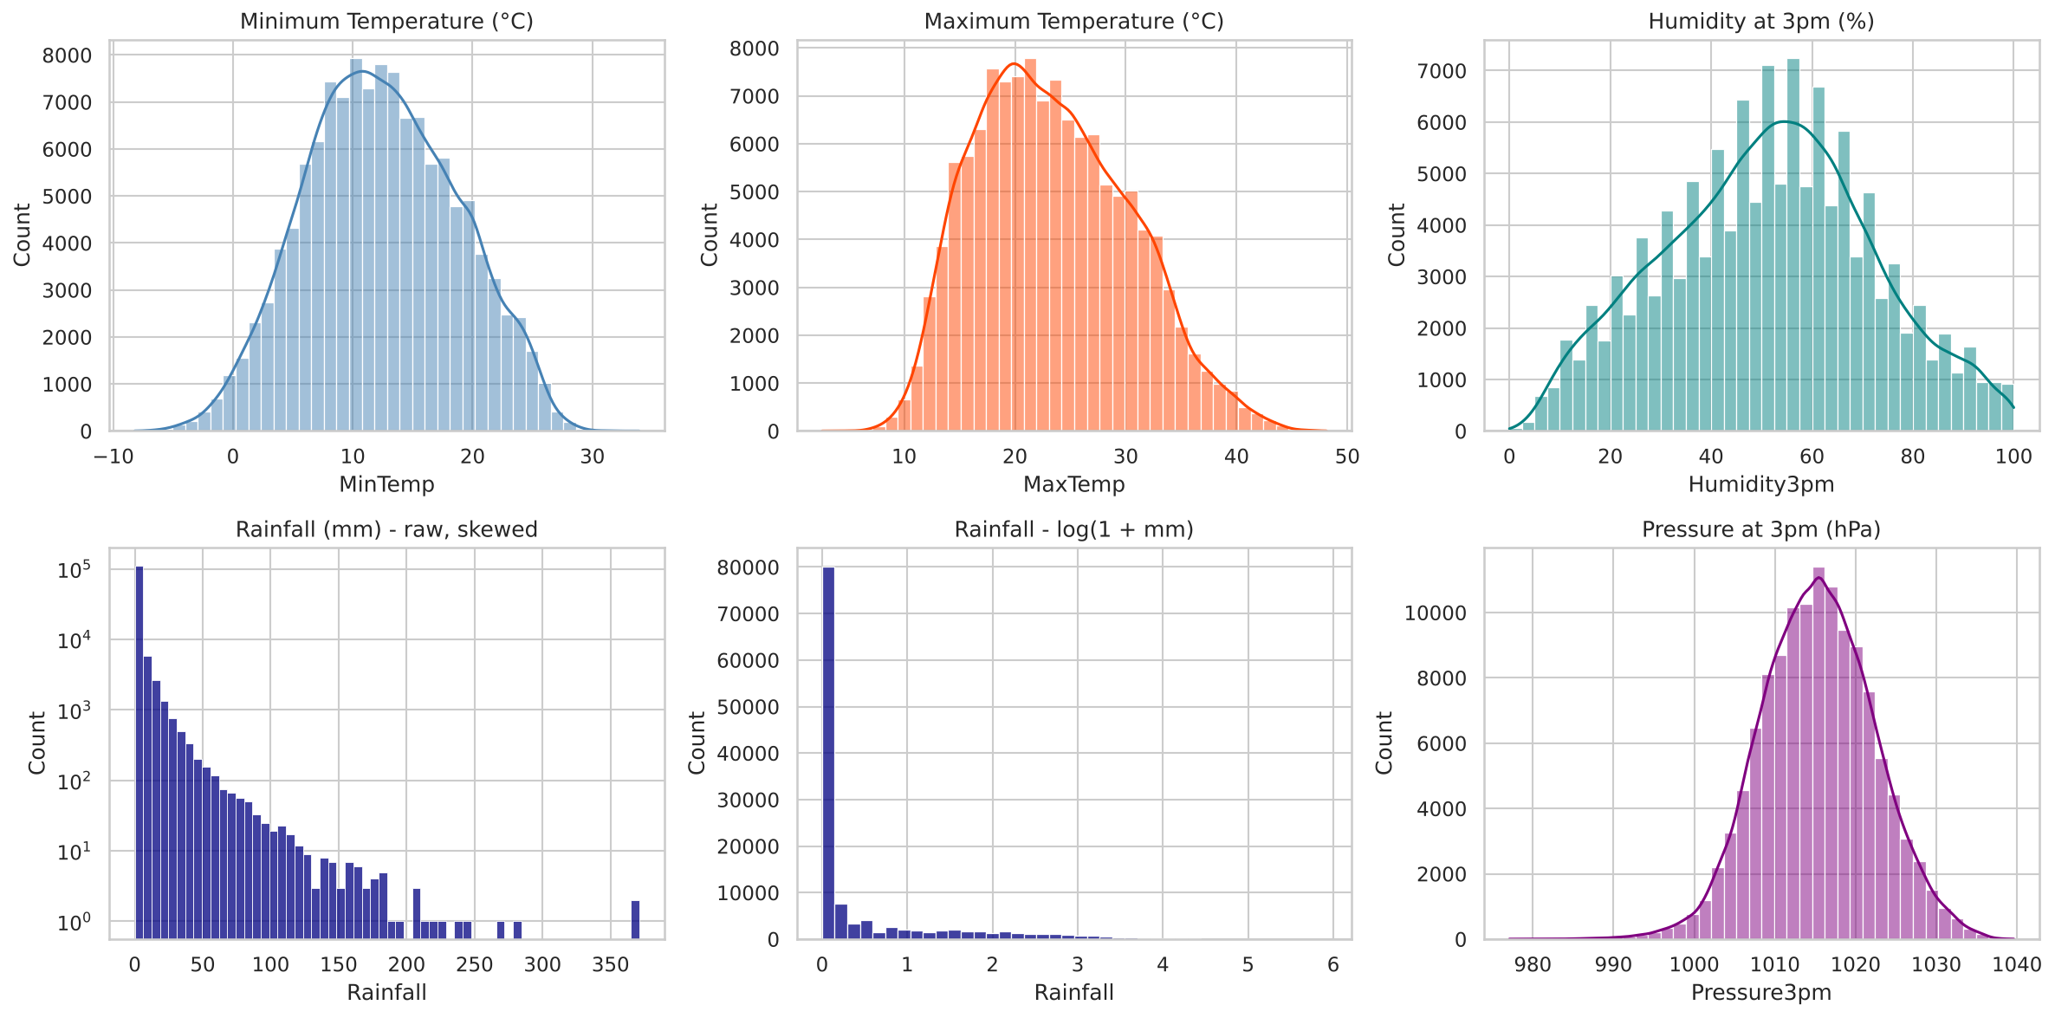
Figure 1: Distributions of temperature, humidity, rainfall and pressure
The temperature histograms are wide because the data include hot northern and cooler southern stations. Humidity at 3 pm is spread between about 0% and 100%. Raw rainfall has a very long tail, and the log version is much easier to work with.
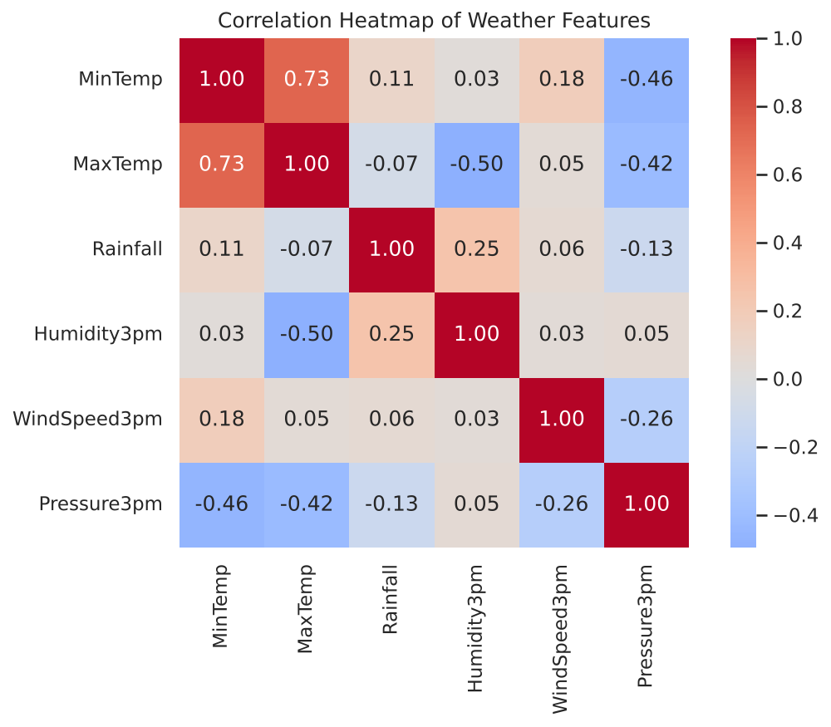
Figure 2: Correlation heatmap of the six weather features
The heatmap shows meaningful relationships: MinTemp and MaxTemp are positively correlated (0.73), MaxTemp and Humidity3pm are negatively correlated (-0.50) because hot afternoons are usually drier, Humidity3pm and Rainfall are positively correlated (0.25), and MaxTemp and Pressure3pm have a correlation of -0.42. No pair is so strongly correlated that a feature must be removed.
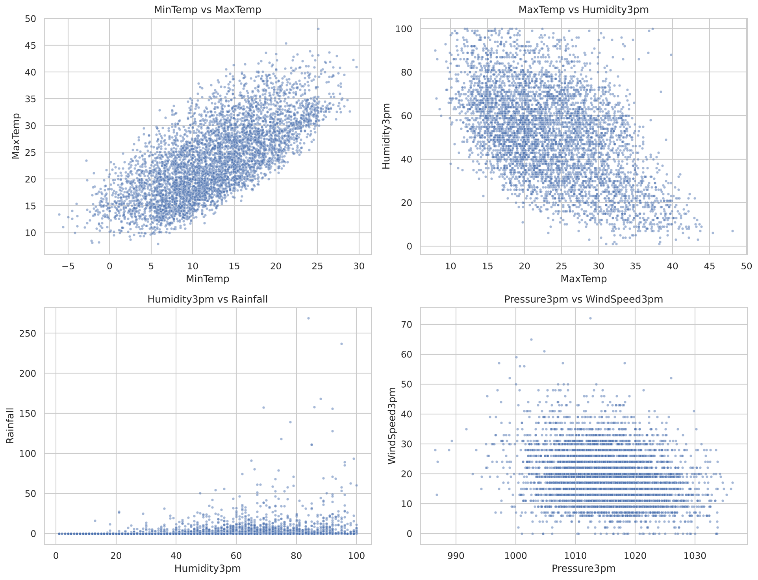
Figure 3: Scatter plots of selected feature pairs
The scatter plots show no clearly separated blobs. Weather changes gradually, so the clusters will be regions of a continuous cloud rather than islands. This is important for interpreting the Silhouette Scores later.

9. Explanation of Clustering Algorithms

9.1 K-Means
K-Means divides the data into k clusters. It starts with k random centres, assigns each point to the nearest centre, moves each centre to the mean of its points, and repeats until the centres stop changing. It minimises the within-cluster sum of squares (inertia). The Elbow method plots inertia against k; the point where the curve bends shows a reasonable k.
- Advantages: fast, simple, works well for compact round clusters.
- Limitations: k must be chosen, sensitive to outliers and scaling, assumes similar-sized round clusters.

9.2 Agglomerative Hierarchical Clustering
Every point starts as its own cluster; the two closest clusters are merged again and again until one cluster remains. With Ward linkage the pair whose merge increases the total variance least is chosen. The result is drawn as a dendrogram, and cutting the tree at a chosen height gives the clusters.
- Advantages: shows cluster structure at all levels, no random start.
- Limitations: memory and time grow quickly with the number of points; a merge can never be undone.

9.3 DBSCAN
DBSCAN (Density-Based Spatial Clustering of Applications with Noise) uses two parameters: eps (radius) and min_samples. A point with at least min_samples points inside its eps-neighbourhood is a core point. Core points that are close to each other join one cluster, border points join the cluster of a nearby core point, and all other points are noise (label −1).
- Advantages: no need to give k, finds arbitrary shapes, identifies outliers.
- Limitations: sensitive to eps and min_samples; struggles when density changes between clusters, and with continuous data that has no density gaps.

9.4 Evaluation measures
- Silhouette Score: for each point, s = (b − a) / max(a, b), where a is the mean distance to its own cluster and b the mean distance to the nearest other cluster. Range −1 to 1; higher is better.
- Davies-Bouldin Index: average, over clusters, of the worst ratio (scatter of two clusters) / (distance between their centres). Lower is better.
Because the data are unlabelled, accuracy cannot be calculated; these internal measures and the interpretability of the clusters are used instead.

10. System Architecture
The system is a simple pipeline in which the output of each stage is the input of the next stage.
Stage | Input | Process | Output
1. Data source | GitHub CSV URL | pandas.read_csv() | 142,193 × 22 table
2. Cleaning | Raw table | Drop duplicates, select 6 features, drop missing rows | 124,426 × 6 table
3. EDA | Clean table | Statistics, histograms, heatmap, scatter plots | Insight, figures 1–3
4. Pre-processing | Clean table | log(1+rainfall), StandardScaler, 5,000-row sample | Scaled matrix 5,000 × 6
5. Clustering | Scaled matrix | K-Means, Agglomerative, DBSCAN | Three label sets
6. Evaluation | Matrix + labels | Silhouette, Davies-Bouldin, clusters, noise | Comparison table and chart
7. Interpretation | Labels + original units | Cluster mean values and naming rules | Weather group names

Block diagram:
Weather CSV (GitHub) → Cleaning → EDA → Log + StandardScaler + Sampling → { K-Means | Agglomerative | DBSCAN } → Evaluation (Silhouette, Davies-Bouldin) → Interpretation of weather groups

11. Implementation
The complete code is provided in Weather_Pattern_Clustering.ipynb. It runs from top to bottom in Google Colab without installing anything. The important parts are explained below in simple language.

11.1 Loading the data
pandas can read a CSV file directly from a web address, so the dataset downloads itself every time the notebook is run.
DATA_URL = "https://raw.githubusercontent.com/tvdboom/ATOM/master/examples/datasets/weatherAUS.csv"
df_raw = pd.read_csv(DATA_URL)

11.2 Cleaning and feature selection
df = df_raw.drop_duplicates().reset_index(drop=True)
FEATURES = ["MinTemp","MaxTemp","Rainfall","Humidity3pm","WindSpeed3pm","Pressure3pm"]
df_clean = df[FEATURES].dropna().reset_index(drop=True)

11.3 Scaling and sampling
X_model = df_clean.copy()
X_model["Rainfall"] = np.log1p(X_model["Rainfall"]) # reduce skew
X_scaled_all = StandardScaler().fit_transform(X_model) # mean 0, std 1
idx = np.random.RandomState(42).choice(len(df_clean), 5000, replace=False)
X = X_scaled_all[idx] # same rows for all algorithms

11.4 K-Means and the Elbow method
The loop trains K-Means for k = 2 to 10 and stores the inertia and the scores. The k with the best Silhouette Score between 3 and 8 is selected.
for k in range(2, 11):
km = KMeans(n_clusters=k, n_init=10, random_state=42).fit(X)
# store km.inertia_, silhouette_score(X, km.labels_), davies_bouldin_score(X, km.labels_)
kmeans = KMeans(n_clusters=best_k, n_init=10, random_state=42).fit(X)

11.5 Agglomerative clustering and dendrogram
Z = linkage(X, method="ward") # merge history
dendrogram(Z, truncate_mode="lastp", p=30) # draw the tree
hc = AgglomerativeClustering(n_clusters=best_hc_k, linkage="ward").fit(X)

11.6 DBSCAN with parameter tuning
A k-distance graph gives a guide for eps. Then every combination of eps (0.3 to 2.0) and min_samples (5, 10, 15, 20, 30) is tested, and the best acceptable setting is chosen.
for eps in np.round(np.arange(0.3, 2.01, 0.1), 2):
for ms in [5, 10, 15, 20, 30]:
lab = DBSCAN(eps=eps, min_samples=ms).fit_predict(X)
# count clusters/noise; silhouette on non-noise points

11.7 Interpreting clusters
For each cluster the average original-unit values are calculated. A cluster is named Hot/Mild/Cool from its mean MaxTemp (compared with the 33rd and 66th percentiles of all days), Dry/Moderate/Humid from its mean Humidity3pm, and Rainy if its mean rainfall is more than twice the overall mean. These names are only descriptions made after clustering; no labels are used for training.
sample_orig.assign(cluster=labels).groupby("cluster").mean()

12. Results and Discussion

12.1 K-Means
k | Inertia | Silhouette | Davies-Bouldin
2 | 22,501 | 0.230 | 1.631
3 | 18,169 | 0.249 | 1.355
4 | 16,037 | 0.218 | 1.516
5 | 14,648 | 0.213 | 1.459
6 | 13,471 | 0.185 | 1.437
7 | 12,666 | 0.182 | 1.449
8 | 11,944 | 0.183 | 1.441
9 | 11,396 | 0.181 | 1.442
10 | 10,903 | 0.168 | 1.455

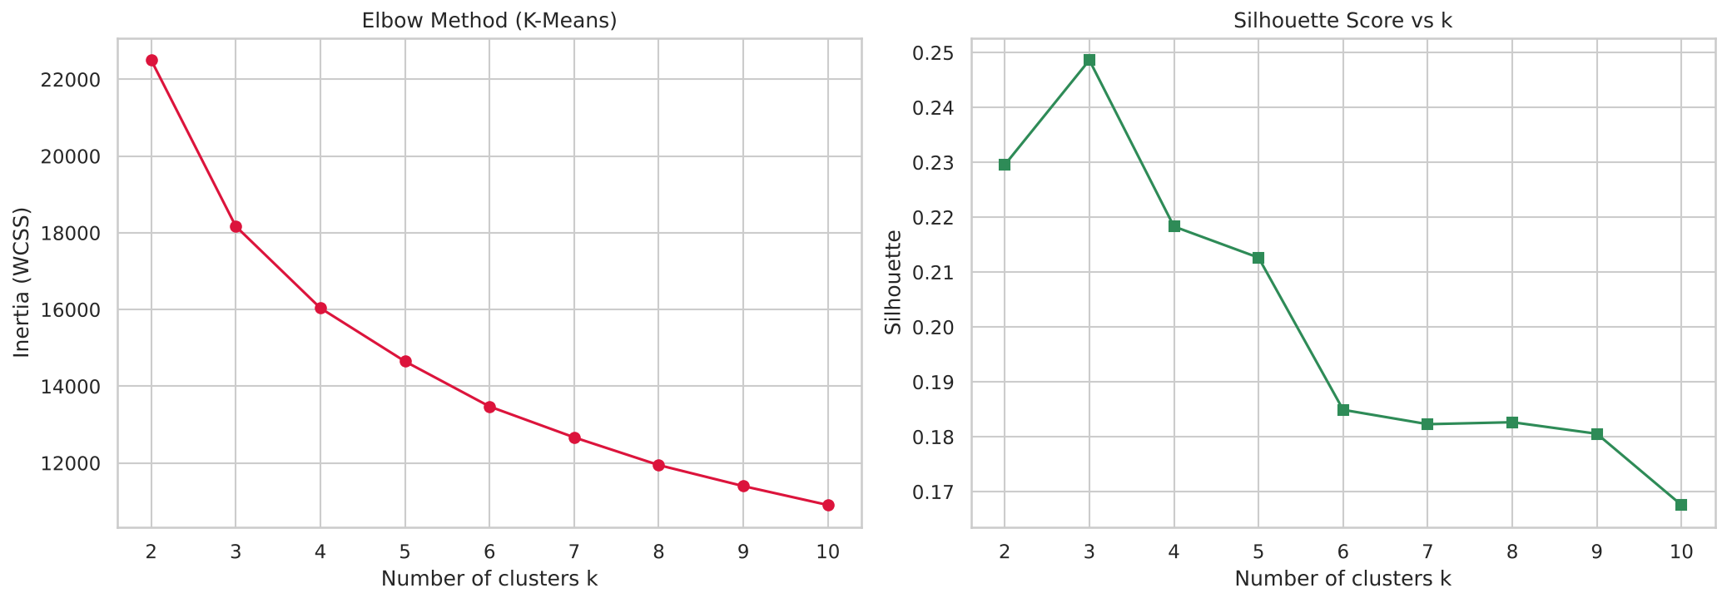
Figure 4: Elbow graph (left) and Silhouette Score against k (right)
The inertia falls steadily as k increases and has no sharp elbow; the curve bends gently around k = 3 to 4. The Silhouette Score is highest at k = 3 (0.249) and the Davies-Bouldin Index is also lowest there (1.355), so k = 3 was selected.
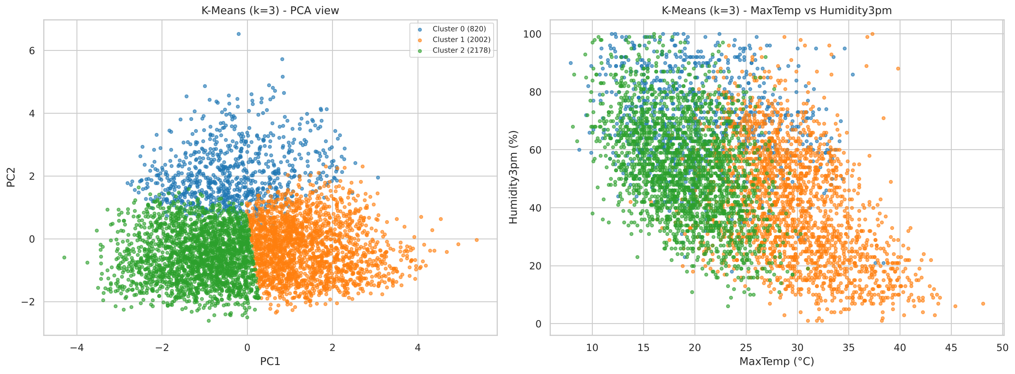
Figure 5: K-Means clusters (k = 3) in PCA space and in MaxTemp–Humidity space
The PCA view (the two components explain 63.08% of the variance) shows three regions that touch each other, which agrees with the low-to-moderate Silhouette value.
ID | Days | Min °C | Max °C | Rain mm | Hum. 3pm % | Wind km/h | Press. hPa | Interpretation
0 | 820 | 14.05 | 20.59 | 13.90 | 70.54 | 21.97 | 1011.93 | Rainy (Mild, Humid)
1 | 2002 | 16.70 | 29.63 | 0.20 | 40.60 | 20.72 | 1011.42 | Hot / Dry
2 | 2178 | 7.93 | 19.02 | 0.36 | 53.47 | 16.28 | 1019.94 | Cool / Moderate humidity

Table: K-Means cluster profiles (average real values per cluster)
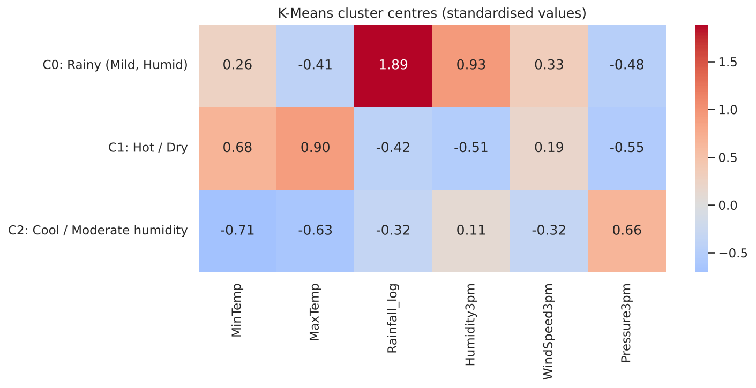
Figure 6: Standardised K-Means cluster centres (red = above average, blue = below average)
Interpretation of the K-Means groups:
- Cluster 0 – Rainy (Mild, Humid) (820 days): average MaxTemp 20.6 °C, MinTemp 14.1 °C, rainfall 13.9 mm, humidity 70.5%, wind 22.0 km/h, pressure 1011.9 hPa.
- Cluster 1 – Hot / Dry (2002 days): average MaxTemp 29.6 °C, MinTemp 16.7 °C, rainfall 0.2 mm, humidity 40.6%, wind 20.7 km/h, pressure 1011.4 hPa.
- Cluster 2 – Cool / Moderate humidity (2178 days): average MaxTemp 19.0 °C, MinTemp 7.9 °C, rainfall 0.4 mm, humidity 53.5%, wind 16.3 km/h, pressure 1019.9 hPa.

12.2 Agglomerative hierarchical clustering
k | Silhouette | Davies-Bouldin
2 | 0.171 | 1.893
3 | 0.192 | 1.580
4 | 0.160 | 1.614
5 | 0.112 | 1.750
6 | 0.115 | 1.734
7 | 0.109 | 1.736
8 | 0.105 | 1.674
9 | 0.109 | 1.650
10 | 0.087 | 1.639

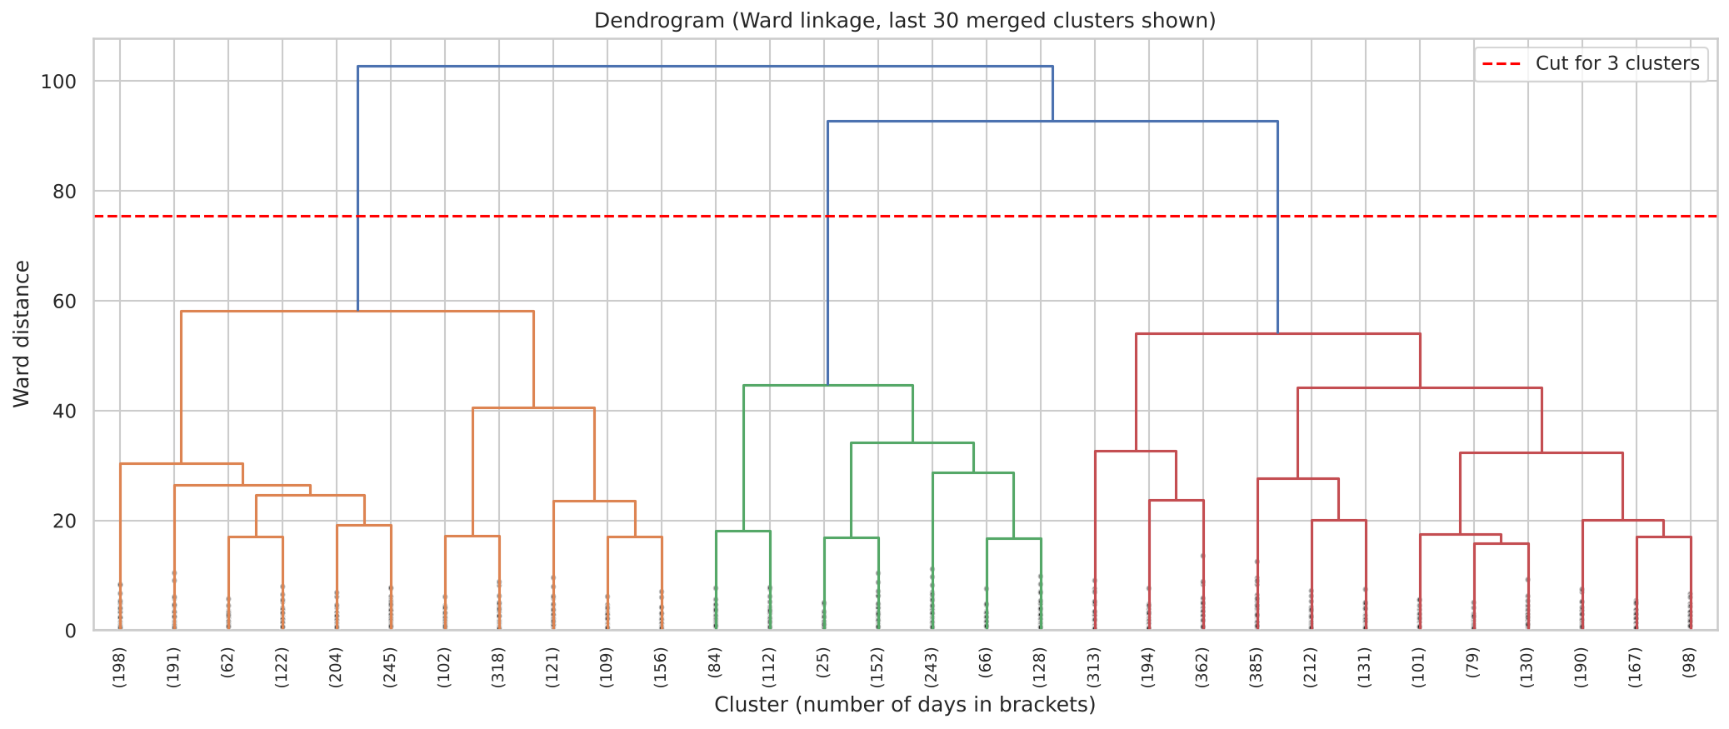
Figure 7: Dendrogram with Ward linkage (last 30 merges shown); the dashed line is the cut
The dendrogram shows that the last merges happen at much larger distances than the early ones. Cutting the tree at the dashed line gives 3 clusters, which also has the best Silhouette Score (0.192).
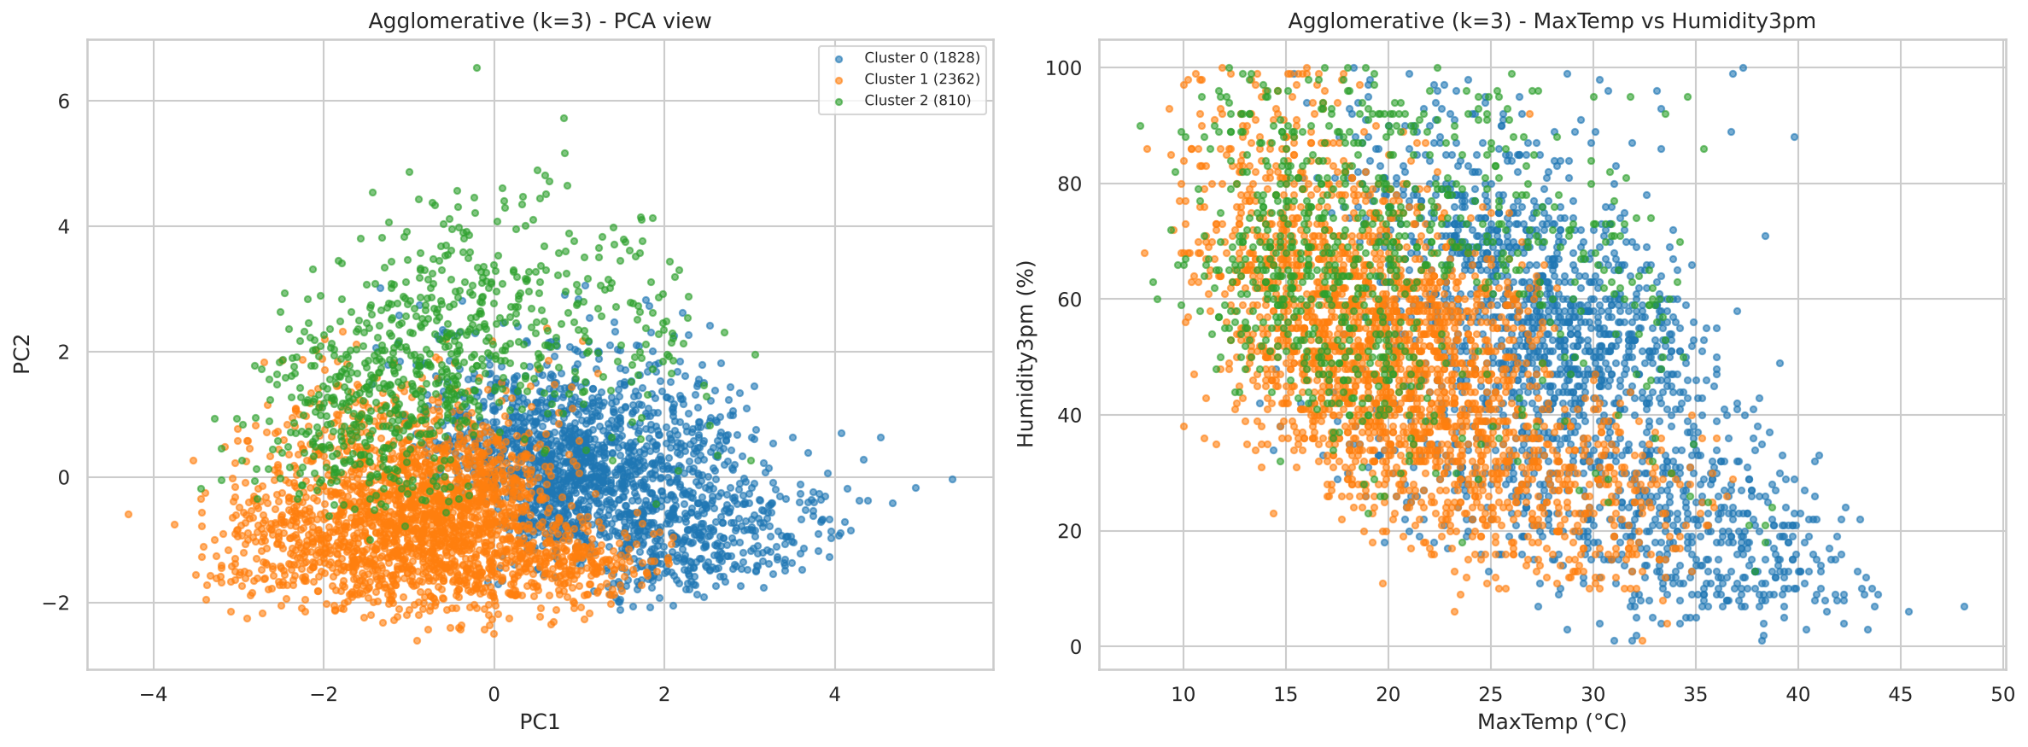
Figure 8: Agglomerative clusters in PCA space and in MaxTemp–Humidity space
ID | Days | Min °C | Max °C | Rain mm | Hum. 3pm % | Wind km/h | Press. hPa | Interpretation
0 | 1828 | 17.35 | 29.00 | 0.45 | 46.33 | 21.71 | 1010.97 | Hot / Moderate humidity
1 | 2362 | 8.61 | 20.61 | 0.17 | 49.49 | 16.30 | 1018.87 | Mild / Moderate humidity
2 | 810 | 12.56 | 19.68 | 13.99 | 66.63 | 20.68 | 1014.14 | Rainy (Cool, Humid)

Table: Hierarchical cluster profiles (average real values per cluster)
Hierarchical clustering finds a similar structure: a rainy, humid, windy group (810 days, close to the K-Means rainy cluster), a hot group, and a cooler high-pressure group. The boundary between the hot and cool groups is placed slightly differently from K-Means, so its Silhouette Score is lower.

12.3 DBSCAN
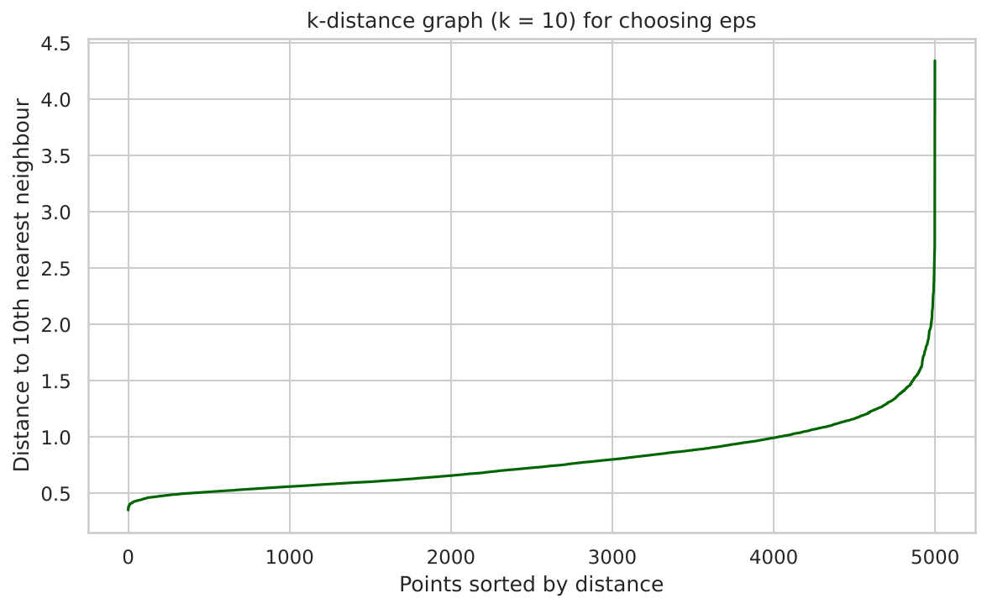
Figure 9: k-distance graph (k = 10) used as a guide for eps
The k-distance curve rises slowly and then sharply near its end, which shows that most points have close neighbours while a small number of points are isolated. A grid search was then performed. 5 settings satisfied the conditions (2–10 clusters, at most 15% noise). The best five are shown below.
eps | min_samples | Clusters | Noise | Noise % | Silhouette | Davies-Bouldin
1.2 | 5 | 2 | 85 | 1.70 | 0.310 | 0.796
0.9 | 5 | 2 | 414 | 8.28 | 0.256 | 0.739
1 | 5 | 3 | 250 | 5.00 | 0.252 | 0.626
0.9 | 10 | 2 | 739 | 14.78 | 0.208 | 0.846
0.8 | 5 | 10 | 747 | 14.94 | 0.041 | 0.840

The selected setting is eps = 1.2 and min_samples = 5. It gives 2 clusters and 85 noise points (1.70%).
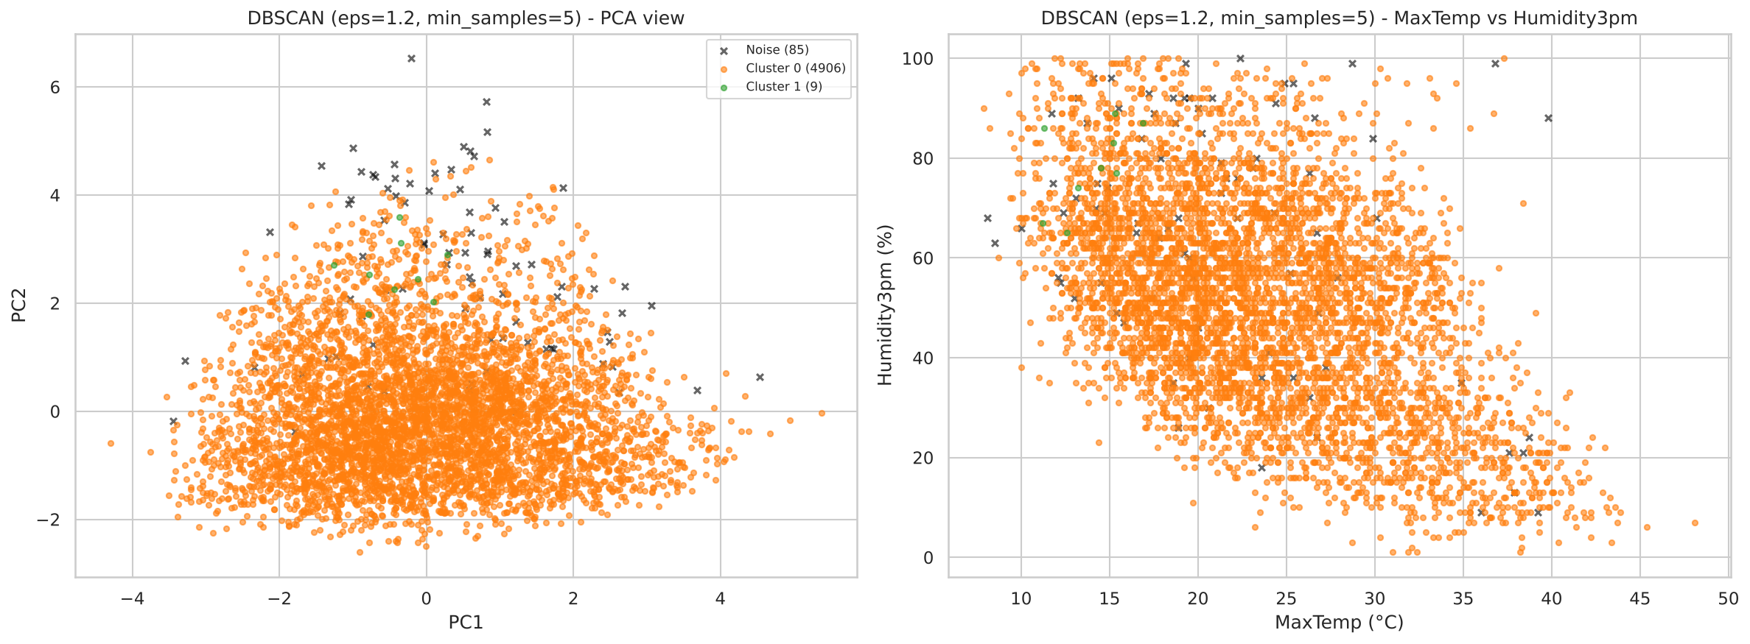
Figure 10: DBSCAN clusters; black crosses are noise points
ID | Days | Min °C | Max °C | Rain mm | Hum. 3pm % | Wind km/h | Press. hPa | Interpretation
Noise | 85 | 13.26 | 21.37 | 29.50 | 65.21 | 32.58 | 1005.36 | Noise / unusual days
0 | 4906 | 12.44 | 23.58 | 2.05 | 50.82 | 18.70 | 1015.41 | Mild / Moderate humidity
1 | 9 | 8.87 | 13.96 | 2.07 | 78.44 | 45.89 | 1004.32 | Cool / Humid

Table: DBSCAN cluster profiles (average real values per cluster)
DBSCAN puts almost all days (4906) in one large cluster, which means that the weather data form one continuous dense cloud without clear gaps. The 85 noise days are not random: on average they have heavy rainfall (29.5 mm), strong wind (32.6 km/h) and low pressure (1005.4 hPa), so DBSCAN effectively detects storm-like extreme days. The second cluster has only 9 days and is too small to be a general weather type.

13. Algorithm Performance Comparison
Algorithm | Clusters | Noise points | Silhouette ↑ | Davies-Bouldin ↓
K-Means | 3 | 0 | 0.249 | 1.355
Agglomerative (Ward) | 3 | 0 | 0.192 | 1.580
DBSCAN | 2 | 85 | 0.310 | 0.796

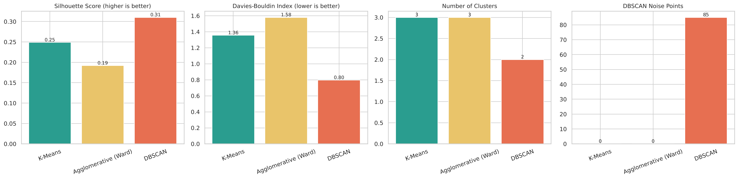
Figure 11: Comparison of the three algorithms
Discussion:
- K-Means has a better Silhouette Score (0.249) and Davies-Bouldin Index (1.355) than Agglomerative clustering (0.192, 1.580) for the same number of clusters (3).
- DBSCAN has the highest Silhouette Score (0.310) and the lowest Davies-Bouldin Index (0.796), but this must be read carefully. Its scores are computed only on non-noise points, and it produced one giant cluster plus a tiny cluster of 9 days. A clustering with one dominant group is easy to score well but does not divide the weather into useful types.
- For describing weather types, K-Means gives the most useful and balanced result. Hierarchical clustering supports the K-Means findings. DBSCAN is most useful for finding unusual days (outliers).
- All Silhouette Scores are low to moderate (below 0.35). This is expected because daily weather changes continuously and the groups overlap. The clusters should be seen as useful summaries of weather regimes, not as sharply separate classes.
- There is no accuracy value in this project, because no labels were used. No accuracy or other score was assumed; all numbers come from the notebook run.

14. Advantages and Limitations

14.1 Advantages of the approach
- Works without labels, so it can be used on any weather record.
- Fully automatic: the data download, cleaning, clustering and evaluation run in one notebook.
- Three different algorithm families are compared on the same data.
- The clusters can be explained with real weather values, which makes the results understandable.
- DBSCAN additionally highlights extreme days.

14.2 Limitations
- Rows with missing values were dropped (17,722 rows), mainly because of missing pressure readings, so some stations are under-represented.
- Only a 5,000-day random sample was clustered, because hierarchical clustering is memory-intensive. Other samples may give slightly different values.
- The data mix different Australian climates and seasons; the Date column is not available in this copy, so seasonal and time effects could not be studied.
- The Silhouette Score and Davies-Bouldin Index favour compact, round clusters and cannot prove that a clustering is “correct”.
- The choice of features, log-transform, range of k and DBSCAN limits influence the result. The cluster names come from simple threshold rules and are subjective descriptions.
- Only six features of the available variables (for example cloud cover, sunshine and evaporation) were used.

15. Real-World Applications
- Climate zoning: grouping stations or days into similar climate regimes.
- Agriculture: finding weather types linked to irrigation needs or crop disease risk.
- Weather forecasting support: using clusters as regime features and detecting unusual days for warnings.
- Energy: relating weather types to electricity demand or solar and wind generation.
- Disaster management: detecting storm-like outlier days as DBSCAN did here.
- Transport and tourism: planning for typical weather types of a region.
- Insurance and risk analysis: grouping extreme weather days for risk assessment.

16. Conclusion
This project successfully applied three unsupervised clustering algorithms to real daily weather observations. After cleaning 142,193 records to 124,426 complete days and standardising six weather features, a 5,000-day sample was clustered. K-Means with k = 3 (Silhouette 0.249, Davies-Bouldin 1.355) revealed three interpretable weather groups: hot and dry days, cool high-pressure days and rainy humid low-pressure days. Agglomerative clustering confirmed a similar structure with lower scores, and DBSCAN (2 clusters, 85 noise points) showed that the data form one continuous cloud in which only a few extreme storm-like days stand out.
The study shows that clustering can discover meaningful weather patterns without labels, but the quality scores are only moderate because weather changes gradually. K-Means was the most practical algorithm for describing weather types, and DBSCAN was most useful for detecting extreme days.

17. Future Scope
- Use the Date column (from the original Kaggle file) to study seasonal and yearly patterns and to cluster monthly weather.
- Cluster each station or climate zone separately, or cluster stations using their average climate.
- Add more variables such as cloud cover, sunshine and evaporation.
- Try other unsupervised methods such as Gaussian Mixture Models, HDBSCAN, OPTICS and Self-Organising Maps.
- Use dimensionality reduction (PCA, t-SNE, UMAP) before clustering and test cluster stability on several random samples.
- Cluster the full dataset using scalable methods such as MiniBatch K-Means.
- Build a web dashboard that assigns a new day’s weather to the nearest cluster.

18. References
[1] Australian Bureau of Meteorology. Climate Data Online. http://www.bom.gov.au/climate/data (original source of the observations).
[2] Kaggle. Rain in Australia (weather-dataset-rattle-package). https://www.kaggle.com/datasets/jsphyg/weather-dataset-rattle-package
[3] GitHub (tvdboom/ATOM). weatherAUS.csv, the copy downloaded by the notebook. https://raw.githubusercontent.com/tvdboom/ATOM/master/examples/datasets/weatherAUS.csv
[4] MacQueen, J. (1967). Some methods for classification and analysis of multivariate observations. Proceedings of the Fifth Berkeley Symposium on Mathematical Statistics and Probability, 1, 281–297.
[5] Lloyd, S. P. (1982). Least squares quantization in PCM. IEEE Transactions on Information Theory, 28(2), 129–137.
[6] Ward, J. H. (1963). Hierarchical grouping to optimize an objective function. Journal of the American Statistical Association, 58(301), 236–244.
[7] Ester, M., Kriegel, H.-P., Sander, J., & Xu, X. (1996). A density-based algorithm for discovering clusters in large spatial databases with noise. Proceedings of KDD-96, 226–231.
[8] Schubert, E., Sander, J., Ester, M., Kriegel, H.-P., & Xu, X. (2017). DBSCAN revisited, revisited: Why and how you should (still) use DBSCAN. ACM Transactions on Database Systems, 42(3), Article 19.
[9] Rousseeuw, P. J. (1987). Silhouettes: A graphical aid to the interpretation and validation of cluster analysis. Journal of Computational and Applied Mathematics, 20, 53–65.
[10] Davies, D. L., & Bouldin, D. W. (1979). A cluster separation measure. IEEE Transactions on Pattern Analysis and Machine Intelligence, PAMI-1(2), 224–227.
[11] Kaufman, L., & Rousseeuw, P. J. (1990). Finding Groups in Data: An Introduction to Cluster Analysis. Wiley.
[12] Jain, A. K. (2010). Data clustering: 50 years beyond K-means. Pattern Recognition Letters, 31(8), 651–666.
[13] Pedregosa, F., et al. (2011). Scikit-learn: Machine learning in Python. Journal of Machine Learning Research, 12, 2825–2830.
[14] Virtanen, P., et al. (2020). SciPy 1.0: Fundamental algorithms for scientific computing in Python. Nature Methods, 17, 261–272.
[15] Harris, C. R., et al. (2020). Array programming with NumPy. Nature, 585, 357–362.
[16] McKinney, W. (2010). Data structures for statistical computing in Python. Proceedings of the 9th Python in Science Conference, 56–61.
[17] Hunter, J. D. (2007). Matplotlib: A 2D graphics environment. Computing in Science & Engineering, 9(3), 90–95.
[18] Waskom, M. L. (2021). seaborn: statistical data visualization. Journal of Open Source Software, 6(60), 3021.

