**DAILY ONLINE ACTIVITIES SUMMARY**

|  |  |  |  |  |  |  |  |  |
| --- | --- | --- | --- | --- | --- | --- | --- | --- |
| **Date:** | **03-07-2020** | | | | | **Name:** | **RAVALI P** | |
| **Sem & Sec** | **6th SEM- B SEC** | | | | | **USN:** | **4AL17CS076** | |
| **Online Test Summary** | | | | | | | | |
| **Subject** | | **-** | | | | | | |
| **Max. Marks** | | **-** | | **Score** | | | **-** | |
| **Certification Course Summary** | | | | | | | | |
| **Course** | CYBER-SECURITY | | | | | | | |
| **Certificate Provider** | | | **UDEMY** | | **Duration** | | | **6 DAYS** |
| **Coding Challenges** | | | | | | | | |
| **Problem Statement: 1 Java program** | | | | | | | | |
| **Status: executed** | | | | | | | | |
| **Uploaded the report in GitHub** | | | | | **Yes** | | | |
| **If yes Repository name** | | | | | [**https://github.com/Ravalipr/Daily-Status.git**](https://github.com/Ravalipr/Daily-Status.git) | | | |
| **Uploaded the report in slack** | | | | | **Yes** | | | |

Certification Course Details:-

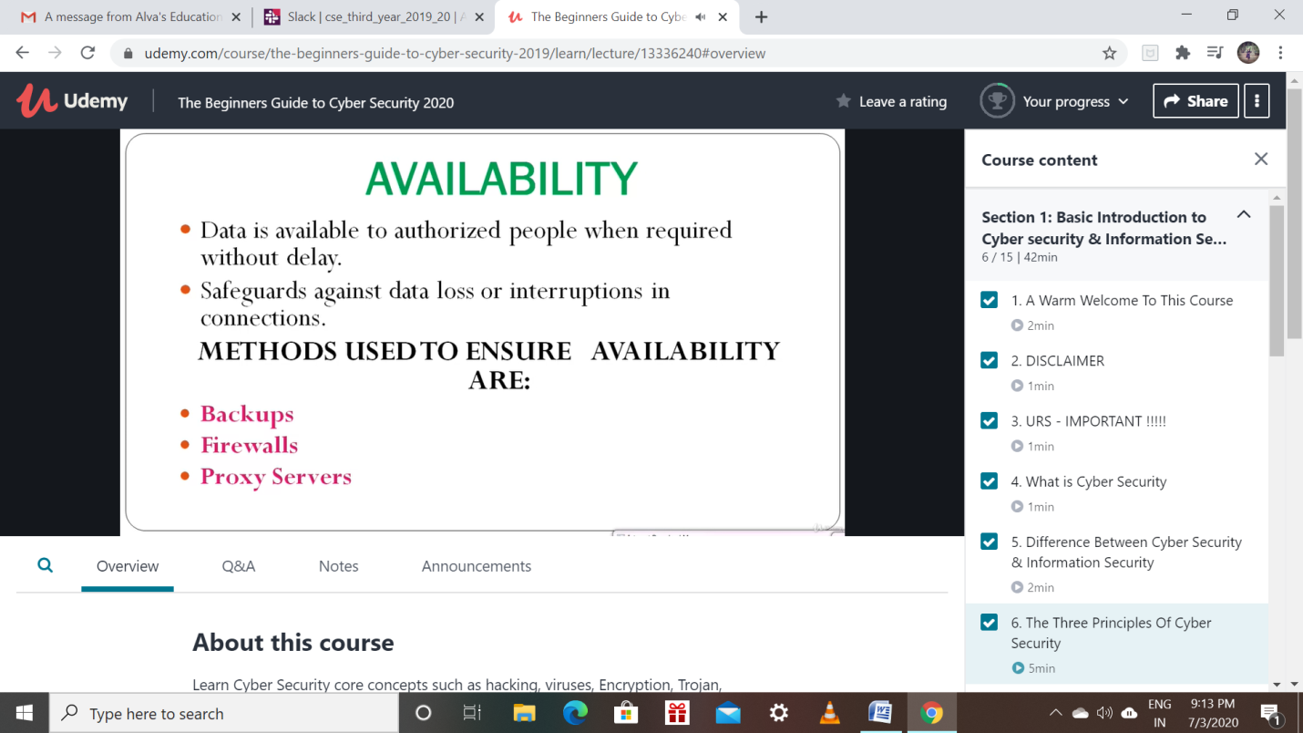

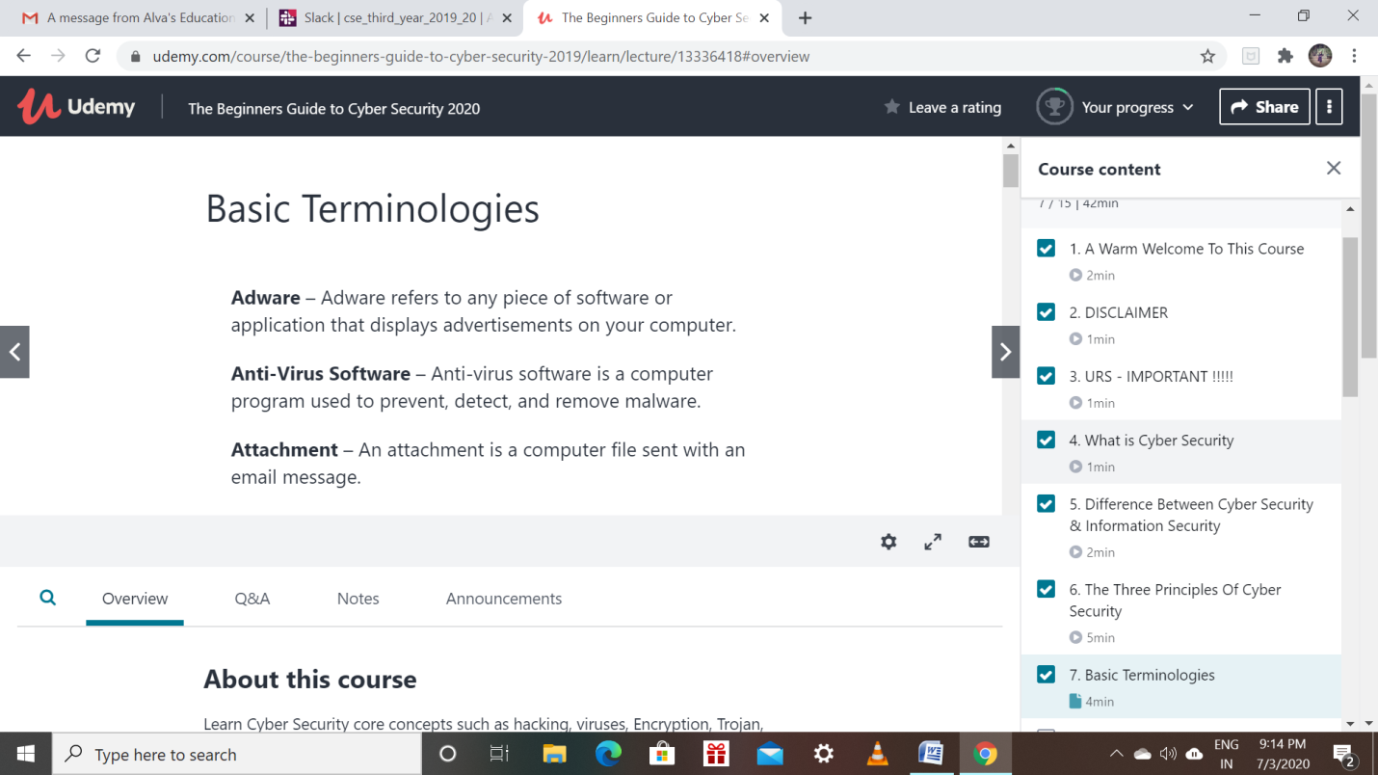

Coding Challenges Details: (Attach the snapshot and briefly write the report for the same)

Program 1

This is output of java program  to find two lines with max characters in descending order.

