**DAILY ONLINE ACTIVITIES SUMMARY**

|  |  |  |  |  |  |  |  |
| --- | --- | --- | --- | --- | --- | --- | --- |
| **Date:** | **04-06-2020** | | | | **Name:** | **RAVALI P** | |
| **Sem & Sec** | **6 B** | | | | **USN:** | **4AL17CS076** | |
| Online Test Summary | | | | | | | |
| **Subject** | | **OPERATING SYSTEM** | | | | | |
| **Max. Marks** | | **30** | | **Score** | | **22** | |
| Certification Course Summary | | | | | | | |
| **Course** | **PYTHON FOR DATA SCIENCE** | | | | | | |
| **Certificate Provider** | | | **IBM** | **Duration** | | | **5 DAYS** |
| Coding Challenges | | | | | | | |
| **Problem Statement-one python program and one java program.** | | | | | | | |
| **Status:Executed** | | | | | | | |
| **Uploaded the report in Github** | | | | **Yes** | | | |
| **If yes Repository name** | | | | **https://github.com/Ravalipr/Daily-Status.git** | | | |
| **Uploaded the report in slack** | | | | **Yes** | | | |

Online Test Details: (Attach the snapshot and briefly write the report for the same)

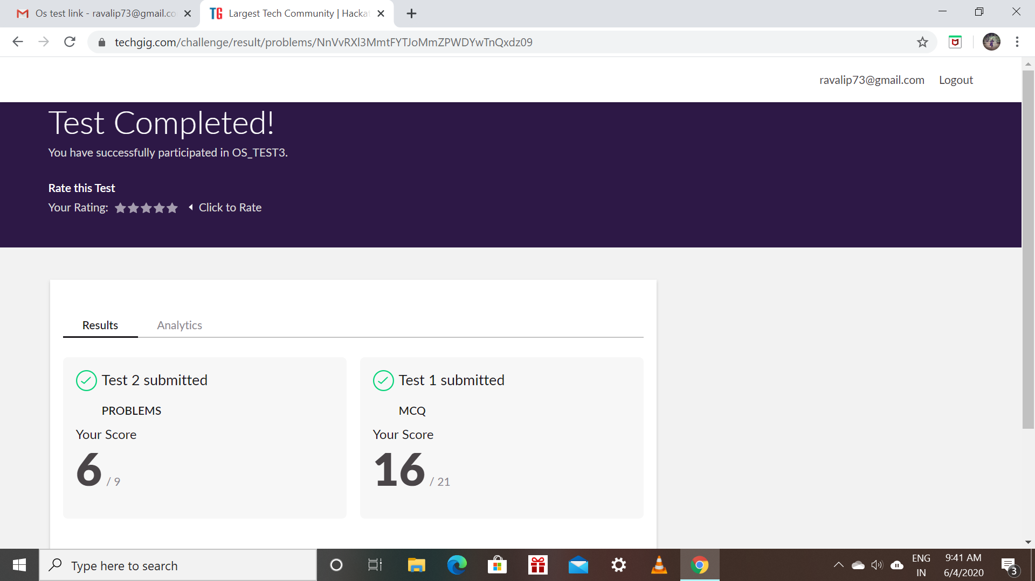

Certification Course Details: (Attach the snapshot and briefly write the report for the same)

* Today’s topic is about writing files with Open and reading files.
* Here we will use pythons open function to get a file object,to create a text file we can apply method write to write data to that file.
* Last taken assessment for that module.

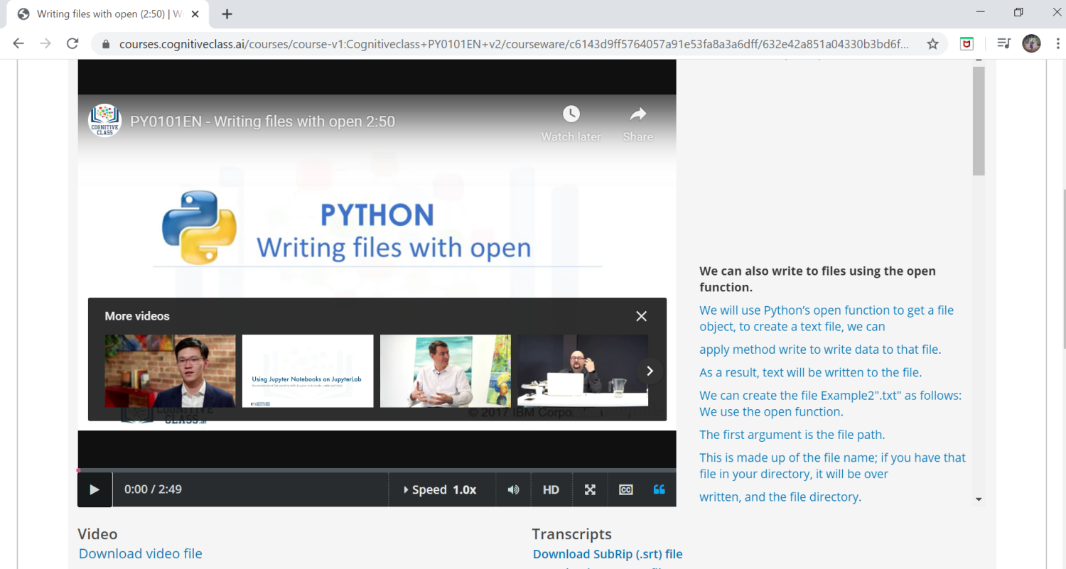

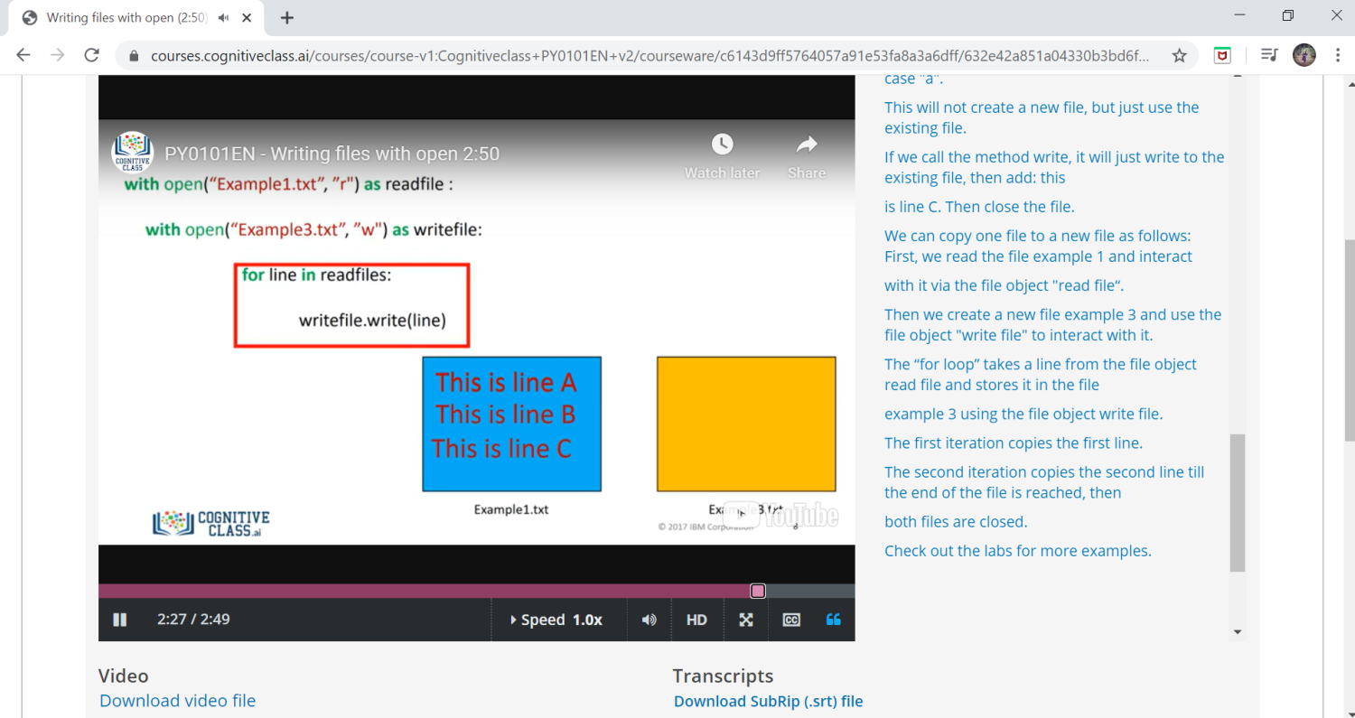

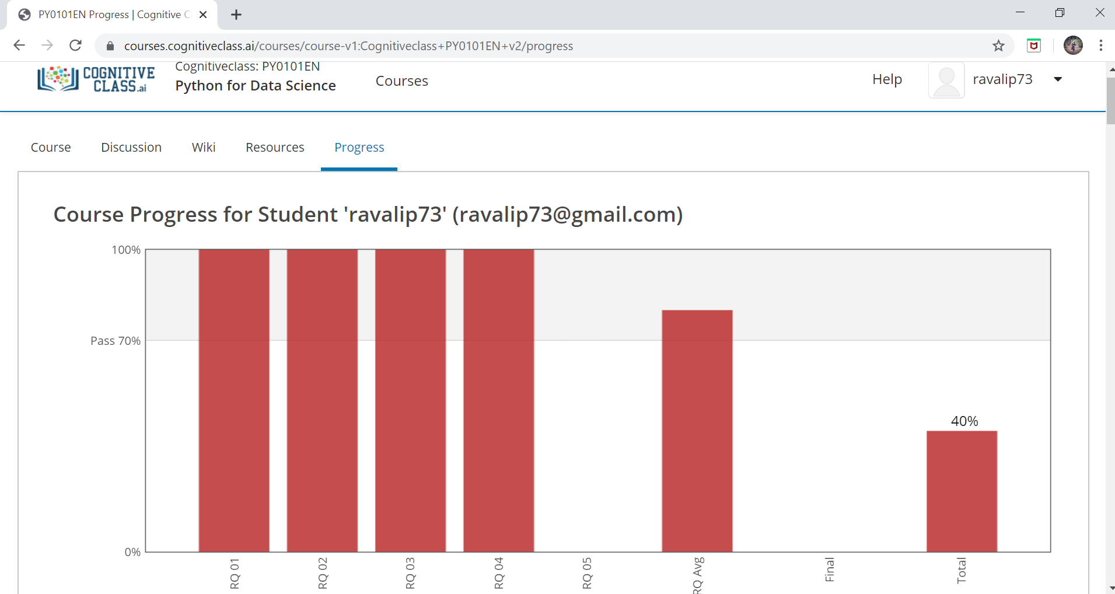

Coding Challenges Details: (Attach the snapshot and briefly write the report for the same)

Program1:

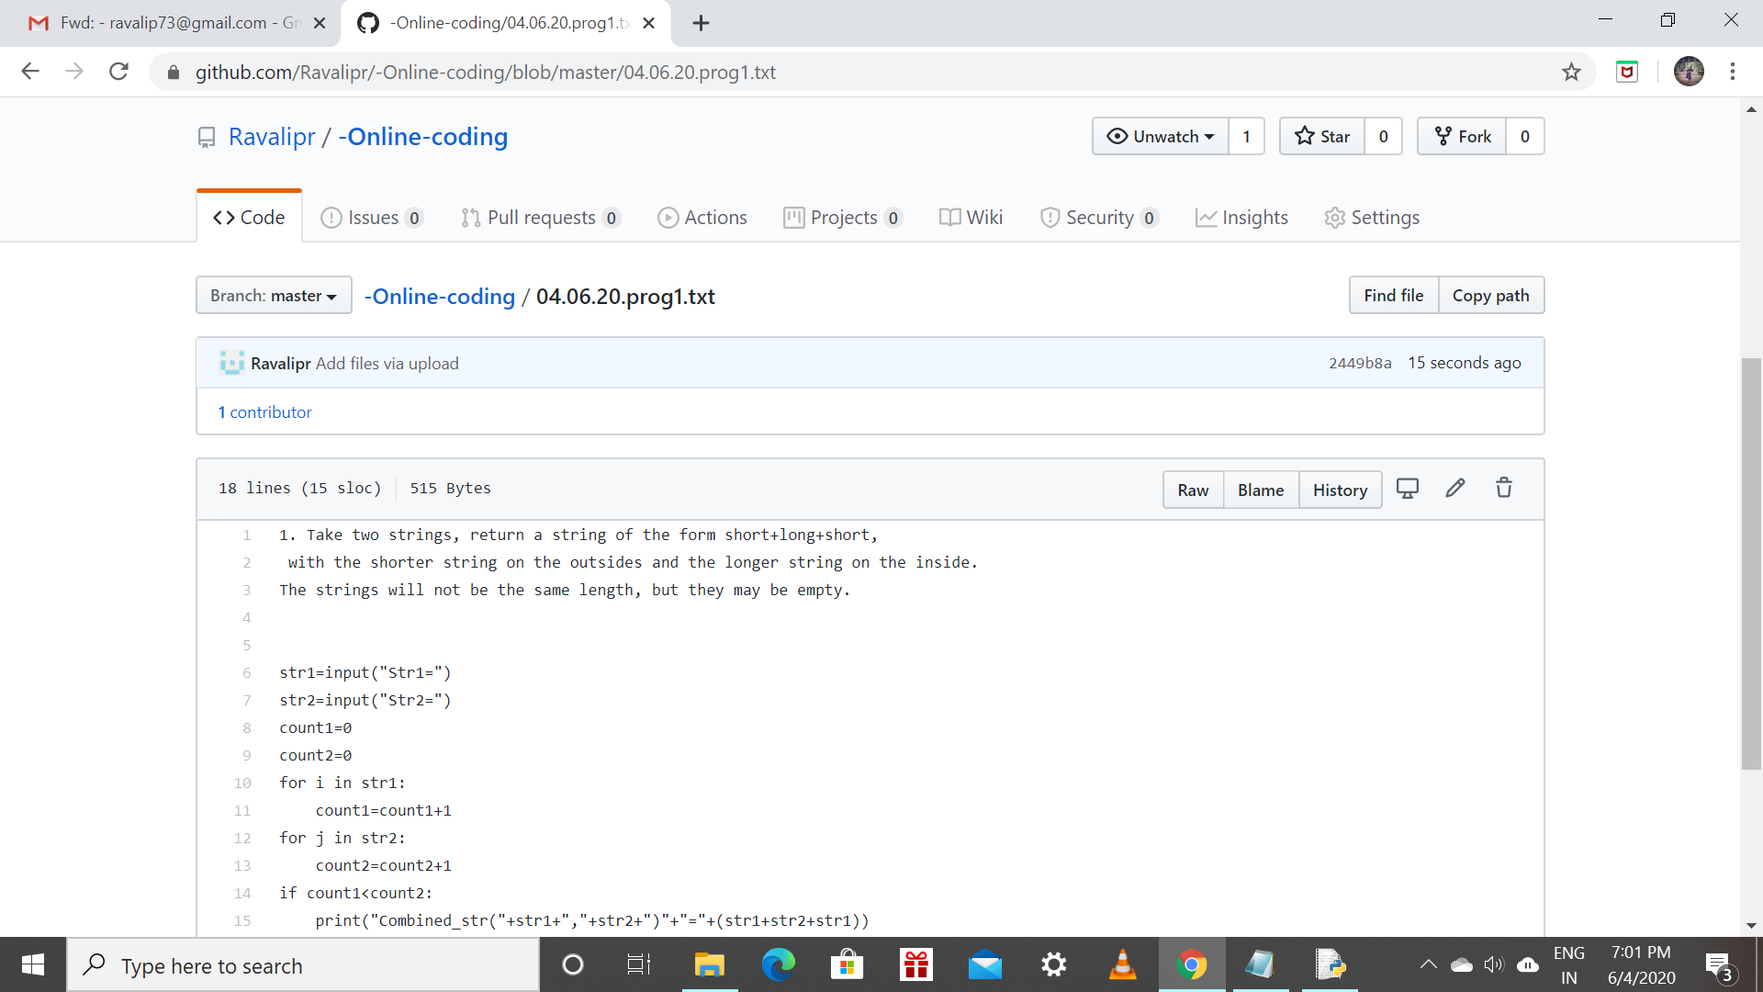

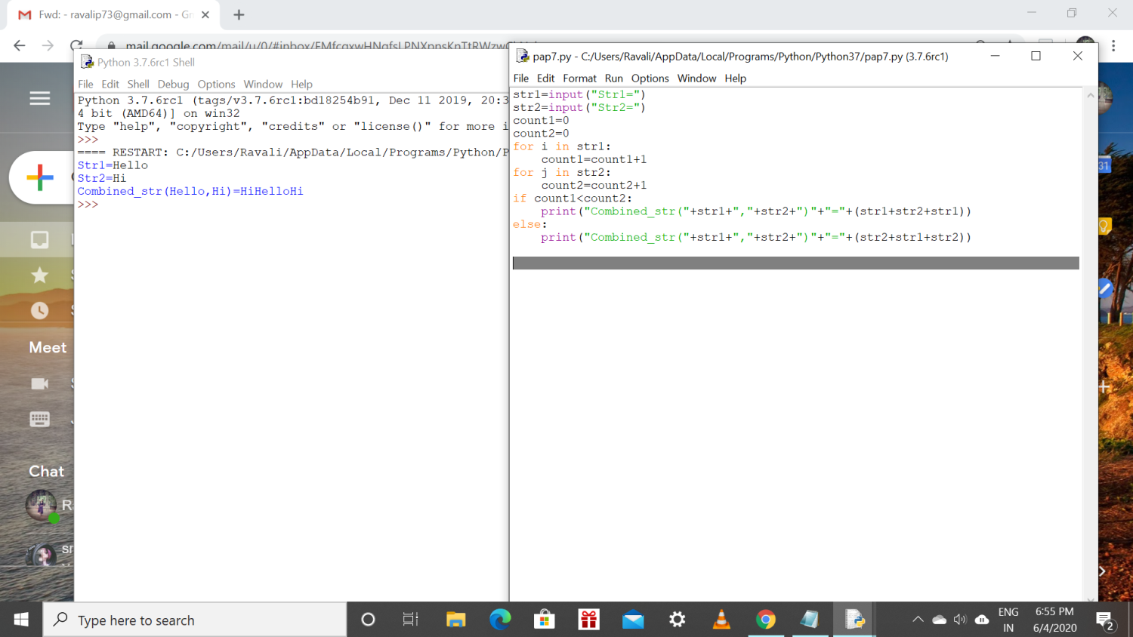

Program 2:

