**DAILY ONLINE ACTIVITIES SUMMARY**

|  |  |  |  |  |  |  |  |  |
| --- | --- | --- | --- | --- | --- | --- | --- | --- |
| **Date:** | **20.06.20** | | | | | **Name:** | **RAVALI P** | |
| **Sem & Sec** | **6th Sem ‘B’ Sec** | | | | | **USN:** | **4AL17CS076** | |
| **Online Test Summary** | | | | | | | | |
| **Subject** | | **C++ Programming** | | | | | | |
| **Max. Marks** | | **--** | | **Score** | | | **TEST1-4**  **TEST2-10** | |
| **Certification Course Summary** | | | | | | | | |
| **Course** | **Placement Training** | | | | | | | |
| **Certificate Provider** | | | **Ms. Ankita Shetty**  **Mr.Pradeep** | | **Duration** | | | **--** |
| **Coding Challenges** | | | | | | | | |
| **Problem Statement:1program** | | | | | | | | |
| **Status: Executed** | | | | | | | | |
| **Uploaded the report in GitHub** | | | | | **yes** | | | |
| **If yes Repository name** | | | | | **https://github.com/Ravalipr/Daily-Status.git** | | | |
| **Uploaded the report in slack** | | | | | **yes** | | | |

**C++ programming Session 1:**

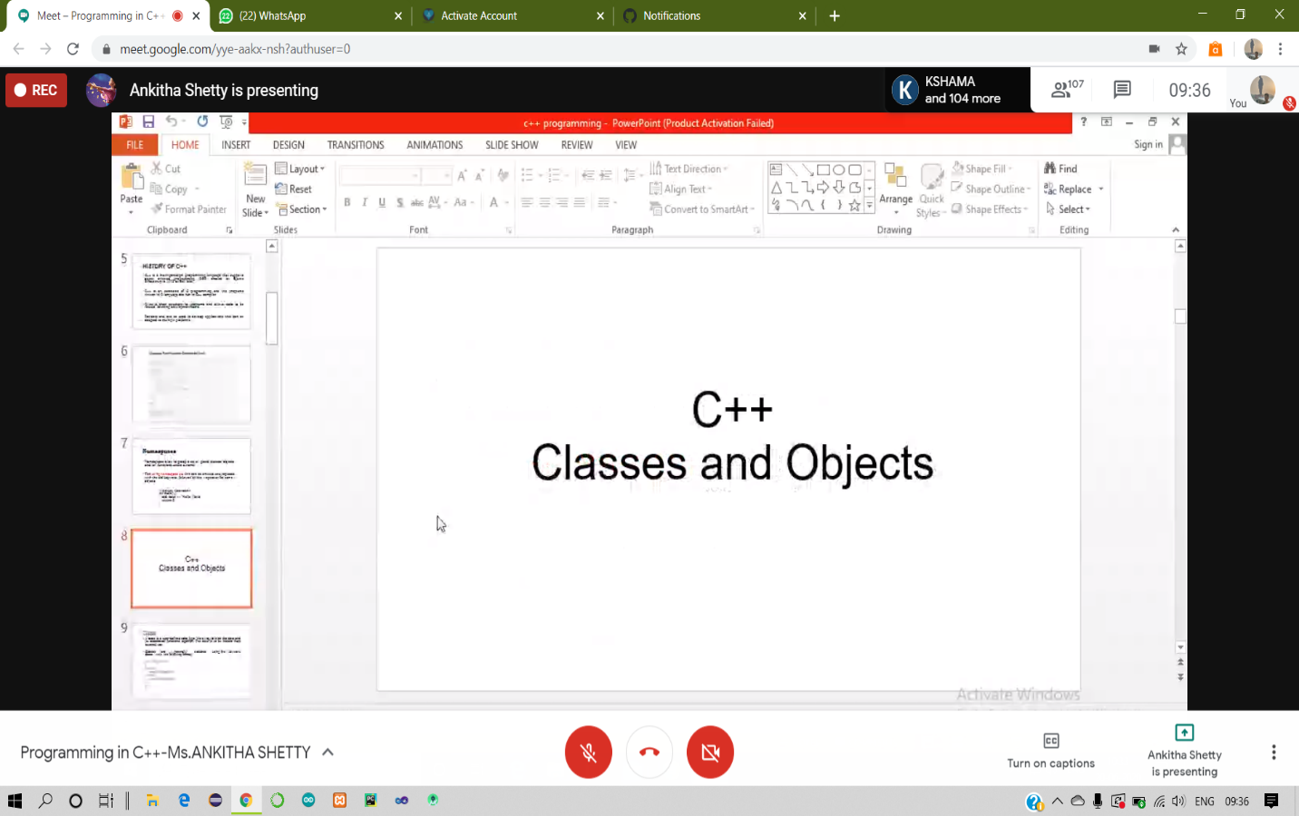

**C++ Programming Session 2**

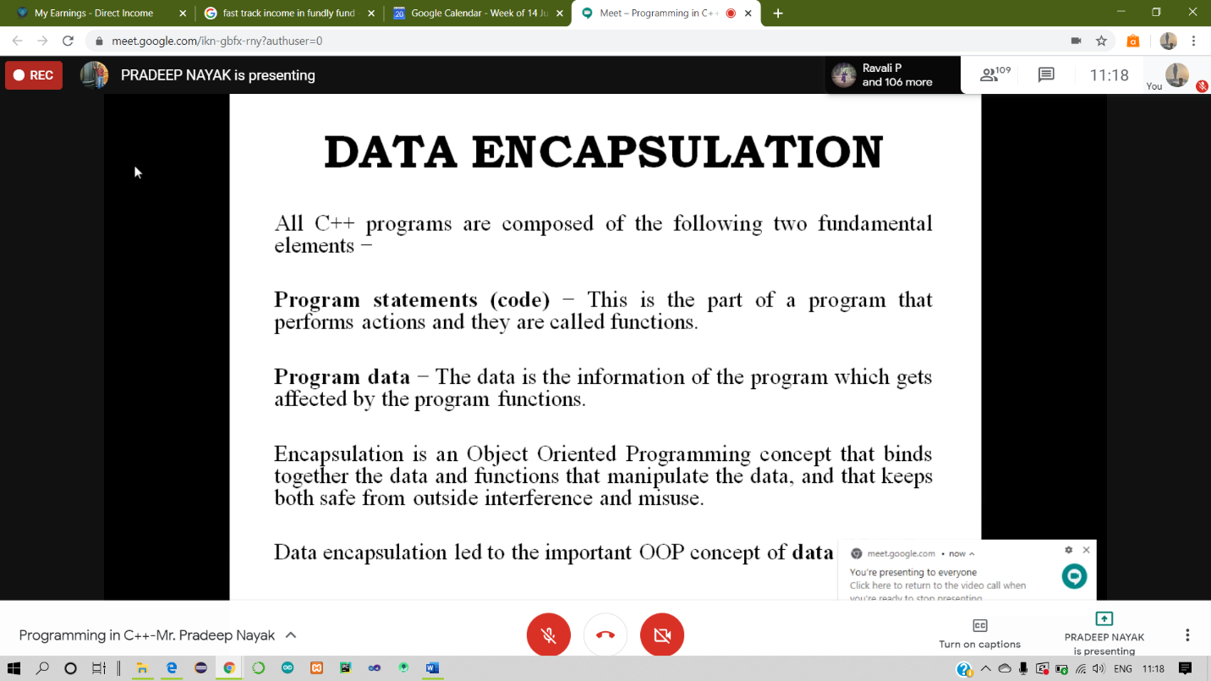

**Coding Challenges Details:**

**Program 1-**

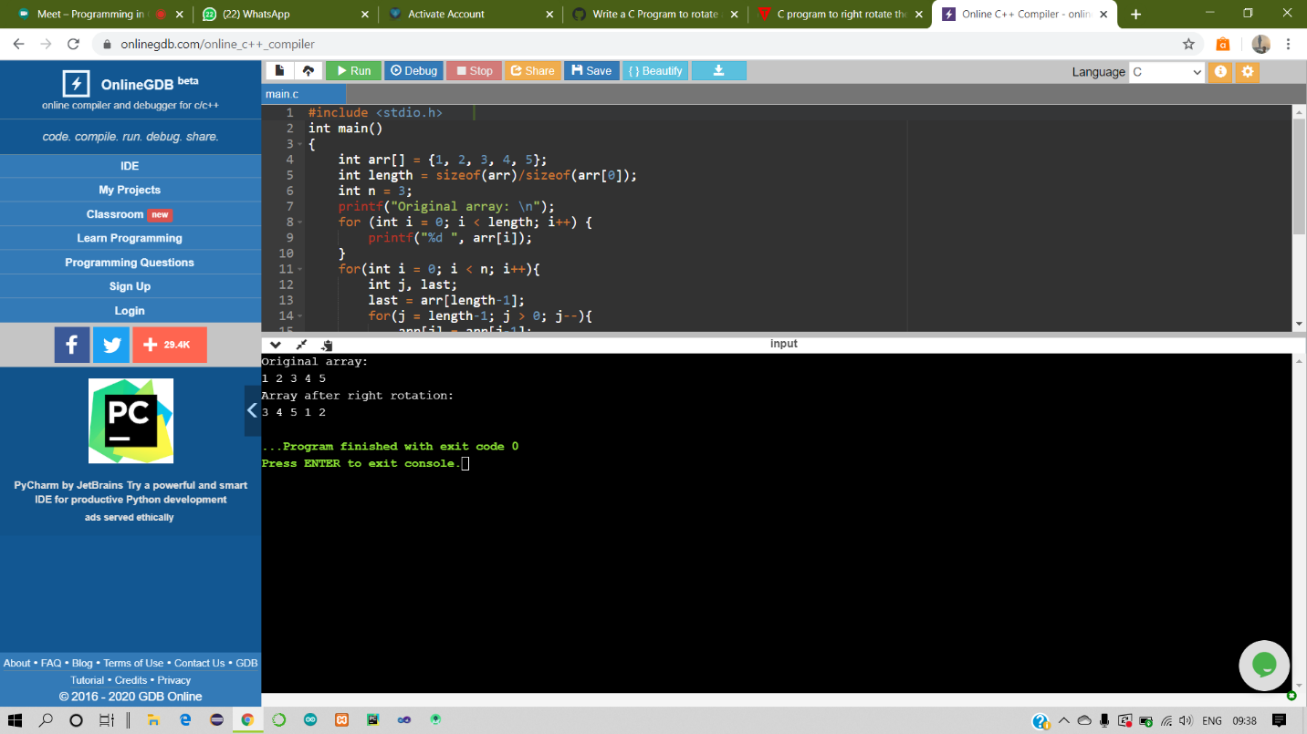

**1-For Report and daily coding challenges** 🡪https://github.com/Ravalipr/Daily-Status.git

**2-For Exercises and Worked problems of workshop** 🡪

**https://github.com/Ravalipr/Python--Workshop5days.git**