|  |  |  |  |  |  |  |  |
| --- | --- | --- | --- | --- | --- | --- | --- |
| **Date:** | **22-06-2020** | | | | **Name:** | **RAVALI P** | |
| **Sem & Sec** | **6th - B** | | | | **USN:** | **4AL17CS076** | |
| **Online Test Summary** | | | | | | | |
| **Subject** | **C++ programming Quiz** | | | | | | |
| **Max. Marks** | **-** | | **Score** | | | **-** | |
| **Certification Course Summary** | | | | | | | |
| **Course** | **1.Pre-Placement Training** | | | | | | |
| **Certificate Provider** | | **-** | | **Duration** | | | **4 HRS** |
| **Coding Challenges** | | | | | | | |
| **Problem Statement:1 Java program and 1Python program** | | | | | | | |
| **Status: Executed** | | | | | | | |
| **Uploaded the report in GitHub** | | | | **yes** | | | |
| **If yes Repository name** | | | | [**https://github.com/Ravalipr/Daily-Status.git**](https://github.com/Ravalipr/Daily-Status.git) | | | |
| **Uploaded the report in slack** | | | | **Yes** | | | |

**programming in c++:**

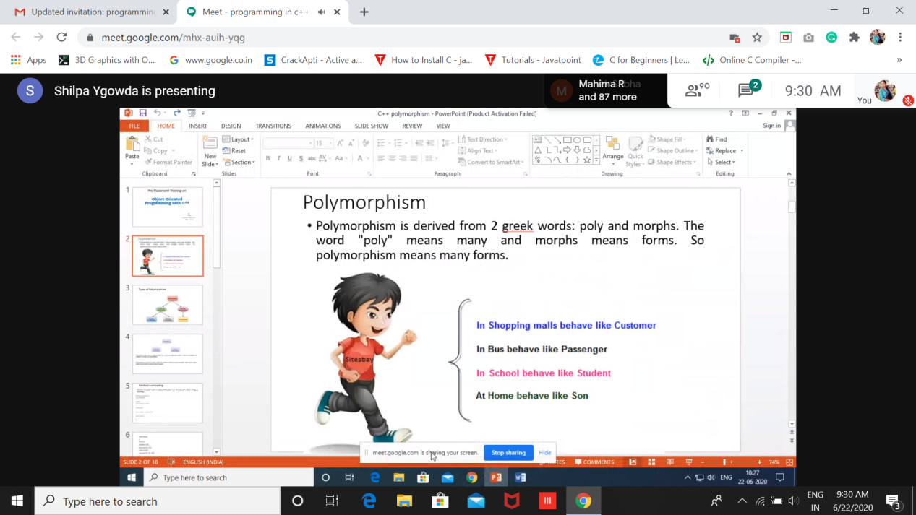

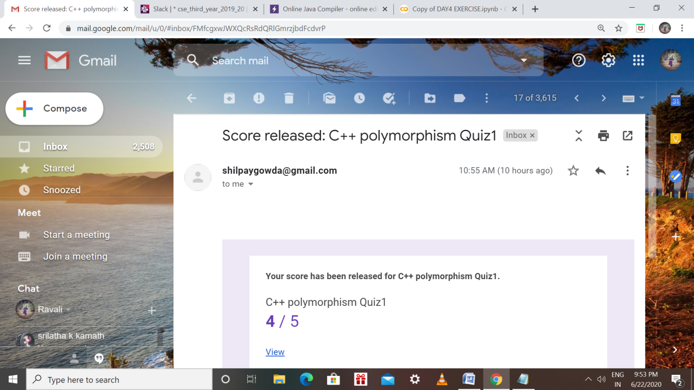

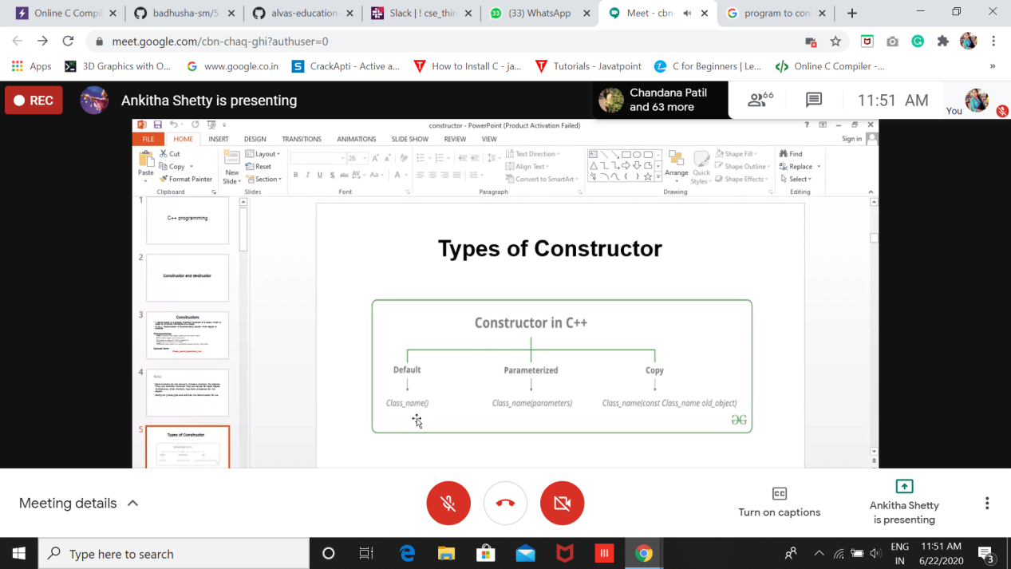

Coding Challenges Details: (Attach the snapshot and briefly write the report for the same

Output screen shots

1.Write a Java program to find maximum repeated words from a file.

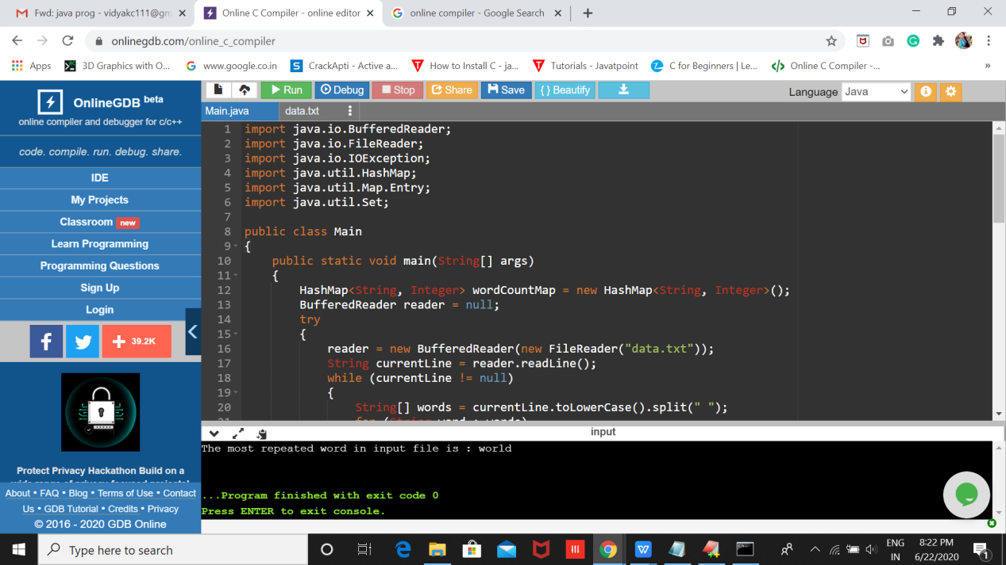

1. Python Program to Read the Contents of a File in Reverse Order

