**DAILY ONLINE ACTIVITIES SUMMARY**

|  |  |  |  |  |  |  |  |
| --- | --- | --- | --- | --- | --- | --- | --- |
| **Date:** | **29-05-2020** | | | | **Name:** | **RAVALI P** | |
| **Sem & Sec** | **6 B** | | | | **USN:** | **4AL17CS076** | |
| Online Test Summary | | | | | | | |
| **Subject** | | **OPERATION RESEARCH** | | | | | |
| **Max. Marks** | | **30** | | **Score** | | **30** | |
| Certification Course Summary | | | | | | | |
| **Course** | **CARRER EDGE** | | | | | | |
| **Certificate Provider** | | | **TCS** | **Duration** | | | **15 DAYS** |
| Coding Challenges | | | | | | | |
| **Problem Statement-2 Java programs and 1 C program** | | | | | | | |
| **Status:Executed** | | | | | | | |
| **Uploaded the report in Github** | | | | **Yes** | | | |
| **If yes Repository name** | | | | **https://github.com/Ravalipr/Daily-Status.git** | | | |
| **Uploaded the report in slack** | | | | **Yes** | | | |

Online Test Details: (Attach the snapshot and briefly write the report for the same)

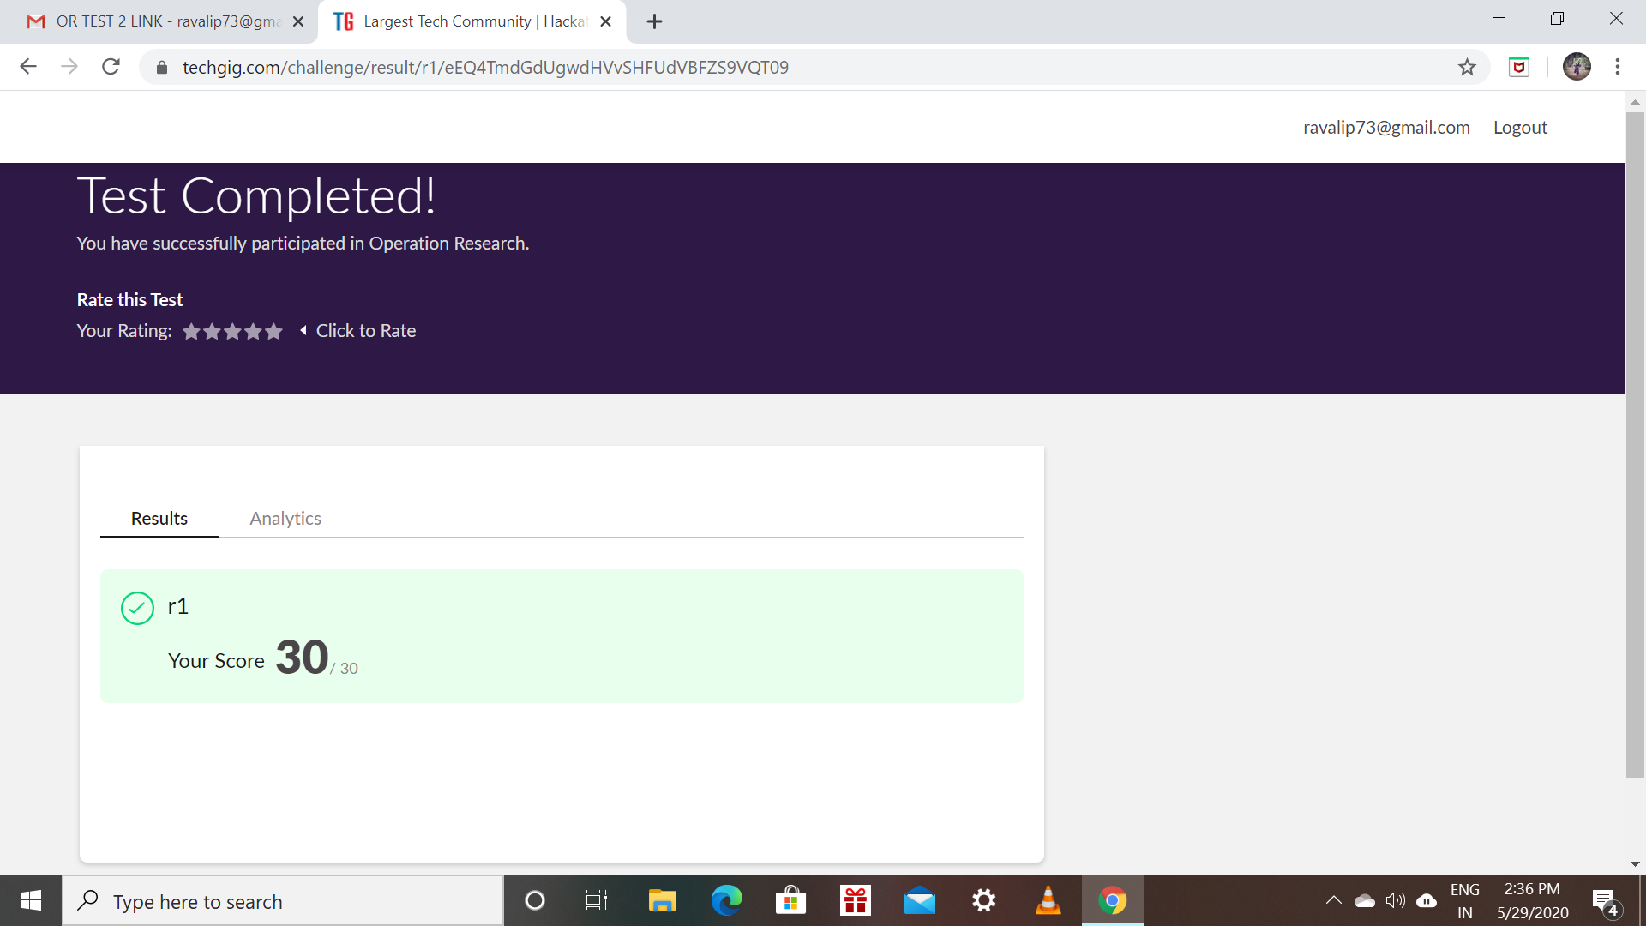

Certification Course Details: (Attach the snapshot and briefly write the report for the same)

* Today’s topic on certification course is about learning of corporate etiquette.
* And also how to write the Emails in the formal manner ,what and all should be included in the email like subject line ,regards, etc…

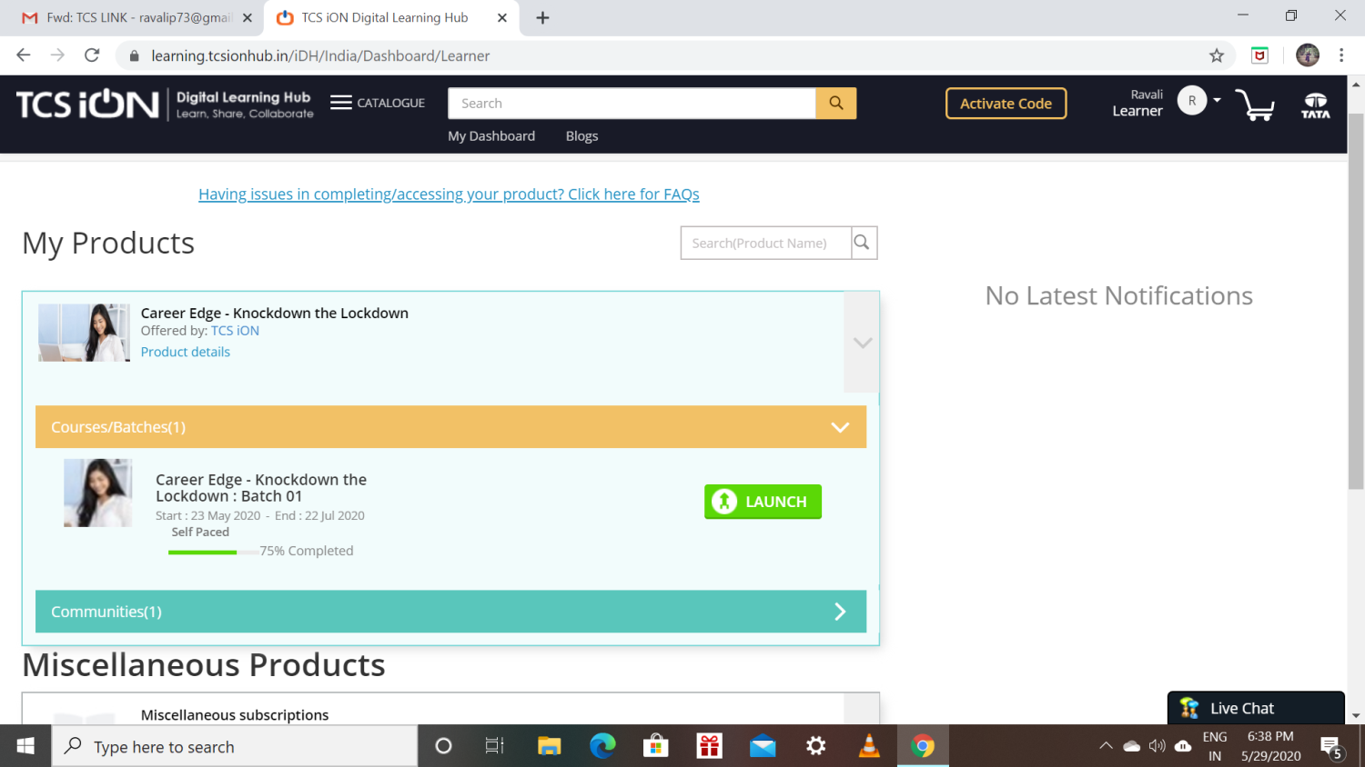

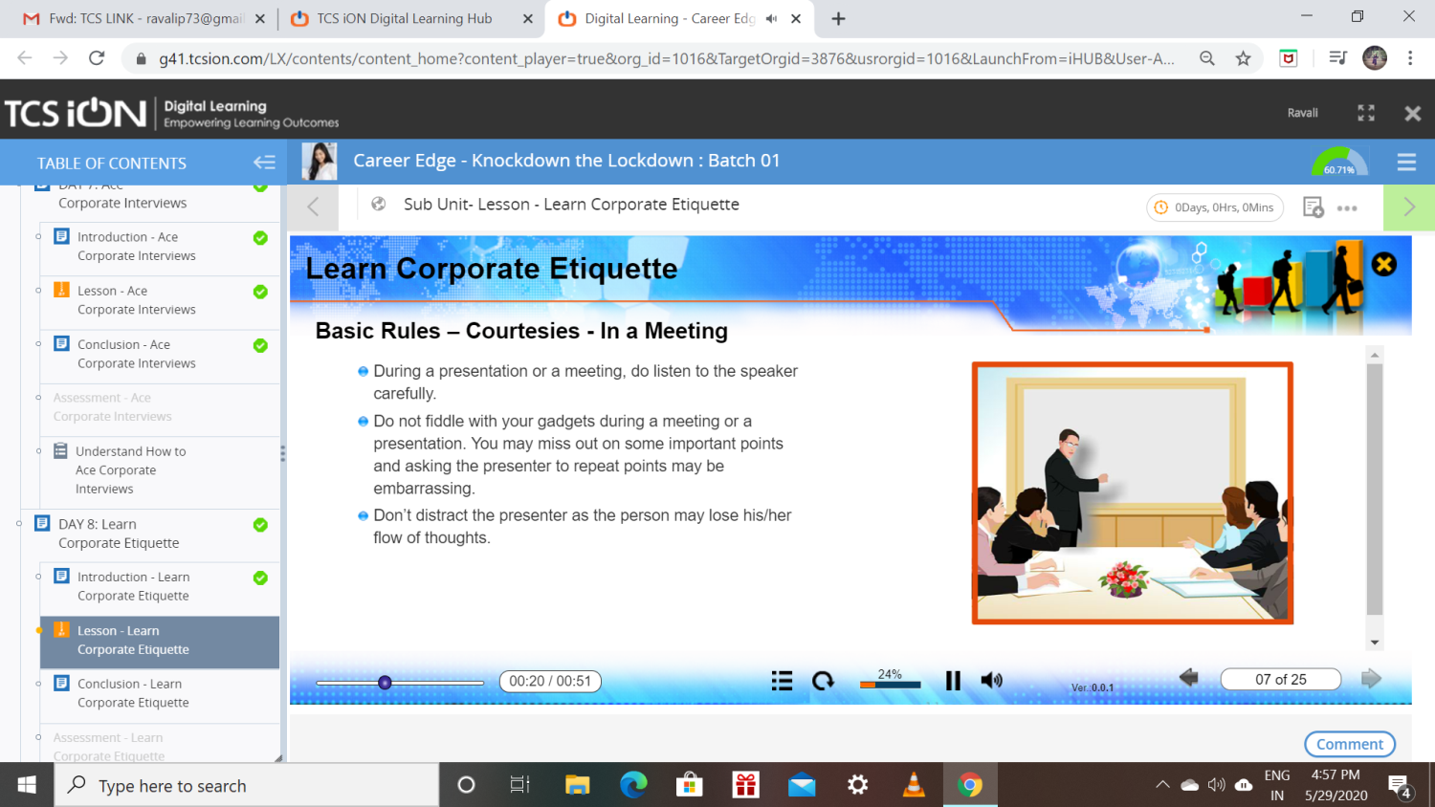

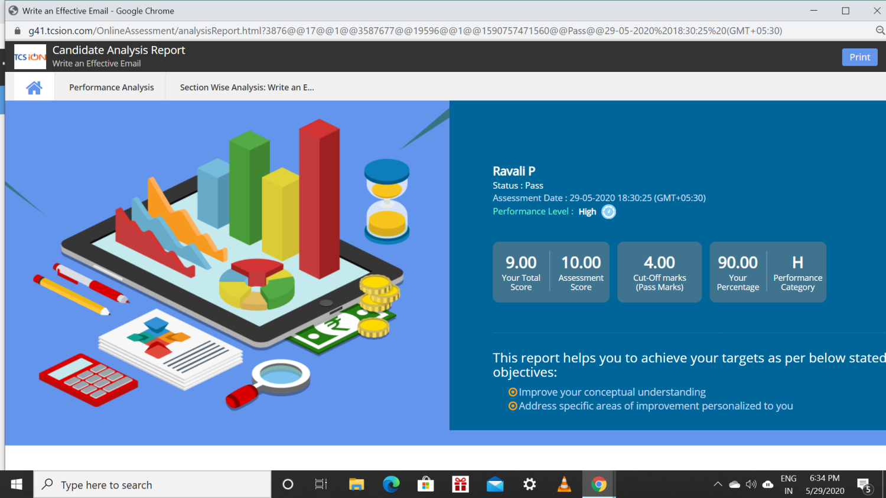

Coding Challenges Details: (Attach the snapshot and briefly write the report for the same)

Program1:

write a c program to solve a system of linear congruences by applying the Chinese Remainder Theorem.

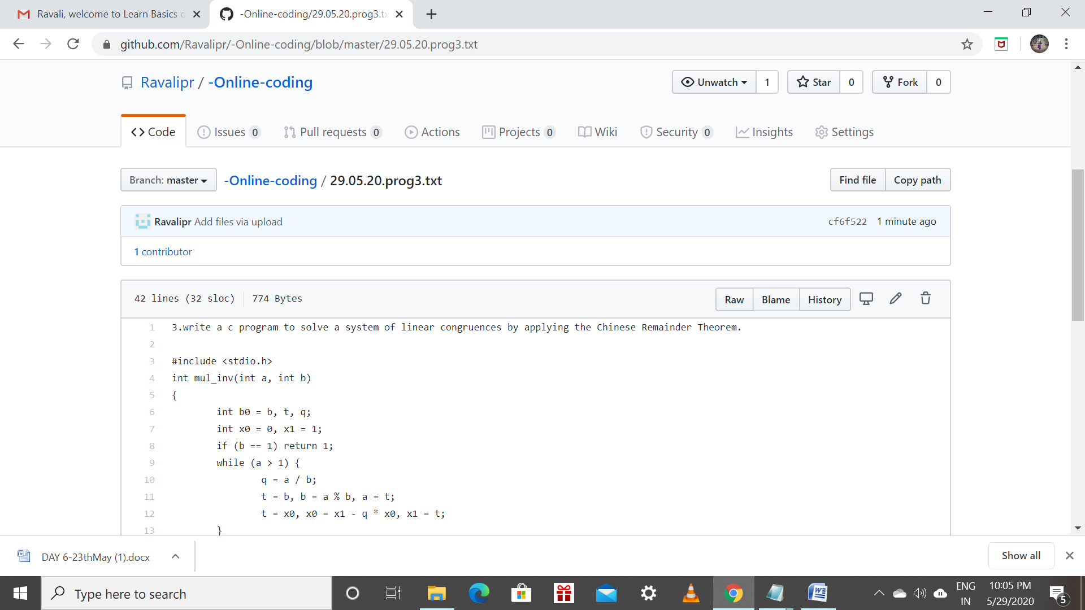

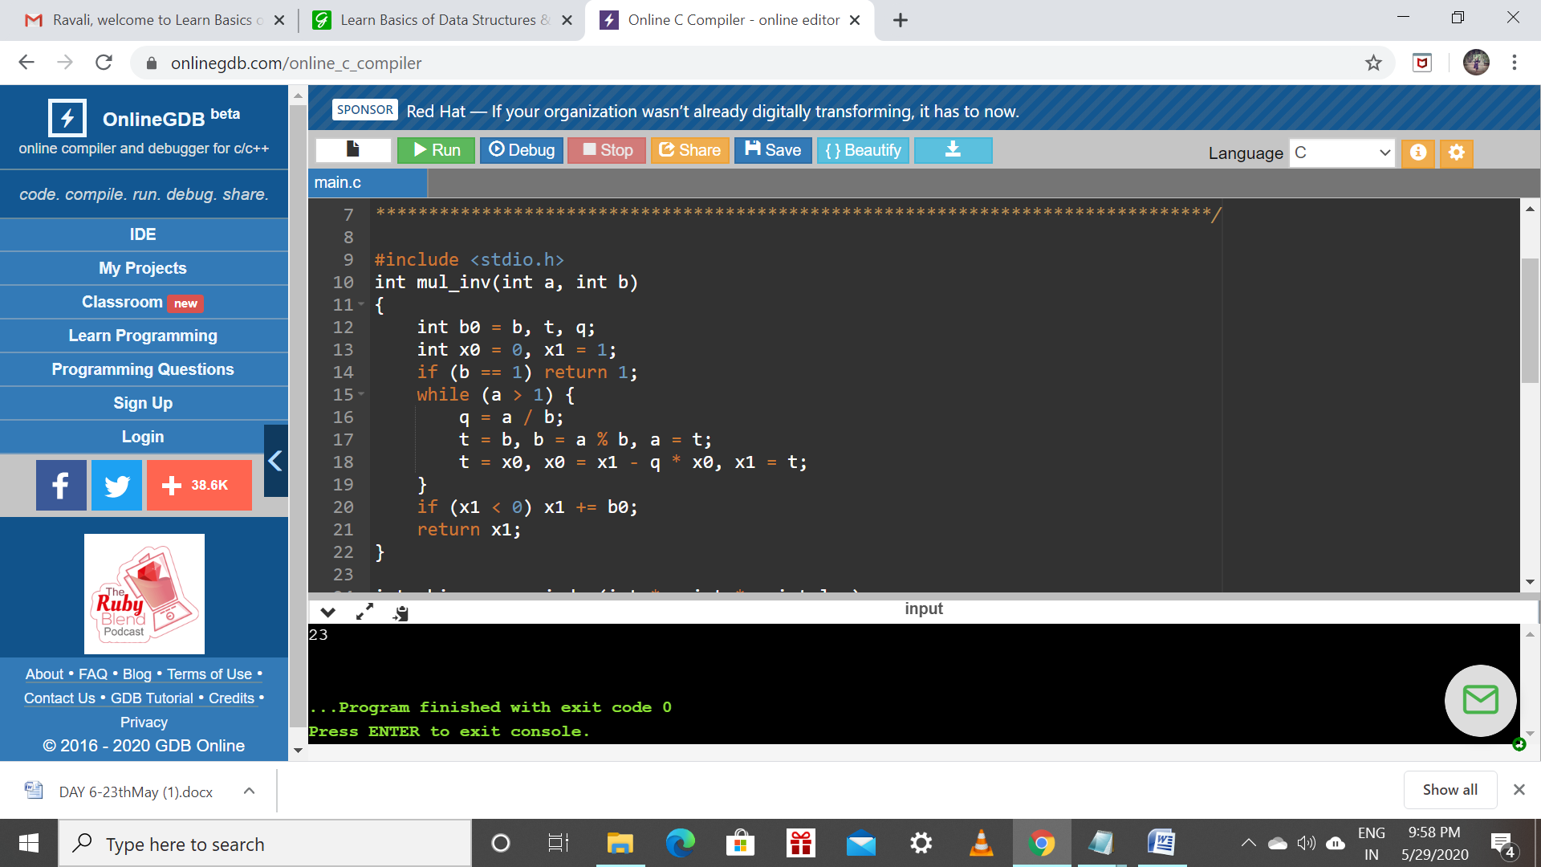

Program 2:

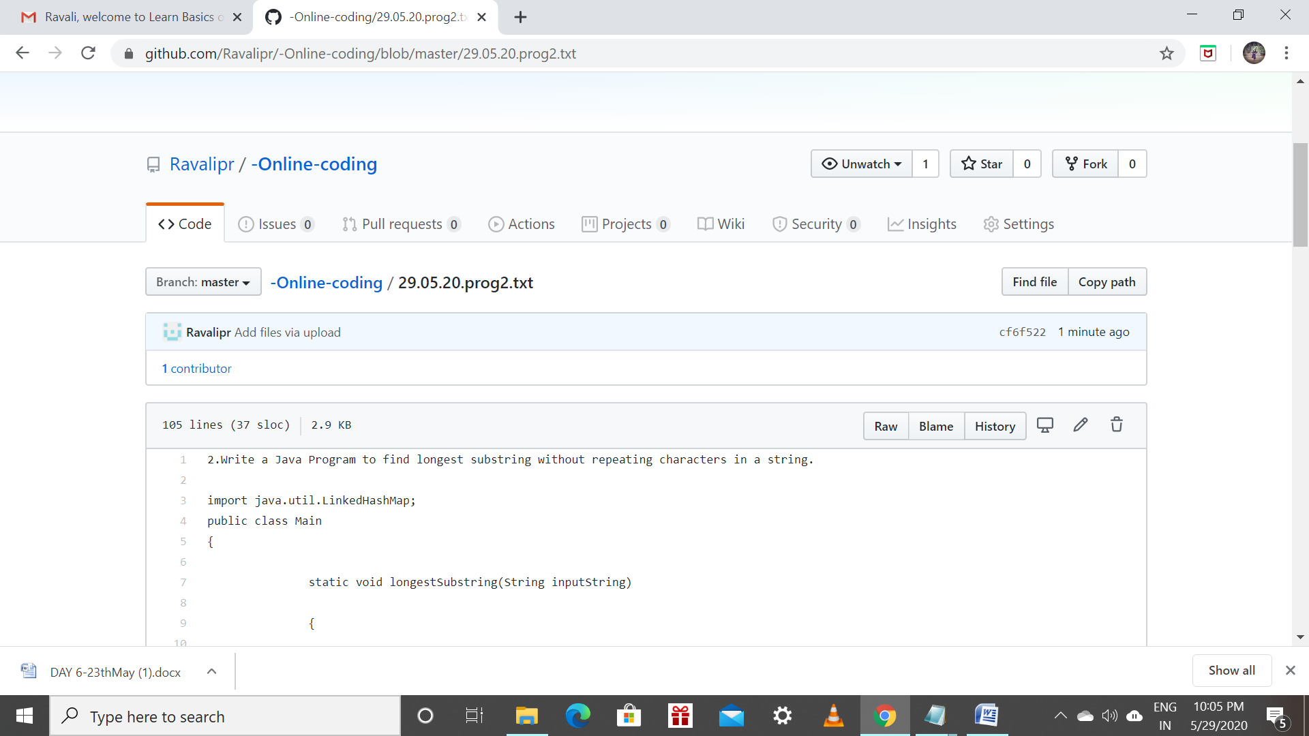

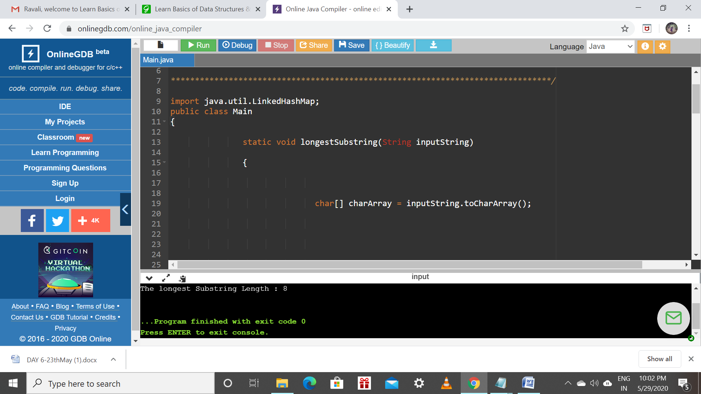

Program 3:

