**DAILY ONLINE ACTIVITIES SUMMARY**

|  |  |  |  |  |  |  |  |  |
| --- | --- | --- | --- | --- | --- | --- | --- | --- |
| **Date:** | **29-06-2020** | | | | | **Name:** | **RAVALI P** | |
| **Sem & Sec** | **6 B** | | | | | **USN:** | **4AL17CS076** | |
| **Online Test Summary** | | | | | | | | |
| **Subject** | | **-** | | | | | | |
| **Max. Marks** | | **-** | | **Score** | | | **-** | |
| **Certification Course Summary** | | | | | | | | |
| **Course** | **Pre-placement Training** | | | | | | | |
| **Certificate Provider** | | | **-** | | **Duration** | | | **4hours** |
| **Coding Challenges** | | | | | | | | |
| **Problem Statement:Python programs to count the number of occurrences of an element in a linked list with and without using recursions.** | | | | | | | | |
| **Status:Done** | | | | | | | | |
| **Uploaded the report in Github** | | | | | **YES** | | | |
| **If yes Repository name** | | | | | <https://github.com/Ravalipr/Daily-Status.git> | | | |
| **Uploaded the report in slack** | | | | | **YES** | | | |

Online Test Details: -

Online Course Details:

Attended class on the topic DBMS [from 9.15am to 11am]

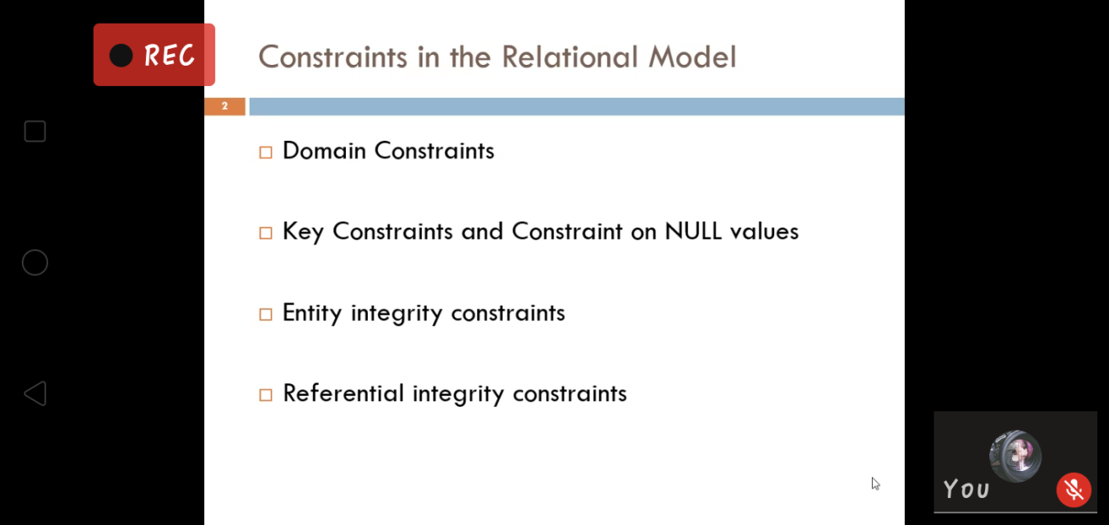

Attended class on the topic Cyber Security [from 11am to 1pm]

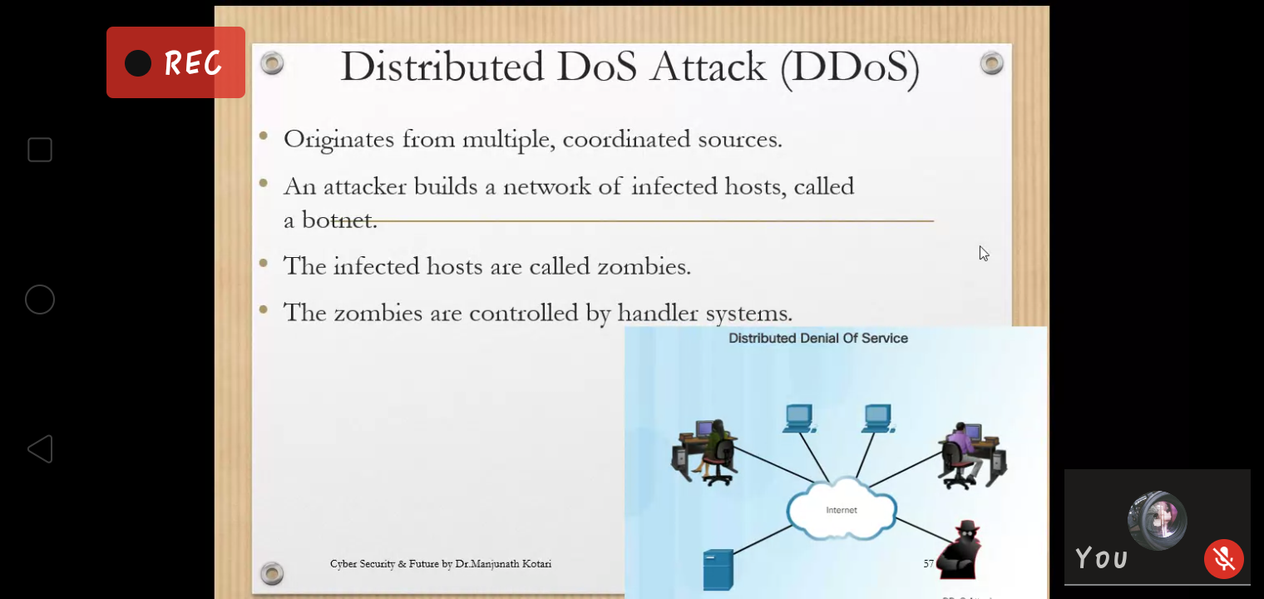

Online Coding Details:

1.Python program to count the number of occurrences of an element in a linked list without using Recursions.

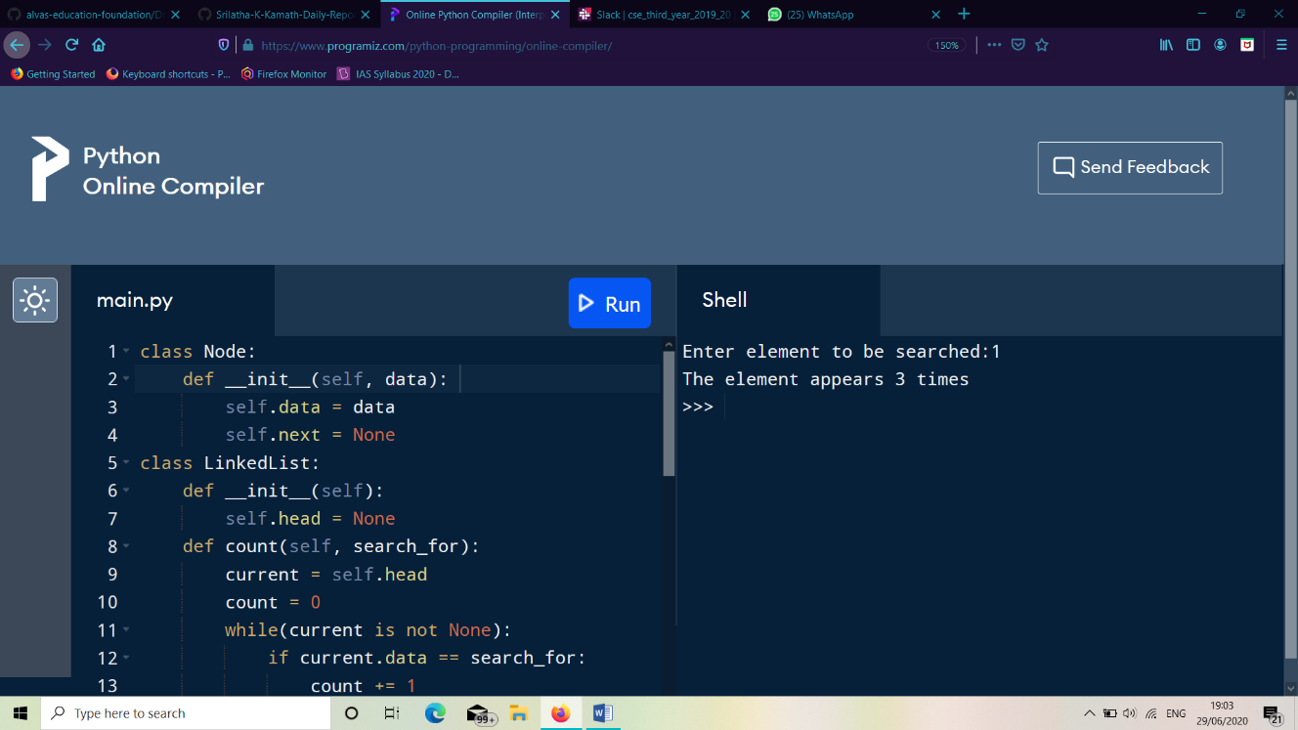

2. Python program to count the number of occurrences of an element in alinked list by using Recursions.

