**DAILY ONLINE ACTIVITIES SUMMARY**

|  |  |  |  |  |  |  |  |
| --- | --- | --- | --- | --- | --- | --- | --- |
| **Date:** | **31-05-2020** | | | | **Name:** | **RAVALI P** | |
| **Sem & Sec** | **6 B** | | | | **USN:** | **4AL17CS076** | |
| Online Test Summary | | | | | | | |
| **Subject** | | **NO TEST CONDUCTED.** | | | | | |
| **Max. Marks** | |  | | **Score** | |  | |
| Certification Course Summary | | | | | | | |
| **Course** | **ROBOTIC PROCESS AUTOMATION** | | | | | | |
| **Certificate Provider** | | | **RPA** | **Duration** | | | **3Hrs** |
| Coding Challenges | | | | | | | |
| **Problem Statement-ONE JAVA PROGRAM.** | | | | | | | |
| **Status:Executed** | | | | | | | |
| **Uploaded the report in Github** | | | | **Yes** | | | |
| **If yes Repository name** | | | | **https://github.com/Ravalipr/Daily-Status.git** | | | |
| **Uploaded the report in slack** | | | | **Yes** | | | |

Online Test Details: (Attach the snapshot and briefly write the report for the same)

Certification Course Details: (Attach the snapshot and briefly write the report for the same)

* Today’s topic on certification course is about Robotic Process Automation (RPA).
* Its about 3Hrs course where they specified about the advantages of the robotics in the growing economy.
* In future generation how the robotics plays an important role etc…

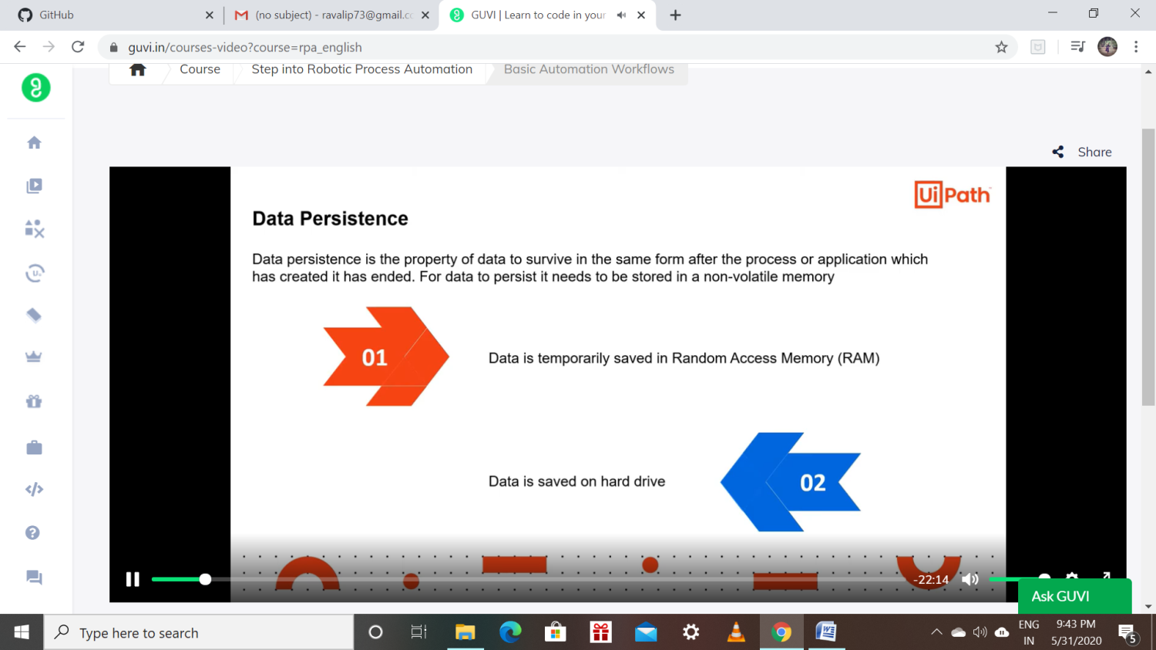

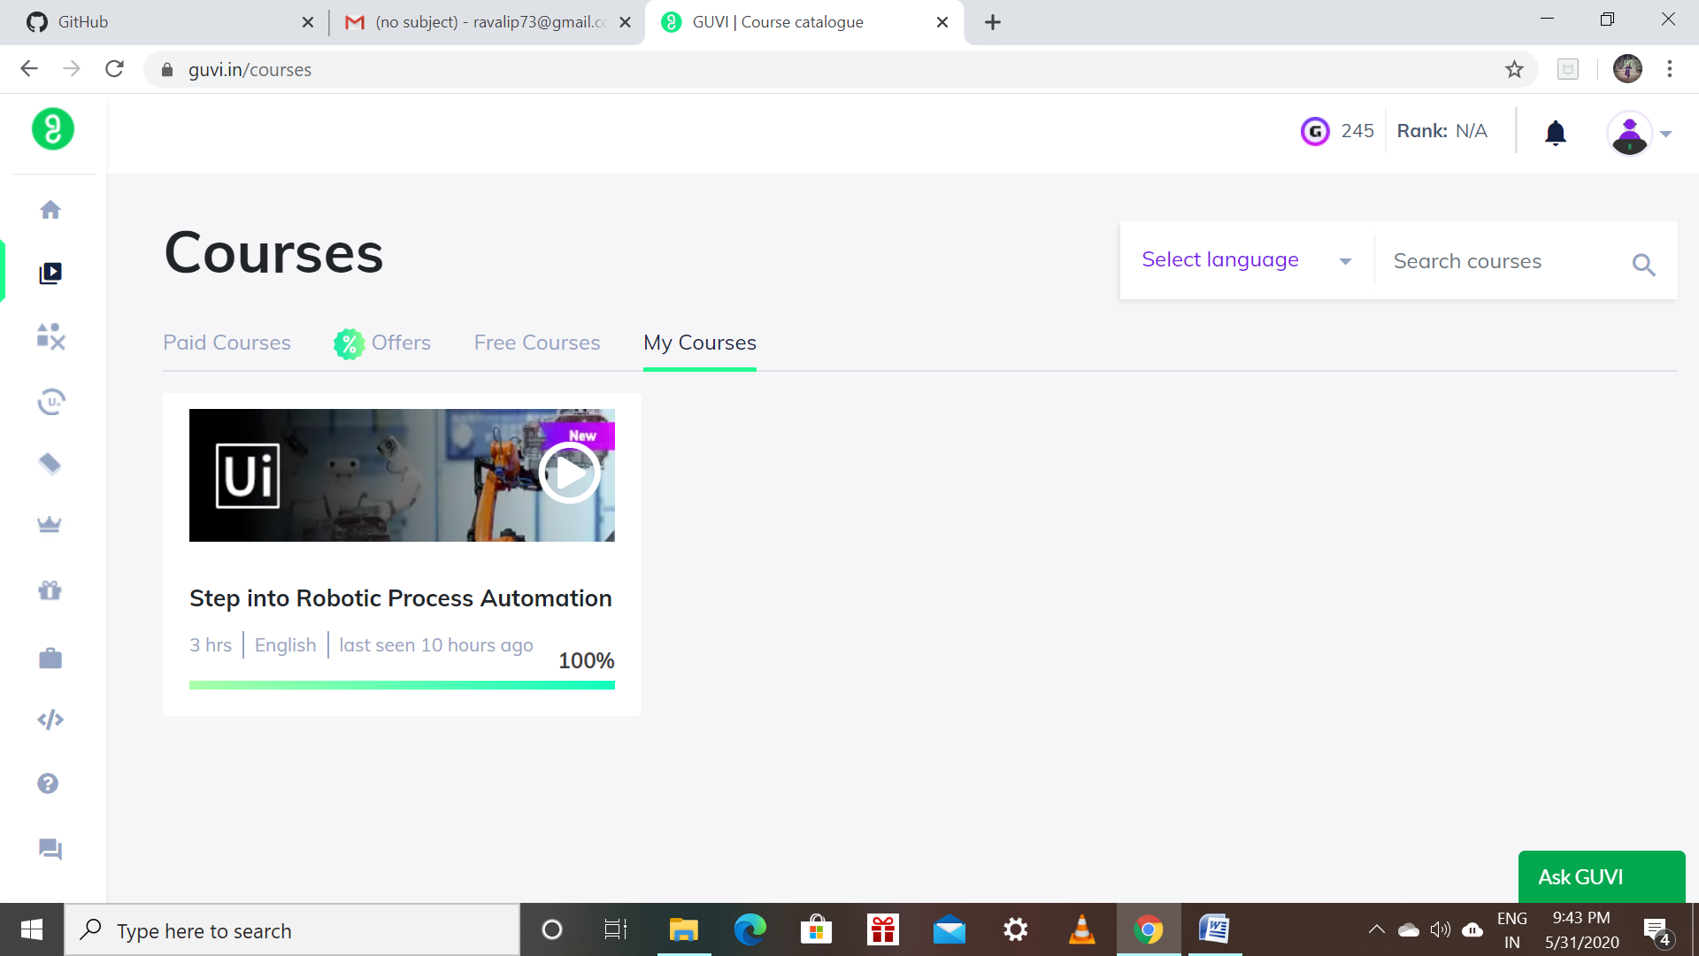

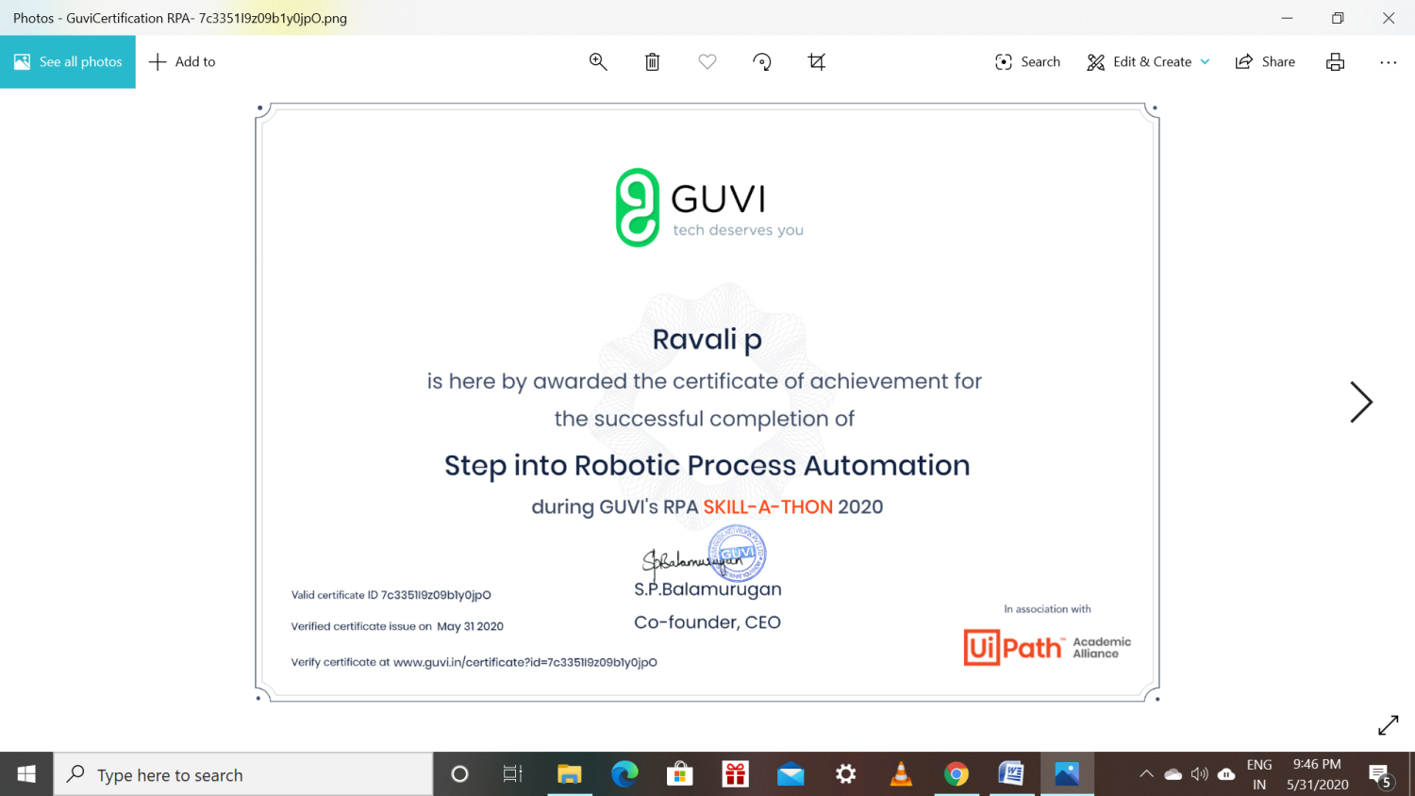

Coding Challenges Details: (Attach the snapshot and briefly write the report for the same):

PROGRAM 1:

