**Software Engineering Assignment**

***Module – 1****: Overview of IT*

1. **What is software? What is software Engineering?**

* **Software** – software is a set of instruction to be executed by any system. A software can also be referred as a data which is used to operate computer or any specific task.
* **Software Engineering** – software engineering is the process of systematic approach to a software development.

1. **Explain types of software.**

* There are various kind of software such as database software, multimedia software, application software, etc.

But the 2 main mandatory software are as follow:

* **System Software** – System software is the software that are already included in the system. For eg. Apps such as CALENDER, CLOCK, CONTACTS, etc. are included in the system.
* **Application Software** – application software is the software that is not included in the system. Hence, it has to be downloaded from the application such as app store or play store.

Instagram, facebook, telegram, etc.

1. **What is SDLC? Explain each phase of SDLC.**

* **SDLC** – *Software Development Life Cycle*, SDLC is a step-by-step approach to any software.
* *Budget + Time + Quality = SDLC*
* There are total 6 phase of SDLC.
* ***Planning/requirement gathering*** – Planning and customer requirement gives the developer a better idea about what to develop.

* ***Analytical part*** – Once the planning is done, the planning should be deeply examine.

* ***Designing*** – designing should be clearcut which makes a customer easily understand. For backend developers there are various designs such as ER diagrams, DFD, Flowchart, use case, etc.

* ***Implementation*** – In the implementation phase all the technical requirements for the software is listed and satisfied.

* ***Testing*** – Doing a QA (quality assurance) test is must before launching the final project. It helps to find the error.
* ***Maintenance*** – *Sales after service* is the most important phase of the SDLC. It gives a +1 point to the developer.

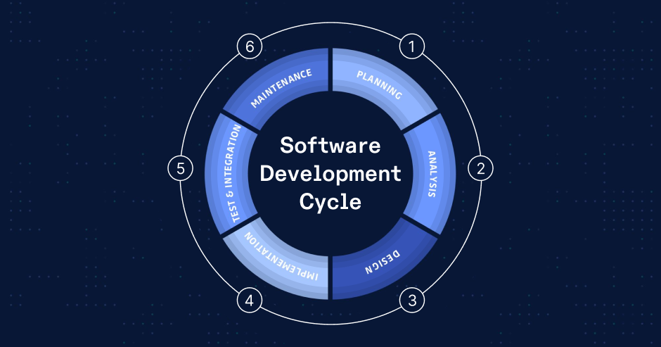

1. **What is DFD? Crete a DFD diagram on Flipkart.**

* ***DFD*** – *Data Flow Diagram*
* The flow of data of a system is represented by DFD. It also gives insight of the inputs and outputs. Only the explanation of type of data is represented by this diagram, it does not have any controls on the flow of system or any loops.
* It provides an overview of:
* **What type of data system process.**
* **What transformations are performed.**
* **Which data is stored.**
* **What kind of results are produced, etc.**

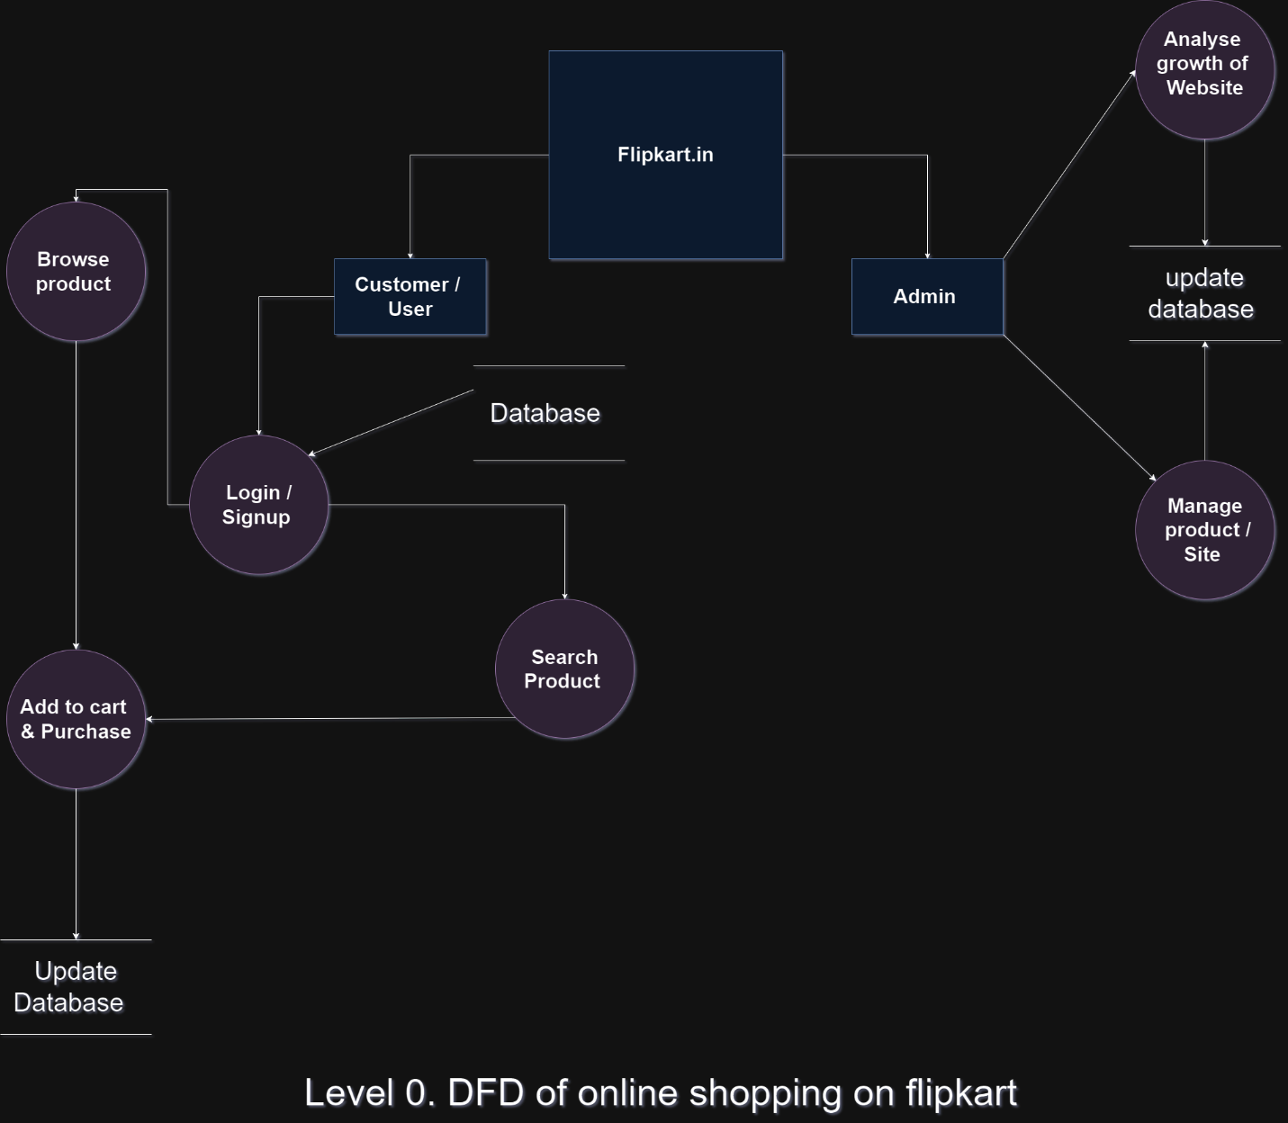

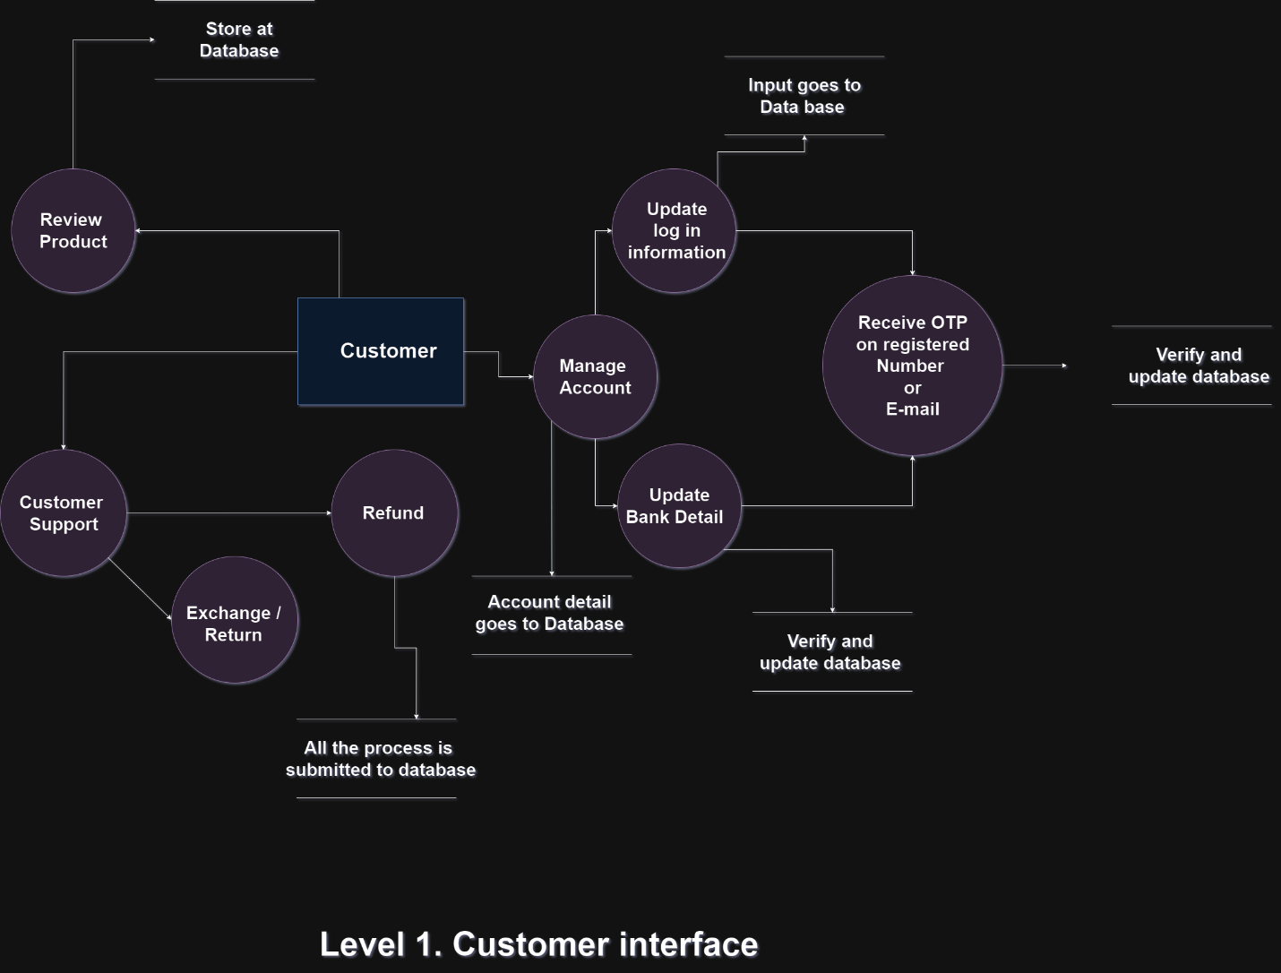

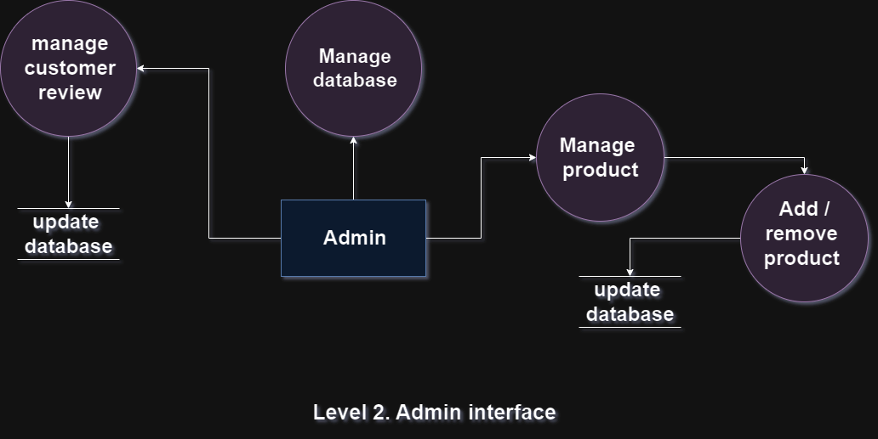

1. **What us flowchart? Create a flowchart to make addition of two numbers.**

* A flowchart is a diagram that represent the workflow.
* It can also be a represented as algorithm for a step-by-step solution for a task.
* Different symbols are used to show different tasks.

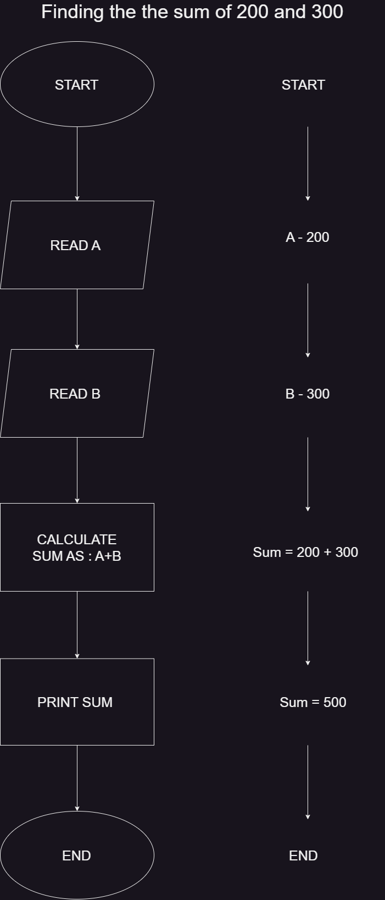

1. **What is use case Diagram? Create a use-case on bill payment on paytm.**

* A use case is the simple way for describing how the users will perform the task on your website.
* It out the user’s point of view as well as the behavior of the system

