Unit - 1: MATHEMATICAL FOUNDATION
Q1. Define Mean and Median, Mode with Example
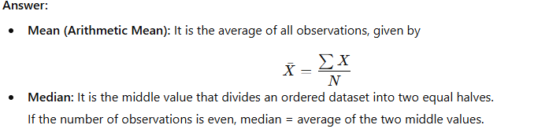
Ex:
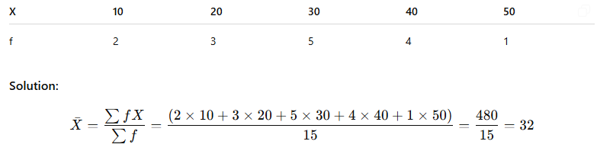
Mean = 32
Mode: A mode is defined as the value that has a higher frequency in a given set of values. It is the value that appears the most number of times.
Example: In the given set of data: 2, 4, 5, 5, 6, 7, the mode of the data set is 5 since it has appeared in the set twice.

Q2. What is the difference between positive and negative correlation?
Answer:
- Positive correlation: When one variable increases, the other also increases (e.g., height and weight).
- Negative correlation: When one variable increases, the other decreases (e.g., speed and time to reach destination).

Positive Correlation Negative Correlation No Correlation
* * *
* * * * *
* * * * * *
* * * * * *
Interpretation: • The closer the points lie to a straight line, the stronger the correlation.
• The direction of the slope indicates whether it is positive or negative.

Q 3. Describe Karl Pearson’s coefficient of correlation and explain the inference procedure for testing its significance.
Ans: 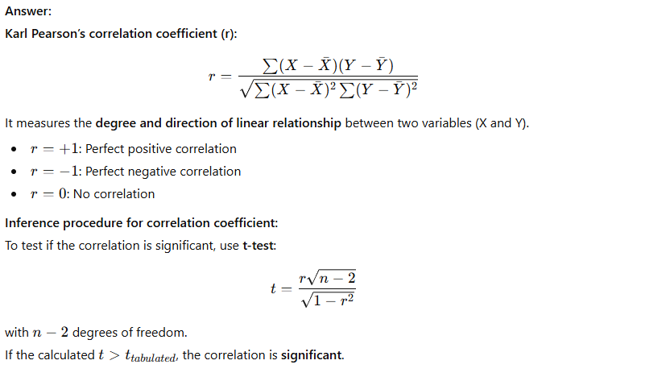
Ex: Calculate Karl Pearson’s coefficient of correlation (r) from the following data:
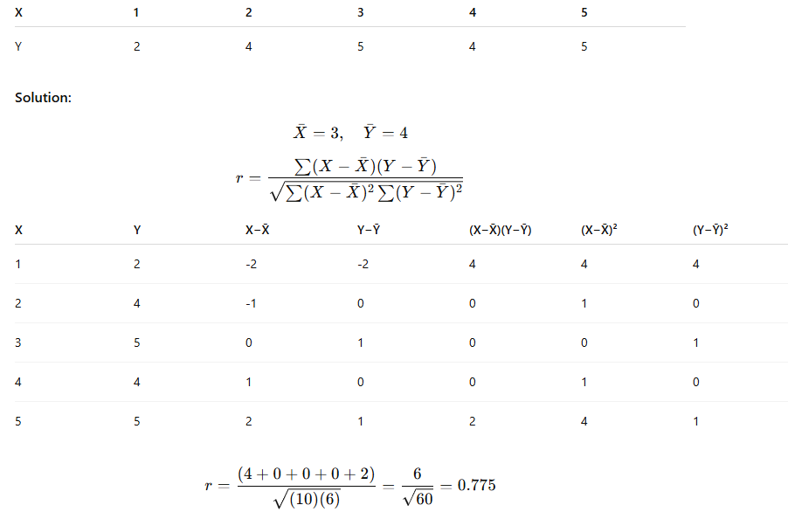
r = 0.78 (positive correlation)
Q4 Explain different types of diagrammatic representation of data with suitable examples.
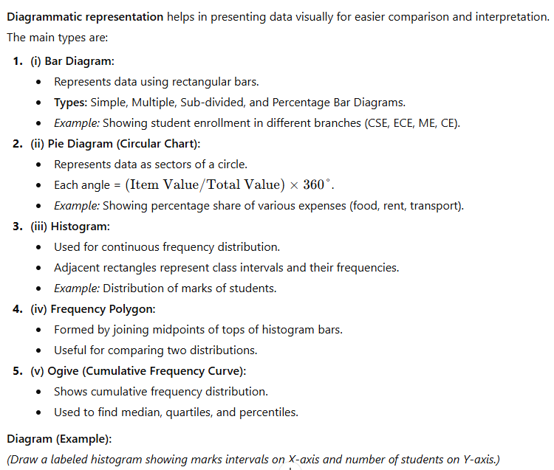
Q5. The following data show the distribution of marks of 50 students. Calculate the mean and standard deviation.
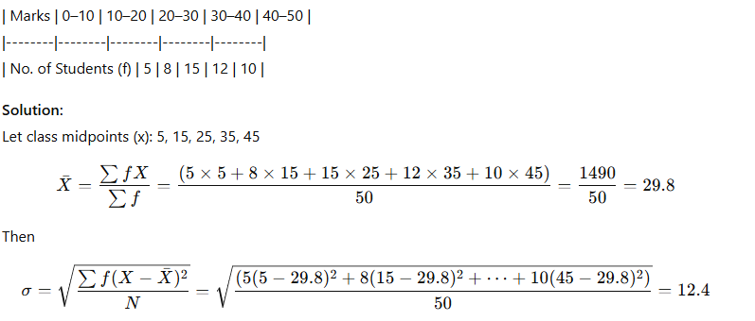
Mean = 29.8, S.D. = 12.4
Q 6 . Explain the concept of linear regression and multiple regression. Derive the regression equation of Y on X.
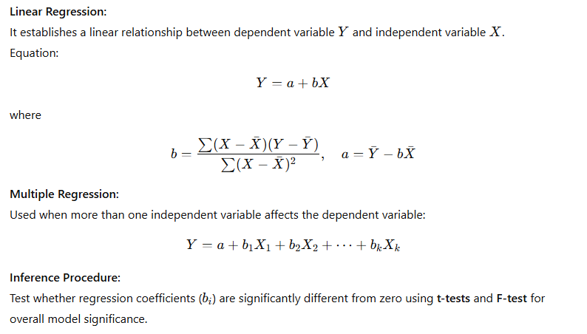
EX. Fit a regression line of Y on X for the following data and estimate Y when X = 6.

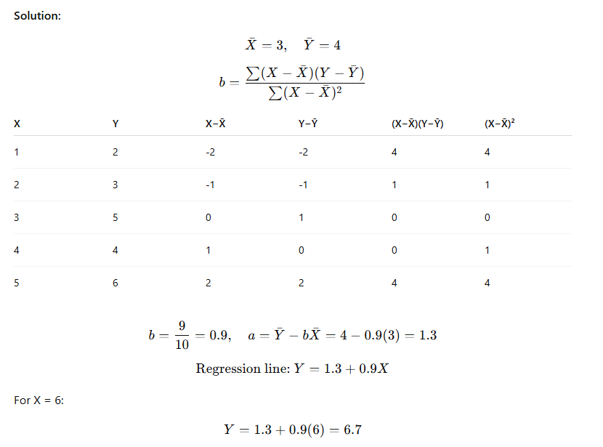
Regression equation: Y = 1.3 + 0.9X
Predicted Y (when X=6) = 6.7
Q 7.Skewness and Kurtosis

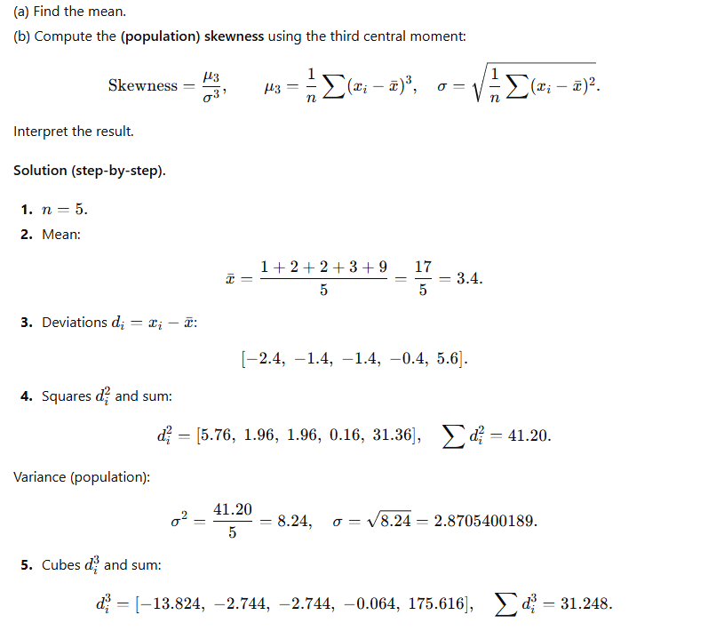
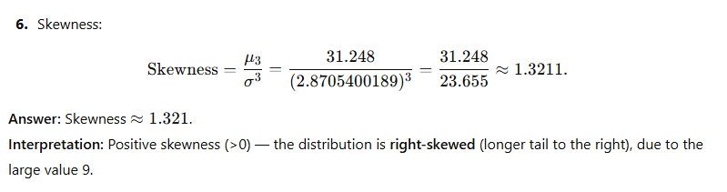
Kurtosis (Numerical)

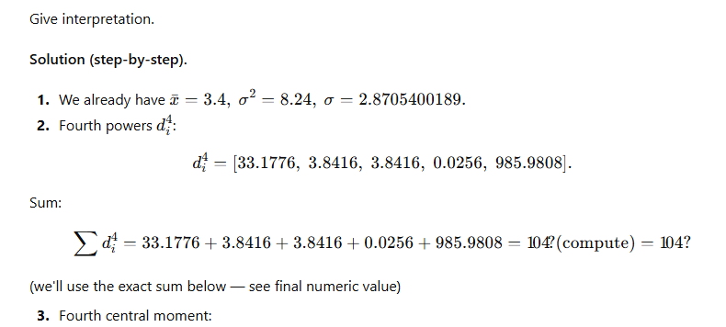
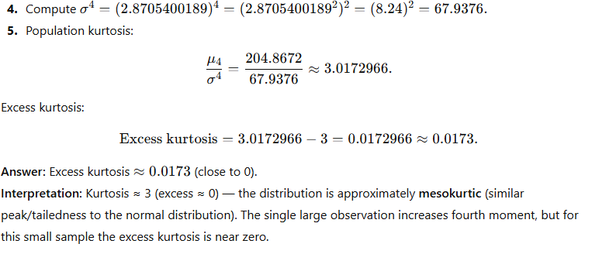

8. (Chebyshev’s Inequality & Markov Inequality)
(a) State and prove Markov’s inequality. What are its applications?
(b) State and illustrate Chebyshev’s inequality for a random variable $X$with mean $μ$and variance $σ^{2}$.
(c) A random variable has mean 20 and variance 9. Use Chebyshev’s inequality to find an upper bound on
$Pr⁡(∣X-20∣≥6)$.
Ans: 
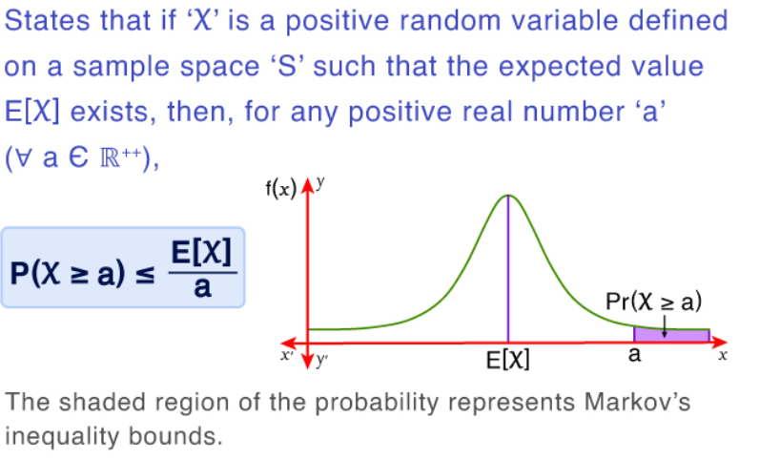
Proof: 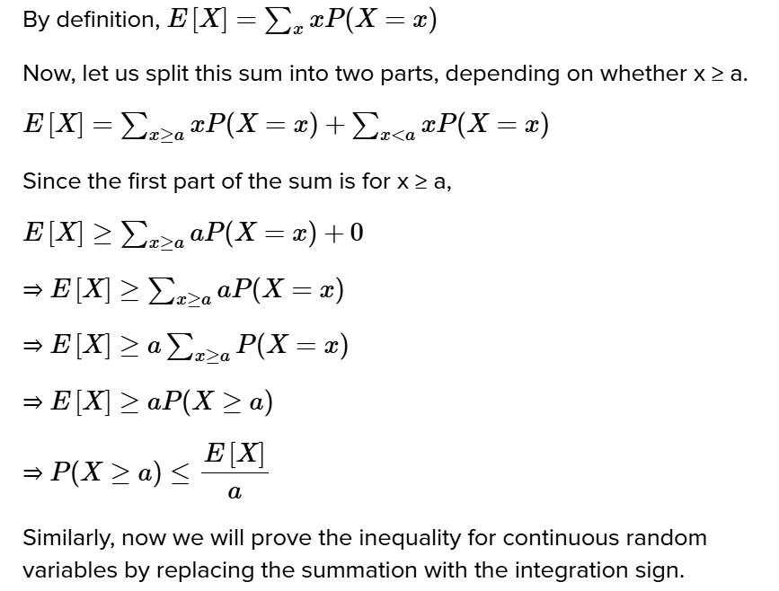
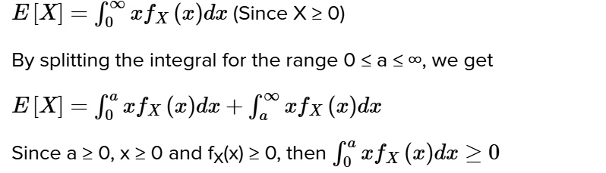
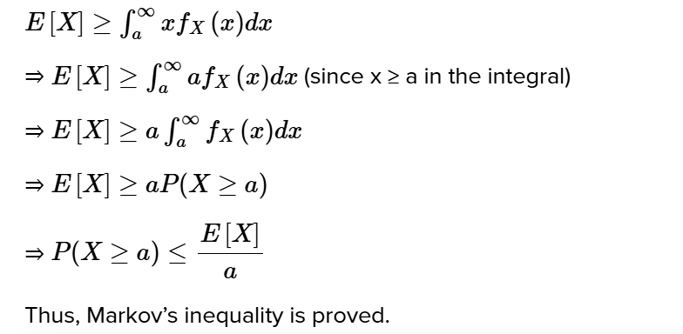
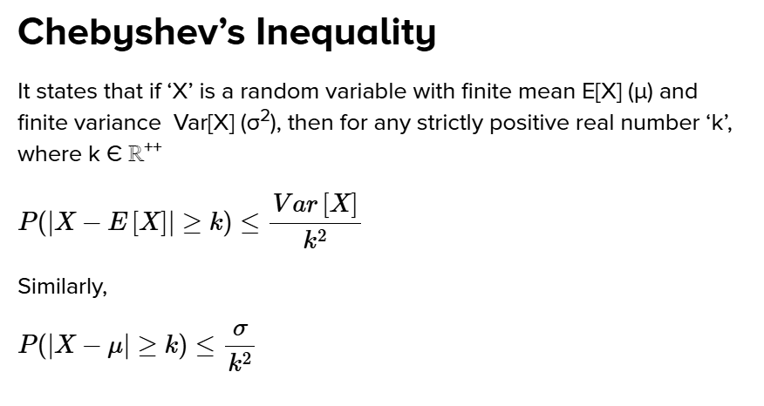
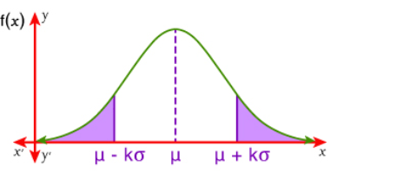
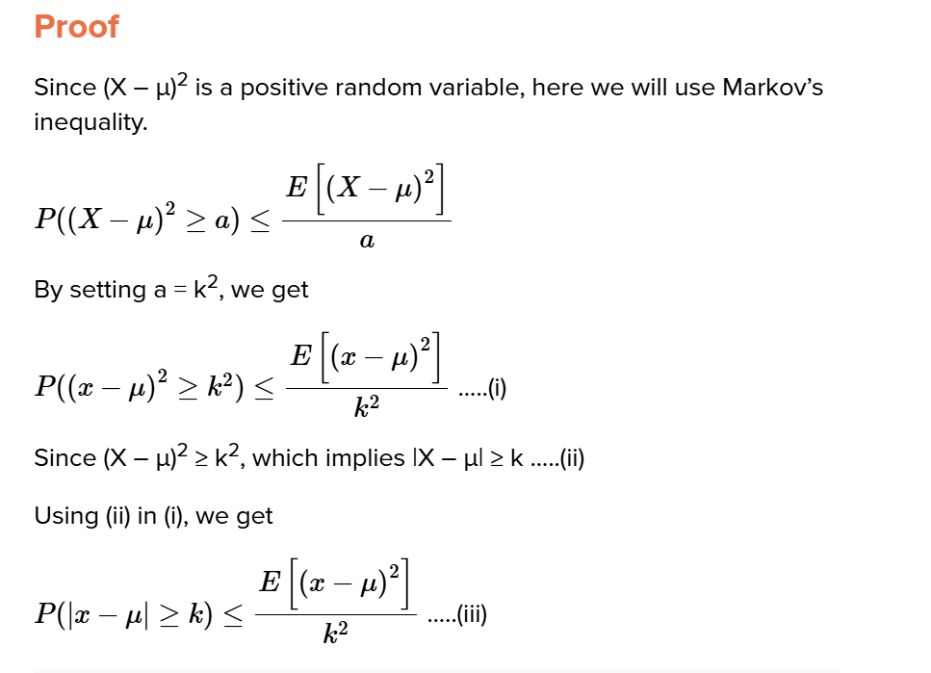 Ans.
Q 9 . (State the Central Limit Theorem (CLT). Explain why CLT is important in statistics.
Ans: a,)Central Limit Theorem — application) — Solution
b.) b) The mean weight of packets produced in a factory is 500 g with standard deviation 25 g. A sample of 64 packets is chosen at random.
Using CLT, find the probability that the sample mean weight lies between 495 g and 505 g.
- Central Limit Theorem (CLT) statement: For i.i.d. random variables X1, X2,X3……..

