Unit-3 Mathematical Foundation

Q1. Define a pseudo-random number?
Ans: A pseudo-random number is a number that appears to be random but is actually generated by a deterministic mathematical formula or algorithm
Q2. Discuss about the Gibbs sampling? How does it work in Markov Chain Monte Carlo?
Ans: Gibbs Sampling is a Markov Chain Monte Carlo (MCMC) method used to generate samples from a multivariate probability distribution when direct sampling is difficult.
It works by sampling each variable conditionally, one at a time, while keeping all other variables fixed.
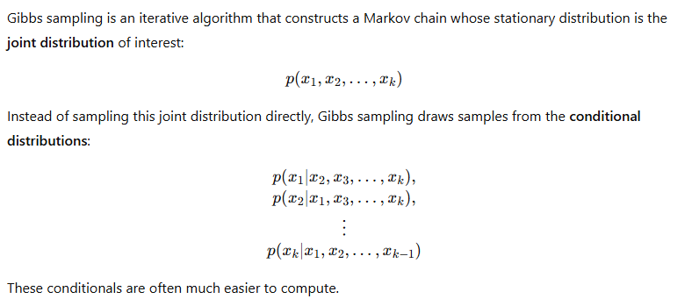
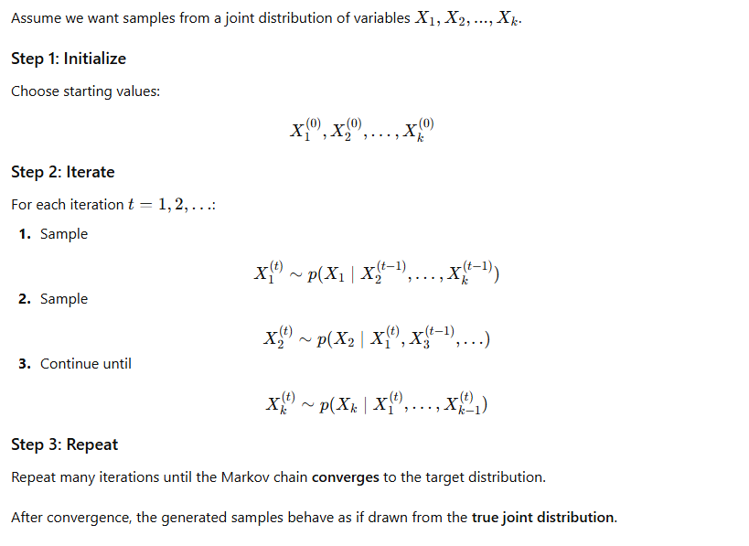
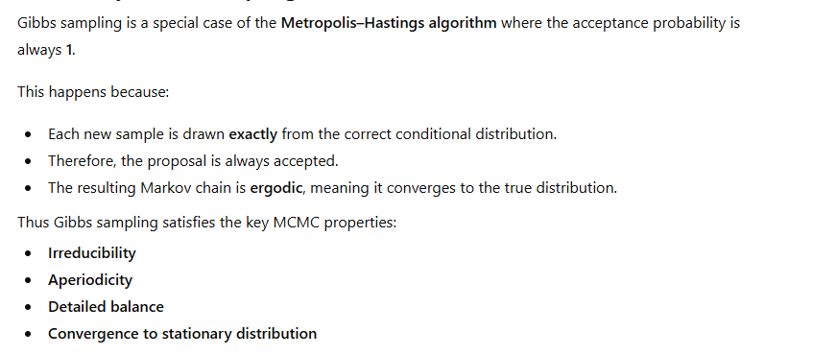
• Simple to implement.
• No rejection step (faster than Metropolis-Hastings).
• Effective when conditional distributions are easy to sample.
Limitations
• Requires all conditional distributions to be available.
• Can mix slowly if variables are highly correlated.
• Convergence diagnosis may be difficult.
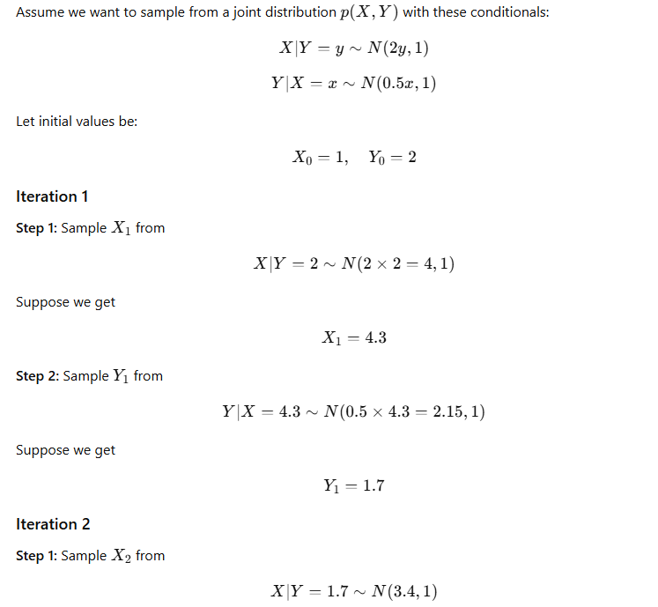
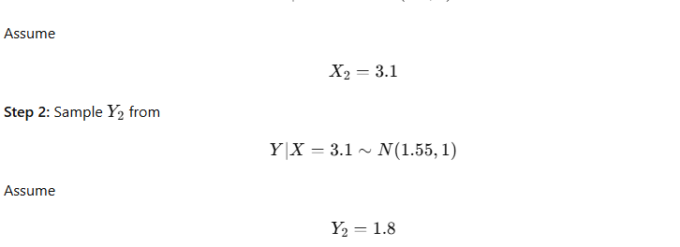
Q3. Discuss the inverse-transform method for generating random numbers. How does it work, and in what types of distributions is this method useful?
Ans: The Inverse-Transform Method (also called inverse CDF method) is a widely used technique to generate random samples from any continuous probability distribution using uniform random numbers.
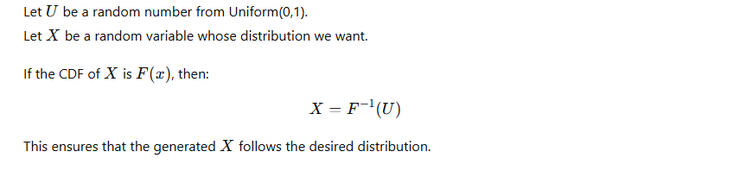

The value of X is a random sample
Now X follows the target distribution.
This works because the CDF transforms variables to a uniform distribution, and the inverse CDF reverses the transformation.
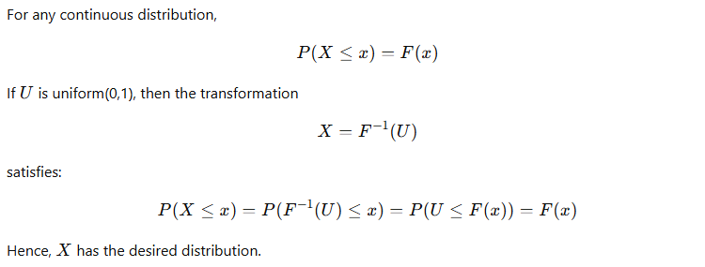

Types of Distributions Where This Method Is Useful

Works Best For:
Distributions with closed-form inverse CDF, such as:
- Exponential distribution
- Uniform distribution
- Logistic distribution
- Laplace distribution
- Weibull distribution (some cases)
- Cauchy distribution

Useful for:
- Continuous distributions where the inverse CDF exists and is easy to compute.

When It Is Not Useful
- When the inverse CDF has no closed-form solution, e.g.,
  - Normal distribution
  - Gamma distribution
  - Beta distribution
In such cases, other methods are preferred:
- Acceptance–Rejection method
- Box–Muller method (for normal)
- Numerical inversion
Q 4. Describe Monte Carlo hypothesis testing. How is it used to evaluate statistical hypotheses, and what advantages does it offer over traditional hypothesis testing methods?
Ans: Monte Carlo Hypothesis Testing is a simulation-based method used to evaluate statistical hypotheses when traditional analytical tests are difficult, impossible, or unreliable.
Instead of using theoretical distributions (like t, χ²), it uses computer-generated random samples to approximate the sampling distribution of a test statistic.
It is a procedure in which:
- We generate many random samples under the null hypothesis.
- Compute the test statistic for each simulated sample.
- Compare the actual test statistic with the simulated distribution.
This gives an empirical p-value, based on simulations rather than theoretical formulas.

How Monte Carlo Hypothesis Testing Works (Step-by-Step)
Assume we want to test a null hypothesis H0H_0H0​.

Step 1: Define a test statistic
For example: mean, difference in means, correlation, variance ratio, etc.
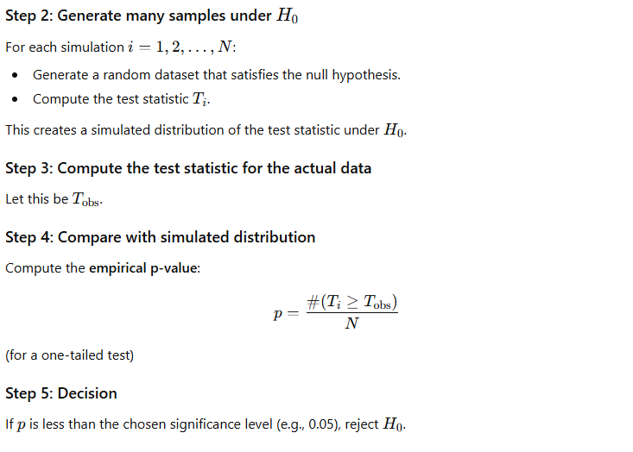

Applications
Monte Carlo hypothesis testing is widely used in:
- Non-parametric tests
- Complex models with no known theoretical distribution
- Bootstrap methods
- Spatial statistics
- Genetic and biological studies
- Finance and econometrics

Advantages Over Traditional Methods

1. No need for theoretical distributions
Useful when:
- The sampling distribution is unknown
- Assumptions of traditional tests (normality, independence) do not hold

2. Works with complex data
Handles:
- Non-linear models
- Complicated dependency structures
- Small sample sizes

3. More accurate p-values
Since p-values are based on simulations, they reflect the true behavior of the test statistic.

4. Flexible
Can be applied to almost any test statistic.

Robust
Less sensitive to violations of assumptions (normality, homoscedasticity, independence).

Limitations
- Requires computational power
- Can be slow for very large simulations
- Results can vary slightly due to randomness
- Must choose a sufficiently large number of simulations (e.g., 10,000)
Q5. Explain Metropolis Hastings algorithm.
Ans: The Metropolis–Hastings (MH) algorithm is a Markov Chain Monte Carlo (MCMC) method used to generate samples from a complex probability distribution when direct sampling is difficult.
It constructs a Markov chain whose stationary distribution is the target distribution

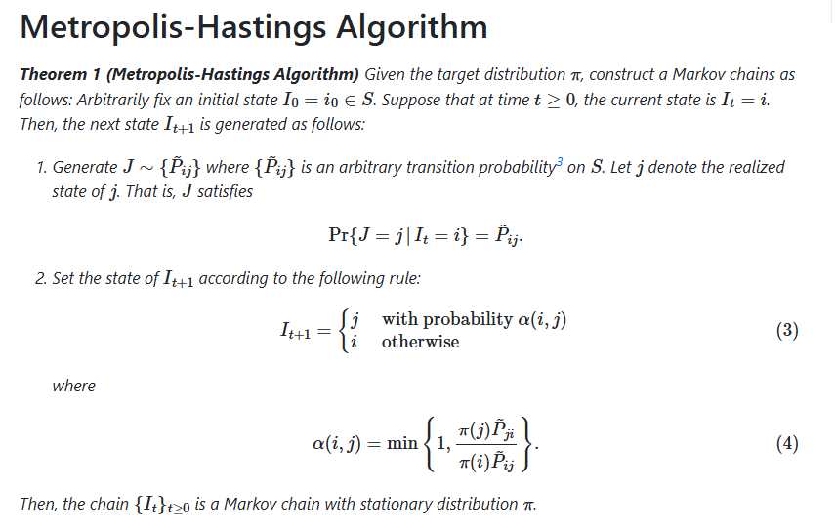
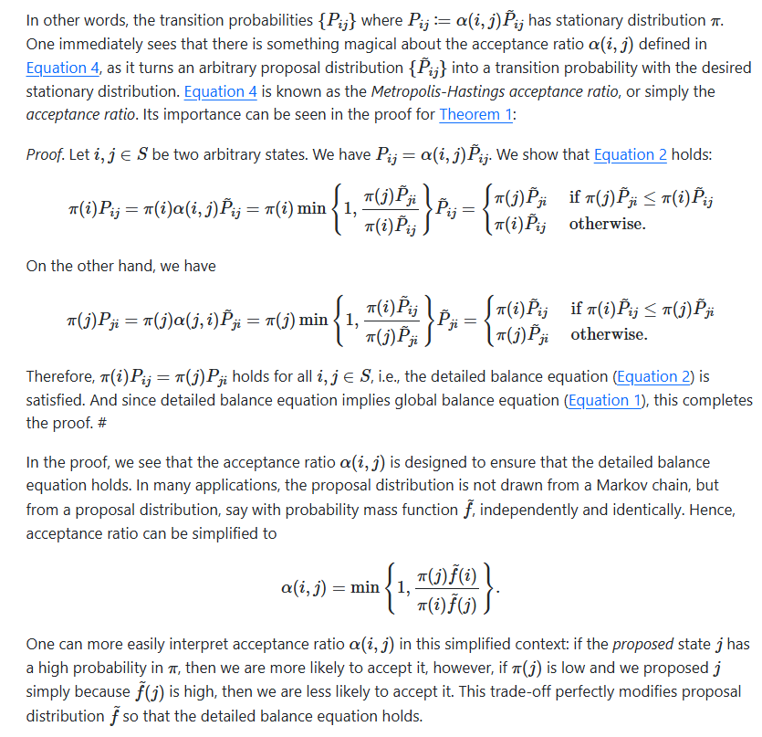
Q 6. Interpret the need of random number generator.
Ans: Random number generators (RNGs) are essential tools in scientific computing, simulations, statistical modelling, and many computational algorithms. They produce sequences of numbers that mimic the properties of true randomness
Why Do We Need Random Number Generators?

Simulation and Modeling
Many real-world systems involve randomness (traffic flow, weather, stock market, queueing systems).
RNGs allow us to simulate these systems and study their behavior.
Example: Monte Carlo simulation relies entirely on random numbers.

2. Statistical Sampling
RNGs are needed to draw random samples from a population or a probability distribution.
This ensures unbiased sampling and supports:
- Bootstrapping
- Resampling methods
- Randomized experiments

3. Cryptography and Security
Strong RNGs are required for:
- Encryption keys
- Password generation
- Secure communication
Poor-quality random numbers can lead to security vulnerabilities.

4. Gaming and Simulations
Games, lotteries, and gambling machines rely on RNGs to produce:
- Fair dice rolls
- Random card shuffling
- Random enemy behavior in video games
Q7. Briefly explain Gibbs sampling.
Ans: Gibbs sampling is a Markov Chain Monte Carlo (MCMC) method used to generate samples from a multivariate probability distribution when direct sampling is difficult.
It works by updating one variable at a time, sampling each variable from its conditional distribution, while keeping all other variables fixed.
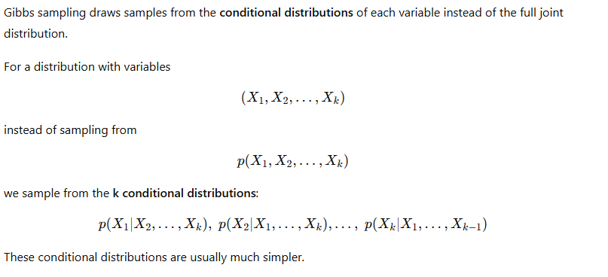
How Gibbs Sampling Works (Step-by-Step)
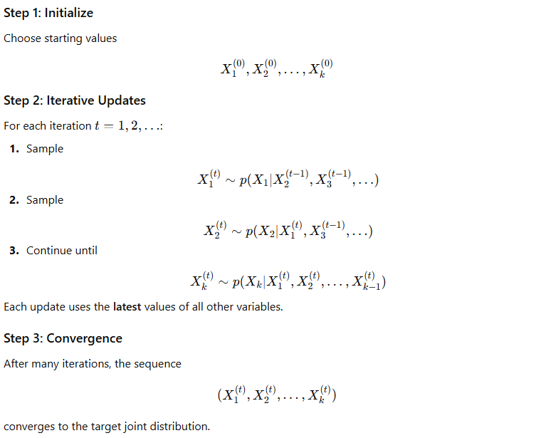
Why Is Gibbs Sampling Part of MCMC?
Gibbs sampling builds a Markov chain where:
- The next state depends only on the current state.
- Each step updates one component of the state vector.
- The chain satisfies the detailed balance condition.
- The chain has the target distribution as its stationary distribution.
Thus, it is an MCMC method because it uses a Markov chain to perform Monte Carlo sampling.

Advantages of Gibbs Sampling
- Easy to implement when conditional distributions are known.
- No rejection step → efficient.
- Good for high-dimensional Bayesian models.

Limitations
- Requires closed-form conditional distributions.
- Can mix slowly if variables are highly correlated.

Q8. Describe the Inverse-Transform Method. Give an example.

Answer: 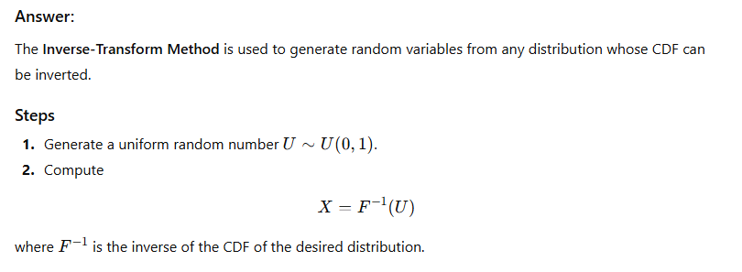

Q 9. Compare Inverse-Transform and Acceptance–Rejection Methods.

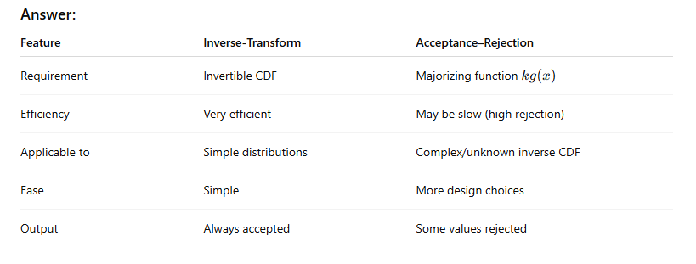

Conclusion
Inverse-transform is best when CDF inversion is easy;
Acceptance–rejection is best when inversion is difficult.

Q10. Explain the process of pseudo-random number generation. Discuss properties of a good generator with an example of LCG.

Answer:
A pseudo-random number generator (PRNG) is an algorithm that produces a sequence of numbers that appear random but are generated deterministically using a mathematical formula.

Properties of a good PRNG
- Uniformity – Numbers should be uniformly distributed in (0,1).
- Independence – No predictable pattern between successive values.
- Reproducibility – Same seed generates the same sequence (useful for simulation).
- Long period – The sequence should not repeat for a long time.
- Efficiency – Should generate numbers quickly.

