Unit-4 MATHEMATICAL FOUNDATION
Q1. Explain inner product in a vector space? Explain the properties of an inner product, such as linearity, symmetry, and positivity.
Ans: 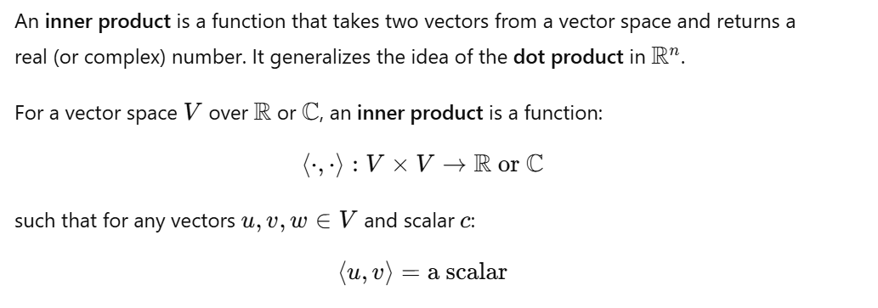
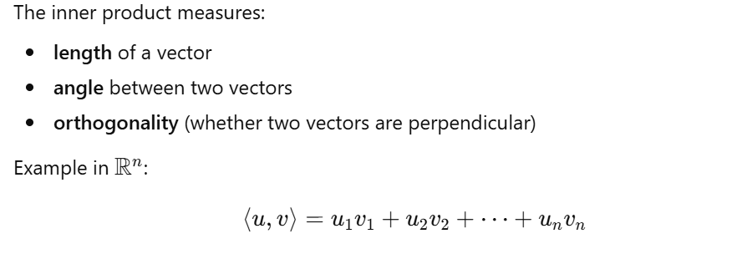





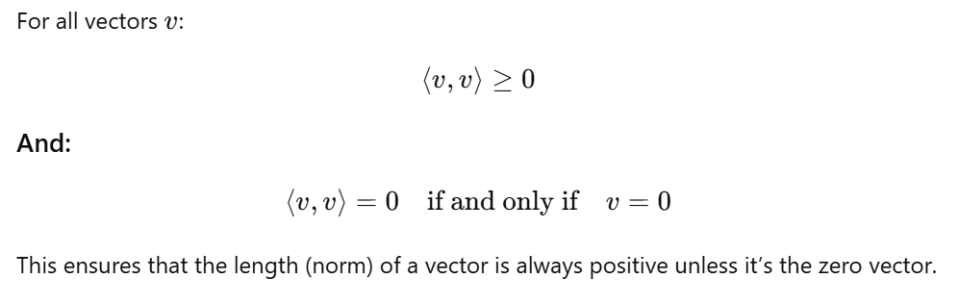
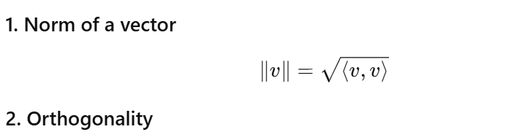
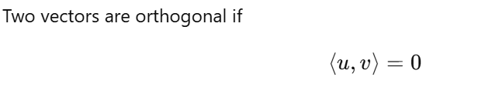
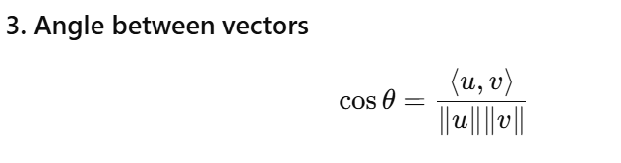
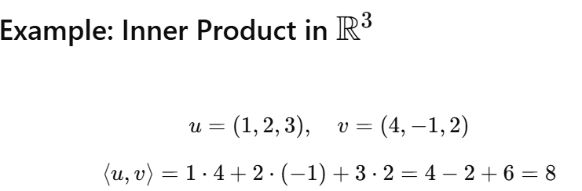
Q2. Describe the Gram-Schmidt process. Explain how this process can be used to convert a set of linearly independent vectors into an orthonormal set.
Ans: 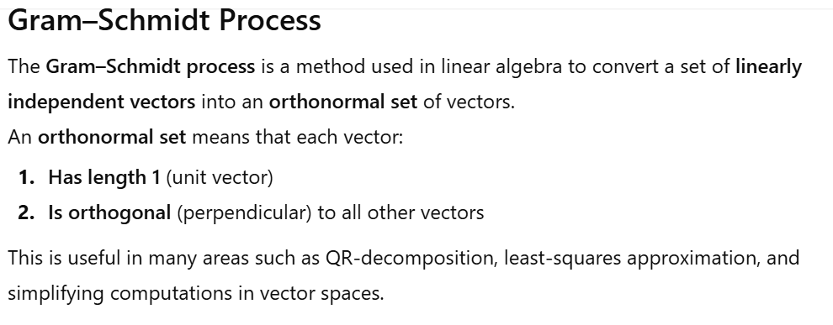
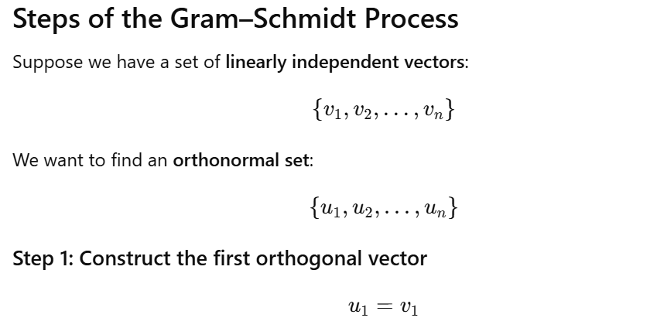
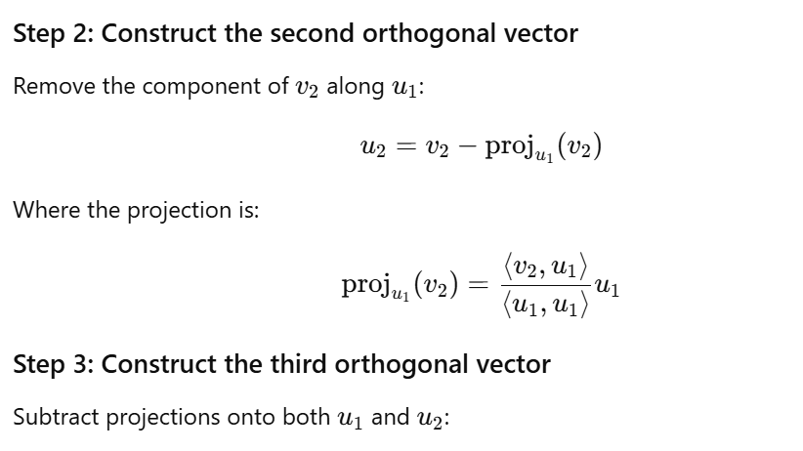
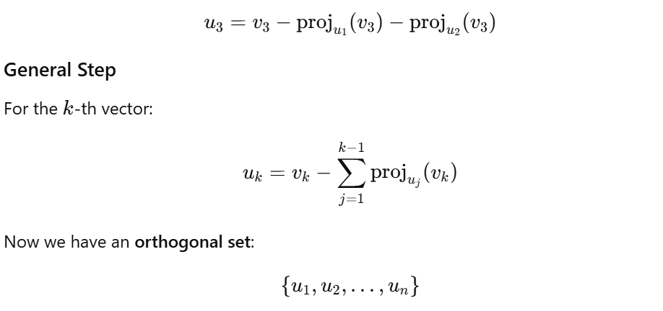
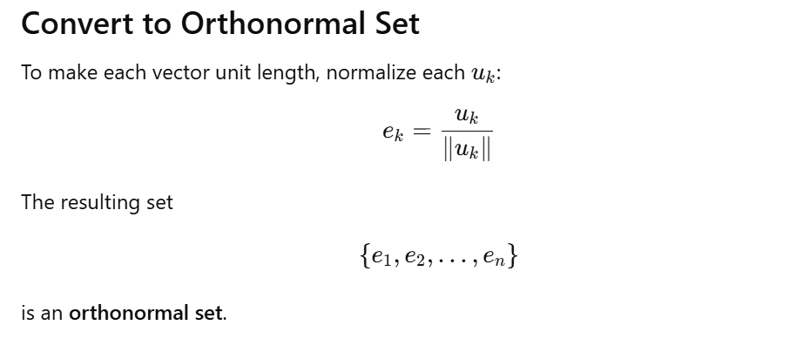
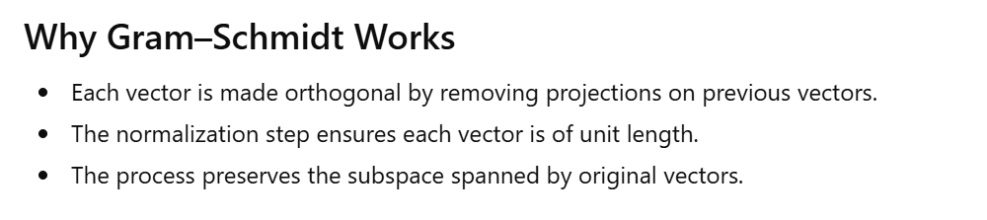
Q3. Discuss vector space, with axioms of vector space.
Ans: A vector space (also called a linear space) is a set of objects called vectors, along with two operations:
- Vector addition
- Scalar multiplication
These operations must satisfy certain axioms. The scalars come from a field (usually the real numbers ℝ or complex numbers ℂ).
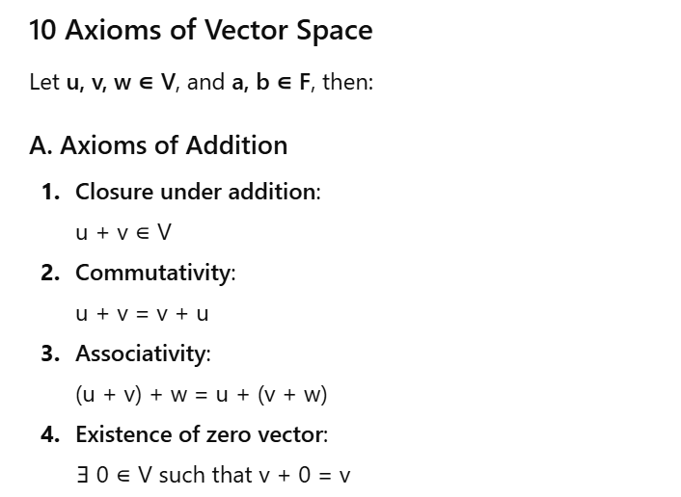
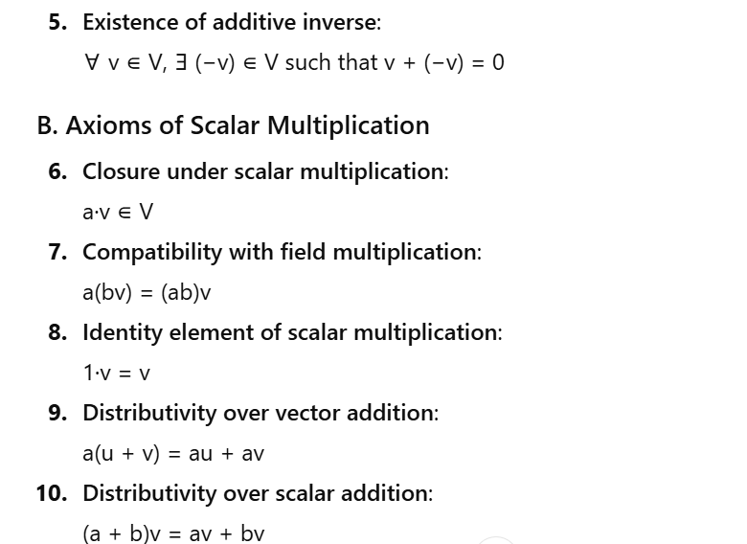
Q4. Explain the proof of Cauchy-schwarz Inequality.
Ans: 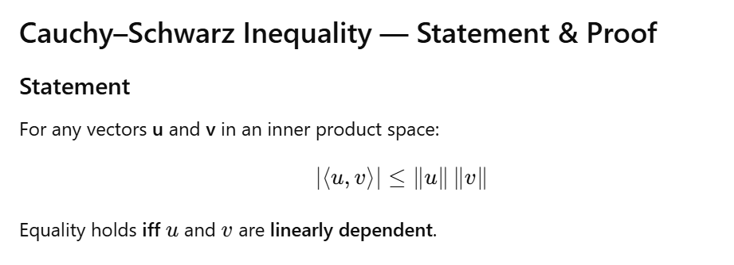
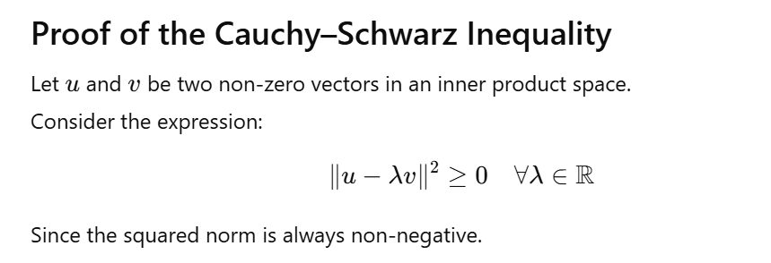
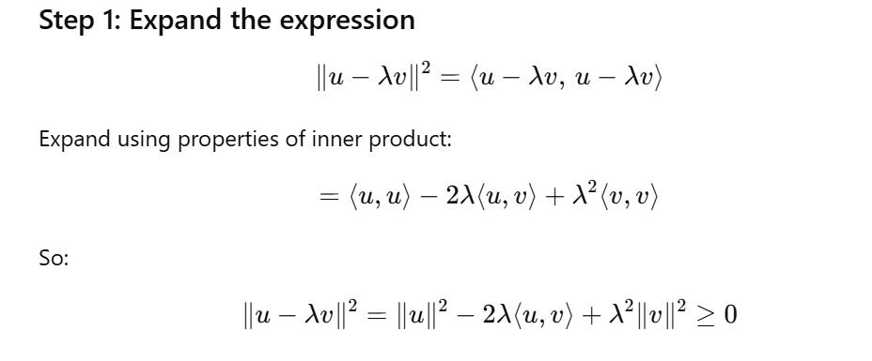
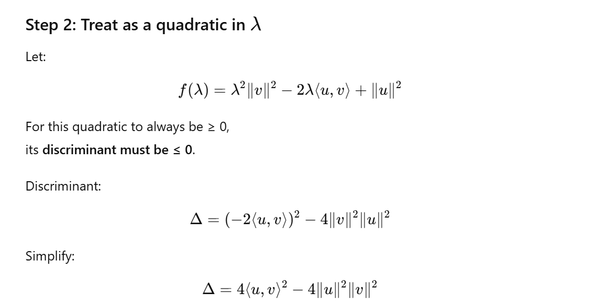
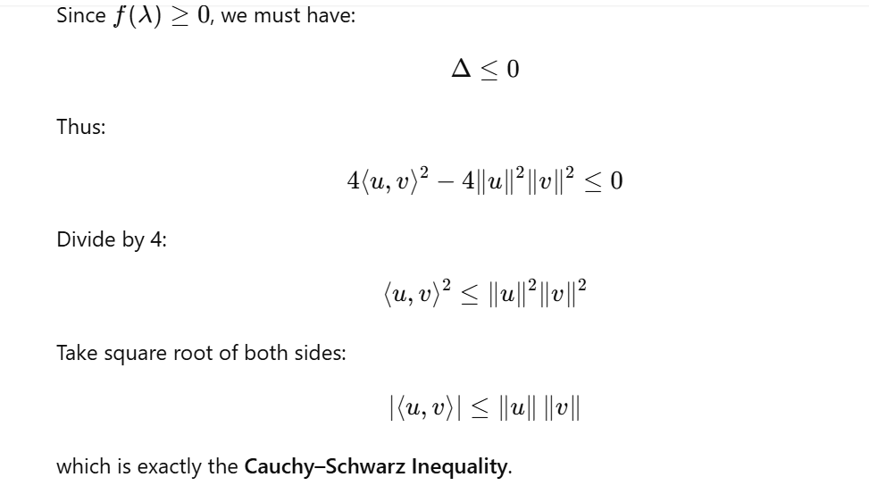
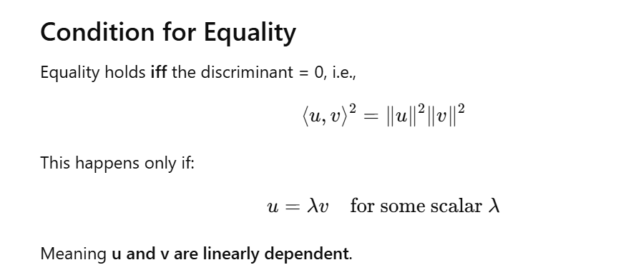

Q5. Explain how to find a basis of vector space.
Ans: How to Find a Basis of a Vector Space
A basis of a vector space V is a set of vectors that satisfies:
- Linear independence
- Span the vector space
That means every vector in the space can be written as a linear combination of basis vectors, and no basis vector can be expressed using the others.
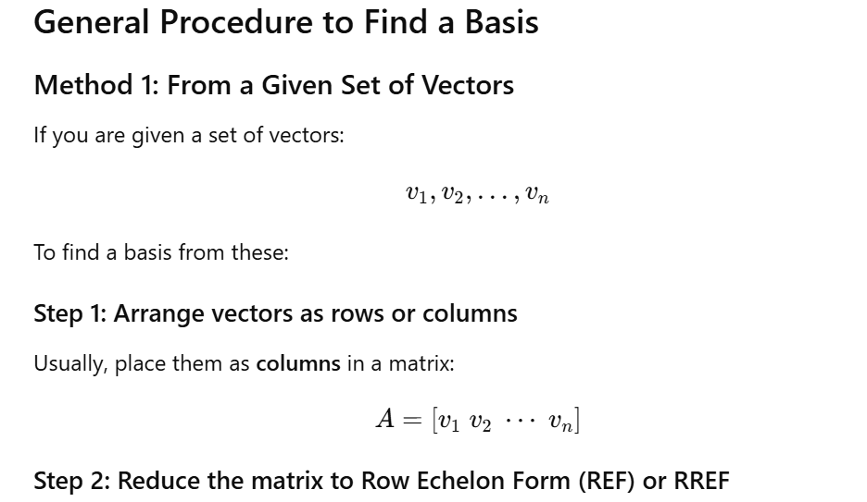
Use Gaussian elimination.
Step 3: Identify pivot columns
The pivot columns of the RREF correspond to vectors in the original set that form a basis.
These pivot columns are linearly independent and span the same space.
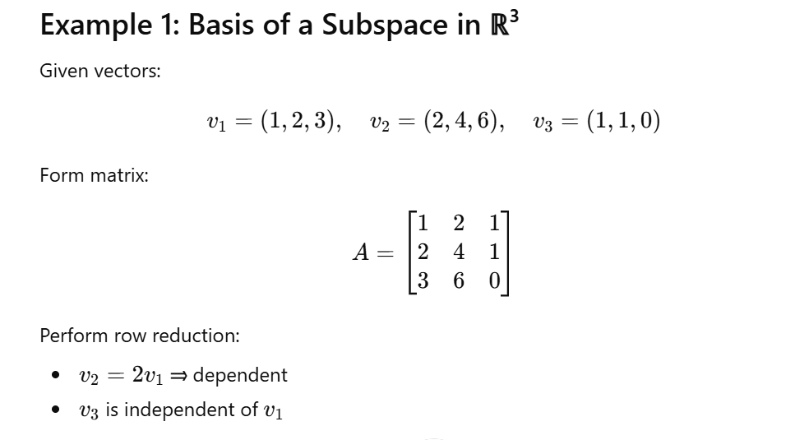
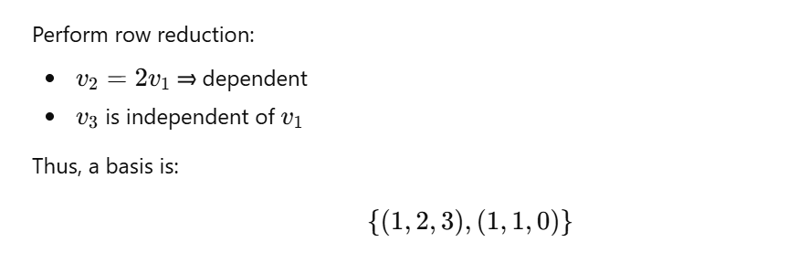
Method 2: Basis of the Solution Space (Null Space)
For homogeneous equations:
Ax=0Ax = 0Ax=0
Steps:
- Reduce A to RREF
- Express solution in terms of free variables
- Write general solution as a combination of vectors
- The vectors corresponding to parameters form a basis of the null space
Method 3: Basis of the Row Space
- Reduce matrix to RREF
- Non-zero rows of the RREF form a basis for row space
Method 4: Basis of the Column Space
- Reduce to RREF
- Locate the pivot columns
- Take the corresponding columns from the original matrix
Method 5: Basis for Span of Vectors
Given:
Span{v1,v2,v3}
Follow steps:
- Construct matrix
- Reduce
- Identify pivot columns
- Those corresponding vectors form basis of the span
Q 6. Explain linear independence.
Ans: 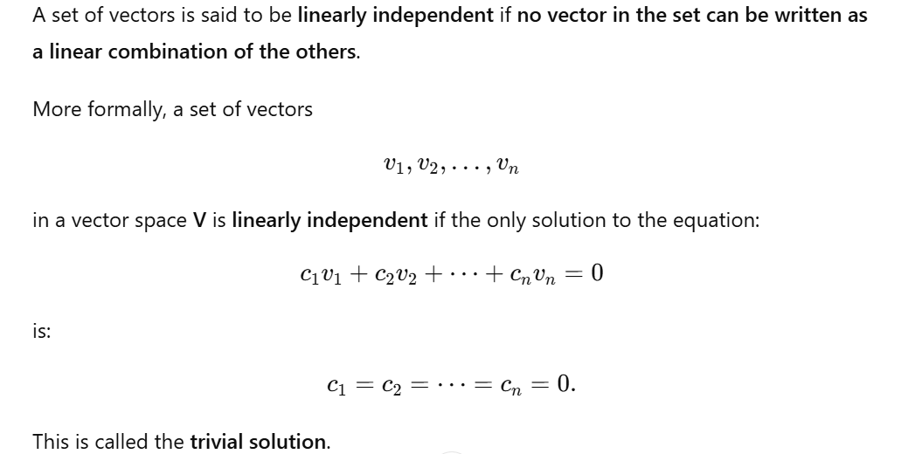
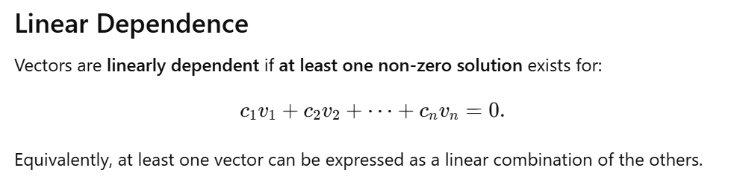
Q7: Explain dimension of vector space with example
Ans: 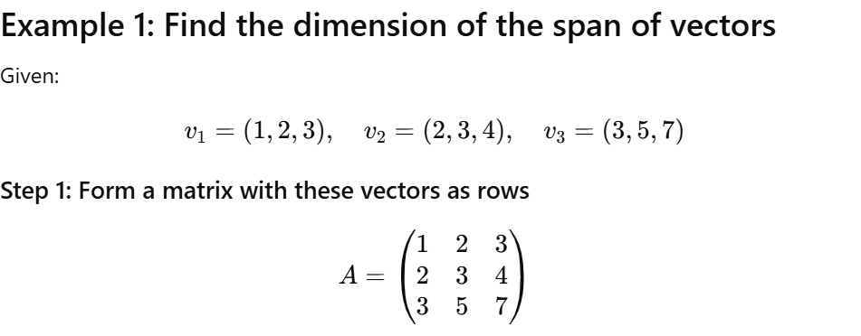
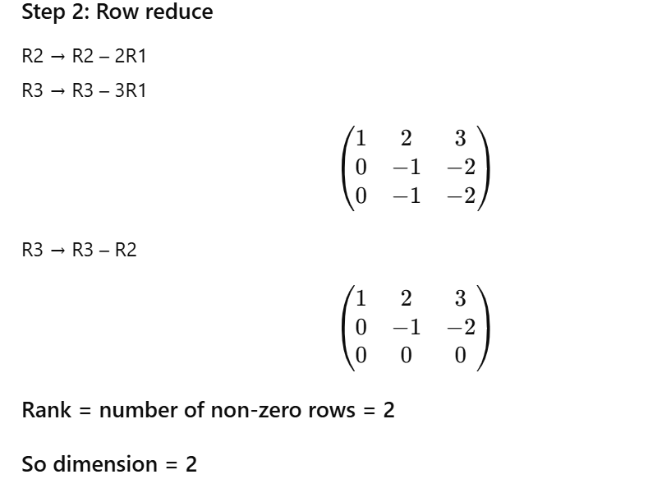

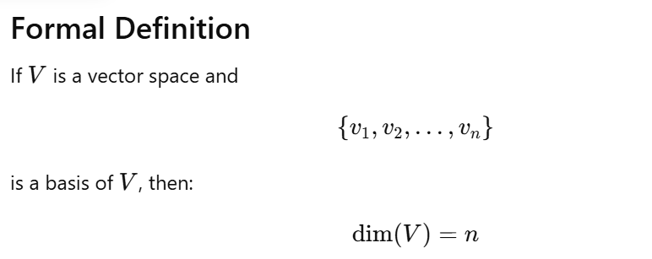
- Linearly independent, and
- Spans the vector space
Since all bases of a vector space have the same number of vectors, this number is called the dimension.

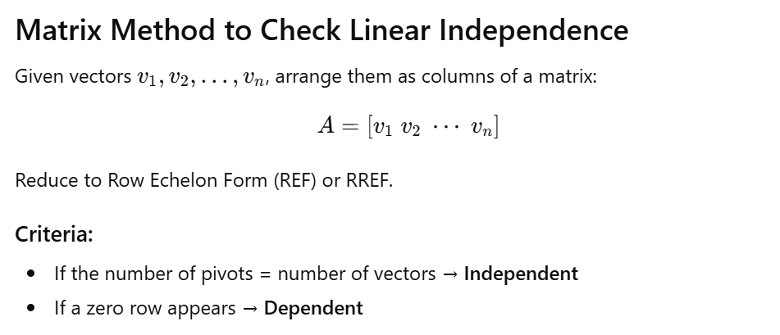

Q8. Provide an example of Cauchy schwarz inequality.
Ans:



