Unit: 1: MATHEMATICAL FOUNDATION Important Question with Ans

Q 1. Explain the concept of dispersion and describe the various measures of dispersion such as range, variance, and standard deviation. How do these measures help in understanding the spread of Data.

Ans: 1. Concept of Dispersion
Dispersion refers to the degree to which data values are spread out or scattered around a central value (such as mean or median).
It indicates how much variation exists in the dataset.
- If dispersion is low, the data values are close to each other.
- If dispersion is high, the data values are widely spread out.
Dispersion helps in understanding reliability, consistency, and risk associated with data.

2. Measures of Dispersion

(a) Range
Definition:
Range is the simplest measure of dispersion.
Range=Maximum value−Minimum value
Advantages:
- Easy to compute
- Useful for quick comparison
Limitations:
- Depends only on two extreme values
- Not reliable if data has outliers

(b) Variance
Definition:
Variance measures the average of squared deviations of each observation from the mean.
For a population:
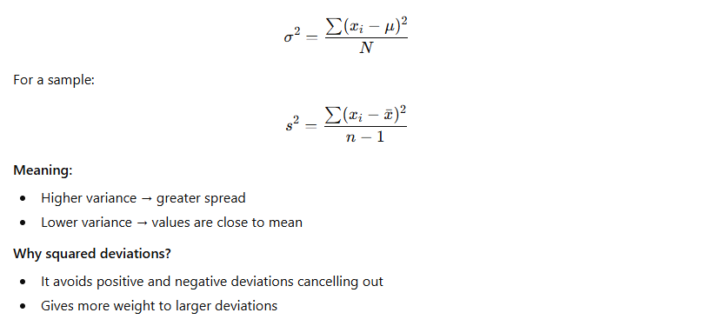

c) Standard Deviation (SD)
Definition:
Standard deviation is the square root of variance.
Interpretation:
- SD is expressed in original units of data
- More intuitive and widely used
- Smaller SD → more consistency in data
- Larger SD → more variability

3. How These Measures Help Understand Data Spread

Range
- Gives a quick idea about overall spread
- Useful for comparing two datasets roughly

Variance
- Shows how far data values deviate from the mean
- Helps in statistical modeling, hypothesis testing, ANOVA, etc.
- Important in finance for measuring risk

Standard Deviation
- Indicates consistency or reliability of data
- Smaller SD → stable performance (e.g., machine accuracy, student marks)
- Larger SD → unpredictable or inconsistent behavior
- Used in normal distribution, control charts, confidence intervals

. Conclusion
Dispersion is essential for understanding the spread and reliability of data.
- Range shows the simplest form of spread.
- Variance shows average squared deviation from the mean.
- Standard deviation gives a practical and interpretable measure of variability.
Together, these measures help in comparing datasets, analyzing risks, and making data-driven decisions.
Q2. Explain probability theory and its importance in statistical analysis. Define measures of probability such as probability mass functions and probability density functions.

Ans: . Probability Theory – Definition
Probability theory is a branch of mathematics that deals with measuring the likelihood of occurrence of uncertain events.
It provides a quantitative description of randomness and uncertainty.
- Probability values range from 0 to 1
  - 0 → impossible event
  - 1 → certain event
  - Values in between → partial chance
Probability helps model and analyze situations where outcomes are not predictable with certainty.

2. Importance of Probability in Statistical Analysis

(a) Foundation of Inferential Statistics
Probability helps us draw conclusions about a population based on sample data, such as:
- Estimation
- Hypothesis testing
- Confidence intervals

(b) Modeling Random Phenomena
Many real-life processes are random, such as:
- Weather forecasting
- Quality control
- Stock market behavior
- Machine failure
Probability theory provides mathematical models to study them.

(c) Decision-Making Under Uncertainty
Used in:
- Risk analysis
- Medical diagnosis
- Engineering reliability
- Insurance and finance

(d) Basis for Probability Distributions
All statistical distributions (normal, binomial, Poisson, etc.) are built using probability theory.

(e) Helps Measure Variability
It quantifies the likelihood of deviations from expected values and helps understand the spread of data.

3. Measures of Probability
Probability distributions describe how probabilities are assigned to outcomes. Two important measures are:
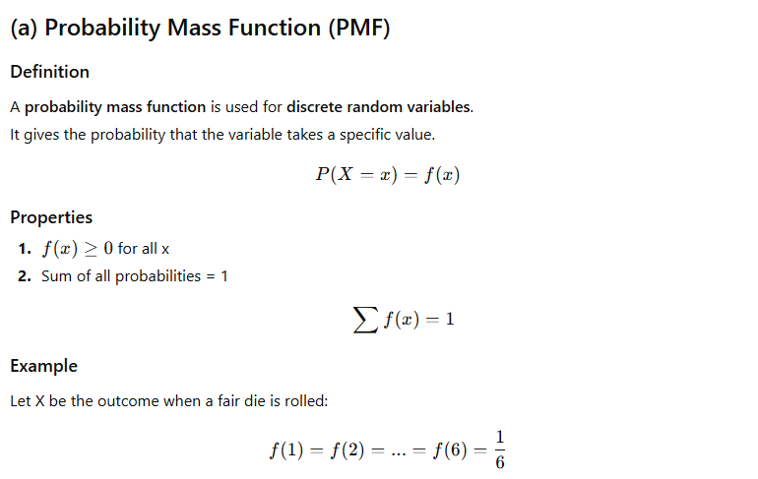
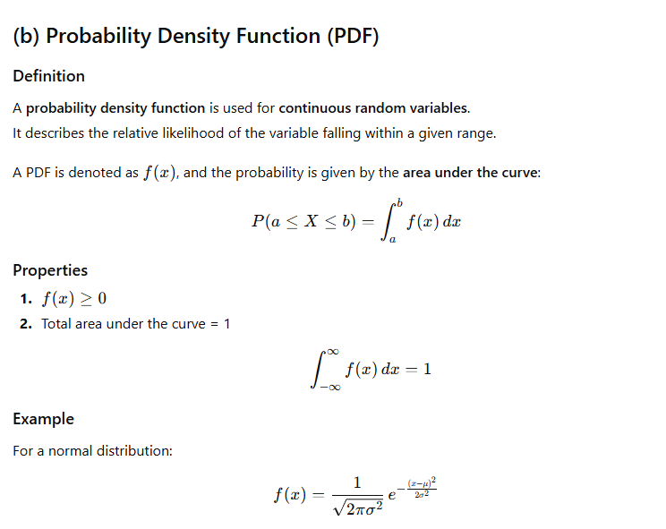
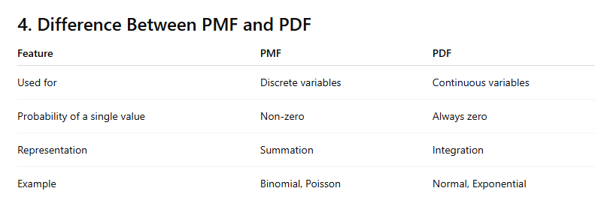

5. Conclusion
Probability theory is essential for handling uncertainty and forming the foundation of statistical inference.
PMFs and PDFs describe how probability is assigned to discrete and continuous outcomes
Q3. Discuss Chebyshev’s inequality and explain how it can be used to estimate the probability that a random variable lies within a certain number of standard deviations from its mean.

Ans: Chebyshev’s Inequality

1. Definition
Chebyshev’s Inequality is a fundamental result in probability theory that gives a lower bound on the probability that a random variable lies within a certain distance from its mean.
It applies to any distribution, regardless of:
- Shape
- Symmetry
- Skewness
- Whether it is discrete or continuous
Therefore, it is considered a distribution-free (non-parametric) inequality.

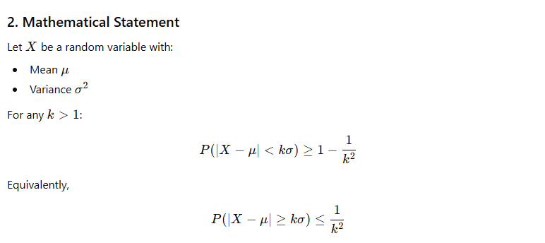
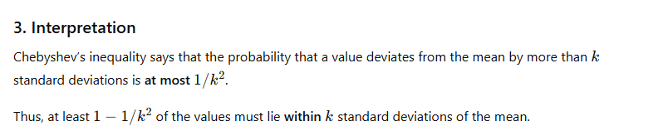
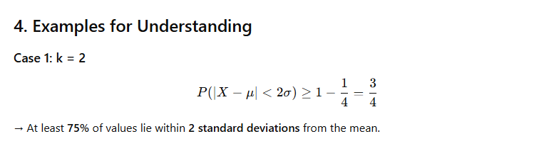
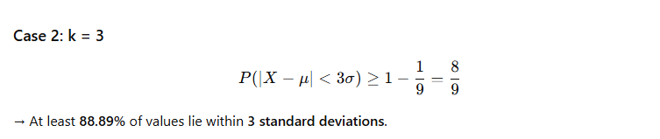
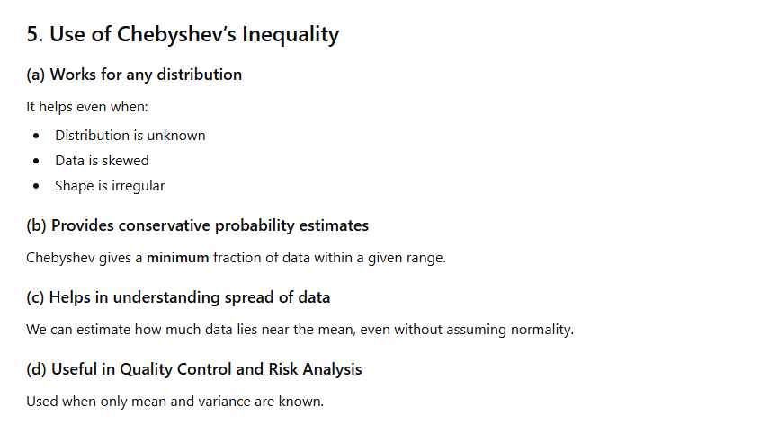
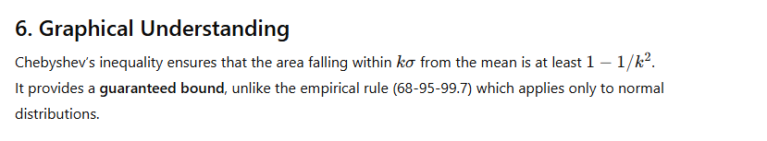

7. Conclusion
Chebyshev's inequality gives a universal bound on the probability that a random variable lies within a specified number of standard deviations from its mean.
It is powerful because it works for all possible distributions, providing a conservative but guaranteed estimate of data concentration around the mean.
Q4. Explain the concept of central tendency and describe the various measures such as mean, Median, mode. Also discuss how these measures differ from each other. Further, explain how combining measures of central tendency with measures of dispersion such as variance and standard deviation helps in understanding the nature and consistency of the dataset.

Ans: 1. Concept of Central Tendency
Central tendency refers to a statistical concept that identifies the central value or typical value around which the data points are distributed.
It provides a single representative value for an entire dataset.
Central tendency helps in:
- Summarizing datasets
- Comparing groups
- Understanding typical behavior
- Supporting decision-making
The three major measures are Mean, Median, and Mode.

2. Measures of Central Tendency
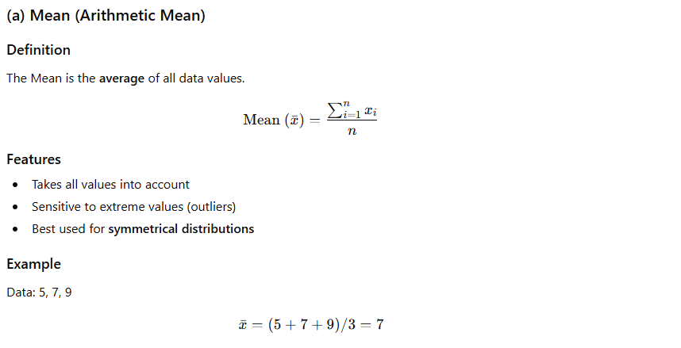
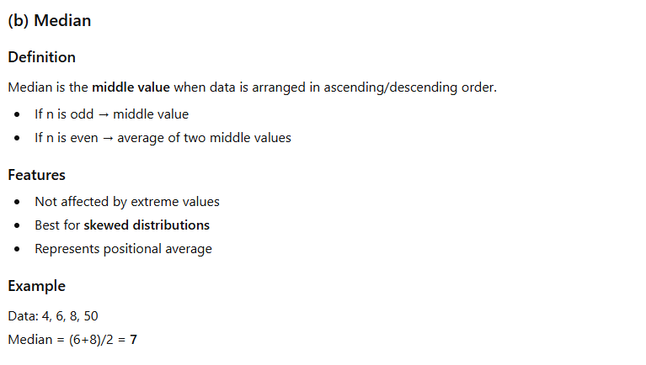
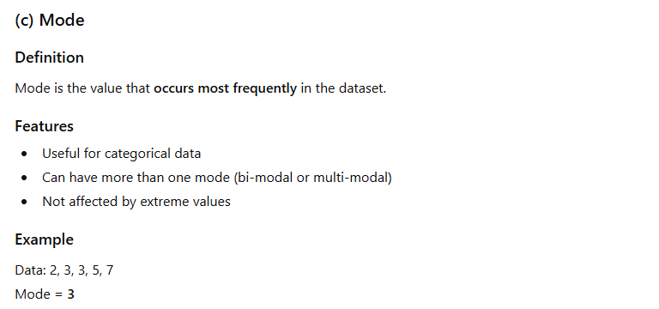

4. Combining Measures of Central Tendency with Dispersion (Variance & SD)
Central tendency tells where the center of the data lies, but does not describe how data is spread around that central value.
To understand dataset consistency, we combine it with dispersion measures such as:
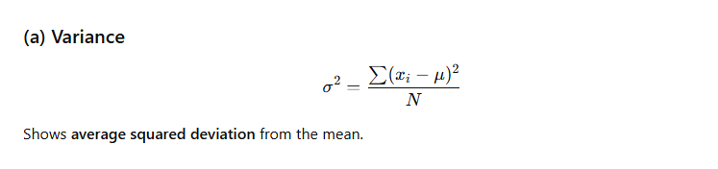
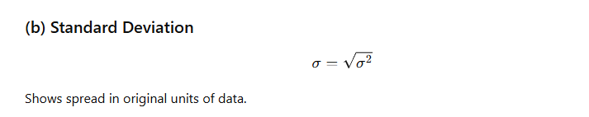

Complete description of data
Central tendency gives the location,
Dispersion gives the spread,
Finally:
Central tendency measures like mean, median, mode summarize data using a single representative value.
However, they do not show how spread out the data is.
By combining these with variance and standard deviation, we gain a deeper understanding of:
- Consistency
- Stability
- Spread
- Reliability
- Shape of distribution
Thus, both central tendency and dispersion together provide a complete picture of the nature of the dataset.
Together they describe the dataset comprehensively.
Q5. . Explain the concept of linear regression and multiple regression. Derive the regression equation of Y on X.
Ans: 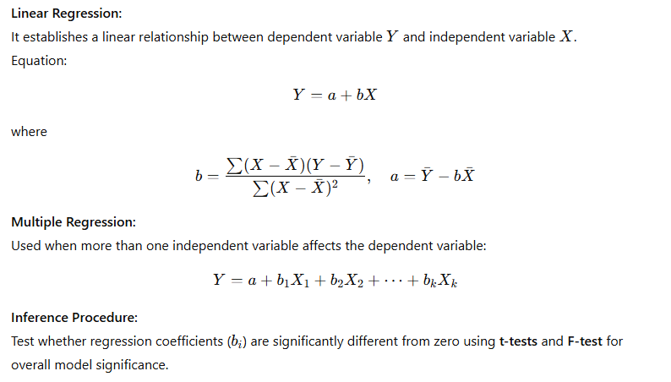
EX. Fit a regression line of Y on X for the following data and estimate Y when X = 6.
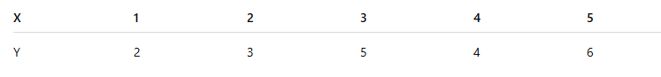
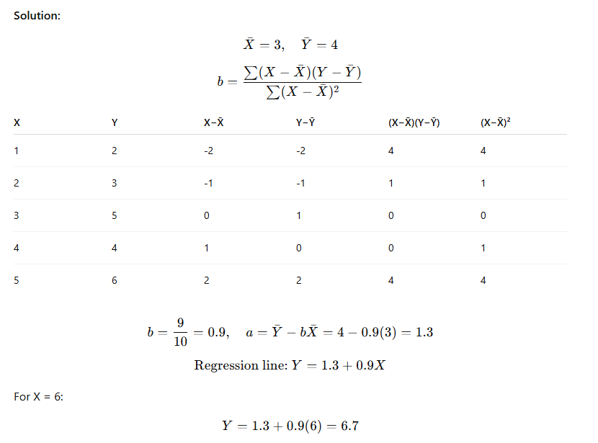
Regression equation: Y = 1.3 + 0.9X
Predicted Y (when X=6) = 6.7

