Unit:2-Mathematical Foundation

Q1. Describe estimation and discuss the difference between point estimation and interval estimation. How does estimation help in making decisions about population parameters based on sample data?

ANS:

Estimation – Definition
Estimation is a statistical process of using sample data to infer the values of unknown population parameters such as population mean (μ), proportion (p), or variance (σ²).
Since collecting data from the whole population is usually impractical, estimation provides a way to make reasonable and reliable statements about the population using samples.
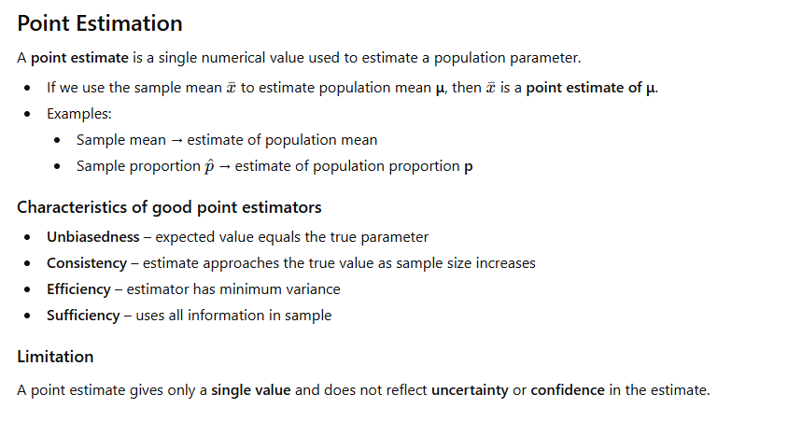
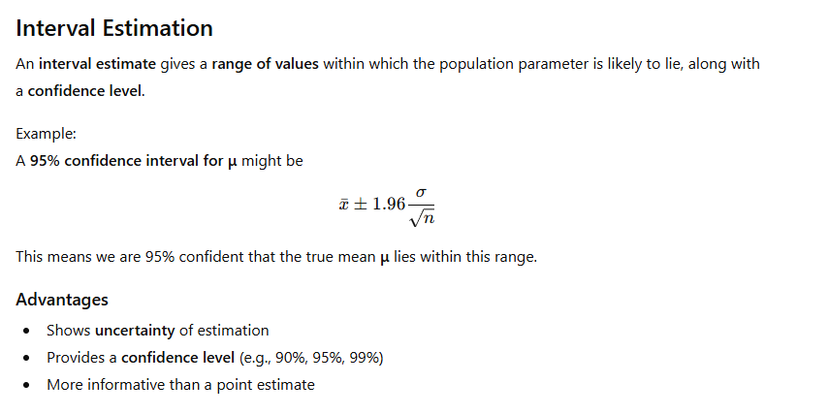
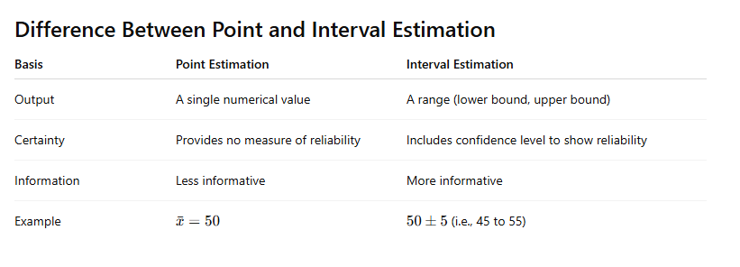
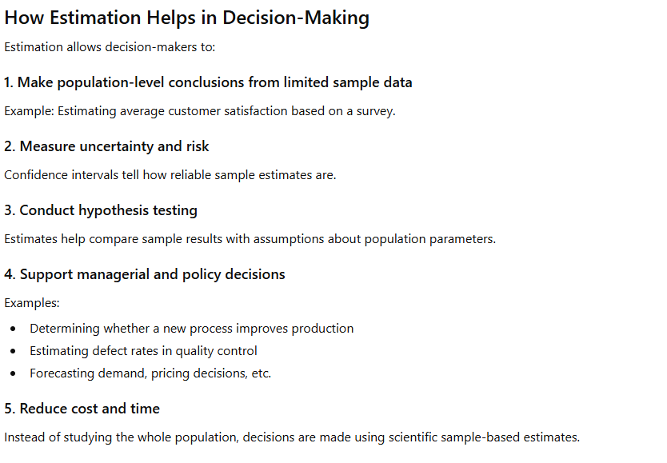
Q2. Discuss the difference between a t-test and a z-test. What are the assumptions underlying each test, and in what situations should each be used?

ANS: t-test vs. z-test
A t-test and a z-test are both statistical hypothesis tests used to compare sample data with population parameters or to compare two samples.
However, they differ mainly in sample size, population variance knowledge, and distribution used.
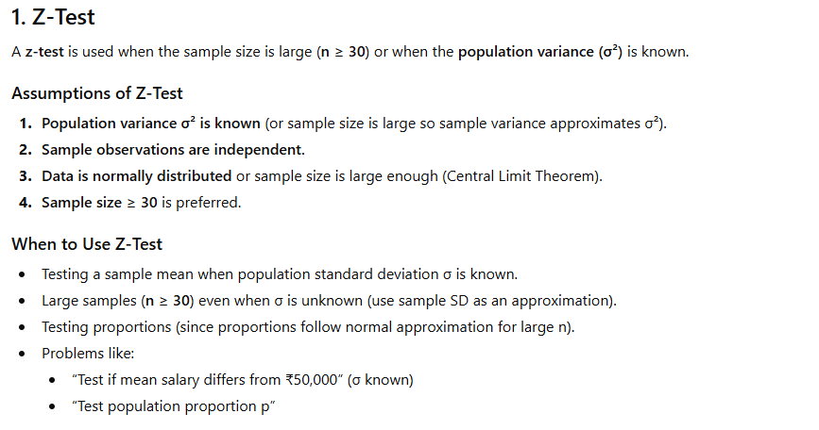
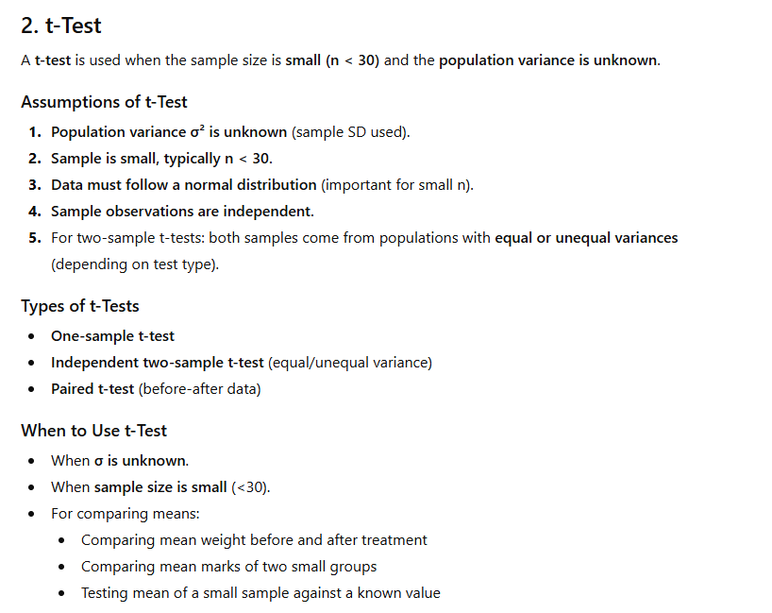
Basis | t-Test | z-Test
Sample size | Small (n < 30) | Large (n ≥ 30)
Population variance | Unknown | Known or approximated
Distribution used | t-distribution | Standard normal (z) distribution
Tail behaviour | Heavier tails (more uncertainty) | Narrower tails
Application | Mean comparison (small sample) | Mean/proportion tests (large sample)

4. Summary for Decision-Making
- Use Z-test when:
  - The sample size is large OR population standard deviation is known.
- Use T-test when:
  - Population standard deviation is unknown AND sample size is small.
  - Data must be normally distributed.
A z-test relies on the normal distribution and known variance, making it suitable for large samples or known population parameters.
A t-test uses the t-distribution to account for extra uncertainty when the population variance is unknown and the sample is small.
Choosing between them ensures valid inference about population parameters.

Q3. What is ANOVA (Analysis of Variance), and how does it help in comparing the means of three or more groups? Explain the concept of between-group variance and within-group variance?

ANS: ANOVA (Analysis of Variance)
ANOVA is a statistical technique used to determine whether there are significant differences among the means of three or more independent groups.
Instead of comparing means using multiple t-tests (which increases error), ANOVA uses variance to test whether group means differ.

Why ANOVA is Needed?
If we compare more than two groups using repeated t-tests, the probability of committing a Type-I error (false positive) increases.
ANOVA avoids this problem by testing all mean differences in one single test.

How ANOVA Works
ANOVA compares two types of variability:
- Between-group variance (variation due to differences among group means)
- Within-group variance (variation due to differences inside each group)
ANOVA calculates a statistic called the F-ratio:
F=Between-group variance / Within-group variance
- If F is large, group means are likely different.
- If F is small, group means are similar.

Between-Group Variance
This measures how much the group means differ from the overall mean.
- It captures differences because of the treatment or factor.
- If the group means are far apart, the between-group variance will be high.
- It represents systematic variation.

Example:
If three group means are 10, 30, and 50, they are very different → high between-group variance.

Decision Logic of ANOVA
- If between-group variance > within-group variance,
→ groups differ significantly → reject H₀: all means are equal
- If between-group variance ≈ within-group variance,
→ group differences are due to random chance → fail to reject H₀
ANOVA is a hypothesis-testing technique used to compare the means of three or more groups by partitioning total variation into between-group and within-group components.
Between-group variance measures differences among group means, reflecting treatment effects.
Within-group variance measures random variation inside each group.
A large ratio of between to within variance (F-value) indicates significant differences among group means.
Q4. 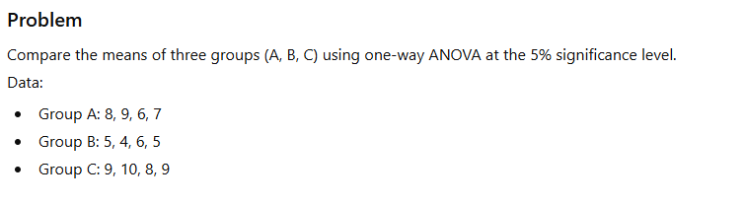
ANS: 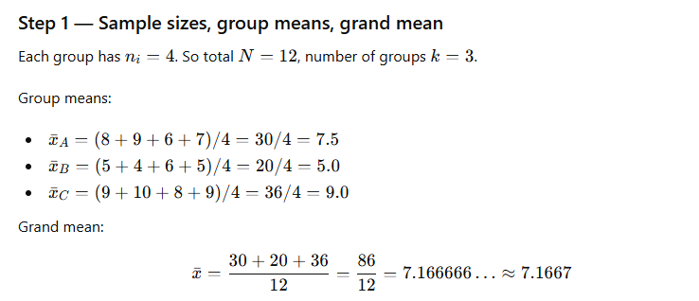
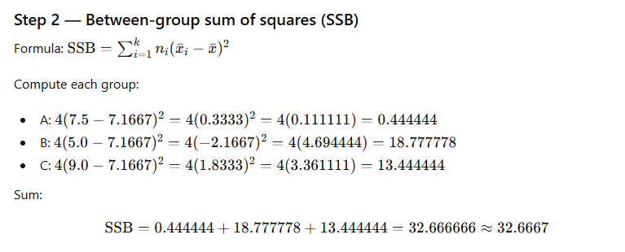
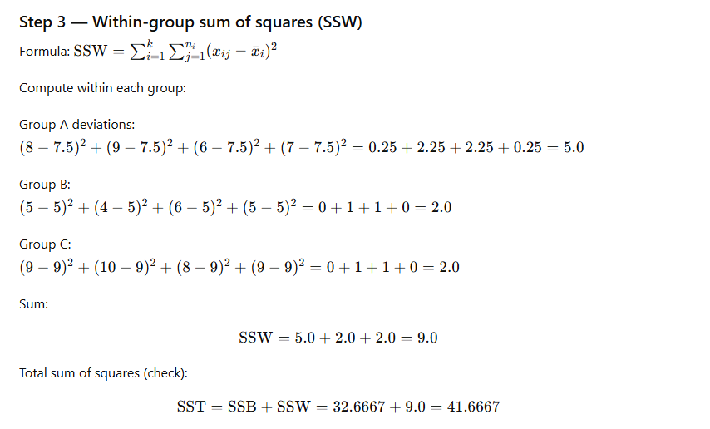
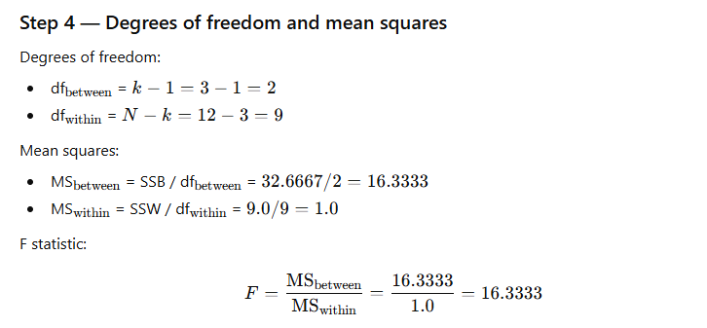
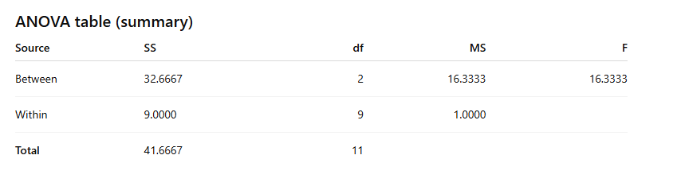
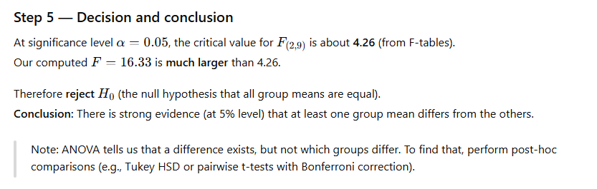
Q5. Discuss Central limit theorem with applications?

Ans: What is the Central Limit Theorem?
The CLT is a statistical theory that states that - if you take a sufficiently large sample size from a population with a finite level of variance, the mean of all samples from that population will be roughly equal to the population mean.
Consider there are 15 sections in class X, and each section has 50 students. Our task is to calculate the average marks of students in class X.
The standard approach will be to calculate the average simply:
- Calculate the total marks of all the students in Class X
- Add all the marks
- Divide the total marks by the total number of students
But what if the data is extremely large? Is this a good approach? No way, calculation marks of all the students will be a tedious and time-consuming process. So, what are the alternatives? Let's take a look at another approach.
- To begin, select groups of students from the class at random. This will be referred to as a sample. Create several samples, each with 30 students.
- Calculate each sample's individual mean.
- Calculate the average of these sample means.
- The value will give us the approximate average marks of the students in Class X.
- The histogram of the sample means marks of the students will resemble a bell curve or normal distribution.

Significance of Central Limit Theorem
The CLT has several applications. Look at the places where you can use it.
- Political/election polling is a great example of how you can use CLT. These polls are used to estimate the number of people who support a specific candidate. You may have seen these results with confidence intervals on news channels. The CLT aids in this calculation.
- You use the CLT in various census fields to calculate various population details, such as family income, electricity consumption, individual salaries, and so on.
The CLT is useful in a variety of fields. Are there any others that come to mind? Put them in the comments section below this tutorial.

Assumptions Behind the Central Limit Theorem
Before we move on further, it is important to understand the assumptions behind CLT:
- The data must adhere to the randomization rule. It needs to be sampled at random.
- The samples should be unrelated to one another. One sample should not impact the others.
- When taking samples without replacement, the sample size should not exceed 10% of the population.
When the population is symmetric, a sample size of 30 is generally considered reasonable.

Why n ≥ 30 Samples?
The sample size of 30 is considered sufficient to see the effect of the CLT. If the population distribution is closer to the normal distribution, you will need fewer samples to demonstrate the central limit theorem. On the other hand, if the population distribution is highly skewed, you will need a large number of samples to understand the CLT.
Q6. Discuss the steps involved in dimensionality reduction using PCA
ANS: Principal Component Analysis (PCA) is a statistical technique used to reduce the dimensionality of a dataset while preserving as much variability as possible. It transforms the original variables into a new set of uncorrelated variables called principal components.
The complete steps involved in PCA are
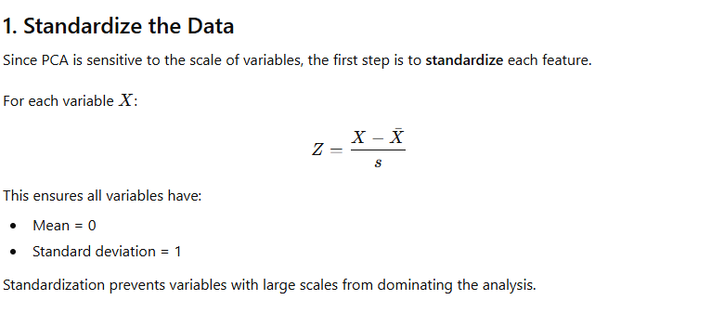
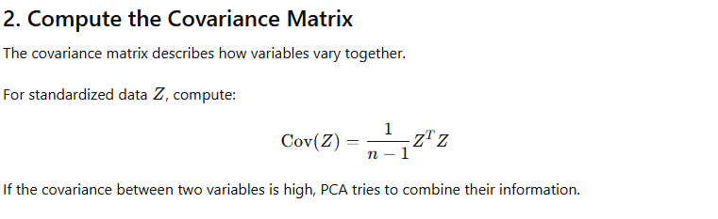
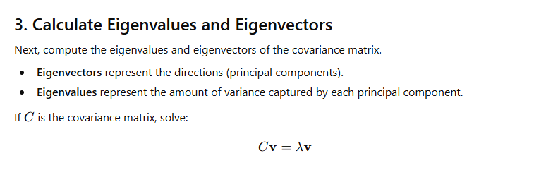
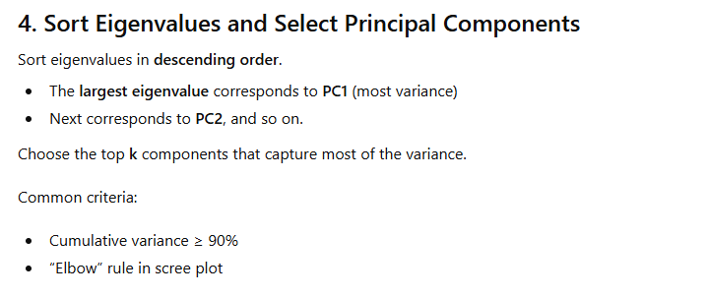
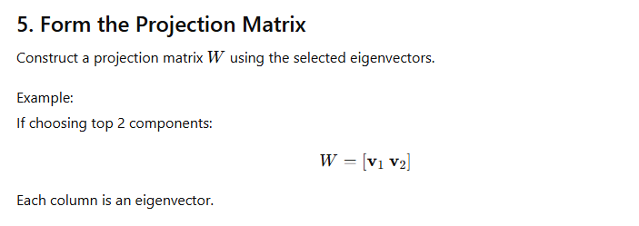
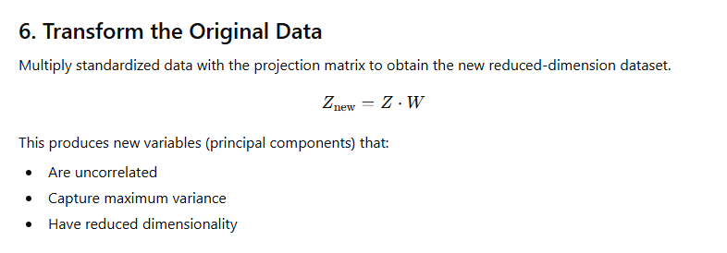
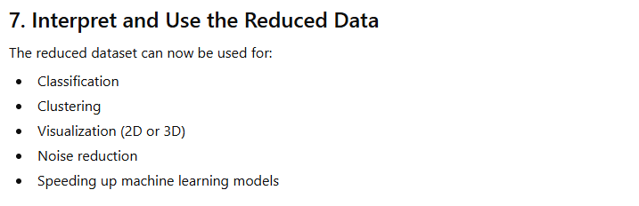

Final Summary :
PCA involves the following steps:
(1) Standardize the dataset,
(2) Compute the covariance matrix,
(3) Calculate eigenvalues and eigenvectors,
(4) Sort them and select principal components,
(5) Form a projection matrix,
(6) Transform data to the reduced feature space, and
(7) Interpret and use the lower-dimensional data.
PCA reduces complexity while preserving most of the important information in the dataset.

Q7. Explain the use of chi square test in hypothesis testing, with suitable example.

Ans: Chi-Square Test in Hypothesis Testing
The Chi-Square (χ²) test is a non-parametric statistical test used to determine whether there is a significant association between categorical variables or whether an observed distribution differs from an expected distribution.
It compares observed frequencies (O) and expected frequencies (E) and checks whether deviations are due to chance or indicate a real effect.
The Chi-Square statistic is:
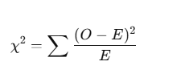

Types of Chi-Square Tests

1. Chi-Square Test for Goodness of Fit
Used to check whether a sample distribution fits a claimed/theoretical distribution.
Example: Does a die follow a uniform distribution?

Chi-Square Test for Independence (Contingency Table Test)
Used to test whether two categorical variables are independent.
Example: Is customer satisfaction independent of gender?

ASSUMPTIONS
- Data are in frequency form (counts).
- Observations are independent.
- Expected frequency in each cell should be ≥ 5.
- Categories must be mutually exclusive.
Q8. 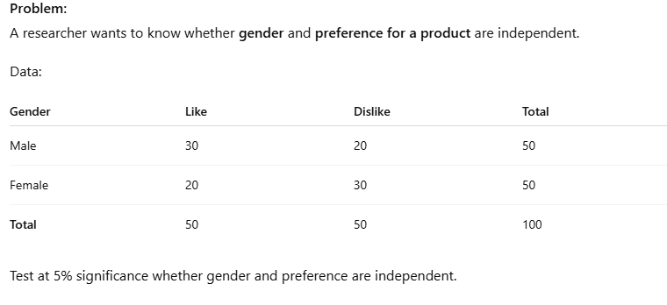

Step 1 — State the hypotheses
- H₀: Gender and product preference are independent.
- H₁: Gender and product preference are dependent.
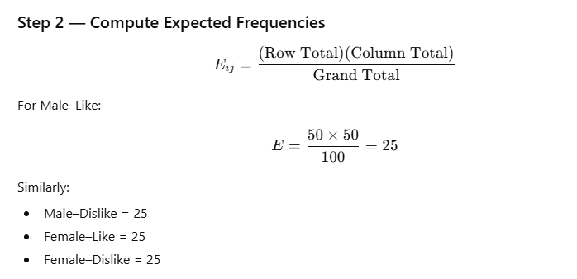

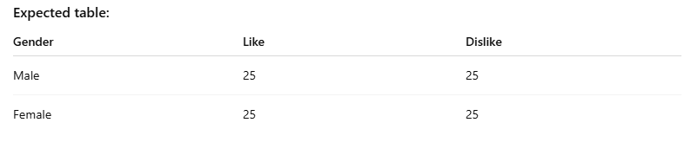
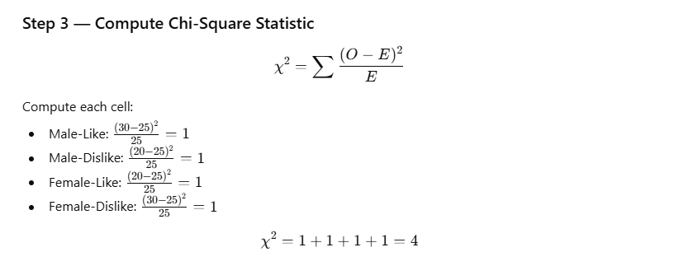
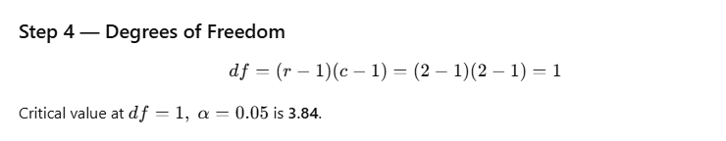

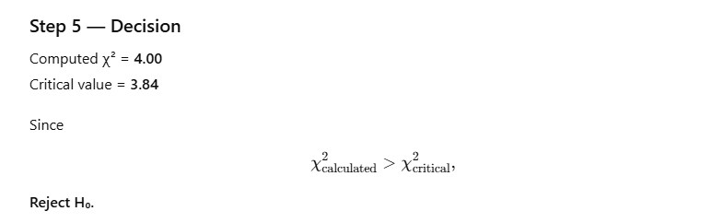

Conclusion
There is significant association between gender and product preference.
Thus, preferences depend on gender.
Q8. Discuss the need of sampling.

ANS: What is Sampling?

The terminology “sampling” indicates the selection of a part of a group or an aggregate with a view to obtaining information about the whole. This aggregate or the totality of all members is known as Population although they need not be human beings. The selected part, which is used to ascertain the characteristics of the population, is called Sample.
Q9 