Unit: 5-MATHEMATICAL FOUNDATION
Q 1. Explain the concepts of eigenvalues and eigenvectors of a matrix. Describe the method of finding eigenvalues using the characteristic equation. Discuss how eigenvectors corresponding to distinct eigenvalues are linearly independent. Provide an example demonstrating the computation of eigenvalues and eigenvectors and their applications
Ans:
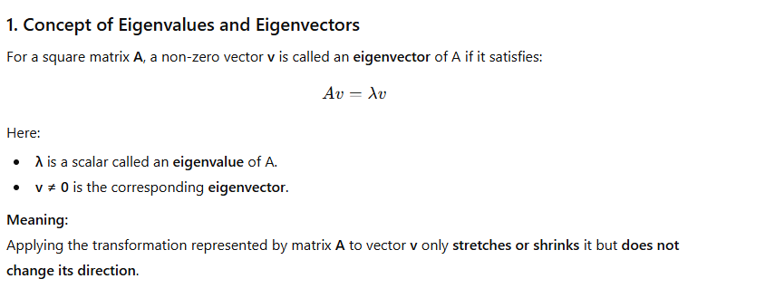
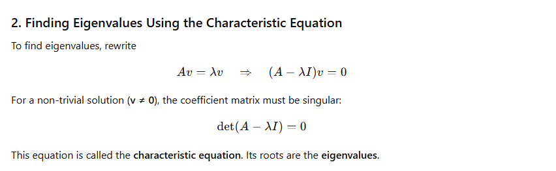
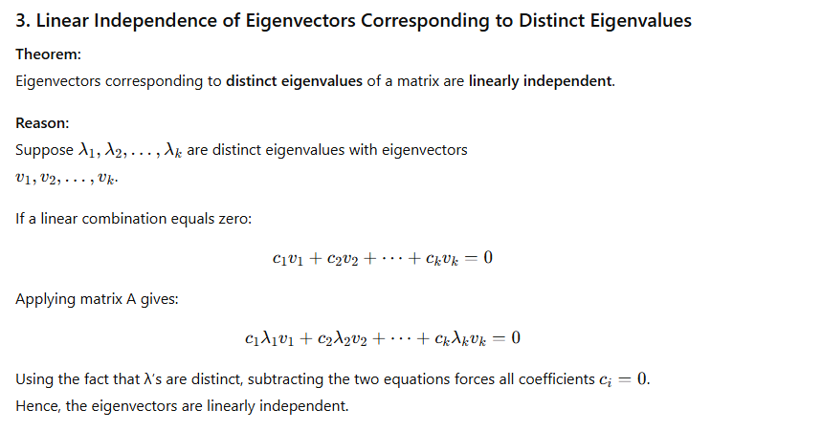
Ex:
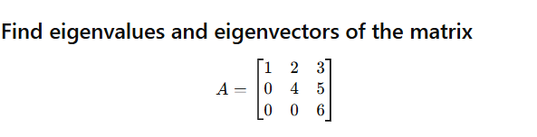

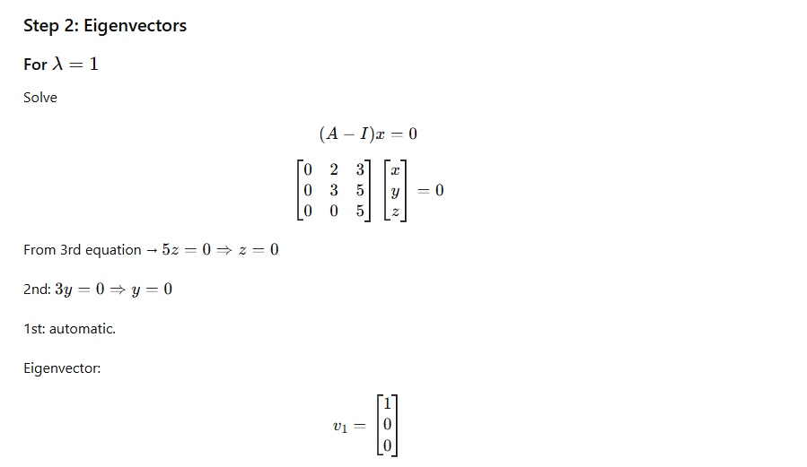
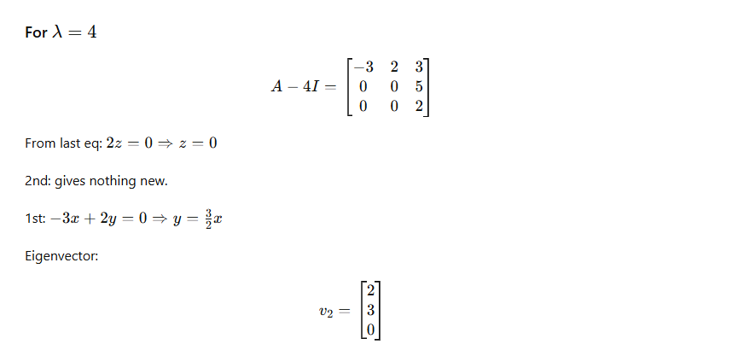
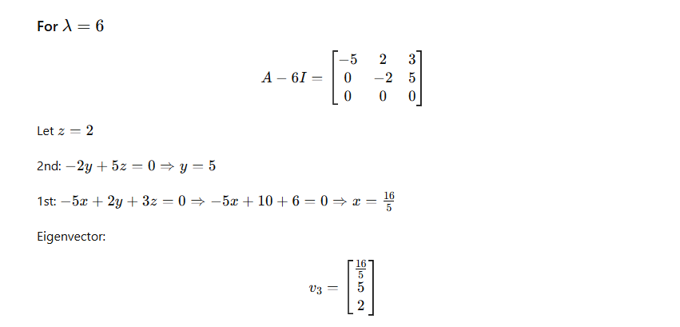
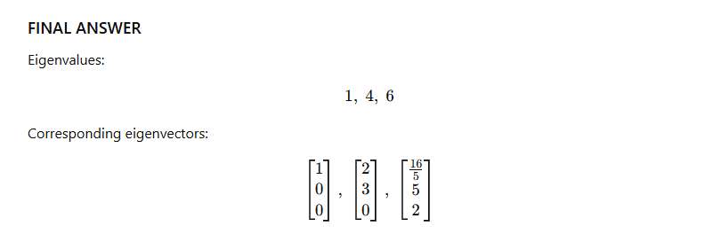

is diagonalizable. If yes, diagonalize it.

Solution
This is a symmetric matrix, so it is always diagonalizable and also orthogonally diagonalizable.
But we compute eigenvalues.

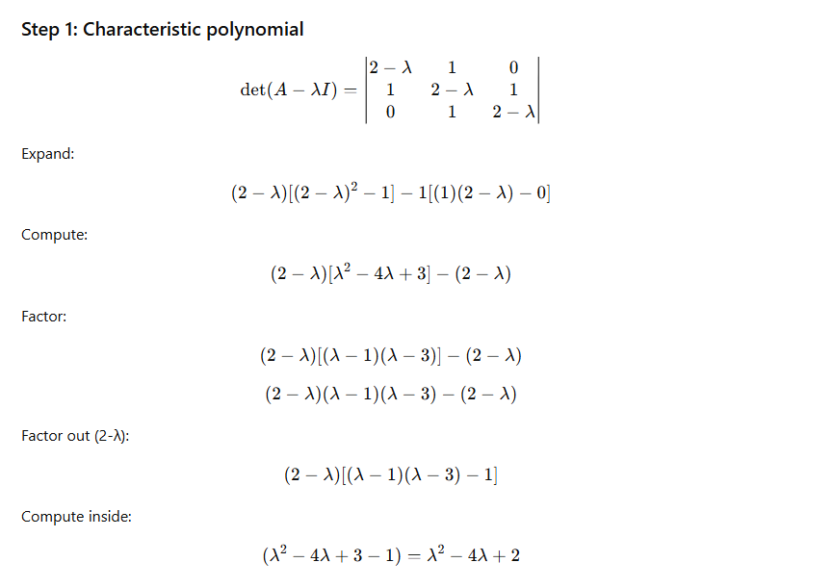
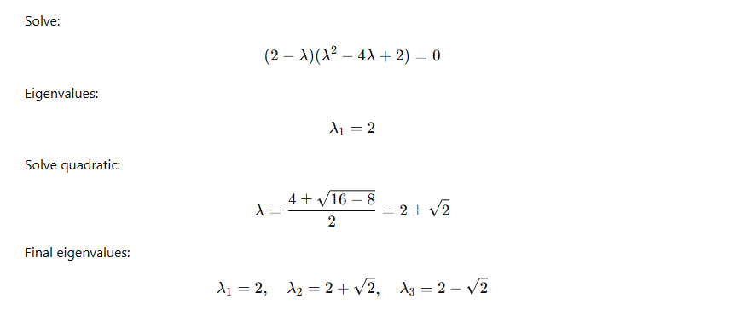
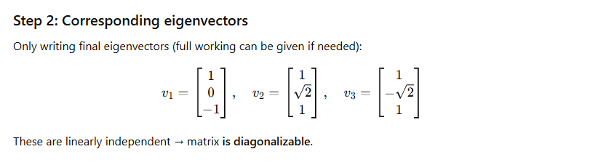

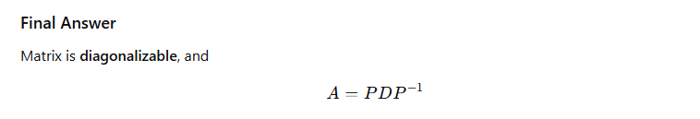


Solution
This matrix is symmetric ⇒ orthogonally diagonalizable.
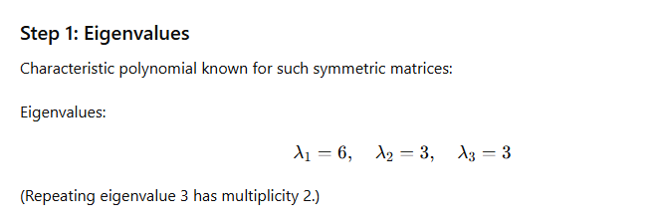
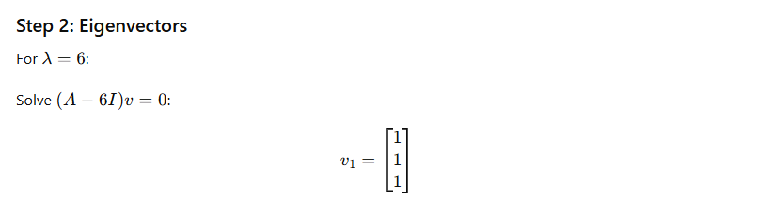
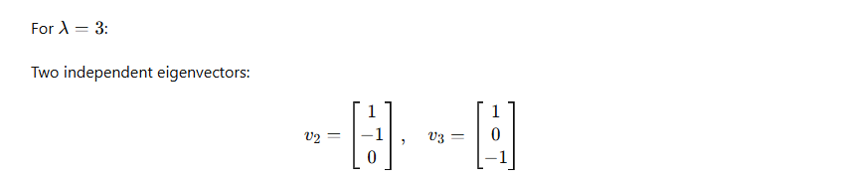
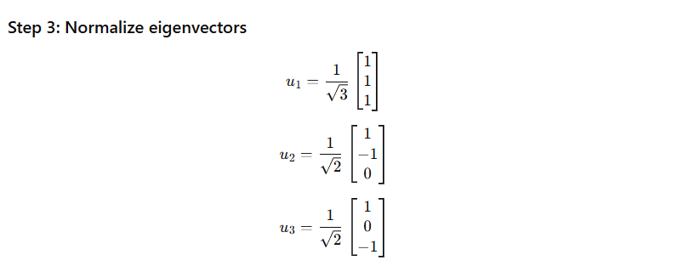



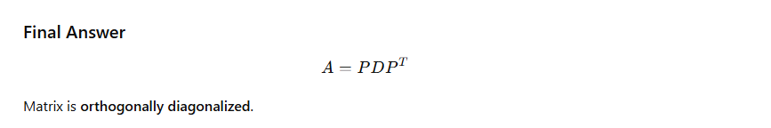

Q4. Explain the concept of symmetric matrices. Discuss the properties of symmetric matrices, particularly their eigenvalues and eigenvectors.

Ans: Symmetric Matrices – Definition, Properties, Eigenvalues & Eigenvectors

1. Definition of a Symmetric Matrix
A square matrix A is called symmetric if:
A=A ^{T}
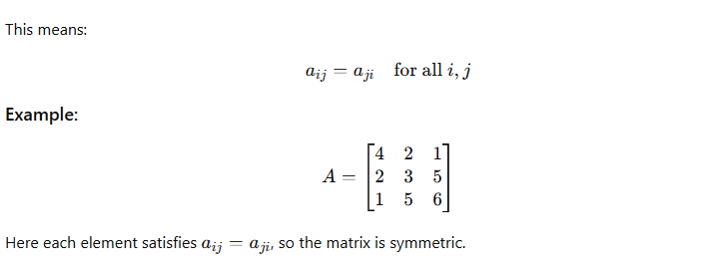

Properties of Symmetric Matrices
Symmetric matrices have several important mathematical properties:
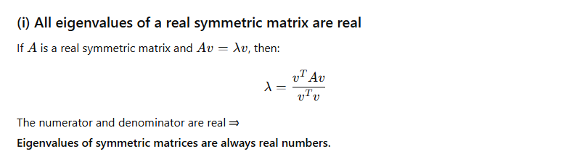
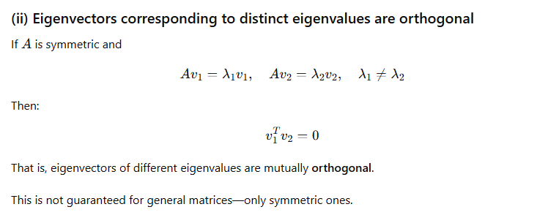
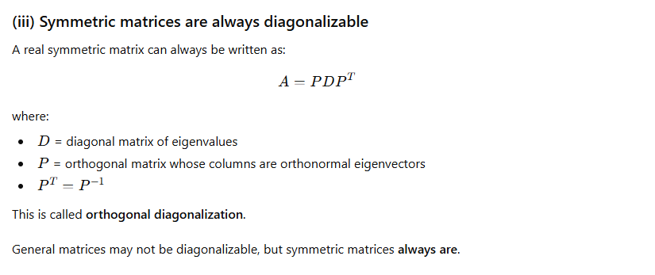
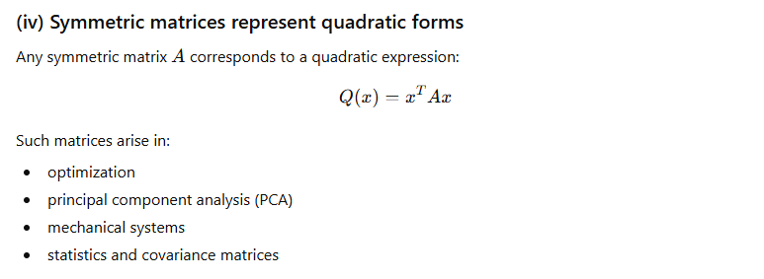
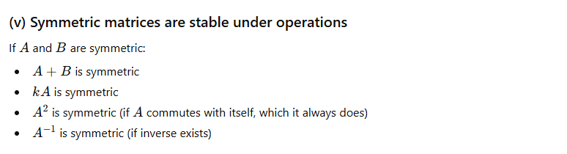

Eigenvalues and Eigenvectors of Symmetric Matrices

Key Ideas:

(i) Eigenvalues are real
This makes symmetric matrices easy to analyze in practical applications.

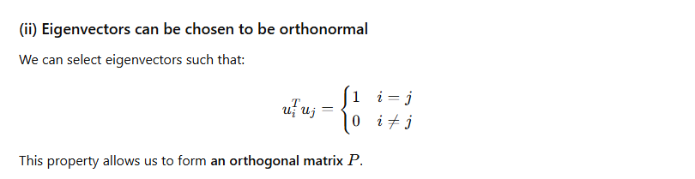
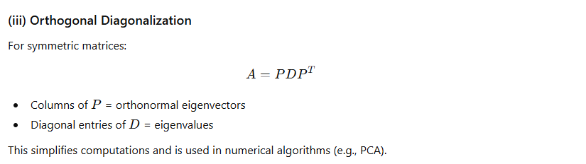
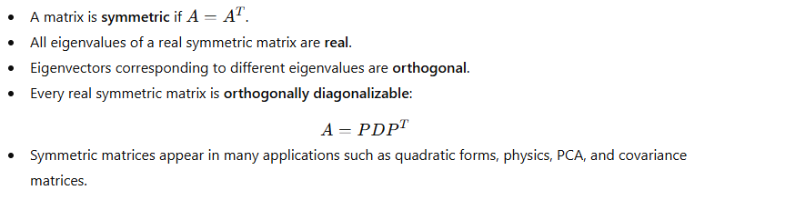
Q 5. Discuss the concept of change of basis in the context of linear transformations. Explain how a basis change affects the matrix representation of a linear transformation?

Ans: Change of Basis in Linear Transformations

Linear transformation and its matrix representation

n
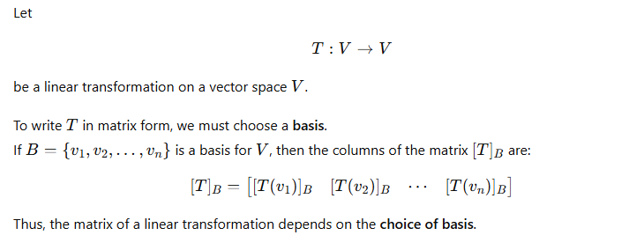
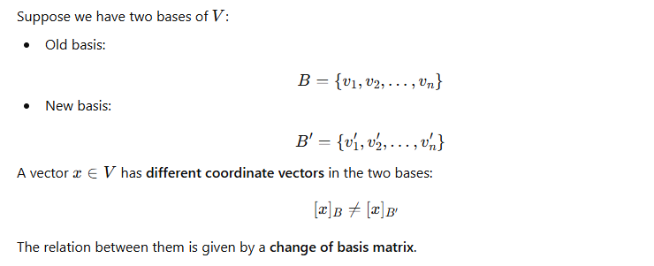
3. Change of Basis Matrix
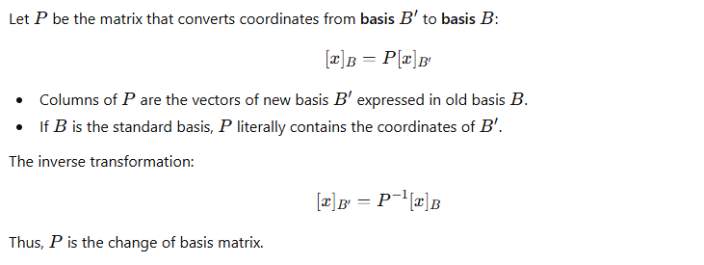
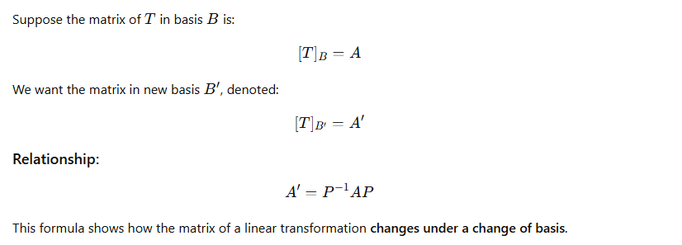

Interpretation
- Changing basis leads to a similar matrix.
- The linear transformation itself does not change.
- Only its matrix representation changes.
- Eigenvalues remain the same (similar matrices have same eigenvalues).
- Eigenvectors change according to the new basis.

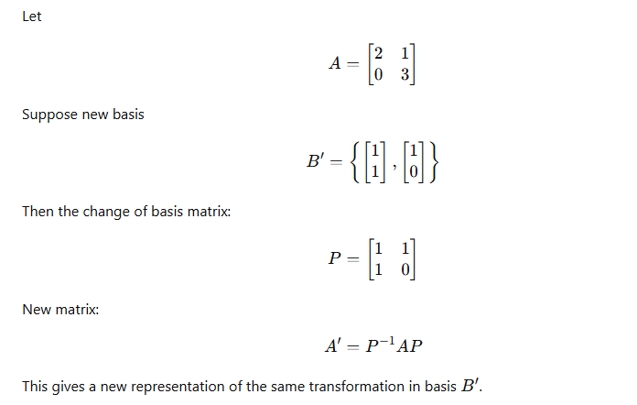

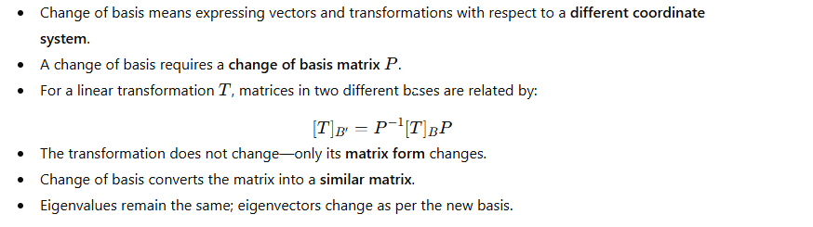
^{Q6.} Define a linear transformation. Explain the conditions that a function T:V→W must satisfy to be considered a linear transformation, where V and W are vector spaces. Provide examples of linear transformations and non-linear transformations.
Ans: 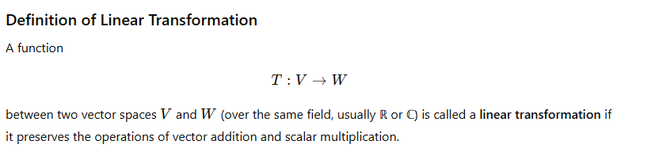
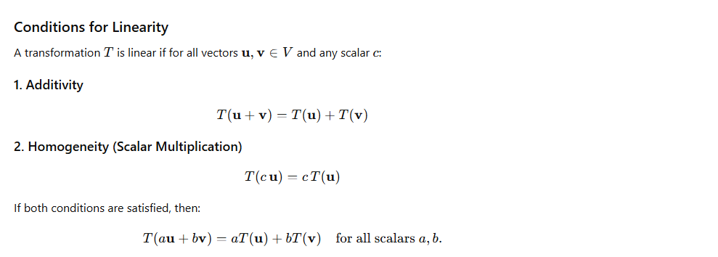
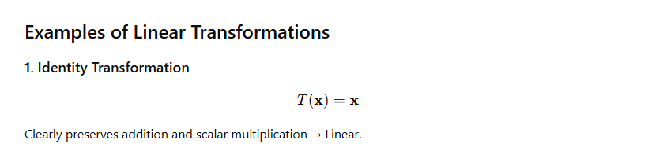
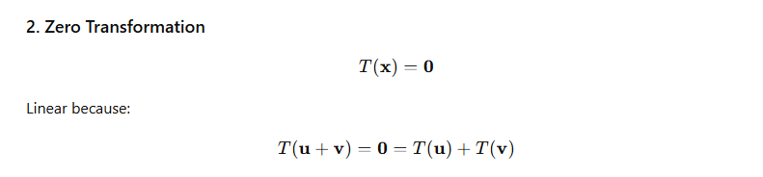
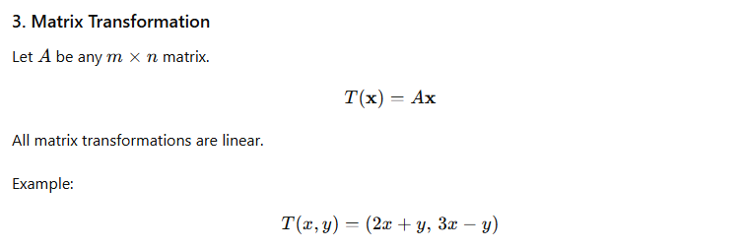
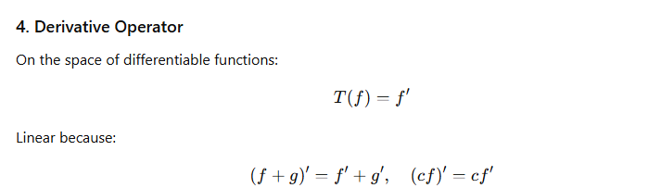
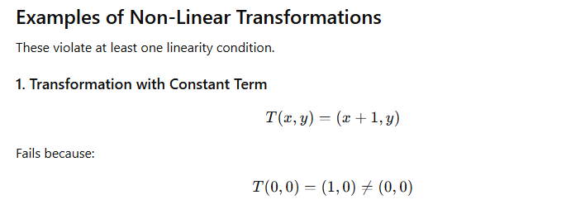
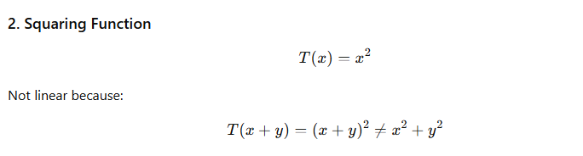
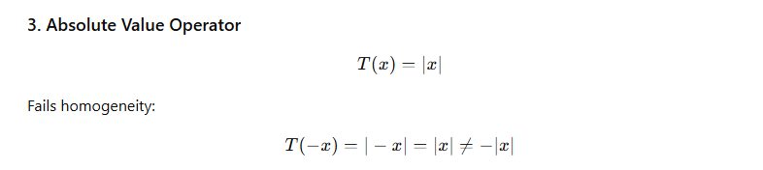
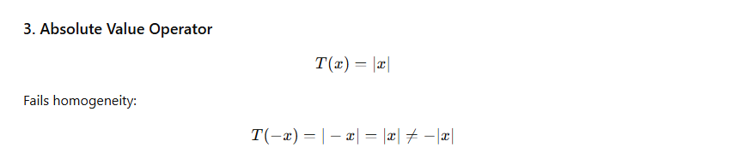
A transformation T:V→W is linear if it satisfies:

Linear transformations preserve the vector-space structure and are often represented by matrices.
Non-linear transformations violate at least one of the above conditions.

