BACHELOR'S THESIS
WoWeather
Android Weather Application
━━━━━━━━━━━━━━━━━━━━━━━━━━━━━━━━
Author | Ravan Aliyev
Student ID | 404580
Program | Degree Project 2
Faculty | Mathematics and Computer Science
University | University of Łódź
Supervisor | Adam Bartoszek
Academic Year | 2025–2026
Submission Date | [Date]
Łódź, 2026

Abstract
WoWeather is a native Android application that presents weather information for a user-selected location through a compact, multi-screen mobile interface. The implemented application supports location search, current conditions, hourly forecasts, a multi-day forecast requested from WeatherAPI.com, saved locations, recent searches, Celsius/Fahrenheit display preferences, connectivity checks, and navigation to daily and hourly detail screens.
The application is written in Kotlin and targets Android API 24 and higher. Source code structure consists of one module that includes packages for the presentation layer, domain layer, data layer, common layer, and dependency injection. REST interaction is achieved using Retrofit and Gson, where OkHttp plays a role of the HTTP client. Room is responsible for persistence storage of saved cities and history of searches, whereas Preferences DataStore stores selected city and unit preference. Dependency injection is realized using Dagger Hilt. All asynchronous procedures are performed using Kotlin coroutines and Flow, and ViewModels use LiveData to provide state and effect streams. User interface is built using Fragments, Navigation Component and Safe Args, View Binding/Data Binding, Material Components, RecyclerView, Glide, Lottie, and MPAndroidChart.
In addition to the standard forecast lists, the application includes a custom wind compass, a sunrise/sunset visualization, an hourly temperature trend chart, manual refresh controls, and a shared-element transition from the Home screen to the Today details screen. This thesis distinguishes implemented behavior from incomplete or planned functionality. In the current source, the AQI panel is a visual prototype that uses a generated value rather than live air-quality data; forecasts are not cached for offline use; GPS-based current location and weather notifications are not implemented; and automated testing is limited to the default template unit test.
Keywords: Android, Kotlin, weather application, MVVM, layered architecture, REST API, Retrofit, Room, DataStore, Hilt, WeatherAPI.com

Table of Contents
1. Introduction | 4
2. Technical Background and Technology Stack | 5
3. Project Objectives and Scope | 6
4. Requirements Analysis | 7
5. System Architecture | 9
6. Implementation | 12
7. Validation and Current Limitations | 14
8. Results and Discussion | 16
9. Conclusion and Future Work | 17
10. References | 18
11. Appendices | 19

1. Introduction

1.1 Background
Weather information is part of everyday planning. People check it before travelling, spending time outdoors, choosing clothing, or organizing daily activities. A mobile weather client therefore needs to retrieve remote data reliably, present a relatively large amount of information in a readable form, preserve basic user choices, and react clearly when network access is unavailable.

1.2 Project Overview
WoWeather (application ID: com.aliyev.woweather) is a single-module Android application. It does not generate meteorological forecasts itself; instead, it acts as a client for WeatherAPI.com. The application lets the user search for a location, stores the selected location locally, requests forecast data, and presents the response across dedicated screens.
- Search for locations using WeatherAPI.com search results.
- Store the selected city token and Celsius/Fahrenheit preference in Preferences DataStore.
- Store saved cities and recent searches in a Room database.
- Display current conditions, hourly data, and multi-day forecast data returned by the forecast endpoint.
- Allow the user to add, select, and delete saved locations.
- Provide Today/Daily details, a single-hour detail screen, and manual refresh controls.
- Observe network connectivity and show a non-cancelable connection error dialog when the network becomes unavailable.

1.3 Purpose of the Documentation
This document describes the source code contained in the submitted WoWeather project. Implemented features, partial features, and planned features are separated deliberately. The goal is to keep the thesis traceable to concrete classes, resources, dependencies, and user flows in the repository rather than describing functionality that is not present in the application.

1.4 Scope
The implemented scope includes:
- Android client for API level 24 and higher.
- REST integration for city search and forecast retrieval.
- Local persistence with Room and Preferences DataStore.
- Fragment-based UI with Navigation Component and Safe Args.
- Location search, saved-city management, recent searches, temperature-unit preference, connectivity handling, custom weather views, and forecast detail screens.
The following are outside the current implemented product scope:
- A project-owned backend server or user-account system.
- GPS/Fused Location Provider based location selection.
- Weather alerts or a complete notification-delivery pipeline.
- Offline caching of the last successful forecast.
- Live AQI data from WeatherAPI.com.
- Web or iOS clients.

2. Technical Background and Technology Stack

2.1 Architectural Approach
The repository follows a layered design inspired by Clean Architecture rather than a strict textbook implementation. Source files are separated into presentation, domain, data, common, and dependency-injection packages. ViewModels call use cases, use cases call repository contracts, and data-layer implementations access remote or local sources. This reduces direct coupling between Fragments and storage/network details.
Implementation note: the design is best described as “layered / Clean Architecture-inspired”. Some domain-side contracts and use cases still work with classes from the data package, so dependency direction is not completely framework-independent in the strict Clean Architecture sense.

2.2 Major Technologies Used
Technology | Version / configuration | Role in WoWeather
Kotlin | 2.1.0 | Primary programming language
Android Gradle Plugin | 8.9.1 | Android build plugin
Android SDK | min 24; target/compile 35 | Supported platform range
Java/JVM target | 17 | Compilation target
Dagger Hilt | 2.57.2 | Dependency injection
Navigation Component | 2.7.5 | Fragment navigation and Safe Args
Retrofit | 2.9.0 | REST API interface
Gson | 2.8.7 | JSON serialization/deserialization
OkHttp | 5.0.0-alpha.2 | HTTP client and interceptors
Chucker | 3.5.2 | Network inspection during development
Room | 2.7.0 | SQLite persistence abstraction
Preferences DataStore | 1.0.0 | Selected city and temperature-unit preferences
Coroutines / Flow | 1.7.1 | Asynchronous work and streams
Android Lifecycle | 2.6.1 | ViewModel / LiveData / lifecycle integration
Glide | 4.15.1 | Weather icon loading and caching
Lottie | 3.4.0 | Splash/loading animation
MPAndroidChart | 3.1.0 | Hourly temperature trend chart
Material Components | 1.10.0 | Material UI components and theme base

2.3 External Weather Service
The application uses the base URL https://api.weatherapi.com/v1/. ApiService defines two endpoints: search.json for location search and forecast.json for current conditions plus forecast data. ApiKeyInterceptor appends the application key as a query parameter to every request. The forecast call receives the selected city token and a days parameter. The application constant DAYS is set to 7, so the client requests seven forecast days; the actual number returned can still depend on the API response and service plan.
GET search.json?q={query}
GET forecast.json?q={cityToken}&days={days}
ApiKeyInterceptor → adds ?key=...
The current implementation does not request air-quality data with an AQI parameter, and the forecast DTO model does not contain live AQI data. The AQI widget therefore must not be described as a live WeatherAPI.com feature.

3. Project Objectives and Scope

3.1 Main Objective
The main objective is to build a maintainable Android weather client that retrieves forecast data from an external REST service, stores user preferences locally, and presents the result through a structured multi-screen interface.

3.2 Specific Objectives
- Separate the project into presentation, domain-oriented, and data responsibilities with repository and use-case abstractions.
- Integrate WeatherAPI.com through Retrofit, OkHttp, and Gson for location search and forecast retrieval.
- Use a common Resource wrapper to represent loading, success, and error states.
- Store the selected-city flag, selected-city token, and Fahrenheit preference in Preferences DataStore.
- Use Room to persist saved cities and recent searches.
- Provide navigation between Splash, Home, Search, Location Manager, Settings, Details, and Hourly Detail screens.
- Observe network connectivity and present an explicit unavailable-network state.
- Present forecast information with lists and custom visual components such as wind direction, sunrise/sunset, and the hourly temperature chart.

3.3 Success Criteria
For the current scope, the application is considered functionally complete when a user can launch it, choose a location, view returned weather information, move through forecast details, store and switch saved locations, change the temperature unit, refresh weather data manually, and receive a clear warning when connectivity is lost. Future-work items are not treated as completed requirements.

4. Requirements Analysis

4.1 Functional Requirements
ID | Requirement | Status in source
FR-01 | Display current weather for the selected city | Implemented
FR-02 | Show hourly forecast cards for the current forecast day | Implemented
FR-03 | Request and display a multi-day forecast (client requests DAYS = 7) | Implemented
FR-04 | Search locations through WeatherAPI.com | Implemented
FR-05 | Save, select, add, and delete saved cities | Implemented
FR-06 | Save and display recent searches | Implemented
FR-07 | Require city selection before Home on first launch | Implemented
FR-08 | Persist and apply Celsius/Fahrenheit preference | Implemented
FR-09 | Open details for Today or a selected forecast day | Implemented
FR-10 | Open a dedicated single-hour detail screen | Implemented
FR-11 | Refresh Home and Details using explicit refresh buttons | Implemented
FR-12 | Display wind direction/speed and sunrise/sunset information | Implemented
FR-13 | Display an hourly temperature trend chart on Details | Implemented
FR-14 | Detect connectivity changes and show a network error dialog | Implemented
FR-15 | Show splash animation and route to Search or Home | Implemented

The Gradle file includes SwipeRefreshLayout, but the current layouts do not use it. Refresh behavior is button-based rather than pull-to-refresh.

4.2 Non-Functional Requirements
ID | Requirement | Implementation evidence
NFR-01 | Android API 24+ compatibility | minSdk 24; compileSdk/targetSdk 35
NFR-02 | Separation of UI, use-case, and data-access responsibilities | presentation/domain/data package structure
NFR-03 | Dependency injection | Hilt modules and @HiltViewModel
NFR-04 | Asynchronous network/local operations | Kotlin coroutines and Flow
NFR-05 | Type-safe view access | View Binding and Data Binding enabled
NFR-06 | Type-safe navigation arguments | Navigation Safe Args
NFR-07 | Visible network-loss state | ConnectivityObserver + non-cancelable Material dialog

4.3 User Role
The application has one end-user role. It has no login, registration, or server-side user account. The WeatherAPI.com key identifies application requests to the external service; it is not user authentication.

4.4 Use Cases
Use case | Main flow
UC-01 First launch | Splash checks connectivity → reads city_selected → Search when false → user selects location → city token saved → Home.
UC-02 View forecast | Home reads city_token → LocationUseCase.getForecast → current/hourly/daily forecast is rendered.
UC-03 View Today/Daily details | Tap Today or a daily item → Details receives city, WeatherType, and optional date → matching forecast day is displayed with hourly list and chart.
UC-04 View hourly detail | Tap an hourly item → HourUiModel is passed through Safe Args → Hourly screen displays the selected hour.
UC-05 Manage locations | Location Manager reads saved cities from Room → user can select a city, delete it, or open Search to add another.
UC-06 Change units | Settings reads isFahrenheitSelected → switch writes to DataStore → forecast screens format temperatures using the stored preference.

5. System Architecture

5.1 High-Level Architecture
PRESENTATION LAYER
MainActivity • Fragments • ViewModels • Adapters
↓
DOMAIN-ORIENTED LAYER
Use cases • Repository interfaces • Domain/UI models
↓
DATA LAYER
Repository implementations • Sources • Services • DTOs • Mappers
WeatherAPI.com (REST) Room database + Preferences DataStore
The project contains one Android application module. Layer separation is achieved through packages and interfaces rather than separate Gradle modules.

5.2 Package Structure
com.aliyev.woweather
├── MyApp.kt
├── common/ base classes, Resource, utilities, custom views
├── data/ DTOs, mappers, repository implementations, sources, API/DAO/DataStore services
├── di/ NetworkModule, LocalModule, DataStoreModule
├── domain/ models, repository interfaces, use cases, connectivity abstraction
└── presentation/ MainActivity, ViewModels, Fragments, adapters

5.3 Presentation Pattern
The presentation layer follows MVVM with explicit state and effect types. BaseViewModel<STATE, EFFECT> exposes LiveData for screen state and one-off effects. A helper collects Flow<Resource<T>> inside viewModelScope and converts loading, success, and error results into UI updates.
Resource.Loading → Loading state
Resource.Success(data) → screen-specific success state
Resource.Error(error) → Error state + optional message effect

5.4 Domain Use Cases
Use case | Responsibility
LocationUseCase | searchCity(query), getForecast(city, days)
DataStoreUseCase | selected-city flag, city token, Fahrenheit preference
SavedCityUseCase | insert/read/delete saved cities
RecentSearchesUseCase | insert/read recent searches
ConnectivityObserverUseCase | one-time availability check and connectivity status Flow

5.5 Remote Data Flow
The main forecast path is:
Fragment → ViewModel → LocationUseCase → ApiRepository → ApiRepositoryImpl → ApiSource → ApiSourceImpl → ApiService → WeatherAPI.com
WeatherAPI.com → DTO → mapper → ForecastUiModel / SearchLocationUiModel → ViewModel → UI
ApiSourceImpl wraps successful Retrofit responses in Resource.Success and failures in Resource.Error. ApiRepositoryImpl emits Resource.Loading first and maps API DTOs to the models consumed by ViewModels and adapters.

5.6 Local Persistence
Room entity | Fields | Purpose
SavedCityDTO | id (auto PK), name, region, country, token | Saved location list and selectable city tokens
RecentSearchesDTO | id (auto PK), name, region, country | Recent location choices shown on Search

The Room database has schema version 1. The two entities are independent tables and have no foreign-key relationship.
DataStore key | Type | Purpose
city_selected | Boolean | Whether a first city has already been selected
city_token | String | WeatherAPI-compatible token such as id:<id>
isFahrenheitSelected | Boolean | Temperature display preference

5.7 Dependency Injection
Module | Main provided objects
NetworkModule | ApiKeyInterceptor, OkHttpClient, Retrofit, ApiService, ApiSource, ApiRepository
LocalModule | ConnectivityManager, RoomDB, DAOs, local sources/repositories, ConnectivityObserver
DataStoreModule | Preferences DataStore and DataStoreRepository

5.8 Navigation Design
Screen | Purpose | Safe Args / important arguments
SplashFragment | Startup animation and routing | None
HomeFragment | Main weather dashboard | Reads city token from DataStore
SearchFragment | Location search and recent searches | None
LocationManagerFragment | Saved locations | None
DetailsFragment | Today/selected-day details and chart | city, WeatherType, nullable date
HourlyFragment | Single-hour details | HourUiModel
SettingsFragment | Fahrenheit preference | None

5.9 Custom and Visual Components
Component | Current behavior
WindCompassView | Draws compass labels and rotates the custom wind arrow using windDegree.
SunriseView | Draws a sunrise/sunset arc and places the sun using API sunrise/sunset values and current time.
AqiView | Draws and animates an AQI-style arc. The displayed value is currently generated in DetailsFragment and is not live API AQI.
MPAndroidChart LineChart | Plots hourly temperatures for the selected day in DetailsFragment.
Binding adapters | Load weather icons with Glide and support text/date binding in XML layouts.

5.10 Security and Release Considerations
The current source contains the WeatherAPI.com key as a constant in Constants.kt, and ApiKeyInterceptor appends it to request URLs. This is acceptable for a local academic prototype, but the key should not be published in a public repository. Before sharing the source, the key should be rotated and moved out of version control, for example into local build configuration. A key bundled into a client APK should still not be treated as a strong secret.
Chucker is currently added to the OkHttp client as a normal implementation dependency rather than a debug-only dependency. For a production release, network inspection should be restricted to debug builds. Release minification is also disabled (isMinifyEnabled = false). The security-crypto dependency is present in Gradle but is not used by the current core flows.

6. Implementation

6.1 Application Startup
MyApp is annotated with @HiltAndroidApp. MainActivity is the single host activity and contains the NavHostFragment. MainViewModel begins observing connectivity when it is created. If the observed connectivity state is not Available, MainActivity shows a non-cancelable Material dialog; pressing OK restarts the activity.
SplashViewModel first performs a synchronous connectivity check. When the network is available, it reads the city-selected flag from DataStore. SplashFragment waits about 2.5 seconds for the splash experience and then routes to Home if a city has already been selected, otherwise to Search.

6.2 Location Search and Selection
SearchFragment listens to changes in the search field. To avoid sending an API request on every keystroke, it cancels the previous coroutine job and waits 300 ms before calling LocationViewModel.searchCity. When the field becomes empty, the screen returns to the recent-search list.
Selecting a search result creates both SavedCityDTO and RecentSearchesDTO entries, stores the selected token in the form id:<location-id>, marks the first selection as complete when necessary, and navigates to Home. Selecting a recent-search item copies its name back into the search field.

6.3 Home Screen
HomeViewModel continuously observes the city token stored in DataStore. When a token is emitted, HomeFragment triggers a forecast request with DAYS = 7. The ViewModel reads the Fahrenheit preference before emitting the Forecast state so that the Fragment and adapters can format temperatures consistently.
- Current city, current temperature, condition icon, and last-update information.
- Hourly RecyclerView based on the first forecast day; items are filtered against the current lastUpdated value.
- Daily RecyclerView containing the forecast days returned by the API.
- Manual refresh button.
- Navigation to Search, Location Manager, Settings, Details, and Hourly screens.
- WindCompassView driven by current.windDegree.
- SunriseView and sunrise/sunset labels using the first forecast day’s astro data.
Home and Details use shared transition names (cardMain and constraintCard) with a move transition when the user opens the Today card.

6.4 Details Screen and Temperature Chart
DetailsFragment receives a city token, WeatherType (TODAY or DAILY), and a date string. It requests the forecast again, selects either the first forecast day or the day matching the passed date, and then displays the selected day, an hourly RecyclerView, and an MPAndroidChart line chart. The chart uses Celsius or Fahrenheit values depending on the stored preference. If no hourly temperature values are available, the chart is hidden.
The AQI card is a prototype. DetailsFragment generates Random.nextInt(0, 100), animates the number, and passes it to AqiView. The current application does not fetch live AQI data from WeatherAPI.com.

6.5 Hourly Detail Screen
HourlyFragment receives a Parcelable HourUiModel through Safe Args and observes the Fahrenheit preference through HourlyViewModel. The screen displays the selected hour’s time, condition icon, temperature, humidity, pressure in millibars, wind speed, and precipitation-related information.

6.6 Saved Location Management
LocationManagerFragment loads the saved-city list from Room. Selecting a city writes its token to DataStore and returns to the previous screen. Deleting a city removes that Room entity and reloads the list. The Add location button opens SearchFragment.

6.7 Settings
SettingsFragment contains a Fahrenheit switch. SettingsViewModel observes isFahrenheitSelected and writes changes through DataStoreUseCase. Home, Details, and Hourly screens all use the same stored value when formatting temperatures.

6.8 Theme and Visual Resources
The application theme extends Theme.Material3.DayNight.NoActionBar. Both values/themes.xml and values-night/themes.xml are present. However, the night resource currently repeats the same basic theme settings and does not define a separate dark color palette. The project therefore has a DayNight-compatible theme scaffold rather than a fully differentiated dark theme.

6.9 Build Configuration
Item | Value in source
Application ID / namespace | com.aliyev.woweather
Version | 1.0 (versionCode 1)
Minimum SDK | 24
Compile / Target SDK | 35 / 35
JVM target | 17
Release minification | Disabled
Build features | Data Binding + View Binding

The submitted archive also contains a runnable app-debug.apk and a screen recording under the “Project For User” folder. These are useful demonstration artifacts but are separate from the application source itself.

7. Validation and Current Limitations

7.1 Automated Test Status
The source tree contains one default local unit test, ExampleUnitTest.addition_isCorrect, which checks that 2 + 2 equals 4. No application-specific mapper tests, repository tests, ViewModel tests, Room integration tests, or Espresso UI tests are present in the submitted source. JUnit and Espresso dependencies are configured, but dependency presence should not be confused with actual automated coverage.

7.2 Manual Validation Checklist
ID | Procedure | Expected behavior
MV-01 | Start with no city selected | Splash checks connectivity and routes to Search after the splash delay.
MV-02 | Search for a location and select it | Location and recent-search records are created, city token is stored, and Home loads the forecast.
MV-03 | Open Location Manager and select another saved city | Selected token changes and Home loads the chosen city.
MV-04 | Delete a saved city | The item disappears from the saved-city list.
MV-05 | Enable Fahrenheit in Settings | Relevant screens format temperature values in °F.
MV-06 | Tap Today or a daily forecast row | Details opens and uses the expected forecast day.
MV-07 | Tap an hourly item | Hourly detail receives the selected HourUiModel.
MV-08 | Press a refresh button | A new forecast request starts and loading UI is shown.
MV-09 | Disconnect the network | Main/Splash shows a non-cancelable connectivity error dialog.

7.3 Known Implementation Issues and Limitations
- Live AQI is not implemented. The AQI value on Details is randomly generated for the visual component.
- The last successful forecast is not cached in Room, so weather data requires a network request.
- The API key is hardcoded in Constants.kt and should be rotated/removed from version control before public release.
- Chucker is attached to the OkHttp configuration for all build variants in the current setup.
- Automated tests are effectively absent beyond the default template unit test.
- GPS/current-device location is not implemented.
- POST_NOTIFICATIONS is declared, but the full notification feature is not implemented.
- The DayNight theme scaffold exists, but there is no separately designed dark palette.
- Recent searches are inserted without deduplication and without an explicit query that orders them by recency.
- Saved-city rows have no uniqueness constraint, so duplicate locations can be stored.
- In fragment_details.xml, the card labelled “Air pressure” is bound to totalprecipIn rather than a pressure value, and the card labelled “Fog” also shows a precipitation value. In fragment_hourly.xml, the pressure card correctly uses pressureMb while the “Fog” label displays precipMm.
- The Details layout contains a buttonMenu view, but DetailsFragment does not currently assign it a click listener.

7.4 Performance Considerations
- Network calls run through suspend functions/coroutines rather than blocking the main thread.
- ViewModel work is scoped to viewModelScope.
- Glide provides caching for remote weather icons.
- RecyclerView lists use the reusable BaseAdapter/DiffUtil mechanism unless a forced update is requested.
- The client requests a bounded maximum of DAYS = 7 forecast days rather than an unlimited range.

8. Results and Discussion

8.1 Project Deliverables
Deliverable | Status
Android source project | Present
Runnable debug APK | Present in Project For User/app-debug.apk
Screen-recording demonstration | Present in Project For User/Screen_recording_20260411_114713.mp4
Layered source structure with DI, networking, and local persistence | Implemented
Thesis documentation aligned with the submitted source | This document

8.2 Evaluation Against Objectives
Objective | Evaluation
Weather search and forecast integration | Implemented with WeatherAPI.com search.json and forecast.json.
Local user-state persistence | DataStore is used for selected city/unit; Room is used for city/search lists.
Structured architecture | Implemented as a single-module layered, Clean Architecture-inspired design; strict dependency purity is not complete.
Multi-screen UI and navigation | Implemented with Fragments, Navigation Component, Safe Args, RecyclerViews, and transitions.
Connectivity awareness | ConnectivityObserver/callbackFlow integration and blocking error dialog are implemented.
Weather visualizations | Wind, sunrise/sunset, and temperature chart are data-driven; AQI is a prototype visualization.
Testing | Not fully achieved; meaningful automated coverage remains future work.

8.3 Discussion
A strong part of the project is the separation between UI screens, use cases, repository contracts, and concrete data sources. Fragments do not call Retrofit services or Room DAOs directly, and Hilt centralizes object construction. Mapping network DTOs into forecast/search UI models also keeps most presentation code independent of raw API response classes.
The main technical debt is related to production hardening rather than the central demonstration flow. API-key handling, release-only network inspection, automated testing, offline forecast caching, duplicate handling, and several UI label/data-binding mismatches should be addressed before treating the application as production-ready. For an academic prototype, however, the existing structure provides clear extension points for those improvements.

9. Conclusion and Future Work

9.1 Conclusion
WoWeather is a functional Android weather client that demonstrates third-party REST integration, local persistence, dependency injection, MVVM-style state handling, fragment navigation, and custom weather-oriented UI components. The core user journey is complete: the user can choose a city, view a forecast, manage saved locations, switch temperature units, refresh data, and open hourly or daily details.
This thesis intentionally separates implemented behavior from planned or partial functionality. That distinction improves reproducibility because a reader can map the documented features back to concrete source classes and resources, while limitations such as simulated AQI and the lack of meaningful automated tests are stated explicitly.

9.2 Future Work
- Replace the AQI prototype with live air-quality data from a supported API response and model it through DTO/domain layers.
- Move API configuration out of version control, rotate the exposed key, and make Chucker debug-only.
- Cache the latest successful forecast in Room and define an explicit offline-reading policy.
- Add unit tests for mappers, use cases, and ViewModels; add Room integration tests and Espresso navigation tests.
- Correct the pressure/precipitation/fog labels and bindings in the detail layouts.
- Add uniqueness/deduplication rules for saved cities and recent searches, plus explicit recency ordering.
- Add GPS-based current location through Android location APIs if it becomes part of the product scope.
- Implement notification/alert behavior only if the declared notification permission is actually required.
- Design a differentiated dark-theme palette and verify contrast/accessibility.
- Consider migrating UI state from LiveData to StateFlow only if the refactor brings a clear benefit to the project.

10. References
1. Google. Guide to app architecture. Android Developers. https://developer.android.com/topic/architecture
2. Martin, R. C. (2017). Clean Architecture: A Craftsman’s Guide to Software Structure and Design. Prentice Hall.
3. JetBrains. Kotlin documentation. https://kotlinlang.org/docs/home.html
4. WeatherAPI.com. API Documentation. https://www.weatherapi.com/docs/
5. Square. Retrofit. https://square.github.io/retrofit/
6. Google. Room persistence library. https://developer.android.com/training/data-storage/room
7. Google. DataStore. https://developer.android.com/topic/libraries/architecture/datastore
8. Google. Hilt dependency injection. https://developer.android.com/training/dependency-injection/hilt-android
9. PhilJay. MPAndroidChart. https://github.com/PhilJay/MPAndroidChart
10. Airbnb. Lottie for Android. https://github.com/airbnb/lottie-android

11. Appendices

Appendix A — Glossary
Term | Definition
API | Application Programming Interface
AQI | Air Quality Index; currently represented by a visual prototype in WoWeather
DAO | Data Access Object used by Room
DTO | Data Transfer Object used for API or local-storage data structures
MVVM | Model–View–ViewModel
REST | Representational State Transfer
Safe Args | Type-safe Fragment arguments provided by Navigation Component
UI model | Mapped model consumed by presentation code

Appendix B — Android Permissions
Permission | Use in the current project
INTERNET | Required for WeatherAPI.com network requests.
ACCESS_NETWORK_STATE | Used for connectivity checks and observation.
POST_NOTIFICATIONS | Declared for Android 13+, but the complete notification feature is not implemented.

Appendix C — Screen Inventory
Layout file | Screen | Purpose
activity_main.xml | MainActivity | Single-activity navigation host
fragment_splash.xml | SplashFragment | Startup animation and routing
fragment_home.xml | HomeFragment | Main weather dashboard
fragment_search.xml | SearchFragment | Location search and recent searches
fragment_location_manager.xml | LocationManagerFragment | Saved locations
fragment_settings.xml | SettingsFragment | Fahrenheit preference
fragment_details.xml | DetailsFragment | Today/daily details, hourly chart, AQI prototype
fragment_hourly.xml | HourlyFragment | Single-hour detail

Appendix D — Screenshots from the Submitted Demonstration
The following frames come from the screen recording included in the submitted project archive. They show the implemented application rather than design mockups.
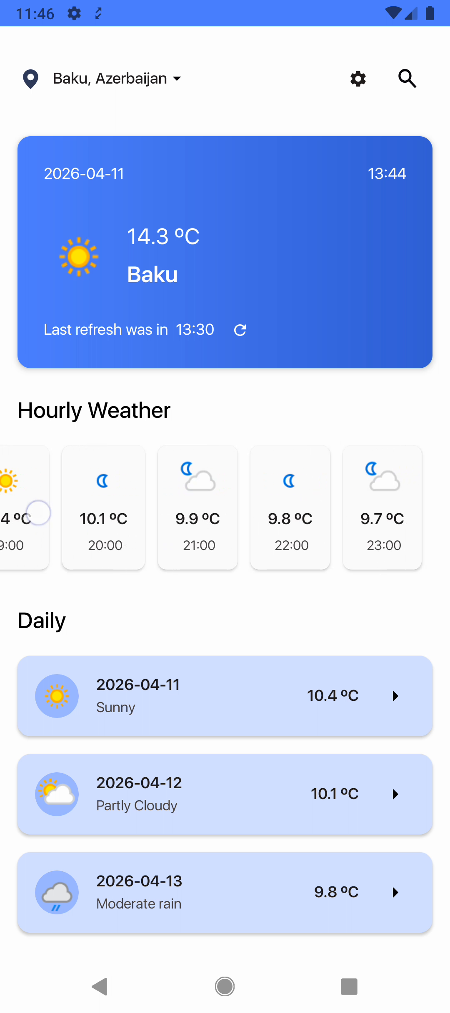  Figure D.1 — Home screen: current conditions, hourly list, and daily forecast. | 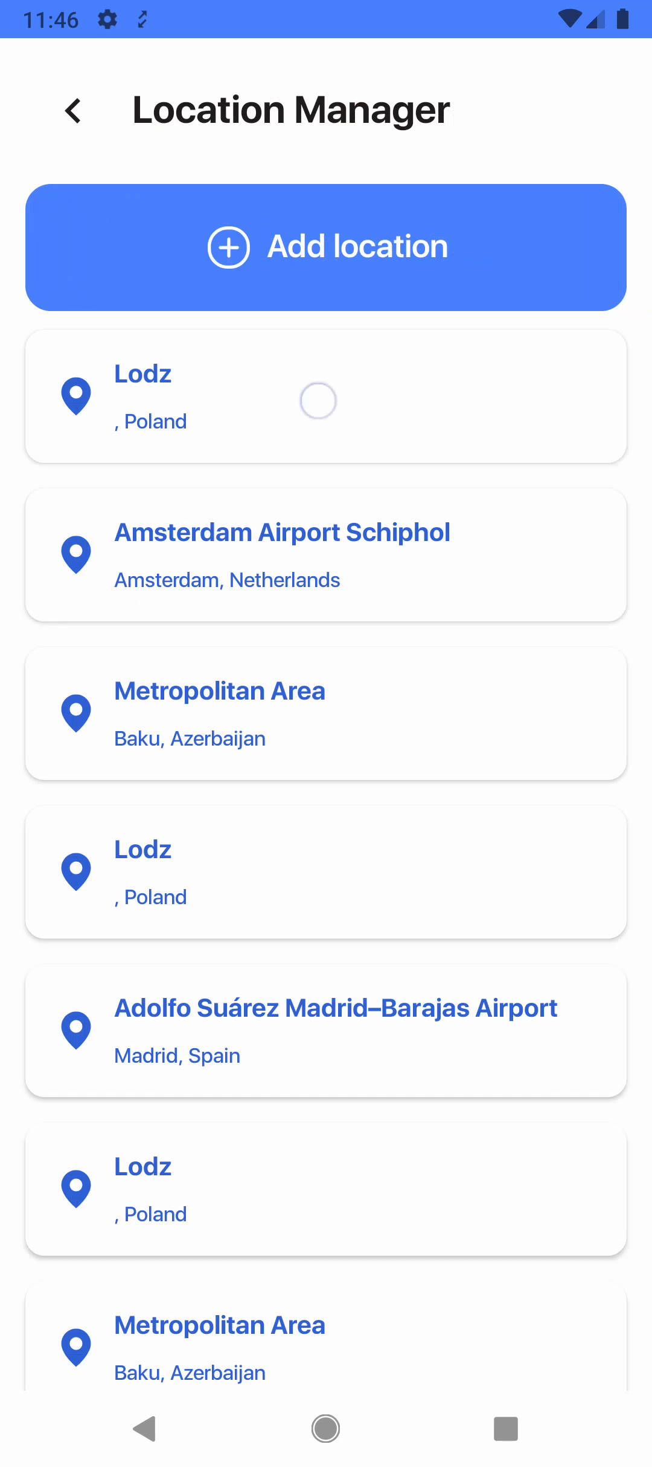  Figure D.2 — Location Manager showing saved locations and the Add location action.

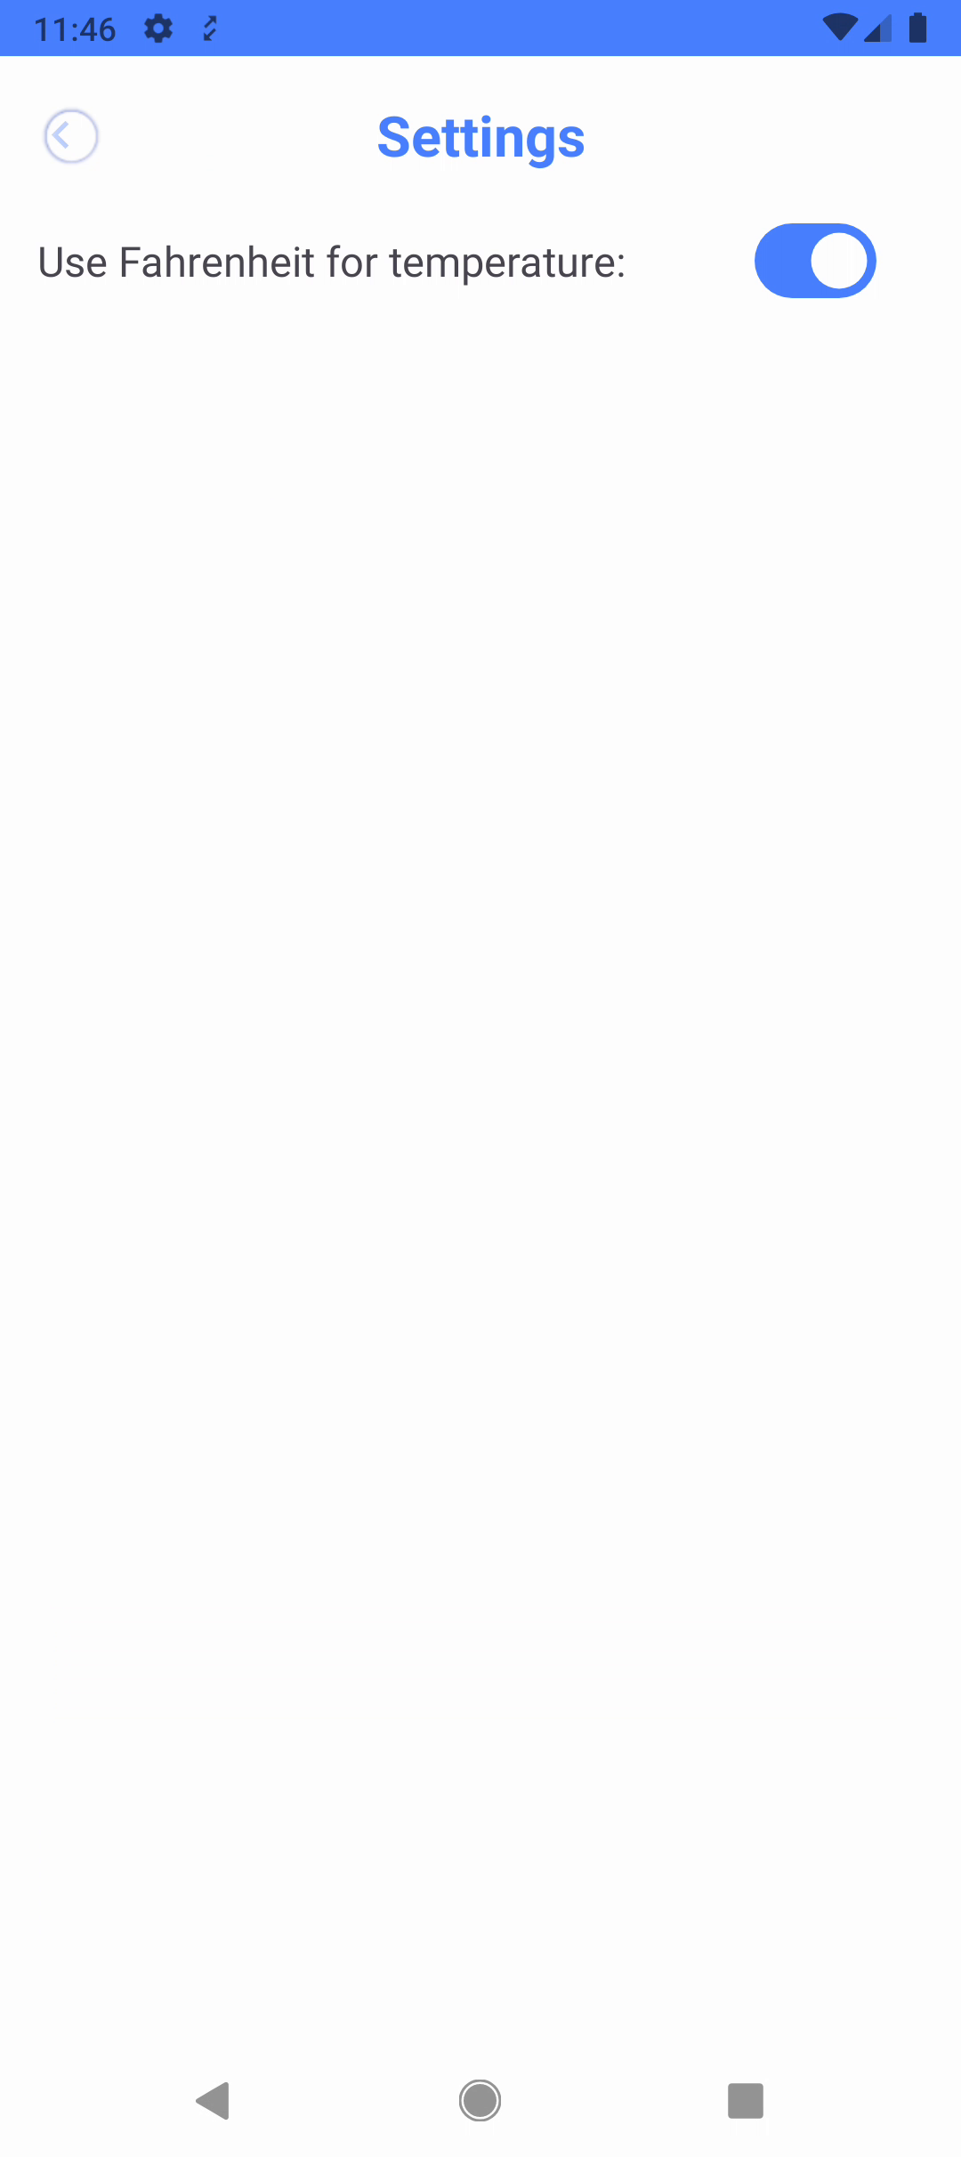  Figure D.3 — Settings screen with the Fahrenheit toggle. | 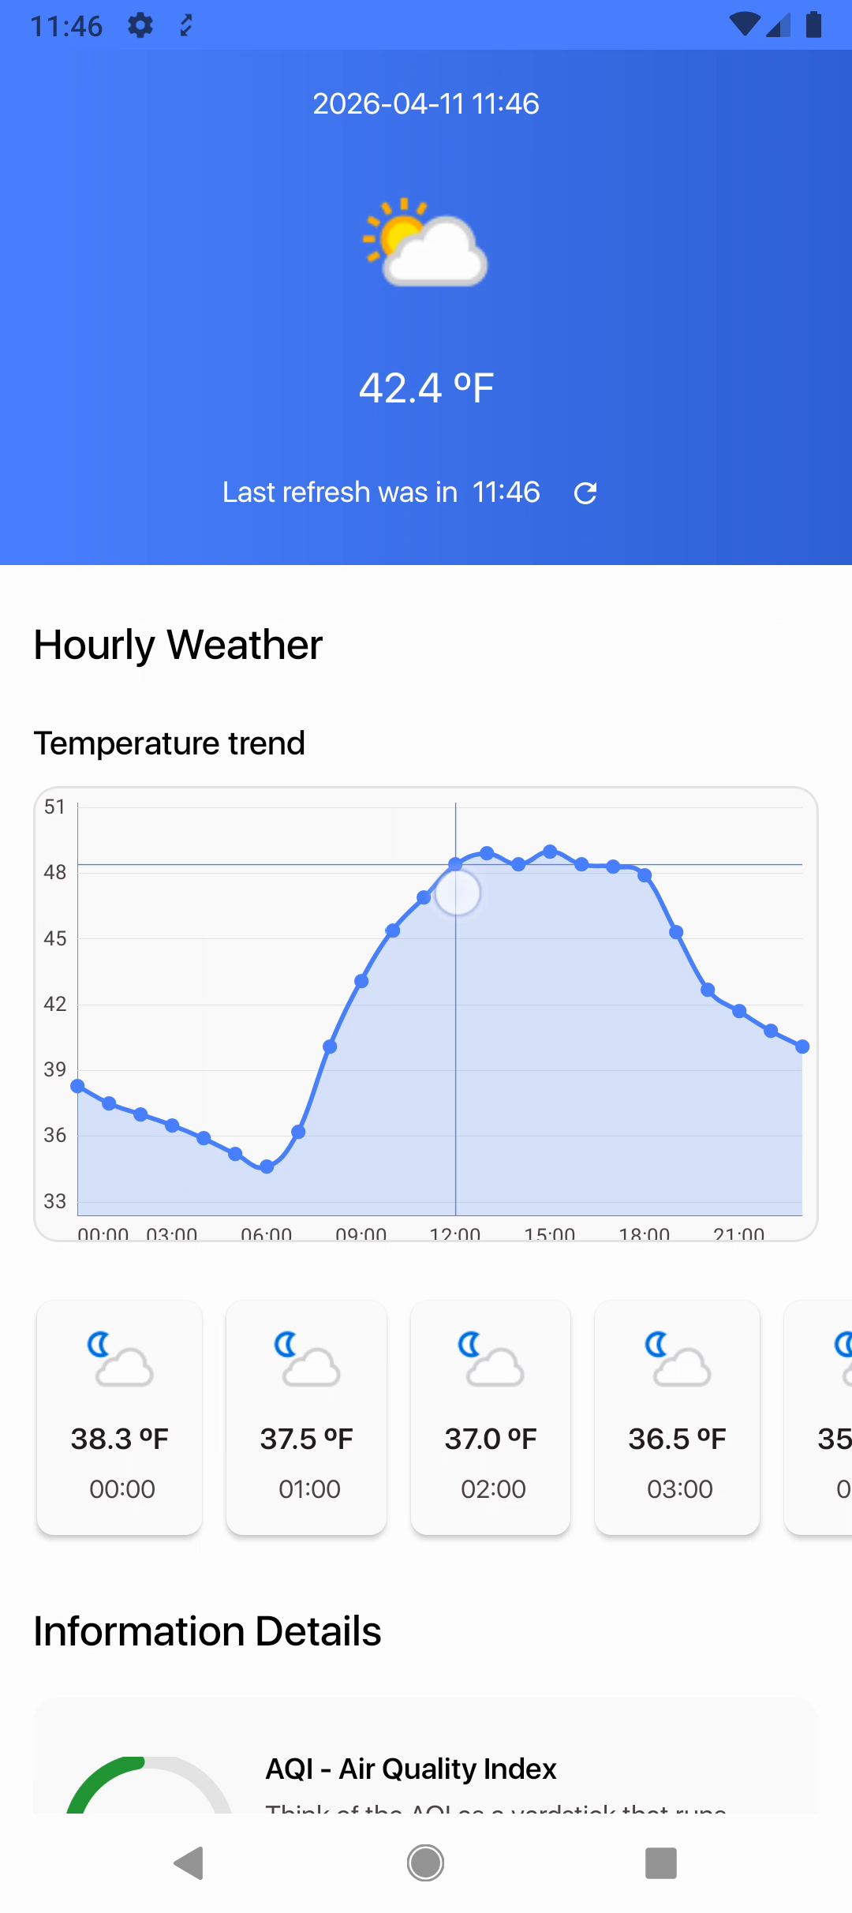  Figure D.4 — Details screen with hourly temperature trend and AQI visual panel.

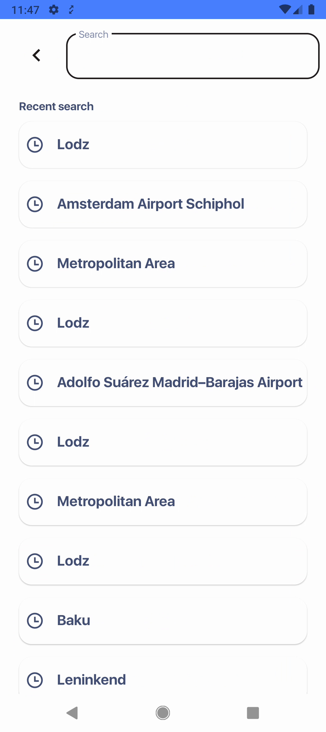
Figure D.5 — Search screen with recent search history.

Appendix E — Sequence Diagram (Load Forecast)
User → HomeFragment: open Home
HomeFragment → HomeViewModel: observe city token / request forecast
HomeViewModel → DataStoreUseCase: read Fahrenheit preference
HomeViewModel → LocationUseCase: getForecast(city, DAYS)
LocationUseCase → ApiRepository: getForecast
ApiRepositoryImpl → ApiSourceImpl: getForecast
ApiSourceImpl → ApiService: GET forecast.json
ApiService → WeatherAPI.com: request
WeatherAPI.com → ApiService: ForecastDTO
ApiRepositoryImpl → Mapper: toForecastUiModel
ApiRepositoryImpl → HomeViewModel: Resource.Success(ForecastUiModel)
HomeViewModel → HomeFragment: HomeUiState.Forecast
HomeFragment → User: render weather data

Appendix F — Personal Contribution Statement
The source code of the WoWeather application submitted with this thesis was developed independently by the author. The author was responsible for the application architecture, Android implementation, user-interface integration, WeatherAPI.com integration, Room/DataStore persistence, dependency-injection setup, navigation, custom views, debugging, and creation of the runnable demonstration build.

Appendix G — Data and Privacy Notes
- The application has no user-account database and does not collect account credentials.
- City names, recent searches, the selected-city token, and the temperature-unit preference are stored locally on the device.
- Weather/location queries are sent to WeatherAPI.com when needed for the external weather service.
- The WeatherAPI.com key present in the source should be revoked/rotated and removed from version control before publishing the repository.

