Bolster-MAS: AASMA 2021 Project Report

Group 49

João Fonseca  
 Instituto Superior Técnico  
 89476  
 Lisbon, Portugal  
 joaomffonseca@tecnico.ulisboa.pt

Tomás Lopes  
 Instituto Superior Técnico  
89552  
 Lisbon, Portugal  
 tomas.lopes@tecnico.ulisboa.pt

Carlos Marques  
Instituto Superior Técnico  
 98639  
 Lisbon, Portugal  
 carlos.a.marques@tecnico.ulisboa.pt

ABSTRACT

Turn-based strategy (TBS) games have dramatically increased in popularity over the past decades, and as such, have become a popular field for the development of Artificial Intelligence. With time, the scope of video games has gone beyond mere entertainment into areas such as corporate management and military use. Using intelligent systems to truly understand how to make the most out of the complex interactions these games allow becomes increasingly important.

In this report, we showcase our simple medieval-style TBS game “Bolster”. We also discuss the key characteristics of the competition-based multi-agent system associated with it, “Bolster-MAS”. In this system, each agent, implemented using stateful extensions to the classic subsumption architecture, represents a player controlling a village, competing in a free-for-all scenario. Finally, we analyze the performance of the agents based on a set of metrics. We conclude that the effectiveness of each starting personality largely depends on the number of players, with a general tendency for cautious/defensive personalities to perform better overall.

1 Introduction

As turn-based strategy (TBS) games have increased remarkably in fame since their inception in the late 1970s, they have also become an increasingly popular focus area in the AI field. Intelligent agents often have the ability to navigate significantly complex environments such as these with great effectiveness; hence, as video games start showing uses in many other relevant fields, devising adequate strategies for these games becomes pertinent.

With this project, our goal was to explore the subject of competition-based multiagent systems in the context of TBS games, taking inspiration from already existing games such as the Civilization series[1] and other similar games such as Tribal Wars[2] to create an environment which corresponds to a simpler, more basic version of these games where each agent acts as a player, competing in a free-for-all scenario until one of them is crowned the winner. The end result of this was the game “Bolster”, and the corresponding multi-agent system, “Bolster-MAS”.

In short, in Bolster, each player manages a village in a medieval setting where they must take decisions regarding resource management and troop mobilization to defeat other players, while also staying alive and maintaining the prosperity of their village. In Bolster-MAS, agents follow a simple priority-based approach, which, when used in combination with each agent’s state and memory, determines the decisions taken by each agent throughout the game.

2 Environment: Bolster

The environment in which the agents of the multi-agent system operate consists of the game Bolster. This game comprises a group of villages, each of them belonging to its own player. Each player can build new infrastructure for their village, upgrade it, and take advantage of it to increase its productivity and grow its military force.

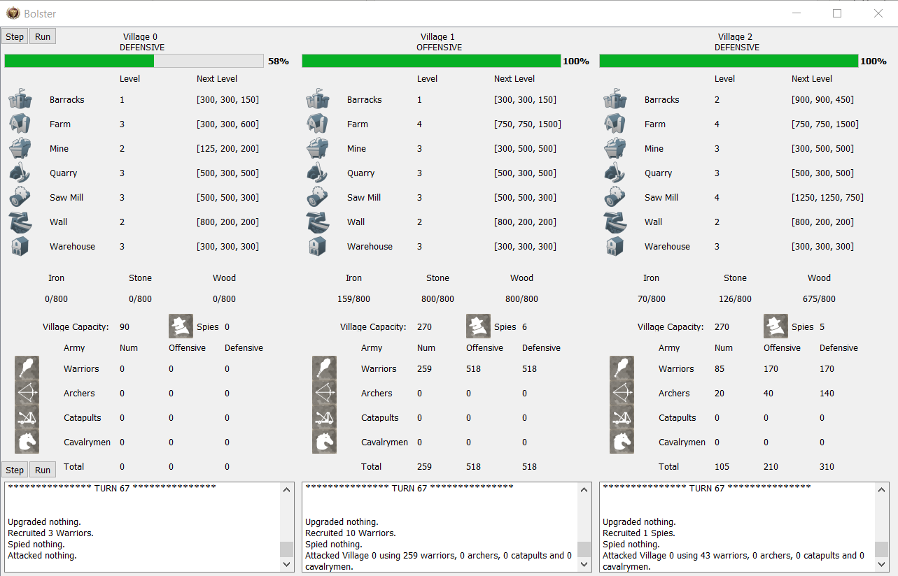

Figure 1. Bolster.

There are seven available buildings, which are all upgradeable and serve different purposes:

* The mine provides iron to the village. The more it is upgraded, the more iron is extracted. Starts at level 1, with a maximum level of 5.
* The quarry provides stone to the village. The more it is upgraded, the more stone is extracted. Starts at level 1, with a maximum level of 5.
* The sawmill provides wood to the village. The more it is upgraded, the more wood is gathered. Starts at level 1, with a maximum level of 5.
* The warehouse is where all the village’s resources are stored. Upgrading it will increase the maximum storage capacity of each resource. Starts at level 1, with a maximum level of 5.
* The farm determines how big the population of the village can be. The higher it is upgraded, the more population the village will be able to sustain, increasing the maximum number of peasants. Starts at level 1, with a maximum level of 5.
* The barracks are used to recruit troops. Upgrading the barracks unlocks the recruitment of different, more specialized types of troops. Starts at level 0, with a maximum level of 3.
* The wall provides a defensive bonus to the troops defending the village. The higher it is upgraded, the higher the defensive bonus is. Starts at level 0, with a maximum level of 3.

Building, upgrading, and recruiting all have their own specific resource costs, which are divided among the three different resources already mentioned: stone, iron, and wood. Upgrade costs get exponentially higher with each building level. Recruiting troops also consumes a peasant per unit alongside the other three resources, and demoting said unit returns that peasant.

There are four classic types of units available, each with a different purpose, excelling at a specific task:

* Warriors are the cheapest units to recruit but are also the weakest. They are the first unit available in the barracks (level 1), with equal offensive and defensive power (2 ATK, 2 DEF), and have a relatively cheap cost.
* Archers are the second available unit (level 2). They are more expensive than Warriors, and they excel at defense (2 ATK, 7 DEF).
* Catapults are made available at the same time as Archers (level 2) and, in opposition, excel at offense (7 ATK, 2 DEF).
* Cavalrymen are the last unit available in the barracks (level 3). They are the strongest unit in the game, with both high defense and offense (8 ATK, 8 DEF).

Units can be used to attack other villages. The outcome of an attack is determined by which side has higher power, calculated based on the attack or defense power of its unit types (depending on the side), the number of units of each type and a random luck factor. The losing army is wiped out, whereas the casualties of the winning army are based on the magnitude of the win and by a separate luck factor.

In the case of a victorious attack, the attacking army steals resources from the defending village and depletes its health points, based on the offensive power of its surviving troops. Villages start with 10,000 health points and regenerate 100 health per turn, up to a maximum of 10,000. Once a village’s health points drop to zero, the player controlling that village loses. The last surviving player is crowned the winner – in which case, we say the game ended in a Victory.

There are two other possible game outcomes. One of them happens when none of the last surviving players (two or more) decide to engage in fights for a total of 100 consecutive turns. This outcome is called a Stalemate. Finally, we have Ties, which happen when the last surviving players kill each other on the same turn (to illustrate, in a game where Player 1, Player 2, and Player 3 are the last surviving players in a match, a tie would happen if, for instance, Player 1 kills Player 2, Player 2 kills Player 3, and Player 3 kills Player1 in the same turn).

After an attack takes place, both the attacker and the defender obtain a detailed report with information that includes the turn in which the attack took place, starting/ending troops on both sides, plundered resources, damage dealt, and each army’s total power. The exception to this is for the case of failed attacks: if a player sends out an attack and loses, that player will not get any information about the opponent, only receiving information about the overall outcome of the fight and casualties.

There is also a fifth unit in the game, which functions differently from other units. Spies are the most expensive unit in the game; even so, they can be recruited with level 1 Barracks. They cannot be sent on normal attacks, cannot die during village defenses and they do not have offensive or defensive power; instead, they can only be used for spying other villages. Spying a village consumes a spy and returns a static copy of the state of the spied village at the time of spying. This copy is called an “Espionage” .

Every turn, each player may take, sequentially, up to one upgrade decision (erecting a new building or upgrading an existing one), one recruitment decision (recruiting or demoting any number of units of a specific unit type), one spying decision (sending off a spy to obtain an espionage of another village) and one attack decision (sending off a specified number of troops of specific unit types to attack a single village).

Each player possesses complete information on the state of its village, including buildings and troops, as well as the name of the villages of the players that have not lost. Additionally, the player also has access to a complete attack report and espionage history.

3 Multi-Agent System: Bolster-MAS

Bolster-MAS (Bolster Multi-Agent System) consists of a set of agents, each competing against one another in an attempt to win games of Bolster. Each agent represents a player, taking the aforementioned decisions for its own village, with the ultimate goal of being the last survivor.

Each agent possesses a set of sensors and actuators. The sensors provide the agents with the information that each player has access to, mentioned at the end of section 2. The actuators allow the agents to create new buildings, upgrade existing ones, recruit and demote units, spy other villages, and send attacks.

The agents in Bolster-MAS were implemented based on the subsumption architecture, extended to include relevant state, personality, and “short-term” memory. This combination of reactive architectural principles and stateful extensions makes for agents with hybrid behavior.

A purely reactive agent would be unsuitable for this kind of environment: in turn-based strategy games such as Bolster, selecting the next move implies careful consideration of recent events, which may lead to changes in strategy and personality required to obtain the best results and to keep up with the other players. With that said, however, the crux of the decision-making process can be done based on simple “principles”, evaluating each one in descending order of priority. In the case of Bolster-MAS, this priority order may change depending on the personality (henceforth named “Stance”) of each agent and/or recent events.

3.1 Memory

Each agent stores, in its memory, different kinds of data. This memory is “short-term” in the sense that although in some cases, all the events regarding a player’s village are stored, only the most recent ones are typically considered during state/stance changes and decision-making. This data includes:

* A log of all the attack reports associated with its village.
* A log of all the espionages sent by the agent.
* The total attack power values of its village over the last ten turns.
* Turns elapsed since last attack.
* Turns elapsed since last defense.
* Turns elapsed since last failed attack.
* Turns elapsed since last failed defense.

The reason why only the most recent information is considered, particularly in the case of attack reports and espionages, is that as the game progresses, the information in these reports becomes outdated, since these do not keep track of the growth of the enemy villages, acting as a simple “snapshot” of the state of the opponents’ villages at the time of the event.

Overall, agents are quite conservative regarding their decision-making. For instance, agents will opt not to send out attacks blindly, only sending out attacks if the agent has access to any kind of information that shows that in a recent turn, the opponent was weaker than itself. More on this in a later section.

3.2 Stance

Each agent starts with one of three possible stances:

* Offensive – favors the recruitment of offensive troops and takes higher risks when sending out attacks.
* Defensive – favors the recruitment of defensive troops and is more conservative when sending out troops, always making sure to stay well defended, even when sending out attacks. Also prioritizes defense-oriented buildings, such as the Wall.
* Neutral – a middle-ground between the two previous stances, favoring the recruitment of hybrid troops that can attack and defend with equal effectiveness.

Each stance is associated with a set of parameters that influence decision-making. These parameters include:

* Recovery turns – determines the number of turns to wait after a defeat before continuing to send attacks to villages it has attacked recently. The more offensive an agent is, the lower this number is, implying less cautious behavior.
* Last turns considered – determines the number of recent turns that an agent can consider when looking at attack reports and espionages. The more offensive an agent is, the higher this number is, making it more prone to making decisions based on outdated information.
* Win magnitude – determines the ratio between its own attack power and an enemy village’s defensive power (from an espionage) required in order to make said village eligible for an attack. The more offensive an agent is, the lower this number is, implying a riskier behavior.
* Own attack power – determines how to compute its own attack power, namely whether to include the offensive stats of its defensive troops or not.
* Turns without fighting – determines how many turns without attacking or defending must elapse before its stance’s offensiveness is increased.
* Warrior/archer/catapult/cavalrymen send ratio – determines the percentage of each troop to send off in attacks. The more offensive an agent is, the more likely they are to send a higher percentage of troops, leaving its own village less defended.

This stance is, by default, dynamic: depending on the circumstances of the game, an agent can change its own stance at the beginning of each turn. This can occur in the following situations:

* If an agent’s village health drops below 25%, that agent becomes defensive.
* If a non-offensive agent does not attack, is not attacked for a specified number of turns and the current turn is above a certain number, its stance becomes more offensive (defensive to neutral, if past turn 75, or neutral to offensive, if past turn 100). This is done so agents take more attacking initiative in later stages of the game, while largely sticking to its initial stance during its early decisions.
* If a non-defensive agent suffers a large reduction in its attack power, its stance becomes more defensive, depending on how significant that reduction is (offensive to neutral, offensive to defensive, or neutral to defensive).

Additionally, each agent is initialized with a “troop focus” parameter, randomly generated between 0.3 and 0.7, which determines the fraction of troops that each agent is willing to spend on troops in a single recruiting decision. This value is independent of the stance.

3.3 Decision-making

Given what we have examined so far regarding agent memory and stance, we can now explain each agent’s decision-making process.

For each of the four decision types (upgrading, recruiting, spying, and attacking), the same overall structure is followed. Firstly, an option generation function is used to determine all the possible decisions that can be taken based on the current resource count and available peasants. Then, a filter function is called to prioritize the generated options. Finally, the highest-priority decision is executed – in some situations, this may be simply doing nothing.

3.3.1 Upgrade decision

Upgrade decisions are based on the following priority system, with the agent executing the first decision that it can take based on the generated options:

* If the farm cannot hold more peasants, upgrade it.
* If resource production is above half of the warehouse capacity for any resource, upgrade the warehouse.
* Upgrade the barracks.
* If the agent is defensive, upgrade the wall.
* Upgrade the resource camp of most the lacking resource.
* If the agent is not defensive, upgrade the wall.
* If the warehouse is full of at least one resource, upgrade it.
* If the warehouse is full, upgrade the farm.
* Upgrade nothing.

3.3.2 Recruit decision

Recruit decisions are based on the following priority system:

* If the village has no available peasants, the farm is at max level and there are non-cavalrymen, non-spy units in the village, demote up to 20 units, prioritizing the demotion of warriors, archers (if offensive), catapults (if defensive), archers (if not offensive), and catapults (if not defensive).
* If the village has 5 or less spies, recruit up to 3 spies.
* Recruit cavalrymen.
* If the agent is offensive, recruit catapults.
* If the agent is defensive, recruit archers.
* Recruit warriors.
* Recruit nothing.

3.3.3 Spying decision

Spying decisions are based on the following priority system:

* If the agent has available spies, spy a random village that it has not spied over the last ten turns.
* Spy nothing.

3.3.4 Attack decision

Attack decisions are based on the following priority system:

* If the agent has recent victorious attacks against villages and is not in recovery mode, re-attack one of those villages at random.
* If the agent has a recent espionage against villages and its own attack power is greater than the defense power of the spied villages by a certain magnitude, attack the one with the lowest defense power.
* Attack nothing.

4 Analysis/Evaluation

Our analysis goes over two main datasets, resultant from two distinct simulations. In both simulations, we had twelve agents – four starting with a defensive stance, four with a neutral stance, and four with an offensive stance – play 2500 games of Bolster. The only difference between both simulations has to do with stance adaptability – for one dataset, each agent’s stance was dynamic, just like previously described (this will be henceforth referred to as the “dynamic dataset”); for the other, the agents’ stances were static, meaning that the agents stuck to their initial stance for the entirety of the game (henceforth referred to as the “static dataset”).

4.1 Metrics

A wide array of metrics was used to analyze the performance of Bolster-MAS. These metrics include:

* Number of turns per game
* Number of turns each agent stays alive per game
* Decisions taken per agent per game
* Successful and failed attacks per agent per game
* Total troop casualties per unit per agent per game
* Troop casualty history per agent per game
* Prosperity rating (a rating that reflects how much the buildings in the village are upgraded / developed) history per agent per game
* Attack power history per agent per game
* Defense power history per agent per game

4.2 Results analysis and empirical evaluation

Firstly, let us analyze the average number of turns per game. The values can be found in Table 1.

Table 1: Average turns per game.

|  |  |  |
| --- | --- | --- |
| **Outcome** | **Avg Turns (dynamic)** | **Avg Turns (static)** |
| Victory | 169.42 | 145.80 |
| Tie | - | 109.00 |
| Stalemate | 295.81 | 267.82 |
| TOTAL | 195.86 | 198.14 |

It is interesting to note that although the average number of turns per game is similar for both datasets, the values for the specific outcomes for the static dataset are both quite lower than for the dynamic counterpart. This may be attributed to agents having more “balanced” behavior with dynamic stances, which, in turn, leads to games being more competitive and drawing out longer.

Even though each outcome is, on average, shorter, the global average is actually ever so slightly higher for the static dataset, which may indicate a higher stalemate rate when compared to games with dynamic agents.

This tendency can be confirmed in Table 2.

Table 2: Percentage of game outcomes.

|  |  |  |
| --- | --- | --- |
| **Outcome** | **% Games (dynamic)** | **% Games (static)** |
| Victory | 79.08 | 57.00 |
| Tie | 0.00 | 0.08 |
| Stalemate | 20.92 | 42.92 |

The first relevant aspect that pops out is the fact that there were close to no ties whatsoever. Ties are an extremely unlikely outcome: even with human players, a game ending in a tie would be very rare, only possible if two or more players, all with extremely low health villages, decided to attack each other in the same turn with significantly powerful armies, in a circular fashion. On top of that, the way the agents are designed, it is almost impossible for this scenario to occur, since at this stage of the game, the agents that are in a favorable position do not give the agents that are losing enough breathing room to allow them to perform a big counter-attack. Ties are more likely for static-stance agents because offensive agents tend to send out attacks while disregarding their own villages’ health points. This makes it possible for two offensive agents to start attacking each other every turn, only stopping until one, or both, of them die.

We can see that most games end in victories in the dynamic dataset, with agents adequately adapting their own stances depending on the circumstances of the game, becoming more offensive if winning, and more defensive if losing, leading to more games being effectively closed out. In the static dataset, the lack of stance adaptability leads to neutral/defensive agents not taking advantage of their leads to guarantee a victory, leading to them not capitalizing hard enough on their early-mid advantages and stalling later on in the game, as they let the other agents catch up.

One interesting thing to note is that a stalemate scenario in a game tends to happen when two or more agents get to a stage in the game where they are not offensively strong enough to defeat the army of any other agent, but they are defensively strong enough to withstand an attack from any other agent. This scenario corresponds to a Nash Equilibrium, where no agent is incentivized to unilaterally take a different action. All agents prefer to simply max out their buildings and their armies while not attacking and occasionally sending a spy for new information, because they know they would not be favored if they did send out an attack.

The theory stated regarding effectiveness at closing out games is corroborated by the values that can be found in Table 3.

Table 3: Percentage of game outcomes per starting stance (dynamic dataset).

|  |  |  |  |
| --- | --- | --- | --- |
| **Outcome** | **% Defensive** | **% Neutral** | **% Offensive** |
| Victory | 31.61 | 18.21 | 50.18 |
| Tie | - | - | - |
| Stalemate | 48.70 | 25.11 | 26.19 |

As we can see, offensive agents are better at closing out games, whereas defensive agents are better at simply staying alive without eliminating other agents.

From the higher win-rate of offensive agents, this may create the misconception that offensive agents tend to perform better. However, this is not necessarily the case, as can be seen in Table 4.

Table 4: Average placement per starting stance.

|  |  |  |
| --- | --- | --- |
| **Starting Stance** | **Avg Placement (dynamic)** | **Avg Placement (static)** |
| Defensive | 5.43 | 4.98 |
| Neutral | 7.11 | 7.51 |
| Offensive | 6.96 | 7.01 |

Keep in mind that with twelve players, the average placement is 6.5, and that for placement purposes, a stalemate is essentially equivalent to a tie (for example, two agents stalemating means both agents get a final placement of 1.5). Note as well that lower average placements correspond to better results.

We can see that although the offensive agents can often close out games effectively and take the number one spot, their inherently risky strategies leave them prone to losing their army and falling behind. Defensive agents may not be as effective at winning games, but by playing safely and conservatively, they can consistently make it far into most games.

These results also show us that neutral agents tend to perform quite poorly, having both the lowest win-rate and the lowest average placement. This can be explained by their mid-game weaknesses since they opt to recruit warriors over archers and catapults because of their hybrid nature. Their armies end up not faring well against other agents who may already have those units, and so the “jack of all trades, master of none” strategy tends to fail, with the agents not being successful enough at either strategy.

This lack of success could potentially be amended by changing the decision-making so that neutral agents recruit archers and catapults in an approximately even split, instead of not recruiting any archers or any catapults whatsoever and simply focusing on hybrid units (i.e., warriors and cavalrymen). This is one of the main aspects of agent behavior that could potentially be improved.

Looking at the top-half placement rate for each starting stance, we can, once again, observe the same tendency, as can be seen in Table 5.

Table 5: Top-half placement rate per starting stance.

|  |  |  |
| --- | --- | --- |
| **Starting Stance** | **% Top-Half Placements (dynamic)** | **% Top-Half Placements (static)** |
| Defensive | 43.52 | 47.29 |
| Neutral | 27.45 | 24.17 |
| Offensive | 29.03 | 28.54 |

There is one very important factor we have not bought up yet: these results are also influenced by the number of players in a game. We decided to run another simulation for comparison purposes with just 3-player games, each starting with a different stance (250 games total), and the results were quite different, as can be seen in Tables 6 and 7.

Table 6: Percentage of game outcomes per starting stance (3 agents per game, 250 games, dynamic stances).

|  |  |  |  |
| --- | --- | --- | --- |
| **Outcome** | **% Defensive** | **% Neutral** | **% Offensive** |
| Victory | 23.32 | 27.46 | 49.22 |
| Tie | - | - | - |
| Stalemate | 40.68 | 28.81 | 30.51 |

Table 7: Average placement per starting stance (3 agents per game, 250 games, dynamic stances).

|  |  |
| --- | --- |
| **Starting Stance** | **% Games** |
| Defensive | 2.01 |
| Neutral | 2.13 |
| Offensive | 1.86 |

In games with a low number of players, agents that start with an offensive stance have significantly better results. In these scenarios, it is easier for offensive agents to overwhelm all other agents in early to mid-stages of the game, overpowering them early on and not letting them recover.

We can conclude that overall, there is not one single starting stance that is better than others. For games with a low number of players, offensive strategies tend to be more successful at both winning games and guaranteeing a higher average placement. For games with more players, the “best” starting stance depends on the main goal to be achieved. If the key objective is to win a higher percentage of games, offensive agents are also quite good at that. However, if the goal is to achieve the best average placement and top-half placement rate possible, even at the cost of a lower win-rate and a higher stalemate-rate, defensive agents are more suitable for the task. Neutral agents, as mentioned earlier, end up not being very successful at either task.

In terms of stance adaptability, agents that start with different stances have different propensities to adapting their own stance. This can be seen in Table 8.

Table 8: Average number of stance changes per agent per game (dynamic dataset).

|  |  |
| --- | --- |
| **Starting Stance** | **Avg Stance Changes** |
| Defensive | 1.09 |
| Neutral | 1.54 |
| Offensive | 1.71 |

This disparity can be explained by the fact that the most common stance change has to do with an agent turning defensive when starting to be in an unfavorable situation. When this happens, defensive agents do not have to switch stances because they are already in the most defensive, cautious stance, but other agents may have to become more defensive once, or even twice (offensive to neutral, then neutral to defensive).

Even though there is a uniform distribution of stances at the start of each game, agents have an overall tendency to become more and more defensive, as can be seen in Table 9.

Table 9: Percentage of turns spent in each stance (dynamic dataset).

|  |  |
| --- | --- |
| **Stance** | **% Turns** |
| Defensive | 45.41 |
| Neutral | 32.72 |
| Offensive | 21.87 |

These results make sense when you consider two important aspects regarding the agent behavior and the results already seen:

* When the health of an agent’s village drops to below a quarter of the max health, that agent turns defensive.
* With 12 players, defensive agents tend to perform better in general, surviving for a greater number of turns, eventually winning by attrition or stalemating.

Depending on whether an agent is in a favorable or unfavorable situation, their stances adapt accordingly. In games that ended in a Victory outcome, most of the winning agents ended the game in either a neutral or offensive stance, as can be seen in Table 10.

Table 10: Percentage of ending stances for winners (dynamic dataset).

|  |  |
| --- | --- |
| **Ending Stance** | **% Wins** |
| Defensive | 3.49 |
| Neutral | 49.17 |
| Offensive | 47.34 |

This heavily contrasts with the ending stances for non-winning, non-tying, non-stalemating agents across all games, as can be verified in Table 11.

Table 11: Percentage of ending stances for non-winners (dynamic dataset).

|  |  |
| --- | --- |
| **Ending Stance** | **% Losses** |
| Defensive | 99.84 |
| Neutral | 0.04 |
| Offensive | 0.12 |

Considering there is only one winner per game, in the case of Victory outcomes, it makes sense for most agents to adopt more defensive strategies as the game progresses. As a few agents start dominating the game, other agents must adopt defensive strategies in order to stay alive.

In regard to success rate of attacks, we were able to gather that 96.65% of the attacks performed by all agents globally were successful, which indicates that the agents are using the information they have at hand extremely well. The failed attacks were mostly performed by offensive agents, who decided to take a riskier attack and ended up getting unlucky in the fight.

The average casualties with respect to the starting stance can be seen in Table 12.

Table 12: Average casualties per starting stance, per game (dynamic dataset).

|  |  |  |  |  |
| --- | --- | --- | --- | --- |
| **Starting Stance** | **Warriors** | **Archers** | **Catapults** | **Cavalry-men** |
| Defensive | 112.2 | 14.18 | 0.00 | 0.0002 |
| Neutral | 184.3 | 18.80 | 0.00 | 0.0004 |
| Offensive | 171.0 | 16.29 | 10.14 | 0.0006 |

You may wonder why the offensive agents, which are the riskier ones, do not have the highest casualty count. This is because as we just mentioned, a large majority of the attacks performed by the agents are successful, which means most of the casualties verified are casualties that arise from defensive losses. This means that casualty counts are actually strongly correlated with how well the agents do in the game, with the agents with the best average placement also having the lowest average casualties and vice-versa. Additionally, neutral agents mostly focus on Warriors, which are cheap and disposable units, which explains the high warrior casualty count for this starting stance compared to the others.

Regarding prosperity rating, defensive power, and offensive power evolution throughout the game, we can see an obvious disparity between the progression of winners (including stalemating agents) and the progression of non-winners. This can be seen in Figures 2 and 3 (defensive power plots omitted for brevity – these plots are significantly similar to the offensive power counterpart).

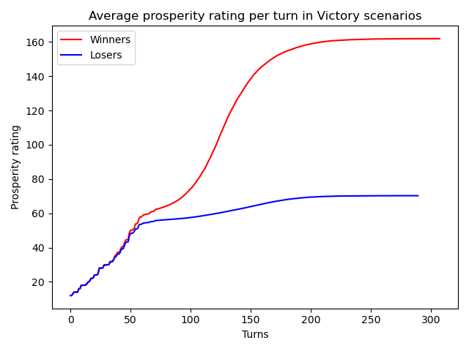

Figure 2. Average prosperity rating per turn (dynamic dataset).

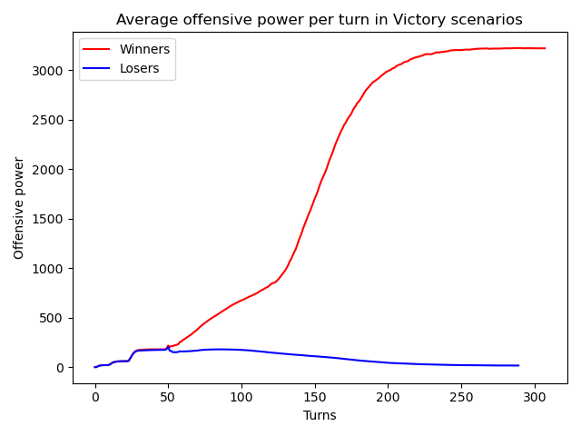

Figure 3. Average offensive power per turn (dynamic dataset).

The first interesting thing to note is how agents are essentially on equal ground until around turn 50. During these turns, agents are focused on upgrading their own infrastructure and recruiting their own armies. Spies are expensive; spending a large amount of resources on spies this early on in the game would greatly delay early development. For this reason, and due to the consequent lack of information that arises from having no spies, no attacks are performed during this stage of the game.

Turns 50-60 seem to be the most important turns in terms of impact on which agents end up doing well. Agents that start losing fights at this stage of the game often have a very hard time recovering, having to spend a lot of resources building up an army from scratch, which in turn, impacts the rate of infrastructure development, which stays stagnated, consequently plateauing the prosperity rating. The agents that come out on top during these mid-game fights end up with a much better position to continue upgrading their buildings and their armies until later stages of the game.

After turn 110 or so, the game tends to become mostly decided. The agent(s) that are still coming out on top in fights start growing even faster, both in prosperity and in power, essentially maxing out its buildings and army, taking full advantage of its peasants and plundered resources. The remaining agents cannot recover, with little to no resources available to rebuild a strong army, being attacked almost every turn until their village eventually falls.

With this, we can define three main stages for a game:

* Early game (turns 1-50) – all agents are in equal footing, leveling their buildings and recruiting troops based on their initial stances.
* Mid game (turns 51-110) – agents start fighting, adapting their stances according to the outcomes of the battles. Agents that come out on top in these fights keep upgrading and progressing, whereas other agents may struggle to do so, and may start to fall behind, or even lose.
* Late game (turns 111+) – most of the agents that fell behind are eliminated by the stronger ones. The agent(s) that were in the lead may start fighting among themselves, leading to a Victory scenario, or have similar powers, leading to a Stalemate caused by the occurrence of a Nash Equilibrium.

5 Conclusion

We showcased our simple medieval-style TBS game called Bolster and the associated competition-based multi-agent system Bolster-MAS. For the multi-agent system, we went over the three stances that each agent possesses – defensive, neutral, and offensive – and how the agents adapt their own stances depending on the specific circumstances of each game.

Furthermore, we performed empirical analysis regarding the differentiating aspects of the agents. We concluded that the effectiveness of each starting stance largely depends on the number of players, with offensive agents performing better at almost all levels with a low player count, and defensive agents much more consistently when there are more players involved.

In the future, this system could be improved in many ways, mainly regarding the poor performance of neutral agents, whose troop recruiting logic could be revised, and the recovery mechanism of the agents overall after a loss, which seemed to perform sub-optimally. More complex ideas could be experimented with in the future, namely regarding troop safekeeping after a devastating attack, or even a counter-attack mechanic.

Concerning the game itself, this could be extended in various ways, such as adding new buildings and units that agents of a certain stance would favor more (similarly to how the Wall benefits the defensive stance, or how catapults benefit the offensive stance) with the aim of shaking up end-game strategies, making them more diverse across all stances.

1. To find out more: <https://en.wikipedia.org/wiki/Civilization_(series)>
2. To find outmore: <https://en.wikipedia.org/wiki/Tribal_Wars>