Education Kernel Grant Proposal
OpenCV AI Competition 2026 Submission Document
Team Name: Devteam Raven: Ravandra Anandito Triyanto

1. Problem Statement and Intended Real-World Impact
A student stuck on a maths problem gets one bit of information back from almost every tool available to them: right, or wrong. If it is wrong, they are told to try again. They already knew that. What they do not know is where it went wrong: whether the setup was fine and they dropped a sign on line three, or whether the whole approach was doomed from the first line.
That is the difference between a grade and a teacher. A human tutor looking at a sheet of handwritten working does not mark the final answer. They run a finger down the page and stop at the first line that does not follow from the one above it.
EdKernel does that. A student photographs or films their handwritten working. OpenCV 5 finds the page, flattens it, cleans it, and cuts it into individual working steps. Each step is checked against the step above it. The tutor then says which line the error is on, and teaches from there.
The impact is access. One-to-one tutoring is the most effective intervention in education and the least evenly distributed, because it is priced by the hour of a human's attention. Per-step feedback on your own handwriting is the part of tutoring that actually costs money to buy, and it is the part no free tool currently does.
2. Planned OpenCV 5 Image and Video Analysis
OpenCV 5 owns everything between the camera and the reasoning model. It is not a preprocessing courtesy: it decides how many model calls happen, what each call contains, and what the unit of assessment is. Remove it and there is no per-step checking, because there are no steps.
OpenCV 5 Vision Pipeline Specification
Stage / Component | Technical Implementation & Purpose
1. Frame Acquisition | cv2.VideoCapture: Replaces a blind ffmpeg fps=1/2 sample with in-process, content-aware frame selection.
2. Blur Rejection | cv2.Laplacian(gray, cv2.CV_64F).var(): Variance of the Laplacian as a sharpness score. Frames below threshold are dropped before costing inference. Aimed at a recorded failure in the current pipeline: a single motion-blurred frame returned 6,146 characters of model monologue instead of a transcription.
3. Pixel-Level Deduplication | cv2.ORB_create + BFMatcher (with cv2.calcHist / cv2.compareHist as cheap first pass): My current pipeline compares transcribed text with difflib at a 0.85 similarity threshold, so every duplicate frame is paid for at full inference cost before it is discovered to be a duplicate. Moving the comparison to the pixels inverts that. Avoids img_hash (contrib-only) to maintain compatibility with the COOL Marketplace build.
4. Page Rectification | cv2.cvtColor -> cv2.GaussianBlur -> cv2.Canny -> cv2.findContours -> cv2.approxPolyDP -> cv2.getPerspectiveTransform -> cv2.warpPerspective: Classic 4-point document scanner that flattens angled phone photos into clean rectangular images.
5. Binarisation & Glare Control | cv2.adaptiveThreshold (Adaptive Gaussian) + cv2.createCLAHE: Handles uneven desk lighting, harsh shadows, and lamp glare.
6. Step Segmentation | cv2.morphologyEx (wide horizontal kernel) -> cv2.findContours: Dilates written lines horizontally into connected regions to extract bounding boxes for each working step. Defines assessment units and enables bounding-box overlay on original photos.

Division of Labour Note: OpenCV finds, flattens, cleans, and cuts. Reading the mathematics inside each box is performed by a downstream vision-language model (no OpenCV equation OCR claimed).
3. Planned AWS Architecture and Services
The cloud infrastructure separates compute-intensive computer vision tasks from orchestration to maximize performance and maintain clean benchmarks.
System Architecture & Flow Map
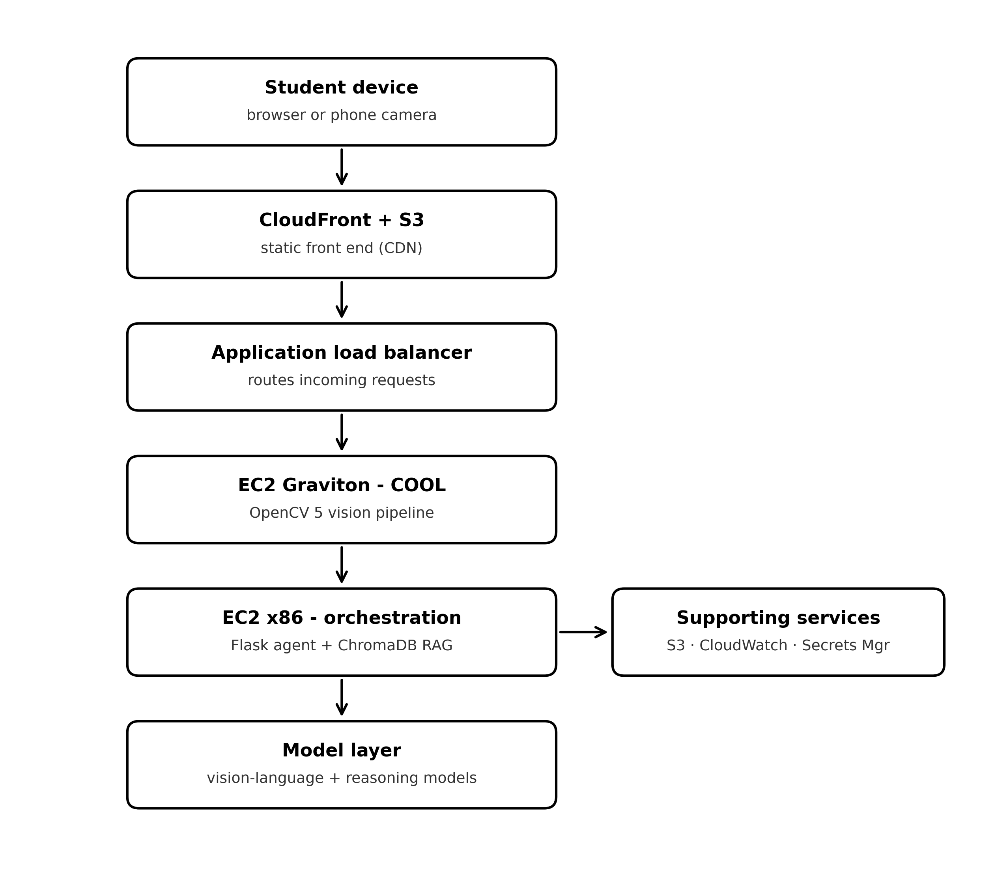
Architecture Tier | AWS Components & Technical Specification
Client Tier | Student Phone / Web Browser (HTTPS)
Edge & Storage | Amazon CloudFront + S3 (Static frontend host, frame storage, step crops, trace logs)
Load Balancing | Application Load Balancer (ALB) routing incoming traffic
Vision Service Tier (Arm / Graviton) | EC2 c8g (Graviton4) running COOL AMI from AWS Marketplace. Runs OpenCV 5 vision pipeline (VideoCapture, Blur reject, ORB dedupe, warpPerspective, adaptiveThreshold, morphology segmentation).
Orchestration Tier (x86) | EC2 m7i (x86) hosting Flask App, session state, ChromaDB RAG grounding. Bound by network I/O to VLM/Reasoning model endpoints.
Observability & Security | Amazon CloudWatch (latency/drop tracking), AWS Secrets Manager (API key isolation), Amazon ECR (pinned container images for judge reproducibility).

Infrastructure Rationale: The x86 / Arm split is deliberate and documented. The image and video workload runs on Graviton under COOL. The orchestration tier stays on x86 because it is bound by network I/O to model endpoints, not compute, keeping the COOL benchmark clean.
4. Target Users and Beneficiaries
Primary users are secondary-school students preparing for SAT and A-level mathematics: specifically students without access to paid one-to-one tutoring, who are currently working from mark schemes that show a final answer and no route to it.
Secondary beneficiaries are teachers, who can photograph a set of scripts and get a distribution of where a class went wrong rather than how many got it right. A cohort that fails the same question for four different reasons needs four different lessons, and that information does not exist in a score.
5. Proposed Evaluation Method and Judge Demonstration
This project already has a working evaluation harness. Current state, measured, not estimated:
- 50 held-out check-mode cases (evals/cases.jsonl): Scored automatically. Latest full run: 50/50 correct verdicts, 0/50 empty explanations.
- 40 regression checks (evals/regress.py): Covering previously resolved bugs, run before every commit.
- Learn-mode evaluation: Currently scores 1/5 (reported honestly as unresolved).
Competition-Specific Metrics & Live Demo
- 1. Step Segmentation Accuracy: Hand-labelled photographed working scored on single-step bounding box precision.
- 2. Error Localisation Accuracy: Evaluation of whether the tutor correctly identifies the precise line of failure on scripts with known errors.
- 3. Inference Calls Saved: Ratio of incoming frames vs. frames sent to VLM/reasoning models (pre/post blur and deduplication).
- 4. COOL Benchmark: Identical container comparison on Graviton with COOL vs. stock OpenCV 5 baseline (per-stage latency & throughput).
- 5. Judge Demonstration: Live web endpoint allowing judges to test handwritten working (at angles/bad lighting) with live bounding box display and perception-to-action traces, accompanied by a <5 min video.
6. Path Selection
Competition Paths: Both COOL and Agentic Vision.
COOL Path Alignment
The three operations AWS names as accelerated (resize, adaptive Gaussian threshold, contour detection) are stages 4, 5 and 6 in the vision pipeline. They constitute the core hot path rather than an isolated benchmark. Core image workloads run on Graviton under COOL.
Agentic Vision Feedback Loop (Perceive -> Decide -> Act)
Loop Stage | Agentic Logic & Action Flow
1. PERCEIVE (OpenCV) | Rectify, threshold, segment -> Produce N step boxes.
2. DECIDE (Agent) | Inspect boxes: If quality low -> re-run stage 4 with new parameters. If boxes merged -> widen morphology kernel & re-segment. If boxes missing -> request new frame. If confident -> proceed.
3. ACT (VLM Call) | Transcribe box 1..N (one tool call per box, count set strictly by OpenCV).
4. PERCEIVE (Reasoning) | Check each step against the step above it to isolate logic break.
5. DECIDE (Tutor Agent) | Identify first invalid step = error line. If ambiguous -> ask student to confirm line.
6. ACT (Interface/UI) | Teach from that line; highlight corresponding bounding box on student's original photograph.
7. Technical Feasibility
The tutor already exists and runs: 4,327 lines of Python across a Flask web front end and a CLI sharing one core (model client, ChromaDB RAG grounding over ~3,500 syllabus chunks, image/video handlers, prompt layer, verdict parser, eval harness). Check mode scores 50/50 today. Build phase focuses on OpenCV 5 vision frontend and agent loop deployment to AWS.
8. Team Bio
Solo entrant: Ravandra Anandito Triyanto.
- Proven Execution: EdKernel built in 3 weeks across 57 commits (28 July to 17 August 2026) in 15 logged sessions.
- Spec-Driven Development: Complete 10-phase build specification in readme.md (Phases 1 to 7 complete).
- Rigorous QA: 40 automated regression checks in evals/regress.py running pre-commit.
- Transparent Engineering: 14 'Known issues' sections in devlog.md tracking active gaps honestly.
- Deep-Stack Understanding: Authored a custom 333-line GPT tokenizer/model/training loop (training/train_tiny.py) without external transformers libraries to master model internals.
- End-to-End Ownership: Single-head coverage of CV, ChromaDB RAG, Flask/CLI, eval methodology, and deployment security.

