LAN Screen Streaming with Application Launcher

Name: Randy Cantu and Ruben Puga
Course: Computer Networks
Instructor: Erik Enriques
Date: 12/10/2025

The Project

This project implements a lightweight LAN-based screen streaming application using only Python, sockets, Tkinter, and OpenCV. The system is built as a single program with two selectable modes:

Sender Mode (Client)
Captures the screen, compresses each frame, and streams them over a TCP socket.

Viewer Mode (Receiver)
Connects to the sender, receives incoming frames, decodes them, and displays the live stream.

This design mirrors the basic functionality behind remote-play or screen-sharing applications, but in a much simpler form intended for learning. The goal was to demonstrate how real-time visual data can be transmitted over a network using minimal tools while emphasizing the networking concepts involved.

Through this project, we explored socket programming, TCP communication, frame encoding/decoding, and client–server architecture.

Breakdown of Implementation

Unified Application Structure

The entire project is a single Python application with a launcher interface.
The launcher allows the user to choose between two modes:

1) Sender (Client)
2) Viewer (Receiver)

Once a mode is selected, the interface provides the required input fields (IP address or port) and launches the appropriate streaming logic.

Network Topology

The application uses a simple two-device LAN topology:

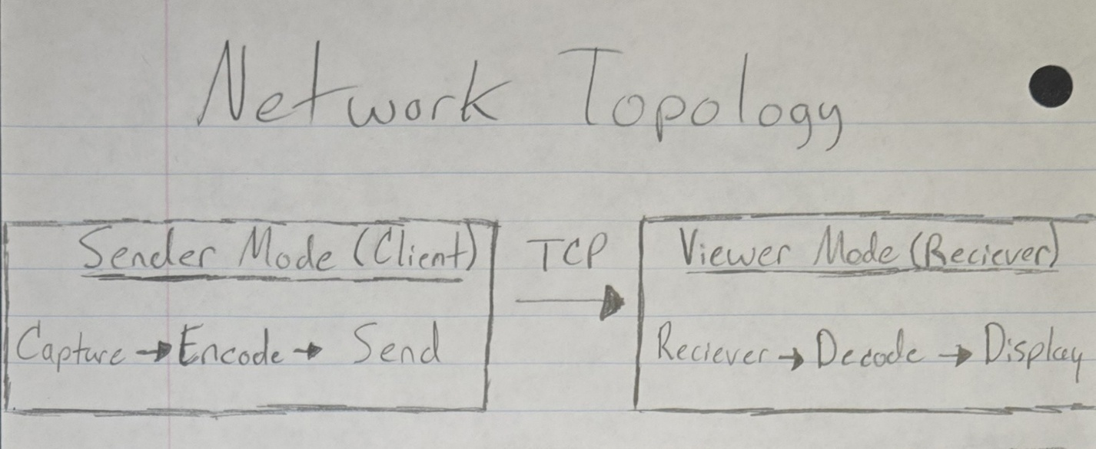
- The viewer listens on a TCP port.
- The sender connects to the viewer’s IP and port.
- Frames are transmitted continuously in one direction (from sender to viewer).

Tools and Technologies

We intentionally used a very small set of tools:

Python
- Core language for application logic, flow control, and data handling.

socket (Python standard library)
- Creates TCP connections between sender and viewer.
- Sends and receives frame data over the network.

OpenCV (cv2)
- Encodes captured frames into compressed byte arrays.
- Decodes received frames back into displayable images.
- Displays the live video feed in a window on the viewer side.

Tkinter
- Provides the launcher user interface.
- Allows mode selection (Sender or Viewer), IP/port input, and start/stop actions.

No additional third-party tools were used beyond OpenCV. This kept the implementation focused on networking and basic image handling.

Sender Mode (Client)

The sender mode is responsible for capturing the screen and transmitting frames to the viewer.

Main responsibilities:

1) Screen Capture
- Captures the current screen frame-by-frame using Python and OpenCV-based methods.

2) Frame Compression
- Each frame is encoded into a compressed format (such as JPEG-like byte data) to reduce the amount of data sent over the network.

3) TCP Streaming
- Connects to the viewer’s IP address and port.
- For each frame:
a. Computes the size of the encoded frame (in bytes).
b. Sends a header that contains the frame size.
c. Sends the actual frame bytes.
- Repeats this process continuously (approximately 10–20 frames per second, depending on system performance).

4) Sender UI (Launcher Integration)
- Provides input fields for:
- Viewer IP address
- Port number
- Includes a “Start Streaming” button to begin sending frames.
- Allows the user to stop streaming and exit cleanly.

Sender-side logical flow:
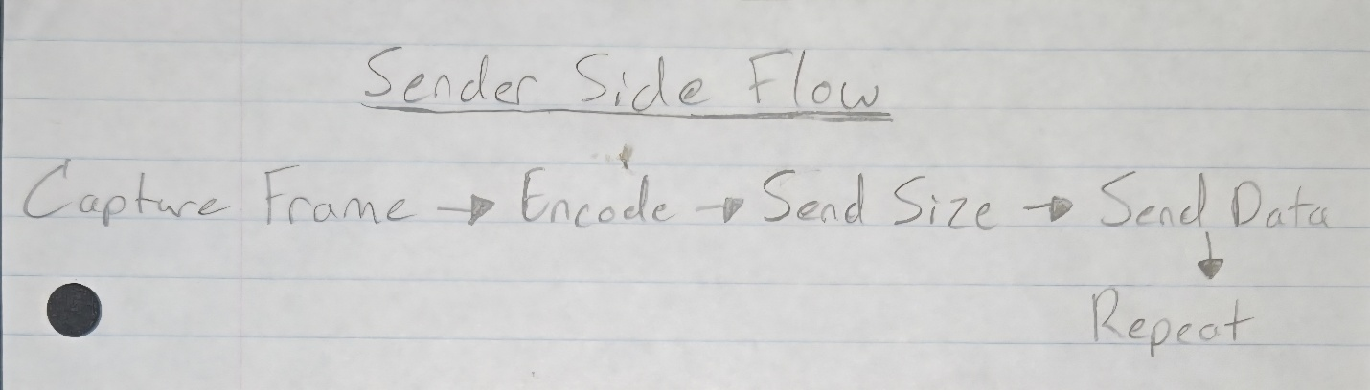

Viewer Mode (Receiver)

The viewer mode is responsible for listening for a connection from the sender, receiving frames, decoding them, and displaying the stream.

Main responsibilities:

1) TCP Listening
- Opens a server socket on a user-specified port.
- Waits for an incoming connection from the sender.

2) Frame Reception
- For each frame:
a. Receives the size header to determine how many bytes to expect.
b. Reads exactly that many bytes from the TCP socket.

3) Frame Decoding
- Uses OpenCV to decode the received byte array back into an image frame.

4) Display
- Displays each decoded frame in a window.
- Updates continuously to create the appearance of a live video stream.

5) Viewer UI (Launcher Integration)
- Provides an input field for the listening port.
- Includes a “Start Viewer” button to begin listening and displaying frames.
- Allows the user to stop the viewer and close the application cleanly.

Viewer-side logical flow:
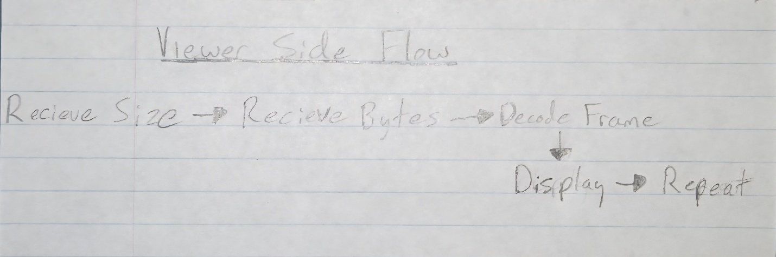

End-to-End Communication Flow

The coordinated behavior of Sender and Viewer modes looks like this:

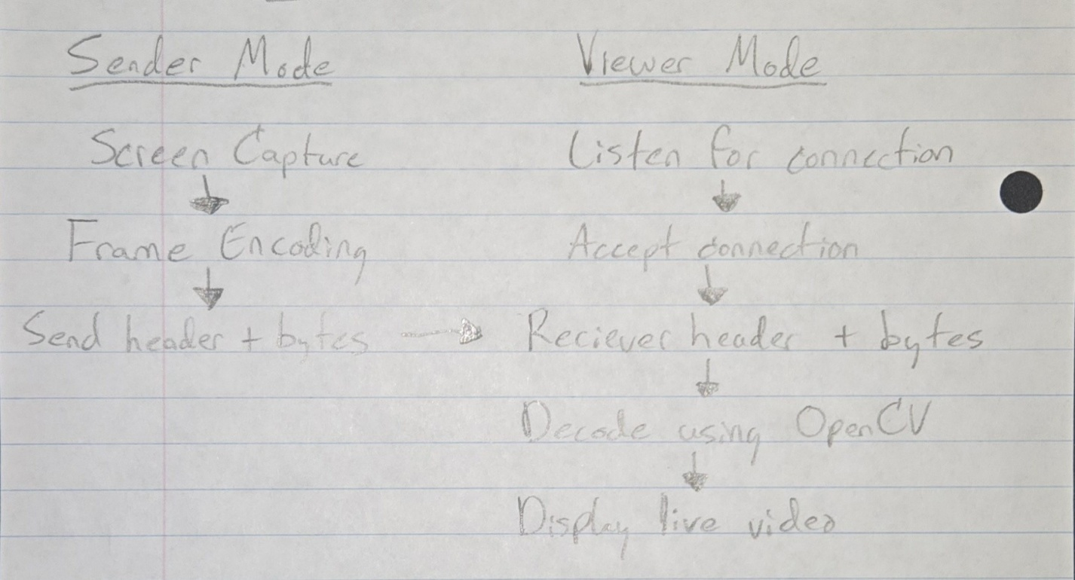
This cycle repeats continuously for the duration of the session, resulting in a live stream of the sender’s screen on the viewer’s device.

Demonstration

The full demonstration of this project is provided through our GitHub repository.

GitHub Repository Link:
https://github.com/Ravanex/NetworksProject

The repository includes:

- The full application code with both modes
- The Tkinter launcher
- All the networking, encoding, and display modules
- A requirements file
- This report (Project_Report.docx)
- A simple README explaining how to run the program
The application can be run on any two computers (or two virtual machines) that:
- Are on the same local network.
- Have Python and the required libraries installed.

Citations

The following references were used while developing this project:

- Python Socket Documentation
https://docs.python.org/3/library/socket.html

- OpenCV Documentation
https://docs.opencv.org

- Tkinter Documentation
https://docs.python.org/3/library/tkinter.html

Reflection

This project helped us understand how real-time screen streaming works at a basic level. By only using Python, sockets, Tkinter, and OpenCV, we had to think through every step of the process. Capturing frames to sending them over the network and finally displaying them smoothly.

We learned how to set up TCP connections, manage continuous data streams, encode and decode images, and build a simple GUI to control everything. Keeping the toolset minimal forced us to understand the networking logic instead of relying on pre-built libraries.

