https://github.com/RavaszTamas/FormalLanguagesLaboratories/tree/main/lab4

Example automaton in EBNF format, FA.in:

State = “A” | “B” | … | “Z” | “q0” | “q1” | …

digit_or_letter = “a” | “b” | … | “z” | “A” | … | “Z” | “0” | … | “9” | … (any other character)

Q = “””State””” { “|” “”” State “”” }

E = “”" digit_or_letter “”” {“|” “””digit_or_letter”””}

DELTA = “”" “(“State”,” digit_or_letter”)” “->” State””" {“|” “”" “(“State”,” digit_or_letter”)” “->” State””" }

q0 = “””State”””

F = “””State””” { “|” “”” State “”” }

Initialization of the automaton happens in these lines, the user can choose any file it deems proper for an automaton.

file_name = input("Enter the name of the file containing the automata:")

finite_automata.parseFromFile(file_name)

The user can initialize the automaton if he needs it, if either of the fields remain null the final method call will return without performing any computations

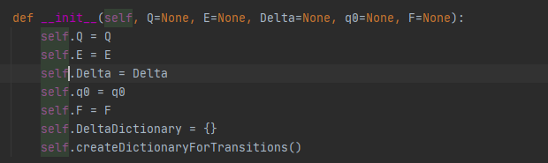

The parsing of the input file:

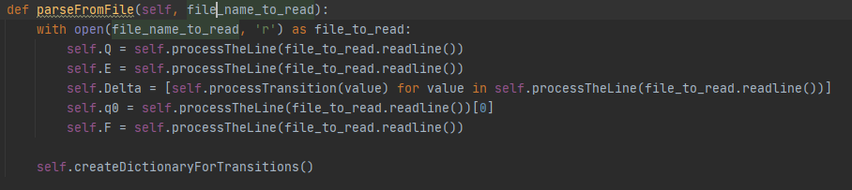

The line is processed as such, where the first symbol is split off and the rest are split by the “|” character, and stripped of they “ characters from the end and the start so that it can be interpreted, I used EBNF in the file also:



Process transition behaves in a similar way, it will try to create a tuple of like ((a,b),c) to represent a transition.

This method is called after a proper initialization of the automaton

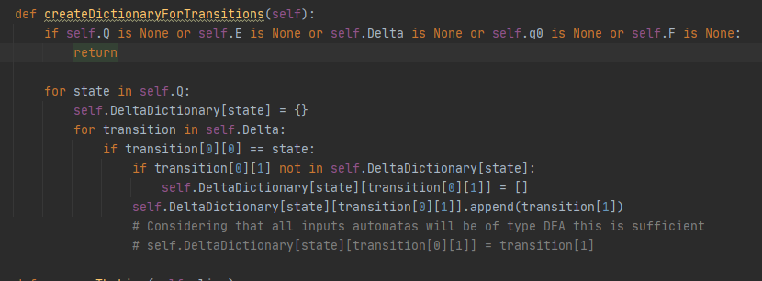

It will be a dictionary where each state will also have it’s dictionary, which represents for a given input where does the automaton arrive. As it can be seen a second implementation is there for the case when we are sure that all inputs are DFA. The current one works also with NFA’s.

This the match method will try to detect if the token is part of the language generated by the automata or not it will recursively call itself and tries to check every possible path until it finds a solution. If not solution is obtained then it will return False as the entered token is not part of the language generated by the automata

