Raveeha Amjad

P17-6123

Documentation:

Syntax error:

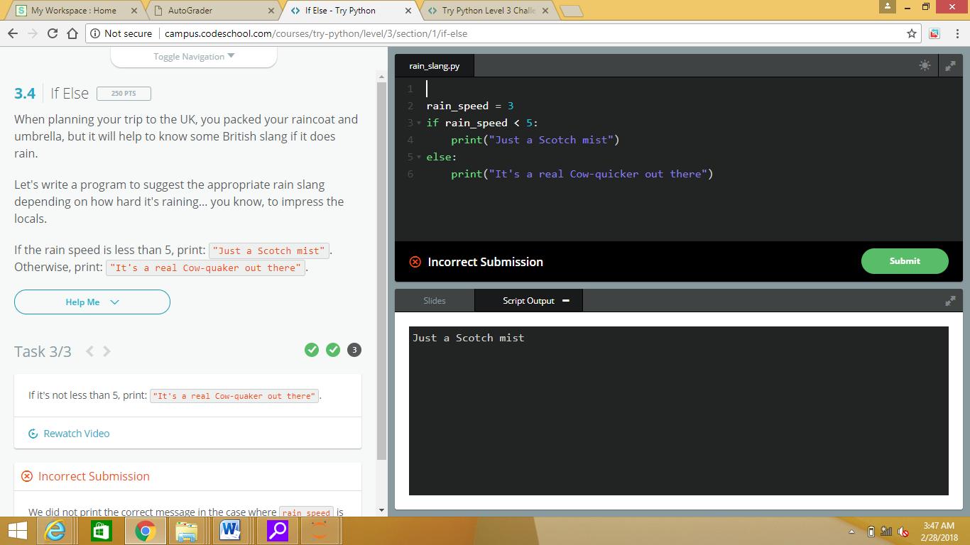

Name error: