Institute Rank Prediction
Machine Learning Project Report
Generated: September 21, 2026

1. Introduction
This project implements a machine learning system to predict the ranking of educational institutes based on their NIRF scores and location data. The system uses the Institute Rankings dataset containing 100 institutes ranked by the National Institutional Ranking Framework (NIRF).
The project consists of three main components:
- ML Model Training (train_model.py) - Trains and evaluates three regression models.
- Flask Backend API (app.py) - REST API serving predictions and data on port 5000.
- Streamlit Frontend UI (ui.py) - Interactive web interface on port 8501.

2. Dataset Description
The dataset contains 100 institutes with the following fields:
- Institute ID - Unique identifier (e.g., IR-O-U-0456)
- Name - Institute name
- City - City where the institute is located
- State - Indian state
- Score - NIRF score out of 100
- Rank - NIRF ranking (1-100)

Dataset Statistics
Total Institutes | 100
Highest Score | 87.31
Lowest Score | 49.04
Average Score | 57.76
Score Range | 49.04 - 87.31

Top 10 Institutes
Rank | Name | State | Score
1 | Indian Institute of Technology Madras | Tamil Nadu | 87.31
2 | Indian Institute of Science | Karnataka | 85.00
3 | Indian Institute of Technology Bombay | Maharashtra | 81.62
4 | Indian Institute of Technology Delhi | Delhi | 80.67
5 | Indian Institute of Technology Kanpur | Uttar Pradesh | 77.25
6 | Indian Institute of Technology Kharagpur | West Bengal | 73.99
7 | Indian Institute of Technology Roorkee | Uttarakhand | 71.73
8 | All India Institute of Medical Sciences, Delhi | Delhi | 70.57
9 | Jawaharlal Nehru University | Delhi | 69.62
10 | Banaras Hindu University | Uttar Pradesh | 68.71

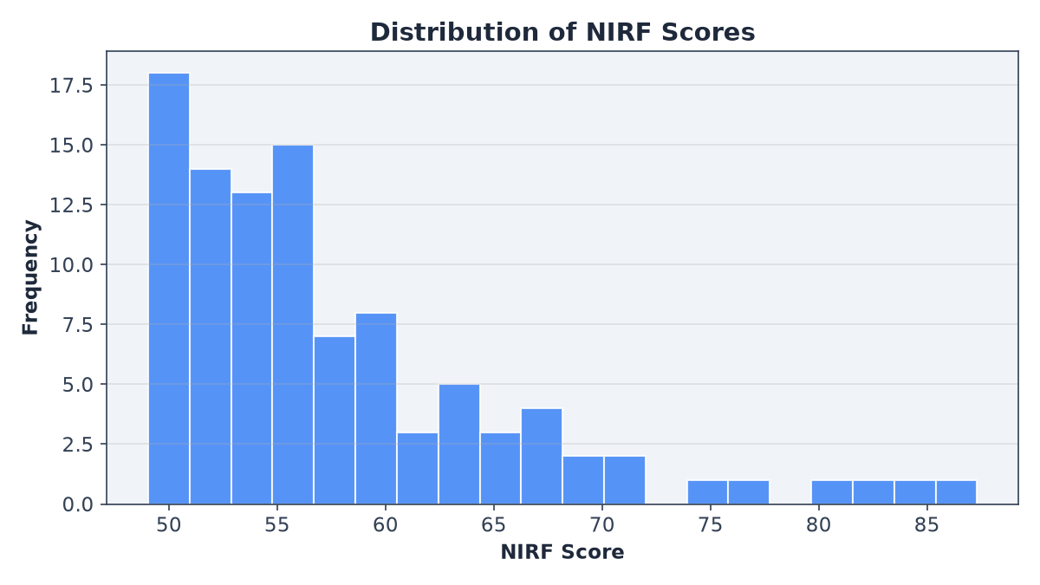
Figure 1: Distribution of NIRF scores across all institutes.
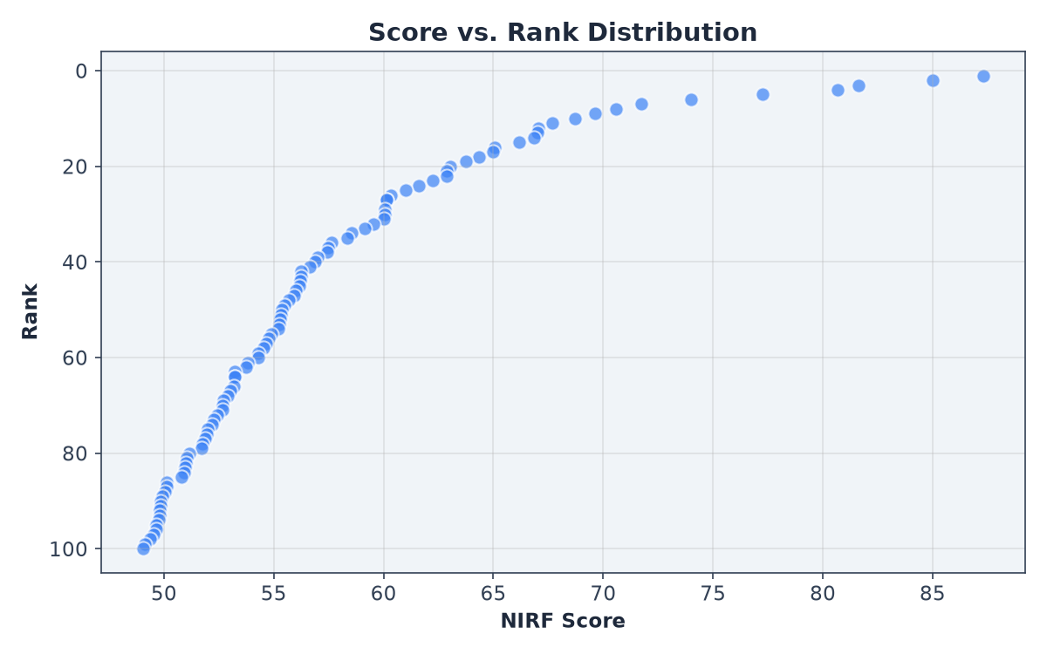
Figure 2: Score vs. Rank scatter plot showing the inverse relationship.
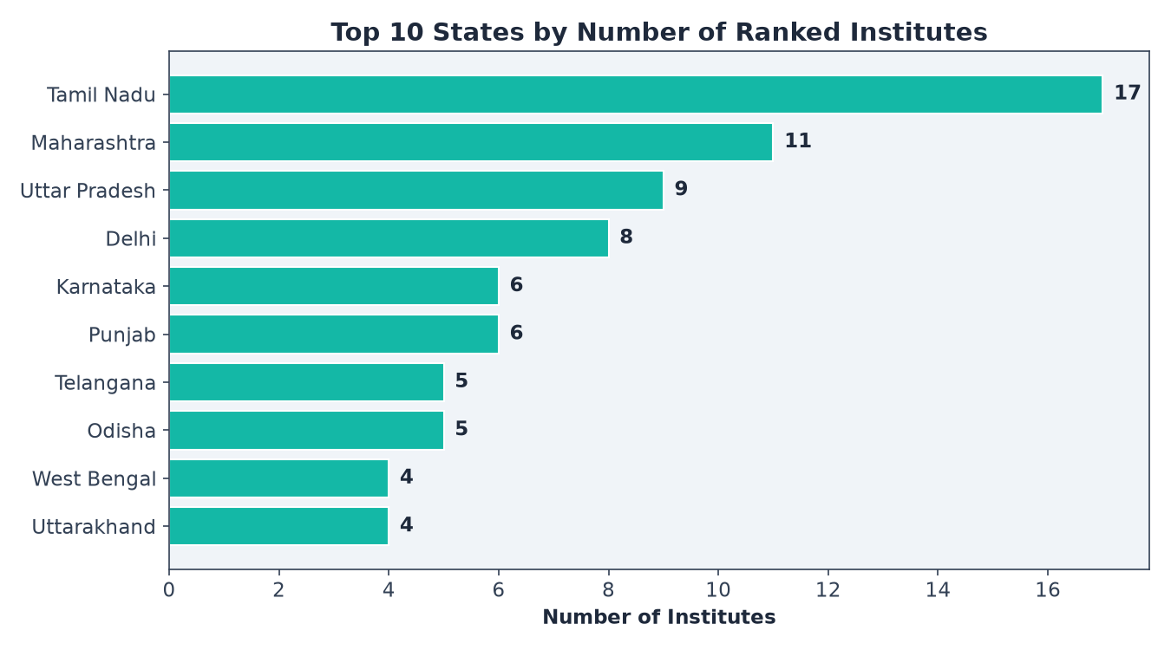
Figure 3: Top 10 states by number of ranked institutes.

3. Methodology

3.1 Feature Engineering
Three features were used for prediction:
- Score (numeric) - The NIRF score directly used as a numeric feature.
- State (categorical) - Label-encoded into numeric values.
- City (categorical) - Label-encoded into numeric values.
Label encoding converts categorical text values into integer codes. Standard scaling was applied for models that benefit from normalized features (Linear Regression, K-Nearest Neighbors).

3.2 Models Trained
Three regression algorithms were trained and compared:

3.3 Train-Test Split
The dataset was split into 80% training and 20% testing sets using random_state=42 for reproducibility.

4. Model Evaluation

4.1 Performance Metrics
Model | R2 Score | MAE | MSE | RMSE
Linear Regression | 0.7230 | 11.88 | 222.00 | 14.90
Random Forest | 0.9981 | 1.03 | 1.54 | 1.24
K-Nearest Neighbors | 0.8678 | 8.92 | 105.92 | 10.29

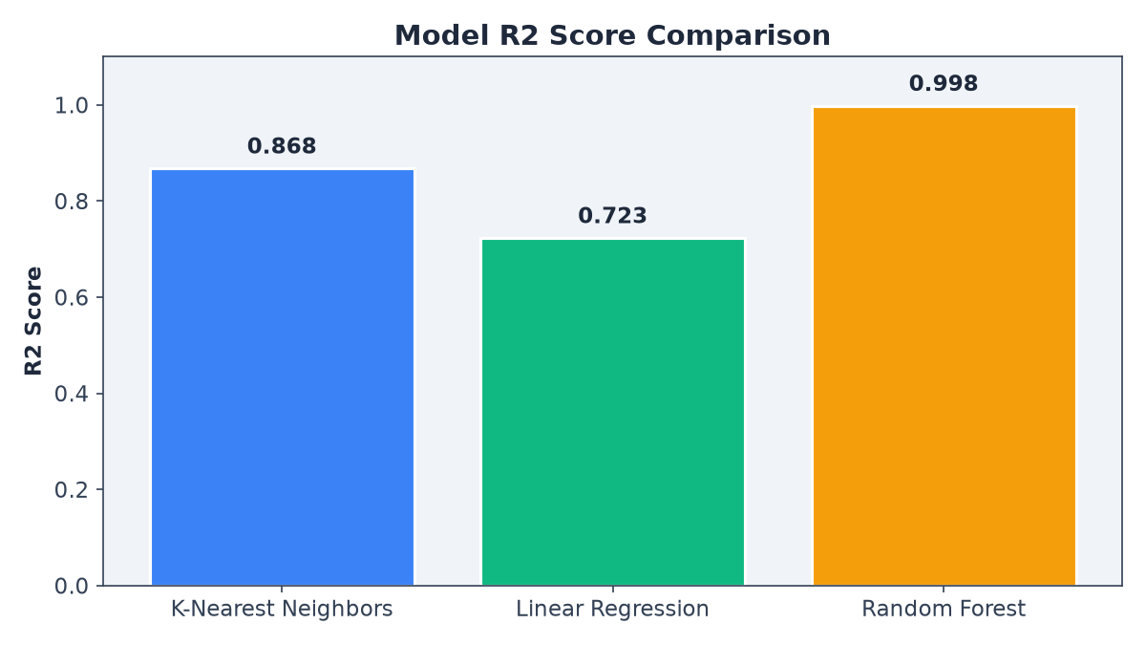
Figure 4: R2 score comparison across models (higher is better).
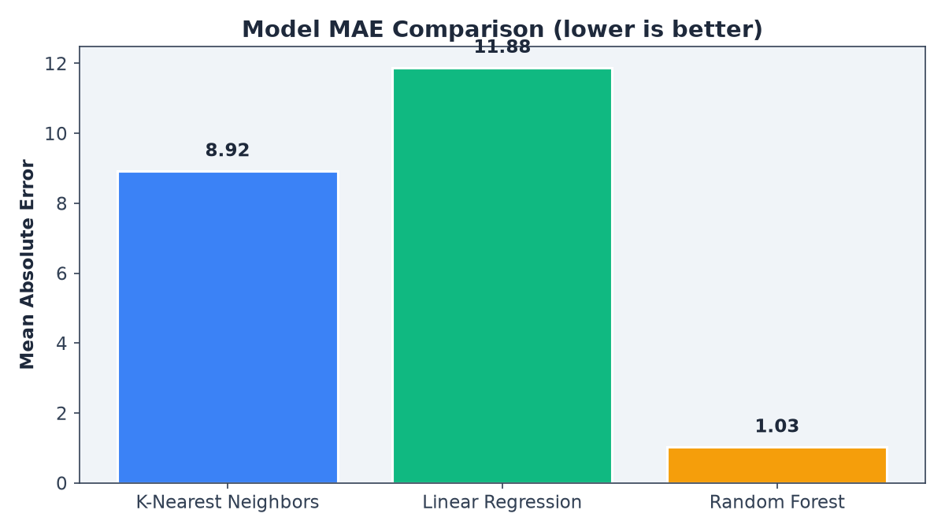
Figure 5: MAE comparison across models (lower is better).
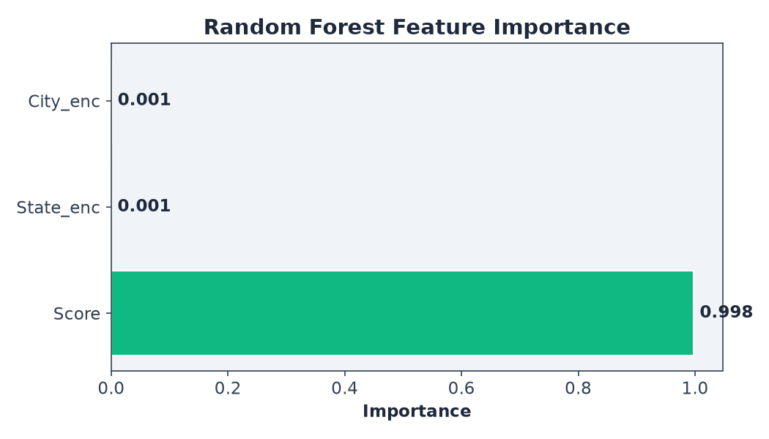
Figure 6: Random Forest feature importance showing Score is the dominant predictor.

4.2 Best Model
The best performing model is Random Forest with an R2 score of 0.9981 and MAE of 1.03. This model was saved and is used by the Flask API for serving predictions.

5. API Documentation
The Flask backend provides a REST API on port 5000 with the following endpoints:
Method | Endpoint | Description
GET | /api/health | Health check - returns API status
GET | /api/model-info | Model metadata and evaluation metrics
GET | /api/dataset | Full institute dataset (100 rows)
GET | /api/states | States and their cities for dropdowns
POST | /api/predict | Predict rank from score, state, city

5.1 Prediction API Example
Request:
POST /api/predict
Content-Type: application/json
{"score": 70, "state": "Delhi", "city": "New Delhi"}
Response:
{
"input": {
"city": "New Delhi",
"score": 70.0,
"state": "Delhi"
},
"model": "Random Forest",
"nearby_institutes": [
{
"Name": "Indian Institute of Technology Delhi",
"Rank": 4,
"Score": 80.67
},
{
"Name": "Indian Institute of Technology Kanpur",
"Rank": 5,
"Score": 77.25
},
{
"Name": "Indian Institute of Technology Kharagpur",
"Rank": 6,
"Score": 73.99
},
{
"Name": "Indian Institute of Technology Roorkee",
"Rank": 7,
"Score": 71.73
},
{
"Name": "All India Institute of Medical Sciences, Delhi",
"Rank": 8,
"Score": 70.57
},
{
"Name": "Jawaharlal Nehru University",
"Rank": 9,
"Score": 69.62
},
{
"Name": "Banaras Hindu University",
"Rank": 10,
"Score": 68.71
},
{
"Name": "Indian Institute of Technology Guwahati",
"Rank": 11,
"Score": 67.67
},
{
"Name": "Indian Institute of Technology Hyderabad",
"Rank": 12,
"Score": 67.04
},
{
"Name": "Jamia Millia Islamia",
"Rank": 13,
"Score": 66.99
},
{
"Name": "Manipal Academy of Higher Education-Manipal",
"Rank": 14,
"Score": 66.86
}
],
"nearest_institute": {
"name": "Jawaharlal Nehru University",
"rank": 9,
"score": 69.62
},
"predicted_rank": 9
}
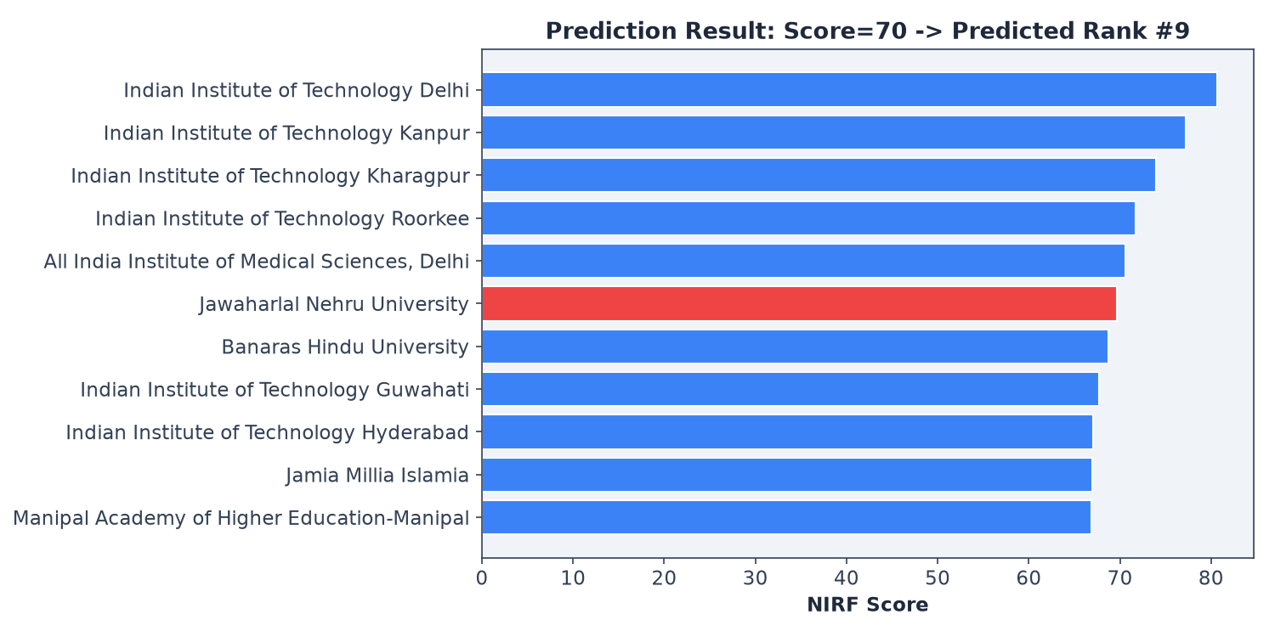
Figure 7: Prediction result for score=70, Delhi. Predicted rank: #9. Nearest known institute: Jawaharlal Nehru University (score=69.62, rank=#9).

6. Frontend UI
The Streamlit frontend provides an interactive web interface with four tabs:
- Predict Rank - Enter score, state, and city to get a predicted rank with visual comparison.
- Model Comparison - Side-by-side R2 and MAE charts for all three models.
- Data Explorer - Filterable, searchable table of all 100 institutes with a score-vs-rank scatter plot.
- Insights - Summary statistics, top states chart, and score distribution histogram.
The UI communicates with the Flask backend via HTTP requests. It uses Plotly for interactive charts and features a dark blue theme.

7. Technology Stack
Component | Technology
Backend API | Flask 3.x with Flask-CORS
Frontend UI | Streamlit 1.x with Plotly
ML Library | scikit-learn 1.x
Data Processing | pandas, numpy
Visualization | matplotlib (reports), Plotly (UI)
Report Generation | python-docx
Language | Python 3.13

8. Conclusion
The Institute Rank Prediction project successfully demonstrates a complete machine learning pipeline from data loading and feature engineering through model training, evaluation, and deployment as a web application. The Random Forest model achieved an R2 score of 0.9981, indicating excellent predictive performance with a mean absolute error of only 1.03 rank positions.
The project architecture separates concerns into three layers: a training script for model development, a Flask API for serving predictions, and a Streamlit UI for user interaction. This modular design allows each component to be developed, tested, and deployed independently.

9. How to Run
- Step 1: Install dependencies
pip install -r requirements.txt
- Step 2: Train the model
python train_model.py
- Step 3: Start the Flask backend
python app.py (runs on port 5000)
- Step 4: Start the Streamlit UI
streamlit run ui.py --server.port 8501 (runs on port 8501)

