1. Create a blog or website using BlogSpot and word press. Customize the theme design and post new article with 500 words.

<https://www.blogger.com/blog/posts/2900685992640528932>

1. Create a new Facebook Business page and post one social media poster for your brand.

<https://m.facebook.com/story.php?story_fbid=pfbid0nRwPAUxdimQ9tD7Wa2U2jAeFmdrahmCJ4FDDAdzssZ9WAumirCXbt3eGz9teShQLl&id=61552618058273&mibextid=Nif5oz>

1. 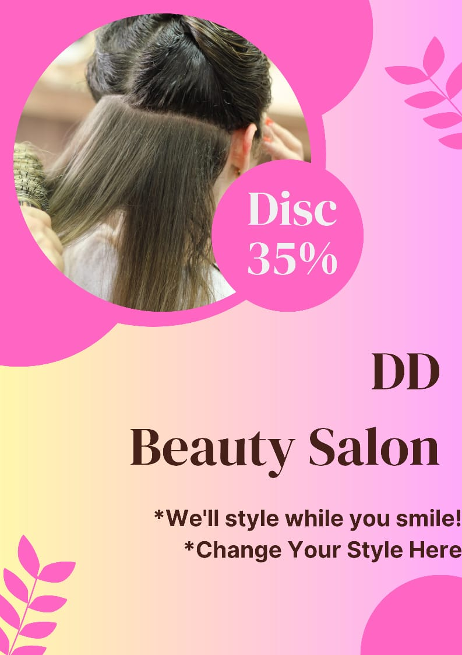Create a design a social media advertisement poster using canva tool.
2. 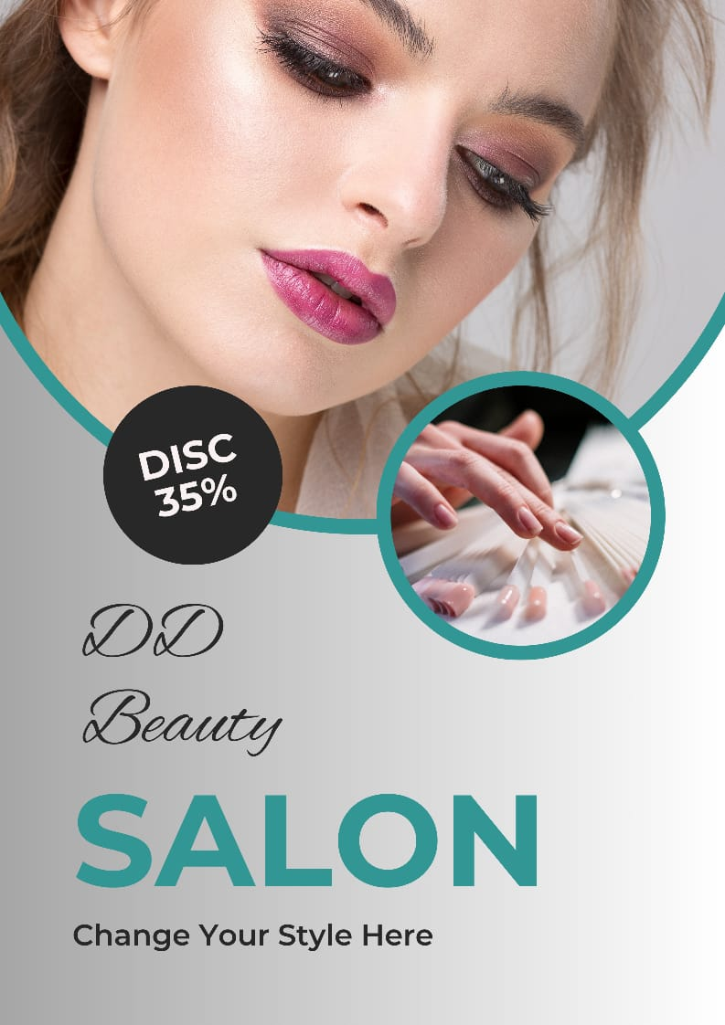Create an email newslewtter and posting in blog.