PT GALAKSI MEGATAMA INDONESIA
Manufacturer of record

TECHNICAL CERTIFICATION DOCUMENT

IECEx/ATEX Certification Document
Gas Leak Detector (GLD) V2
Prepared in direct reference to the IECEx/ATEX Certification Information Requirements issued by the certification body (ExCB) — covering all three sections of that checklist: Section 1, Basic Information (Application and Organization); Section 2, Technical Documentation (Items 1–6: product description; name, model, and specification list; functional description and technical parameters; product photographs; intended use and installation environment; and design and manufacturing information); and Section 3, Sample Information.
Document Control
Document title | IECEx/ATEX Certification Document — Gas Leak Detector (GLD) V2
Document no. | GMI/GLD/IECEX-TDF/2026-001
Revision | 2.3
Date | 7 October 2026
Status | Working Document — Draft for Internal Review
Classification | Confidential — prepared for ATEX/IECEx certification body (ExCB) submission
Certification subject | Node Sensor (GLD) — V2
Applicant / Manufacturer | PT Galaksi Megatama Indonesia
Reference checklist | IECEx/ATEX Certification Information Requirements

Revision History
REVISION | DATE | DESCRIPTION
0.1 | 11 September 2026 | Initial issue — Section 2 (Items 1–6) and Section 3.
0.2 | 17 September 2026 | Section 1, Basic Information (Application and Organization), added — Items 1.1–1.5. Document now covers all three sections of the checklist.
0.3 | 22 September 2026 | Manufacturer-of-record for Section 1 changed to PT Galaksi Megatama Indonesia (legal documents on file). Section 2.6.g draft content (safety warnings, installation procedures, operating modes, commissioning equipment) added.
0.4 | 22 September 2026 | Candidate enclosure component data (ADC12 die-cast alloy, M20×1.5 cable entry, electrostatic-safety parameters) added to Sections 2.3.c, 2.6.a, and 2.6.c, sourced from a supplier reference drawing in the casing partner's supply chain.
0.5 | 22 September 2026 | Enclosure material grade confirmed as ADC12 (Section 2.3.c, status raised to Final with an explicit caveat that this extrapolates from the casing manufacturer's sub-component drawing, not a direct callout on the main enclosure drawing). Cable entry (Section 2.3.c) confirmed as a 2-conductor cable labeled L+/L−, each conductor ≈0.75 mm diameter.
0.6 | 22 September 2026 | Total weight corrected to 2.3 kg; IP rating confirmed as IP66; operating humidity confirmed as 10–90% RH non-condensing (standard industrial rating, matched to a comparable certified product); cable gland confirmed as M20×1.5 (IP66-rated) — all raised to Final (Section 2.3.c). Removed the ambiguous “no plastic or PVC” parenthetical from the product description (Section 2.1) and generalized “L-bracket” to “bracket” in that same narrative sentence (the dimensioned bracket/U-bolt specification in Section 2.3.c is unaffected). “GLD V2 (Version 2)” simplified to “GLD V2”.
0.7 | 22 September 2026 | “L-bracket” terminology corrected throughout to “U-bolt mounting plate” (Sections 2.1, 2.3.c, 2.6.g), matching the actual CAD drawing (a flat 250×250 mm plate secured by 2× U-bolts — not an angled/L-shaped bracket).
0.8 | 24 September 2026 | Total weight, operating temperature, and operating humidity (Sections 2.3.c, 2.5) updated to 2.378 kg, −20°C to +60°C, and 5–95% RH respectively, per current project specification data.
0.9 | 25 September 2026 | Section 2.6.c (material specification sheets, non-metallic materials) expanded with the specific IEC 60079-0 requirements (CTI class, glow-wire/flame-retardancy, Tg vs. the confirmed operating range, UV/weathering resistance) and a list of the non-metallic components in GLD's own design that this item will need to cover (sensor mesh/flame-arrestor cover, cover-to-body sealing gasket, cable-gland seal, antenna feedthrough insulator); status remains Not yet available pending the casing partner's data.
1.0 | 25 September 2026 | Section 2.6.c updated with materials confirmed from a newer casing-partner assembly drawing: the protective mesh cover is stainless steel (metallic, outside the scope of this non-metallic-materials item) and the cover-to-body seal is a rubber gasket (compound/grade still not specified).
1.1 | 25 September 2026 | Added an explicit equipment-boundary statement to Section 2.3.a: the Node Sensor (GLD) receives only 24 VDC at its terminal and never carries 220 VAC internally; the AC/DC adapter is a separate, site-supplied device outside the certified unit's physical boundary. Section 2.6.c cable-gland seal remark clarified as specified together with the M20×1.5 gland itself from the BP18-1Z reference, per project direction, rather than as a separately sourced item.
1.2 | 28 September 2026 | Type of protection narrowed to a single team recommendation, Ex d (flameproof enclosure), in Sections 1.1 and 2.5 — selected over Ex e and Ex i based on the existing ADC12 die-cast enclosure with a stainless-steel mesh flame path (matching the three certified reference products reviewed) and the MQ-sensor heaters' continuous, unregulated power draw being difficult to reconcile with intrinsically safe energy limits for Group IIC. Section 2.6.e updated accordingly. Still an internal recommendation, not an ExCB decision.
1.3 | 28 September 2026 | Applicant/Manufacturer identity simplified to a single entity, PT Galaksi Megatama Indonesia, throughout the document (document number prefix changed to GMI/...). The separate “design and development authority” and “technical partner” entries were removed (Sections 1.1, 1.3, 2.2, letterhead, Document Control); narrative passages describing electronics design/engineering work were made generic rather than deleted, to avoid implying the Manufacturer performed work it did not.
1.4 | 30 September 2026 | Section 2.6.f populated with a preliminary internal surface-temperature measurement (eight thermocouple channels; normal, maximum-load and fan-stalled conditions; 180 minutes each), including extrapolation to the +60°C maximum ambient: highest value ≈114°C (MQ sensor body, fan stalled) against an effective T4 limit of 130°C. Status raised from Not yet available to Partially available; open measurement items listed. Sections 1.1 and 2.5 temperature-class remarks updated accordingly.
1.5 | 7 October 2026 | Section 2.6.a extended with the released main-board electrical schematic (26 sheets, Section 2.6.a.7) and ten annotated PCB layout views with board data (Section 2.6.a.8), including the protection-device list, grounding description and open verification items. Schematic status raised to Available; PCB layout remains Partially available.
1.6 | 7 October 2026 | Section 2.6.a: the “GLD ATEX CASE v3” dimensioned enclosure drawing and the BP18-1Z supplier reference drawing are now reproduced as figures, and a new Section 2.6.a.1 adds the complete mechanical, enclosure and assembly drawing set (ATEX CASING v2 sheet and six CAD views, all seven GLD ATEX CASE v3 sheets, BP18-1Z, component/structure/terminal/grounding drawings, assembly sequence and MQ sensor dimension drawings) with a drawing register.
1.7 | 7 October 2026 | Full audit against the reviewer's revision guide: added 2.4.1 photo-set coverage; 2.6.b.1–2 Ex-critical mechanical (EX-01…17) and electrical (EL-01…13) BOM; 2.6.c.1 non-metallic materials register (MAT-01…11); 2.6.d.1 manufacturing process control d.1–d.13; 2.6.e.1–3 gas path, ignition-source assessment IS-01…17 and protection concept e.3.1–e.3.11; 2.6.f.1 temperature-class structure f.1–f.12 with results table; 2.6.g.1 usage and installation instructions g.2–g.20; 2.6.h.1 proposed nameplate (gas only, −20…+60 °C); 2.6.i.1 required Ex component certificates; 3.1/3.3–3.4 sample register (GLD2-0x1001) and fixtures; Annex compliance matrix.
1.8 | 7 October 2026 | Section 2.4.2 added: photo set of the current production configuration (23 photographs, complete assembly sequence, Figures 4-101–4-123). Audit tables updated from the photographs: DC fan identified as CIXIKEJI CX5010B5H, 5 V 0.23 A (EX-05); prototype cable gland is a general-purpose polymer type to be replaced by a certified Ex d gland (EX-07, MAT-02, IS-13); blanking plug, grounding screw and BAT terminal located (EX-08, EX-12, EX-17); photo-coverage table 2.4.1 updated.
1.9 | 7 October 2026 | Section 2.6.a.8: top/bottom renders of the GLD V4 main board and of the separate PCB cover (terminal board) added (Figure 8-11), with terminal designations and the changes from V3 (motherboard mounting holes to the PCB cover; separate PCB cover terminating the field connections).
2.0 | 7 October 2026 | Nameplate location added: flat top face of the base enclosure beside the antenna (Figure 4-124, Section 2.4.2; Section 2.6.h.1); photo-coverage table updated.
2.1 | 7 October 2026 | Antenna interface photographs added (Figures 4-125 outside, 4-126 inside: brass SMA bulkhead through the enclosure wall with U.FL pigtail); EX-09 and EX-06 updated; photo coverage 10/12.
2.2 | 7 October 2026 | Thread dimensions estimated from photographs and added (Figure 4-127; new Section 2.6.e.3 item e.3.12): cover ≈M100 × 2 with ≈10 threads (≈20 mm) engaged, side entries M20 × 1.5, antenna SMA 1/4″-36 UNS, compared with the IEC 60079-1 threaded-joint rules; EX-02, EX-07, EX-08 and EX-09 updated. All values marked as estimates pending the enclosure manufacturer's drawing.
2.3 | 7 October 2026 | Caliper measurements of the base and cover O-ring added (Figures 4-128–4-132): neck wall 10.50 mm at the root and 5.80 mm at the top, threaded-neck height ≈14.8 mm, bore ≈Ø84.7 mm, O-ring cord Ø2.70 mm. Cover thread re-estimated as ≈M96 × 1.5 (derived) replacing ≈M100 × 2; e.3.12, EX-01, EX-02, EX-06 and MAT-01 updated. The measured bore differs from the Ø94.7 mm of the BP18-1Z drawing.

Table of Contents
Right-click and choose Update Field to generate the table of contents.

About This Document
This document is a working technical file prepared against the official IECEx/ATEX Certification Information Requirements checklist issued by the certification body (ExCB). It follows that checklist section by section: “1. Basic Information (Application and Organization)”, “2. Technical Documentation”, and “3. Sample Information”. Section 1 is administrative: it sets out every particular the ExCB requires and states which are already confirmed and which remain to be supplied from corporate records, without entering assumed values.
Scope of this document. This is a compilation of design evidence and an honest readiness assessment against the ExCB checklist, prepared in support of a future submission — it is not itself a certificate and does not constitute self-certification. The final enclosure/casing (material selection, manufacture, gasket, and cable entry) is being developed by an external mechanical/casing partner (PT Galaksi Megatama Indonesia — legal identity confirmed, Section 1.4) and is not yet in the authors' possession; items that depend on that design (material datasheets, manufacturing process description, explosion-protection calculations) are reported as not yet available for that reason, not because the work has stalled. The product is still at from-scratch development/prototype stage — no finalized, serialized units exist yet, which is why a formal sample register (Section 3.1) is not yet available either.

Original excerpt, Section 2 & 3 — source: IECEx ATEX Certification Information Requirements (ExCB):
“1) Detailed product description; 2) Product name, model, and specification list; 3) Complete and clear functional description and technical parameters (electrical parameters, mechanical parameters, etc.); 4) Clear product photos (overall and key components); 5) Description of intended use and installation environment (e.g., gas group IIC/IIB/IIA if applicable, temperature group T1–T6, ambient temperature range, area classification 0/1/2 or 20/21/22); 6) Design and manufacturing information [a–i: drawings, BOM, material datasheets, manufacturing process, explosion-protection calculations, temperature group calculation, usage and installation instructions, nameplate information, Ex component certificates]. 3. Sample Information: 1) model, serial number, and status of the sample; 2) necessary test fixtures or auxiliary equipment.”

1. Basic Information (Application and Organization)
Five items per the original checklist: the application form, the business license/company registration certificate, the organizational chart and contact information, the manufacturing plant address and production-facility profile, and — where applicable — the ISO 9001 certificate together with the quality manual and procedure index.
How this section is presented. The items below are administrative rather than technical: they are satisfied by corporate records held by the manufacturer's legal and administrative functions, not by engineering output. Every required field is therefore set out in full so that it can be collected in a single pass, with its current status stated plainly. No field has been filled with an assumed or placeholder value.

Applicant and Manufacturer of record for this document: PT Galaksi Megatama Indonesia. This section reports the legal/corporate particulars of PT Galaksi Megatama Indonesia, since it holds the Indonesian industrial manufacturing business license (NIB) relevant to fabricating the equipment (KBLI 25119/25120/28221/25920 — metal products, pressurized-vessel-class containers, metalworking machinery, and special metal-treatment services). PT Galaksi Megatama Indonesia is recorded as the sole applicant and manufacturer throughout this document. This attribution reflects a working decision recorded 28 September 2026 based on PT Galaksi's legal documents (deed of establishment, NIB, NPWP, MOLHR ratification decree, tax registration certificate) supplied to the authors — it has not yet been confirmed directly with the company's officers as the final arrangement for the ExCB submission and should be verified before formal filing.

Original excerpt, Section 1 — source: IECEx ATEX Certification Information Requirements (ExCB):
“1. Basic Information (Application and Organization): 1) Application form (provided by ExCB as a template). 2) Manufacturer's business license/company registration certificate. 3) Manufacturer's organizational chart and contact information. 4) Address of manufacturing plant and brief introduction of production facilities. 5) (If applicable) ISO 9001 certificate, quality manual, and directory of procedure documents (for QAR/QAN review).”

1.0 · Status Summary — Section 1
ITEM | STATUS | HELD BY
1.1 Application form (ExCB template) | Template not yet received | Issued by the ExCB
1.2 Business license / company registration | Partially available | Manufacturer (PT Galaksi Megatama Indonesia) — legal documents now on file; a few particulars still open
1.3 Organizational chart and contact information | Partially available | Manufacturer — Board of Directors/Commissioners names known from the deed; a full org chart and named ExCB contacts remain to be provided
1.4 Manufacturing plant address and facility profile | Partially available | Manufacturer's registered office and production-site addresses now on file; floor profile, process capability, and quality system still pending
1.5 ISO 9001 certificate, quality manual, procedure index | To be confirmed | Manufacturer — quality function

1.1 · Application Form
The application form is issued by the certification body as a template and has not yet been received; it is therefore not reproduced here. The information needed to complete it, however, is already consolidated in this document, and is restated below in the order an application form normally requests it so that transcription is a single step once the template arrives.
APPLICATION FIELD | VALUE | STATUS | REFERENCE
Applicant / manufacturer | PT Galaksi Megatama Indonesia | Confirmed | Section 1.2
Product name | Gas Leak Detector (GLD) — Node Sensor | Confirmed | Section 2.2
Model / version | GLD V2 | Confirmed | Section 2.2
Scope of certification | Node Sensor (GLD) only | Confirmed | Section 2.1
Requested area classification | Zone 1, Equipment Category 2G, Group II | Requested — subject to ExCB assessment | Section 2.5
Requested temperature class | T4 (≤135 °C) | Target — preliminary internal measurement supports it; formal verification outstanding | Sections 2.5, 2.6.f
Requested gas group | IIC | Internal recommendation, not an ExCB decision | Section 2.5
Type of protection | Ex d — flameproof enclosure | Internal recommendation, not an ExCB decision | Section 2.5
Standards to be applied | IEC 60079-0, together with IEC 60079-1 (flameproof enclosures “d”) | Dependent on the item above | Section 2.6.e
Certification route requested | IECEx Certificate of Conformity and/or ATEX EU-type examination | To be confirmed with the ExCB
Intended markets | To be provided | To be provided

The three requested classification parameters above are the applicant's proposal. They are recorded here as a request, not as an agreed or granted classification.

1.2 · Business License / Company Registration Certificate
REQUIRED PARTICULAR | STATUS | REMARKS
Registered legal name | Available | PT Galaksi Megatama Indonesia.
Legal form and shareholding status | Available | Perseroan Terbatas (limited liability company), National Private / PMDN (domestic investment), Small Enterprise scale. Deed No. 52 (22 Sep 2022, Notary Steffi Alphanie, S.H., M.Kn., Cilegon City): President Director Nur Rohman (2,250 shares), Director Antonius Prasetyo (2,625 shares), Commissioner Crisa Andi Sujatmiko (2,625 shares); authorized capital Rp300,000,000, paid-up Rp75,000,000.
Business registration number | Available | NIB (Business Identification Number) 0510220020593, issued 5 Oct 2022 under Indonesia's risk-based business licensing (OSS) system.
Taxpayer identification number | Available | NPWP 61.126.496.1-427.000 (16-digit: 0611264961427000), Tax Service Office of Pratama West Bekasi, registered 29 Sep 2022.
Deed of establishment and latest amendment | Partially available | Deed of Establishment No. 52 dated 22 Sep 2022, ratified by Ministry of Law and Human Rights Decree No. AHU-0067398.AH.01.01.Year 2022 (29 Sep 2022, Company Register No. AHU-0194149.AH.01.11.Year 2022). No subsequent amendment deed has been supplied; whether one exists is unconfirmed.
Registered (domicile) address | Available | Plaza Summarecon Bekasi, Jl. Bulevar Ahmad Yani Kav. K.01, Level 7, Harapanmulya Village, Medansatria Sub-district, Bekasi City, West Java, Postal Code 17143.
Scope of business activity relevant to this product | Partially available | NIB lists KBLI 25119 (other prefabricated metal products for construction), 25120 (tanks, reservoirs and containers of metal – explicitly including pressurized gas cylinders), 28221 (machinery/machine tools for metalworking), and 25920 (special metal-treatment industrial services), among others, at production sites in Cikarang Selatan and Mustikajaya, Bekasi. This is a general metal-fabrication license; it does not by itself constitute an Ex-specific manufacturing qualification.
Scanned certificate, with English translation where requested | Available | NIB, NPWP, Deed of Establishment, MOLHR ratification decree, and Certificate of Registration (SKT) are on file with sworn English translations (Fikri Said Obed, S.S., Sworn Translator, Jakarta, 19 Sep 2026). Notarization/legalization requirements for ExCB submission to be confirmed.

1.3 · Organizational Chart and Contact Information
REQUIRED PARTICULAR | STATUS | REMARKS
Organizational chart | Partially available | Statutory Board of Directors/Commissioners known from the deed of establishment (below); a functional chart showing the units responsible for design, production, and quality, and the reporting line between them, has not been provided.
Board of Directors and Board of Commissioners | Available | President Director: Nur Rohman. Director: Antonius Prasetyo. Commissioner: Crisa Andi Sujatmiko. (Deed No. 52, 22 Sep 2022.)
Authorized signatory for the application | To be confirmed | The President Director (Nur Rohman) is the statutory officer entitled to represent the company (Articles of Association, Art. 12.5.a); whether he is the specific individual who will sign the ExCB application is not yet confirmed.
Certification project contact | To be provided | Name, position, e-mail, and telephone — the single point of contact for ExCB correspondence.
Technical contact for the product | To be provided | The engineer who will answer technical queries on the technical file.
Quality contact | To be provided | Counterpart for the quality assessment referred to in 1.5.
Correspondence address and working language | To be provided | English is assumed for correspondence with the ExCB unless stated otherwise.

1.4 · Manufacturing Plant Address and Introduction of Production Facilities
The Manufacturer's registered office and NIB-listed production-site addresses are now on file (below). Facility floor profile, process capability, and quality-system detail are not yet documented. The product is at prototype stage, and the specific location where serial units will be produced has not been fixed — this is stated as a fact of the current development phase, not as an omission from the file.
PRODUCTION ELEMENT | STATUS | REMARKS
Manufacturer's registered office and production sites | Available | PT Galaksi Megatama Indonesia — registered office: Plaza Summarecon Bekasi, Jl. Bulevar Ahmad Yani Kav. K.01, Level 7, Bekasi City, West Java. NIB-registered production sites: Jl. Kp. Jatipilar, Cikarang Selatan, Bekasi Regency; and Jl. WR Supratman, Mustikajaya, Bekasi City. NIB lists metalworking KBLI including 25120 (Manufacture of Tanks, Reservoirs and Containers of Metal – explicitly covers pressurized gas cylinders), 25119, 28221 (metalworking machinery), and 25920 (special metal-treatment services). This confirms a licensed general metal-fabrication business — it is not an Ex-certified enclosure manufacturer license, and no ISO 9001 or Ex-specific quality certificate has been supplied.
Printed circuit board fabrication and assembly | Partially available | The electronic design is maintained as a native EasyEDA/JLCPCB project and the component supply chain is referenced to LCSC supplier part numbers throughout the bill of materials (Section 2.6.b). The fabrication and assembly provider, and its address, remain to be confirmed in writing.
Enclosure / casing manufacture | Partially available | Enclosure development and manufacture sits with the Manufacturer, PT Galaksi Megatama Indonesia (identity and registered addresses above). Plant floor profile, process capability, and Ex-specific process controls remain to be provided (see remaining rows below and Sections 2.6.c/2.6.d).
Final assembly, configuration, and functional test | Prototype stage | Currently carried out in the development laboratory environment. The production location for serial units has not been fixed.
Production facility profile | To be provided | Floor area, principal equipment, staffing, and nominal throughput — the “brief introduction” requested by the checklist.
Incoming inspection and final quality control | To be provided | Arrangements for verifying purchased components and finished units.
Ex-specific routine verification | To be provided | Routine tests and verifications required of production units once a type of protection is selected.

Where any stage of serial manufacture is subcontracted, certification bodies normally expect each manufacturing location covered by the quality assessment to be identified by name and address. The final list of locations therefore depends on the production arrangement adopted after the prototype stage.

1.5 · ISO 9001 Certificate, Quality Manual, and Procedure Index
REQUIRED PARTICULAR | STATUS | REMARKS
ISO 9001 certificate | To be confirmed | Whether the manufacturer currently holds certification and, if so, the certificate number, scope, issuing body, and validity period.
Quality manual | To be provided
Index of procedure documents | To be provided | A directory is sufficient at this stage; individual procedures are normally requested during the assessment itself.
Documented control of Ex-relevant characteristics | To be provided | How drawings, changes, and the characteristics that secure the type of protection are controlled in production.
Records of routine verification | To be provided | Record format for the routine tests referred to in 1.4.

Note on the quality requirement. The checklist marks this item “if applicable” and links it to quality assessment review. Under both schemes a manufacturer is expected to demonstrate a quality system covering Ex production before certificates are issued — through an IECEx Quality Assessment Report, or through the corresponding production-quality or product-verification arrangement under ATEX — whether or not ISO 9001 certification is held. The route that applies to this application is to be confirmed with the ExCB; ISO 9001 certification, where held, generally shortens that assessment rather than replacing it.

2. Technical Documentation
Six items per the original checklist (1–6, with Item 6 comprising sub-items a–i). This revision addresses the complete section: Items 1–6.

2.1 · Detailed Product Description
The Gas Leak Detector (GLD) is an IoT-based, multi-sensor gas leak detection device designed for the early detection of flammable and process gases in oil & gas refinery environments (process units, tank farms, pipe racks, and storage/loading-unloading areas). This document addresses the GLD unit itself as the subject of the current IECEx/ATEX certification.
Functionally, the GLD integrates eight channels of metal-oxide semiconductor gas sensors (MQ series), an edge-AI microcontroller/processor (ESP32-S3), and a LoRa radio module (star-topology wireless transmission) within a single fixed-point unit installed at locations with gas-leak risk. An on-device AI gas-classification model runs directly on the unit so that detection decisions do not depend on a continuous connection to a central server. When gas concentration exceeds a defined threshold, the unit triggers a local alarm (an integrated visual/audible alarm module) and simultaneously transmits an alarm notification over the LoRa network to the operator dashboard.
The enclosure is designed for hazardous-area deployment at refinery sites, using metal materials (aluminum alloy and stainless steel) and mounted via a U-bolt mounting plate to existing structures without drilling or welding. Important: this design-intent statement does not constitute a claim that the enclosure has passed testing or has been Ex-certified — the explosion-protection scheme, gas group, temperature class, and target installation zone will be addressed in Section 2.5.
The current production power configuration is continuous 24 VDC, supplied via an AC/DC adapter connected to the site electrical supply. A portable battery power path (Li-ion 18650) remains under development (R&D) and has not become a deployed production configuration.

2.2 · Product Name, Model, and Specification List
Product name | Gas Leak Detector (GLD) — Node Sensor
Model / version | GLD V2
Manufacturer | PT Galaksi Megatama Indonesia
End client / program owner | PT Pertamina Patra Niaga (initial deployment site: Refinery Unit IV, Cilacap)
Primary function | Acquisition of 8-channel gas sensor data and LoRa transmission
Microcontroller | ESP32-S3-WROOM-1U-N16R8
LoRa radio module | E22-900MM22S
Dimensions (L×W×H) | 200 × 90 × 290 mm
Enclosure material | Aluminum alloy (ADC12 die-cast) + stainless steel

Source: official product technical datasheet (Revision 4.0), cross-referenced with internal technical specification documentation and EMC parameter measurement data.

2.3 · Functional Description and Technical Parameters (Electrical, Mechanical, etc.)
Functional workflow (normal operating mode): sense → process → transmit. Each of the eight gas sensors continuously samples ambient conditions → data is normalized and classified by the on-device AI model (ESP32-S3) → the result is transmitted over the LoRa network (star-topology transmission) at a configurable interval (default 10 seconds), or immediately (event-driven) when an alarm condition is detected. Gas alarms are triggered through two parallel channels: a local visual/audible alarm module on the unit itself, and a push notification transmitted over the LoRa network to the dashboard — the alarm-push pathway has been successfully tested on a campus mesh network (field validation at a production refinery installation is still pending).

2.3.a · Electrical Parameters — Node Sensor (GLD)
PARAMETER | SPECIFICATION | STATUS | REMARKS
Main power input | 24 VDC | Final — production config. | Continuous power supply from a site AC/DC adapter.
AC/DC adapter input | 220 VAC, 50 Hz | Final | Compliant with the Indonesian national electrical grid standard (PLN).
AC/DC adapter output | 24 VDC | Final
Internal operating voltage | 5 VDC & 3.3 VDC | Final | 5 VDC for the MQ sensor/heater circuitry; 3.3 VDC for ESP32-S3 logic. Per-rail current not yet documented separately.
Equipment boundary (mains exposure) | None — 24 VDC only | Final | The Node Sensor (GLD) itself receives only 24 VDC at its terminal and never carries 220 VAC internally. The AC/DC adapter (220 VAC/50 Hz → 24 VDC) is a separate, site-supplied device outside the physical boundary of the certified unit; its own installation location (e.g., relative to the hazardous-area zone) is a site electrical-design matter, not a parameter of this equipment.
Maximum input current | ≈0.33 A @ 24 VDC | Calculated | Calculated from measured maximum power consumption (7.995 W) divided by 24 VDC.
Maximum power consumption | 7.995 W @ 24 VDC | Measured — production config. | Applies to the continuous-power configuration. The battery (R&D) configuration is recorded separately at 5.75 W — a different operating mode, not a data conflict.
Electrical protection (fuse, reverse polarity, overvoltage, overcurrent) | 2× resettable PPTC fuse (F1/F2); TVS/ESD suppression diodes (D1, D4/D5/D11, D6); Schottky diodes (D7/D13, D8/D9, D12) | Partially available — component-level evidence | Real components exist per the EasyEDA/JLCPCB bill of materials (Section 2.6.b): 2× Littelfuse MINISMDC260F/16 resettable fuses (F1, F2, overcurrent), a Ruilong SMBJ33A TVS diode (D1) and 3× UMW LESD5D5.0CT1G / 1× DOWO SM712 ESD-protection arrays (D4, D5, D11, D6), and multiple Schottky diodes — MDD SS54 (D7, D13), MDD SS14 (D8, D9), GOOD-ARK SK36 (D12). This is genuine evidence that overcurrent and transient/ESD protection circuitry exists on the board. The rail and circuit role of each device are now tabulated from the released schematic (Section 2.6.a.7). Two points remain to be confirmed there: the voltage rating of F1/F2 on the 24 V line, and whether the input P-channel MOSFETs are intended to provide reverse-polarity protection.

2.3.b · Sensor and Communication Parameters — Node Sensor (GLD)
PARAMETER | SPECIFICATION | STATUS | REMARKS
Gas sensors | MQ-2, MQ-3B, MQ-4, MQ-5, MQ-6, MQ-7B, MQ-8, MQ-135 (8 channels) | Final | Metal-oxide semiconductor sensors; sensing element directly exposed to ambient air.
AI gas-classification model | On-device classifier — 3 classes: Clean Air, LPG, H₂ | Final | Runs locally on the ESP32-S3 (Running/Inference mode); outputs a class label and a confidence value. Does not yet cover CO₂, Benzene, CO, or H₂S.
Environmental sensor (temperature/humidity) | SHT40-AD1B-R2 (I2C) | Final | Auxiliary temperature/humidity input included in the primary hardware design; values are available for status/telemetry.
Analog-to-digital converter | ADS1256IDBR | Final | 24-bit multi-channel analog acquisition for the 8 sensor channels; 30,000 SPS, firmware SPI clock 1.92 MHz.
Processing unit | ESP32-S3-WROOM-1U-N16R8 | Final | Certified under FCC (2AC7Z-ESPS3WROOM1U), TELEC, and CE (per Espressif data) — RF/EMC certifications, not an “Ex component” certification.
Communication module | LoRa, E22-900MM22S module | Final | Certified under CE, FCC, and RoHS (per Ebyte data) — RF/EMC certifications, not an “Ex component” certification.
Operating frequency | 920 MHz | Final | Star-topology transmission; within the regional 920–923 MHz ISM band (Indonesia).
Transmit power (firmware configuration) | 17 dBm | Final | The radio module supports up to 22 dBm — 17 dBm is an operational configuration, not the module's maximum limit.
Bandwidth / spreading factor / coding rate | 125 kHz / SF7 / CR 4/5 | Final | Source: EMC parameter table and official product technical datasheet.
Antenna | External, omnidirectional, SMA male connector, 3 dBi gain | Final | On some units, the 2.4 GHz Wi-Fi antenna remains inside the enclosure and must be relocated externally.
Data transmission interval | Configurable, default 10 seconds | Final | Alarm events are transmitted immediately, independent of the periodic interval.
Other interfaces | SPI, LoRa | Final | External ports/connectors: USB, sensor, power, fan, antenna, alarm buzzer.
RS-485 / Modbus interface | Read-only Modbus RTU slave, 9600 bit/s 8N1, Unit ID 1 (THVD1410DR transceiver) | Final | Provides 8 read-only registers (device status word, classification result, confidence, battery voltage, power source, external power, LoRa transmission counter, node ID); not used for product control.

2.3.c · Mechanical Parameters — Node Sensor (GLD)
PARAMETER | SPECIFICATION | STATUS | REMARKS
Enclosure material | Aluminum alloy (ADC12 die-cast) + stainless steel | Final | Per project confirmation, the production enclosure is sourced from a commercially available CE/ATEX-marketed explosion-proof gas-detector housing product line (referenced supplier listing: Alibaba.com, “CE ATEX Explosion Proof H2 Sensor”), consistent with the cast-metal housing, threaded “Ex”-marked cable entry, and sensor mesh cover shown in the product photography (Section 2.4). This is corroborated by an internal case CAD drawing (“GLD ATEX CASE v3,” dated 8 September 2026) specifying a cylindrical sensor-case body (Ø102 mm outer housing ring, Ø90/Ø80 mm internal bores) that incorporates a stainless-steel filter mesh disc, a small DC cooling fan, and a transparent viewing window. PVC is not used in any housing or bracket component. Alloy grade — ADC12: the enclosure metal is die-cast aluminum grade ADC12 (a standard, widely used die-cast aluminum alloy), per project confirmation. Caveat on how this grade was established: ADC12 is the material called out on a Chinese enclosure-component manufacturer's drawing for a related die-cast sub-component (“Universal Base,” part no. BP18-1Z, from the same casing-partner supply chain — see Section 2.6.a); the “GLD ATEX CASE v3” drawing of the main enclosure body itself does not carry its own material callout. The project has confirmed ADC12 as the enclosure grade on the basis that the same casing manufacturer's die-cast product line uses this alloy consistently — this is an extrapolation from the supplier's sub-component drawing, not a direct material callout on the main enclosure drawing, and should be verified against the casing partner's own datasheet for the enclosure body before formal ExCB submission.
Dimensions (L × W × H) | 200 × 90 × 290 mm | Final | Consistent between the technical specification documentation and the EMC parameter table.
Total weight | 2.378 kg | Final | Total weight of PCB, casing, and sensors combined; project-confirmed value, not yet documented against a calibrated weighing record.
Mounting method | U-bolt mounting plate, following the design already installed at the refinery | Final | Mounted to existing structures without drilling or welding.
Ingress protection (IP rating) | IP66 | Final | Project-confirmed value; not yet independently tested/verified against IEC 60529.
Cable entry (gland) | M20×1.5 cable gland (IP66-rated); power cable is 2-conductor, labeled L+/L− (positive/negative of the 24 VDC supply), each conductor ≈0.75 mm diameter | Final | Conductor count and per-conductor wire diameter confirmed by the project. Gland thread size (M20×1.5) is selected by engineering judgment to match the BP18-1Z reference drawing from the same casing-manufacturer supply chain (Section 2.6.a) — a standard, IP66-rated gland size well suited to this conductor count/diameter, not an independent gland datasheet or fit test on GLD's own enclosure. Overall cable outer diameter and insulation rating remain to be documented.
Antenna mounting | External, SMA male connector | Final
Operating temperature | −20°C to +60°C (ambient) | Final | Project-confirmed value — a key input for temperature class (T1–T6) determination in Section 2.5. Not yet documented against a calibrated test record.
Operating humidity | 5–95% RH, non-condensing | Final | Project-confirmed value. Not yet documented against a calibrated test record.

Source: internal technical specification documentation, Sections 1.1–1.3 (Node Sensor), cross-referenced with the official product technical datasheet (Revision 4.0) and component certification verification (ESP32-S3-WROOM-1U, E22-900MM22S).
Rows marked “Pending confirmation” above do not reflect a documentation oversight — this is an honest status indicator. These fields are intentionally left blank because no official data yet exists (not yet measured, tested, or decided). They must not be filled with estimates in future revisions without a clear supporting data source.

2.4 · Product Photographs — Overall and Key Components
The seven photographs below were taken directly from the Node Sensor (GLD) V2 prototype unit (no capture-date metadata is available in the source files). The first three photographs show the fully assembled unit from different angles; the remaining four show key components in close-up.
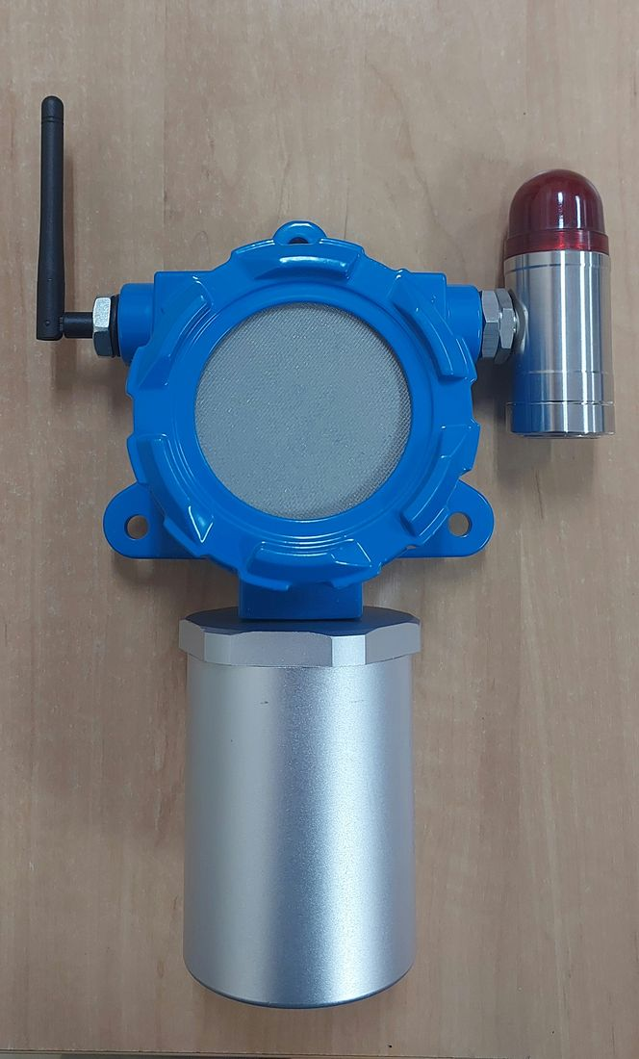  Complete unit — front view  The fully assembled Node Sensor (GLD): the main enclosure (blue) with sensor mesh cover, external LoRa antenna, and a visual alarm module (cylindrical housing, red lens) mounted on the right side. | 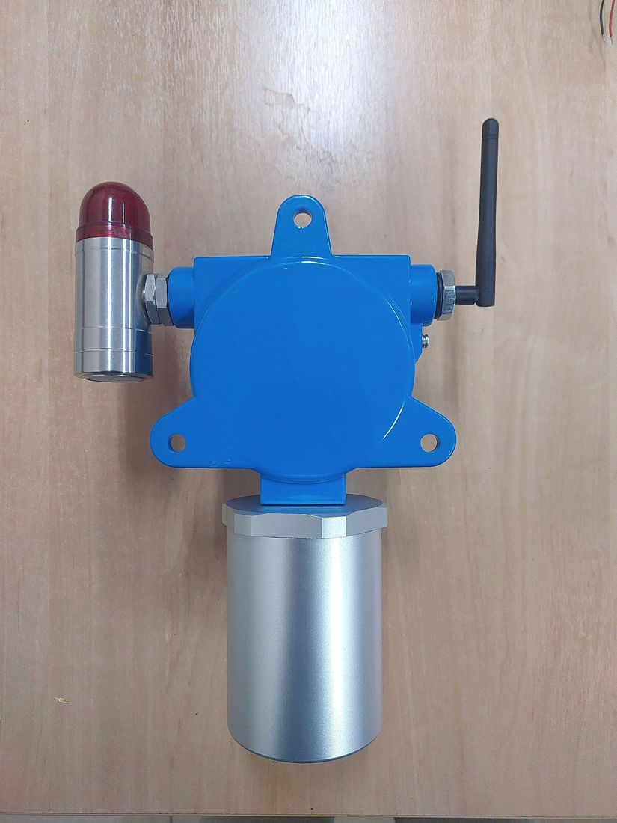  Complete unit — alternate angle  An alternate view of the assembled unit, showing the position of the antenna, alarm module, and the cable-gland side of the enclosure.
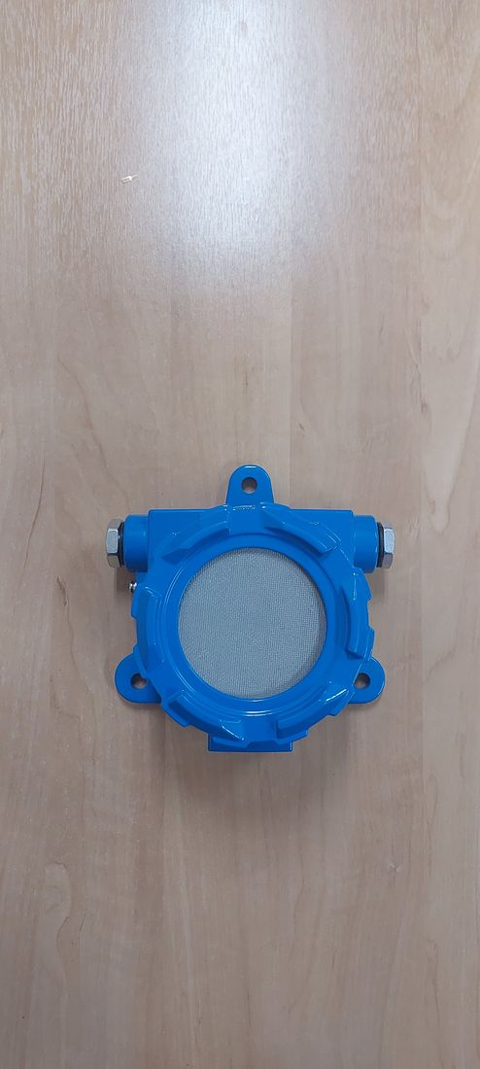  Complete unit — front view (without antenna and alarm module)  The main enclosure with the sensor mesh cover installed, shown in a flat front view illustrating the enclosure shape and its four mounting bolt holes. | 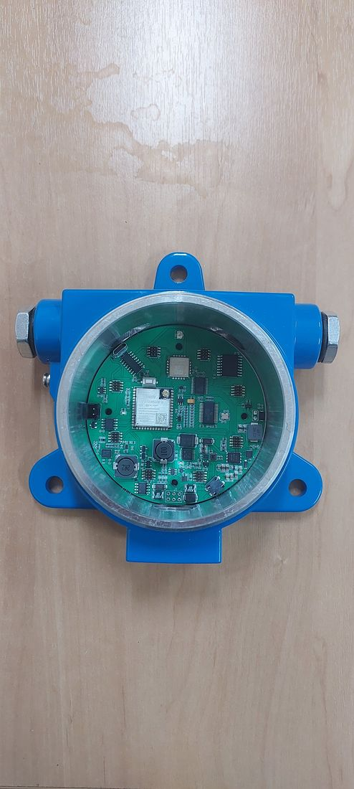  Key component — PCB inside enclosure (before sensor modules)  The main PCB installed inside the enclosure prior to gas sensor module installation. The ESP32-S3-WROOM-1U microcontroller, LoRa radio module, and power circuitry are visible.
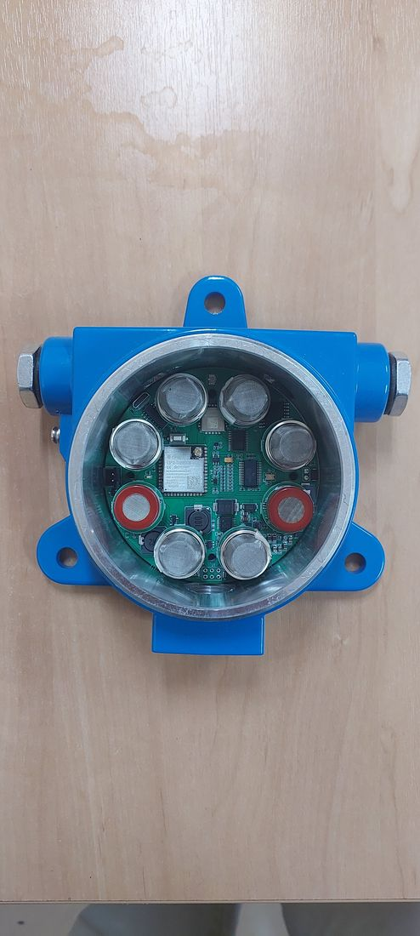  Key component — PCB with eight gas sensor modules  The same PCB with eight channels of MQ-series gas sensors (MQ-2, MQ-3B, MQ-4, MQ-5, MQ-6, MQ-7B, MQ-8, MQ-135) installed around the central microcontroller. | 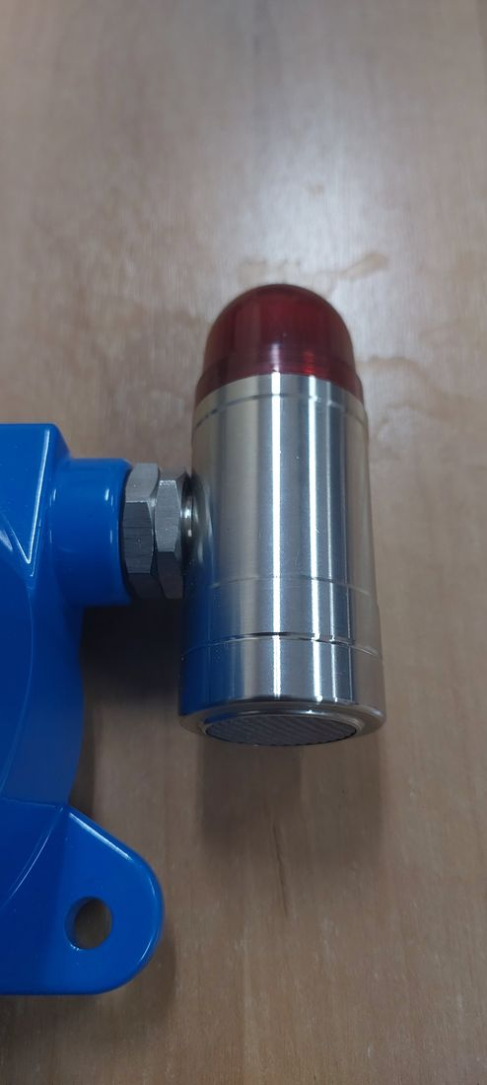  Key component — visual alarm module (close-up)  The visual alarm (beacon/strobe) module, constructed of metal with a red lens, connected to the main enclosure via a dedicated cable gland.
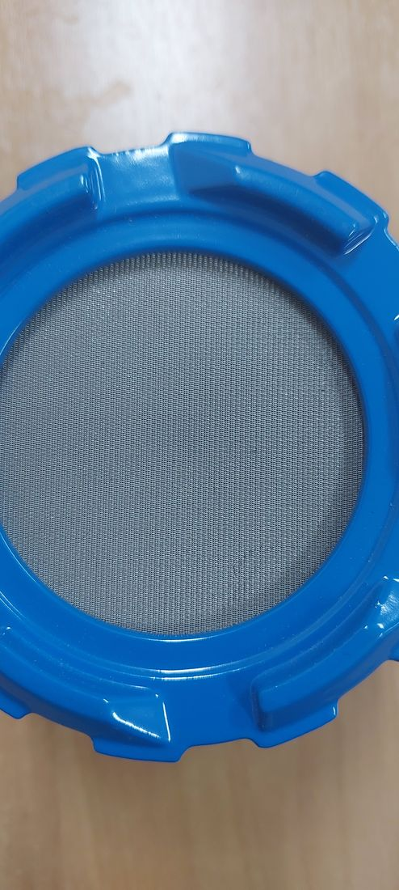
Key component — sensor mesh cover (close-up)
The metal mesh cover that protects the gas sensing elements while serving as a diffusion path for gas to reach the sensors beneath.

Photographic completeness — status as-is. The seven photographs above cover the complete unit and its key components (PCB, sensor modules, alarm module, mesh cover), substantively satisfying checklist Item 2.4. Still outstanding: (a) formally labeled photographs of each face (front/back/left/right/top/bottom) with a scale reference, as is customary in ExCB submission packages; (b) separate photographs of individual components such as the battery, gaskets/seals, terminals, and cable glands.

2.4.2 Current production configuration — assembly photo set (7 October 2026)
Photographs of one unit of the current production configuration (latest enclosure and main board), taken in assembly order from the empty base enclosure to the closed unit. No Ex marking is shown; the MQ sensor mesh is not described as flame-arresting.
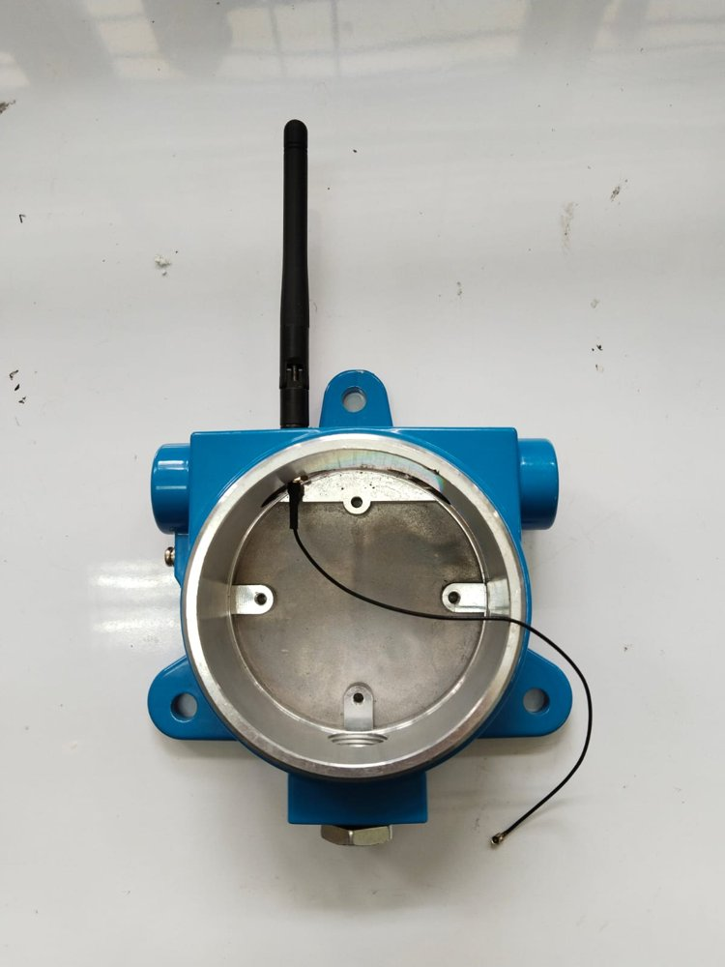  Figure 4-101. GLD V2 – Base enclosure before assembly.  Machined bore of the base enclosure with the PCB mounting bosses; the external antenna is fitted at the top and its internal coaxial lead (U.FL) is routed inside. | 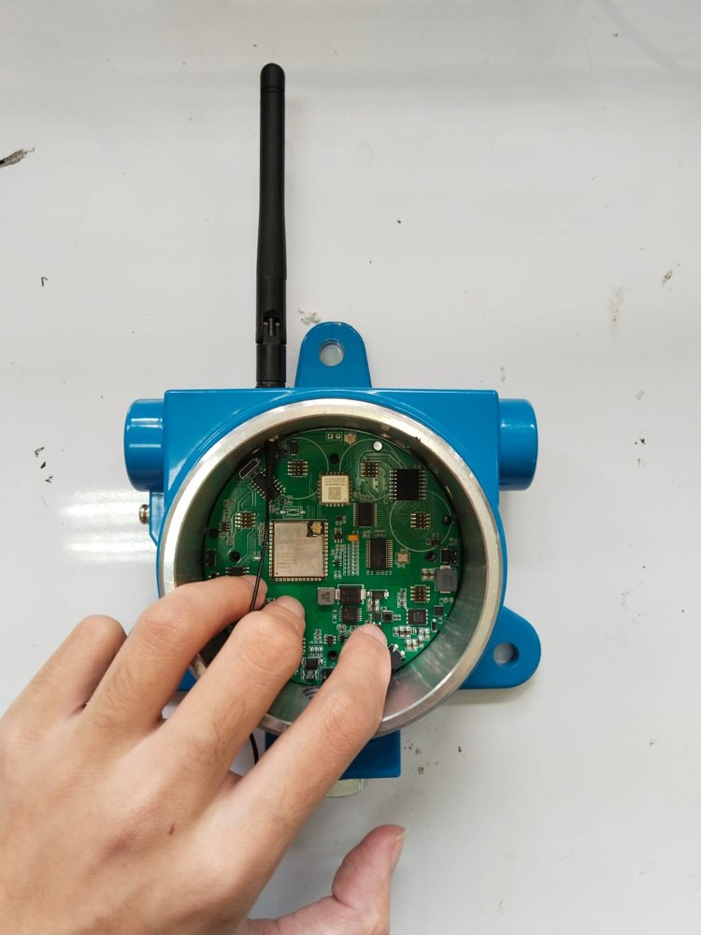  Figure 4-102. GLD V2 – Main board placed in the base enclosure.  Main PCB with the ESP32-S3 module and LoRa module seated on the mounting bosses.
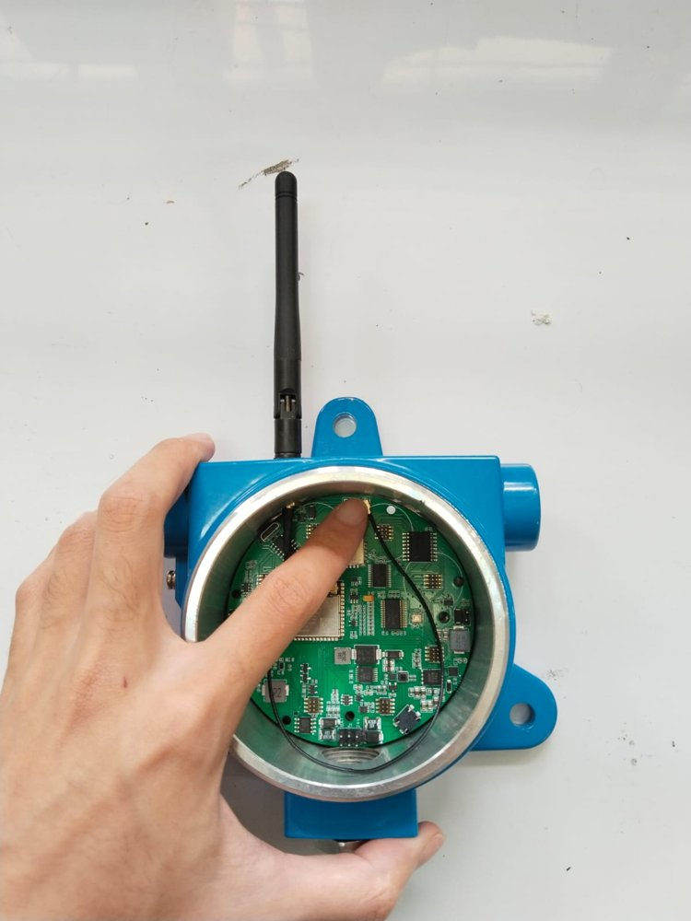  Figure 4-103. GLD V2 – Antenna lead connected to the main board.  U.FL coaxial connector of the antenna lead plugged onto the main board. | 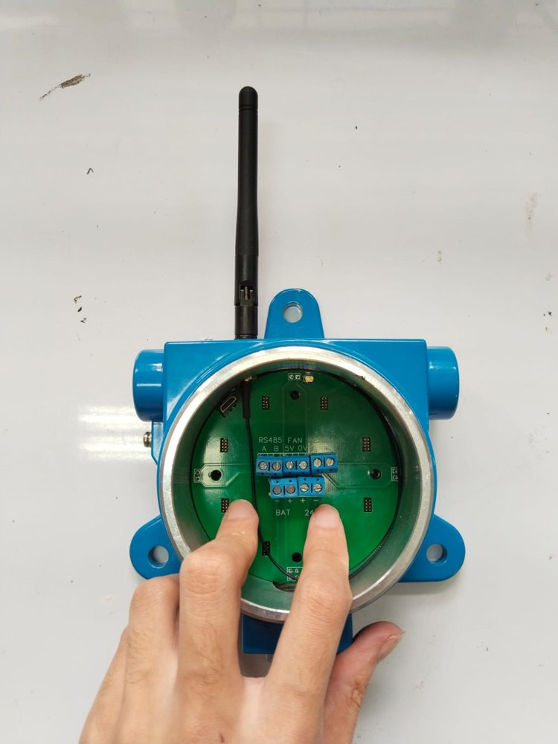  Figure 4-104. GLD V2 – PCB cover / terminal board fitted.  Terminal board with screw terminals labelled RS485 A/B, FAN 5V/0V, ALARM, BAT −/+ and 24V +/−; eight 2×4 headers for the sensor modules and a micro-USB service port.
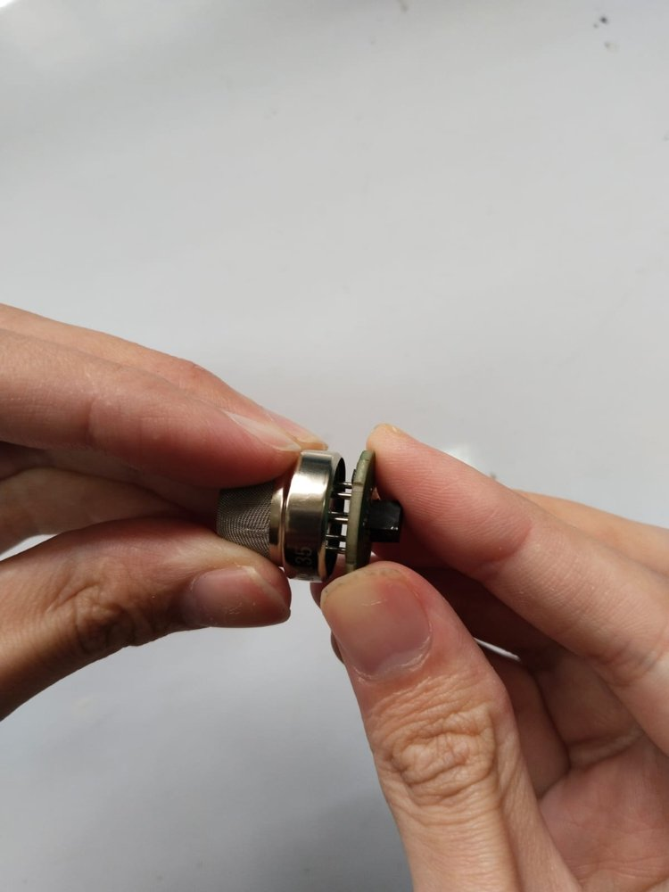  Figure 4-105. GLD V2 – Sensor module.  MQ-series sensor with its integrated stainless-steel protective mesh, mounted on a round carrier board. | 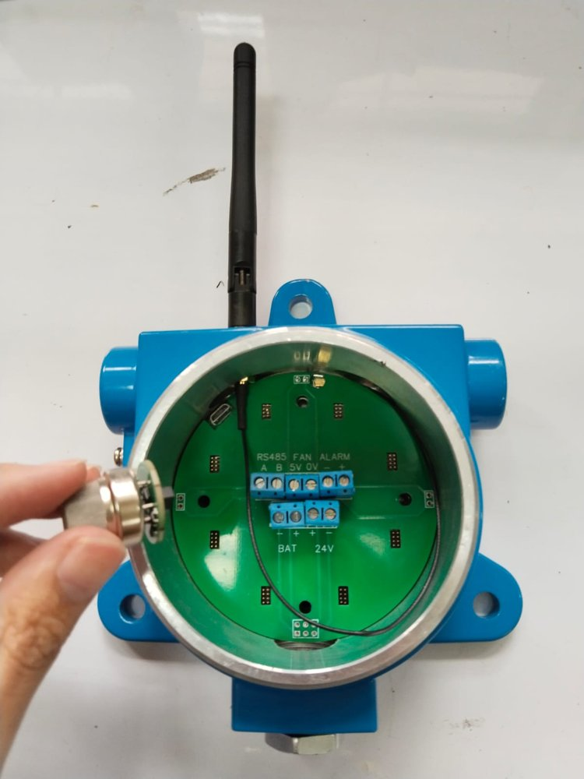  Figure 4-106. GLD V2 – Sensor module being inserted.  Sensor module plugged into one of the eight headers.
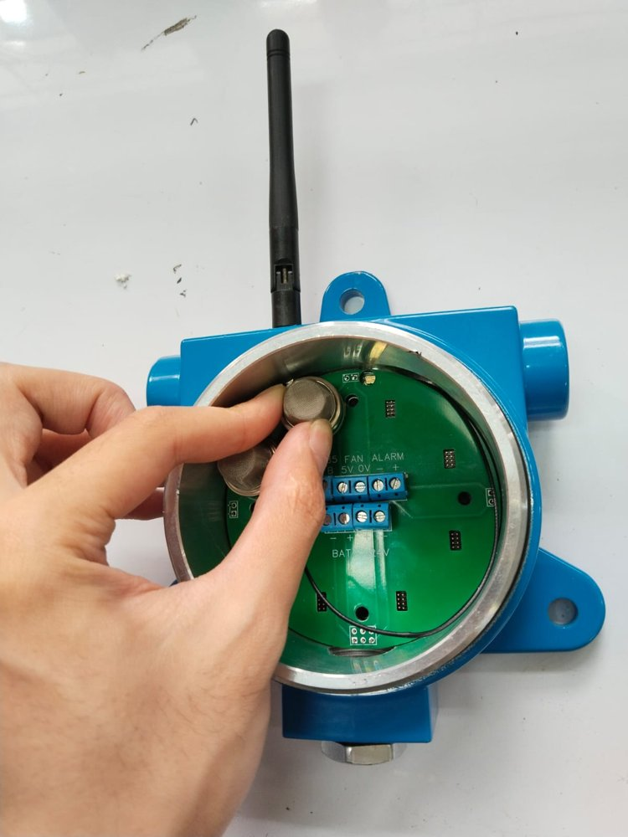  Figure 4-107. GLD V2 – Sensor modules fitted.  Sensor modules installed on the terminal board positions. | 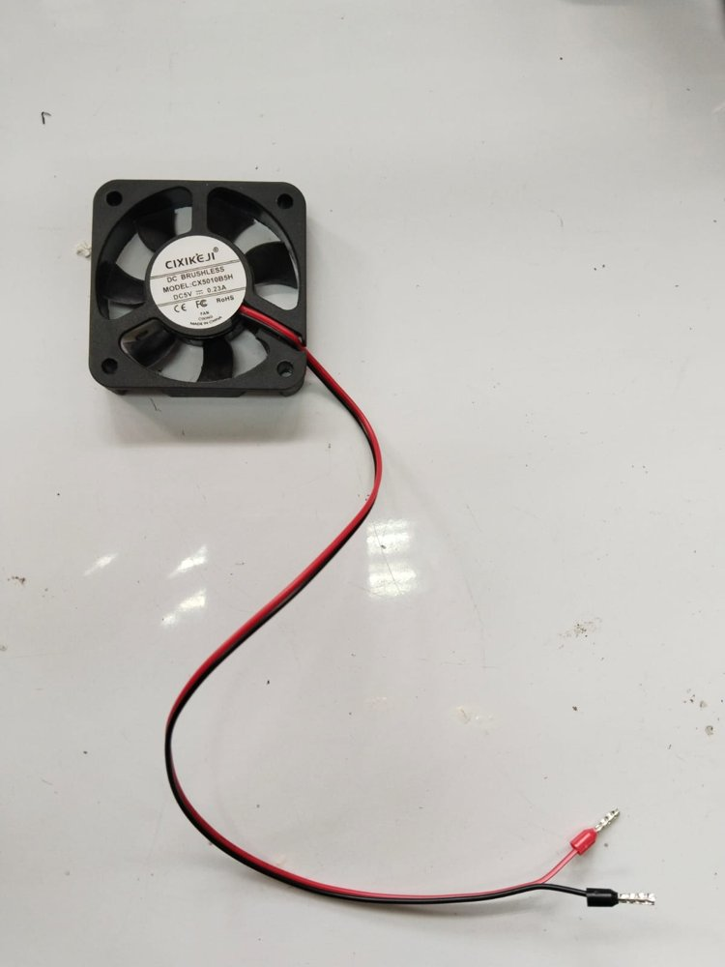  Figure 4-108. GLD V2 – DC sampling fan.  CIXIKEJI DC brushless fan, model CX5010B5H, DC 5 V 0.23 A (label marks CE, FC, RoHS), with ferrule-terminated leads.
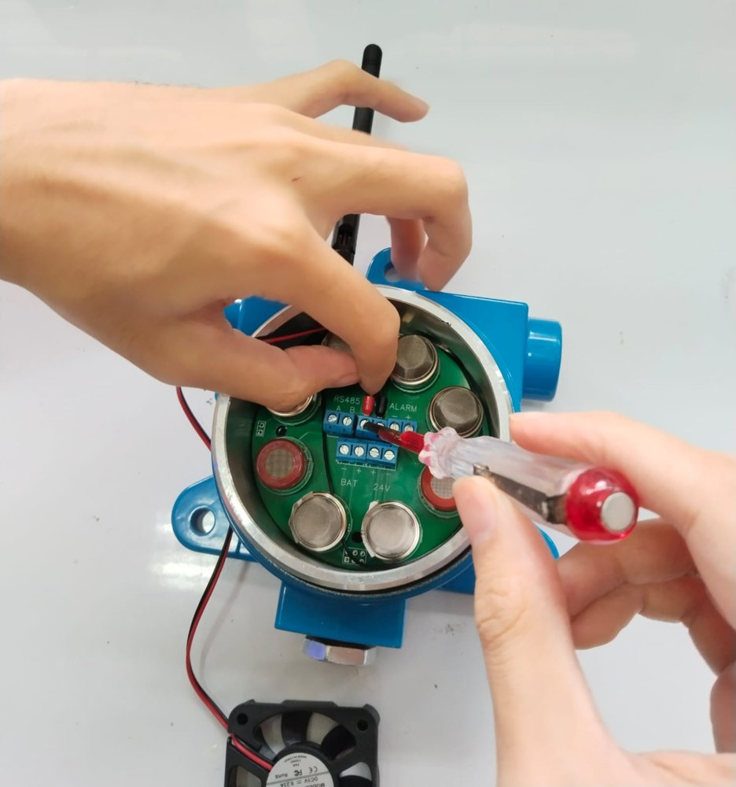  Figure 4-109. GLD V2 – Fan leads terminated.  Fan leads connected to the FAN 5V/0V terminal. | 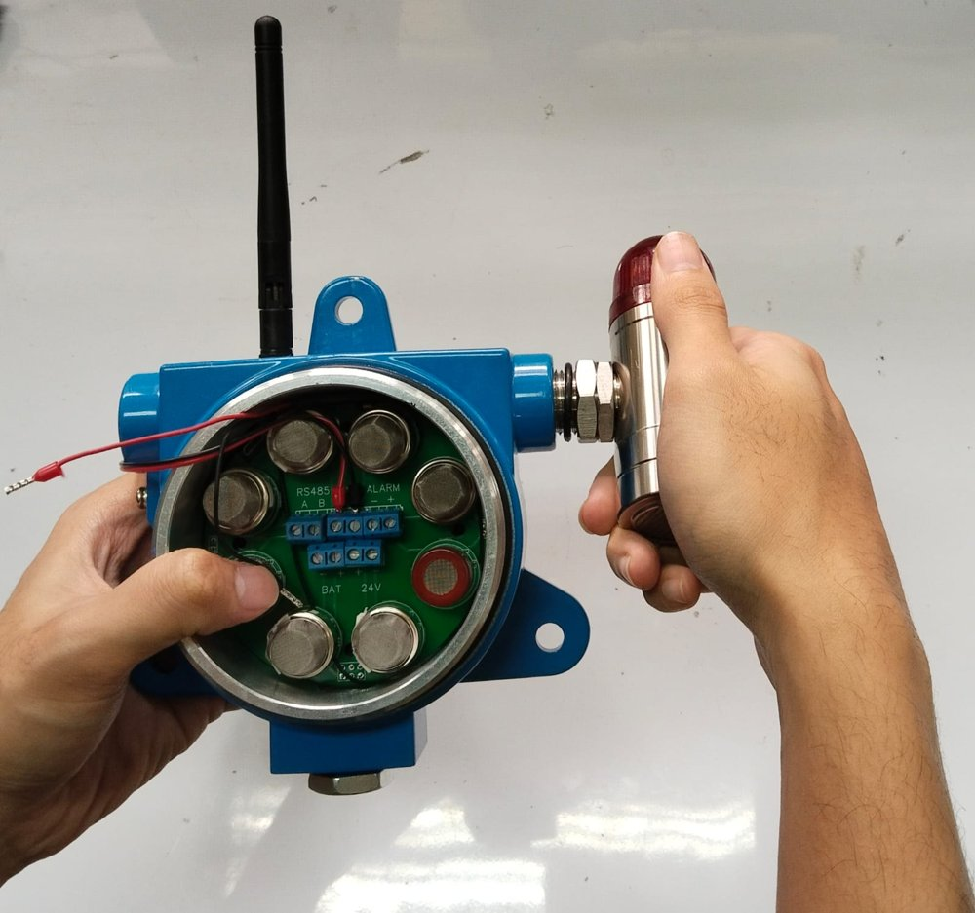  Figure 4-110. GLD V2 – Alarm beacon fitted.  Visual/audible alarm beacon (stainless-steel body, red dome) threaded into the right-hand entry; its leads are routed to the terminal board.
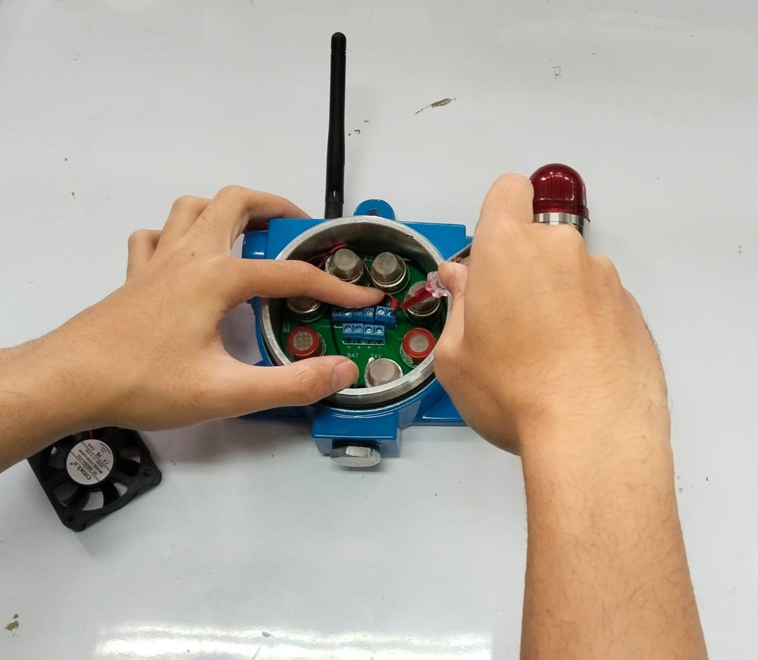  Figure 4-111. GLD V2 – Alarm leads terminated.  Beacon leads connected to the ALARM terminal. | 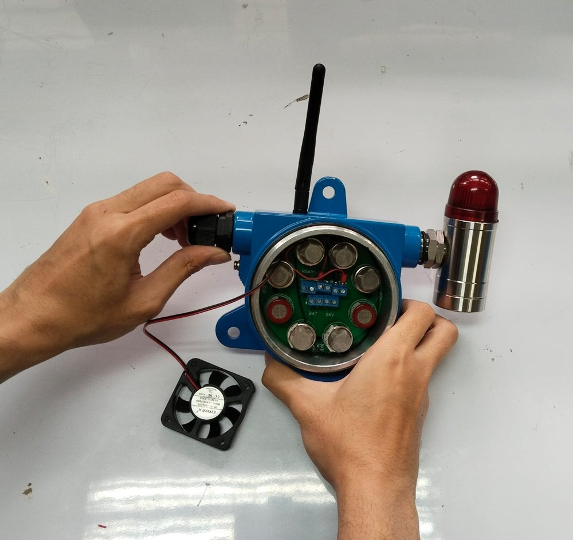  Figure 4-112. GLD V2 – Cable gland fitted to the left-hand entry.  Cable gland of the current prototype (black polymer body) installed in the power-cable entry.
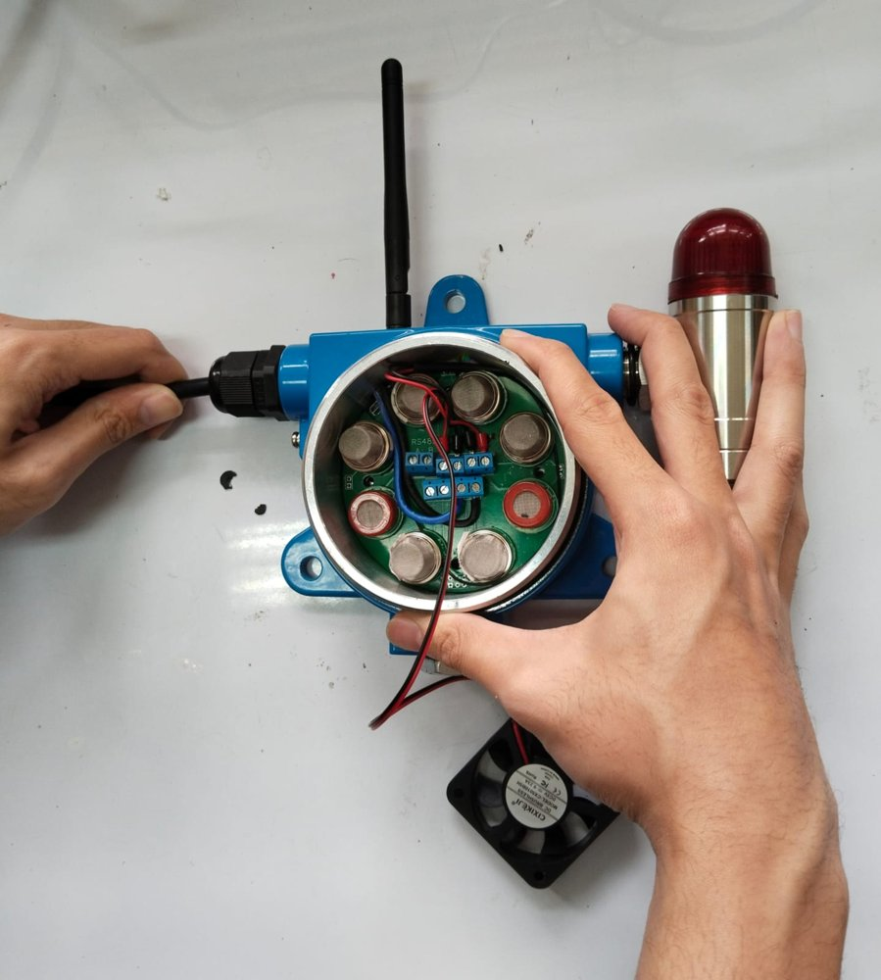  Figure 4-113. GLD V2 – 24 VDC cable inserted.  24 VDC supply cable passed through the cable gland. | 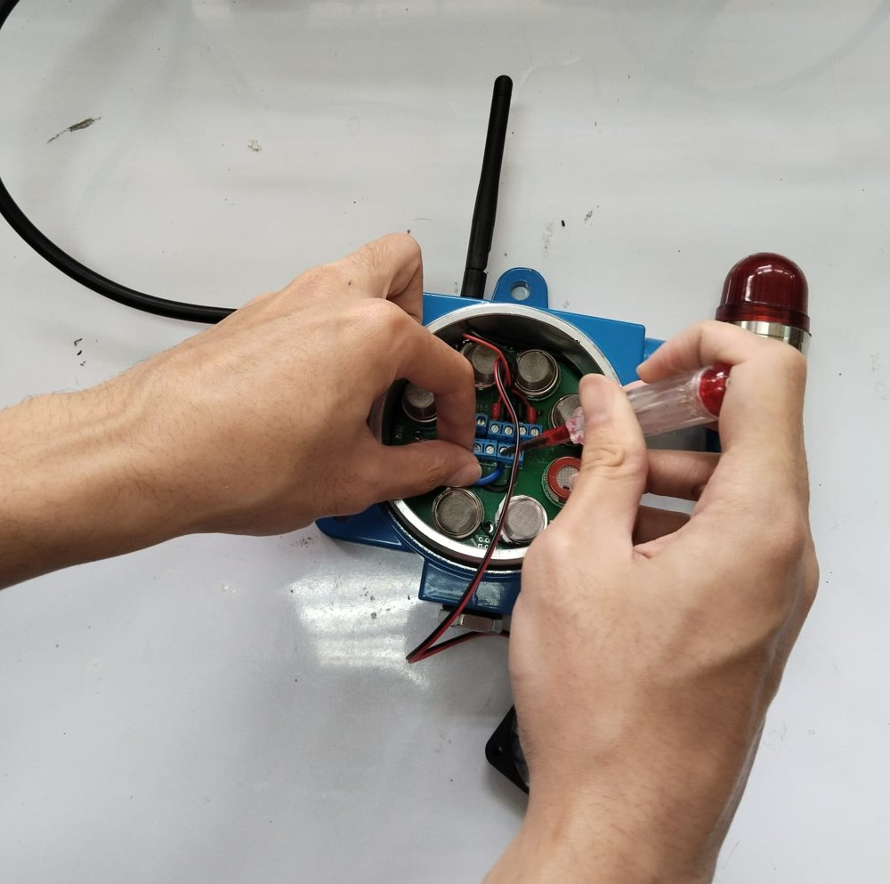  Figure 4-114. GLD V2 – 24 VDC conductors terminated.  Supply conductors connected to the 24V +/− terminal.
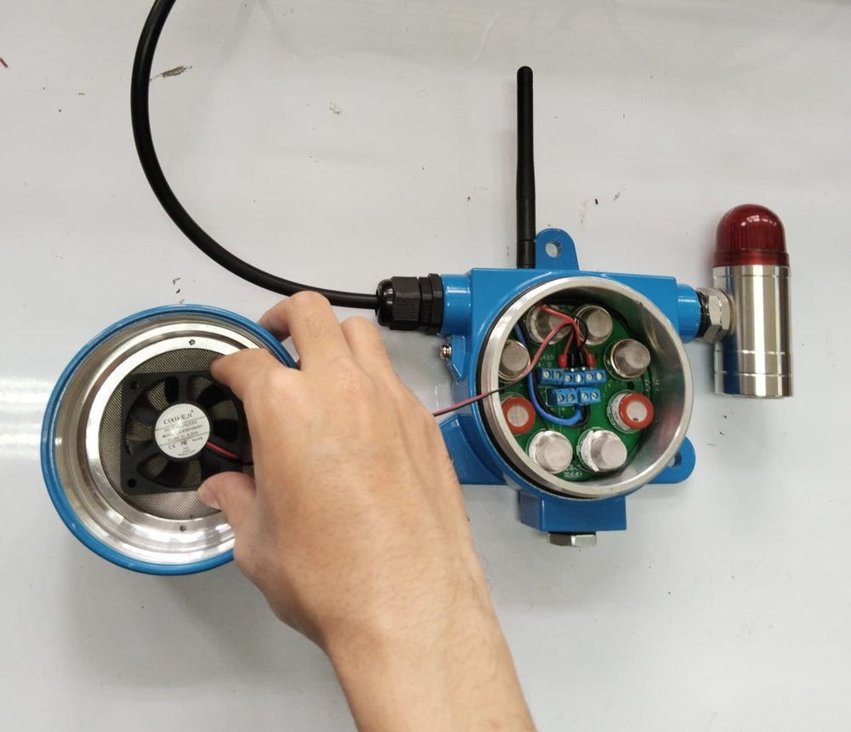  Figure 4-115. GLD V2 – Cover with sampling fan.  Enclosure cover with the DC fan mounted directly behind the stainless-steel mesh; cover being fitted. | 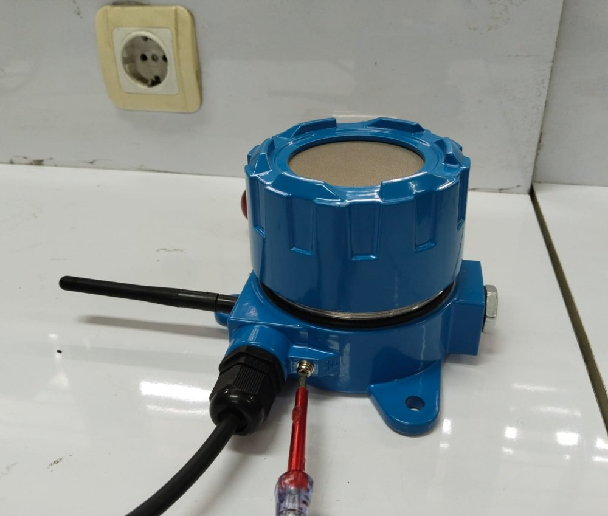  Figure 4-116. GLD V2 – Assembled unit — grounding.  Cover closed; the external grounding screw beside the cable gland is being tightened.
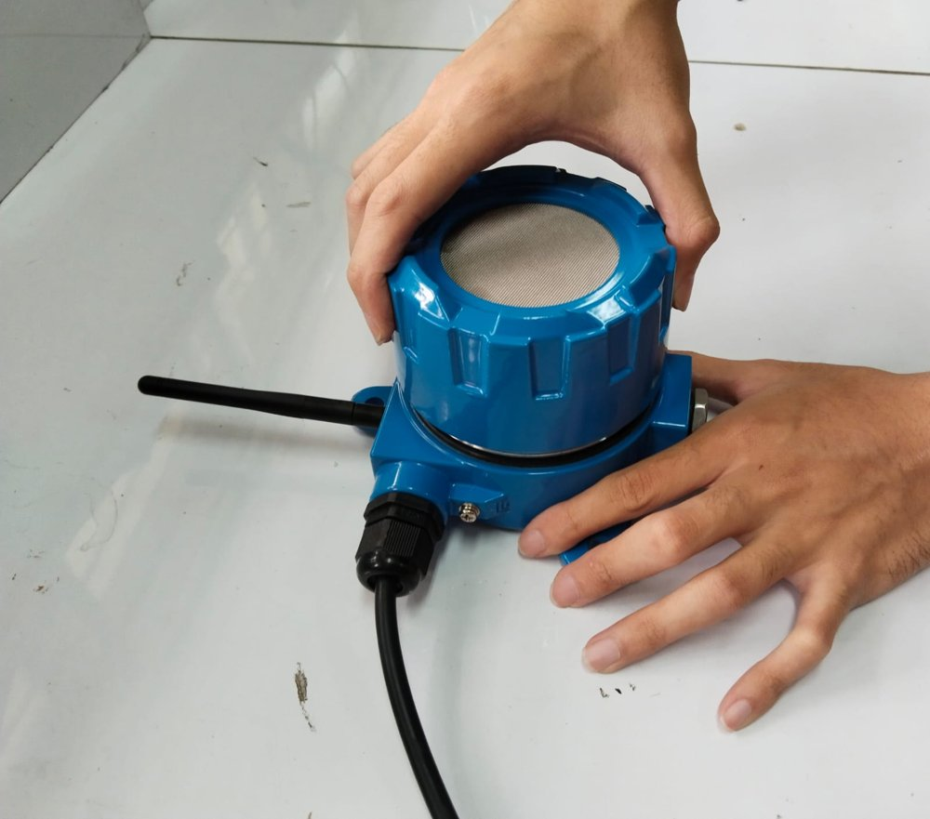  Figure 4-117. GLD V2 – Threaded cover being closed.  The threaded cover is screwed onto the base by hand. | 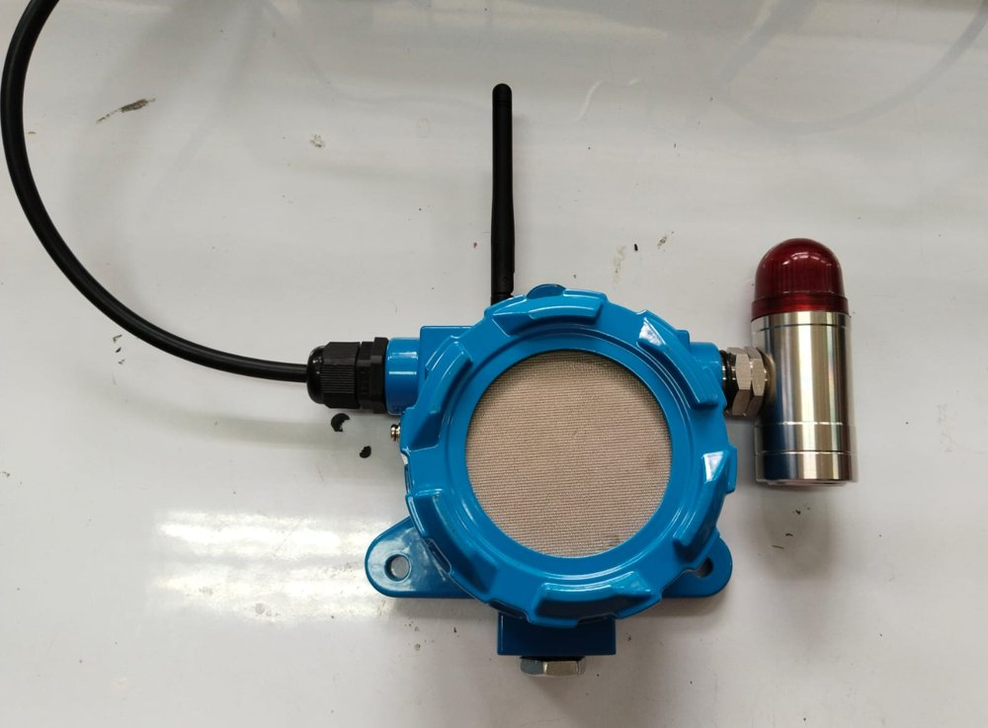  Figure 4-118. GLD V2 – Assembled unit — front view.  Stainless-steel mesh sensing face; cable gland (left), alarm beacon (right), antenna (top).
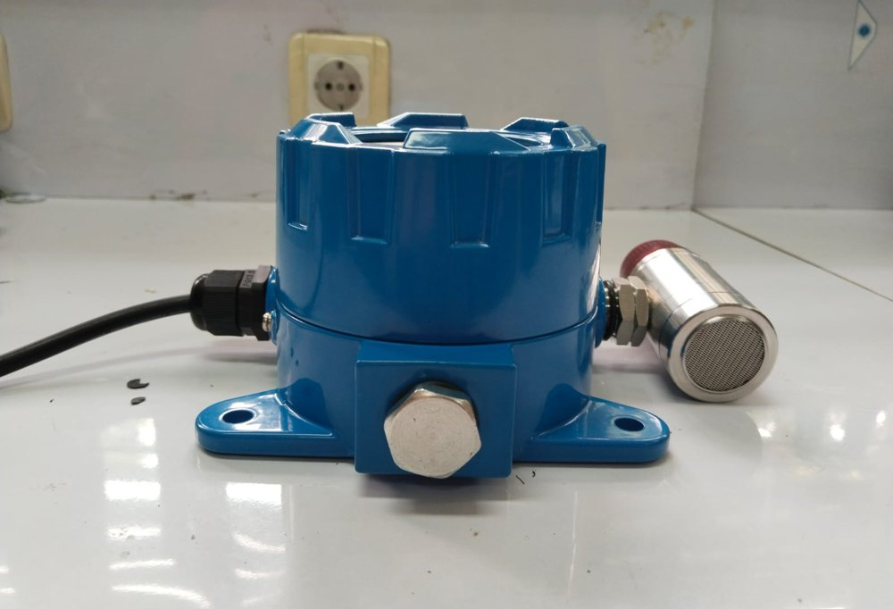  Figure 4-119. GLD V2 – Assembled unit — side view with blanking plug.  Hexagon blanking plug closing the lower entry; alarm beacon on the right. | 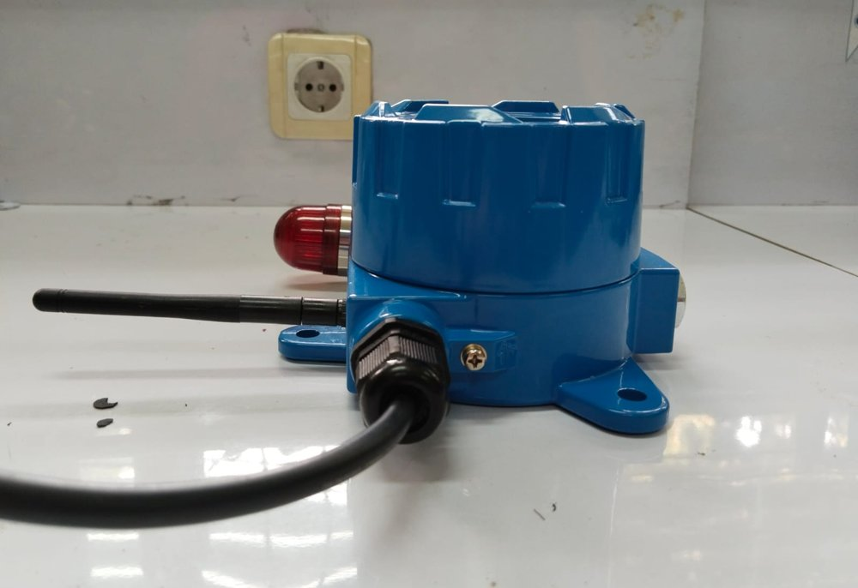  Figure 4-120. GLD V2 – Assembled unit — side view with cable entry.  Cable gland, external grounding screw and antenna.
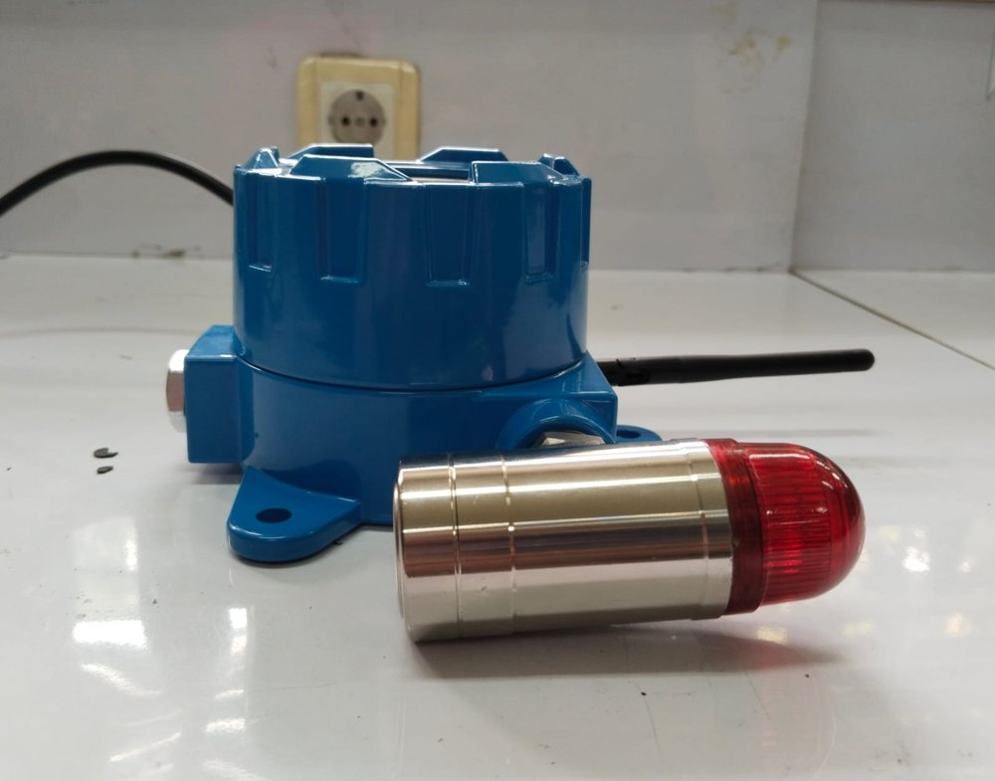  Figure 4-121. GLD V2 – Assembled unit — side view with beacon.  Alarm beacon and mounting lugs. | 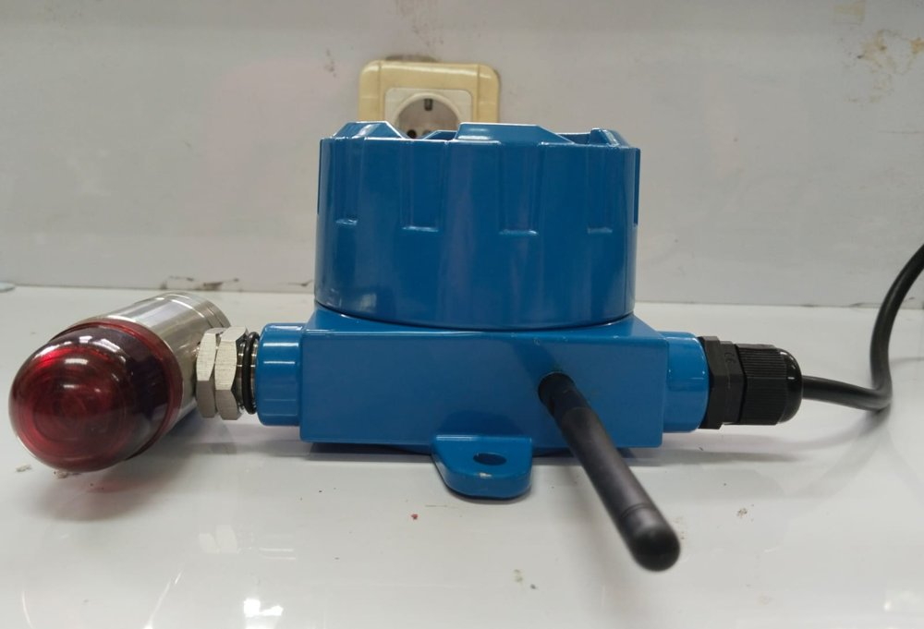  Figure 4-122. GLD V2 – Assembled unit — side view of the base.  Beacon entry (left), cable gland (right) and antenna.
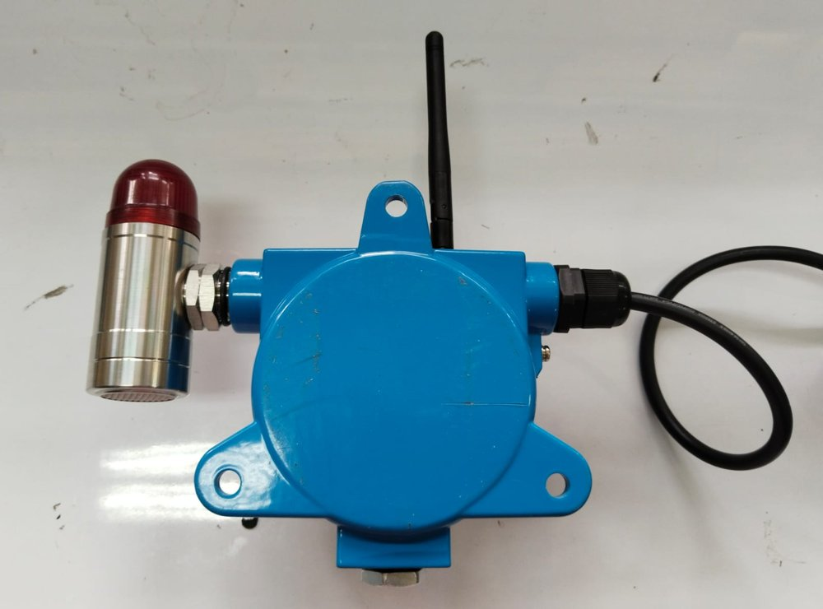  Figure 4-123. GLD V2 – Assembled unit — rear view.  Rear face of the base with mounting lugs; antenna (top), beacon (left), cable gland (right). | 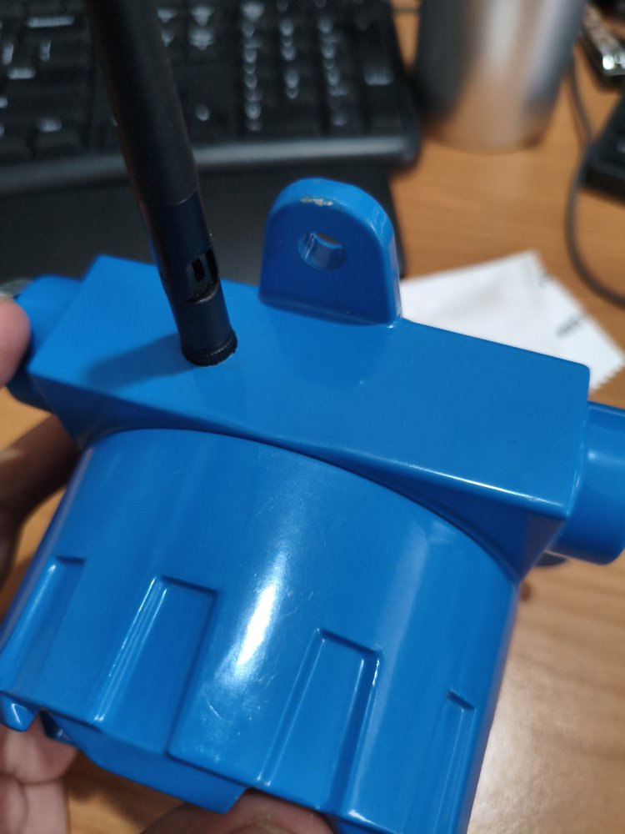  Figure 4-124. GLD V2 – Nameplate position.  Flat top face of the base enclosure beside the antenna, between the antenna and the mounting lug — the intended location of the nameplate (marking still draft; not yet fitted).
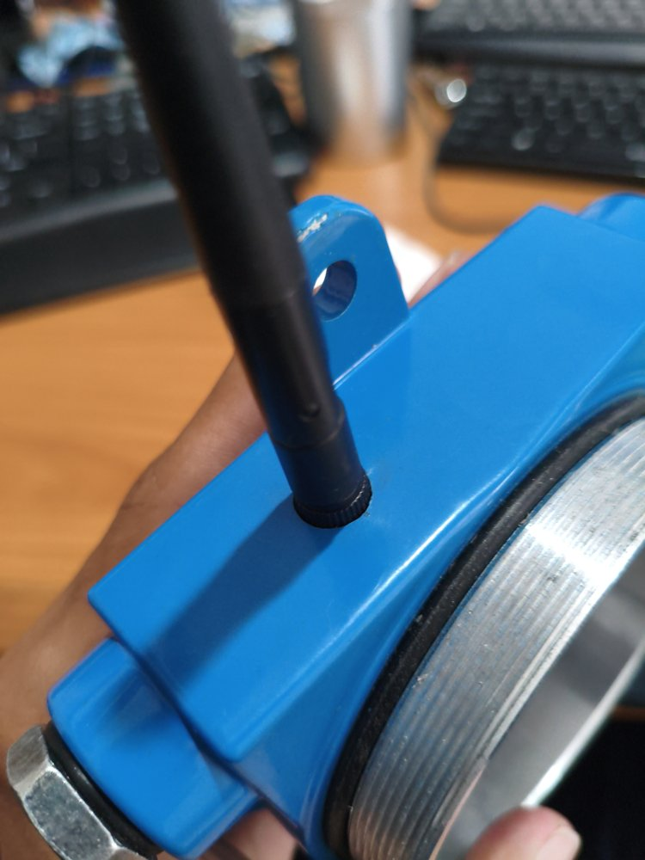  Figure 4-125. GLD V2 – Antenna interface — outside.  External antenna screwed onto its connector on the top face of the base enclosure; the threaded cover joint with its black O-ring and the hexagon blanking plug with O-ring are also visible. | 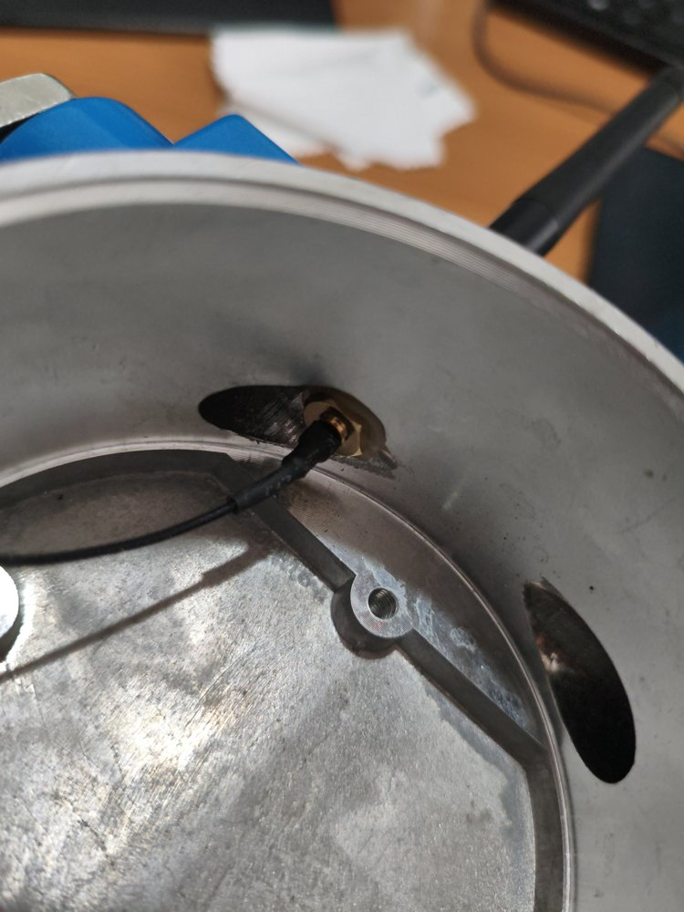  Figure 4-126. GLD V2 – Antenna interface — inside the enclosure.  Brass SMA bulkhead seated in a spot-faced hole through the enclosure wall, with the U.FL pigtail running to the main board; PCB mounting boss below.
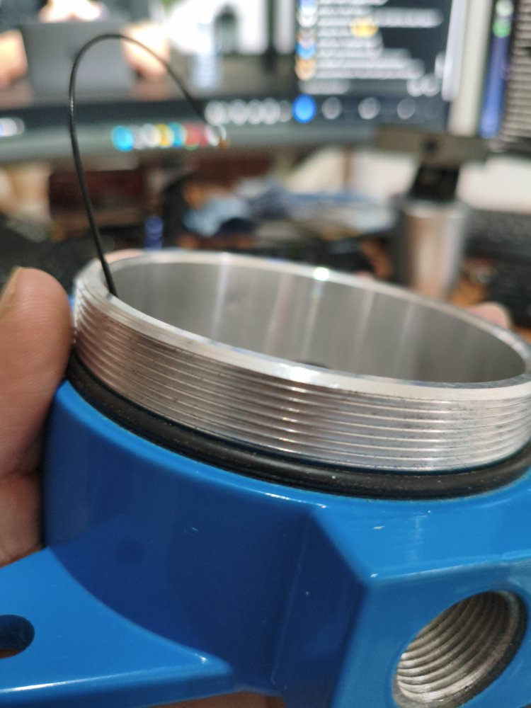  Figure 4-127. GLD V2 – Cover thread and side-entry thread.  External thread on the base neck that carries the threaded cover (about 10 visible threads), black O-ring at the root of the thread, and an internally threaded side entry (estimated M20 × 1.5). Caliper measurements of the same neck are given in Figures 4-128 to 4-131; see Section 2.6.e.3. | 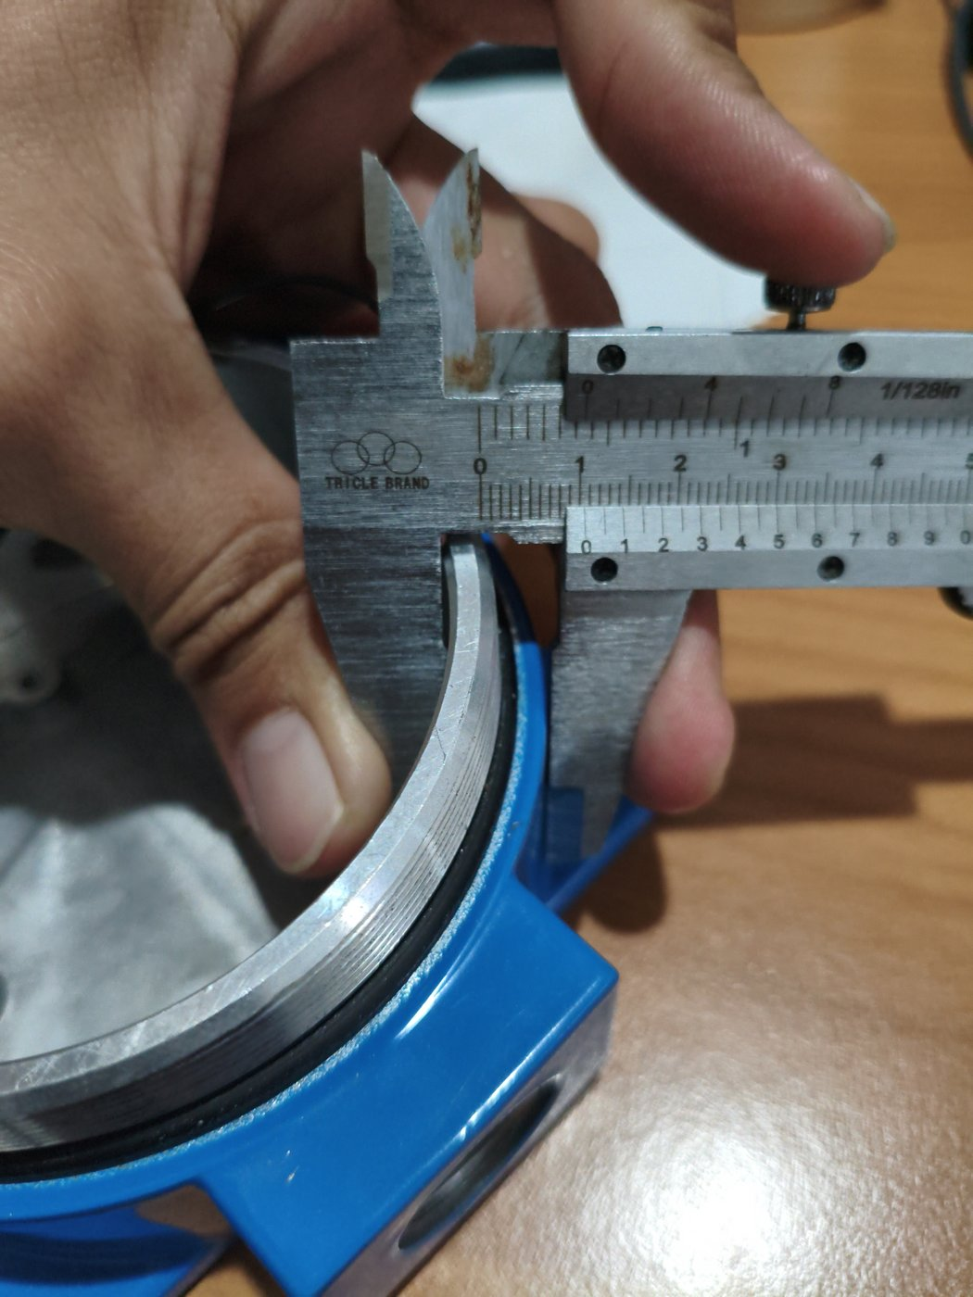  Figure 4-128. GLD V2 – Base neck wall at the O-ring — caliper 10.50 mm.  Vernier caliper (0.05 mm) across the neck wall at its root, just above the O-ring: reading 10.50 mm.
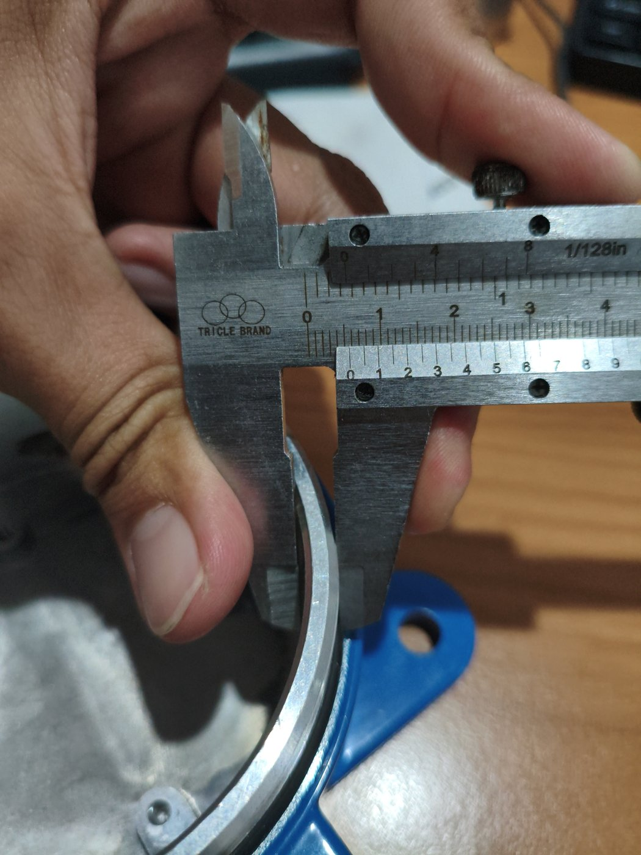  Figure 4-129. GLD V2 – Base neck wall at the top — caliper 5.80 mm.  Caliper across the threaded neck wall at its top edge (inner bore to thread crest): reading 5.80 mm. | 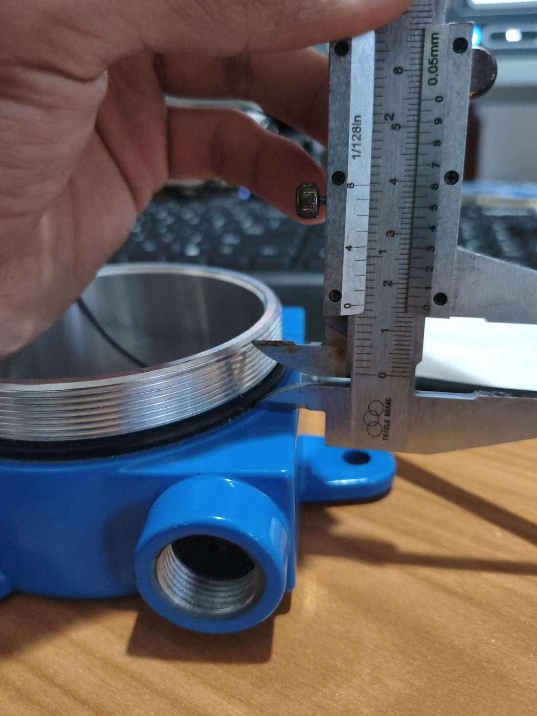  Figure 4-130. GLD V2 – Threaded neck height — caliper ≈14.8 mm.  Caliper held vertically from the base shoulder (O-ring level) to the top of the threaded neck: reading ≈14.8 mm; about 10 thread crests are visible over this height.
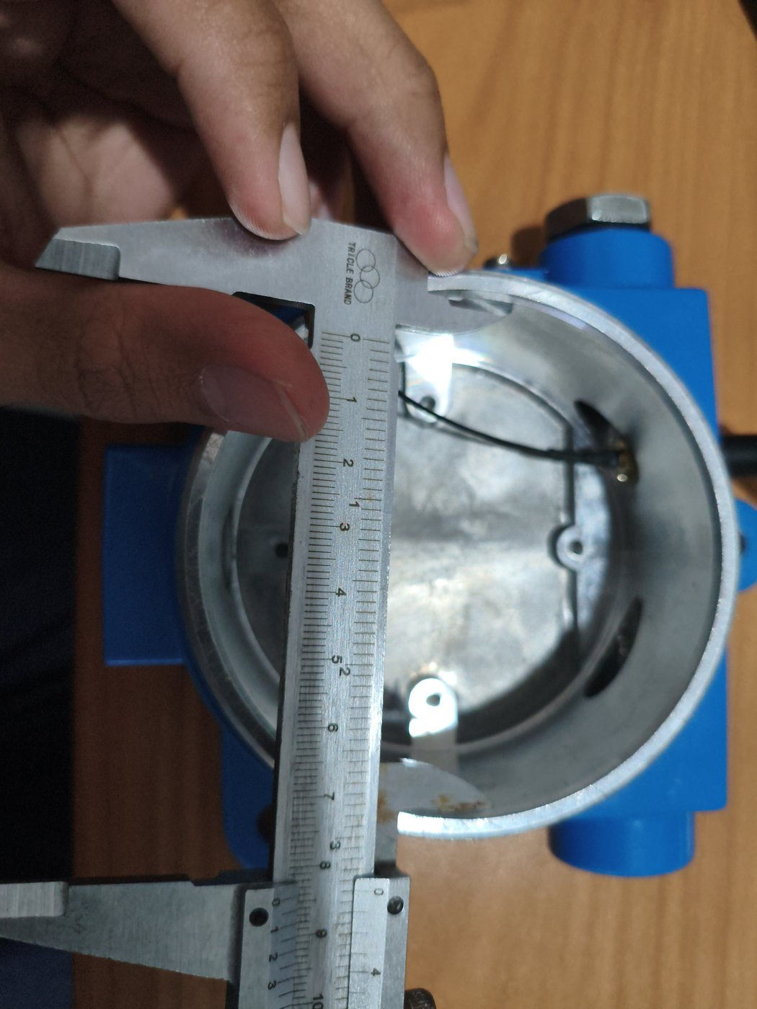  Figure 4-131. GLD V2 – Base inner bore — caliper ≈84.7 mm.  Inside jaws across the bore of the base at the top of the neck: reading ≈84.7 mm. | 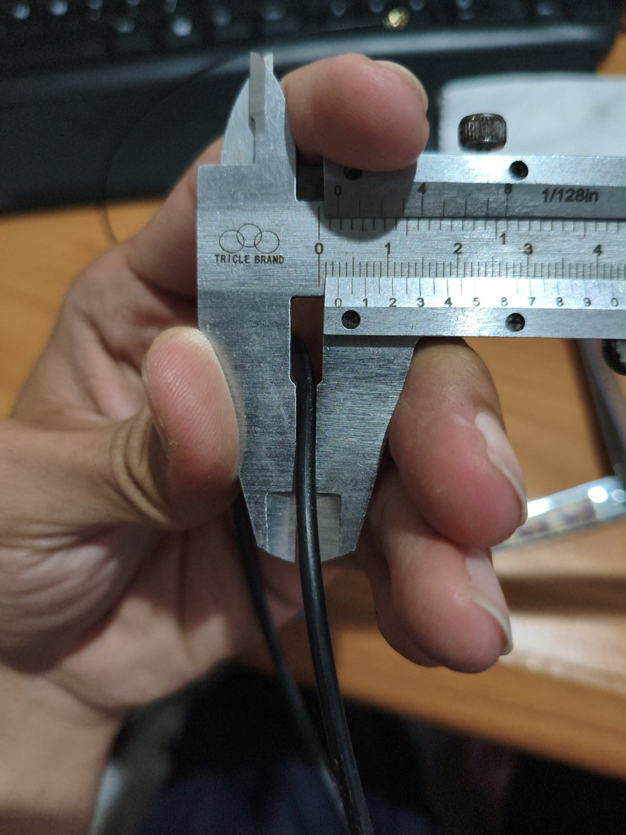  Figure 4-132. GLD V2 – Cover O-ring — cord cross-section 2.70 mm.  Black rubber O-ring of the cover-to-base joint measured across its cord: reading 2.70 mm.

2.4.1 Photo-set coverage against the revision guide
The revision guide asks for a photo set covering twelve views. The table maps each requested view to the figures already included in this document and lists the views still to be photographed on the current production configuration (latest enclosure and PCB). Captions follow the format “Figure 4-n. GLD V2 – <title>” with a one-sentence description; no Ex marking is shown as final and the MQ sensor mesh is not described as flame-arresting.
# | Requested view | Status | Where shown / action
1 | Overall external view — front, rear, left, right, top, bottom | Available | Current production unit: Figures 4-118 (front), 4-119…4-122 (sides), 4-123 (rear), 4-116 (closed, top); CAD views M-A2 and M-B1…M-B4.
2 | Product identification / nameplate area | Available | Figure 4-124: flat top face of the base beside the antenna; marking draft, plate not yet fitted.
3 | Front sensing area (mesh, cover, fan behind it) | Available | Figure 4-115 (fan behind the mesh in the cover), 4-118 (mesh face); M-D4.
4 | Internal sensing section (8 MQ sensors, fan, chamber) | Available | Figures 4-107, 4-109…4-115 (sensor modules fitted, fan and cover); M-D6.
5 | MQ sensor close-up (integrated protective mesh) | Available | Figure 4-105 (sensor module); M-D1.
6 | Main PCB — component side and underside | Partial | Figures 4-102, 4-103 (component side in the enclosure); top/bottom renders of main board and PCB cover (Figure 8-11); layout views 2.6.a.8. Photograph of the real board underside to be added.
7 | Power input and terminal area | Available | Figures 4-104 (labelled terminal board), 4-112…4-114 (gland, cable, 24V termination).
8 | Grounding / bonding point | Partial | Figures 4-116, 4-120 (external grounding screw); close-up with lug and conductor to be added.
9 | Cable entry and antenna interface (all penetrations) | Available | Figures 4-112 (cable gland), 4-110 (beacon entry), 4-119 (blanking plug), 4-125/4-126 (antenna bulkhead outside and inside), 4-127 (cover and entry threads), 4-128–4-132 (caliper measurements of the base neck, bore and cover O-ring).
10 | Alarm module (LED/buzzer, gasket, fixing) | Available | Figures 4-110, 4-111; M-D5, M-E4.
11 | Enclosure opened — complete internal arrangement | Available | Figure 4-115 (open base with sensors and terminals next to the cover with fan).
12 | Exploded / assembly sequence photographs | Available | Figures 4-101…4-117 (complete assembly sequence); exploded illustrations M-D8, M-D9, M-E1.

2.5 · Description of Intended Use and Installation Environment (Gas Group, Temperature Class, Area Classification)
The GLD is intended for continuous, fixed-point monitoring of flammable and toxic gas leaks in oil & gas refinery hazardous areas — process units, tank farms, pipe racks, and loading/unloading areas. The specific Ex classification parameters below reflect the project engineering team's current recommendation, developed from the intended deployment envelope and the gases the device is designed to detect; none of these parameters has yet been confirmed with the certification body (ExCB) or a notified body, and none should be treated as final.
PARAMETER | RECOMMENDED VALUE | STATUS | RATIONALE / REMARKS
Gas group | IIC | Team recommendation — pending ExCB confirmation | Hydrogen (H₂) is one of the three gases the classifier is designed to detect (Section 2.3.b); IIC is required for hydrogen and inherently covers IIB and IIA.
Temperature class | T4 (≤135°C) | Team recommendation — pending verification | Supported by a preliminary internal surface-temperature measurement (Section 2.6.f): the highest value, extrapolated to the +60°C maximum ambient, is ≈114°C (MQ sensor body, fan-stalled condition), below the T4 limit less the 5 K margin (130°C). Not yet final — several measurement points and conditions remain open (see 2.6.f), and confirmation requires ExCB type testing.
Ambient temperature range | −20°C to +60°C | Final | Project-confirmed value, consistent with the Mechanical Parameters table (Section 2.3.c). Used as the reference for extrapolating the preliminary surface-temperature measurements in Section 2.6.f to worst-case ambient.
Area classification (zone) | Zone 1 | Team recommendation — pending ExCB confirmation | Assessed as sufficient for the general refinery deployment envelope, including areas near storage. Zone 0 would only apply if the detector were installed directly inside a tank vapor space.
Type of protection | Ex d — flameproof enclosure | Team recommendation — pending ExCB confirmation | Selected over Ex e and Ex i based on the existing enclosure design: a die-cast aluminum (ADC12) housing with a stainless-steel wire mesh over the sensing element functions as a flame path/flame arrestor, the same pattern used by the three comparable certified gas detectors reviewed as references (all Ex d). Ex i was set aside because the MQ-series sensor heaters draw continuous power (≈0.75 W each) directly from an unregulated 24 VDC supply rather than through certified current-limiting barriers, difficult to reconcile with intrinsically-safe energy limits for Group IIC. Ex e was not pursued because it is not intended for enclosures with normally-energized, potentially arcing parts such as the sensor heaters.

These are engineering recommendations, not a certification decision. An independent readiness assessment of the same checklist item, prepared separately from the underlying firmware/hardware repository, reached the same conclusion — gas group, temperature class, ambient range, zone, and type of protection are not yet formally established. Final classification requires explicit agreement with the ExCB.

2.6 · Design and Manufacturing Information
Nine sub-items (a–i) per the original checklist. Status is reported item by item below; most sub-items are not yet available — this is reported plainly rather than implied to be complete.

2.6.a · Complete Drawings (Assembly, Component, Electrical Schematic, PCB Layout, Enclosure Structure, Junction Box, Terminal, Grounding)
An electrical schematic capture and a corresponding PCB layout exist for the GLD V2 main board as native EasyEDA/JLCPCB source design files (not just a derived summary). From the schematic's traced net list, a supporting block-diagram set (9 sheets, functional/block level, 204 components mapped with documented pin-to-net traceability) has been produced and is reproduced in full below. Field labels in the source diagrams are in Indonesian; English captions are provided under each sheet.
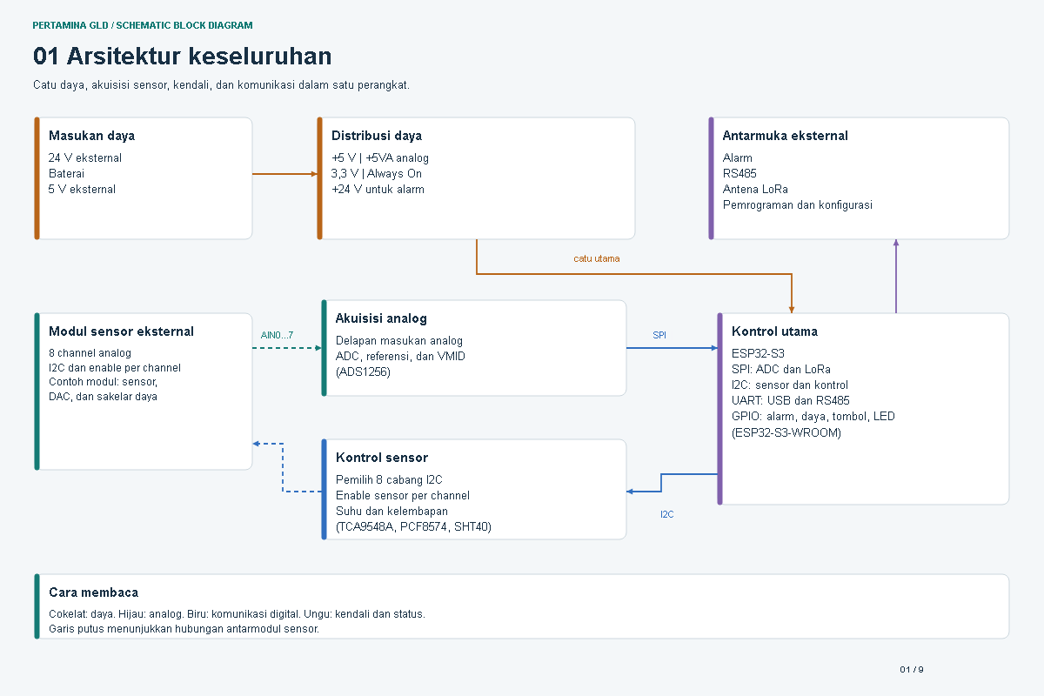
Sheet 1 of 9 — Overall architecture
Power input, power distribution, analog acquisition, sensor control, main control (ESP32-S3), and external interfaces (alarm, RS-485, LoRa antenna, programming/configuration).
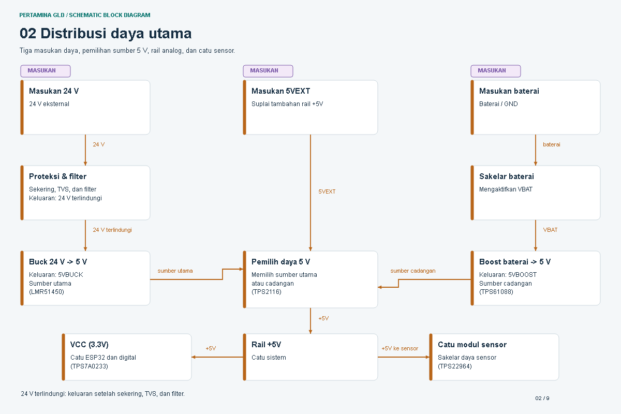
Sheet 2 of 9 — Main power
Main power input rails and distribution: +5 V / +5VA analog, 3.3 V, and +24 V for the alarm circuit.
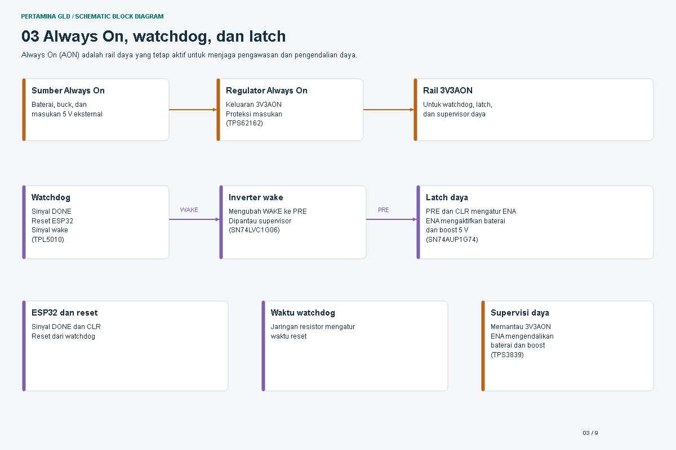
Sheet 3 of 9 — Always-on power
The always-on power domain that remains active independent of the main control state.
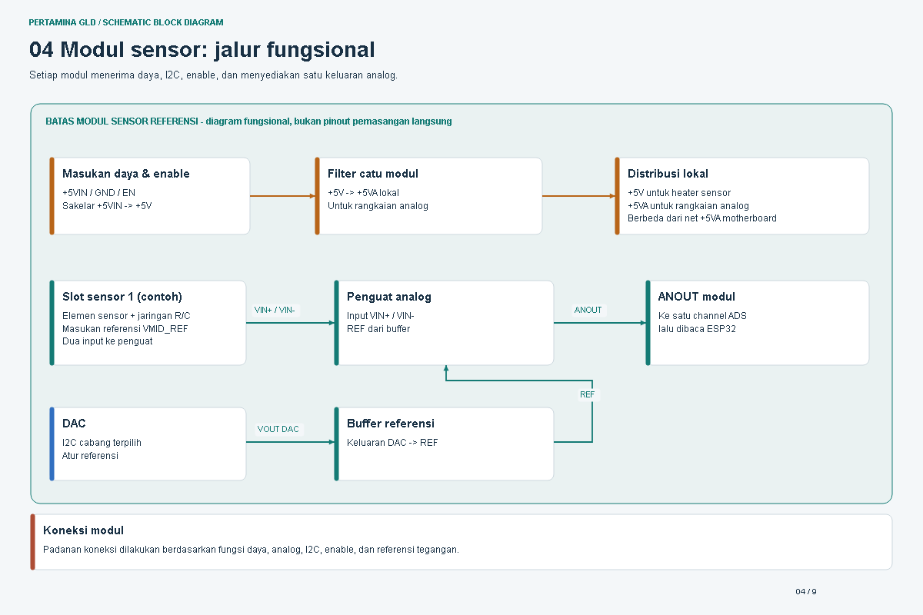
Sheet 4 of 9 — Sensor module
The external gas sensor module: 8 analog channels with per-channel I2C enable, including the sensor, DAC, and power-switch sub-blocks.
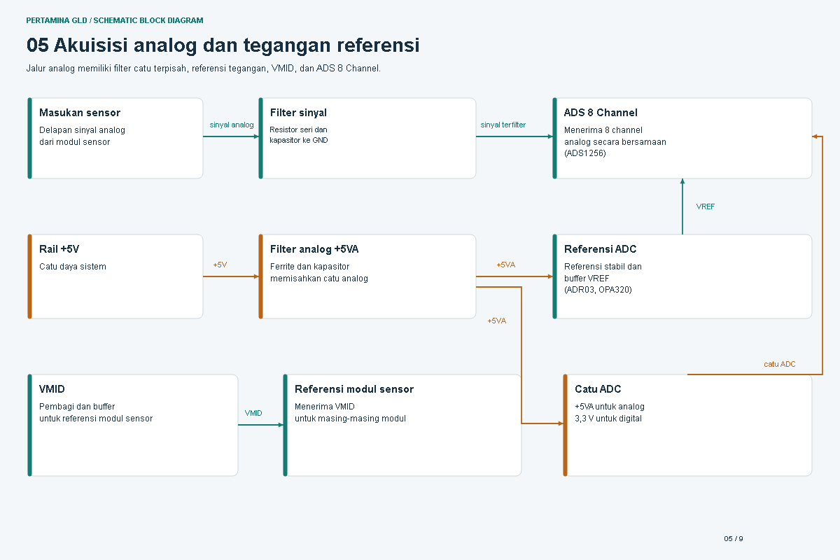
Sheet 5 of 9 — Analog acquisition
The 8-channel analog acquisition front end: analog inputs, ADC (ADS1256), reference, and VMID biasing.
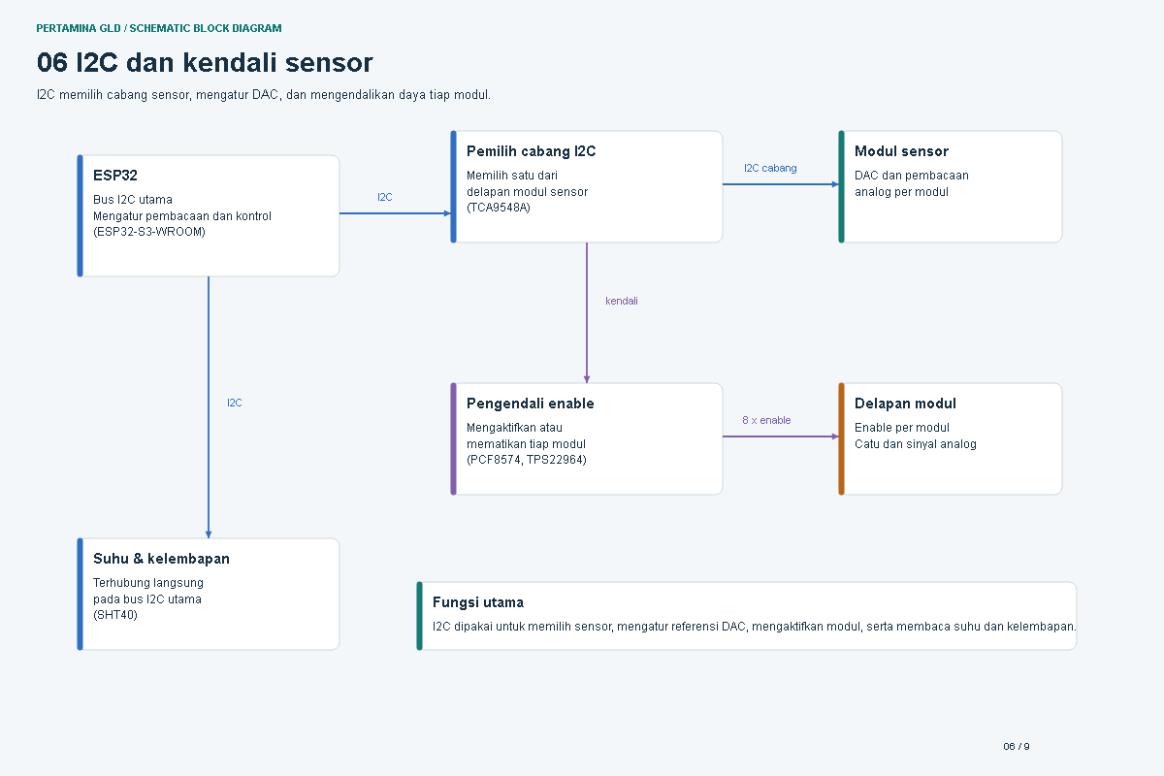
Sheet 6 of 9 — I2C & sensor control
I2C channel selection (TCA9548A), per-channel sensor enable (PCF8574), and the temperature/humidity sensor (SHT40).
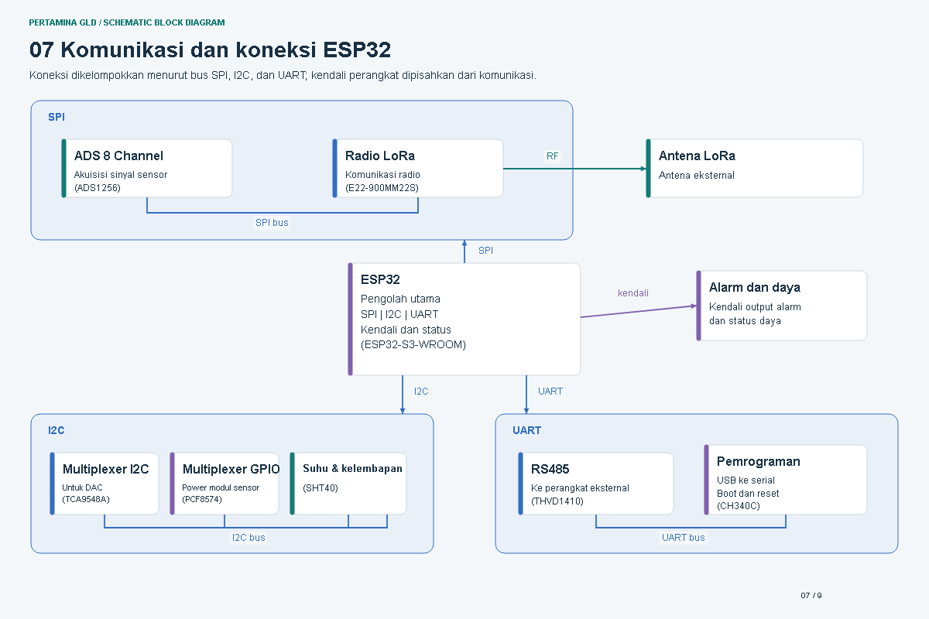
Sheet 7 of 9 — ESP32 connections
Main controller (ESP32-S3) interface map: SPI to the ADC, I2C to sensor/control, UART for USB and RS-485, and GPIO for alarm, power, button, and LED.
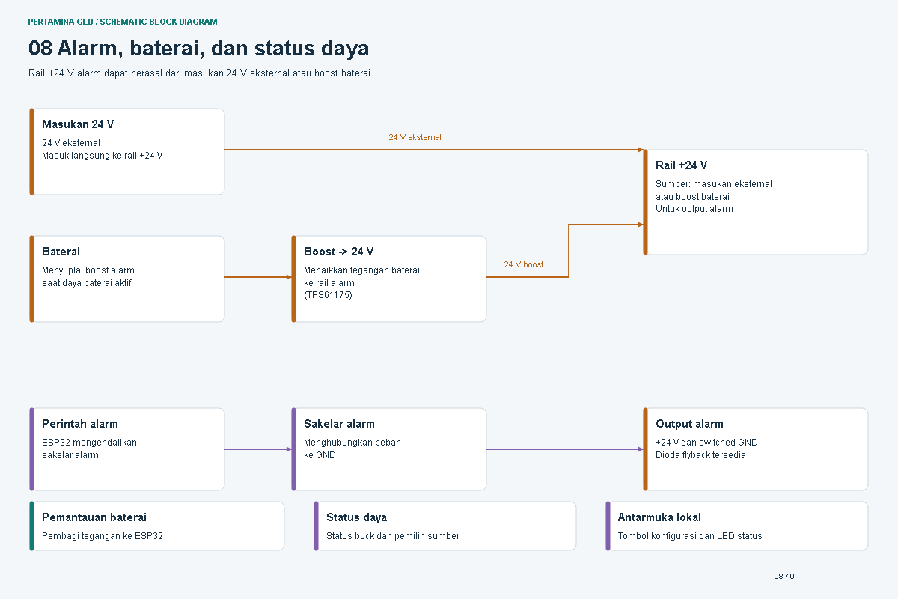
Sheet 8 of 9 — Alarm & status
Alarm output and status-indication circuitry driven from the main controller.
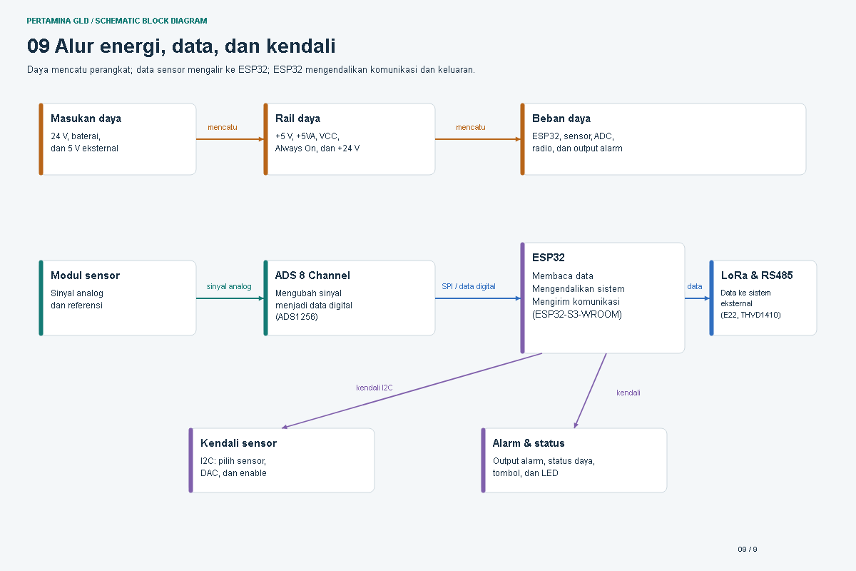
Sheet 9 of 9 — System flow
Overall signal and data flow across the board, summarizing how the preceding eight sheets connect end to end.
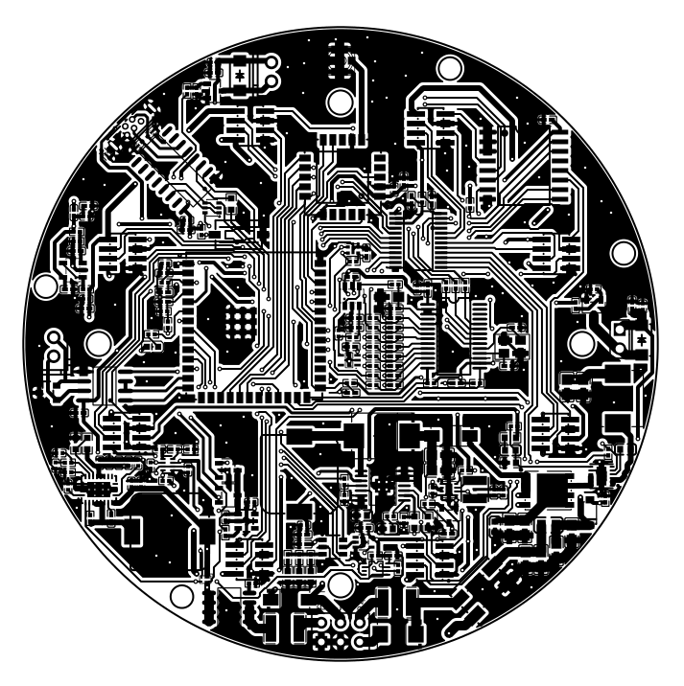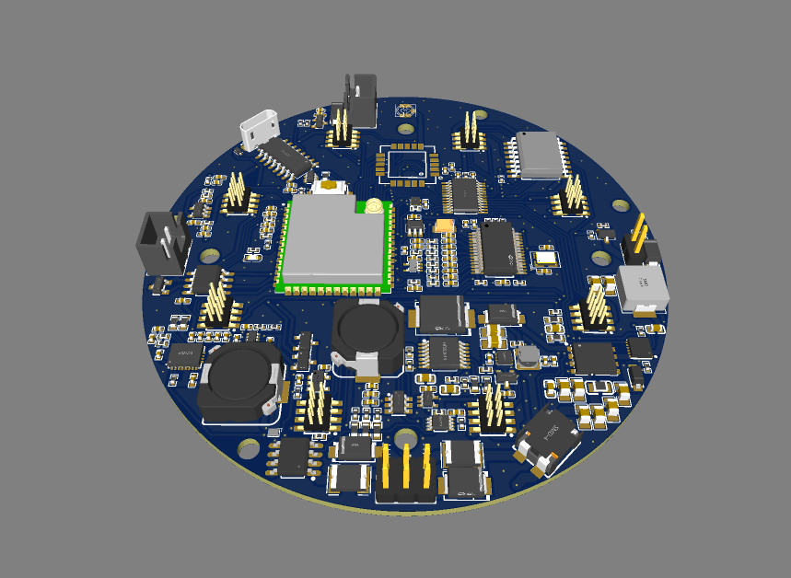
Main board PCB layout (top copper) and 3D populated render
Both exported directly from the EasyEDA/JLCPCB source project (production-intent board, circular outline with six mounting holes). The 3D render shows the ESP32-S3-WROOM module, micro-USB connector, power inductors, and 8-channel I2C header block in their real placed positions; it is an illustrative render, not a dimensioned drawing.
A dimensioned mechanical drawing sheet also exists for the enclosure's external envelope and its mounting hardware, drafted from a solid CAD model (STEP format, millimeter units) with a formal title block, orthographic and isometric views, and a parts table — reproduced below.
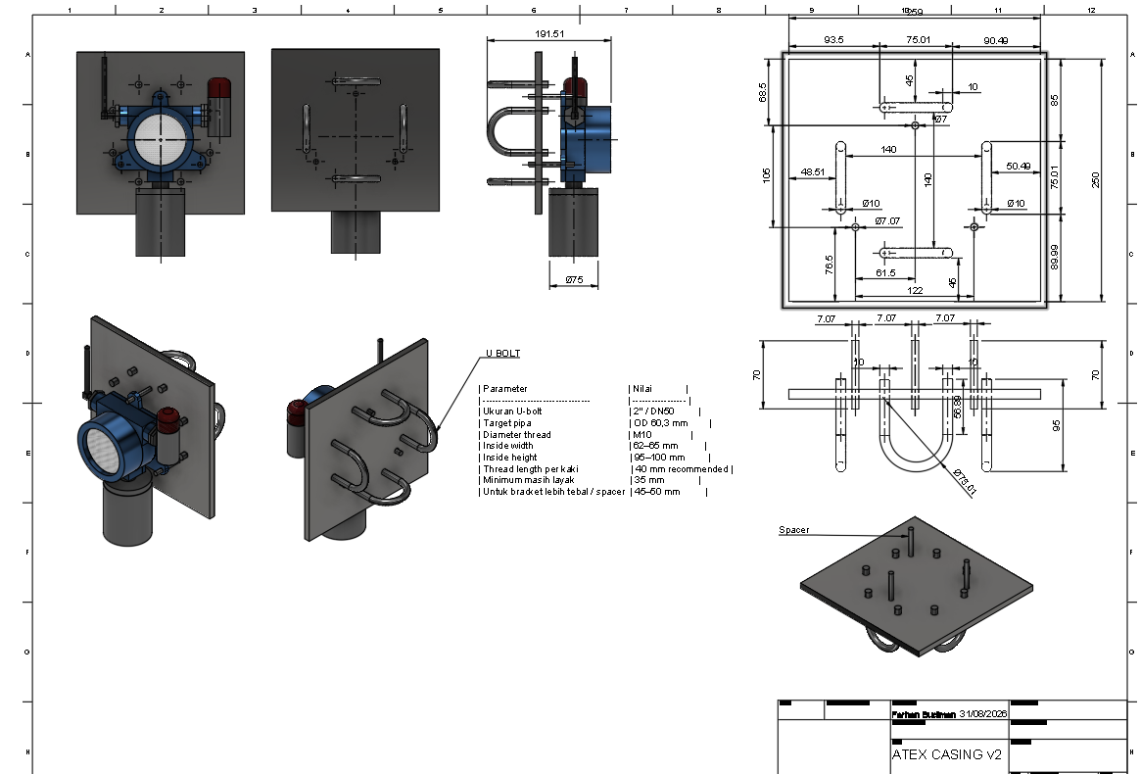
Enclosure envelope & mounting bracket — dimensioned drawing sheet
Orthographic and isometric views with real dimensions (enclosure neck Ø75 mm, overall probe height 191.51 mm, mounting plate 250×250 mm with toleranced hole pattern), a U-bolt parameter table (2″/DN50, M10 thread), and a title block (drafted 31 Aug 2026). Source: dimensioned CAD drawing derived from a STEP solid model of the enclosure and bracket assembly.
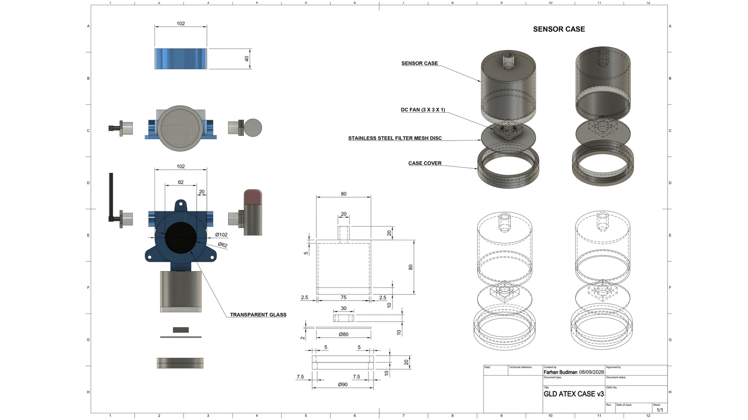
“GLD ATEX CASE v3” — dimensioned enclosure drawing sheet
Internal contingency/alternate enclosure design (drafted 8 Sep 2026) with real dimensions. Shown as a dimensioned reference; not yet confirmed as the production enclosure.
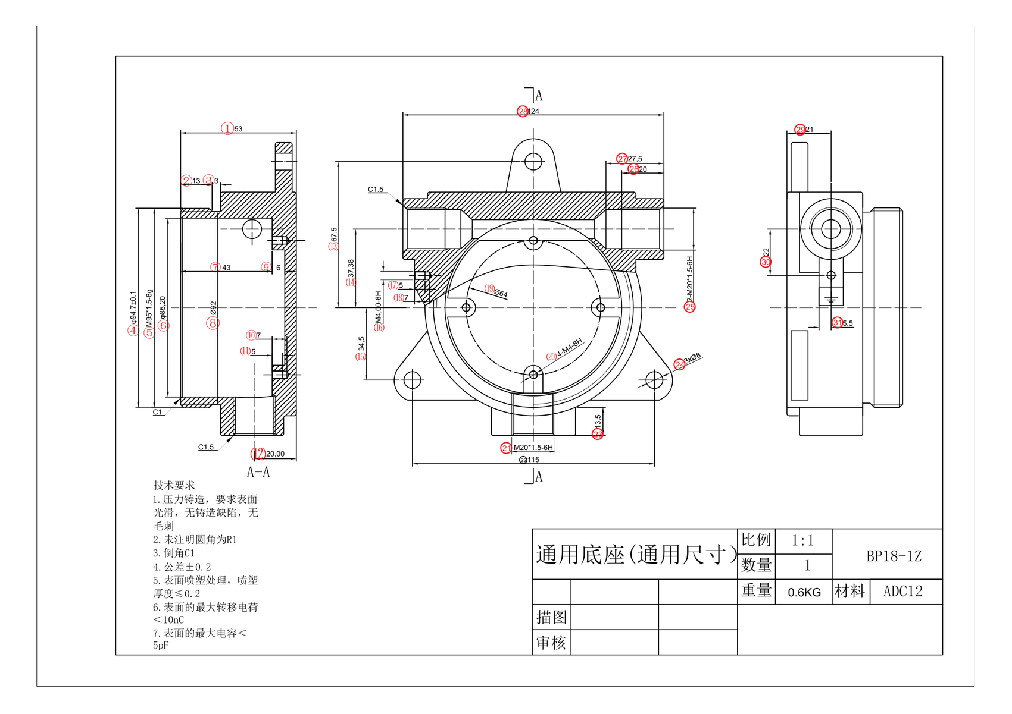
“Universal Base” BP18-1Z — supplier reference drawing
Die-cast base from the casing partner's supply chain (ADC12, 0.6 kg, 2× M20×1.5-6H cable entries). Candidate junction-box/terminal sub-component under evaluation; footprint does not match the GLD main enclosure.
DRAWING TYPE | STATUS | REMARKS
Electrical schematic (component-level) — main board | Available | Actual component-level schematic issued as 26 sheets (drawing nos. PGLD-GLD-V4-MB-SCH-01 to -26, rev. 1.0, 19 Jul 2026), each with a sheet information table and component description table (Section 2.6.a.7). Drawing-number prefix to be aligned with the applicant's document control; verification items listed in 2.6.a.7 remain open. Sensor-module board schematic not yet included.
PCB layout — main board | Partially available | Ten annotated layout views (top, bottom, placement, dimensions Ø84 mm, mounting holes, connectors, power area, sensor interface, grounding) issued as PGLD-GLD-V4-MB-PCB-01 to -10 (Section 2.6.a.8). Open: layout revision/date, laminate data (grade, UL 94, Tg, CTI, thickness, copper weight) and the sensor-module board layout.
Assembly drawing | Partially available | A dimensioned drawing sheet exists for the enclosure/bracket mounting assembly (title block, orthographic + isometric views, parts table). It covers the external envelope and mounting hardware, not the internal PCB/component assembly sequence.
Component drawing | Not yet available
Enclosure structure drawing (gap, length, volume) | Partially available | External envelope is dimensioned (from a real STEP solid model, millimeter units) in the drawing above. The Ex-d-specific flame-path parameters — joint gap, length, and free internal volume — are not called out; that dimensioning has to be added deliberately once a protection concept is confirmed (Section 2.5), not derived automatically from the CAD export.
Junction box / terminal / grounding connection drawings | Candidate reference only | A Chinese enclosure-component supplier's drawing for a die-cast “Universal Base” (part no. BP18-1Z, material ADC12, 0.6 kg, drawing scale 1:1) has been received via the casing partner's supply chain. It specifies 2× M20×1.5-6H cable-entry threads, 4× M4-6H and 1× M5×1.5-6g fixing threads, 3× Ø8 mm mounting holes, an internal bore up to Ø94.7 mm, and overall dimensions approximately 124×115×67.5 mm. Its footprint does not match GLD's main enclosure (200×90×290 mm), so this is understood as a candidate junction-box/terminal sub-component under evaluation, not yet confirmed as part of GLD's design. A dedicated grounding connection drawing has not been provided.

Real dimensioned CAD drawings now exist for the enclosure's external envelope and mounting hardware, and native PCB layout/schematic source files exist for the electronics. What is still missing for a certifiable drawing package: internal component/assembly drawings, junction box and grounding-connection drawings, and — specific to explosion protection — flame-path gap/length/volume dimensioning, which requires a confirmed protection concept before it can be drawn.

2.6.a.1 Mechanical, enclosure and assembly drawings — complete set
This subsection reproduces every mechanical, enclosure and assembly drawing currently available for the GLD: the CAD drawings of the primary enclosure and mounting plate, the full sheet set of the GLD ATEX CASE v3 enclosure design, the supplier drawing of the candidate junction-box base, and the component, structure, terminal, grounding, assembly-sequence and sensor drawings of the manufacturer's design package. Each figure carries a reference number (M-xx) listed in the register below.
Drawing register
Ref. | Title | Type | Group
M-A1 | ATEX CASING v2 — enclosure envelope & U-bolt mounting plate, dimensioned sheet | Dimensioned CAD drawing | A
M-A2 | ATEX CASING v2 — six orthographic CAD views (front, rear, left, right, top, bottom) | CAD render | A
M-B1 | GLD ATEX CASE v3 — sheet 1: isometric views of the assembled detector | CAD render | B
M-B2 | GLD ATEX CASE v3 — sheet 2: top and bottom views | CAD render | B
M-B3 | GLD ATEX CASE v3 — sheet 3: side and rear views | CAD render | B
M-B4 | GLD ATEX CASE v3 — sheet 4: front/back and mounting-lug views | CAD render | B
M-B5 | GLD ATEX CASE v3 — sheet 5: exploded views (four viewpoints) | CAD exploded view | B
M-B6 | GLD ATEX CASE v3 — sheet 6: exploded views of the sensor-head stack | CAD exploded view | B
M-B7 | GLD ATEX CASE v3 — sheet 7: dimensioned drawing with title block | Dimensioned CAD drawing | B
M-C1 | Universal Base BP18-1Z — supplier reference drawing | Supplier dimensioned drawing | C
M-D1 | LoRa antenna, MQ sensor and enclosure body & cover | Component photographs | D
M-D2 | Rubber gasket — locations | Component photographs | D
M-D3 | Rubber gasket — part | Component photograph | D
M-D4 | Stainless wire-mesh plate | Component photographs | D
M-D5 | Visual/audible alarm beacon; motherboard inside base casing | Component photographs | D
M-D6 | Motherboard with MQ sensors inside base casing | Component photograph | D
M-D7 | Common base design | Dimensioned drawing | D
M-D8 | Overall exploded views I and II | Exploded line drawing | D
M-D9 | Overall exploded view III | Exploded line drawing | D
M-D10 | Motherboard PCB power-in and PCB cover (terminal module) | CAD render | D
M-D11 | Motherboard and PCB cover | CAD render | D
M-D12 | Component drawing | Component photographs | D
M-D13 | Electrical block diagram and enclosure structure | Block diagram / dimensioned drawing | D
M-D14 | Terminal — 24 VDC power in | Photographs | D
M-D15 | Grounding | Photograph | D
M-E1 | Assembly drawing — exploded view | Assembly illustration | E
M-E2 | Assembly step — casing cover | Assembly illustration | E
M-E3 | Assembly step — sensor case and rubber gasket | Assembly illustration | E
M-E4 | Assembly step — LED & buzzer | Assembly illustration | E
M-E5 | Assembly step — 24 VDC power in | Assembly illustration | E
M-E6 | Assembly step — put motherboard into base casing | Assembly photographs | E
M-E7 | Assembly step — secure motherboard; install LoRa antenna cable | Assembly photographs | E
M-E8 | Assembly step — antenna position | Assembly photographs | E
M-E9 | Assembly step — alarm cables, DC fan and cover closure | Assembly photographs | E
M-F1 | MQ-2 and MQ-3 — sensor parameters and dimension drawings | Sensor data sheet | F
M-F2 | MQ-4 and MQ-5 — sensor parameters and dimension drawings | Sensor data sheet | F
M-F3 | MQ-6 and MQ-7 — sensor parameters and dimension drawings | Sensor data sheet | F
M-F4 | MQ-8 and MQ-135 — sensor parameters and dimension drawings | Sensor data sheet | F

Status of this drawing set: the CAD sheets (M-A1, M-B7, M-C1, M-D7) carry real dimensions and title blocks; the remaining figures are CAD renders, line illustrations or photographs of production parts. Controlled, toleranced drawings that call out the Ex d flame-path parameters (joint gap and length, thread engagement, free internal volume) are still to be issued by the enclosure manufacturer. Two figures still show superseded details: M-E3 labels a battery case and M-D14 labels the power input as "battery or 24 VDC"; the production configuration is 24 VDC only. M-E8 records that the antenna has moved from the side to the top of the base enclosure.

A. Primary enclosure and mounting — ATEX CASING v2
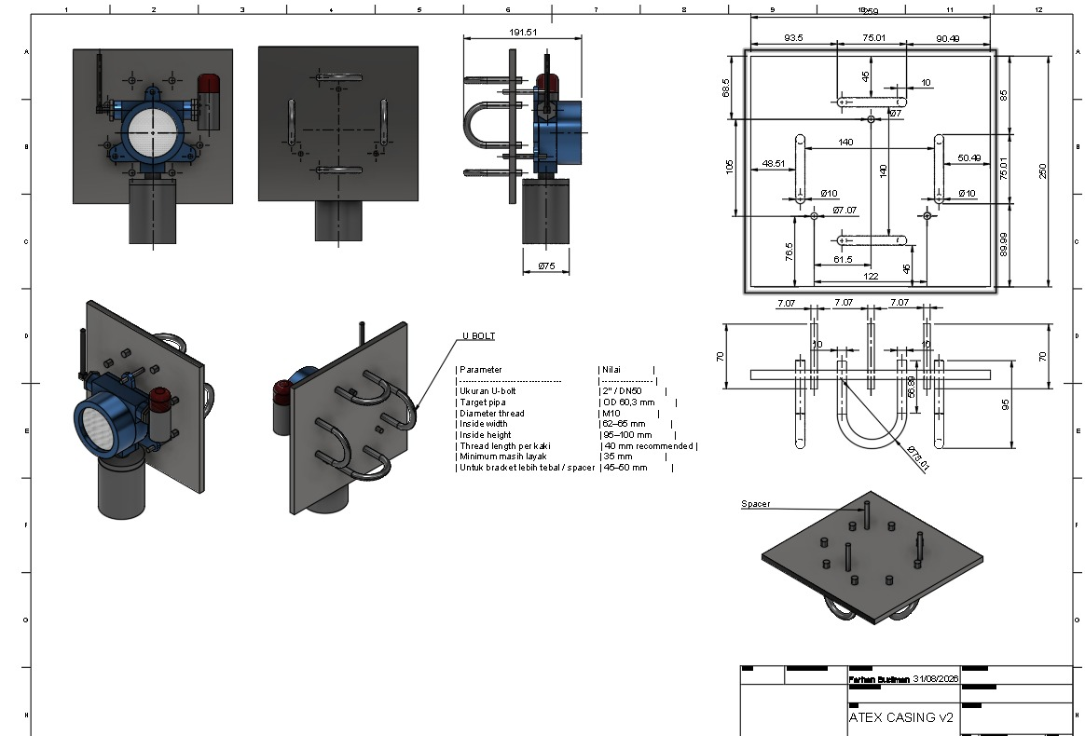
M-A1. ATEX CASING v2 — enclosure envelope & U-bolt mounting plate, dimensioned sheet
Orthographic and isometric views with real dimensions (enclosure neck Ø75 mm, overall probe height 191.51 mm, mounting plate 250 × 250 mm with toleranced hole pattern), U-bolt parameter table (2″/DN50, M10 thread) and title block (drafted 31 Aug 2026). Drawn from the STEP solid model (mm).
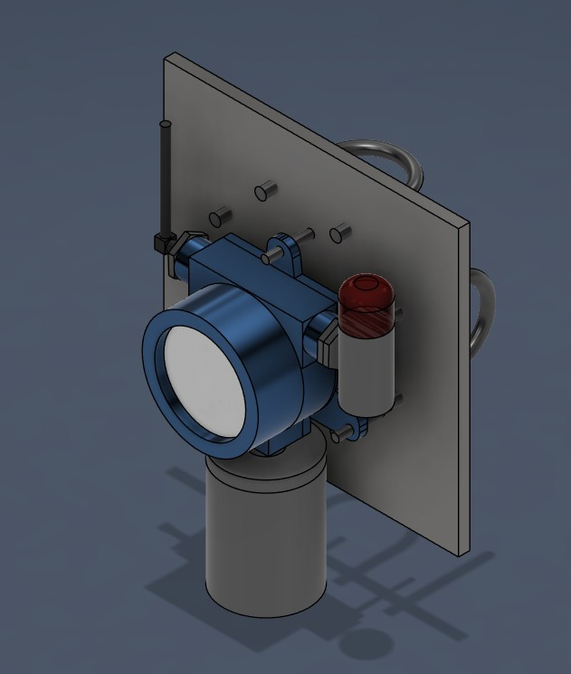  Front view | 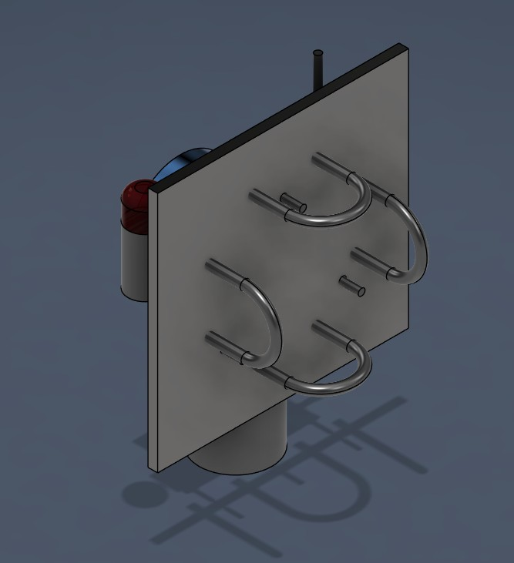  Rear view | 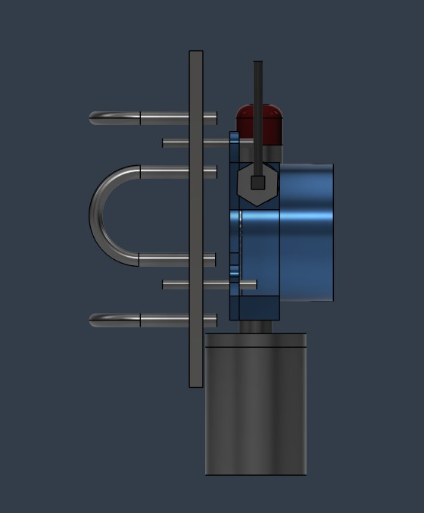  Left view
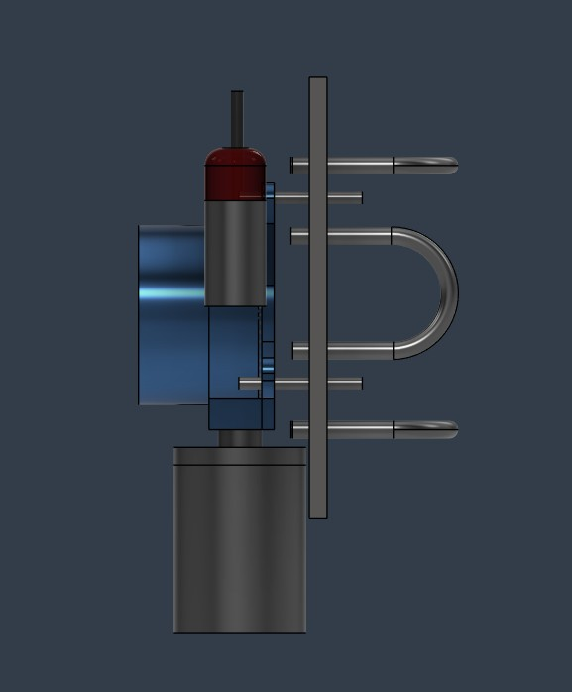  Right view | 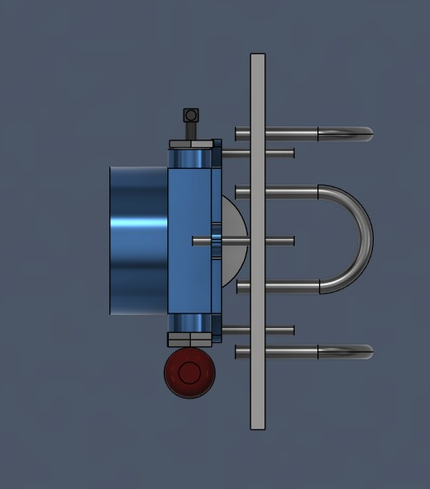  Top view | 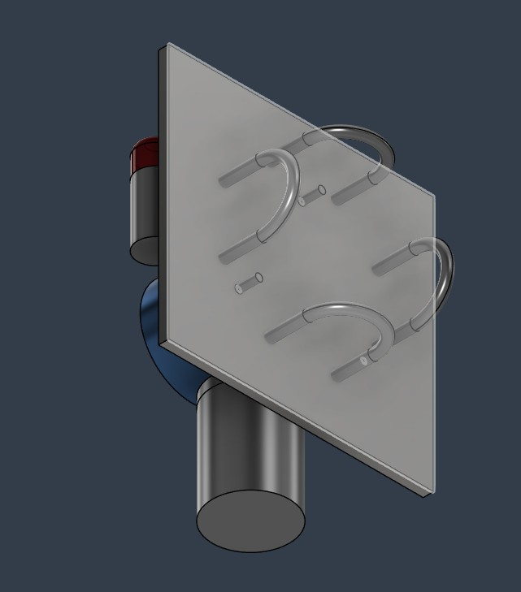  Bottom view
M-A2. ATEX CASING v2 — six orthographic CAD views
Rendered from the same STEP solid model as M-A1 (enclosure, sensor head and U-bolt mounting plate).

B. Enclosure design GLD ATEX CASE v3 — complete sheet set
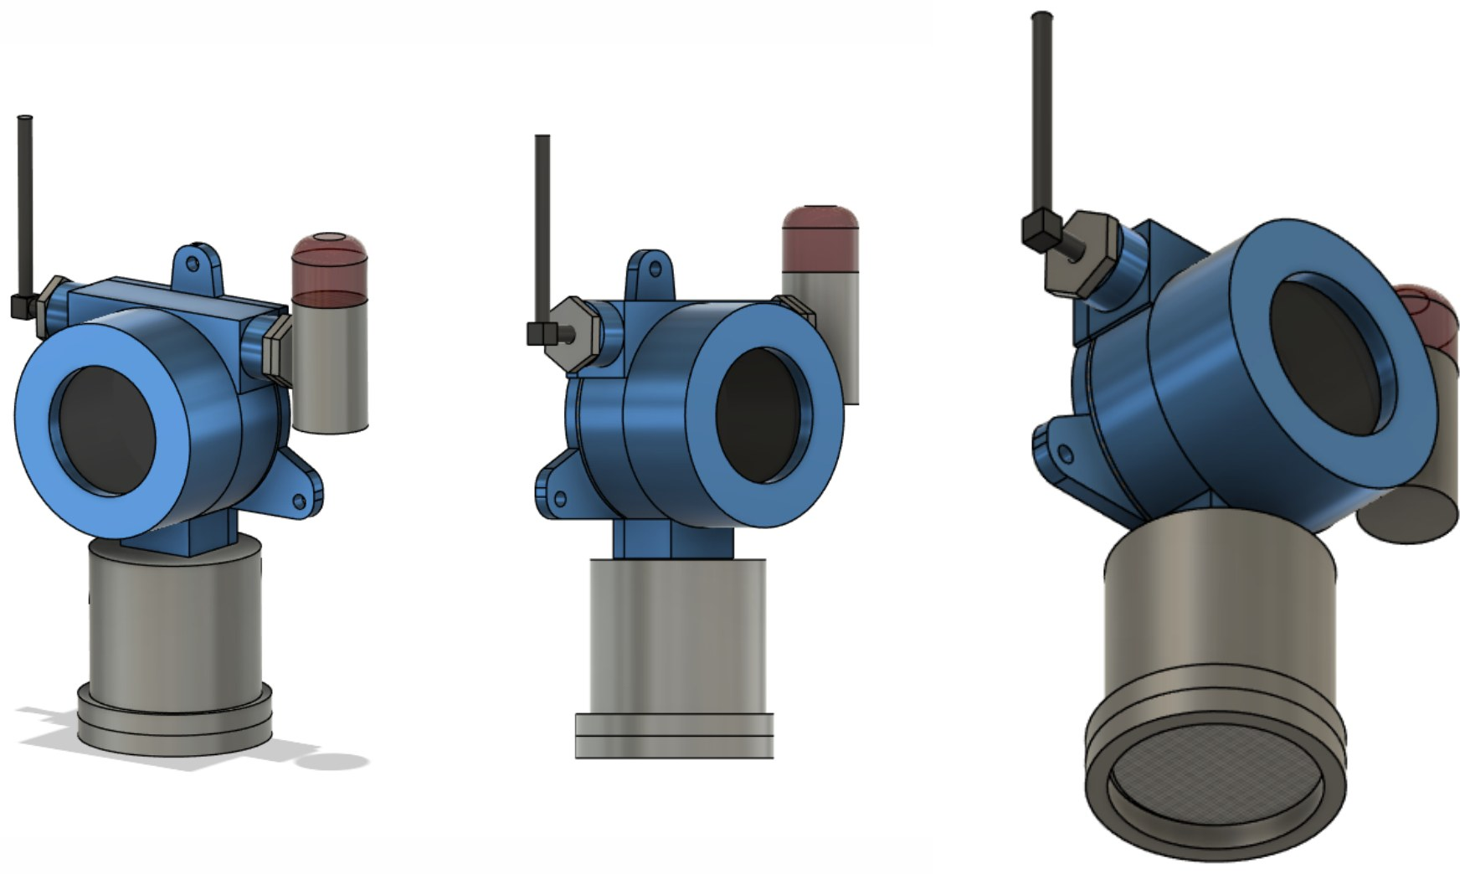
M-B1. GLD ATEX CASE v3 — sheet 1: isometric views of the assembled detector
Assembled enclosure with sensor head, external antenna and alarm beacon, three isometric viewpoints.

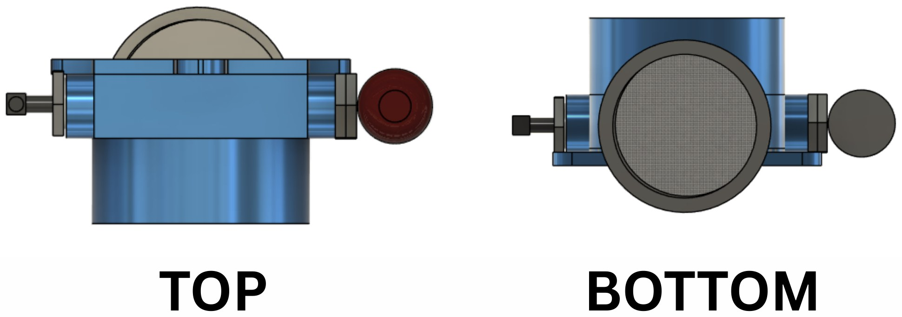
M-B2. GLD ATEX CASE v3 — sheet 2: top and bottom views
Top view (cable-entry bosses, alarm beacon, antenna) and bottom view (sensor-head mesh face).

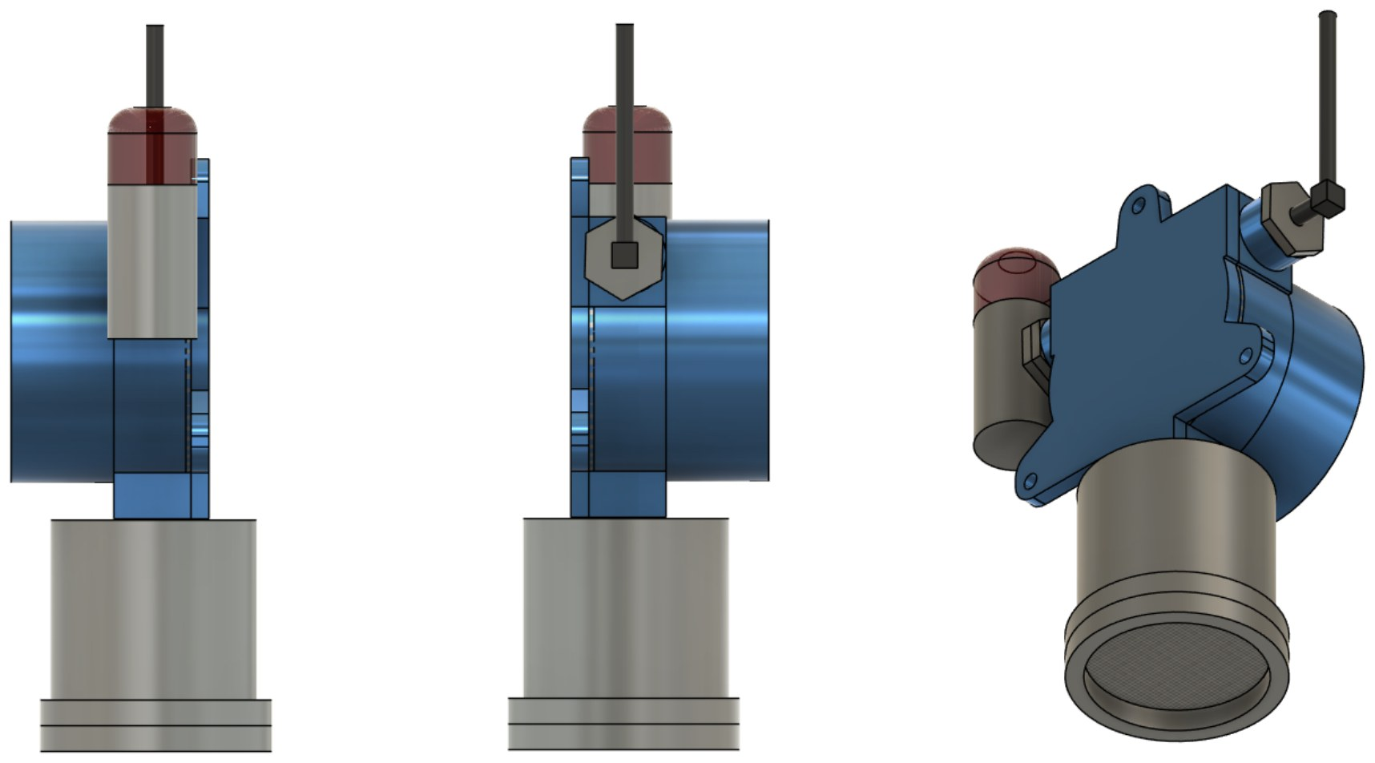
M-B3. GLD ATEX CASE v3 — sheet 3: side and rear views
Left, right and rear-isometric views showing the base, sensor head, beacon and antenna positions.

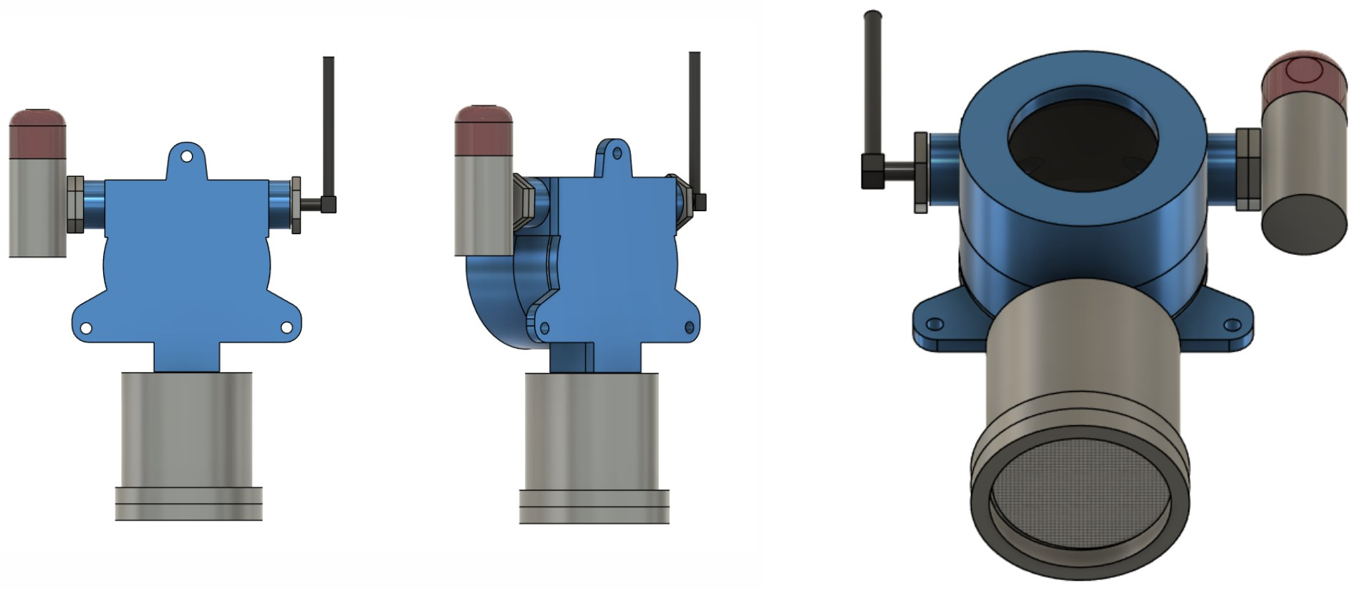
M-B4. GLD ATEX CASE v3 — sheet 4: front/back and mounting-lug views
Views showing the wall-mounting lugs of the base and the cover opening.

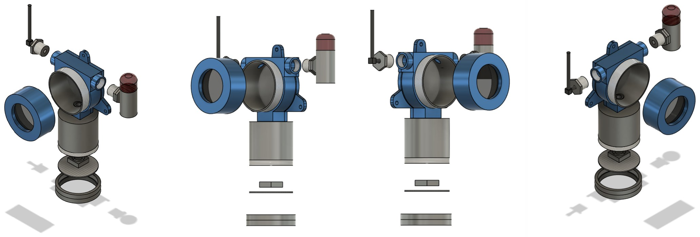
M-B5. GLD ATEX CASE v3 — sheet 5: exploded views (four viewpoints)
Exploded assembly: base, cover, sensor case, mesh disc, sensor-case cover, beacon, antenna and glands.

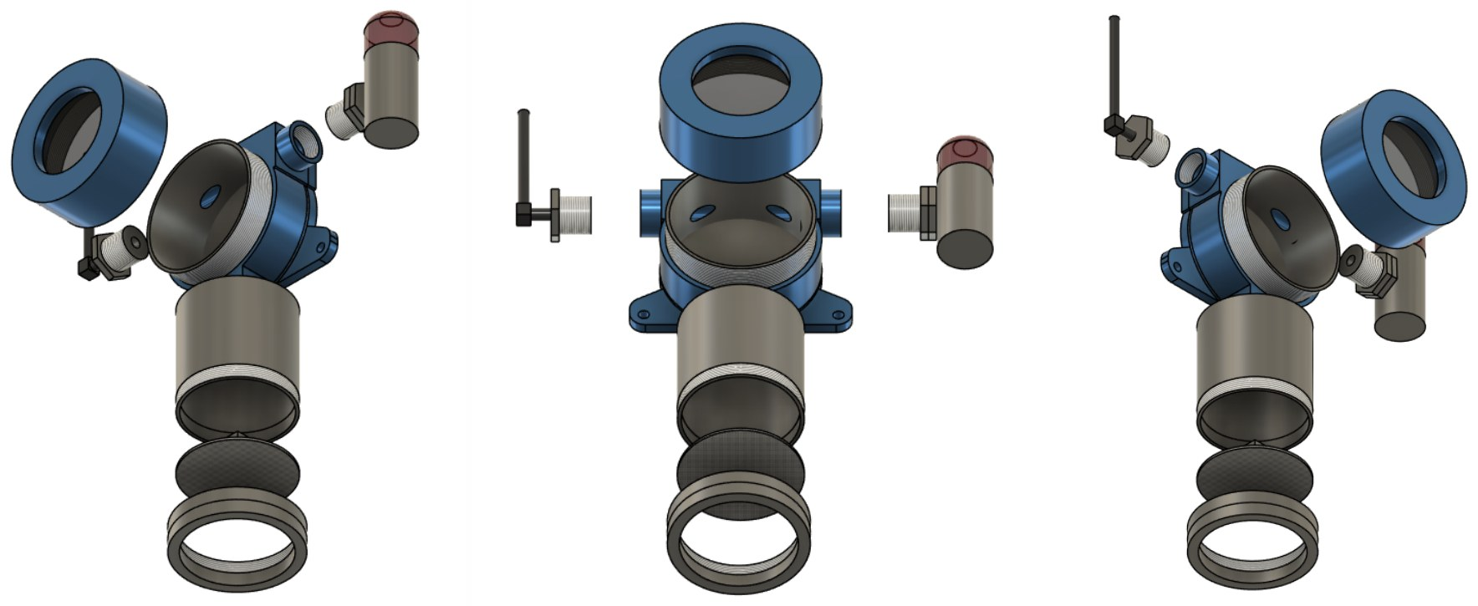
M-B6. GLD ATEX CASE v3 — sheet 6: exploded views of the sensor-head stack
Sensor case, DC fan, stainless-steel filter mesh disc and case cover shown in stacking order.

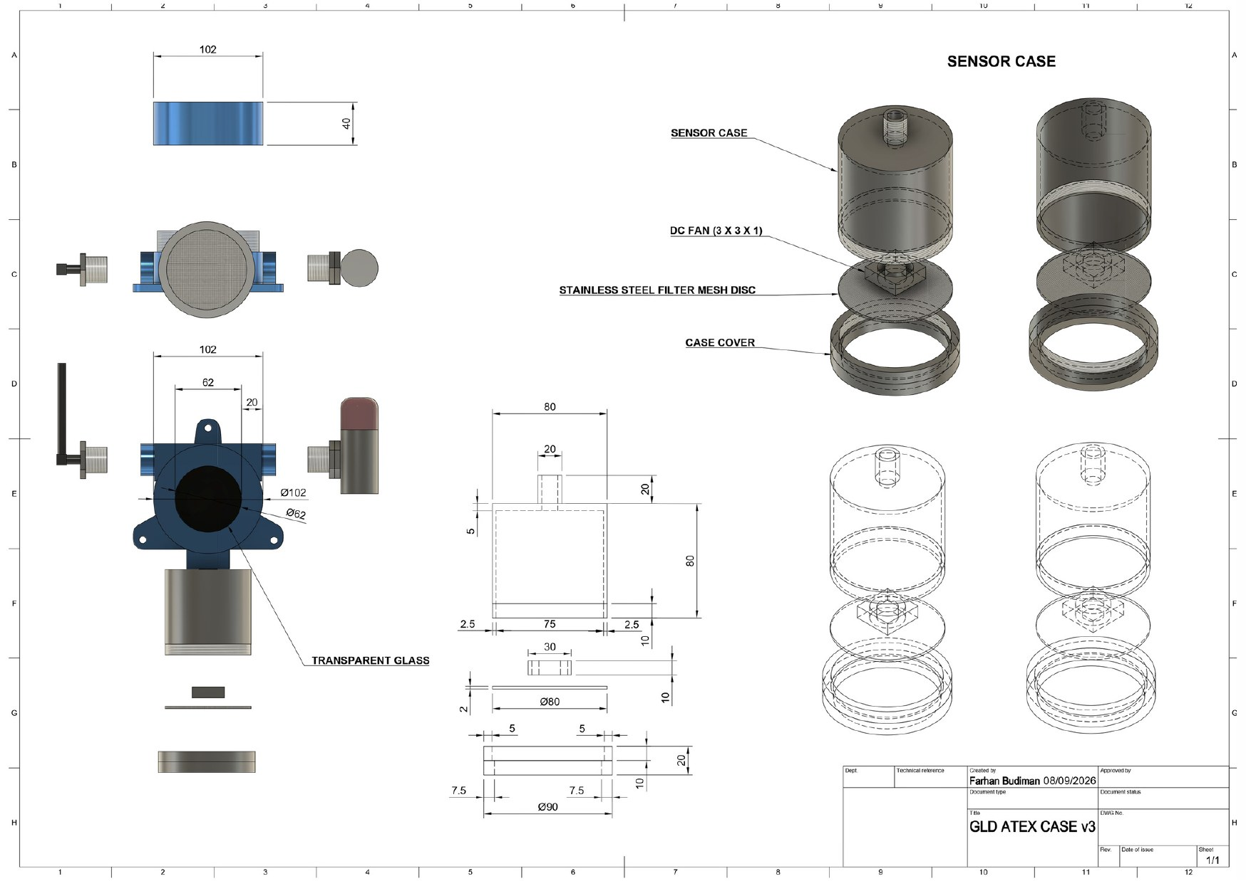
M-B7. GLD ATEX CASE v3 — sheet 7: dimensioned drawing with title block
Dimensioned orthographic views and section of the sensor case; callouts for sensor case, DC fan, stainless-steel filter mesh disc, case cover and transparent glass; title block “GLD ATEX CASE v3” (drafted 8 Sep 2026). Internal contingency/alternate enclosure design.

C. Junction-box / terminal base — supplier drawing
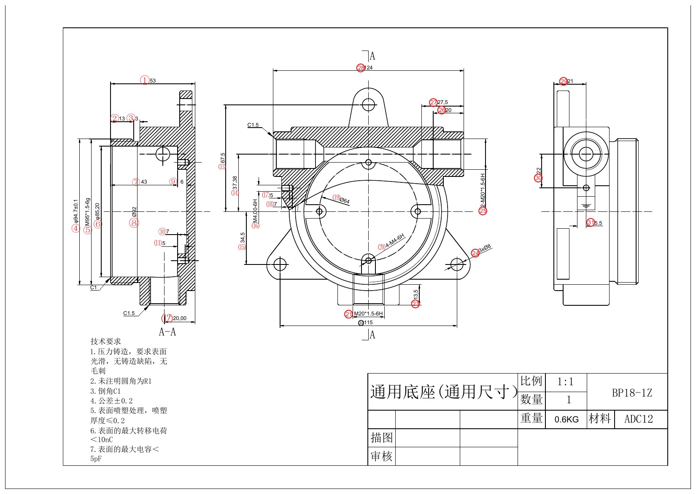
M-C1. Universal Base BP18-1Z — supplier reference drawing
Die-cast base, material ADC12, 0.6 kg, scale 1:1: 2 × M20×1.5-6H cable-entry threads, 4 × M4-6H and 1 × M5×1.5-6g fixing threads, 3 × Ø8 mm mounting holes, internal bore up to Ø94.7 mm, overall ≈124 × 115 × 67.5 mm. Candidate junction-box/terminal sub-component from the casing supply chain.

D. Components, structure, terminal and grounding
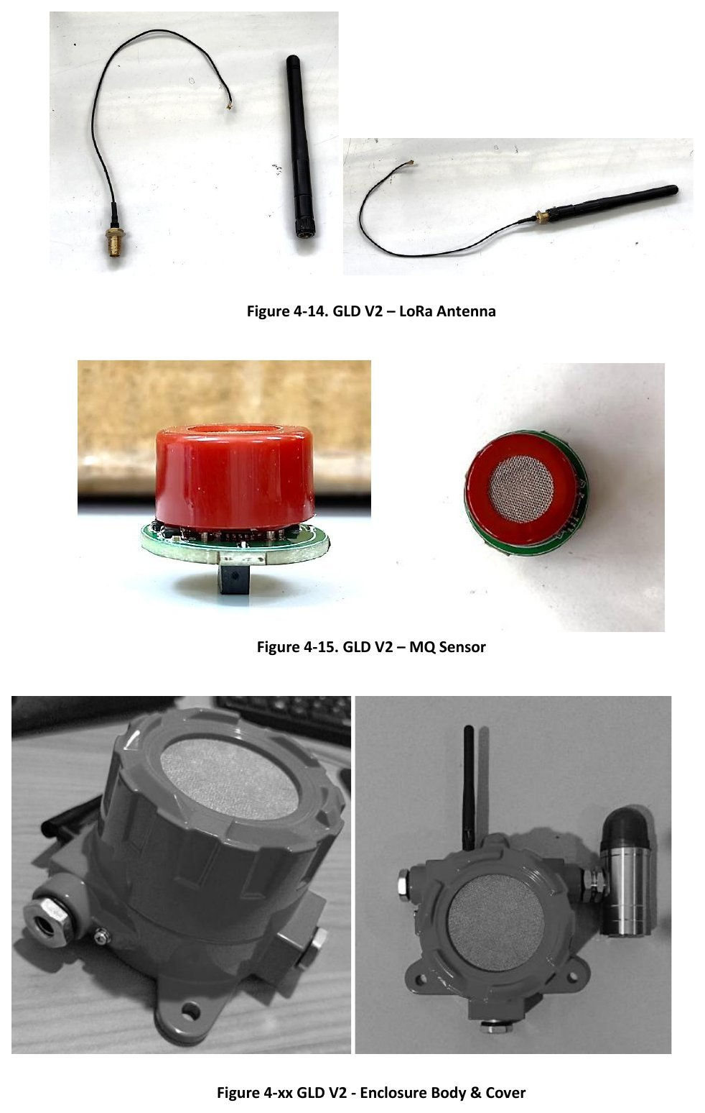
M-D1. LoRa antenna, MQ sensor and enclosure body & cover
External LoRa antenna with cable, MQ sensor with integrated stainless-steel mesh, and the enclosure body and cover (production parts).
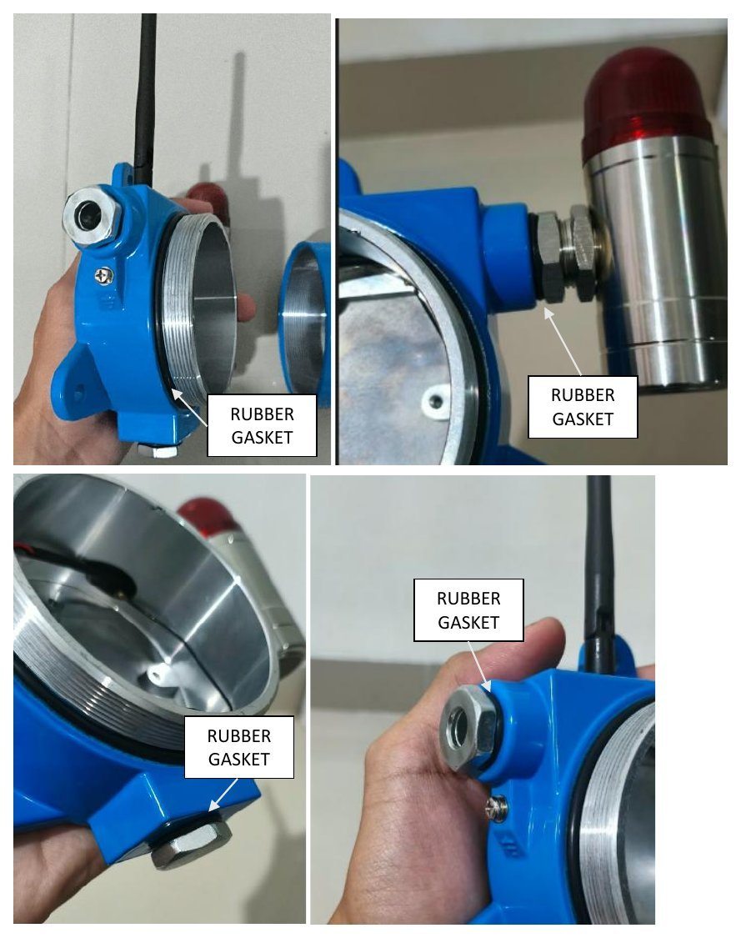
M-D2. Rubber gasket — locations
Rubber gaskets fitted at the cover-to-body and sensor-head joints (four locations marked).
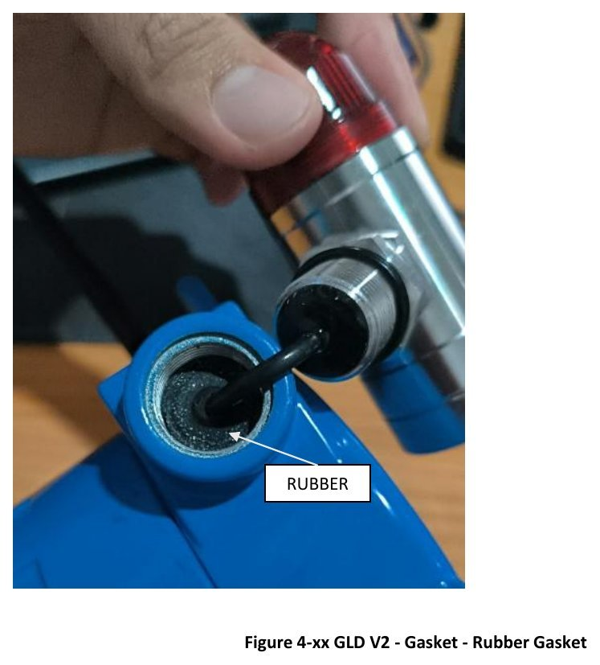
M-D3. Rubber gasket — part
Rubber gasket as a separate part.
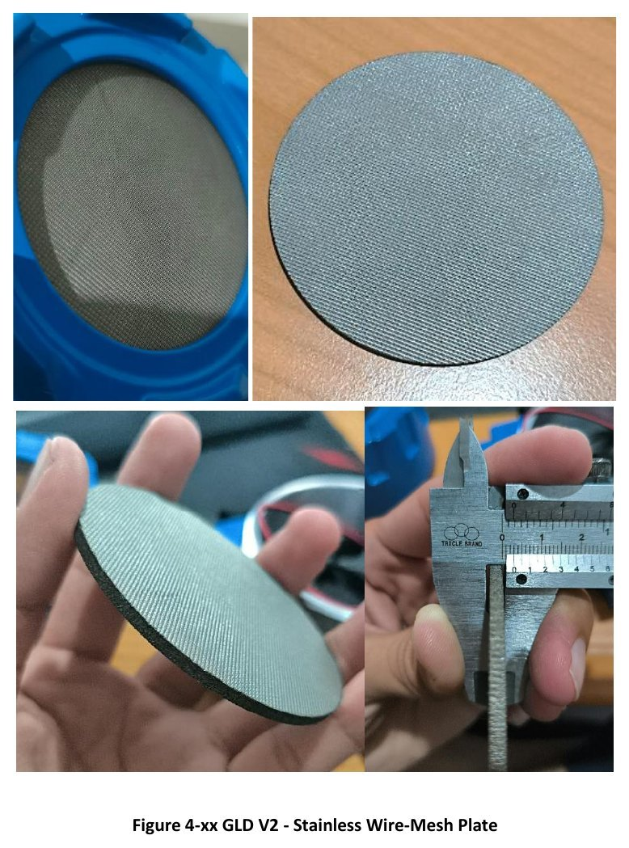
M-D4. Stainless wire-mesh plate
Front stainless-steel wire-mesh plate (gas inlet) and its seating in the cover.
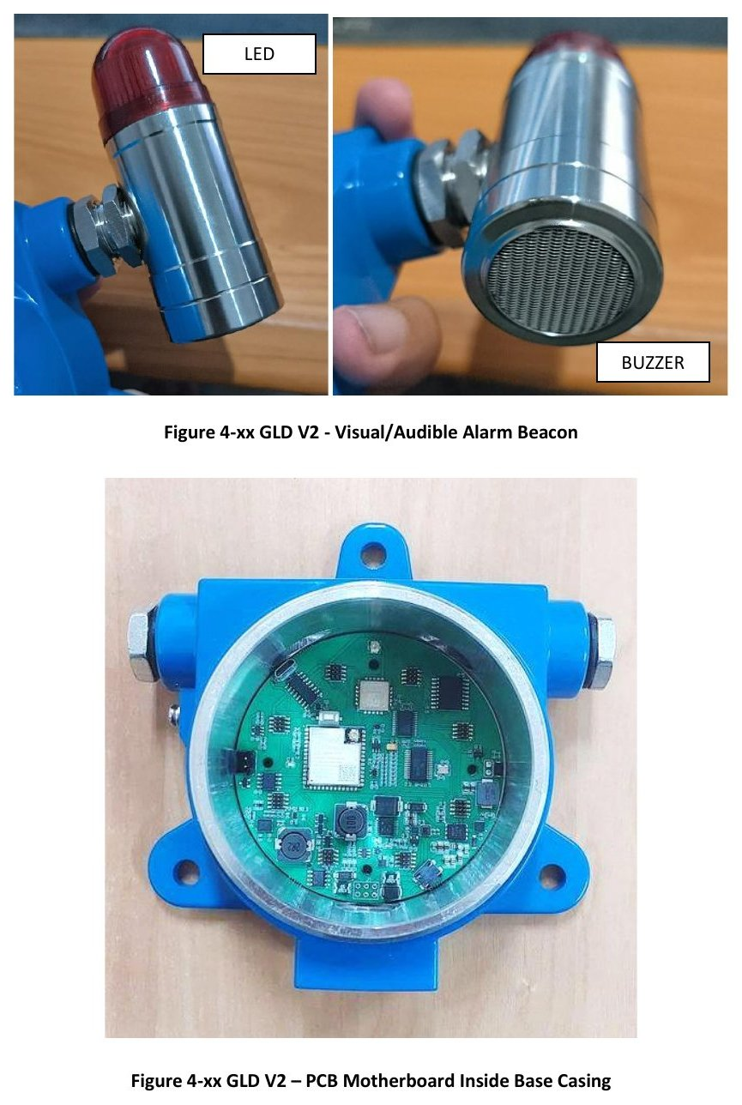
M-D5. Visual/audible alarm beacon; motherboard inside base casing
LED and buzzer beacon with rubber gasket; main PCB mounted in the base enclosure.
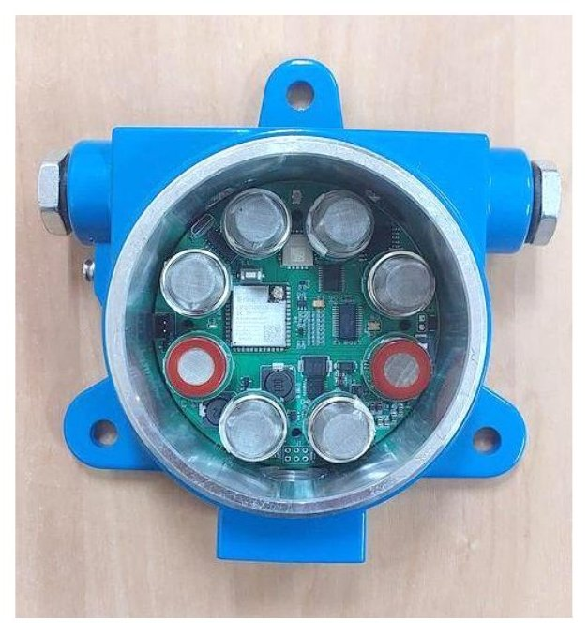
M-D6. Motherboard with MQ sensors inside base casing
Main PCB with the eight MQ sensors fitted, seen through the open base enclosure.
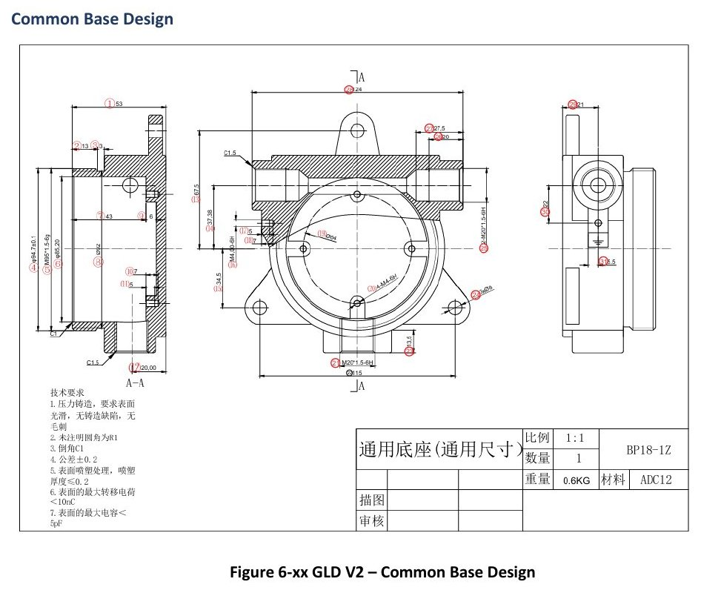
M-D7. Common base design
Dimensioned base design drawing with title block.
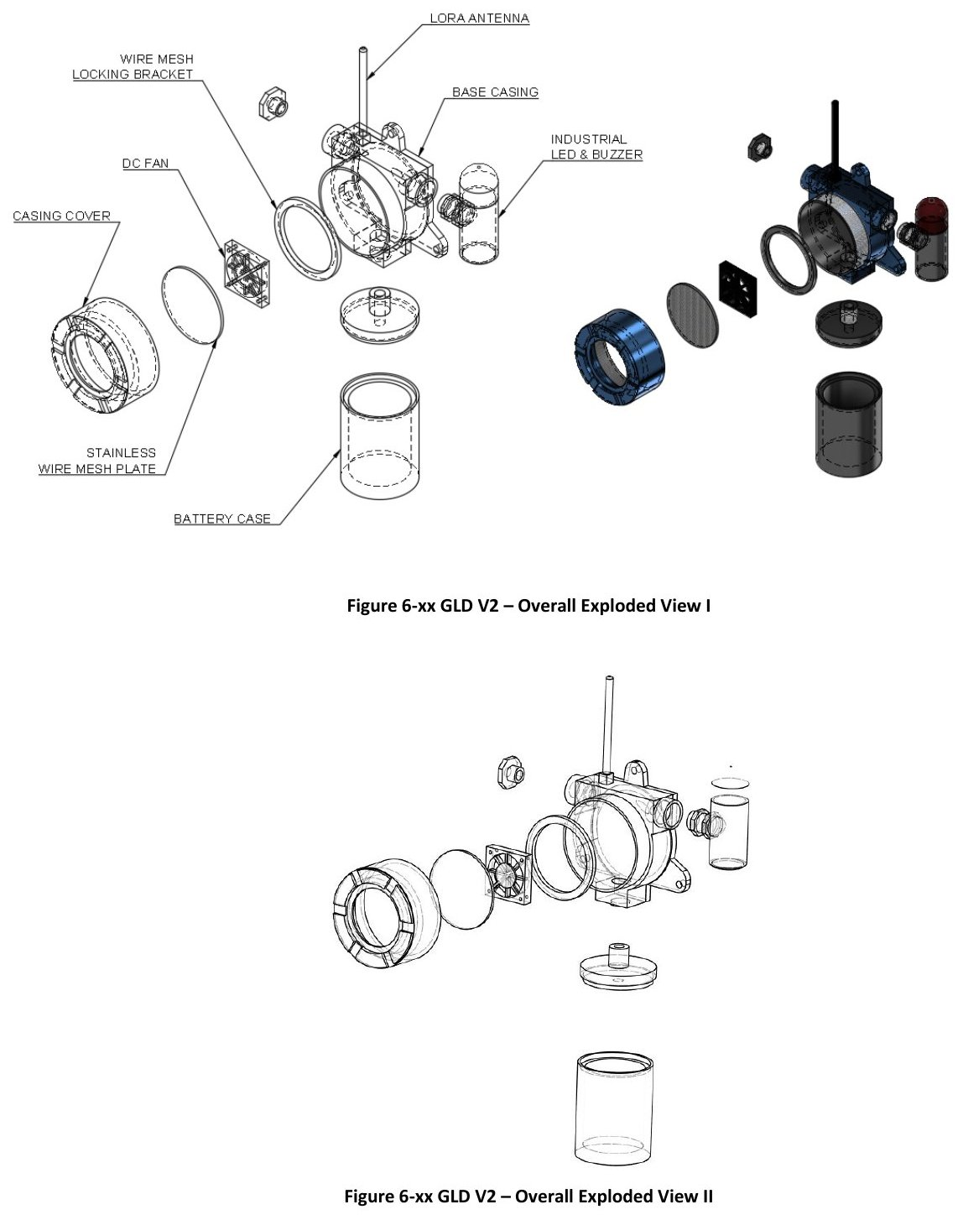
M-D8. Overall exploded views I and II
Labelled exploded line drawings of the complete detector (cover, mesh, fan, sensor head, base, glands, beacon, antenna).
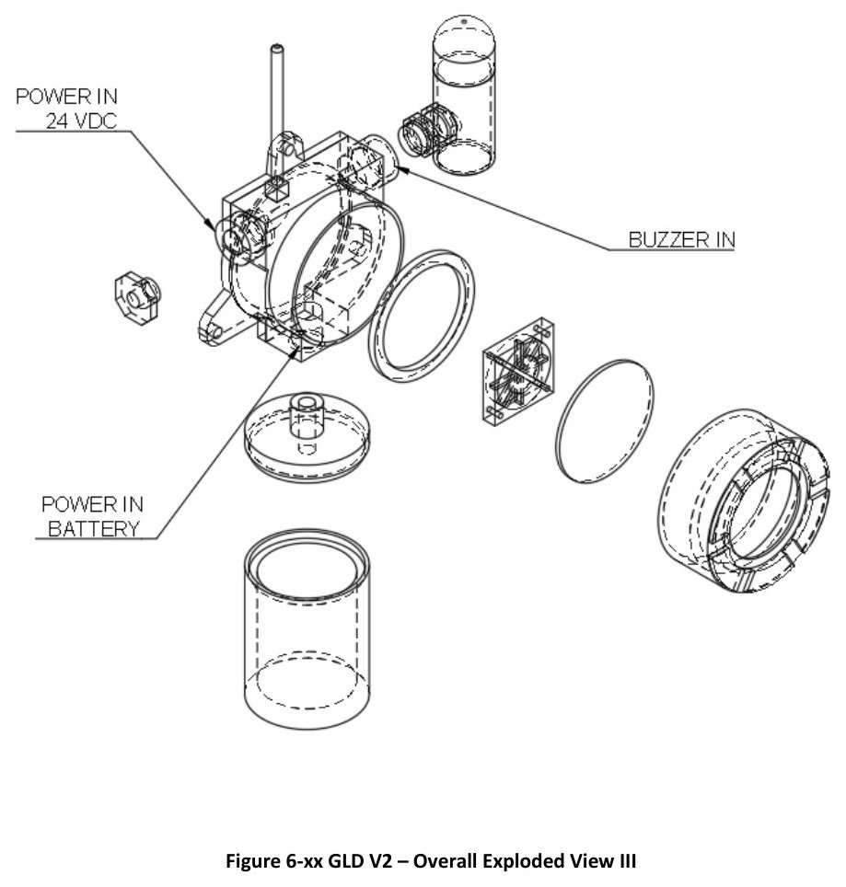
M-D9. Overall exploded view III
Exploded line drawing, third viewpoint.
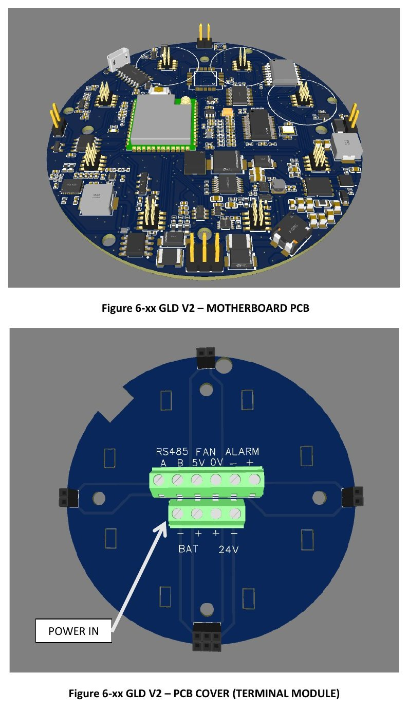
M-D10. Motherboard PCB power-in and PCB cover (terminal module)
Populated main PCB (3D) and the PCB cover carrying the terminal module with the 24 VDC power-in position marked.
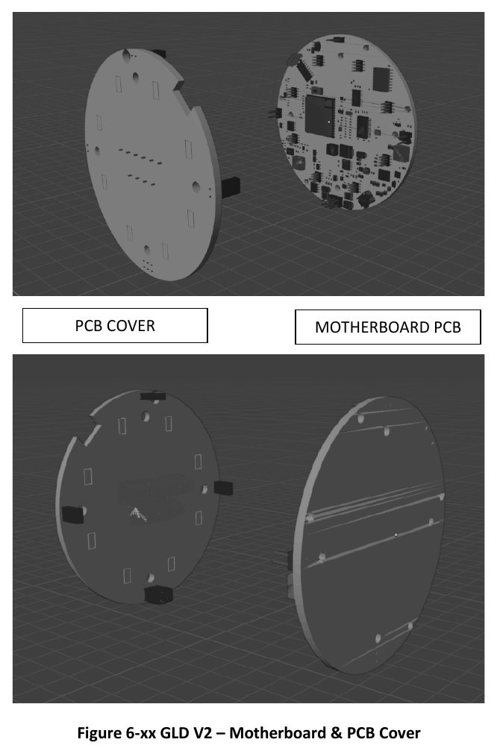
M-D11. Motherboard and PCB cover
Main PCB and PCB cover shown as separate parts.
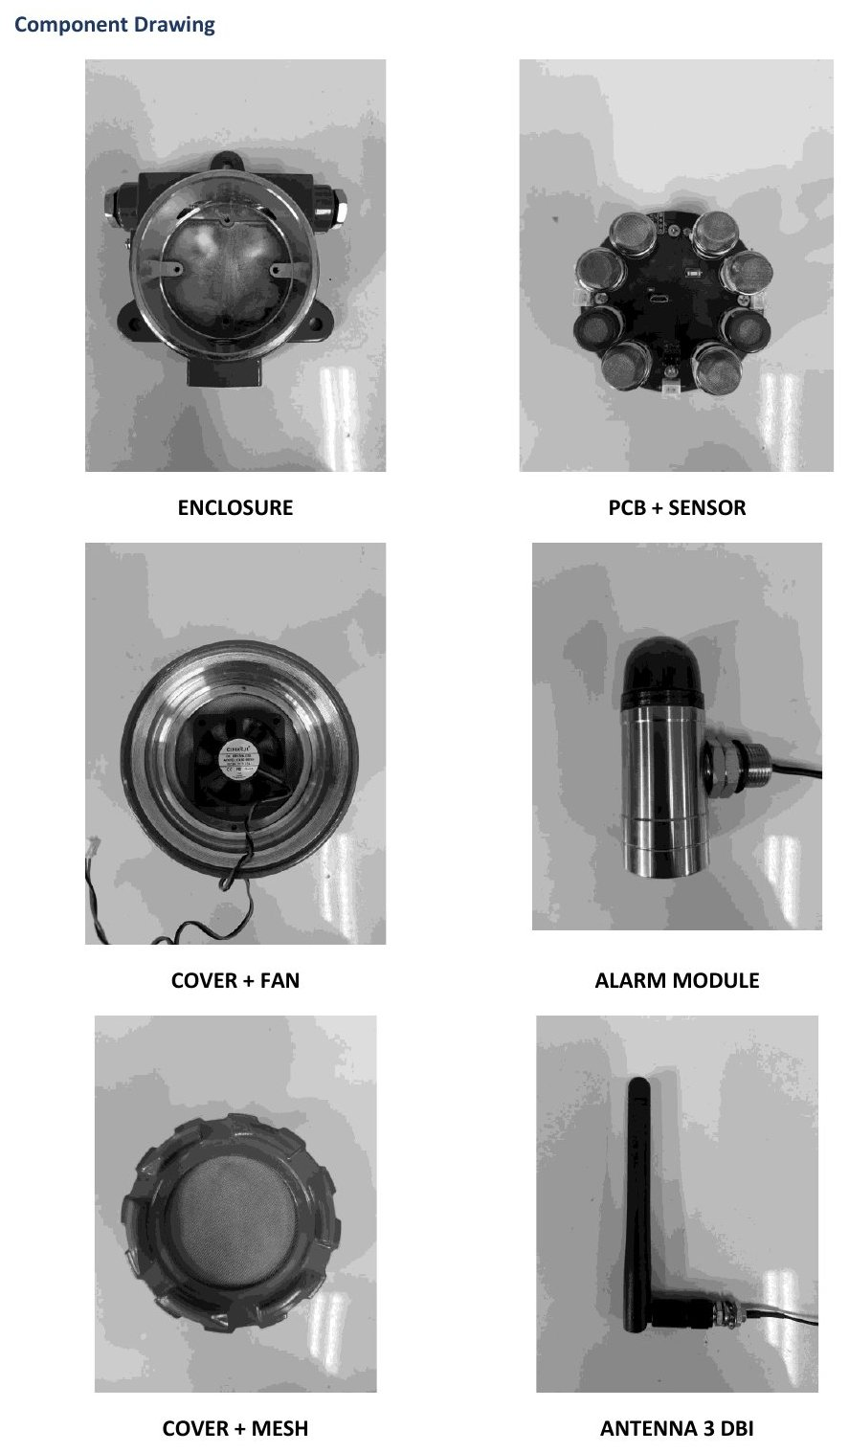
M-D12. Component drawing
Enclosure; PCB + sensors; cover + fan; alarm module; cover + mesh; antenna 3 dBi.
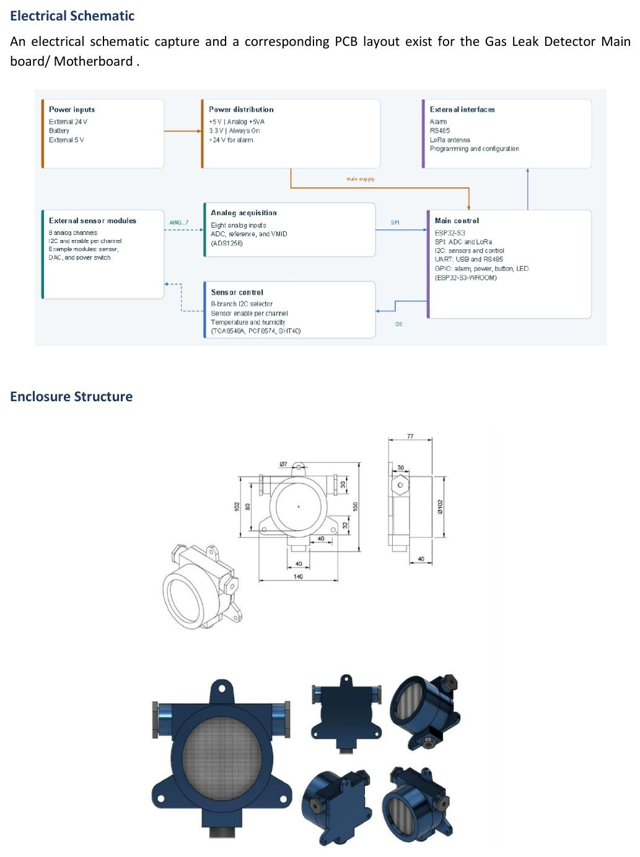
M-D13. Electrical block diagram and enclosure structure
Block diagram of the main board and dimensioned enclosure-structure views.
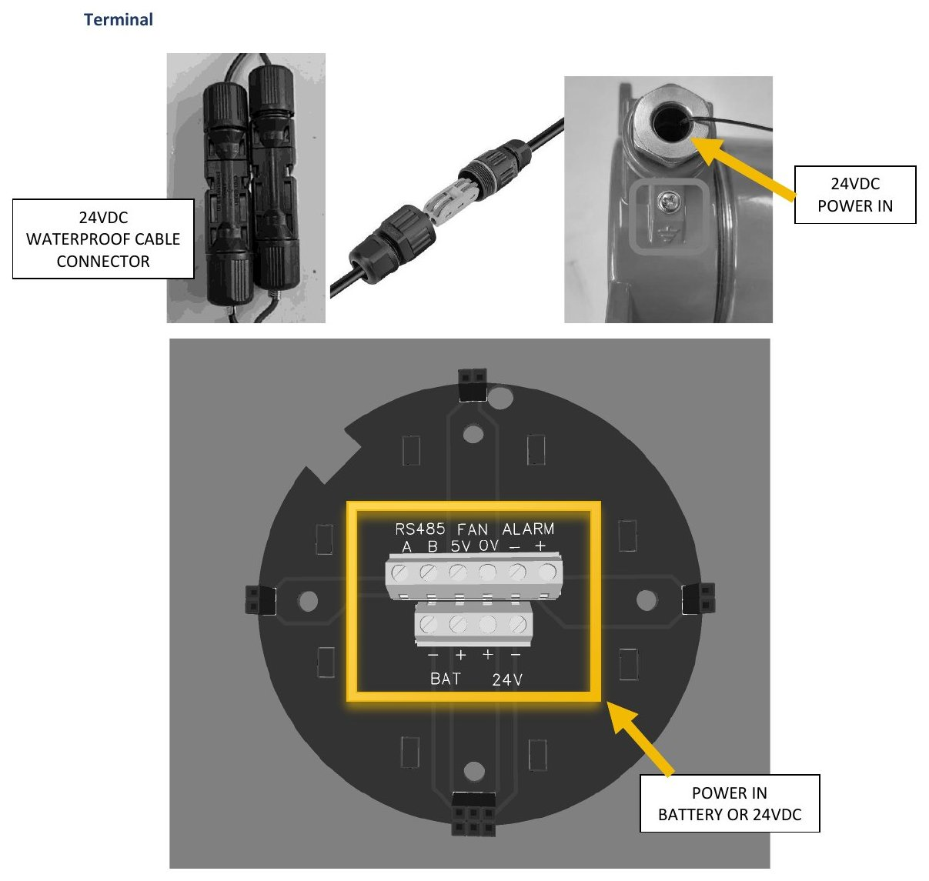
M-D14. Terminal — 24 VDC power in
24 VDC waterproof cable connector and the terminal block on the PCB cover.
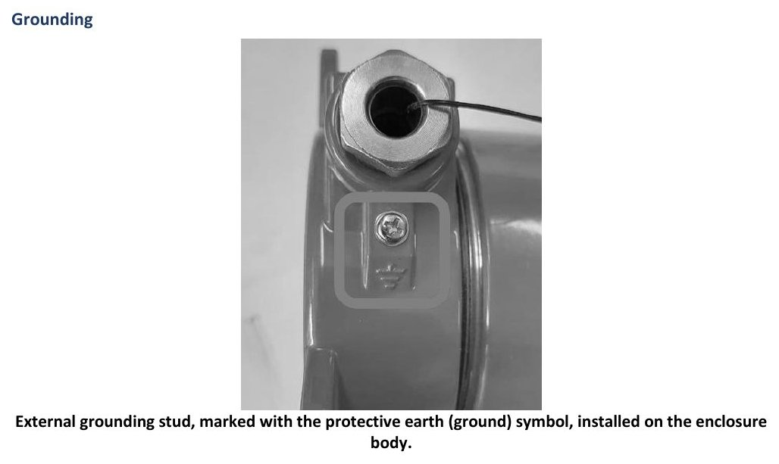
M-D15. Grounding
External grounding stud, marked with the protective-earth symbol, installed on the enclosure body.

E. Assembly sequence
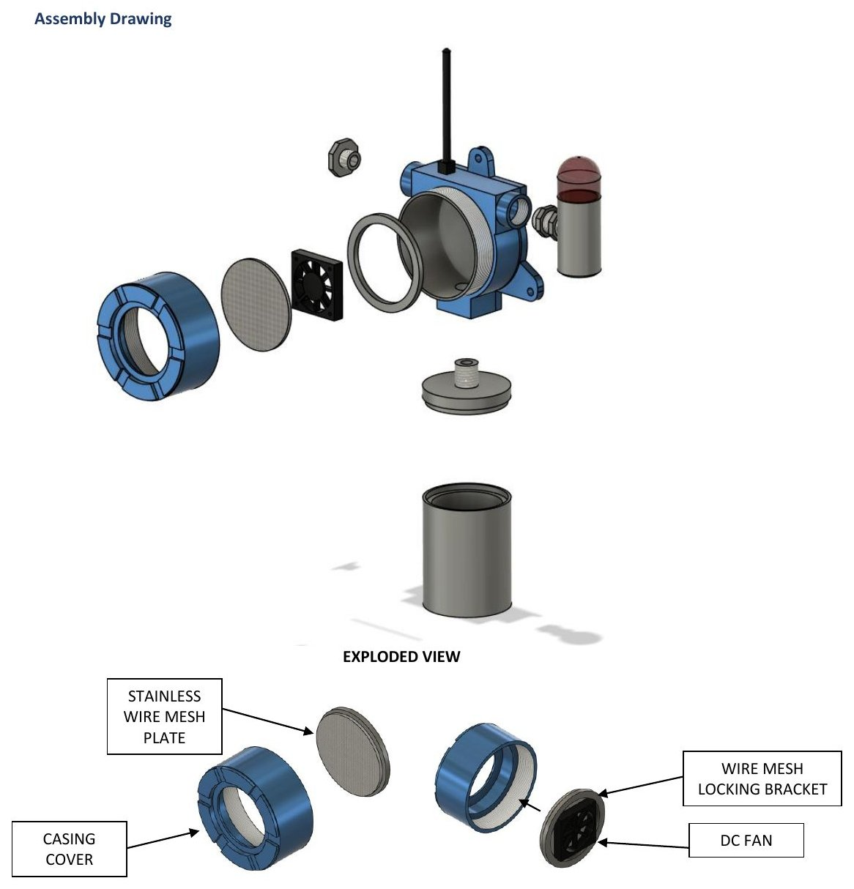
M-E1. Assembly drawing — exploded view
Casing cover, stainless wire-mesh plate, wire-mesh locking bracket and DC fan.
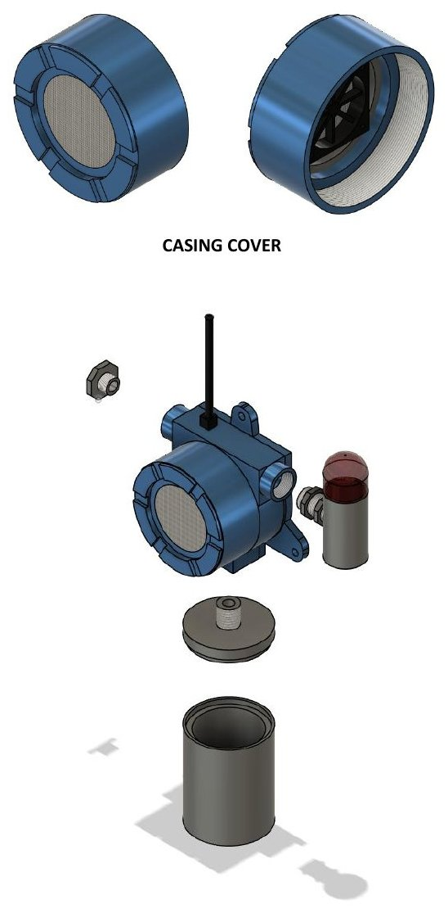
M-E2. Assembly step — casing cover
Casing cover parts.
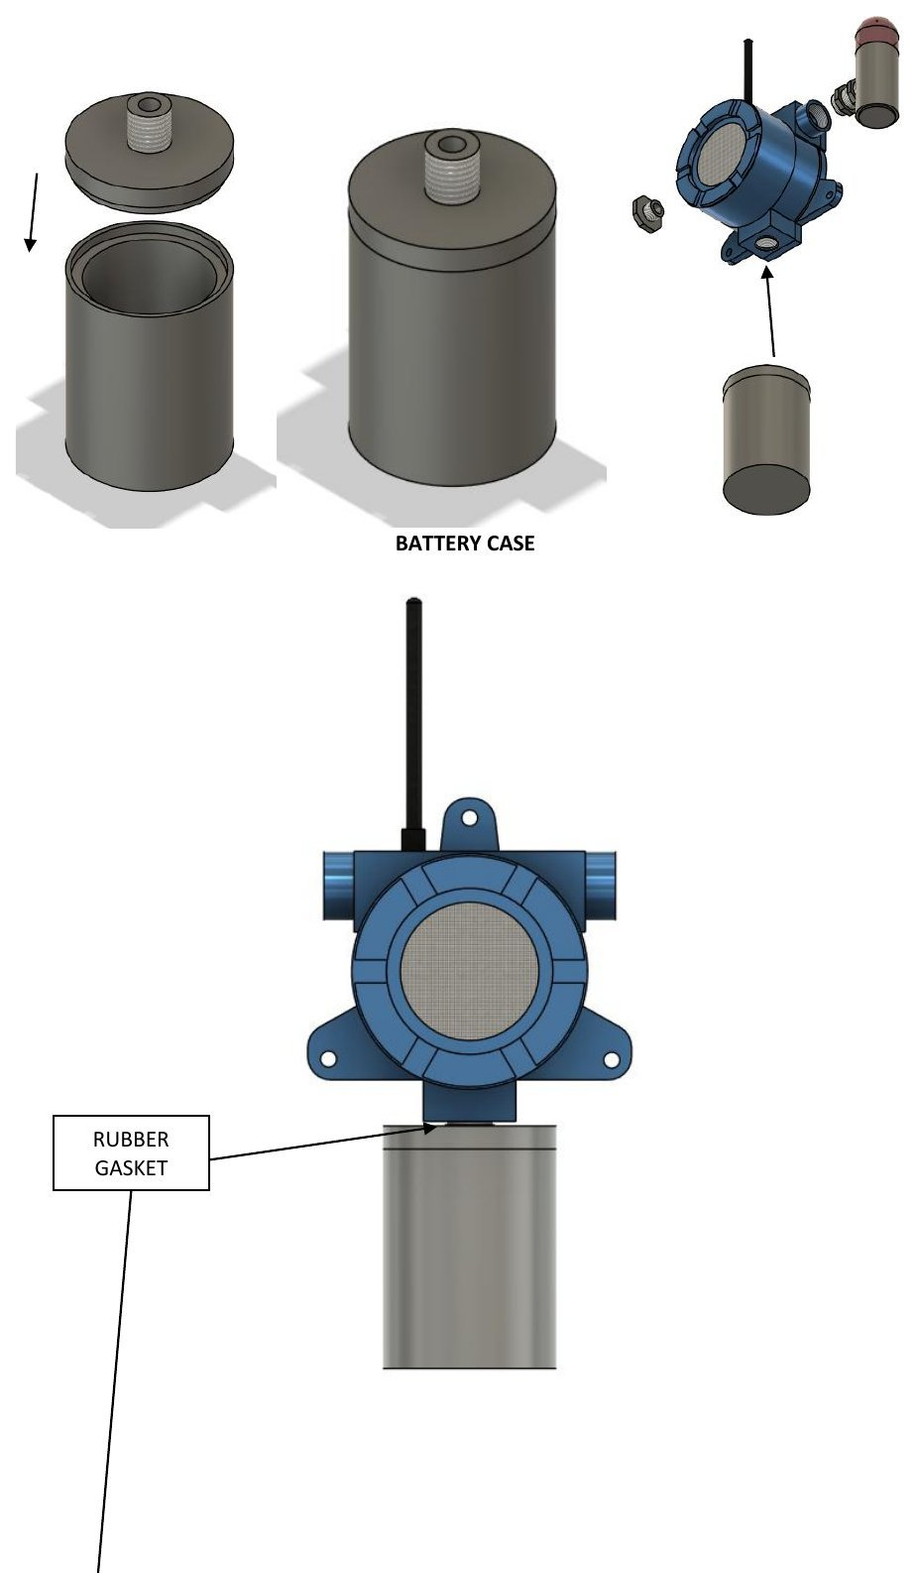
M-E3. Assembly step — sensor case and rubber gasket
Sensor case with rubber gasket (drawing also labels a battery case — see note).
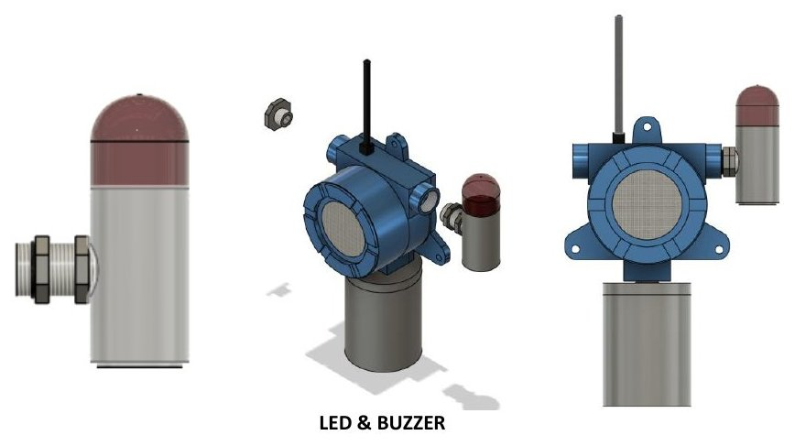
M-E4. Assembly step — LED & buzzer
Alarm beacon fitted to the base.
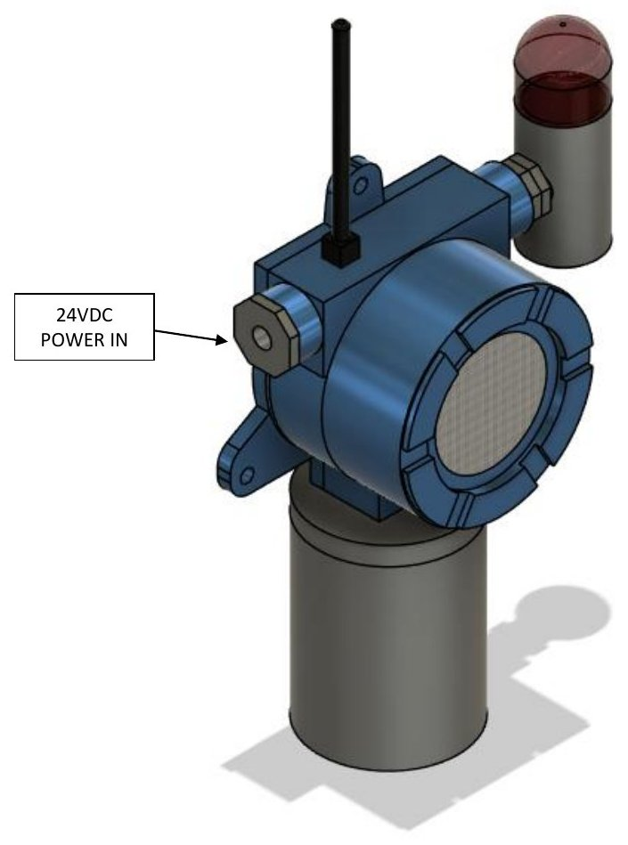
M-E5. Assembly step — 24 VDC power in
Cable entry for the 24 VDC supply.
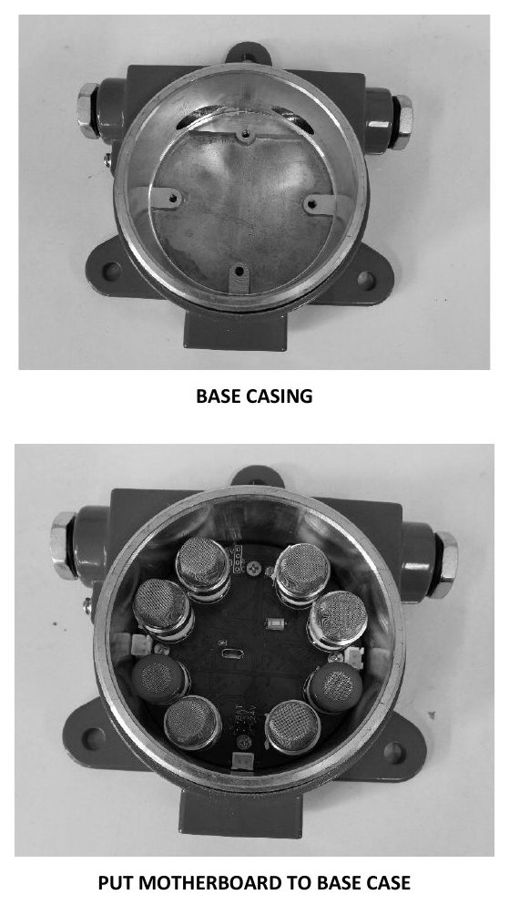
M-E6. Assembly step — put motherboard into base casing
Base casing and motherboard placement.
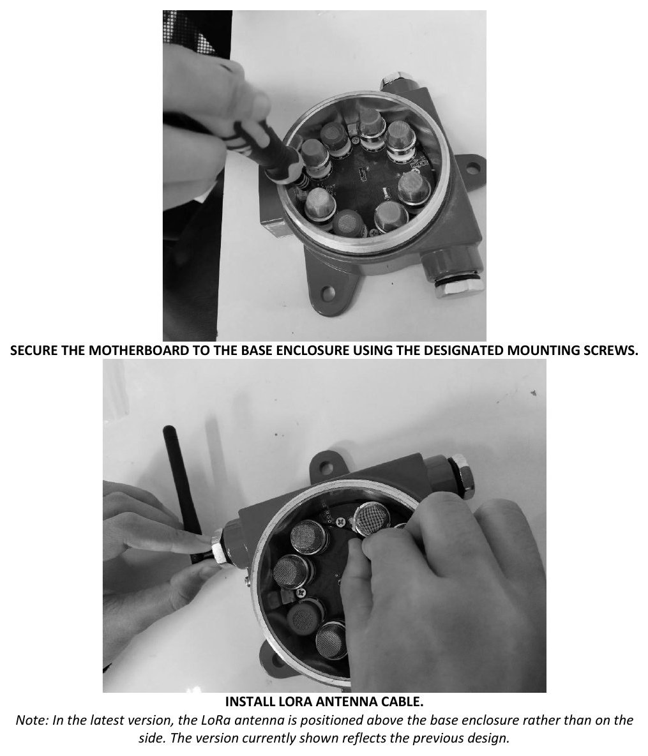
M-E7. Assembly step — secure motherboard; install LoRa antenna cable
Secure the motherboard with the designated mounting screws and install the antenna cable.
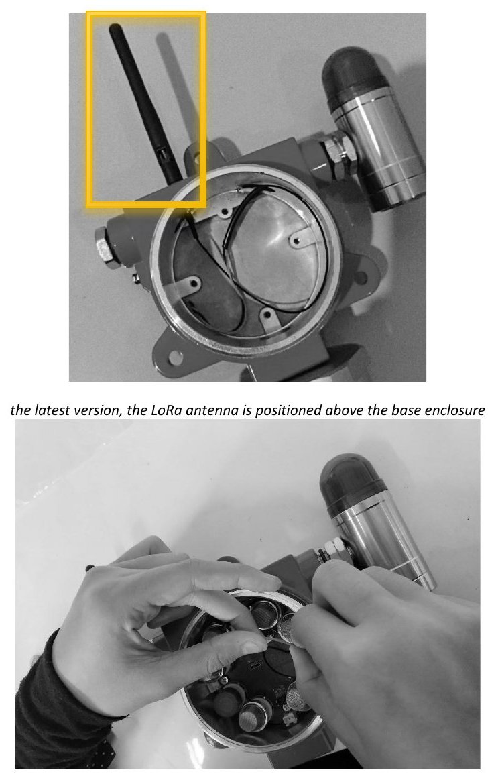
M-E8. Assembly step — antenna position
In the current version the LoRa antenna is positioned above the base enclosure (earlier side position superseded).
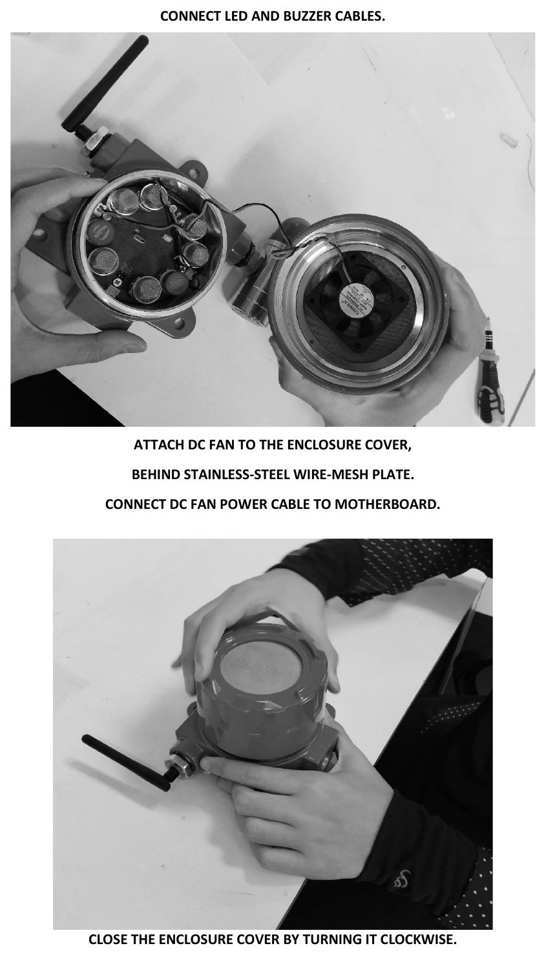
M-E9. Assembly step — alarm cables, DC fan and cover closure
Connect LED/buzzer cables; attach DC fan to the cover behind the stainless-steel mesh plate; connect the fan cable; close the cover by turning it clockwise.

F. MQ sensor dimension drawings
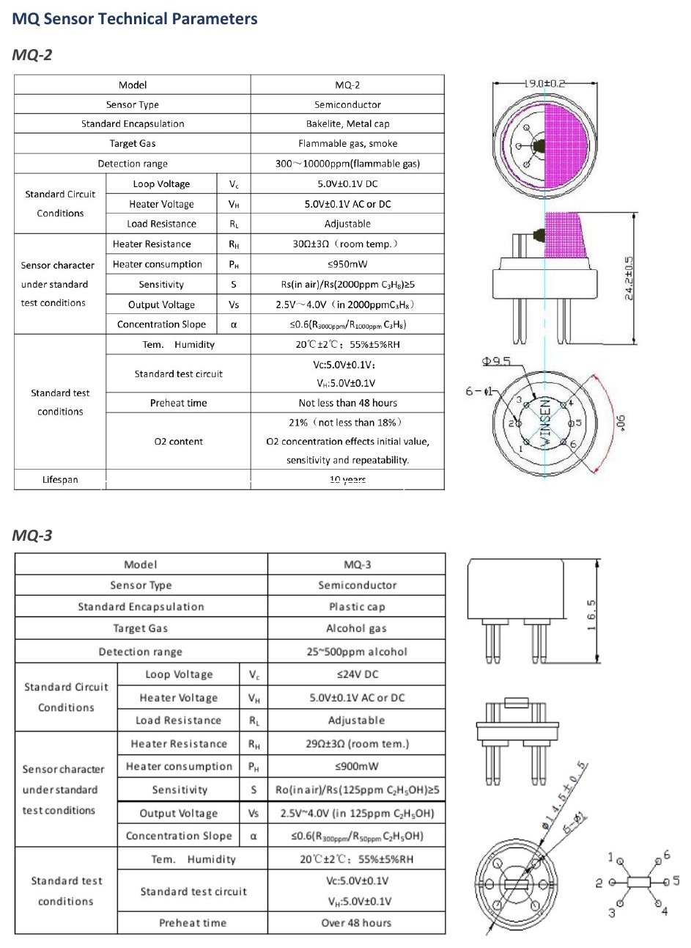
M-F1. MQ-2 and MQ-3 — sensor parameters and dimension drawings

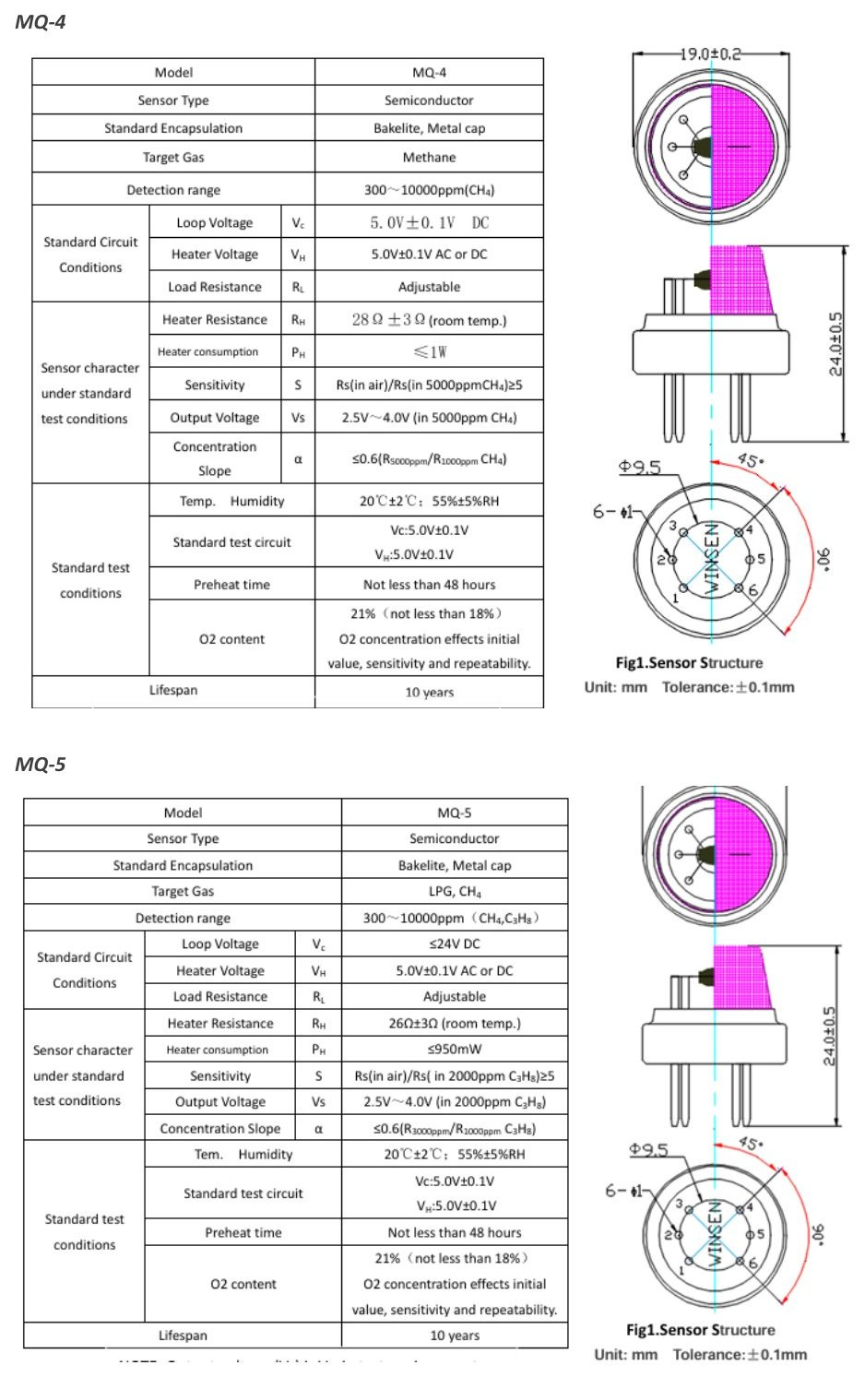
M-F2. MQ-4 and MQ-5 — sensor parameters and dimension drawings

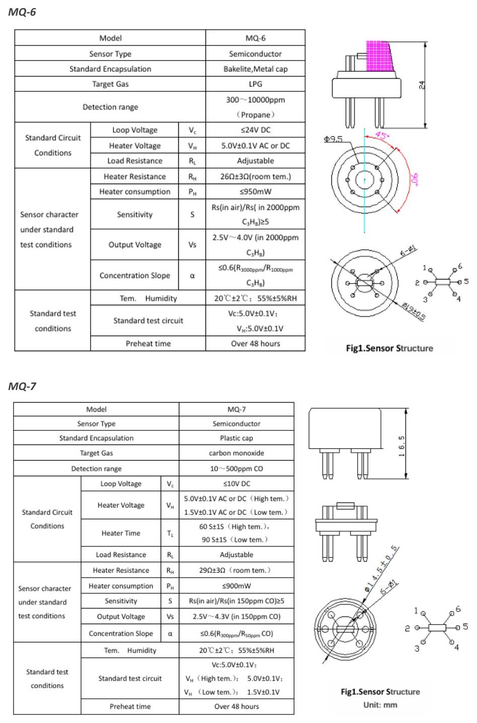
M-F3. MQ-6 and MQ-7 — sensor parameters and dimension drawings

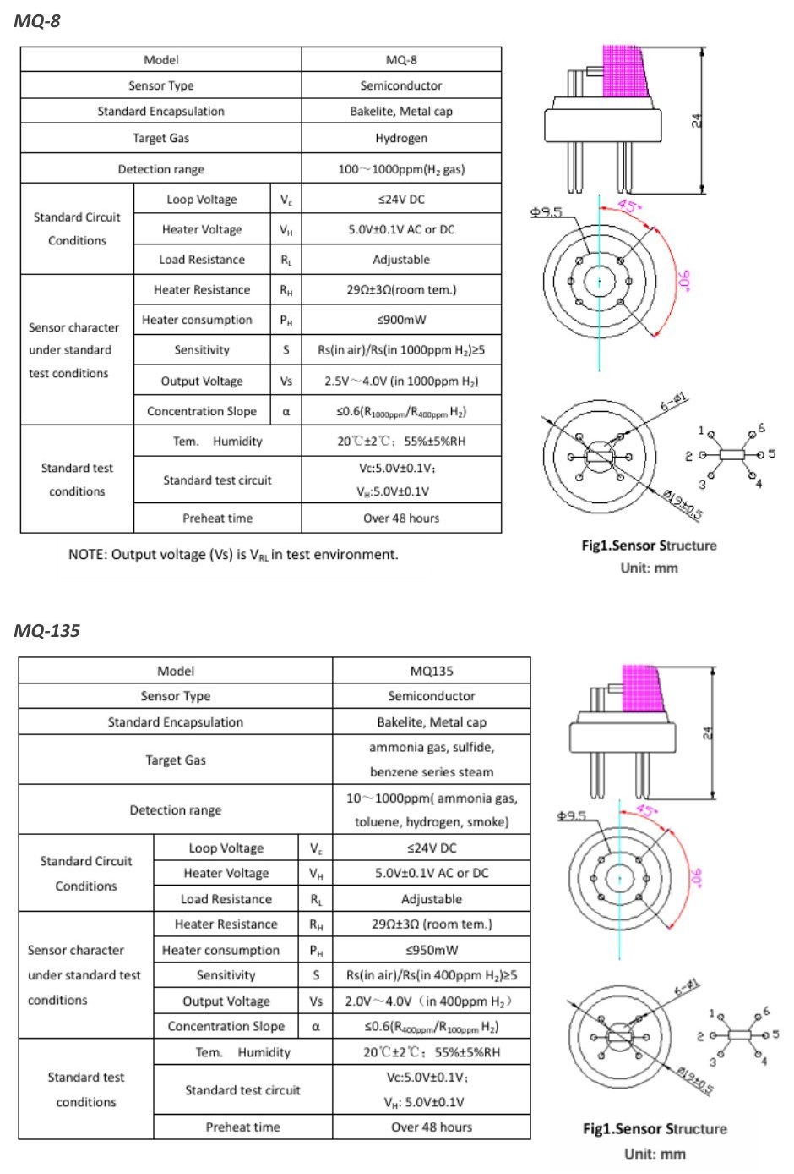
M-F4. MQ-8 and MQ-135 — sensor parameters and dimension drawings

2.6.a.7 Main PCB schematic
The electrical schematic of the GLD main board is provided as the actual circuit schematic (not a block diagram). It is presented as 26 figures, each cut from the original EasyEDA schematic around one functional block. Every component in a figure is enclosed in a numbered boundary box, and the same number is used in the description table printed with that figure. Each figure carries a sheet information table with the drawing/document number, revision, date, title and sheet number (n of 26).
Sheet register
Drawing no. | Title | Requirement covered
PGLD-GLD-V4-MB-SCH-01 | 24 VDC input, input protection and 24 V to 5 V buck (U36) | 24 VDC input; input protection
PGLD-GLD-V4-MB-SCH-02 | Power connector J1, battery input and external 5 V | 24 VDC input
PGLD-GLD-V4-MB-SCH-03 | Battery load switch (U14) | Input protection
PGLD-GLD-V4-MB-SCH-04 | 5 V power-path mux (U13) | 5 V rail
PGLD-GLD-V4-MB-SCH-05 | Battery boost to about 24 V (U1, TPS61175) | 5 V rail / +24 V backup
PGLD-GLD-V4-MB-SCH-06 | Battery boost to 5 V (U41, TPS61088) | 5 V rail
PGLD-GLD-V4-MB-SCH-07 | 5 V to 3.3 V buck (U43) | 3.3 V rail
PGLD-GLD-V4-MB-SCH-08 | Always-on 3.3 V LDO and its source selection (U42) | 3.3 V rail
PGLD-GLD-V4-MB-SCH-09 | TPL5010 timer/watchdog (U46) | 3.3 V rail
PGLD-GLD-V4-MB-SCH-10 | ENA latch (U51) and open-drain inverter (U15) | 3.3 V rail
PGLD-GLD-V4-MB-SCH-11 | 3V3AON voltage supervisor (U16) | 3.3 V rail
PGLD-GLD-V4-MB-SCH-12 | Sensor module connector H2 (one connector as example) | MQ heater supply
PGLD-GLD-V4-MB-SCH-13 | Sensor module connectors H1–H8 | MQ heater supply; sensor interface
PGLD-GLD-V4-MB-SCH-14 | Sensor module enable I/O expander (U12) | MQ heater supply (module enable)
PGLD-GLD-V4-MB-SCH-15 | VMID bias of about 2.5 V (U3) | MQ sensor analog circuitry
PGLD-GLD-V4-MB-SCH-16 | Analog +5VA supply filter (L6) | MQ sensor analog circuitry
PGLD-GLD-V4-MB-SCH-17 | Sensor module I2C multiplexer (U33) | MQ sensor analog circuitry
PGLD-GLD-V4-MB-SCH-18 | Temperature and humidity sensor (U44, SHT40) | Analog circuitry (environment)
PGLD-GLD-V4-MB-SCH-19 | ADS1256 ADC with input filters (AIN), clock and decoupling | ADC; analog circuitry
PGLD-GLD-V4-MB-SCH-20 | 2.5 V voltage reference and VREF buffer | ADC
PGLD-GLD-V4-MB-SCH-21 | ESP32-S3-WROOM-1U-N16R8 with support parts (incl. status LED) | ESP32-S3; LED
PGLD-GLD-V4-MB-SCH-22 | USB, CH340C and auto-reset | ESP32-S3 (programming)
PGLD-GLD-V4-MB-SCH-23 | E22-900MM22S LoRa module and antenna connector | LoRa
PGLD-GLD-V4-MB-SCH-24 | 5 V fan driver (Q5, J3) | Fan driver
PGLD-GLD-V4-MB-SCH-25 | 24 V alarm output driver (Q4, J2) | LED / buzzer (alarm) driver
PGLD-GLD-V4-MB-SCH-26 | RS-485 transceiver (U47) | RS-485 / Modbus

All sheets: revision 1.0, date 2026-07-19.
Coverage of the required schematic content
Required content (2.6.a.7) | Where shown | Status
24 VDC input | Sheets 01, 02 | Provided
Input protection | Sheets 01–03; protection-device table below | Provided — see findings 1–2
5 V rail | Sheets 01 (buck U36), 04–06 | Provided
3.3 V rail | Sheets 07–11 | Provided
MQ heater supply | Sheets 12–14 (+5 V and enable to each sensor module) | Partly — heater switch is on the sensor module (finding 4)
MQ sensor bridge / analog circuitry | Sheets 15–18; AIN filters on sheet 19 | Partly — load resistor is on the sensor module (finding 4)
ADC | Sheets 19, 20 | Provided
ESP32-S3 | Sheets 21, 22 | Provided
LoRa | Sheet 23 | Provided
Fan driver | Sheet 24 | Provided
LED / buzzer driver | Sheet 25 (24 V alarm output J2); status LED on sheet 21 | Provided
RS-485 / Modbus | Sheet 26 | Provided
Protection devices | Table below | Provided
Grounding | Text below | Provided — PE point not drawn (finding 5)
Title block per sheet | Sheet information table on every figure | Provided

Protection devices
Designator | Part | Location | Function | Sheet
F1 | MINISMDC260F/16-2 | Series with 24V+ after J1 | Overcurrent on 24 V line (PTC) | 01
D1 | SMBJ33A | After F1, to 24V− | Surge / transient clamp on 24 V line (TVS) | 01
L1 | ACM7060-301-2PL | Series with 24V+ and return | Common-mode noise | 01
L4 | MPZ2012S101AT000 | Series with +24V | High-frequency noise (ferrite) | 01
D2 / R26 | LBZT52C12T1G / 100k | Gate of Q3 | 12 V gate-source limit for Q3 | 01
Q3 | SI7465DP-T1-GE3 | +24V to buck input | High-side switch | 01
F2 | MINISMDC260F/16-2 | Series with battery input J1.2 | Battery overcurrent (PTC) | 02
Q2 / R1 | AO4407 / 100k | Battery to VBAT_IN | High-side switch | 02
D7 / D13 | SS54 | 5VEXT to +5V; boost to +24V | Reverse-current blocking (OR-ing) | 02, 05
D3 / D10 | BAT54C | Source of U42 (3V3AON) | OR-ing of supply sources | 08
D8 / D9 | SS14 | Loads J2 and J3 | Flyback for inductive loads | 24, 25
D4 / D5 / D11 | LESD5D5.0CT1G | USB D−, D+, VBUS | USB ESD | 22
D6 | SM712 | RS-485 A/B | RS-485 line TVS | 26
L6 | GZ1005D600TF | +5V to +5VA | Analog supply noise isolation | 16

Grounding
- The circuit uses a single GND net; there is no separate AGND or chassis-ground net. The AGND/PGND/DGND pins of all ICs are connected to GND.
- The 24 V return (J1 pin 5, 24V−) enters GND through one winding of common-mode choke L1 (pin 2 to pin 3). J1 pins 1 and 3 are connected directly to GND.
- The analog supply +5VA is separated from +5V by ferrite bead L6; analog and digital ground are joined at GND.
- The shell/EP pads of USB1 and the GND pads of the LoRa module/antenna connector are connected to GND.
- A connection point from circuit GND to the enclosure / protective earth is not drawn on the schematic; it is defined by the enclosure grounding/bonding drawing.
Findings to be resolved before the dossier is finalised
# | Finding (from the schematic) | Action
1 | F1 and F2 are MINISMDC260F/16-2; the "/16" suffix normally means a 16 V rating, while F1 is on the 24 V line. | Confirm the PTC voltage rating from the datasheet or change the part.
2 | Q3 (24 V) and Q2 (battery) have the source on the input side and the gate pulled to GND; with this orientation the body diode does not block reverse polarity. | Confirm the intended function. Any description of "P-channel MOSFET reverse-polarity protection" must match the actual circuit.
3 | Battery input, battery boost to 24 V (TPS61175) and to 5 V (TPS61088), battery load switch and power-path mux are populated on the main board. | Decide whether the battery path is excluded (depopulated / not fitted) or included in the certified configuration; the production configuration is stated as 24 VDC only.
4 | Each sensor connector H1–H8 carries only +5 V, VMID, enable, I2C and AIN. The per-channel heater switch and the sensor load resistor are not on the main board. | Provide the sensor-module schematic and layout as a separate drawing set.
5 | Single GND net; no chassis/PE connection point on the board. | Show the GND-to-enclosure/PE arrangement in the grounding/bonding drawing.
6 | RS-485 has TVS D6 only; no 120 Ω termination or A/B bias resistors. | Confirm termination/bias is provided externally (installation note) or is not required.
7 | Converter output voltages (≈5.0 V, ≈24 V, ≈5.3 V) are calculated from feedback resistors, not measured. | Record measured rail voltages in the routine/functional test.
8 | The load type on alarm output J2 (24 V siren/beacon) is not defined on the schematic. | Identify the alarm module (manufacturer/model, current) in the BOM (6.b).

Schematic figures (sheets 01–26)
The pages below reproduce the schematic figures exactly as issued, including the per-figure sheet information table and component description table.
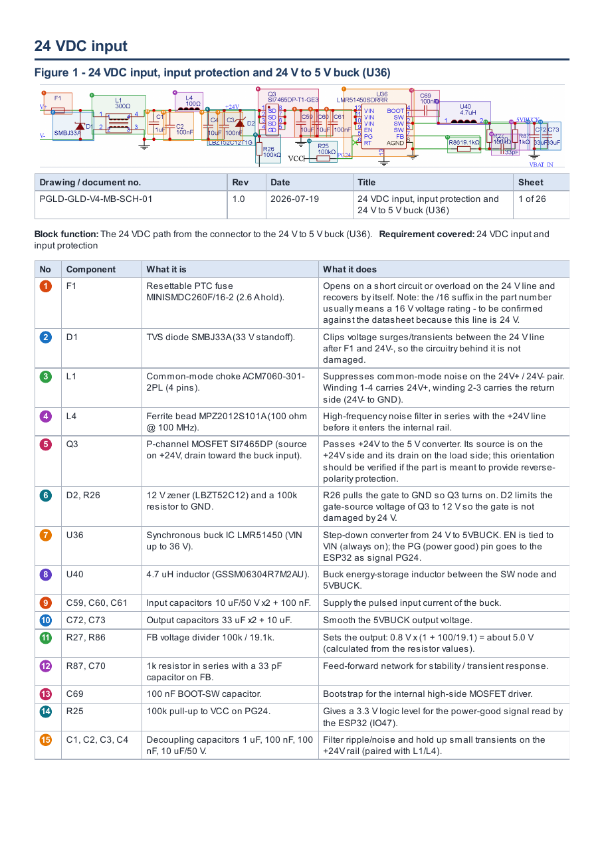

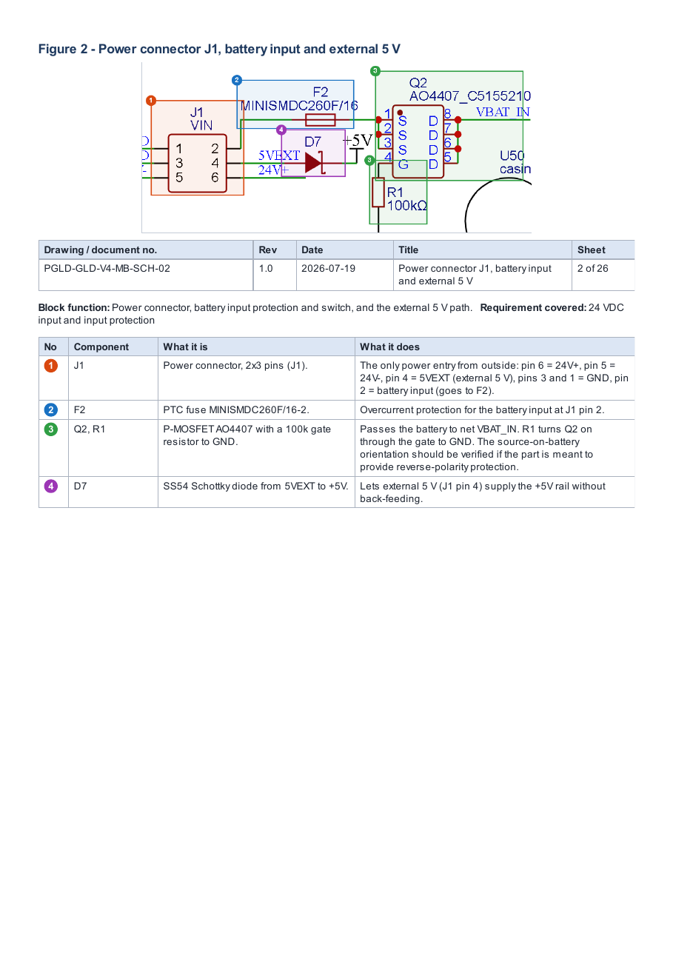

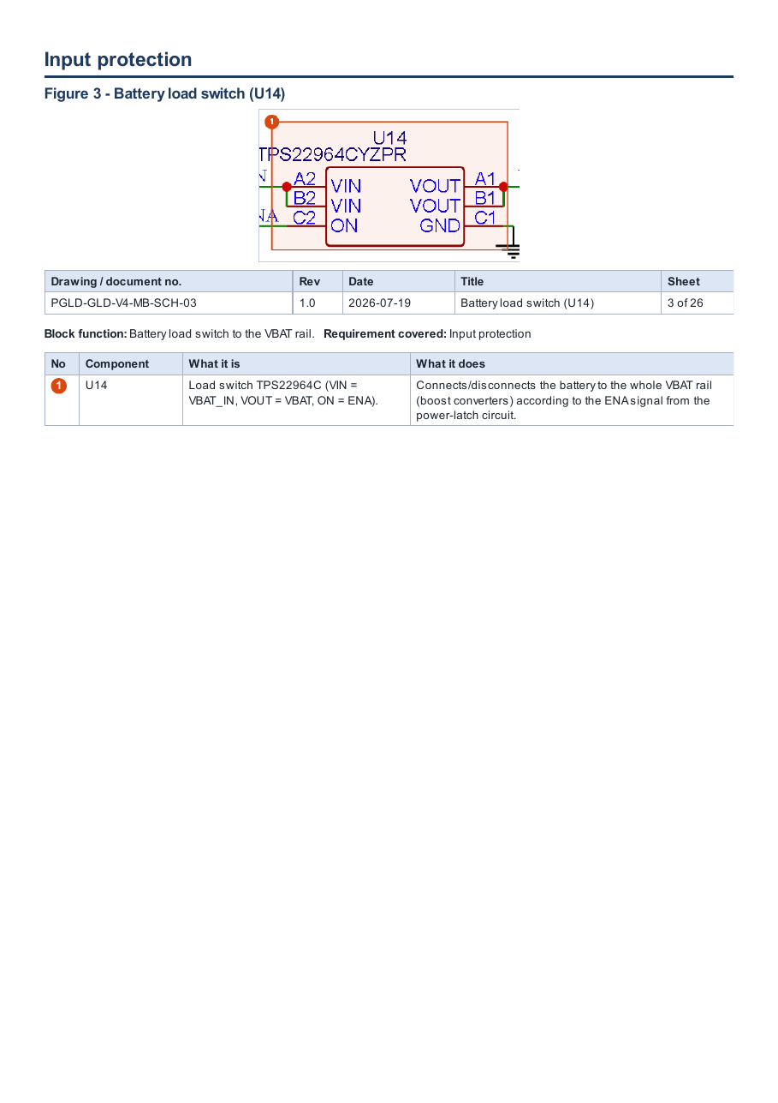

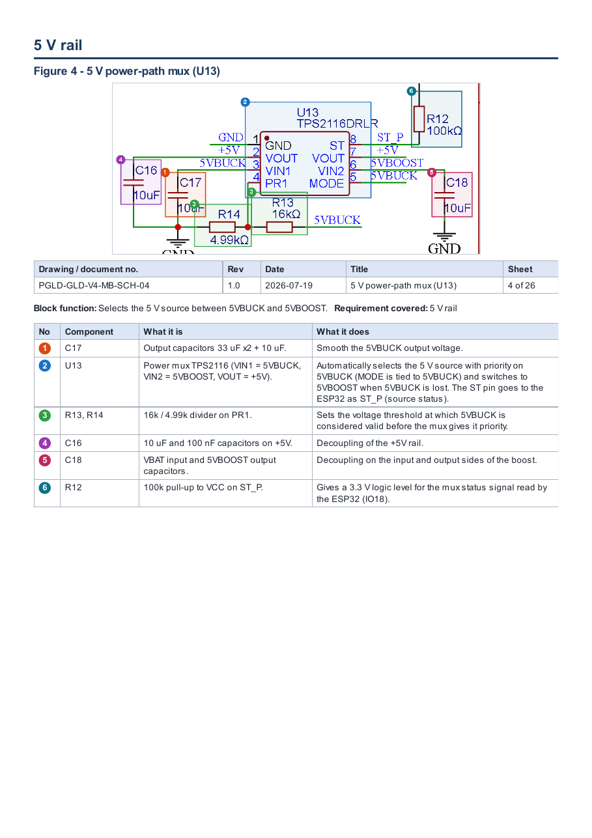

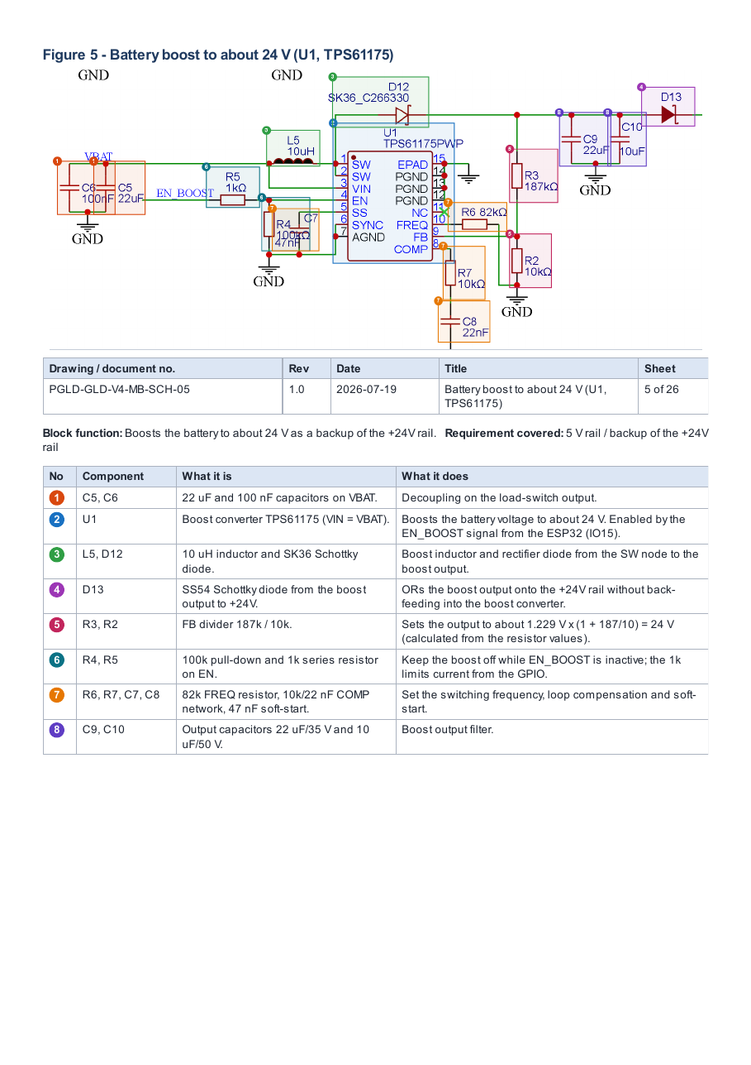

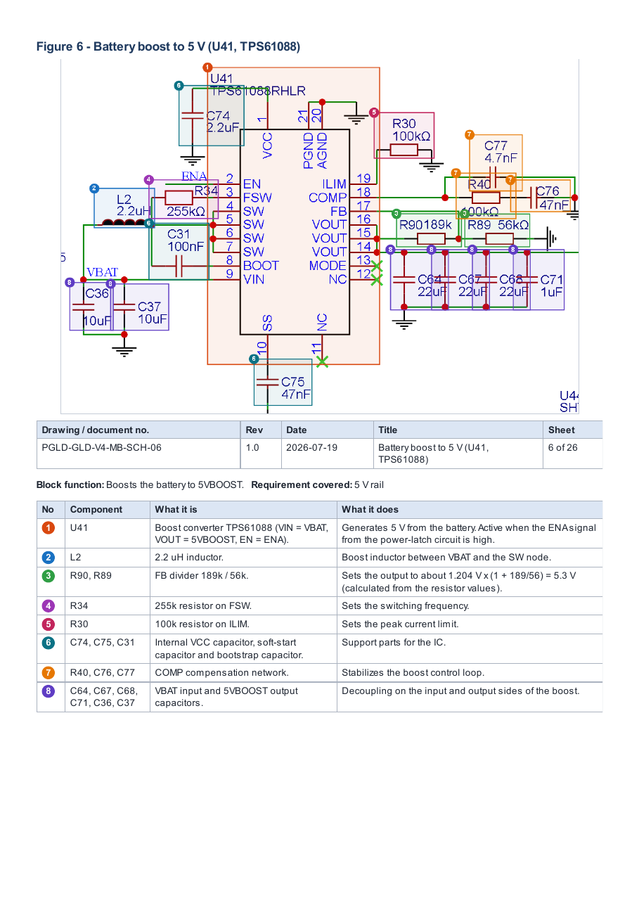

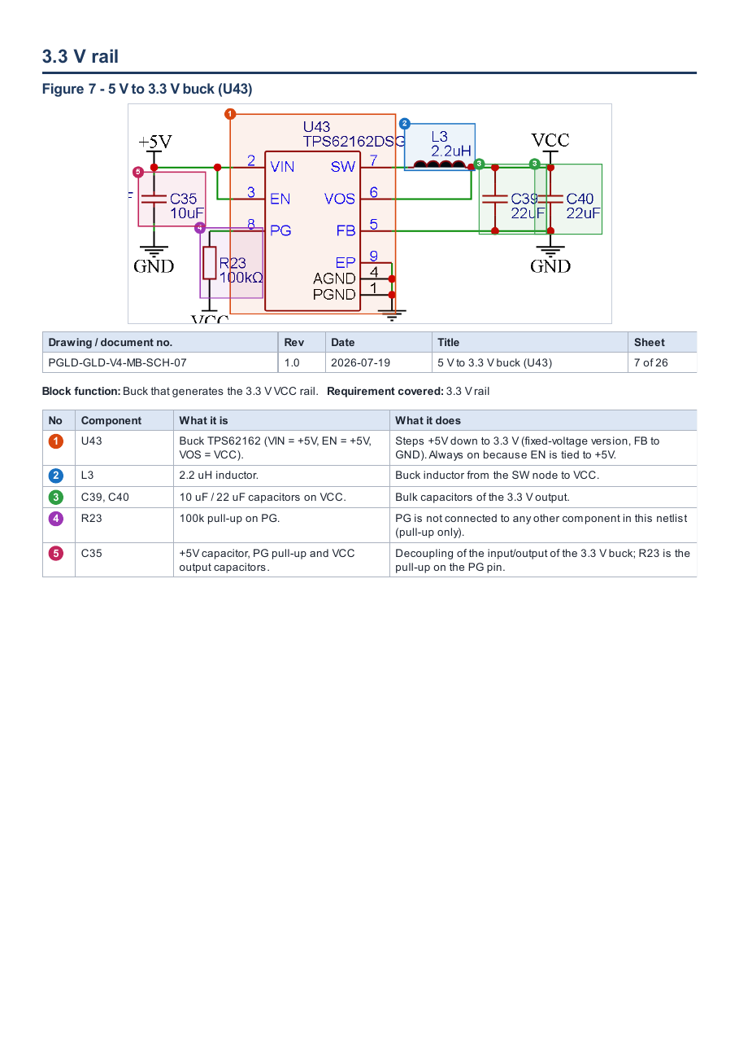

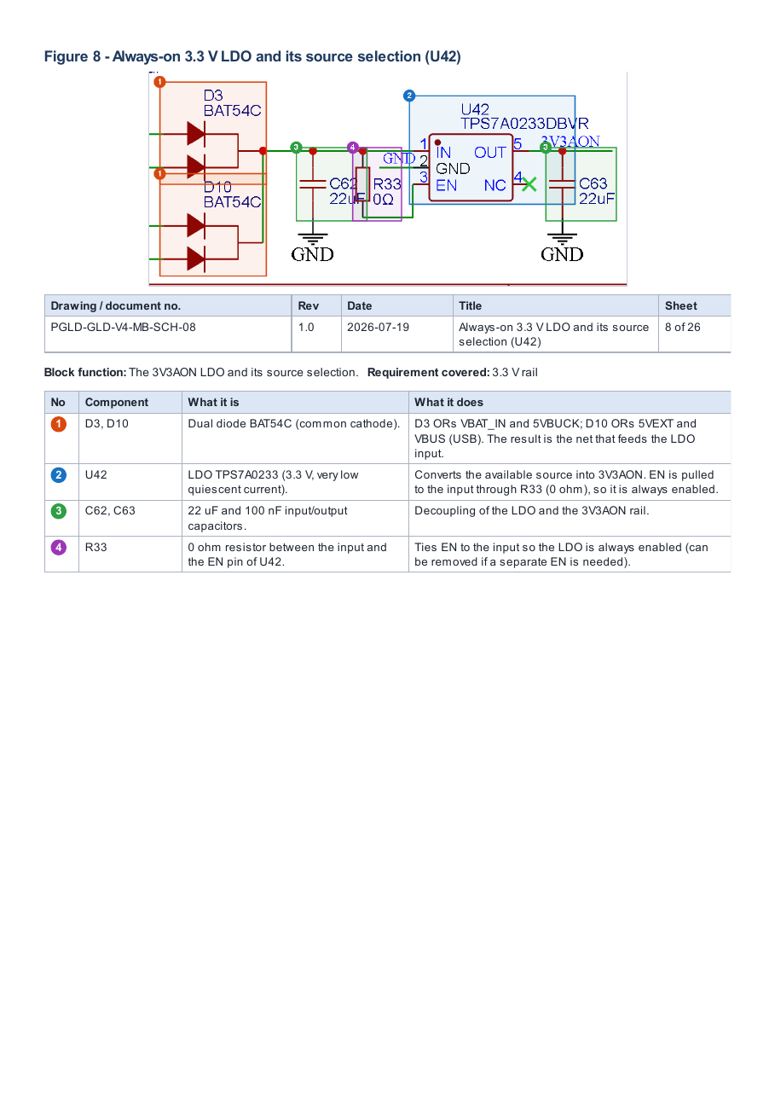

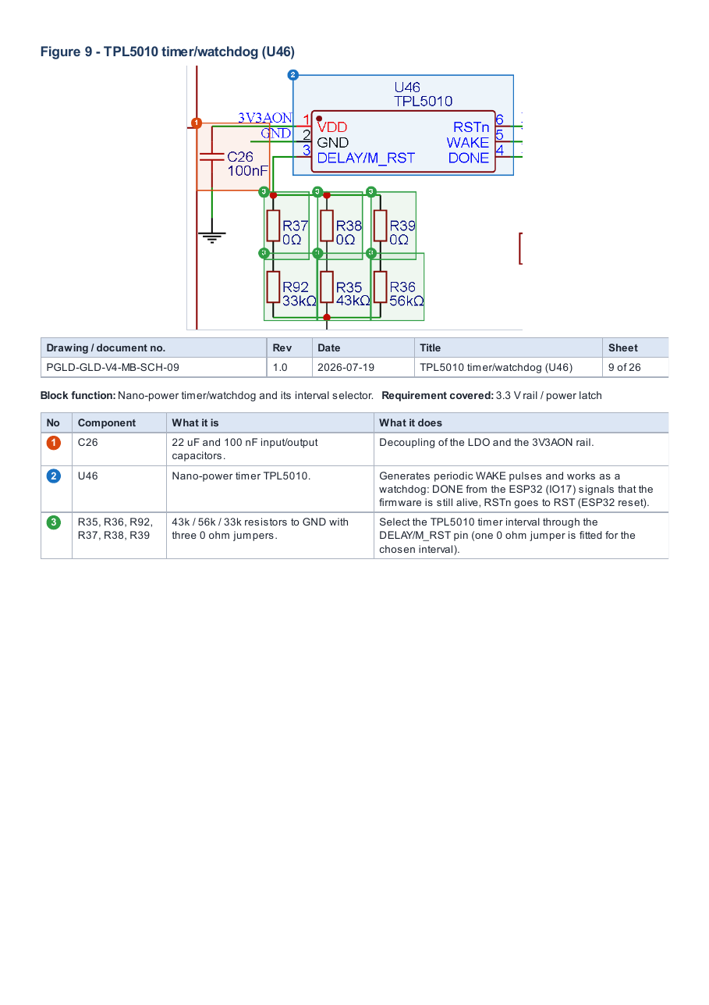

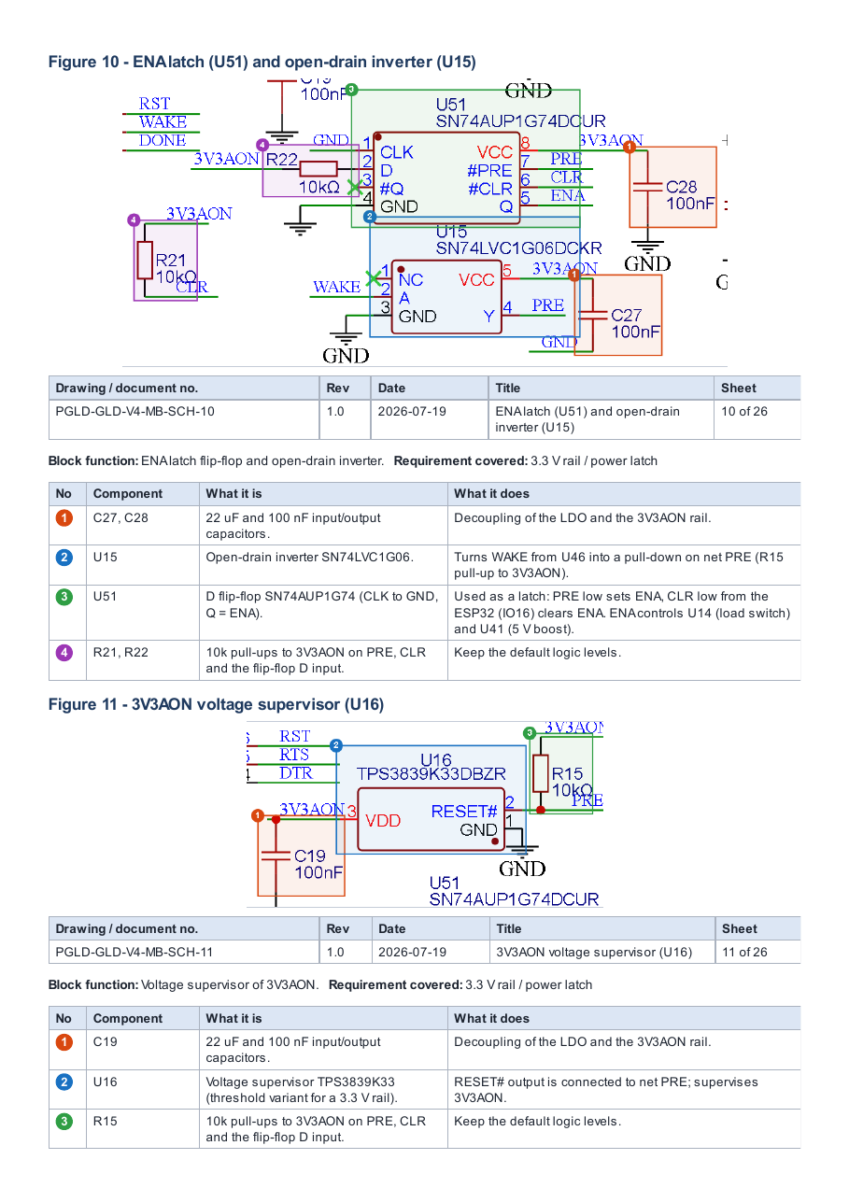

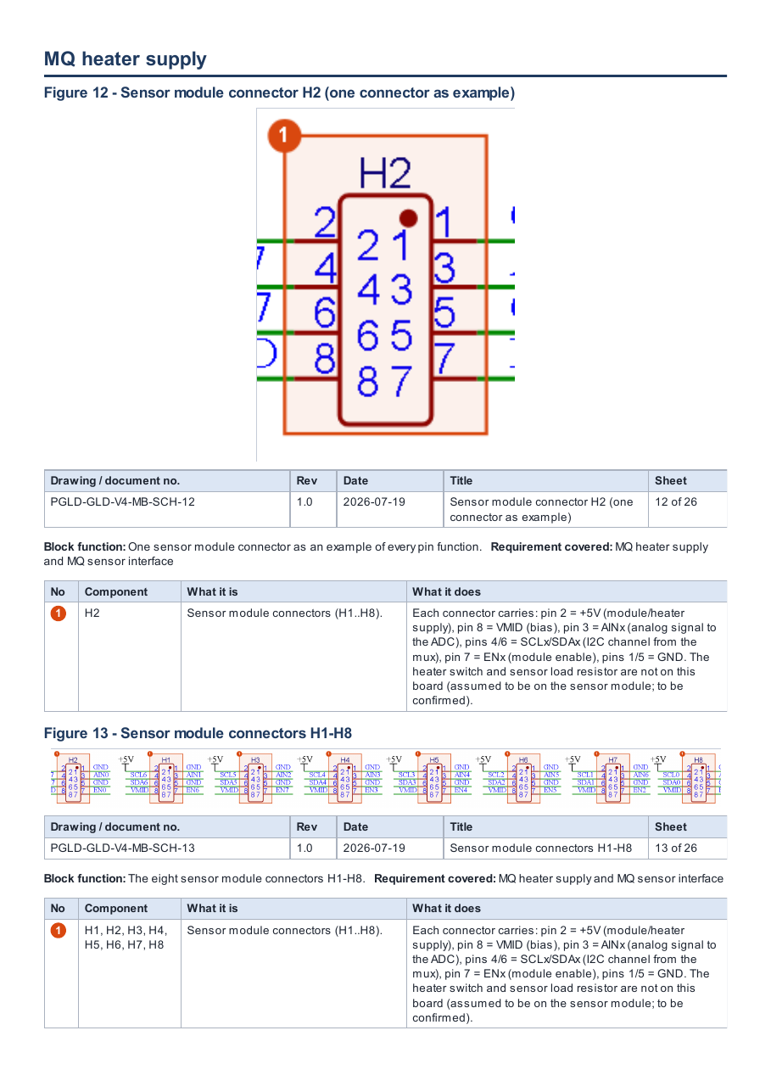

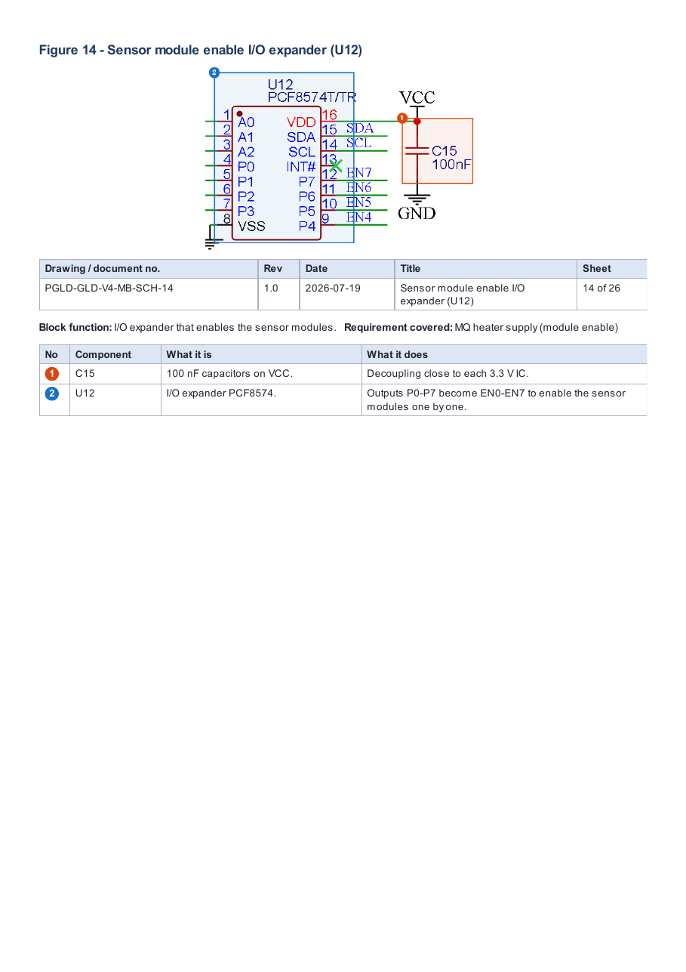

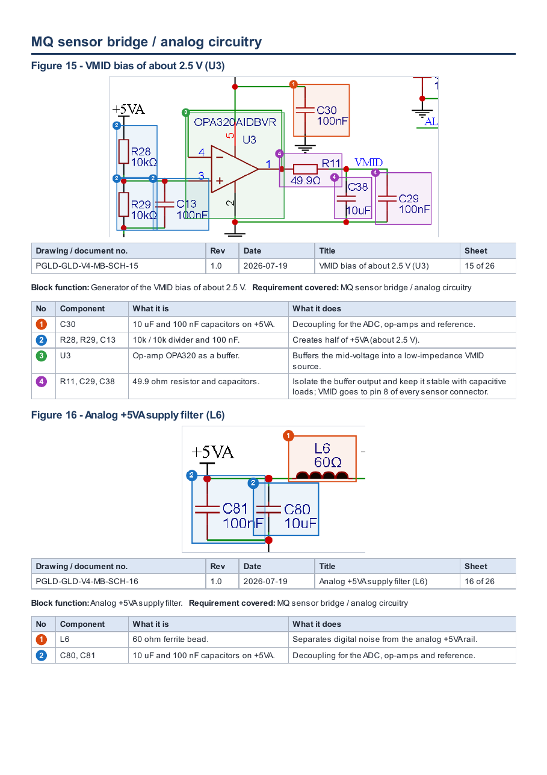

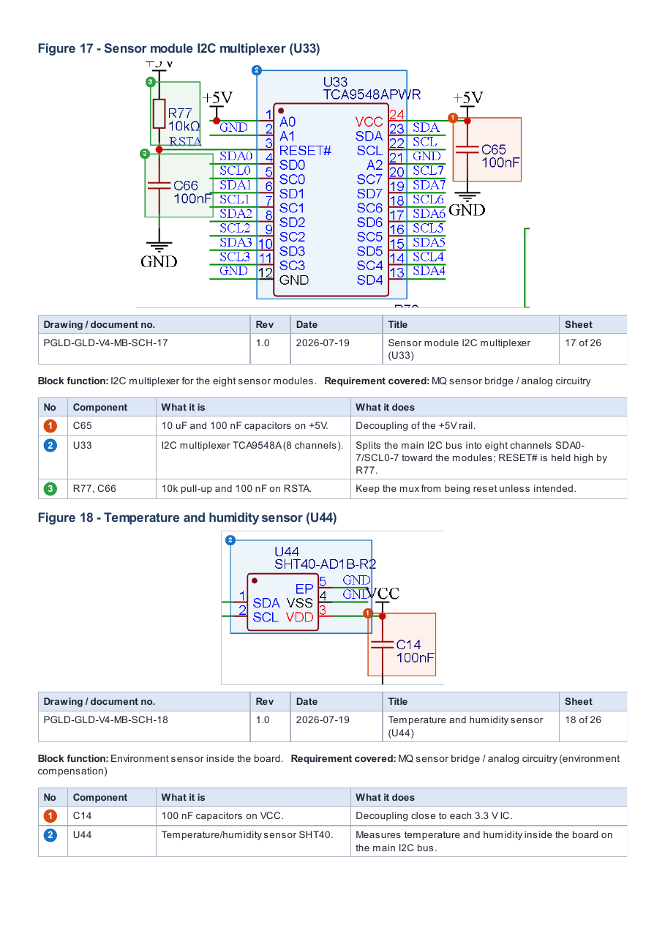

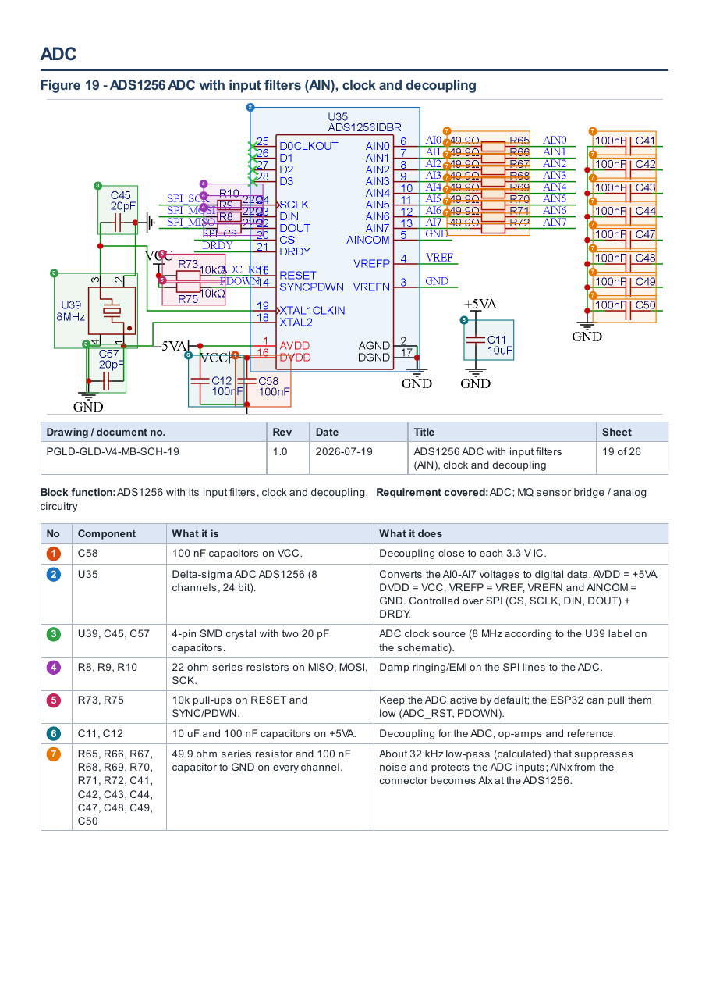

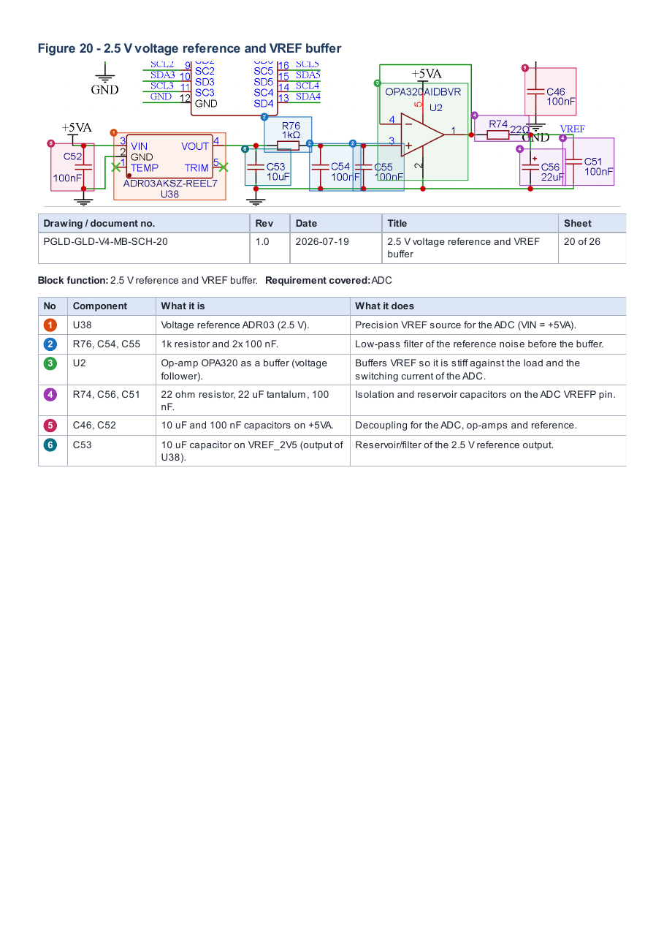

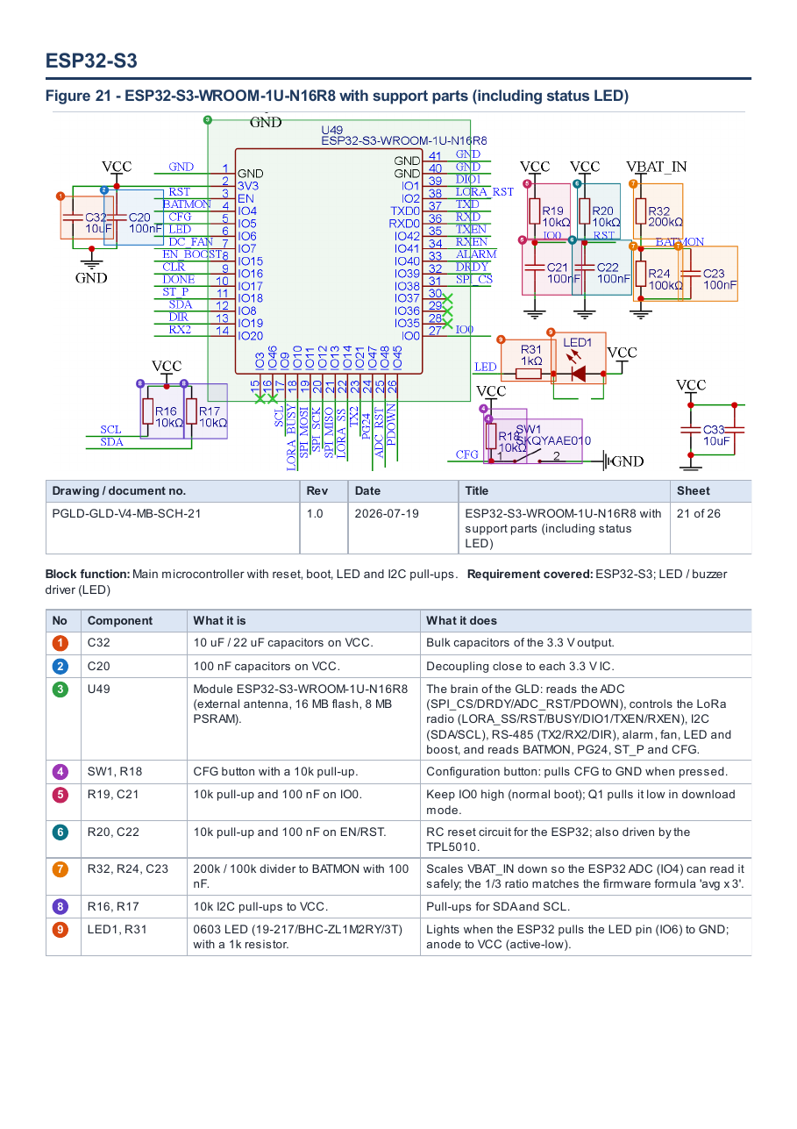

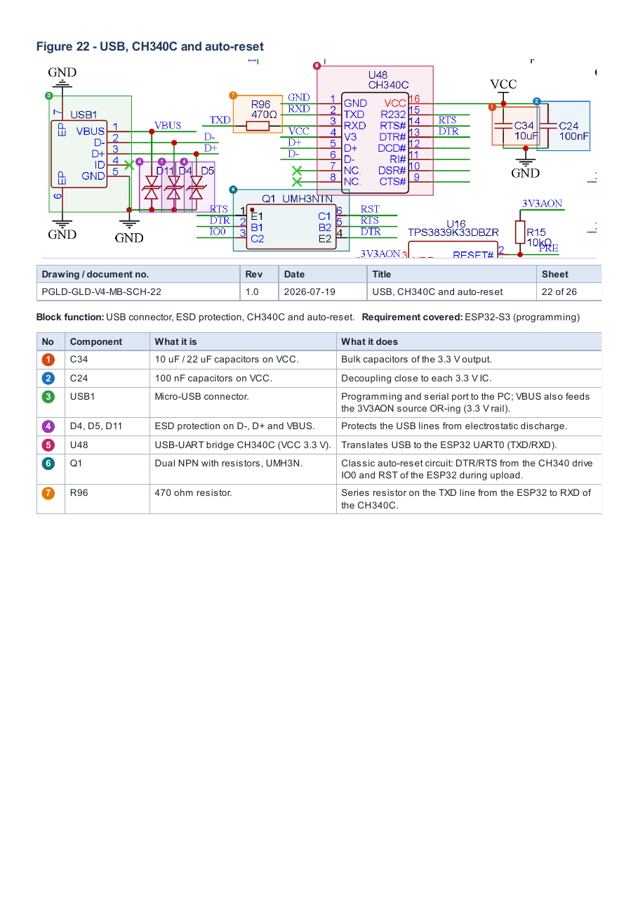

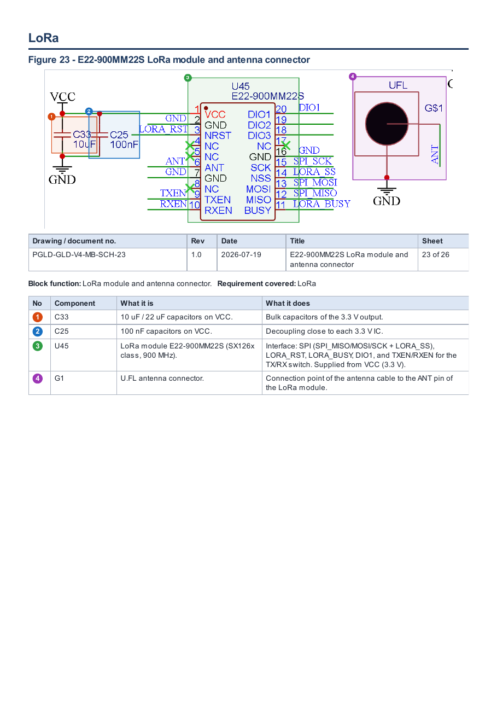

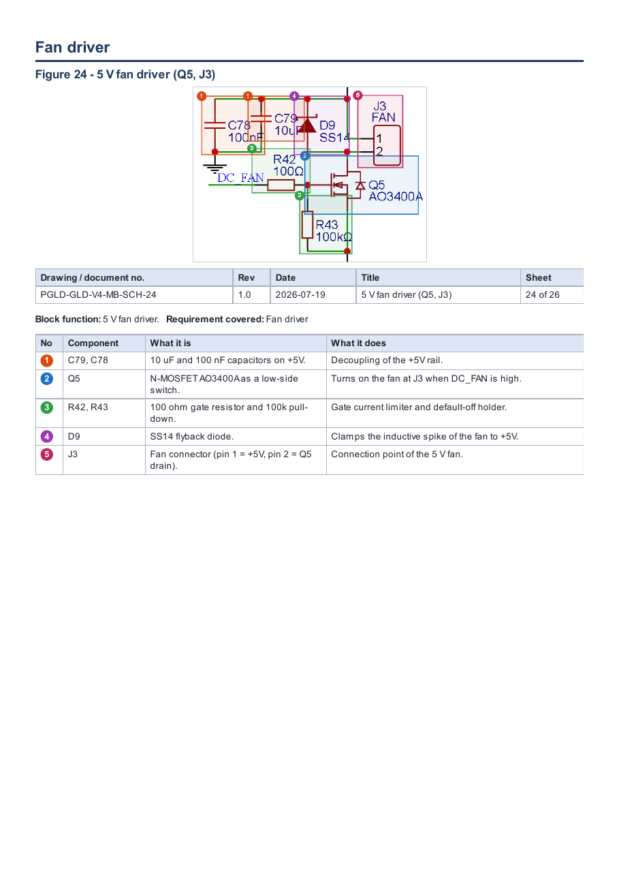

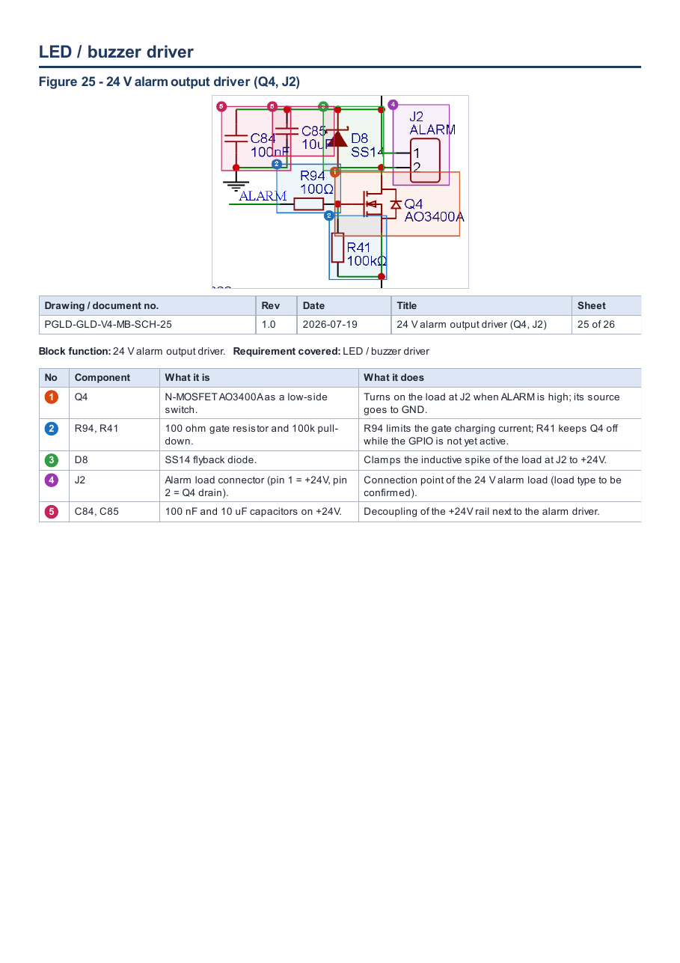

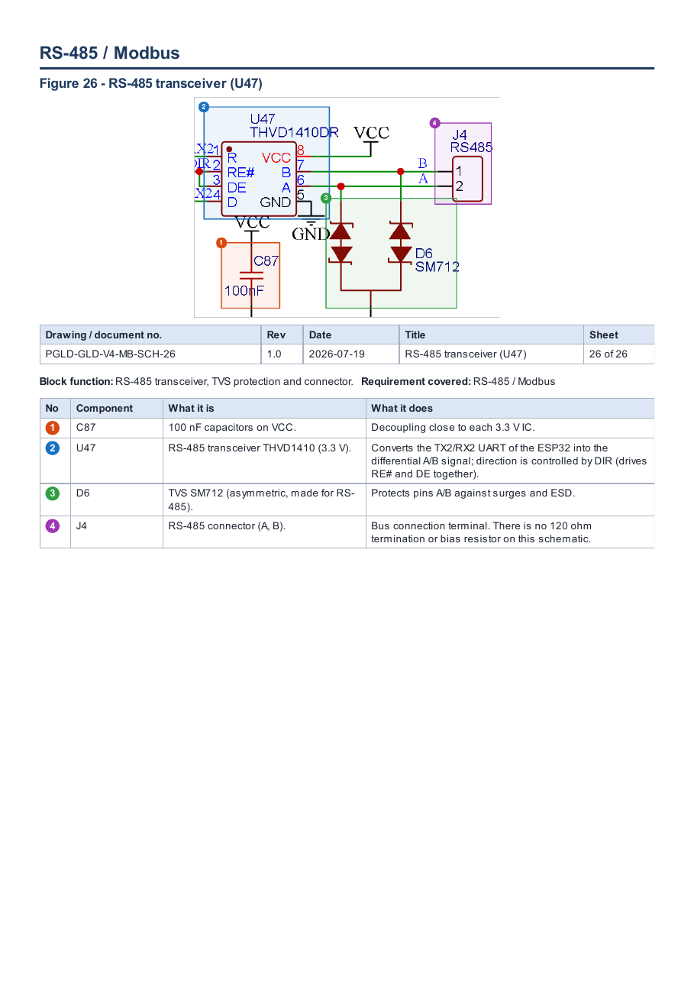

2.6.a.8 PCB layout
The layout of the GLD main board is presented in ten views generated from the EasyEDA PCB file of the same project. Each view highlights one aspect required by item 2.6.a.8; numbered markers on the view correspond to the legend printed below it.
Board data
Parameter | Value | Source / status
Board name | Main Board GLD (MotherBoardGLDVer2) | Layout file
Board outline | Circular, Ø 84.0 mm | Dimension in view 04
Copper layers | Top and bottom (two views of copper) | Views 01, 02
Component side | All SMD parts on top; only through-hole connectors pass to the bottom | View 02
Enclosure fixing holes | 4 × Ø 3.2 mm on Ø 64 mm pitch circle, at (0, +32), (+32, 0), (0, −32), (−32, 0) mm from centre | View 05
Additional holes | 4 × Ø 3.0 mm near the board edge (≈ ±39 mm from centre) | View 05 — purpose (casing screw or standoff) to be confirmed against the mechanical drawing
Ground | GND pour on top and bottom; 176 of 400 vias stitch the GND pours | Views 09, 10
Laminate, thickness, copper weight | Not stated in the layout package | To be provided (FR-4 grade, UL 94 rating, Tg, CTI) — see 6.b / 6.c
Layout revision / date | Not stated in the layout package | To be added to the drawing table

Drawing register
Drawing no. | Title | Requirement covered | Rev / date
PGLD-GLD-V4-MB-PCB-01 | Top layer | Top layer | TBC
PGLD-GLD-V4-MB-PCB-02 | Bottom layer | Bottom layer | TBC
PGLD-GLD-V4-MB-PCB-03 | Component placement | Component placement | TBC
PGLD-GLD-V4-MB-PCB-04 | Board dimensions | Board dimensions | TBC
PGLD-GLD-V4-MB-PCB-05 | Mounting holes | Mounting holes | TBC
PGLD-GLD-V4-MB-PCB-06 | Connectors | Connectors | TBC
PGLD-GLD-V4-MB-PCB-07 | High-current / power area | High-current / power area | TBC
PGLD-GLD-V4-MB-PCB-08 | Sensor interface | Sensor interface | TBC
PGLD-GLD-V4-MB-PCB-09 | Grounding arrangement — top | Grounding arrangement | TBC
PGLD-GLD-V4-MB-PCB-10 | Grounding arrangement — bottom | Grounding arrangement | TBC

Coverage of the required layout content
Required content (2.6.a.8) | Where shown | Status
Top layer | View 01 | Provided
Bottom layer | View 02 | Provided
Component placement | View 03 | Provided
Board dimensions | View 04 | Provided
Mounting holes | View 05 | Provided — purpose of 4 × Ø 3.0 mm holes to confirm
Connectors | View 06 | Provided
High-current / power area | View 07 | Provided
Sensor interface | View 08 | Provided
Grounding arrangement | Views 09, 10 | Provided
One set per board (Main, Sensor, Alarm, Terminal) | Main board only | Open — sensor-module board layout to be added

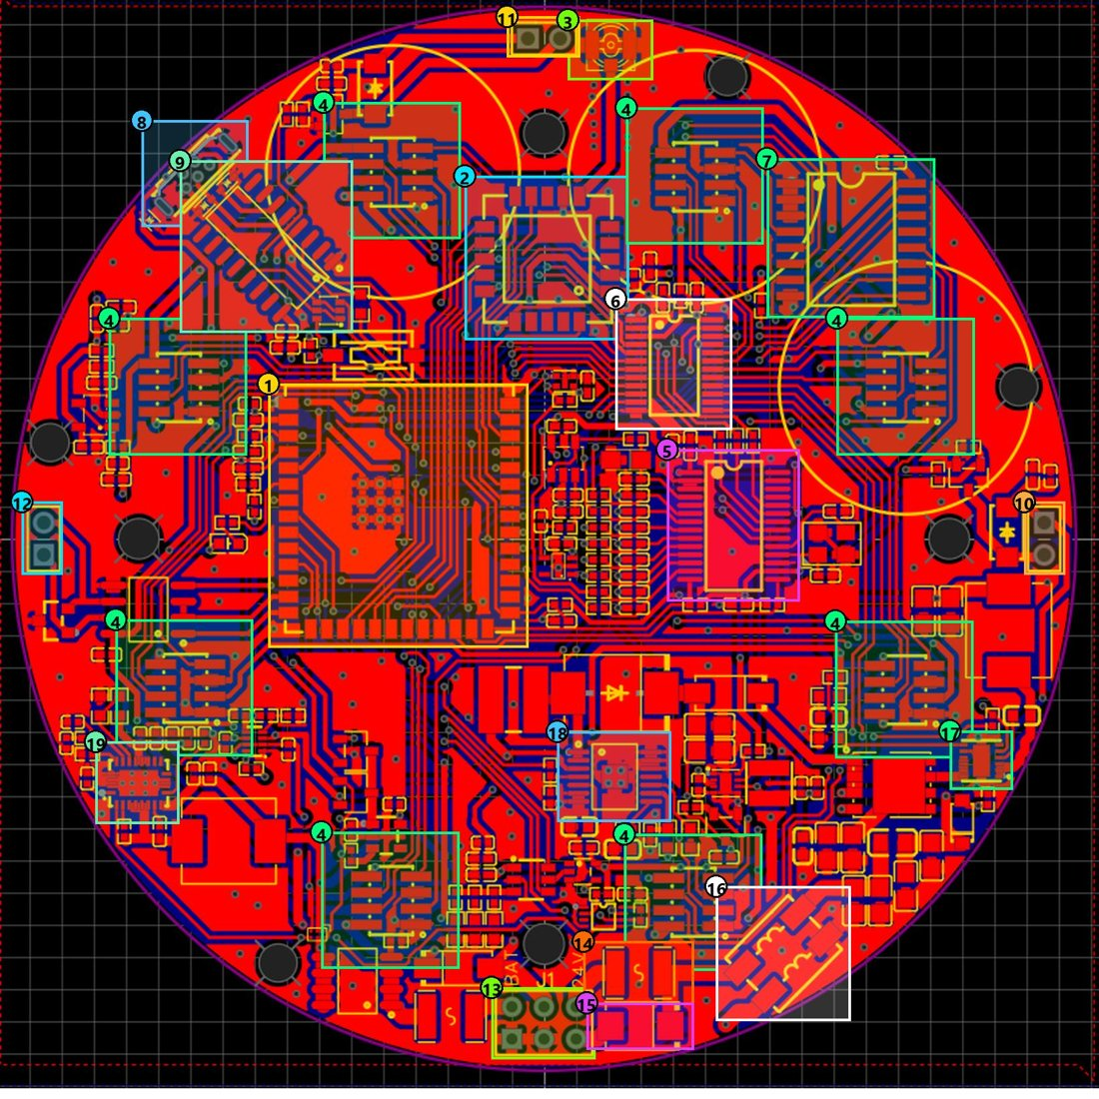
Figure 8-1. Top layer — Main Board GLD
Drawing no. | Rev | Date | Title | Sheet
PGLD-GLD-V4-MB-PCB-01 | TBC | TBC | Top layer | 1 of 10

No | Item | Description
1 | ESP32-S3 | Main MCU module: runs the GLD firmware; SPI to LoRa and ADC, I²C to sensors, GPIO for alarm/fan.
2 | LoRa E22-900MM22S | LoRa radio for communication with the cluster head.
3 | U.FL antenna connector | Connection to the external LoRa antenna.
4 | Sensor ports (8) | Eight 2 × 4 headers around the board, one per sensor module (yellow circle = module outline).
5 | ADS1256 | 24-bit ADC reading the eight analog sensor channels.
6 | TCA9548A | 8-channel I²C multiplexer, one channel per sensor port.
7 | PCF8574 | I/O expander providing the enable signals EN0–EN7 for each sensor.
8 | Micro-USB | USB port for firmware flashing and serial debug.
9 | CH340C | USB-to-UART converter for programming and serial monitor.
10 | ALARM connector | 24 V siren/beacon output.
11 | FAN connector | 5 V fan output.
12 | RS-485 connector | RS-485 bus (A/B).
13 | VIN connector | Power input: 24V+, 24V−, 5VEXT, GND, BAT (battery).
14 | PTC fuse | Limits current on the 24 V line under short circuit.
15 | TVS | Clamps voltage surges on the 24 V input.
16 | Common-mode filter | Filters common-mode noise on the 24 V input.
17 | Buck 24 V → 5 V | LMR51450 regulator stepping 24 V down to 5 V.
18 | Battery boost → 24 V | TPS61175 boosting the battery to the +24V rail.
19 | Battery boost → 5 V | TPS61088 generating 5 V from the battery.

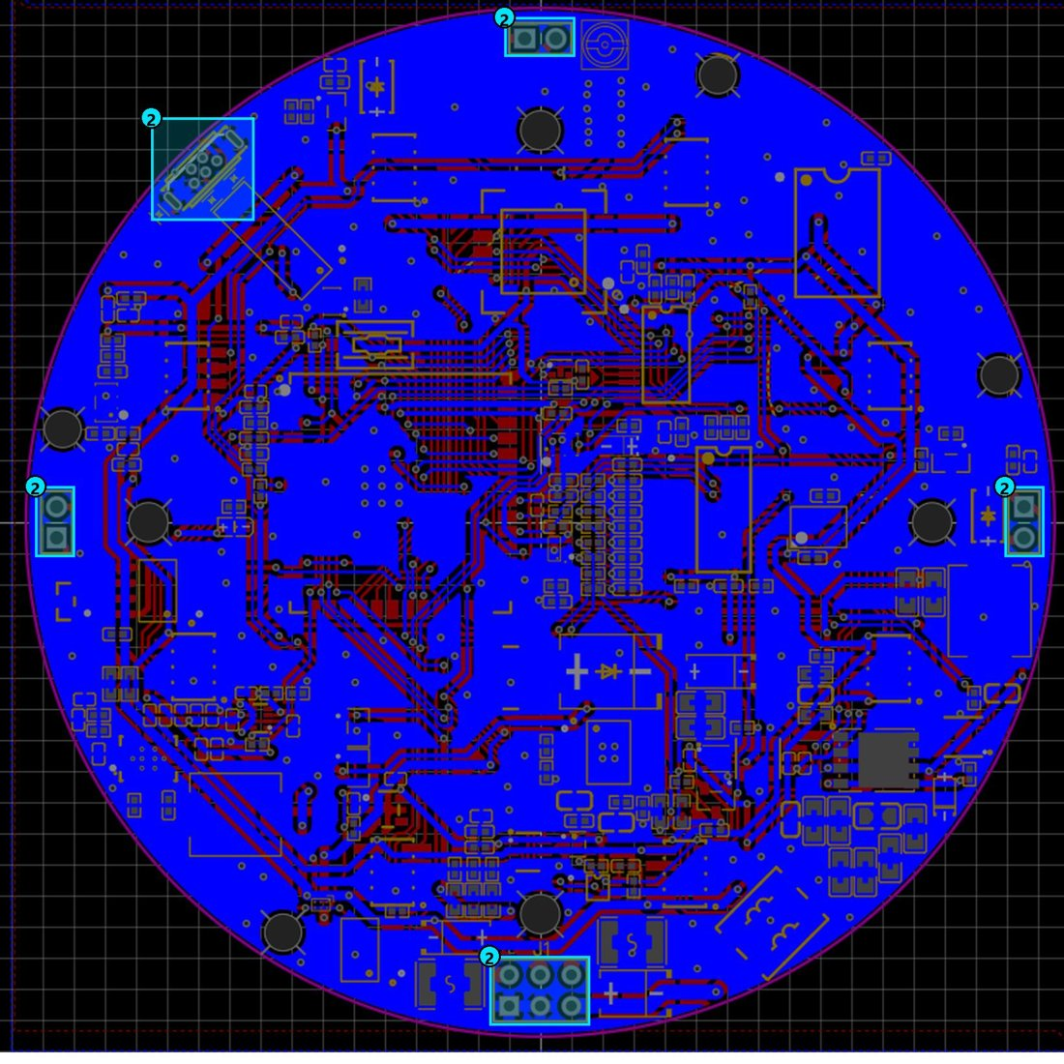
Figure 8-2. Bottom layer — Main Board GLD
Drawing no. | Rev | Date | Title | Sheet
PGLD-GLD-V4-MB-PCB-02 | TBC | TBC | Bottom layer | 2 of 10

No | Item | Description
1 | Bottom GND pour (solid blue area) | GND plane filling almost the whole bottom side; connected to the top pour through vias.
2 | Through-hole connectors | The only parts passing through to the bottom; all SMD parts are on the top side.

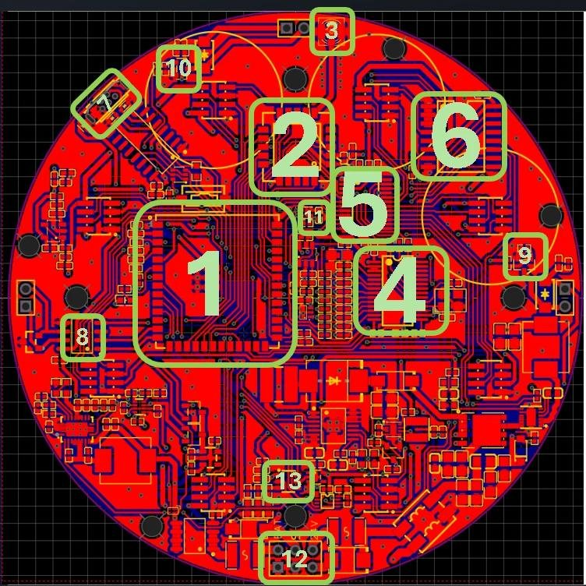
Figure 8-3. Component placement — Main Board GLD
Drawing no. | Rev | Date | Title | Sheet
PGLD-GLD-V4-MB-PCB-03 | TBC | TBC | Component placement | 3 of 10

No | Item | Description
1 | ESP32-S3 | Main MCU: runs the firmware and controls all blocks.
2 | LoRa (E22-900MM22S) | LoRa radio for communication with the cluster head.
3 | Antenna (U.FL) | External LoRa antenna connector.
4 | ADS1256 | 24-bit ADC for the eight analog sensor channels.
5 | TCA9548 | 8-channel I²C mux, one channel per sensor port.
6 | PCF8574 | I/O expander for the enable signals EN0–EN7.
7 | USB | Micro-USB + CH340C for firmware flashing and serial monitor.
8 | RS-485 | THVD1410 transceiver for the RS-485 bus.
9 | Alarm driver | MOSFET switching the 24 V siren/beacon.
10 | Fan driver | MOSFET switching the 5 V fan.
11 | SHT40 | Temperature and humidity sensor inside the enclosure.
12 | Power block | Power input and protection (VIN connector, fuse, TVS, filter).
13 | TPL5010 | Watchdog timer that wakes the system periodically.

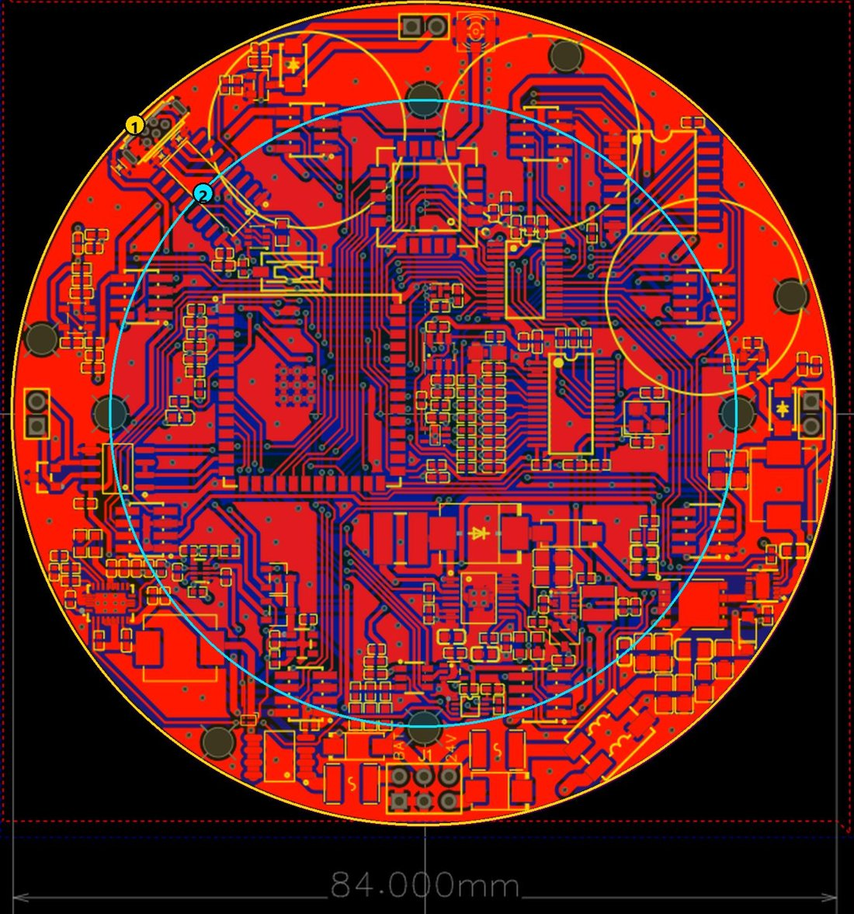
Figure 8-4. Board dimensions — Main Board GLD
Drawing no. | Rev | Date | Title | Sheet
PGLD-GLD-V4-MB-PCB-04 | TBC | TBC | Board dimensions | 4 of 10

No | Item | Description
1 | Board diameter: 84 mm | Circular board (outline) matching the round aluminium enclosure.
2 | Enclosure-hole pitch circle: Ø 64 mm | The four enclosure fixing holes lie on this circle, 90° apart.

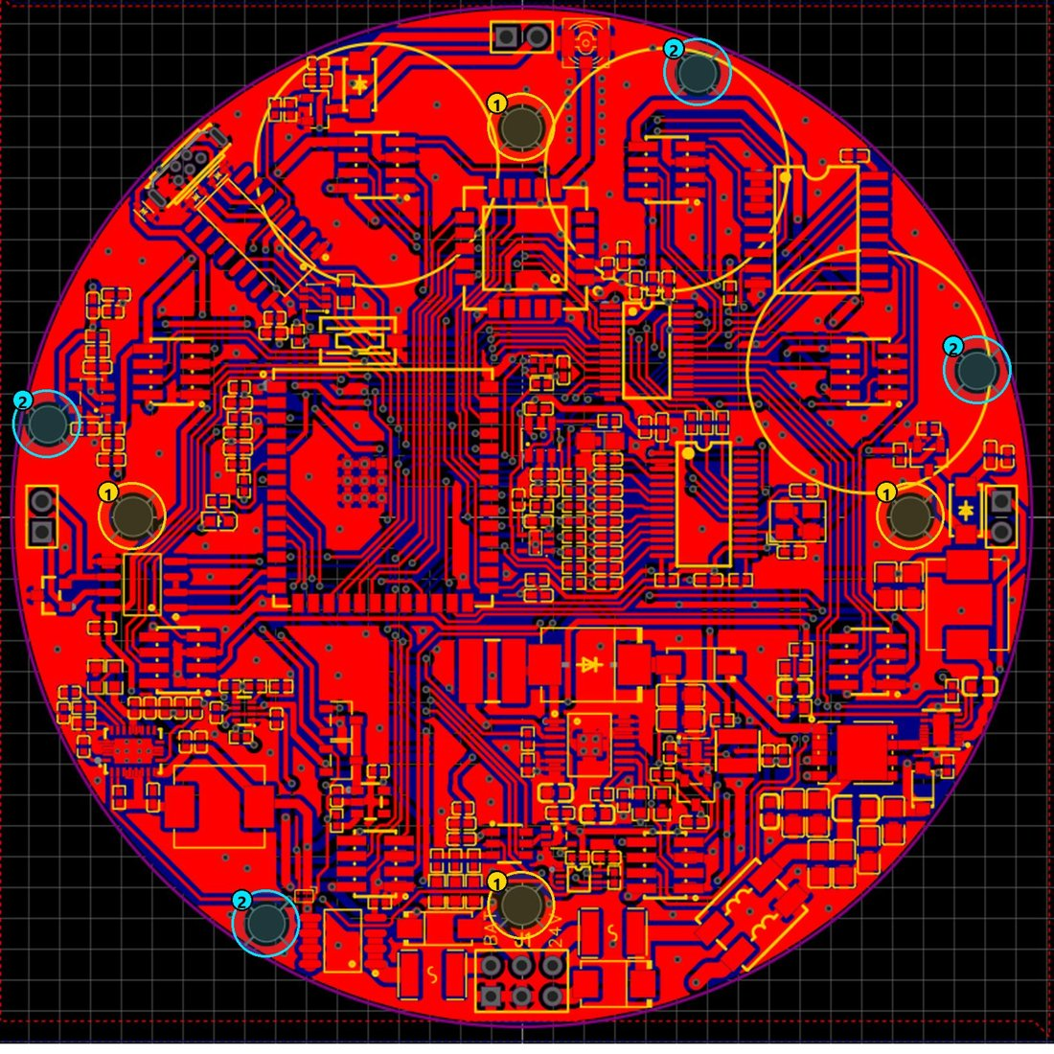
Figure 8-5. Mounting holes — Main Board GLD
Drawing no. | Rev | Date | Title | Sheet
PGLD-GLD-V4-MB-PCB-05 | TBC | TBC | Mounting holes | 5 of 10

No | Item | Description
1 | Enclosure holes (4 × Ø 3.2 mm) | Hole pattern of the enclosure footprint on the Ø 64 mm circle; board-to-enclosure fixing screws. Positions from centre: (0, +32), (+32, 0), (0, −32), (−32, 0) mm.
2 | Additional holes (4 × Ø 3.0 mm) | Four further fixing holes near the board edge (≈ ±39 mm from centre). Exact use (enclosure screw or standoff) to be confirmed with the mechanical drawing.

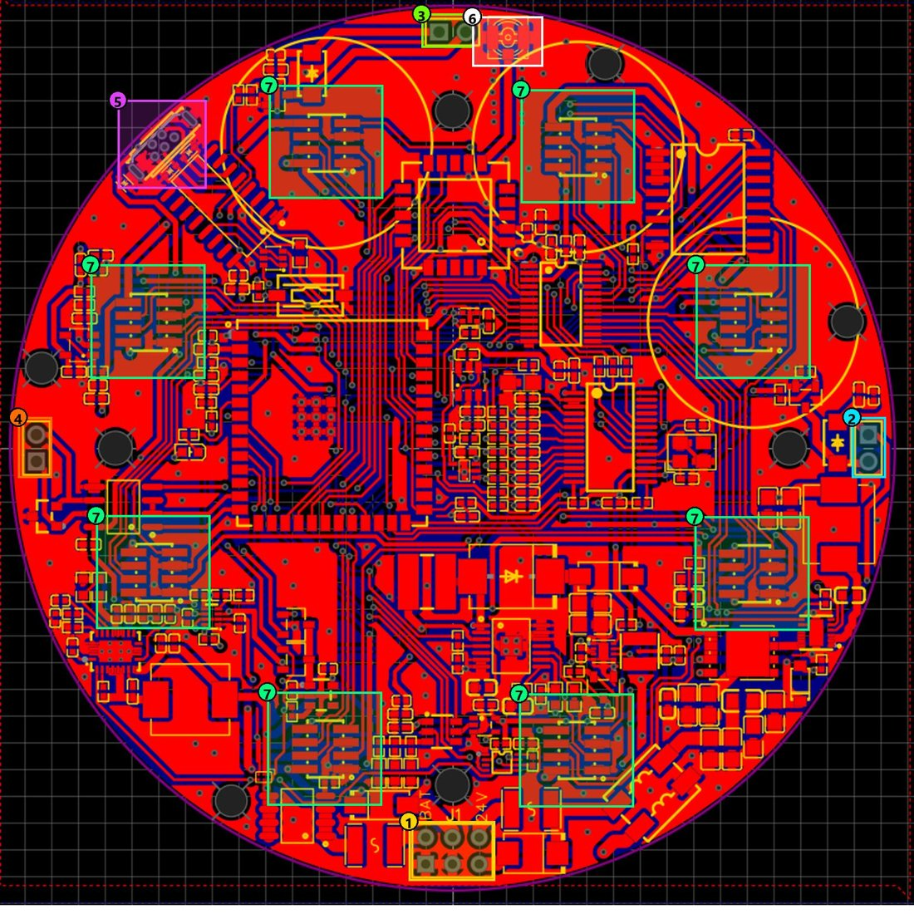
Figure 8-6. Connectors — Main Board GLD
Drawing no. | Rev | Date | Title | Sheet
PGLD-GLD-V4-MB-PCB-06 | TBC | TBC | Connectors | 6 of 10

No | Item | Description
1 | VIN | Power input, 2 × 3 pins: 24V+, 24V−, 5VEXT, GND, BAT (battery).
2 | ALARM | 24 V siren/beacon output (pin 1 = +24V, pin 2 = MOSFET switch side).
3 | FAN | 5 V fan output (pin 1 = +5V, pin 2 = MOSFET switch side).
4 | RS-485 | RS-485 bus: B (pin 1) and A (pin 2).
5 | Micro-USB | Firmware flashing and serial debug.
6 | U.FL (antenna) | External LoRa antenna connector.
7 | Sensor ports (8) | Eight 2 × 4 headers (1.27 mm pitch): GND, +5V, AINx, SCLx, SDAx, ENx, VMID — one sensor module each.

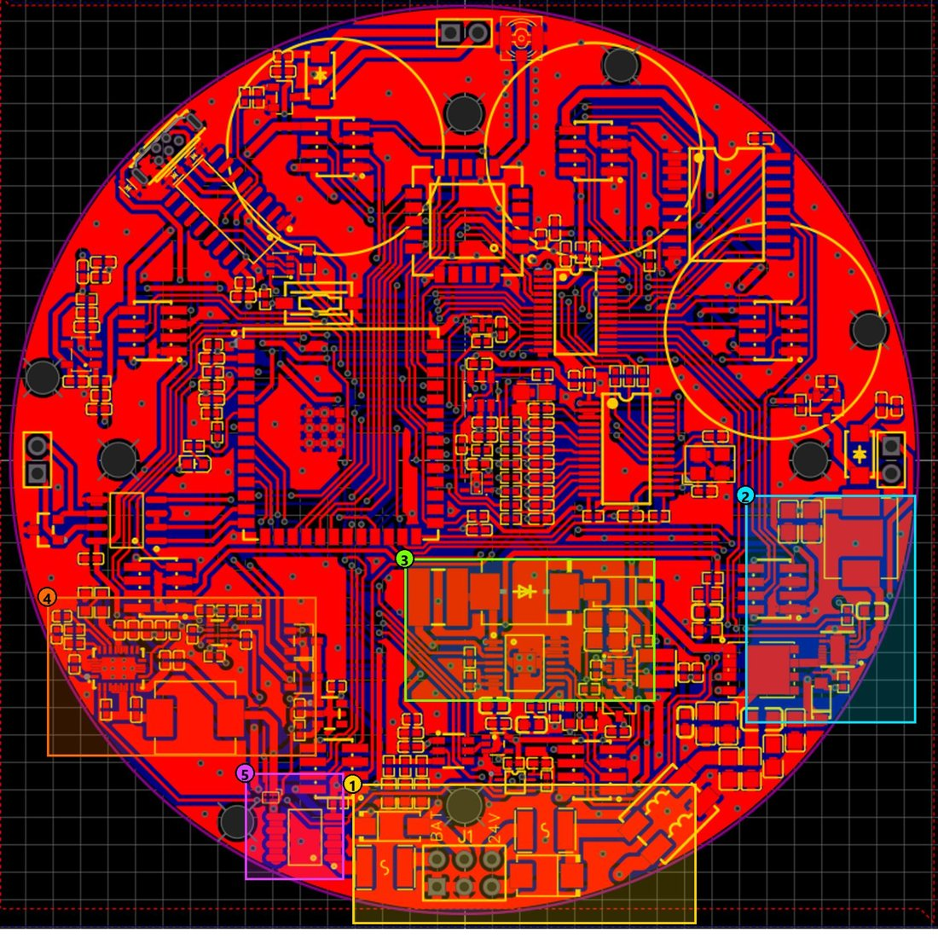
Figure 8-7. High-current / power area — Main Board GLD
Drawing no. | Rev | Date | Title | Sheet
PGLD-GLD-V4-MB-PCB-07 | TBC | TBC | High-current / power area | 7 of 10

No | Item | Description
1 | Power input & protection | VIN connector, fuse, TVS, common-mode filter, ferrite: 24 V entry path.
2 | 24 V → 5 V converter | LMR51450 buck, 4.7 µH inductor, P-MOSFET switch.
3 | Battery → 24 V converter | TPS61175 boost, 10 µH inductor, SK36 diode and OR-ing diode to the +24V rail.
4 | Battery → 5 V converter + power mux | TPS61088 boost, 2.2 µH inductor, TPS2116 power mux selecting the 5 V source.
5 | Battery protection | Fuse, P-MOSFET, load switch: disconnects the battery when the system sleeps.

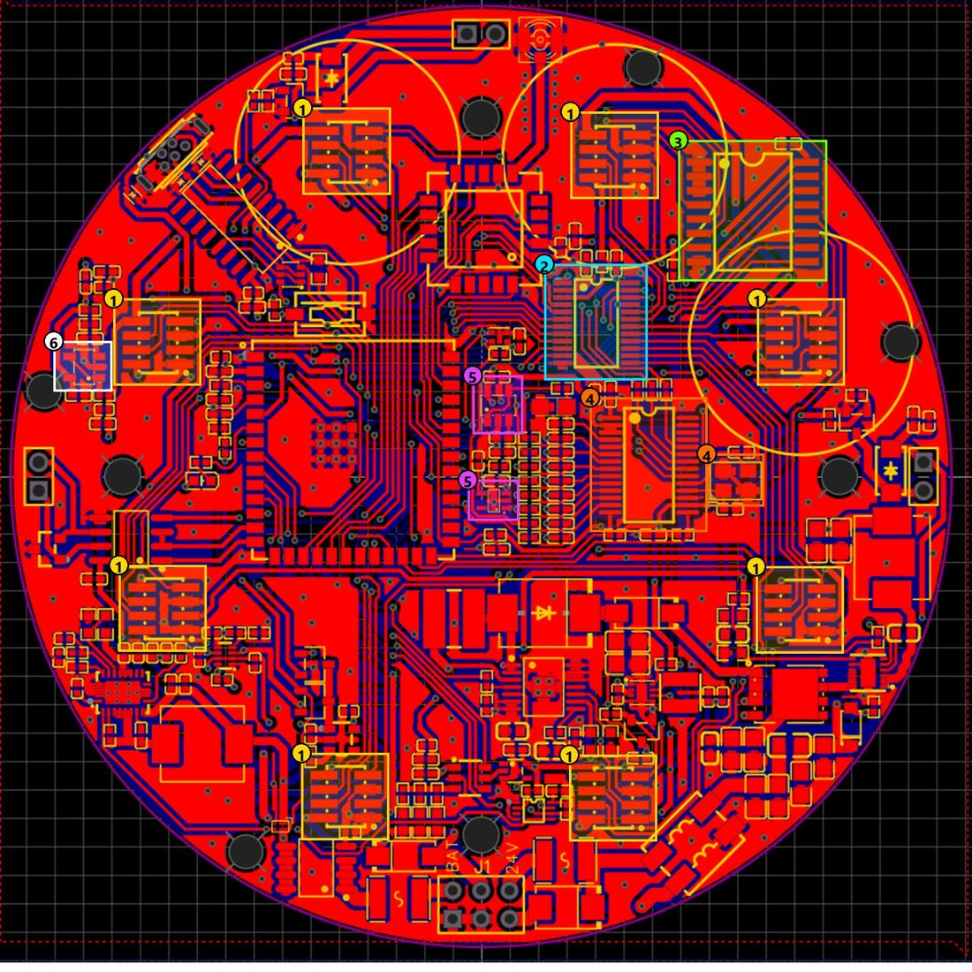
Figure 8-8. Sensor interface — Main Board GLD
Drawing no. | Rev | Date | Title | Sheet
PGLD-GLD-V4-MB-PCB-08 | TBC | TBC | Sensor interface | 8 of 10

No | Item | Description
1 | Sensor ports (8) | Eight headers: +5V, GND, VMID, ENx, SDAx/SCLx (I²C per channel), AINx (analog to ADC).
2 | TCA9548A | I²C mux splitting the ESP32 I²C bus into 8 channels for 8 sensors.
3 | PCF8574 | I/O expander generating EN0–EN7 to switch each sensor module.
4 | ADS1256 + 8 MHz crystal | 8-channel 24-bit ADC, SPI to ESP32, clocked from an 8 MHz crystal.
5 | 2.5 V reference + buffer | ADR03 generates VREF, buffered by OPA320 for the ADC.
6 | VMID buffer | OPA320 follower generating VMID (analog mid-bias) for the sensor modules.

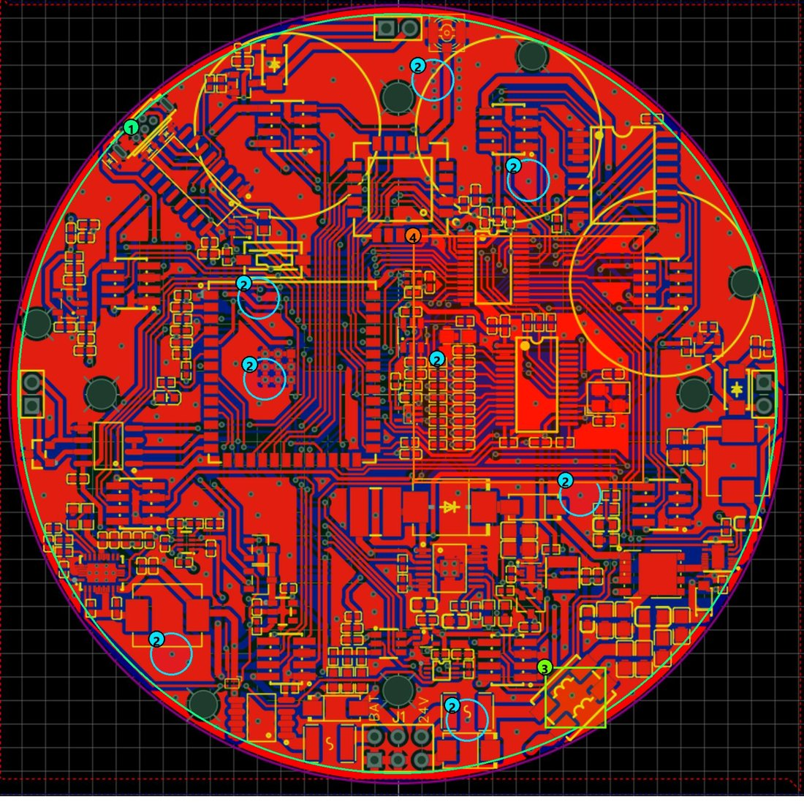
Figure 8-9. Grounding arrangement (top) — Main Board GLD
Drawing no. | Rev | Date | Title | Sheet
PGLD-GLD-V4-MB-PCB-09 | TBC | TBC | Grounding arrangement — top | 9 of 10

No | Item | Description
1 | GND pour | One GND copper area (green line along the board edge) on top and bottom, filling all free area: short return paths and noise shielding.
2 | GND vias (examples) | 176 of the 400 vias connect the top and bottom GND pours; blue circles mark examples.
3 | 24V− → GND at the common-mode filter | The 24 V input return (24V−) joins system GND through the return winding of the common-mode choke.
4 | Analog area without split ground | Single GND net. The analog area (ADS1256, voltage reference, OPA320) is separated through the +5VA supply (ferrite), not by a split ground.

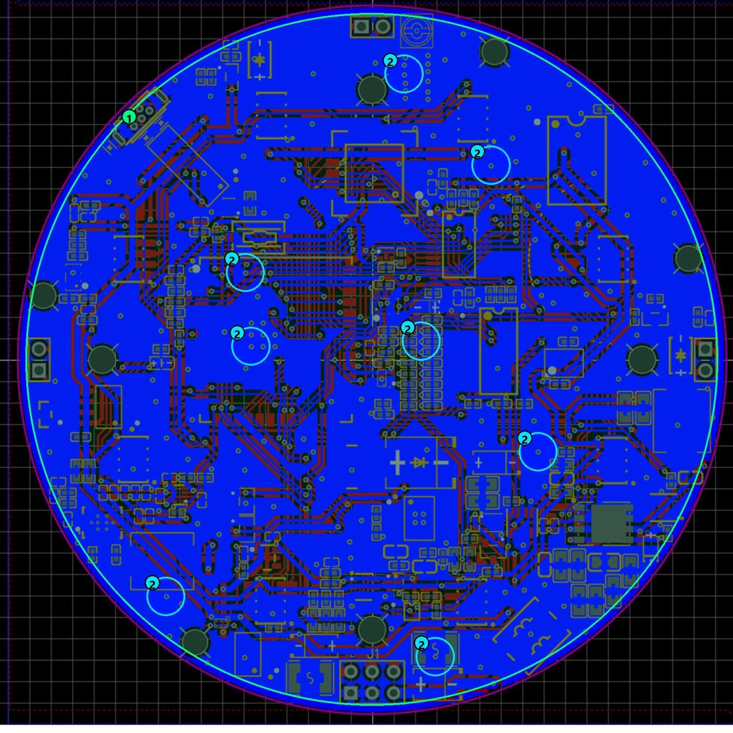
Figure 8-10. Grounding arrangement (bottom) — Main Board GLD
Drawing no. | Rev | Date | Title | Sheet
PGLD-GLD-V4-MB-PCB-10 | TBC | TBC | Grounding arrangement — bottom | 10 of 10

No | Item | Description
1 | GND pour | Bottom GND copper area filling all free area.
2 | GND vias (examples) | 176 of 400 vias stitch the top and bottom GND pours; blue circles mark examples.

3D renders — main board and PCB cover (terminal board), GLD V4
The GLD V4 electronics consist of two stacked circular boards: the main board (motherboard) and a separate PCB cover (terminal board) that carries the field-wiring terminals and covers the motherboard. Renders exported from the PCB design; they show the boards as designed, not a dimensioned drawing.
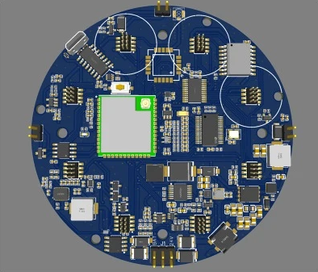  Main board — top (component side) | 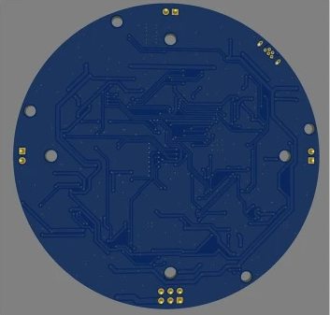  Main board — bottom
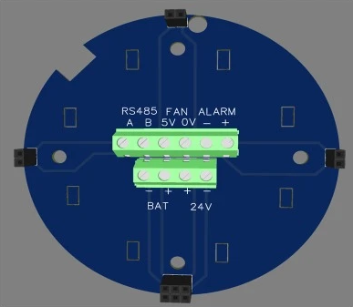  PCB cover (terminal board) — top | 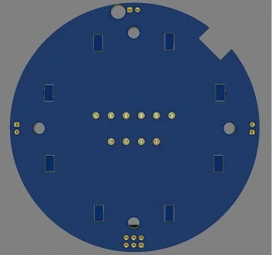  PCB cover (terminal board) — bottom
Figure 8-11. GLD V4 — main board and PCB cover (terminal board), top and bottom renders
Item | Description
Terminal designations (PCB cover, top) | RS485 A, B · FAN 5V, 0V · ALARM −, + · BAT −, + · 24V +, −
Board-to-board interconnection | Header connectors at the board edge (four positions) and pin rows on the underside of the PCB cover
Change from V3 — mounting | Bolt holes added for mounting the motherboard to the PCB cover
Change from V3 — PCB cover | A separate PCB cover added to terminate the field connections and to cover the motherboard
Note | The BAT −/+ terminal is present on the PCB cover; its status in the certified configuration (24 VDC only) is to be decided together with the battery path on the main board.

Open items for 2.6.a.8: (a) layout revision and date for the drawing table; (b) PCB laminate grade, UL 94 rating, Tg, CTI, board thickness and copper weight; (c) purpose of the 4 × Ø 3.0 mm holes; (d) layout drawings of the sensor-module board; (e) dimensioned/layout drawings of the PCB cover (terminal board).

2.6.b · Bill of Materials (BOM) for Explosion-Safety-Relevant Components
A complete, itemized electronic-component BOM for both the main board and the external sensor board now exists, exported directly from the EasyEDA/JLCPCB source project (manufacturer, manufacturer part number, and LCSC supplier part number for each line item; 89 line items / 214 placed components on the main board, 14 line items / 24 placed components on the sensor board — full tables below). This is real, traceable sourcing data and materially improves on the previous status.
It does not, however, satisfy this checklist item as written. The checklist asks specifically for the explosion-safety-relevant BOM — enclosure, gaskets, terminals, cable entry devices, switches, light sources, battery, potting compound, and plastic parts, each with material grade and Ex/UL/CCC certification status. None of those mechanical/safety items appear in an electronic CAD BOM: the enclosure is present only as a placeholder mechanical symbol (designator U50, no manufacturer or dimensional data attached), and the gas sensor itself (MQ2, designator I1) has no manufacturer or supplier part number recorded — it is sourced outside the LCSC/JLCPCB supply chain and its Ex status is unverified. Comparative research on Ex-rated enclosure products from other manufacturers exists internally as a reference for target specifications only — it describes third-party products, not this product's actual components, and is not included here.
DESIGNATOR | VALUE / PART | QTY | MANUFACTURER | MANUFACTURER PART NO. | LCSC #
C1 | 1uF | 1 | SAMSUNG | CL21B105KBFNNNE | C28323
C2,C3 | 100nF | 2 | YAGEO | CC0805KRX7R9BB104 | C49678
C4,C59,C60,C10 | 10uF | 4 | muRata | GRM21BR61H106KE43L | C440198
C72,C73 | 33uF | 2 | TDK | C2012X5R1A336MTJ00E | C342635
C7 | 47nF | 1 | SAMSUNG | CL10B473KB8NNNC | C1622
C8 | 22nF | 1 | SAMSUNG | CL10B223KB8NNNC | C21122
C70 | 33pF | 1 | SAMSUNG | CL10C330JB8NNNC | C1663
C61,C69 | 100nF | 2 | YAGEO | CC0603KRX7R9BB104 | C14663
C87,C12,C13,C14,C41,C42,C43,C44,C46,C47,C48,C49,C50,C51,C52,C54,C55,C58,C65,C66,C15,C6,C19,C20,C21,C22,C23,C24,C25,C26,C27,C28,C29,C30,C31,C84,C78,C81 | 100nF | 38 | SAMSUNG | CL05B104KO5NNNC | C1525
CN3,CN1 | XH-2A-black | 2 | BOOMELE | XH-2A黑色 | C24193
D1 | SMBJ33A | 1 | RUILON | SMBJ33A | C10219
D2 | LBZT52C12T1G | 1 | LRC | LBZT52C12T1G | C12747
D3,D10 | BAT54C | 2 | CJ | BAT54C | C2135
D4,D5,D11 | LESD5D5.0CT1G_C5199850 | 3 | UMW | LESD5D5.0CT1G | C5199850
D6 | SM712 | 1 | DOWO | SM712 | C293966
D7,D13 | SS54_C22452 | 2 | MDD | SS54 | C22452
D12 | SK36_C266330 | 1 | GOOD-ARK | SK36 | C266330
F1,F2 | MINISMDC260F/16 | 2 | Littelfuse | MINISMDC260F/16-2 | C16490
G$1 | UFL | 1 | — | — | —
J1 | VIN | 1 | — | — | C65114
L1 | 300Ω | 1 | TDK | ACM7060-301-2PL-TL01 | C76580
L2 | 2.2uH | 1 | SXN | SMDRH105R-2R2NT | C10164
L3 | 2.2uH | 1 | APV | ANR3015T2R2M | C6364793
L4 | 100Ω | 1 | TDK | MPZ2012S101AT000 | C15957
L5 | 10uH | 1 | SXN | SMDRH105R-100MT | C9185
LED1 | 19-217/BHC-ZL1M2RY/3T | 1 | EVERLIGHT | 19-217/BHC-ZL1M2RY/3T | C72041
Q1 | UMH3NTN | 1 | ROHM | UMH3NTN | C123008
Q2 | AO4407_C5155210 | 1 | JSMSEMI | AO4407 | C5155210
Q3 | SI7465DP-T1-GE3 | 1 | VISHAY | SI7465DP-T1-GE3 | C499482
R3 | 187kΩ | 1 | UNI-ROYAL | 0603WAF1873T5E | C22896
R6 | 82kΩ | 1 | UNI-ROYAL | 0603WAF8202T5E | C23254
R86 | 19.1kΩ | 1 | UNI-ROYAL | 0603WAF1912T5E | C22897
R87 | 1kΩ | 1 | UNI-ROYAL | 0603WAF1001T5E | C21190
R89,R36 | 56kΩ | 2 | UNI-ROYAL | 0603WAF5602T5E | C23206
R90 | 189k | 1 | YAGEO | RT0603BRD07189KL | C861174
R92 | 33kΩ | 1 | UNI-ROYAL | 0603WAF3302T5E | C4216
R96 | 470Ω | 1 | UNI-ROYAL | 0603WAF4700T5E | C23179
SW1 | SKQYAAE010 | 1 | ALPSALPINE | SKQYAAE010 | C115352
U1 | TPS61175PWP | 1 | TI | TPS61175PWP | C2879383
U36 | LMR51450SDRRR | 1 | TI | LMR51450SDRRR | C6890985
U40 | 4.7uH | 1 | ABC | GSSM06304R7M2AU | C2928306
U41 | TPS61088RHLR | 1 | TI | TPS61088RHLR | C87357
U42 | TPS7A0233DBVR | 1 | TI | TPS7A0233DBVR | C5142805
U43 | TPS62162DSG | 1 | TI | TPS62162DSGR | C40256
U46 | TPL5010 | 1 | TI | TPL5010DDCR | C473912
U47 | THVD1410DR | 1 | TI | THVD1410DR | C2671345
U48 | CH340C | 1 | WCH | CH340C | C84681
U50 | casingAlGasLeak | 1 | — | — | —
U51 | SN74AUP1G74DCUR | 1 | TI | SN74AUP1G74DCUR | C140267
USB1 | U-D-M5DD-W-1 | 1 | 韩国韩荣 | U-D-M5DD-W-1 | C145795
C11,C53,C32,C33,C34,C35,C36,C37,C16,C17,C18,C38,C85,C79,C80 | 10uF | 15 | SAMSUNG | CL05A106MQ5NUNC | C15525
C45,C57 | 20pF | 2 | FH | 0402CG200J500NT | C1554
C56 | 22uF | 1 | Kyocera AVX | TAJA226M010RNJ | C7183
R8,R9,R10,R74 | 22Ω | 4 | UNI-ROYAL | 0402WGF220JTCE | C25092
R11,R65,R66,R67,R68,R69,R70,R71,R72 | 49.9Ω | 9 | FH | RC-02K49R9FT | C140147
R73,R75,R77,R2,R15,R16,R17,R18,R19,R20,R21,R22,R7,R28,R29 | 10kΩ | 15 | UNI-ROYAL | 0402WGF1002TCE | C25744
R76,R5,R31 | 1kΩ | 3 | UNI-ROYAL | 0402WGF1001TCE | C11702
U2,U3 | OPA320AIDBVR | 2 | TI | OPA320AIDBVR | C92494
U33 | TCA9548APWR | 1 | TI | TCA9548APWR | C130026
U35 | ADS1256IDBR | 1 | TI | ADS1256IDBR | C28186
U38 | ADR03AKSZ-REEL7 | 1 | ADI | ADR03AKSZ-REEL7 | C206683
U39 | 8MHz | 1 | JYJE | 3TJ480000NYLBC | C2924618
U44 | SHT40-AD1B-R2 | 1 | Sensirion | SHT40-AD1B-R2 | C2909890
U45 | E22-900MM22S | 1 | EBYTE | E22-900MM22S | C5333985
U49 | ESP32-S3-WROOM-1U-N16R8 | 1 | ESPRESSIF | ESP32-S3-WROOM-1U-N16R8 | C3013946
U12 | PCF8574T/TR | 1 | HGSEMI | PCF8574T/TR | C2987288
R13 | 16kΩ | 1 | UNI-ROYAL | 0402WGF1602TCE | C25759
R14 | 4.99kΩ | 1 | YAGEO | RC0402FR-074K99L | C137965
U13 | TPS2116DRLR | 1 | TI | TPS2116DRLR | C3235557
U14 | TPS22964CYZPR | 1 | TI | TPS22964CYZPR | C431579
U15 | SN74LVC1G06DCKR | 1 | TI | SN74LVC1G06DCKR | C7828
U16 | TPS3839K33DBZR | 1 | TI | TPS3839K33DBZR | C96333
C9 | 22uF | 1 | TDK | C2012X5R1V226MT000E | C338080
R23,R24,R25,R1,R26,R27,R4,R30,R12,R40,R41,R43 | 100kΩ | 12 | UNI-ROYAL | 0402WGF1003TCE | C25741
R32 | 200kΩ | 1 | UNI-ROYAL | 0402WGF2003TCE | C25764
C39,C40,C62,C63,C64,C67,C68,C5 | 22uF | 8 | TAIYO YUDEN | JDK105CBJ226MV-F | C385994
C71 | 1uF | 1 | SAMSUNG | CL05A105KA5NQNC | C52923
R33,R37,R38,R39 | 0Ω | 4 | UNI-ROYAL | 0402WGF0000TCE | C17168
C74 | 2.2uF | 1 | SAMSUNG | CL05A225MQ5NSNC | C12530
C75,C76 | 47nF | 2 | FH | 0402B473K500NT | C82219
R34 | 255kΩ | 1 | YAGEO | AC0402DR-07255KL | C226702
R35 | 43kΩ | 1 | UNI-ROYAL | 0603WAF4302T5E | C23172
C77 | 4.7nF | 1 | FH | 0402B472K500NT | C1538
D8,D9 | SS14 | 2 | MDD | SS14 | C2480
J2 | ALARM | 1 | — | — | C124375
Q4,Q5 | AO3400A | 2 | AOS | AO3400A | C20917
R94,R42 | 100Ω | 2 | UNI-ROYAL | 0402WGF1000TCE | C25076
H2,H1,H3,H4,H5,H6,H7,H8 | X1321WVS-2X04J-C40D53 | 8 | XKB Connection | X1321WVS-2x04J-C40D53 | C2881909
L6 | 60Ω | 1 | Sunlord | GZ1005D600TF | C23478

External sensor board (gas-sensing front end):
DESIGNATOR | VALUE / PART | QTY | MANUFACTURER | MANUFACTURER PART NO. | LCSC #
H1 | X1321FVS-2X04-C43D48 | 1 | XKB Connection | X1321FVS-2x04-C43D48 | C2684732
R9 | 1kΩ | 1 | UNI-ROYAL | 0402WGF1001TCE | C11702
U5 | TPS22919DCKR | 1 | TI | TPS22919DCKR | C2149796
I1 | MQ2 | 1 | — | MQ2 | —
C7,C8 | 10uF | 2 | SAMSUNG | CL05A106MQ5NUNC | C15525
L1 | 60Ω | 1 | Sunlord | GZ1005D600TF | C23478
R1 | 10MΩ | 1 | UNI-ROYAL | 0402WGJ0106TCE | C26086
R2,R3 | 10kΩ | 2 | UNI-ROYAL | 0402WGF1002TCE | C25744
R7,R8 | 20kΩ | 2 | UNI-ROYAL | 0402WGF2002TCE | C25765
C1,C2,C3,C4,C5,C6 | 100nF | 6 | SAMSUNG | CL05B104KO5NNNC | C1525
R4,R5,R6 | 49.9Ω | 3 | FH | RC-02K49R9FT | C140147
U1 | INA333AIDGKR | 1 | TI | INA333AIDGKR | C19450
U2 | LM321DTR(XBLW) | 1 | XBLW | LM321DTR(XBLW) | C18723612
U3 | MCP4725A0T-E/CH | 1 | MICROCHIP | MCP4725A0T-E/CH | C144198

Status: Partially available. Full electronic-component BOM with real manufacturer/supplier data now exists (source: EasyEDA/JLCPCB export, 11 Sep 2026). The explosion-safety-relevant subset the checklist actually asks for — enclosure, gasket, cable entry device, battery, potting compound, and the gas sensor itself, with material grade and Ex/UL/CCC certification for each — remains not yet compiled. These are mechanical/safety parts, not electronic components: the enclosure itself is under design by an external mechanical/casing development partner (legal identity now confirmed as PT Galaksi Megatama Indonesia — see Section 1.4) and its bill of materials has not yet been provided to the authors.

2.6.b.1 Ex-critical mechanical / construction components
Components whose substitution could affect the explosion-protection concept, in the format requested by the revision guide. The electronic BOM above remains the full component list; this table is the Ex-critical subset and is controlled by part number or drawing number.
Ref. | Component | Manufacturer | Part / drawing no. | Material / rating | Safety function | Evidence | Status
EX-01 | Main enclosure body | PT Galaksi Megatama Indonesia | GLD ATEX CASE v3 / common base (M-B7, M-D7) | ADC12 die-cast aluminium alloy; threaded-neck wall 10.50 mm at the root / 5.80 mm at the top, bore ≈Ø84.7 mm (caliper, Figures 4-128–4-131); body wall thickness elsewhere and surface treatment TBC | Flameproof enclosure (Ex d, proposed) | Drawings M-B7, M-D7 | Open
EX-02 | Enclosure cover (threaded) | PT Galaksi Megatama Indonesia | TBC | Aluminium alloy; mating base-neck thread height ≈14.8 mm with ≈10 threads (caliper, Figure 4-130); thread size indicatively ≈M96 × 1.5 (derived from bore Ø84.7 mm + 2 × 5.80 mm wall and thread count) — to be confirmed on drawing | Flameproof joint | Figures 4-127–4-131; assembly M-E9 | Open — measured/estimate
EX-03 | Front stainless-steel wire-mesh plate + locking bracket | TBC | TBC (M-D4, M-E1) | Stainless steel; grade, mesh/pore size, thickness, layers TBC | Gas inlet; flame-path element if certified | Photograph, assembly illustration | Open
EX-04 | MQ sensor integrated protective mesh | Sensor manufacturer TBC | MQ-2, MQ-3B, MQ-4, MQ-5, MQ-6, MQ-7B, MQ-8, MQ-135 | Stainless-steel mesh (per sensor construction) | Protective element; no flame-arresting claim | Sensor data sheets (M-F1…M-F4) | Open
EX-05 | DC sampling fan | CIXIKEJI | CX5010B5H (DC brushless, 50 × 50 × 10 mm frame) | DC 5 V, 0.23 A (≈1.2 W); CE/FCC/RoHS only — no Ex certification; max. temperature TBC | Gas sampling; potential ignition source (IS-02) | Label, Figure 4-108; driven by Q5 (sheet 24) | Partial
EX-06 | Gaskets / O-rings | TBC | TBC (M-D2, M-D3) | Rubber; cover O-ring cord Ø2.70 mm (caliper, Figure 4-132); inner diameter, compound, hardness, temperature range TBC | Environmental sealing (IP66) | Photographs; O-rings on cover joint and blanking plug (Figures 4-125, 4-132) | Open
EX-07 | Cable gland (24 VDC entry) | TBC | TBC | M20×1.5 entry thread (BP18-1Z reference; consistent with Figure 4-127); Ex d barrier gland required for IIC; cable range, IP, temperature TBC | Cable-entry flame path and sealing | Current prototype uses a general-purpose black polymer gland (Figure 4-112) — to be replaced by a certified metallic Ex d barrier gland | Pending certificate
EX-08 | Blanking plug / adaptor | TBC | TBC | Metallic hexagon plug with O-ring in the lower entry; thread est. M20×1.5; certification TBC | Closes unused entry | Figure 4-119 | Pending certificate
EX-09 | Antenna bulkhead / SMA interface | TBC | TBC | Brass SMA bulkhead (standard 1/4″-36 UNS thread) in a spot-faced hole through the enclosure wall, U.FL pigtail inside; engagement and sealing TBC | Enclosure penetration (flame path under Ex d) | Figures 4-125, 4-126 | Open
EX-10 | External antenna | TBC | TBC | Omnidirectional, 3 dBi, SMA; material/environmental rating TBC | RF radiator | M-D1 | Open
EX-11 | LED / buzzer alarm beacon | TBC | TBC | Driven at 24 V from J2 (sheet 25); housing, gasket, current TBC | Local alarm; separate penetration | M-D5 | Open
EX-12 | Grounding stud | TBC | TBC | External stud with PE symbol; size and material TBC | Protective earth / bonding | M-D15; Figures 4-116, 4-120 | Open
EX-13 | Mounting fasteners | TBC | U-bolt mounting plate (M-A1) | U-bolt 2″/DN50, M10 thread; plate 250 × 250 mm; fastener grade TBC | Mechanical retention | Drawing M-A1 | Partial
EX-14 | Internal insulating parts (PCB cover / terminal module) | TBC | M-D10, M-D11; Figure 8-11 | Material, flammability, CTI TBC | Insulation of terminals | CAD render | Open
EX-15 | PCB substrate | TBC (PCB fabricator) | Main board Ø84 mm (2.6.a.8) | Laminate grade, UL 94 rating, Tg, CTI, thickness TBC | Carrier of energized circuits | Layout views | Open
EX-16 | Potting / adhesive | — | — | Not used in the current design (to be confirmed) | — | — | TBC
EX-17 | Battery and holder | — | Battery path on main board (sheets 02–06); BAT −/+ terminal on the terminal board (Figure 4-104); battery case in M-E3 | — | Included only if retained in the certified configuration | Schematic | Decision required

2.6.b.2 Ex-critical electrical components
Electrical components that affect input protection, fault energy, heater power, surface temperature, isolation, switching or ignition risk. Data from the released main-board schematic (2.6.a.7) and the electronic BOM.
Ref. | Component | Manufacturer | Part no. | Rating | Safety function | Evidence | Status
EL-01 | Resettable PTC fuse F1 (24 V) / F2 (battery) | Littelfuse | MINISMDC260F/16-2 | I-hold 2.6 A, I-trip 5.0 A, V-max 16 V | Overcurrent protection | Datasheet; sheets 01, 02 | Review — 16 V rating on a 24 V line
EL-02 | TVS diode D1 | Ruilon | SMBJ33A | V-RWM 33 V, P-pk 600 W | Input transient/overvoltage | Datasheet; sheet 01 | Final
EL-02a | TVS D6 (RS-485), ESD D4/D5/D11 (USB) | DOWO / UMW | SM712 / LESD5D5.0CT1G | Line clamps | Interface protection | Sheets 22, 26 | Final
EL-03 | P-MOSFET Q3 + zener D2 | Vishay / LRC | SI7465DP-T1-GE3 / LBZT52C12T1G | V-DS, I-D per datasheet; V-GS limited to 12 V | Input switch (reverse-polarity function TBC) | Sheet 01 | Review — orientation
EL-03a | Common-mode choke L1, ferrite L4 | TDK | ACM7060-301-2PL / MPZ2012S101AT000 | Per datasheet | Input EMI filtering | Sheet 01 | Final
EL-04 | Buck converter U36 (24 V → 5 V) | Texas Instruments | LMR51450 | VIN ≤ 36 V; output ≈5.0 V (calculated) | Power conversion; possible hot surface | Sheet 01 | Final
EL-04a | Buck converter U43 (5 V → 3.3 V), LDO U42 | Texas Instruments | TPS62162 / TPS7A0233 | 3.3 V rails | Logic supply | Sheets 07, 08 | Final
EL-05 | Boost converters U1 (batt → 24 V), U41 (batt → 5 V) | Texas Instruments | TPS61175 / TPS61088 | Battery path | Power conversion; possible hot surface | Sheets 05, 06 | Decision required — battery path
EL-05a | Battery load switch U14, power mux U13, P-MOSFET Q2 | TI / JSMSEMI | TPS22964C / TPS2116 / AO4407 | Battery path | Battery switching | Sheets 02–04 | Decision required — battery path
EL-06 | Power inductors | ABC / SXN / APV | GSSM06304R7M2AU 4.7 µH; SMDRH105R-2R2NT; ANR3015T2R2M; SMDRH105R-100MT | I-sat, I-rms, ΔT TBC | Possible hot surface | Sheets 01, 05, 06, 07 | Open — ΔT not measured
EL-07 | MQ heater supply | — | +5 V to sensor connectors H1–H8; enable via PCF8574 (U12) | Heater voltage 5 V; per-channel switch on sensor module | Heater power / surface temperature | Sheets 12–14 | Open — sensor-module schematic
EL-08 | Fan driver Q5 + flyback D9 | — / MDD | AO3400A / SS14 | Low-side switch, 5 V | Fan current | Sheet 24 | Final
EL-09 | Alarm driver Q4 + flyback D8 | — / MDD | AO3400A / SS14 | Low-side switch, 24 V output J2 | Alarm load switching | Sheet 25 | Final
EL-10 | Main PCB | PCB fabricator TBC | MotherBoardGLDVer2 | Ø84 mm, two copper layers | Carrier of energized circuits | 2.6.a.8 | Open — laminate data
EL-11 | ESP32-S3 module | Espressif | ESP32-S3-WROOM-1U-N16R8 | 3.3 V | Main energized electronics | Sheet 21 | Final
EL-12 | LoRa module | Ebyte | E22-900MM22S | 0–22 dBm, 920–923 MHz | RF source | Sheet 23 | Final
EL-13 | Terminals / connectors | Boomele / TBC | J1 power 2×3 (pin 6 = 24V+, pin 5 = 24V−); XH-2A; H1–H8 2×4 1.27 mm | Current/voltage rating TBC | Loose-contact heating / sparking | Sheets 02, 13 | Open — VIN connector MPN

Status legend: Final = confirmed and documented; Review = data exists but a rating or function must be checked; Open = data not yet available; TBC = to be confirmed; Pending certificate = certificate to be obtained; Decision required = design decision needed; N.A. = not applicable.

2.6.c · Material Specification Sheets / Datasheets (Non-Metallic Materials)
Datasheets or supplier conformity declarations for non-metallic materials (enclosure components, seals, insulators, potting compounds) — covering heat/cold resistance, anti-aging, anti-static, flame retardancy, CTI value, and chemical resistance — have not yet been collected.
Per IEC 60079-0:2017, once GLD's specific non-metallic components are identified the applicable requirements are: a Comparative Tracking Index (CTI) class per Table 5/6 appropriate to the equipment's creepage/clearance design; a glow-wire or needle-flame flame-retardancy result per §26.4–26.5; a glass-transition temperature (Tg) safely outside the confirmed −20°C to +60°C ambient operating range (Section 2.3.c); and UV/weathering-resistance data for any component exposed outdoors. These thresholds are cited from the standard itself and have not yet been matched against actual component datasheets.
Non-metallic components in the design that this item will need to cover: the cover-to-body sealing gasket providing the IP66 rating (Section 2.3.c — identified as a rubber gasket in the casing partner's assembly drawing, specific compound/grade not yet specified); the integral seal of the candidate M20×1.5 cable gland — per project direction, specified together with the gland itself from the BP18-1Z reference (Section 2.3.c), rather than as a separately sourced component; and the antenna/SMA feedthrough insulator (material not yet specified). The protective mesh cover over the gas-sensing element is now identified as a stainless-steel wire mesh in the same assembly drawing — being metallic, it falls outside this specific non-metallic-materials checklist item.
Status: Not yet available. Dependent on the enclosure design and material selection, which sits with the external casing development partner (PT Galaksi Megatama Indonesia, Section 1.4) rather than the authors; this data has been formally requested from that partner. Partial candidate data: the BP18-1Z reference drawing (Section 2.6.a) specifies a powder-coating surface treatment with two electrostatic-safety parameters directly relevant to this checklist item — maximum surface charge transfer <10 nC and maximum surface capacitance <5 pF (coating thickness ≤ 0.2 mm). These are the type of parameter IEC 60079-0 requires for coated/non-metallic surfaces on Ex equipment, but they describe a supplier's candidate component, not a confirmed datasheet for GLD's own enclosure finish.

2.6.c.1 Non-metallic materials register (MAT-01 … MAT-11)
Format requested by the revision guide. Each material is to be supported by the supplier's datasheet or conformity declaration covering service-temperature range, heat/cold resistance, ageing, flame retardancy (UL 94 / glow-wire), CTI where relevant, electrostatic properties, chemical and UV/weather resistance, and Tg where relevant. Where the material is not yet identified the item stays Open.
Ref. | Component | Material / grade | Manufacturer | Important properties | Evidence | Status
MAT-01 | Cover-to-body gasket | Rubber O-ring, cord Ø2.70 mm (measured); compound TBC | TBC | Temp. range, ageing, chemical resistance | Datasheet | Open
MAT-02 | Cable-gland body and sealing ring | Current prototype: black polymer gland (Figure 4-112); final: per certified Ex d gland | Gland supplier | Temp., flame rating, UV/chemical, electrostatic | Datasheet / certificate | Open
MAT-03 | Main PCB laminate | FR-4 type expected; exact grade TBC | PCB fabricator | Tg, CTI, UL 94 | Material datasheet | Open
MAT-04 | Connector housings (J1, XH-2A, H1–H8) | TBC | Boomele / TBC | CTI, UL 94, temp. rating | Datasheet | Open
MAT-05 | Wire insulation (24 VDC cable, 2 conductors L+/L−, Ø≈0.75 mm) | TBC | TBC | Temp. rating, flame rating | Cable datasheet | Open
MAT-06 | Antenna housing / insulator | TBC | TBC | Temp., UV, electrostatic properties | Datasheet | Open
MAT-07 | Fan impeller / housing | Plastic (grade TBC) | CIXIKEJI (CX5010B5H) | Temp., flame rating, mechanical | Fan datasheet | Open
MAT-08 | Adhesive / sealant | Not used (TBC) | — | Temp., chemical resistance, ageing | Datasheet | TBC
MAT-09 | Enclosure powder coating | Powder coating ≤0.2 mm (BP18-1Z reference) | Casing supply chain | Charge transfer <10 nC; surface capacitance <5 pF | Supplier drawing | Partial
MAT-10 | Transparent window (GLD ATEX CASE v3) | Glass; type TBC | TBC | Impact and thermal-shock tests for Ex d windows; temp. rating | Drawing M-B7 | Open
MAT-11 | Alarm beacon lens / dome | TBC | TBC | UV, impact, electrostatic, flame rating | Datasheet | Open

2.6.d · Manufacturing Process Description
A description of manufacturing processes relevant to explosion-protection safety (enclosure machining accuracy control, explosion-proof surface treatment, welding, potting, die-casting, bonding) has not yet been documented.
Status: Not yet available. This describes the casing partner's (PT Galaksi Megatama Indonesia) manufacturing process, not an internal electronics process — it will need to be obtained from that partner once their process is finalized.

2.6.d.1 Manufacturing and assembly process control
Manufacturing and assembly processes that may affect explosion protection are controlled through approved drawings, work instructions, inspection criteria and production records. The sub-sections below follow the structure of the revision guide; parameters that the enclosure manufacturer has not yet issued are marked TBC rather than assumed.
d.1 Enclosure manufacturing and machining control
Body and cover are produced by die casting (ADC12) and machined to controlled drawings. Safety-critical dimensions — threaded joints, wall thickness, sealing surfaces and other flame-path features — are inspected against the specified tolerances before assembly. Inspection method, measuring equipment and acceptance criteria: TBC (enclosure manufacturer). For Ex d, gap, joint length and thread engagement are the controlled characteristics.
d.2 Enclosure surface treatment
Powder coating is shown on the BP18-1Z reference (≤0.2 mm, charge transfer <10 nC, surface capacitance <5 pF). Coating of flame-path surfaces is not permitted unless approved. Final treatment for the GLD enclosure: TBC.
d.3 Front stainless-steel mesh assembly
The mesh plate is fitted with its locking bracket in the specified orientation (M-E1) and inspected for deformation, damage, contamination or incomplete seating before the cover is accepted. Mesh part number, fastening torque and any adhesive: TBC.
d.4 DC fan installation
The DC fan is attached to the enclosure cover behind the stainless-steel mesh plate and its cable connected to J3 (M-E9). Airflow direction, screw type, torque, clearance to the mesh and connector locking are to be defined on the assembly drawing (TBC).
d.5 MQ sensor array installation
Eight MQ sensors (MQ-2, MQ-3B, MQ-4, MQ-5, MQ-6, MQ-7B, MQ-8, MQ-135) are mounted on the sensor modules at fixed positions H1–H8. Position/type correspondence is verified visually to prevent interchange; the integrated sensor mesh must be undamaged. Position map: TBC on a controlled drawing.
d.6 PCB assembly and inspection
SMT assembly by the PCB assembler from the released design files (EasyEDA/JLCPCB), followed by visual inspection, polarity/orientation check, firmware programming and functional test. PCB revision is recorded for traceability. Assembler name/address and AOI use: TBC.
d.7 Cable entry and terminal assembly
Only the approved gland/adaptor for the M20×1.5 entry is used; thread verification, sealing ring, cable size, tightening torque and treatment of unused entries (approved blanking plug) are checked. The 24 VDC supply is connected to J1 pins 6 (24V+) and 5 (24V−). Torque values: TBC.
d.8 Grounding and bonding assembly
External grounding stud with washer–lug–nut sequence; continuity between stud and all conductive enclosure parts is tested before release. Stud size, torque and continuity acceptance limit: TBC.
d.9 Gasket and sealing installation
Correct gasket part, orientation, clean and undamaged sealing surfaces, no twisting; replacement whenever damaged or after a defined number of openings (TBC).
d.10 Final enclosure closure
Clean mating/threaded surfaces, close the cover by turning clockwise to full engagement, apply the locking feature and inspect after closure. Minimum thread engagement and final torque: TBC.
d.11 Firmware and configuration control
Each unit is programmed with the approved firmware version, AI model version (three classes: clean air, LPG, H2), configuration file, alarm thresholds and LoRa settings. Programming is verified and recorded against the serial number. Changes require controlled approval and a rollback path.
d.12 Final inspection and routine test
Visual inspection; enclosure integrity; mesh condition; fan operation; 8/8 sensor detection; power consumption at 24 VDC (≤8 W); alarm test; LoRa communication; grounding continuity; IP/leak check if required as a routine test; serial number and documentation check. Ex d routine overpressure test, if required by the certificate: TBC.
d.13 Applicability of special processes
Process | Applicability
Die casting | Applicable — enclosure in ADC12 die-cast aluminium
Machining of flame-path surfaces | Applicable for Ex d (final concept to be confirmed)
Welding | Not used in the current design (to be confirmed by the enclosure manufacturer)
Potting | Not used (to be confirmed)
Bonding adhesive | Not used unless specified for mesh or seal (TBC)
Surface treatment (powder coating) | Applicable — parameters per enclosure manufacturer (TBC)

2.6.e · Explosion-Protection Calculations and Explanations (if applicable)
Flame-path (joint gap, length) and free-internal-volume calculations specific to Ex d (Section 2.5, team recommendation) have not yet been performed, pending final enclosure geometry from the casing development partner and a confirmed protection concept with the ExCB.
Status: Not yet available — pending ExCB confirmation of the Ex d protection concept and final enclosure design.

2.6.e.1 Gas access path and internal arrangement
Ambient gas enters through the stainless-steel mesh at the front of the enclosure. During the sampling cycle the internal DC fan draws gas through this mesh into the sensing chamber, where the eight MQ sensors are installed. Each MQ sensor has its own stainless-steel protective mesh around the sensing element, so the sampled gas passes two successive mesh structures before reaching the sensing element.
2.6.e.2 Identification and assessment of potential ignition sources
Ref. | Potential ignition source | Mechanism | Exposure / existing feature | Assessment required | Status
IS-01 | MQ sensor internal heater | Hot surface | Two meshes between atmosphere and element | Measured sensor-body surface ≤78.4 °C (fan stalled, 24.8 °C ambient); confirm heater construction and any flame-arresting function from manufacturer data | Open
IS-02 | DC sampling fan | Winding heating, commutation, stalled rotor | Front mesh upstream of fan | Fan CIXIKEJI CX5010B5H, 5 V 0.23 A; body measured 36.3 °C; confirm locked-rotor behaviour | Open
IS-03 | Main PCB | Arc/spark, component failure, overheating | Gas accessibility of PCB volume TBC | Confirm whether the PCB volume is separated from the sensing chamber (see e.3.2) | Open
IS-04 | DC/DC converters | Semiconductor / inductor heating, switching fault | Depends on IS-03 | PTC, TVS and MOSFET input stage present; converter temperatures not yet measured | Open
IS-05 | 24 VDC terminals and connectors | Make/break spark, loose-contact heating | Depends on IS-03 | Confirm terminal location, rating, torque, creepage/clearance | Open
IS-06 | LED / audible alarm module | Switching, heating, fault | Separate beacon housing | Obtain module construction/certification data | Open
IS-07 | ESP32-S3 / LoRa / digital electronics | Overheating, electrical fault | Depends on IS-03 | Assess maximum component temperatures | Open
IS-08 | RF transmitter / antenna | RF energy | External antenna | Max. 22 dBm into a 3 dBi antenna; assess against IEC 60079-0 RF threshold | Open
IS-09 | Power inductors | Surface heating | Depends on IS-03 | Measure worst-case ΔT | Open
IS-10 | MOSFETs, diodes, protection devices | Local overheating on overload/surge | Depends on IS-03 | Verify ratings and protective-device coordination (F1/F2 voltage rating) | Open
IS-11 | Electrostatic charging of non-metallic parts | ESD | Gasket, antenna insulation, gland parts | Identify exposed non-metallic parts and dimensions (MAT register) | Open
IS-12 | Metallic enclosure and joints | Spark from poor bonding/impact | External atmosphere | Verify bonding continuity and grounding | Open
IS-13 | Cable entry / gland / blanking devices | Loss of protection | External atmosphere | Prototype gland is a general-purpose polymer type; finalize Ex d gland/plug list (EX-07, EX-08) | Open
IS-14 | Front stainless-steel mesh | Flame transmission path | Direct interface | Confirm construction; certificate/test if claimed as flame-arresting | Open
IS-15 | MQ sensor protective mesh | Flame transmission path | Around each sensing element | No flame-arresting claim without manufacturer documentation | Open
IS-16 | Mechanical impact / friction | Mechanical spark | Fan is the only moving part | Confirm fan clearance and retention | Open
IS-17 | Battery circuit | High fault current, cell heating | Battery path populated on main board | Decide exclusion/depopulation from the certified configuration | Decision required

2.6.e.3 Explosion-protection concept and protective construction
e.3.1 Overall concept
Potential ignition sources are isolated from the external atmosphere, enclosed in a protective construction, or controlled so they cannot ignite it. The applicant proposes flameproof enclosure Ex d (marking proposal II 2G Ex db IIC T4 Gb), subject to ExCB confirmation.
e.3.2 Gas-accessible and protected volumes
The front sensing chamber is intentionally gas-accessible. Whether the main PCB is separated from it by a partition (PCB plate) or shares the same volume is still to be confirmed on the section drawing; the assessment of IS-03…IS-10 depends on this.
e.3.3 Front stainless-steel mesh
First protective element in the gas inlet; mechanical protection and, only where supported by certification, flame arresting.
e.3.4 MQ sensor protective construction
Each sensor's integrated stainless-steel mesh surrounds the sensing and heating structure; no Ex claim without manufacturer documentation.
e.3.5 DC fan
Located in the gas path behind the mesh; surface temperature, winding temperature, stalled rotor and commutation to be assessed.
e.3.6 Main electronics
Main PCB, converters, processing and RF electronics and connectors are treated as potential ignition sources; protection depends on e.3.2.
e.3.7 Flame-transmission paths
Front gas inlet, cover joint, threaded interfaces, cable entries, antenna interface, alarm-module connection and any other wall penetration are to be identified and controlled; gap/length/volume values to be supplied by the enclosure manufacturer.
e.3.8 Cable entries, antenna, alarm module
All penetrations use components compatible with the final concept, gas group IIC, temperature range, IP66 and the M20×1.5 thread.
e.3.9 Grounding and electrostatic protection
The metallic enclosure is bonded to protective earth through the external grounding stud; conductive parts keep electrical continuity.
e.3.10 Temperature protection
Surface temperatures of sensors, fan, converters, enclosure and alarm module are evaluated at maximum load and fault conditions (2.6.f); T-class assigned only after testing.
e.3.11 Fault and abnormal conditions
Fan stall (measured), blocked airflow, heater abnormality, converter failure, short circuit, loose terminal and maximum ambient are to be covered.
e.3.12 Threaded joints — measured and estimated dimensions
The cover-joint dimensions below were measured by the applicant with a vernier caliper (0.05 mm) on the current production base (Figures 4-128 to 4-132): neck wall 10.50 mm at the root and 5.80 mm at the top, threaded-neck height ≈14.8 mm, bore ≈Ø84.7 mm, O-ring cord Ø2.70 mm. Thread size and pitch are derived from these readings and the visible thread count; the entry threads are estimates taken from photographs (Figures 4-119, 4-125–4-127) and from the BP18-1Z supplier drawing. Note that the measured bore (≈Ø84.7 mm) differs from the Ø94.7 mm bore of the BP18-1Z drawing, so that drawing is not the controlled drawing of this base. They are given to show how each threaded flame path compares with the IEC 60079-1 rules for threaded joints and must be replaced by the values on the enclosure manufacturer's controlled drawing.
Joint | Thread (measured / estimated) | Engagement | IEC 60079-1 threaded-joint rule (Group IIC) | Assessment (preliminary) | Status
Cover to base (main enclosure) | ≈M96 × 1.5, derived (external thread on the base neck; bore Ø84.7 + 2 × 5.80 mm wall; ≈10 crests over ≈14.8 mm) | Threaded-neck height ≈14.8 mm (measured); ≈10 threads; engaged length ≤14.8 mm depending on the cover | ≥5 full threads engaged; axial engagement ≥8 mm where free volume >100 cm³ (≥5 mm for ≤100 cm³); medium or fine tolerance class (6g/6H) | Free internal volume >100 cm³ (bore Ø84.7 mm gives 56 cm² cross-section; >100 cm³ at any depth >18 mm) → ≥8 mm rule applies; available thread height 14.8 mm with ≈10 threads appears to exceed the minimum — engaged length with the cover screwed home still to be measured | Open — measured
Cable entry (left) | M20 × 1.5-6H (BP18-1Z drawing) | TBC (wall thickness) | ≥5 full threads engaged; thread length per gland certificate | Requires certified Ex d gland | Open — estimate
Beacon entry (right) | M20 × 1.5 (est.) | TBC | ≥5 full threads engaged | Beacon thread and certificate to be confirmed | Open — estimate
Lower entry (blanking plug) | M20 × 1.5 (est.) | TBC | ≥5 full threads; certified Ex d plug | Plug fitted with O-ring (Figure 4-125) | Open — estimate
Antenna bulkhead | SMA 1/4″-36 UNS (standard) | TBC | Flame path through the wall must be assessed or a certified Ex d bushing used | Bushing not certified | Open — estimate

2.6.f · Temperature Group Calculation (Hottest-Point Temperature Estimation)
A preliminary internal surface-temperature measurement has been carried out on a GLD V2 unit using thermocouples at eight locations (plus an ambient reference), under three conditions: normal operation, maximum load, and fan stalled (an expected malfunction of the internal DC cooling fan). Each condition was logged for 180 minutes at an ambient temperature of approximately 24–25°C.
CHANNEL | LOCATION | RATIONALE
T amb | Air around the unit | Reference temperature
TC-1 | Hottest MQ sensor body | The sensor heater is the main potential heat source
TC-2 | DC fan motor/body | Normal and stalled-fan heating
TC-3 | DC/DC converter | Power component — not yet measured
TC-4 | Power inductor | Potential hot spot — not yet measured
TC-5 | MOSFET / power diode | Potential local heating — not yet measured
TC-6 | Hottest PCB area | PCB temperature verification
TC-7 | External enclosure surface near the heat source | Candidate external maximum
TC-8 | Other external enclosure surface | Confirms the external maximum is not missed

Maximum values recorded over the 180-minute runs, and the same values extrapolated to the +60°C maximum rated ambient (Section 2.5) by adding the measured temperature rise above ambient:
CONDITION | MEAN T AMB | MQ SENSOR BODY (TC-1) | PCB (TC-6) | FAN (TC-2) | EXTERNAL ENCLOSURE (TC-7/8)
Normal operation | 24.9°C | 44.2 → ≈79°C | 52.4 → ≈88°C | 36.3°C | 32.1 → ≈67°C
Maximum load | 24.2°C | 55.0 → ≈91°C | 58.3 → ≈94°C | 30.2°C | 34.8 → ≈71°C
Fan stalled (malfunction) | 24.8°C | 78.4 → ≈114°C | 63.4 → ≈99°C | 36.3°C | 43.9 → ≈79°C

Preliminary reading against T4. The T4 limit is 135°C; with the 5 K margin applied for temperature classes T3–T6 under IEC 60079-0, the effective limit is 130°C. The highest extrapolated value, ≈114°C on the MQ sensor body in the fan-stalled condition, leaves a margin of about 16 K. The heater element itself (in the approximate 200–400°C range typical of this sensor class) sits inside the sensor can and was not measured directly; the measured sensor-body surface is 44–78°C. Under the recommended flameproof concept (Ex d, Section 2.5), the temperature class is governed by the external surfaces of the flameproof enclosure, whose extrapolated maximum is ≈79°C.
Open items before this can be treated as a temperature-class verification:
• TC-3, TC-4 and TC-5 (DC/DC converter, power inductor, MOSFET/power diode) have not been measured; no independent hot-spot location check has been recorded.
• The alarm/transmit condition has not been measured.
• Thermal equilibrium was not demonstrated in every run: the PCB reading under maximum load was still rising in the final hour (46.4 → 55.8 → 58.3°C), above the 2 K/h stability criterion.
• Two short excursions on TC-7 (43.4 and 43.9°C) in the fan-stalled run, with neighbouring readings near 30°C, should be checked for thermocouple contact before the external maximum is finalised.
• Test metadata is not yet recorded: date, operator, unit identification, thermocouple type, supply voltage (the most unfavourable voltage within the rated range should be used), and whether the enclosure was fully closed.
• Extrapolation to +60°C assumes a constant temperature rise above ambient; confirmation requires testing at maximum ambient as part of ExCB type testing.
Status: Partially available — preliminary internal measurement. Indicates T4 is achievable with margin; not a substitute for type testing, and the open items above must be closed first.

2.6.f.1 Temperature-class evaluation structure (revision guide f.1–f.12)
f.1 Proposed temperature class
T4 (≤135 °C; effective limit 130 °C with the 5 K margin). Final assignment only after the hot-spot measurements, extrapolation to maximum ambient and fault conditions are complete.
f.2 Maximum ambient temperature
+60 °C, the rated maximum of the operating range −20 °C to +60 °C. Note: an assessment at +85 °C would raise the fan-stalled sensor-body value to about 139 °C, above the T4 limit; +85 °C is therefore not the rated ambient.
f.3 Candidate hottest points
Ref. | Component / location | Reason | Measurement status
T-01 | MQ sensor heater / sensor head | Heater active during operation | Measured (TC-1)
T-02 | DC fan motor/electronics | Sampling and stalled condition | Measured (TC-2)
T-03 | 5 V converter (U36 LMR51450) | Supplies MQ heaters | Not measured (TC-3 planned)
T-04 | 3.3 V regulator (U43/U42) | MCU supply | Not measured
T-05 | Boost/buck converter ICs | Switching losses | Not measured (TC-3 planned)
T-06 | Power inductors | Copper/core losses | Not measured (TC-4 planned)
T-07 | Input MOSFET / protection devices | Conduction/fault heating | Not measured (TC-5 planned)
T-08 | ESP32-S3 | Processing / AI inference | Covered by PCB hottest area (TC-6)
T-09 | LoRa module | RF transmission | Not measured at maximum TX
T-10 | LED/buzzer alarm module | Alarm active | Not measured
T-11 | Main enclosure external surface | Governs T-class under Ex d | Measured (TC-7/TC-8)
T-12 | Front mesh / cover near sensor chamber | Heater and airflow | Not measured

f.4 Worst-case operating condition
- maximum permitted input supply voltage
- maximum ambient temperature (+60 °C)
- all eight MQ heaters energized
- ESP32-S3 performing AI inference
- LoRa transmitting at the maximum approved power (22 dBm)
- local alarm active
- DC fan operating according to the production sampling cycle
f.5 Fan failure / airflow loss
Measured: fan-stalled run of 180 min. Sensor body rose from 44.2 °C (normal) to 78.4 °C, PCB from 52.4 °C to 63.4 °C, external enclosure from 32.1 °C to 43.9 °C — the fan-stalled condition is the governing case so far.
f.6 Blocked or restricted mesh
Not tested. To be included where it affects internal cooling.
f.7 Electrical fault conditions
Regulator fault, heater overvoltage, shorted load, abnormal high current and component overload: not tested; to be assessed by test or by circuit-protection analysis (EL-01…EL-07).
f.8 Measurement method
Thermocouples at eight points plus ambient reference, logged for 180 minutes per condition. To be recorded for each point: ambient, input voltage, current, operating mode, fan/alarm/RF state, stabilization time and temperature. Thermocouple type and calibration: not yet recorded.
f.9 Thermal stabilization
Criterion ≤2 K/h. The PCB reading under maximum load was still rising in the final hour (46.4 → 55.8 → 58.3 °C) and must be repeated until stable.
f.10 Temperature correction / extrapolation
T(Ta,max) = Ta,max + (T,measured − T,amb,test). Example from the fan-stalled run: 60 + (78.4 − 24.8) ≈ 114 °C. Use of this method is subject to ExCB acceptance; confirmation at maximum ambient is part of type testing.
f.11 Results table
Ref. | Point | Condition | Test ambient | Measured | Rise | Est. at +60 °C | Status
T-01 | MQ sensor body | Normal | 24.9 °C | 44.2 °C | 19.3 K | ≈79 °C | Measured
T-01 | MQ sensor body | Maximum load | 24.2 °C | 55.0 °C | 30.8 K | ≈91 °C | Measured
T-01 | MQ sensor body | Fan stalled | 24.8 °C | 78.4 °C | 53.6 K | ≈114 °C | Measured
T-02 | Fan motor | Normal / stalled | 24.9 / 24.8 °C | 36.3 °C | 11.4 / 11.5 K | ≈71 °C | Measured
T-03 | 5 V converter IC | Maximum load | — | — | — | — | Not measured
T-04 | Power inductor | Maximum load | — | — | — | — | Not measured
T-05 | PCB hottest area (incl. ESP32-S3) | Fan stalled | 24.8 °C | 63.4 °C | 38.6 K | ≈99 °C | Measured
T-05 | PCB hottest area | Maximum load | 24.2 °C | 58.3 °C | 34.1 K | ≈94 °C | Preliminary — not stable
T-06 | LoRa module | Maximum TX | — | — | — | — | Not measured
T-07 | Alarm module | Alarm active | — | — | — | — | Not measured
T-08 | External enclosure | Fan stalled | 24.8 °C | 43.9 °C | 19.1 K | ≈79 °C | Preliminary — check TC-7 contact

f.12 Preliminary temperature-class statement
The GLD is proposed for temperature class T4. The final classification remains open pending the remaining hot-spot measurements (T-03, T-04, T-06, T-07, T-09, T-10, T-12), thermal stabilization at maximum load, maximum-ambient confirmation and the relevant fault conditions. The highest extrapolated value so far, ≈114 °C, is below the effective T4 limit of 130 °C.

2.6.g · Usage and Installation Instructions (Draft)
SUB-ITEM | STATUS | REMARKS
a) Safety warnings | Draft available | Drafted below (18 Sep 2026); not yet reviewed against a selected explosion-protection concept.
b) Installation requirements (cable entry, torque, grounding, cleaning) | Draft available | Procedural text drafted below; the mechanical mounting method itself (U-bolt mounting plate, no drilling/welding — Section 2.3.c) and the specific cable gland/torque values are still pending final component selection.
c) Operating instructions and maintenance requirements | Draft available | Drafted below, alongside a firmware command/operation reference (Serial, MQTT, LoRa protocol) used for engineering commissioning. Ex-specific maintenance frequency/content is not yet defined pending protection-concept selection.

Status: Draft text available (source: internal working draft, Rev. 18 Sep 2026). This is a draft for review, not a finalized, Ex-approved installation and operation manual. It has not been checked against a selected type of protection (Ex d/e/i, Section 2.6.e), a confirmed temperature class (Section 2.6.f), or finalized cable-entry/enclosure hardware. It also feeds the standalone Instruction_Manual_GLD deliverable.

2.6.g.a · Safety Warnings (Draft)
- Only trained and authorized personnel may install, commission, operate, inspect, or maintain the detector.
- Isolate and verify the 24 VDC supply before opening the enclosure or changing wiring. Apply the site lockout/tagout procedure.
- Use only the approved production power arrangement: 24 VDC.
- Perform alarm tests with appropriate site controls and hearing protection where audible devices are connected.
- Perform sensor nulling only in confirmed clean air. Accept the operation only when all eight sensors report a complete 8/8 result; otherwise correct the cause and repeat.
- Do not drill, weld, enlarge cable entries, bypass protective devices, or modify the enclosure without written engineering and Ex approval.
- Remove the unit from service if there is visible damage, water ingress, an unresolved sensor fault, failed alarm proof, or a loss of protective-earth continuity.
2.6.g.b · Detailed Installation Requirements (Draft)
Cable entry method: Use only cable glands, adaptors, blanking elements, and seals approved for the final protection concept, certificate, thread form, IP rating, cable outer diameter, and installation temperature. Do not create new entries, enlarge an entry, leave unused entries open, or substitute a general-purpose gland. Maintain the manufacturer sealing and clamping sequence. Record the installed component part number and certificate reference.
Torque requirements: Torque values shall comply with the approved enclosure, terminal, cable-gland, and blanking-plug manufacturer instructions. (Specific torque figures are not yet available — dependent on final hardware selection.)
Grounding requirements: Connect the enclosure to the approved protective-earth system using the designated grounding terminal. Verify continuity before energization.
Cleaning requirements: For routine cleaning, isolate the equipment as required by site procedure and use a soft lint-free cloth lightly dampened with clean water or an approved mild cleaner. Do not use abrasives, aggressive solvents, dry compressed air, high-pressure spray, or tools that can damage the enclosure, gasket, label, antenna, or cable entries. Keep liquid out of all openings.
2.6.g.c · Operating Instructions and Maintenance Requirements (Draft)
Before each operating period, check power, enclosure condition, diagnostic status, communication status, and the absence of active faults. Treat an alarm as a real process-safety event until the site response procedure establishes otherwise. If the detector reports a fault or loses required communication, notify the responsible operator and place the affected detection point in the site impairment process. Do not change firmware, model files, alarm thresholds, or calibration parameters from the field without controlled approval and a documented rollback path.
Three operating modes are distinguished:
MODE | PURPOSE | USE RESTRICTION
Inference | Normal gas-class inference and alarm operation | Production operating mode after commissioning
Dataset | Engineering / data-collection activity | Not a substitute for approved detection operation
Nulling | Sensor baseline / calibration activity | Clean air only; perform under approved procedure; require complete 8/8 result

2.6.g.1 Usage and installation instructions — complete structure (g.2 … g.20)
The following sections complete the draft instructions above in the structure of the revision guide (g.1 Safety warnings is given in 2.6.g.a). Values not yet defined are stated as such in the notes of each section.
g.2 Permitted installation environment
The Gas Leak Detector (GLD) is intended for fixed installation in hazardous areas associated with oil and gas refinery facilities, including process units, tank farms, pipe racks, and storage/loading-unloading areas in which flammable gas atmospheres may be present.
The current certification target is Equipment Group II, Category 2G / EPL Gb, for installation in Zone 1 gas hazardous areas, subject to confirmation by the ExCB. The proposed gas group is IIC, and the proposed temperature class is T4. Final confirmation of the gas group and temperature class shall be based on the completed explosion-protection assessment, applicable component documentation, and the results of the required temperature evaluation and testing.
The GLD is intended to operate within an ambient temperature range of −20 °C to +60 °C and an operating relative-humidity range of 5–95% RH, non-condensing, as defined in the current product specification.
Installation shall be limited to locations and environmental conditions that are within the certified equipment marking and the conditions of use stated in the final certificate and approved instruction manual. The equipment shall not be installed in a hazardous area having a more severe gas group, temperature classification, ambient-temperature range, or other environmental condition than those covered by the final certification.
The GLD is intended for gas hazardous-area service only within the current certification scope. Installation in combustible-dust hazardous areas is excluded unless such use is separately assessed, tested, and approved as part of the certification scope.
The detector shall be installed in a position that permits free access of the surrounding atmosphere to the front gas-sampling inlet. The stainless-steel gas-entry mesh and the associated sampling path shall not be obstructed, covered, sealed, painted, or otherwise modified in a manner that could impair gas access to the sensing section.
The unit shall be mounted as a fixed installation using the approved mounting arrangement and in accordance with the orientation and mechanical details specified in the controlled drawings. Adequate clearance shall be maintained around the gas-sampling inlet, cable entries, antenna interface, and enclosure joints to permit correct operation, inspection, and maintenance.
The installation location shall protect the equipment from mechanical damage, unauthorized modification, excessive contamination, and environmental conditions beyond the approved operating limits. Cable entries, grounding connections, antenna interfaces, and other enclosure penetrations shall be installed only in accordance with the approved product configuration and the applicable installation instructions.
g.3 Mechanical mounting
The Gas Leak Detector (GLD) shall be installed as a fixed-mounted device using the approved mechanical mounting bracket provided for the product. The mounting arrangement shall correspond to the configuration defined in the controlled mechanical drawings and shall not be modified without engineering review and approval.
The GLD is intended to be attached to existing plant structures by means of the approved bracket arrangement. Installation shall not require drilling, welding, machining, or other permanent modification of the supporting plant structure unless such modification is separately approved by the site owner and is outside the certified GLD construction.
The mounting bracket, fasteners, clamps, and associated hardware shall be of the specified type, material, size, and mechanical strength defined in the approved production drawings and bill of materials. Substitution of mounting components that may affect the mechanical integrity or certified configuration of the equipment shall not be permitted without controlled engineering approval.
The detector shall be mounted securely so that it cannot become loose, rotate unintentionally, or move under normal service conditions, vibration, maintenance activity, or foreseeable external mechanical loading. All mounting fasteners shall be tightened in accordance with the torque values specified in the approved assembly or installation documentation.
The installed orientation shall conform to the orientation specified in the controlled mechanical drawings. The installation shall maintain unobstructed access to the gas-sampling inlet, front stainless-steel mesh, antenna interface, cable-entry points, grounding connection, and enclosure joints required for normal operation, inspection, and maintenance.
The gas-sampling inlet shall not be positioned directly against a wall, pipe, mounting plate, structural member, or other obstruction that could restrict the flow of ambient gas into the sensing area. Adequate clearance around the sampling inlet shall be maintained in accordance with the approved installation drawing.
The mounting location shall be selected so that the enclosure and its associated components are protected from foreseeable mechanical impact, excessive vibration, deformation, and other mechanical stresses that could impair the integrity of the enclosure, gas-entry assembly, cable entry, antenna interface, alarm module, or grounding connection.
After installation, the mounting assembly shall be visually inspected to confirm correct orientation, secure fastening, absence of enclosure deformation, and unobstructed access to the sensing inlet and service interfaces.
g.4 Gas inlet / sensing-area requirements
The Gas Leak Detector (GLD) shall be installed and maintained so that the gas-sampling inlet and sensing area remain continuously accessible to the surrounding atmosphere during normal operation.
Ambient gas enters the detector through the stainless-steel mesh located at the front of the enclosure. During the sampling cycle, the internal DC fan assists the movement of ambient gas through the front mesh and into the sensing area. Eight MQ-series gas sensors are installed within this sensing area. Each MQ sensor incorporates an additional stainless-steel protective mesh surrounding its sensing element.
The front gas-entry mesh, sampling opening, and associated airflow path shall remain unobstructed. The gas inlet shall not be covered, sealed, painted, taped, coated, or otherwise modified in a manner that could restrict or alter the intended gas flow to the sensing area. No additional filter, membrane, screen, protective cover, or other material shall be installed over the gas inlet unless specifically approved as part of the certified product configuration.
The detector shall be installed with sufficient clearance around the gas-sampling inlet to allow free circulation of the surrounding atmosphere. The front sensing inlet shall not be positioned directly against a wall, pipe, mounting plate, structural member, insulation, or other object that could restrict gas entry or interfere with the intended sampling airflow. The required minimum clearance, where applicable, shall be defined in the controlled installation drawing.
The stainless-steel front mesh shall be maintained in its approved production configuration. It shall not be removed, replaced, drilled, enlarged, reshaped, or substituted with a different mesh or protective element unless the change has been evaluated and approved through the applicable engineering and Ex certification change-control process.
The integrated protective mesh of each MQ sensor shall also remain intact and free from mechanical damage, deformation, contamination, or blockage. MQ sensors with damaged or missing protective mesh shall not be used.
The sensing area shall be kept free from excessive dust, deposits, oil, paint, corrosion products, insects, or other contamination that could obstruct the front mesh, fan, individual sensor meshes, or the intended gas-sampling path. Cleaning shall be performed only in accordance with the approved maintenance instructions and shall not damage the mesh, fan, sensor surfaces, enclosure sealing features, or other Ex-critical components.
The DC sampling fan shall be installed in the approved position and orientation behind the front stainless-steel mesh. The airflow direction, fan mounting, electrical connection, and mechanical clearance shall conform to the controlled assembly drawing. The fan shall not be substituted with a different model without controlled engineering review and approval.
The gas-sampling path shall be considered part of the controlled product construction. Any modification that changes the geometry, mesh arrangement, fan position, airflow path, sensing-chamber volume, or position of the MQ sensors shall require evaluation before implementation.
During inspection and maintenance, the front mesh, fan, sensing area, and individual MQ sensor meshes shall be checked for blockage, damage, contamination, corrosion, or other conditions that could affect gas access or the approved protection concept. If any such condition is detected, the detector shall be removed from normal service until the condition has been corrected and the unit has been verified as suitable for operation.
Note: The minimum clearance in front of the gas inlet, the approved fan orientation, and any dimensional requirements of the sensing chamber shall be specified in the controlled mechanical and installation drawings.
g.5 Electrical supply
The Gas Leak Detector (GLD) shall be supplied from a 24 VDC power source in accordance with the approved product configuration. The current production configuration is intended for continuous operation from a 24 VDC supply. The product documentation presently identifies the 24 VDC supply as being derived from an AC/DC adapter connected to the site electrical supply.
The GLD internal power system converts the 24 VDC input to the required internal operating voltages. A 5 VDC rail is used for the MQ sensor/heater circuitry, while a 3.3 VDC rail is used for the ESP32-S3 logic and other applicable low-voltage electronics.
The currently documented maximum power consumption is 8 W at 24 VDC. The corresponding calculated input current at this operating point is approximately 0.33 A. This value is derived from the measured maximum power consumption divided by the nominal 24 VDC input voltage.
The 24 VDC input incorporates electrical protection features including resettable PTC devices, a 33 V TVS device on the 24 V input, and P-channel MOSFET input stages. These circuits are intended to provide protection against overcurrent, transient overvoltage, and reverse-polarity or other abnormal input conditions as defined by the final approved electrical design.
The polarity of the 24 VDC supply shall be verified before energizing the equipment. Power shall be connected only through the designated power-input terminals or connector defined in the approved wiring and terminal drawings. The power-input connection shall not be modified, bypassed, or connected to an alternative supply arrangement that is not included in the approved product configuration.
The equipment shall be de-energized before opening the enclosure, connecting or disconnecting field wiring, or carrying out maintenance activities that require access to the internal electrical system. The applicable site isolation and lockout/tagout procedures shall be followed before such work is performed.
The 24 VDC supply, associated field wiring, cable entry, terminals, protective-earth connection, and upstream protective devices shall be installed in accordance with the approved product documentation and applicable site electrical requirements.
Any alternative power source, power-conversion arrangement, battery supply, or other electrical configuration that is not included in the approved production configuration shall not be used unless it has been separately evaluated and approved through the applicable engineering and Ex certification change-control process.
Note: The permitted 24 VDC input-voltage tolerance, maximum startup/inrush current, required upstream fuse or circuit-breaker rating, and detailed terminal/wire-size requirements shall be defined in the final approved electrical specification and installation drawing.
g.6 Cable entry
The Gas Leak Detector (GLD) shall use only cable-entry devices that are approved for the final certified product configuration. Cable glands, adaptors, blanking elements, seals, and associated entry components shall be compatible with the final explosion-protection concept, certificate requirements, thread form, ingress-protection rating, cable outer diameter, and permitted installation temperature range.
The cable-entry arrangement shall be installed exactly as defined in the approved mechanical drawings and installation instructions. No cable-entry opening shall be drilled, enlarged, re-machined, re-threaded, or otherwise modified in the field. Unused entries shall not be left open and shall be closed using the approved blanking element specified for the certified configuration.
The cable gland or entry device shall be selected for the actual cable type and cable outer diameter used in the installation. The manufacturer’s specified sealing, clamping, and assembly sequence shall be maintained. The installed cable shall be properly retained so that mechanical loading is not transferred to the internal electrical terminals.
All threaded cable-entry components shall be fully engaged in accordance with the minimum thread-engagement requirements defined by the approved enclosure and cable-entry configuration. Where a locking element is specified, it shall be applied only after the required thread engagement has been achieved.
Tightening of cable glands, adaptors, blanking elements, and related fittings shall comply with the torque values specified by the approved component manufacturer and the controlled installation documentation. Excessive tightening that could damage threads, seals, or enclosure parts shall be avoided, and insufficient tightening that could compromise sealing or mechanical retention shall not be permitted.
During installation and maintenance, the cable-entry components shall be inspected for correct part number, thread compatibility, sealing-element condition, proper cable clamping, complete thread engagement, and absence of mechanical damage, corrosion, cracking, or deformation. Components showing damage or deterioration shall not be reused unless specifically permitted by the approved component instructions.
The installed cable-entry component shall be traceable to the approved product configuration. The manufacturer, model or part number, thread type, applicable certificate reference, and installation details shall be recorded where required by the production or installation documentation. The current draft already requires recording the installed component part number and certificate reference.
Any substitution of a cable gland, adaptor, blanking plug, sealing element, or other cable-entry component shall be subject to controlled engineering review before implementation. A general-purpose cable gland or an entry component not covered by the approved product configuration shall not be used.
Note: The final cable-entry device manufacturer, model, thread designation, cable-diameter range, temperature range, ingress-protection rating, applicable Ex marking, certificate reference, and installation torque shall be confirmed in the controlled BOM and installation drawing before certification documentation is finalized.
g.7 Grounding and bonding
The metallic enclosure of the Gas Leak Detector (GLD) shall be connected to the site protective-earth system using the designated external grounding stud provided on the enclosure. The grounding point shall be clearly identified by the protective-earth symbol and shall remain accessible for installation, inspection, and maintenance.
The protective-earth connection shall be installed using the approved grounding hardware, including the specified grounding stud, terminal lug, washers, fasteners, and other associated components defined in the controlled mechanical drawing and bill of materials.
All conductive enclosure parts that are required to be electrically bonded shall maintain reliable electrical continuity so that hazardous potential differences and electrostatic charge accumulation are minimized. The bonding arrangement between enclosure parts shall not be modified, insulated, painted over at the contact interface, or otherwise altered in a manner that could impair electrical continuity.
Before the GLD is energized, the protective-earth connection and bonding continuity shall be verified. The continuity check shall confirm that the external grounding stud is electrically connected to the applicable conductive enclosure parts in accordance with the approved design.
The grounding conductor, terminal lug, and grounding hardware shall be mechanically secure and protected against loosening, corrosion, and accidental disconnection. Tightening shall be carried out in accordance with the torque values specified in the approved assembly and installation documentation.
Where surface coatings, anodizing, paint, oxidation, or other insulating layers are present, the grounding and bonding contact surfaces shall be prepared or constructed so that the required electrical continuity is maintained. No unapproved coating, sealant, adhesive, or insulating material shall be introduced between designated bonding surfaces.
The protective-earth connection shall not be used as a mechanical support point for unrelated cables or equipment. The grounding arrangement shall be reserved for the intended protective-earth and bonding function defined by the approved product design.
During periodic inspection and maintenance, the grounding stud, lug, fasteners, bonding points, and accessible conductive connections shall be checked for looseness, corrosion, contamination, mechanical damage, or any other condition that could impair electrical continuity. Any defective grounding or bonding connection shall be corrected before the equipment is returned to service.
Any modification to the grounding stud, bonding arrangement, enclosure contact surfaces, grounding conductor arrangement, or associated hardware shall be subject to controlled engineering review before implementation.
Note: The grounding-conductor size, terminal-lug type, fastening torque, bonding arrangement, and continuity acceptance criteria shall be defined in the final controlled grounding drawing and installation documentation.
- posisi grounding stud,
- diameter/ukuran stud,
- urutan washer–lug–nut,
- material hardware,
- simbol PE,
- nilai torque,
- acceptance limit continuity.
g.8 Antenna installation
The Gas Leak Detector (GLD) uses an external omnidirectional antenna connected to the internal LoRa communication module through the approved RF interface. The production configuration specified in this documentation uses a 3 dBi external antenna with an SMA interface
The antenna shall be installed only in the position and orientation defined in the approved mechanical and assembly drawings. For the current production configuration, the antenna interface is located at the upper part of the base enclosure. Earlier side-mounted antenna arrangements shown in superseded photographs or drawings shall not be used for the certified production configuration.
The antenna, SMA connector, internal RF cable, U.FL connection where applicable, mounting hardware, sealing elements, and enclosure penetration shall correspond to the approved production configuration. Substitution of the antenna, connector, RF cable, bulkhead fitting, or associated mounting parts shall not be permitted without controlled engineering review and approval.
The antenna shall be mounted securely so that vibration, accidental movement, or handling does not loosen the RF connector or compromise the enclosure interface. The SMA connection shall be fully engaged and tightened in accordance with the approved component and assembly instructions. Excessive torque that could damage the connector, enclosure, sealing element, or internal RF cable shall be avoided.
The antenna mounting arrangement shall maintain the required enclosure sealing and mechanical integrity. Any gasket, O-ring, sealing washer, bulkhead fitting, or other sealing component associated with the antenna penetration shall be installed in the correct sequence and orientation defined in the controlled drawing.
The antenna installation shall not introduce any unapproved opening, gap, modification, drilling, or additional penetration through the enclosure wall. The antenna interface shall not be enlarged, re-machined, re-threaded, or otherwise modified in the field.
The external antenna shall be positioned so that it is not mechanically obstructed or excessively loaded by nearby plant structures, piping, cable trays, or other equipment. The installation arrangement shall minimize the risk of mechanical impact, bending, loosening, or damage to the antenna and its enclosure interface.
The antenna shall not be used as a lifting point, support point, handle, or attachment point for other equipment or cables.
During installation and periodic inspection, the antenna and RF interface shall be checked for secure fastening, corrosion, cracking, deformation, damaged insulation, loose connectors, damaged sealing components, and other conditions that could affect RF performance, enclosure integrity, or the approved Ex configuration. Any damaged component shall be replaced only with an approved equivalent specified in the controlled BOM.
The antenna type, gain, RF connector, cable assembly, and mounting arrangement shall remain consistent with the approved radio configuration. Any change in antenna type, antenna gain, cable length, RF connector arrangement, or mounting position shall be subject to engineering review to determine whether it affects the approved RF and explosion-protection configuration.
Note: The approved antenna manufacturer, model, maximum antenna gain, SMA connector part number, RF cable type and length, mounting torque, sealing arrangement, and final installation position shall be specified in the controlled BOM and mechanical drawing.
g.9 Commissioning
Commissioning of the Gas Leak Detector (GLD) shall be performed only after the mechanical installation, electrical connection, cable-entry installation, grounding/bonding connection, antenna installation, and enclosure assembly have been completed in accordance with the approved installation documentation.
Commissioning shall be carried out only by trained and authorized personnel. Before energizing the equipment, the installer shall verify that the GLD is installed in the permitted hazardous-area environment and that the installation corresponds to the approved product configuration.
Prior to initial energization, the following items shall be verified:
- the enclosure is correctly assembled and free from visible mechanical damage, corrosion, deformation, or contamination;
- the front stainless-steel gas-entry mesh is clean, intact, correctly installed, and unobstructed;
- the gas-sampling inlet has adequate clearance from surrounding structures;
- the DC sampling fan is correctly installed and mechanically unobstructed;
- all cable-entry devices, adaptors, blanking elements, and seals are correctly installed and securely tightened;
- the 24 VDC input wiring is connected with the correct polarity;
- the protective-earth and bonding connections are securely installed and electrical continuity has been verified;
- the antenna and RF interface are correctly installed and securely fastened; and
- all enclosure covers, threaded joints, fasteners, and locking features are correctly engaged in accordance with the approved assembly instructions.
After completion of the pre-energization inspection, the GLD may be energized from the approved 24 VDC supply. The supply voltage, polarity, and equipment current consumption shall be checked for conformity with the approved electrical specification. The current production configuration identified in the draft is based on continuous 24 VDC operation.
Following power-up, the GLD shall be allowed to complete its normal start-up and sensor stabilization sequence in accordance with the approved operating procedure. The operator shall verify that the processing unit, sensor-acquisition system, sampling fan, alarm module, and communication functions initialize without an active fault condition.
A sensor baseline or nulling procedure shall be performed only in confirmed clean air. The nulling procedure shall be considered acceptable only when all eight MQ sensor channels report a complete 8/8 successful result. If the nulling sequence is incomplete or any sensor channel reports a fault, the cause shall be investigated and corrected before the detector is placed into normal service.
The sampling function shall be verified by confirming that the internal DC fan operates during the applicable sampling cycle and that no physical obstruction exists in the gas-inlet or sensing path.
The local alarm function shall be tested to confirm correct operation of the integrated visual and audible alarm. Where a controlled gas test is used, the test shall be performed in accordance with the approved site procedure and with appropriate safety precautions.
The LoRa communication function shall be verified by confirming successful transmission of status and/or alarm information from the GLD to the designated cluster head or gateway. Any required wired diagnostic or Modbus communication interface may also be verified as part of the commissioning procedure where applicable.
Before the GLD is released for normal operation, the operator shall confirm that:
- no unresolved sensor or system fault is present;
- all eight sensor channels are operational;
- the local alarm function has been verified;
- the LoRa communication link is operational;
- the grounding connection is intact;
- the gas-sampling inlet remains unobstructed; and
- the enclosure, cable entries, antenna interface, and other Ex-critical mechanical features remain correctly assembled.
If any required commissioning check is unsuccessful, the GLD shall not be placed into normal detection service until the cause has been identified, corrected, and the affected commissioning checks have been repeated successfully.
The commissioning results shall be recorded and shall include, as applicable, the product model and serial number, hardware revision, firmware version, AI model/configuration version, date of commissioning, supply voltage, nulling result, alarm-test result, communication-test result, grounding-continuity result, and identification of the responsible commissioning personnel.
Note: The required sensor stabilization/warm-up time, permitted 24 VDC input range, acceptance limits for grounding continuity, maximum commissioning current, and detailed gas-test procedure shall be defined in the final approved operating and commissioning procedure.
g.10 Operating modes
The Gas Leak Detector (GLD) provides defined operating modes for normal gas-detection service, engineering/data-collection activities, and sensor baseline adjustment. Each operating mode shall be used only for its intended purpose and in accordance with the approved operating procedure.
Inference Mode
Inference Mode is the normal production operating mode of the GLD. In this mode, the detector acquires data from the eight MQ-series gas sensor channels, processes the sensor data using the embedded processing and gas-classification functions, evaluates the configured alarm criteria, and performs the normal alarm and communication functions.
Inference Mode shall be used after installation and commissioning have been successfully completed. The detector shall remain in this mode during normal gas-monitoring service unless an authorized maintenance, calibration, or engineering activity requires another approved mode.
Dataset Mode
Dataset Mode is intended for engineering and controlled data-collection activities. This mode may be used to acquire sensor data for development, verification, characterization, or other approved engineering purposes.
Dataset Mode is not a substitute for normal approved gas-detection operation and shall not be relied upon as the production operating mode while the detector is being used for normal hazardous-area gas monitoring. This limitation is already stated in the current draft.
Use of Dataset Mode shall be restricted to authorized personnel and shall be performed under a controlled procedure. Any engineering activity that changes firmware, AI model files, alarm thresholds, calibration parameters, or other controlled configuration items shall be subject to the applicable engineering change-control process.
Nulling Mode
Nulling Mode is intended for sensor baseline adjustment before or during approved commissioning and maintenance activities. The nulling procedure shall be performed only in confirmed clean air so that the baseline values of the eight MQ sensor channels are not influenced by the presence of target or interfering gases.
The nulling operation shall be considered acceptable only when all eight sensor channels complete the procedure successfully and report a complete 8/8 result. If the nulling process is incomplete or one or more channels do not pass, the cause shall be investigated and corrected before the detector is returned to normal service. The current draft already specifies clean-air operation and the complete 8/8 requirement.
After completion of Nulling Mode, the detector shall be returned to Inference Mode before being released for normal gas-detection operation.
Operating-Mode Control
Selection or change of operating mode shall be restricted to authorized operation, commissioning, maintenance, or engineering procedures. Operating-mode changes shall not bypass or disable any required safety, alarm, diagnostic, or configuration-control function of the approved product.
The active operating mode shall be identifiable through the approved diagnostic or service interface where applicable. Before the detector is released for normal service, the responsible personnel shall verify that the GLD has been returned to Inference Mode and that no unresolved fault or incomplete maintenance condition remains.
g.11 Normal operation
Following successful installation, commissioning, and completion of the required sensor nulling procedure, the Gas Leak Detector (GLD) shall be placed in Inference Mode for normal gas-monitoring operation. Inference Mode is the approved production operating mode of the detector.
Before each operating period, the responsible personnel shall verify that the GLD is energized correctly, that the enclosure and external components show no visible damage, that the diagnostic status is normal, that the required communication link is available, and that no unresolved fault condition is present.
During normal operation, the GLD monitors the surrounding atmosphere using the eight MQ-series gas sensor channels. Sensor data are acquired and processed locally by the ESP32-S3 processing unit, and the embedded gas-classification function evaluates the multi-sensor response pattern. The principal detection and classification functions are performed locally within the GLD and therefore do not depend on a continuous connection to a central server.
During the applicable sampling cycle, ambient gas is admitted into the sensing area through the front stainless-steel mesh. The internal sampling arrangement assists the exposure of the eight MQ-series sensors to the surrounding atmosphere. Each MQ sensor provides an electrical response that is acquired by the detector electronics for subsequent processing and classification.
When the processed sensor response satisfies the configured alarm criteria, the GLD shall activate the integrated local visual and audible alarm and transmit the alarm information through the LoRa communication network to the associated monitoring system. The current product description defines these local and remote alarm paths as parallel alarm functions.
Any gas alarm generated during normal operation shall be treated as a genuine process-safety event until the applicable site response procedure has established otherwise. The operator shall follow the site-specific alarm-response procedure and shall not disregard, suppress, or bypass an active alarm without authorized investigation.
If the GLD reports a sensor, system, or diagnostic fault, or if the required communication link is lost, the responsible operator shall be informed and the affected detection point shall be handled in accordance with the site impairment procedure. The detector shall not be considered fully available for normal monitoring while an unresolved fault condition remains.
During normal operation, the front gas-sampling mesh and sensing inlet shall remain unobstructed. The enclosure, antenna, cable entries, grounding connection, and other Ex-critical external features shall remain in their approved installed condition. No enclosure cover, cable-entry device, sensor assembly, mesh, antenna interface, or other controlled construction feature shall be removed or modified while the detector is in normal service.
Firmware, AI model files, alarm thresholds, calibration parameters, and other controlled configuration settings shall not be changed in the field unless the change has been authorized through the approved engineering and configuration-control process and a documented rollback method is available.
If visible enclosure damage, water ingress, an unresolved sensor fault, a failed alarm function, or loss of protective-earth continuity is detected, the GLD shall be removed from normal service until the condition has been corrected and the detector has been verified as suitable for continued operation.
Normal operation shall be resumed only after any maintenance or corrective action has been completed, the enclosure has been correctly reassembled, the required functional checks have been successfully performed, and the GLD has been returned to Inference Mode with no unresolved fault condition.
g.12 Alarm and fault handling
The Gas Leak Detector (GLD) shall provide alarm and fault indications in accordance with the approved production configuration and operating software. During normal operation, the detector continuously evaluates the processed response of the eight MQ-series gas sensor channels and the associated system diagnostic information.
When the configured alarm criteria indicate a gas-leak condition, the GLD shall initiate two parallel alarm paths:
1. activation of the integrated local visual and audible alarm; and
2. transmission of the alarm information through the LoRa communication network to the associated cluster head, gateway, or operator monitoring system, as applicable to the approved system configuration.
The local gas-detection and alarm-decision functions are performed within the GLD and shall not depend on a continuous connection to the remote monitoring system. Loss of the LoRa communication link shall therefore be treated as a communication or system-availability fault and shall not by itself be interpreted as confirmation that no hazardous gas condition exists.
Any gas alarm generated by the GLD shall be treated as a genuine process-safety event until the applicable site alarm-response procedure has established otherwise. The operator shall follow the site-specific emergency or gas-response procedure and shall not ignore, suppress, bypass, or disable an active gas alarm without authorized investigation.
Where the detector identifies a sensor fault, diagnostic fault, communication loss, power-related fault, or other condition that may impair the availability of the detection function, the responsible operator shall be notified and the affected detection point shall be placed into the applicable site impairment process until the fault has been corrected and the detector has been verified as suitable for continued operation.
A sensor-related fault shall be investigated whenever one or more of the eight MQ sensor channels fail the required diagnostic, baseline, or nulling criteria. A detector that cannot complete the required eight-channel sensor verification shall not be returned to normal gas-detection service until the cause has been identified and corrected. The current draft requires a complete 8/8 result for the nulling operation.
Fault investigation shall include, as applicable, verification of the 24 VDC power supply, internal sensor acquisition, sampling fan operation, local alarm module, LoRa communication, grounding continuity, enclosure condition, gas-entry path, and the status of the eight sensor channels.
If visible enclosure damage, water ingress, an unresolved sensor fault, a failed alarm proof test, or loss of protective-earth continuity is identified, the GLD shall be removed from service until the condition has been corrected and the detector has successfully completed the required inspection and functional verification.
Alarm or fault conditions shall not be cleared merely by power cycling, resetting, reconfiguring, or modifying the detector unless such action forms part of the approved operating or maintenance procedure. Any corrective action shall preserve the approved hardware, firmware, AI-model, alarm-threshold, calibration, and explosion-protection configuration.
Firmware, model files, alarm thresholds, and calibration parameters shall not be changed in the field as a means of suppressing an alarm or clearing a fault unless the change has been formally authorized through the controlled engineering and configuration-management process.
After a fault has been corrected, the GLD shall undergo the applicable functional checks before being returned to normal service. These checks shall include, as applicable, sensor-status verification, nulling in confirmed clean air, sampling-fan verification, local alarm verification, LoRa communication verification, grounding-continuity verification, and confirmation that no unresolved diagnostic condition remains.
The detector shall be returned to normal Inference Mode only after the required checks have been completed successfully and the responsible personnel have confirmed that the unit is suitable for continued operation.
Condition | Required action

Gas alarm | Treat as a real process-safety event and follow the site gas-response procedure
Sensor fault | Investigate affected sensor channel(s); do not return to service until resolved
Nulling incomplete / not 8/8 | Correct the cause and repeat nulling in confirmed clean air
LoRa communication loss | Notify operator and place affected detection point in the site impairment process
Local alarm failure | Remove detector from normal service until repaired and verified
Grounding fault | De-energize/remove from service until continuity is restored
Water ingress / enclosure damage | Remove from service and inspect before recommissioning
Fault corrected | Repeat applicable functional checks and return to Inference Mode only after successful verification

g.13 Cleaning
Cleaning of the Gas Leak Detector (GLD) shall be carried out only in accordance with the approved maintenance procedure and with the equipment isolated as required by the applicable site safety procedure.
For routine external cleaning, a soft, lint-free cloth lightly dampened with clean water or an approved mild cleaning agent shall be used. Cleaning shall be performed carefully so that the enclosure surface, labels, antenna, cable-entry components, seals, and other external parts are not damaged.
Abrasive materials, aggressive solvents, dry compressed air, high-pressure water spray, or tools that could damage the enclosure, gasket, label, antenna, cable entries, or other product components shall not be used. Liquid shall not be permitted to enter the equipment through openings, cable entries, enclosure joints, or other interfaces.
Particular attention shall be given to the condition of the front protective mesh and sensing area. The mesh shall remain free from visible deposits, contamination, corrosion products, or other material that could obstruct the gas-sampling path. The current maintenance schedule already requires periodic visual inspection of the sensor and protective mesh.
Cleaning of the sensing area shall be performed without deforming, puncturing, removing, or otherwise damaging the protective mesh or sensor assemblies. The integrated protective mesh of the MQ sensors shall not be mechanically altered during cleaning or maintenance.
The enclosure sealing surfaces, gasket, cable-entry seals, antenna interface, and other sealing components shall be visually inspected during cleaning for signs of deterioration, cracking, deformation, contamination, or mechanical damage. Any condition that could impair the enclosure or sealing performance shall be corrected before the detector is returned to service.
After cleaning, the GLD shall be inspected to confirm that no liquid, residue, foreign material, or cleaning agent remains in a manner that could interfere with the gas-sampling inlet, enclosure sealing, cable entry, antenna interface, grounding connection, or normal operation of the detector.
If cleaning reveals visible damage, water ingress, damaged sealing components, or other conditions that could affect safe operation, the GLD shall be removed from service until the condition has been corrected and the required inspection has been completed. The draft already requires removal from service in cases such as visible damage or water ingress.
Note: Any detailed cleaning method for the front stainless-steel mesh and the integrated MQ sensor mesh shall be defined only after the approved mesh construction and sensor manufacturer instructions have been confirmed.
g.14 Periodic inspection and maintenance
The Gas Leak Detector (GLD) shall be subject to periodic inspection and preventive maintenance throughout its service life in order to maintain the gas-detection function, enclosure integrity, electrical safety, and the explosion-protection characteristics of the approved product configuration.
Inspection and maintenance shall be performed only by trained and authorized personnel in accordance with the approved maintenance procedure and the applicable hazardous-area safety requirements of the installation site.
Before any maintenance activity requiring the enclosure to be opened, the GLD shall be isolated from the 24 VDC power supply and the applicable site lockout/tagout procedure shall be followed. The enclosure shall not be opened while an explosive atmosphere may be present unless the equipment has been de-energized and the area has been confirmed safe in accordance with the applicable site procedure.
Routine Operational Inspection — Daily / Each Shift
During each operating shift, or at the frequency defined by the site operating procedure, the operator shall verify the general operational condition of the detector. The inspection shall include:
- verification that the GLD is correctly powered;
- verification that no active sensor or system fault is present;
- inspection of the external enclosure for visible damage, corrosion, deformation, or evidence of water ingress;
- verification of the diagnostic status;
- verification of the LoRa communication status; and
- confirmation that the detector remains available for normal gas-monitoring operation.
These checks correspond to the daily/each-shift inspection currently defined in the maintenance schedule.
Three-Month Inspection
At intervals not exceeding three months, the gas-sampling inlet, front stainless-steel protective mesh, sensing area, and accessible sensor components shall be visually inspected. The inspection shall confirm that:
- the front mesh is clean and unobstructed;
- no excessive dust, oil, deposits, insects, corrosion products, or other contamination restricts the gas-sampling path;
- the front mesh shows no deformation, puncture, mechanical damage, or corrosion;
- the MQ sensor assemblies and their integrated protective meshes show no visible damage or contamination; and
- the sensing inlet remains correctly positioned and unobstructed by surrounding structures.
Cleaning, where required, shall be carried out in accordance with Section g.13 and shall not damage or alter the approved mesh or sensing arrangement. The current draft specifies visual inspection of the sensors and protective mesh at three-month intervals.
Six-Month Inspection and Functional Verification
At intervals not exceeding six months, a more detailed functional and mechanical inspection shall be carried out. The following activities shall be performed as applicable:
- verification of the local visual and audible alarm function;
- verification of sensor status;
- sensor nulling/baseline verification in confirmed clean air in accordance with the approved procedure;
- inspection of the enclosure joints, threaded interfaces, and other explosion-protection-related surfaces for corrosion, contamination, wear, or mechanical damage;
- inspection of the front mesh and gas-sampling path;
- inspection of the DC sampling fan for correct operation and absence of obstruction or abnormal mechanical condition; and
- verification that no unresolved diagnostic or communication fault remains.
The existing draft specifies alarm-function testing, sensor recalibration/nulling, and inspection of flame paths and cover threads at six-month intervals.
Where nulling is performed, it shall be carried out only in confirmed clean air. The procedure shall be accepted only when all eight sensor channels successfully complete the required 8/8 result. If the required result is not obtained, the cause shall be investigated and corrected before the GLD is returned to normal service.
Annual Comprehensive Inspection
At least once every twelve months, a comprehensive inspection of the complete GLD installation shall be performed. The inspection shall include, as applicable:
- protective-earth and bonding continuity verification;
- inspection of the external grounding stud, terminal lug, washers, and associated fastening hardware;
- inspection and verification of cable glands, cable-entry devices, adaptors, blanking elements, and sealing components;
- verification of terminal and applicable mechanical tightening conditions;
- inspection of enclosure gaskets and seals for ageing, cracking, hardening, deformation, contamination, or other deterioration;
- inspection of enclosure joints, threads, and safety-critical mechanical interfaces;
- inspection of the antenna, SMA interface, sealing arrangement, and RF cable connection;
- inspection of the alarm module and associated enclosure interface;
- inspection of the front gas-entry mesh, sampling fan, sensing area, and MQ sensor assemblies;
- verification of the local alarm function;
- verification of LoRa communication;
- review of sensor condition and remaining service life; and
- confirmation that the hardware, firmware, AI model, and configuration correspond to the approved product configuration.
The current draft specifies annual grounding-continuity verification, cable-gland and terminal checks, gasket/seal assessment, and evaluation of sensor-element service life.
Maintenance of Ex-Critical Components
Components that form part of the approved explosion-protection construction shall not be repaired, replaced, modified, or substituted with unapproved alternatives. This includes, as applicable, the enclosure, cover, front stainless-steel mesh, cable-entry components, seals and gaskets, grounding hardware, antenna interface, alarm-module interface, sampling fan, and other components identified in the Ex-critical BOM.
If an Ex-critical component is damaged or requires replacement, only the approved replacement component specified in the controlled BOM or other formally approved documentation shall be used. Any proposed substitution shall be subject to controlled engineering review before implementation.
Conditions Requiring Removal from Service
The GLD shall be removed from normal service if inspection or maintenance identifies a condition that could impair the detector function or the approved protection concept, including visible enclosure damage, water ingress, an unresolved sensor fault, failed alarm verification, or loss of protective-earth continuity. These conditions are already identified in the current safety instructions.
The equipment shall not be returned to normal operation until the identified condition has been corrected and the applicable inspection, functional verification, and commissioning checks have been completed successfully.
Maintenance Records
Periodic inspection and maintenance activities shall be documented. Records shall include, as applicable, the equipment model and serial number, inspection date, operating condition, findings, maintenance activities performed, components replaced, nulling or functional-test results, grounding-continuity result, firmware/configuration identification where relevant, and identification of the personnel performing the work.
Interval | Minimum activities

Daily / Each Shift | Power, enclosure condition, diagnostics, active faults, LoRa communication
Every 3 Months | Front mesh, MQ sensor area, contamination, blockage, visible sensor/mesh damage
Every 6 Months | Alarm test, nulling 8/8, fan operation, enclosure/thread/interface inspection
Annually | Comprehensive inspection, PE/bonding continuity, glands/terminals, gasket/seals, antenna interface, alarm, LoRa, sensor service-life review

g.15 Sensor Nulling / Calibration
Sensor nulling shall be performed as part of commissioning and periodic maintenance in order to establish or verify the baseline condition of the eight MQ-series gas sensor channels.
The nulling procedure shall be carried out only in confirmed clean air, under conditions where the sensor responses are not influenced by the presence of target gases or other significant contaminants.
The nulling procedure shall be considered successful only when all eight sensor channels complete the procedure and report a complete 8/8 successful result. If one or more sensor channels fail to complete the nulling sequence, the detector shall not be returned to normal gas-detection operation until the cause has been identified and corrected.
Before nulling is initiated, the operator shall confirm that the GLD has completed its required start-up and sensor-stabilization sequence and that no unresolved system or sensor fault is present.
Nulling shall not be used to suppress, compensate for, or conceal a sensor fault, excessive sensor drift, contamination, abnormal sensor response, or other malfunction.
After successful completion of nulling, the GLD shall be returned to Inference Mode and the normal diagnostic status shall be verified before the detector is released for service.
Any calibration or gas-response verification beyond the nulling/baseline procedure shall be performed only in accordance with an approved calibration procedure using the applicable reference gas and test equipment. Calibration parameters shall not be changed in the field except through the controlled configuration-management process.
g.16 Inspection of Ex-Critical Parts
Components identified as Ex-critical shall be inspected at the specified maintenance intervals and whenever the equipment is opened, serviced, repaired, or otherwise disturbed.
Ex-critical parts include, as applicable, the enclosure body and cover, front stainless-steel mesh assembly, enclosure joints and threaded interfaces, gaskets and seals, cable-entry devices, adaptors, blanking elements, grounding and bonding hardware, antenna interface, alarm-module interface, sampling fan, MQ sensor assemblies, and other components identified in the controlled Ex-critical BOM.
Inspection shall confirm that each Ex-critical component:
- corresponds to the approved manufacturer, model, material, and part number;
- is correctly installed in the approved orientation and position;
- shows no unacceptable corrosion, wear, cracking, deformation, contamination, or mechanical damage;
- has not been drilled, machined, re-threaded, reshaped, coated, or otherwise modified without approval;
- retains the specified sealing, fastening, thread engagement, or mechanical retention characteristics; and
- remains consistent with the approved product drawings and bill of materials.
Enclosure threads, joints, mesh assemblies, gaskets, cable-entry components, and other interfaces affecting the protection concept shall be examined carefully for damage or deterioration before the equipment is returned to service.
Any Ex-critical part that is damaged, missing, incorrectly installed, or inconsistent with the approved configuration shall be treated as a non-conforming condition. The GLD shall not be returned to normal operation until the condition has been corrected and the affected protection-related features have been re-inspected.
g.17 Firmware / Configuration Control
The GLD firmware, embedded AI model, alarm parameters, communication settings, calibration data, and other controlled configuration items shall be maintained under formal configuration control.
Only firmware and AI-model versions that have been approved for the applicable GLD hardware revision shall be installed in production or field equipment.
The approved software configuration shall be identifiable by controlled version information, build identification, checksum/hash, or other traceable configuration identifier as defined by the project configuration-management procedure.
Firmware, AI model files, alarm thresholds, calibration parameters, communication settings, or other safety-related configuration items shall not be changed in the field without authorized engineering approval and a documented rollback method.
Any configuration change that could affect sensor acquisition, gas classification, alarm generation, fan operation, power consumption, communication behavior, diagnostic functions, or other characteristics relevant to the certified product shall be evaluated before release.
Following an approved firmware or configuration update, the GLD shall undergo the applicable verification procedure before being returned to service. This shall include confirmation of the installed version, sensor status, normal operating mode, alarm function, communication function, and absence of unresolved diagnostic faults.
Production and maintenance records shall identify the firmware version and, where applicable, the AI-model and configuration versions installed in each GLD unit.
g.18 Repair / Replacement Restrictions
Repair, replacement, and modification of the GLD shall be carried out only by trained and authorized personnel using approved procedures and approved replacement components.
No field modification shall be made to the enclosure, gas-sampling path, front stainless-steel mesh, cable-entry openings, antenna interface, alarm-module interface, grounding arrangement, enclosure joints, threads, sealing surfaces, or other Ex-critical construction features.
Drilling, welding, machining, re-threading, enlarging cable entries, bypassing protective devices, or any other unauthorized modification of the approved enclosure or protection-related construction is prohibited.
Replacement parts shall correspond to the approved part number, material, rating, manufacturer, and configuration identified in the controlled BOM or other approved technical documentation.
Substitution of the front mesh, fan, MQ sensor type, gasket, cable gland, antenna, alarm component, electrical protection device, enclosure part, or any other Ex-critical component shall not be permitted without controlled engineering review and, where applicable, certification assessment.
Damaged enclosure joints, threads, sealing surfaces, or other protection-related mechanical features shall not be repaired by uncontrolled re-machining, filing, grinding, coating, or other field rework.
Following repair or replacement, the affected assembly shall be inspected and the applicable functional and safety checks shall be completed before the GLD is returned to normal service.
The GLD shall be removed from service if visible damage, water ingress, an unresolved sensor fault, failed alarm verification, or loss of protective-earth continuity is identified.
g.19 Storage / Transport
During storage and transport, the GLD shall be protected against mechanical impact, excessive vibration, moisture ingress, corrosive contamination, dust accumulation, and other conditions that could damage the enclosure, sensing inlet, antenna, cable-entry components, grounding connection, or other controlled product features.
The detector shall be stored and transported in suitable protective packaging that prevents movement, impact, deformation, or abrasion of the enclosure and external components.
Particular care shall be taken to protect the front stainless-steel mesh, antenna, enclosure threads, sealing surfaces, cable-entry interfaces, and grounding stud from impact or contamination.
The GLD shall not be transported or stored with the gas-sampling inlet exposed to conditions likely to introduce excessive dust, oil, liquid, or other contaminants into the sensing area.
Covers, plugs, protective packaging, or other temporary transport protection used during shipping shall be removed before installation and shall not remain in place over the gas-sampling inlet during operation.
Before installation after storage or transport, the GLD shall be visually inspected for mechanical damage, corrosion, contamination, loose components, damaged seals, damaged mesh, or other abnormal conditions. Any damaged or suspect equipment shall be evaluated before being energized or placed into hazardous-area service.
The permitted storage-temperature range, storage humidity, packaging specification, and transportation environmental limits shall be defined in the final product specification and controlled logistics documentation.
g.20 Decommissioning
Decommissioning of the Gas Leak Detector (GLD) shall be performed only by trained and authorized personnel in accordance with the applicable site electrical-isolation and hazardous-area procedures.
Before removal of the equipment, the 24 VDC supply shall be isolated and verified de-energized. The applicable lockout/tagout procedure shall be applied where required.
The enclosure shall not be opened and electrical connections shall not be disconnected while an explosive atmosphere may be present unless the equipment has been de-energized and the area has been confirmed safe in accordance with the site procedure.
After the equipment has been safely isolated, the power wiring, grounding conductor, antenna connection, communication interfaces, mounting hardware, and associated field connections may be disconnected in accordance with the approved removal procedure.
Any cable entry, conduit, or field wiring remaining at the installation location after removal of the GLD shall be left in a condition that maintains the safety and integrity of the remaining installation. Open hazardous-area cable or conduit entries shall be closed or otherwise made safe in accordance with the applicable site requirements.
The removed GLD shall be identified as decommissioned and shall not be returned to hazardous-area service unless it has been inspected, repaired where necessary, and recommissioned in accordance with the approved procedures.
Equipment intended for disposal shall be handled in accordance with the applicable site and regulatory requirements for electronic equipment, metallic components, printed circuit boards, and other materials contained in the product.
Where the unit has been exposed to process gas, chemical contamination, or other hazardous substances, appropriate site decontamination and handling procedures shall be followed before repair, transport, storage, or disposal.

2.6.h · Nameplate Information
Nameplate artwork cannot yet be finalized: it depends on the certificate number, protection marking, temperature class, ambient range, IP rating, and serialization scheme — none of which has been assigned yet.
Status: Not yet available.

2.6.h.1 Proposed nameplate content (draft — not a certified marking)
The nameplate artwork is finalized only after certification. The content below is the applicant's proposal for gas atmospheres only; no dust marking (category D / Ex t) is proposed, and the ambient range is the rated −20 °C to +60 °C.
Field | Proposed content | Status
Nameplate location | Flat top face of the base enclosure beside the antenna (Figure 4-124); plate size and fixing method (rivets/adhesive) TBC | Final (location)
Manufacturer | PT Galaksi Megatama Indonesia, Bekasi, Indonesia | Final
Product / model | Gas Leak Detector — GLD V2 | Final
Serial number | Per unit (sample: GLD2-0x1001) | Final
Year of manufacture | Per unit | Final
ATEX equipment group / category | II 2G | Proposed — pending ExCB
Ex marking | Ex db IIC T4 Gb | Proposed — pending ExCB
Ambient temperature | −20 °C ≤ Ta ≤ +60 °C | Final (rated range)
IP rating | IP66 | Proposed — test evidence pending
Electrical rating | 24 VDC, 8 W max. | Final
Cable entry | M20×1.5 | TBC
Certificate numbers | ATEX / IECEx certificate numbers | Pending certificate
CE marking + notified-body number | CE xxxx | Pending certificate
Warnings | “WARNING – DO NOT OPEN WHEN AN EXPLOSIVE ATMOSPHERE MAY BE PRESENT”; additional warnings (e.g. electrostatic charging) as required by the certificate | Proposed

2.6.i · Ex Component Certificates
No components in this design currently hold an Ex component certificate. As noted in Section 2.3.b, the processing unit (ESP32-S3-WROOM-1U-N16R8) and the communication module (E22-900MM22S) hold RF/EMC certifications (FCC, TELEC, CE, RoHS) — these are not Ex component certificates and do not satisfy this item.
Status: Not yet available.

2.6.i.1 Components requiring Ex certificates
Ex-certified components needed for the proposed Ex d construction (gas group IIC). Each certificate must cover gas group IIC, the ambient range −20 °C to +60 °C and the thread form used.
Component | Required certification | Supplier / certificate no. | Status
Flameproof enclosure (if a certified empty enclosure is used) | Ex db IIC component certificate (ATEX/IECEx) | TBC | Pending certificate
Cable gland, 24 VDC entry | Ex d barrier gland for IIC, M20×1.5, IP66 | TBC | Pending certificate
Blanking plug / adaptor | Ex d IIC, M20×1.5 | TBC | Pending certificate
Front mesh / flame arrestor (if claimed) | Certificate or test evidence of flame-arresting function | TBC | Pending certificate
Alarm beacon (if outside the flameproof enclosure) | Ex certificate of the beacon, or inclusion in the equipment assessment | TBC | Open
Antenna feed-through (if a certified bushing is used) | Ex d IIC bushing | TBC | Open
ESP32-S3 module, LoRa module | RF/EMC certificates only (FCC, TELEC, CE) — not Ex certificates | Espressif / Ebyte | N.A. for Ex

3. Sample Information
Model, serial number, and sample status (whether the unit can be powered on and operated), together with any required test fixtures or auxiliary equipment.

3.1 · Model, Serial Number, and Status
Sample submitted: model GLD V2 (GLD_V2), serial number GLD2-0x1001. The sample powers on and runs in Inference (normal operation) mode. The full sample register is given in Section 3.3.
Status: Available — sample identified (GLD2-0x1001). Firmware and AI-model version still to be recorded on the sample label and test record.

3.2 · Test Fixtures and Auxiliary Equipment
A draft internal functional test plan identifies the minimum equipment anticipated for bench-level verification (this plan has not yet been executed and is not evidence of lab readiness):
TEST GROUP | MINIMUM EQUIPMENT
Firmware / serial | Engineering commissioning tool or serial terminal; firmware package with recorded version
I2C / ADC / DAC | No additional equipment for protocol-level acknowledgement/readback; multimeter or oscilloscope where physical voltage must be substantiated
Power / watchdog timer | Controlled 24 V supply, an applicable battery source, multimeter, and oscilloscope/logic analyzer
Alarm | The actual alarm load, multimeter/oscilloscope, and hearing protection if an audible buzzer is fitted
LoRa | At least one counterpart Cluster Head/Gateway device with recorded configuration
RS-485 / Modbus | An RS-485/USB-RS485 master with proper termination and the agreed register map

Status: Draft plan only — not yet executed, and not evidence of ExCB/laboratory test readiness.

A second, commissioning-oriented equipment list is drafted separately (source: internal working draft, Rev. 18 Sep 2026), organized by physical test apparatus rather than by test group:
EQUIPMENT | PURPOSE
Regulated 24 VDC power supply | Provides a stable 24 VDC supply to the GLD during commissioning and functional testing.
Digital multimeter | Measures the actual voltage, verifies polarity and continuity, and supports grounding/bonding verification.
Calibrated gas source / gas test kit | Provides the required gas types to verify that the sensors respond correctly when exposed to the target gases.
Gas test chamber | Provides a controlled gas-exposure environment so that gas concentration, exposure time, and test conditions can be reproduced.
Alarm load / relay simulator | Physically verifies that the alarm output and connected electrical load operate correctly.
LoRa peer / gateway | Verifies that data transmitted by the GLD is successfully received by the intended system.
Laptop and approved software | Used to review diagnostic information, configuration, logging, firmware identification, and to store commissioning and test evidence.
Calibrated torque screwdriver | Ensures that glands, terminals, enclosure fasteners, and grounding connections are tightened to the approved torque values.

3.3 Sample register (current)
Item | Value | Status
Model | GLD V2 (GLD_V2) | Final
Serial number | GLD2-0x1001 | Final
Status | Powers on and runs in Inference / normal operation mode | Final
Hardware revision | Main board MotherBoardGLDVer2, schematic rev. 1.0 (19 Jul 2026) | Final
Firmware / AI model version | To be recorded on the sample label and test record | Open
Configuration | 24 VDC production configuration; battery path status per decision EX-17 | Decision required

3.4 Test fixtures and auxiliary equipment (revision-guide list)
Equipment | Purpose
Regulated 24 VDC power supply | Stable 24 VDC during commissioning and functional testing
Digital multimeter | Voltage, polarity, continuity and grounding/bonding verification
Calibrated gas source / gas test kit | Verify sensor response to the target gases
Gas test chamber | Reproducible controlled gas exposure
Alarm load / relay simulator | Verify the 24 V alarm output (J2) and its load
LoRa peer / gateway | Verify reception of transmitted data
Laptop and approved software | Diagnostics, configuration, logging, firmware identification
Calibrated torque screwdriver | Glands, terminals, enclosure fasteners and grounding to approved torque

Annex · Compliance matrix against the reviewer's revision guide
Each requirement of the revision guide, where it is addressed in this document, and its status.
Guide item | Requirement | Section | Status
1.1 | Application form | 1.1 | Final
1.2 | Business licence / registration | 1.2 | Final
1.3 | Organisation chart and contacts | 1.3 | Partial — QA/production functions to add
1.4 | Plant address and facilities | 1.4 | Partial — PCB assembler to add
1.5 | ISO 9001 | 1.5 | Open — audit planned Oct 2026
2.1–2.3 | Product description, specification, technical parameters | 2.1–2.3 | Final
2.4 | Photo set (12 views) | 2.4, 2.4.1, 2.4.2 | Partial — 10/12 available, 2 partial (PCB underside photo, grounding lug with conductor)
2.5 | Intended use and environment (IIC, T4, Zone 1, −20…+60 °C) | 2.5 | Final (proposed classification)
6(a).1–6(a).6 | Assembly, section, enclosure, mesh, MQ arrangement, fan drawings | 2.6.a, 2.6.a.1 | Partial — controlled toleranced drawings to issue
6(a).7 | Main PCB schematic | 2.6.a.7 | Final (main board); sensor module open
6(a).8 | PCB layout | 2.6.a.8 | Partial — rev/date, laminate data, sensor module
6(a).9–6(a).13 | Terminal, grounding, cable entry, antenna, alarm drawings | 2.6.a.1 (M-D14, M-D15, M-D5) | Partial — dimensioned drawings to issue
6.b | Ex-critical BOM (EX-01…17, EL-01…13) | 2.6.b, 2.6.b.1–2 | Partial
6.c | Non-metallic materials (MAT register) | 2.6.c, 2.6.c.1 | Open — supplier datasheets
6.d | Manufacturing process (d.1–d.13) | 2.6.d, 2.6.d.1 | Partial — parameters TBC
6.e | Ignition sources IS-01…17 and protection concept e.3 | 2.6.e, 2.6.e.1–3 | Partial
6.f | Temperature class f.1–f.12 | 2.6.f, 2.6.f.1 | Partial — measurements outstanding
6.g | Usage and installation instructions g.1–g.20 | 2.6.g, 2.6.g.1 | Draft available
6.h | Nameplate (gas only, −20…+60 °C) | 2.6.h, 2.6.h.1 | Proposed
6.i | Ex component certificates | 2.6.i, 2.6.i.1 | Pending certificate
3.1–3.2 | Sample and fixtures | 3.1–3.4 | Final

This is a working document, prepared in stages, drafted in direct reference to the IECEx/ATEX Certification Information Requirements (original English/Mandarin version issued by the certification body). Data sources: the official product technical datasheet (Revision 4.0), internal technical specification documentation, EMC parameter measurement data, and product photography. Fields marked “Pending confirmation” are not yet final and must not be relied upon for procurement or certification purposes without further verification.

