

CMP 310
Operating Systems

Spring 2025
Section #2

H.W. 1

Name: Mohamed Alawadhi
ID: b00094286

1.
Code: -
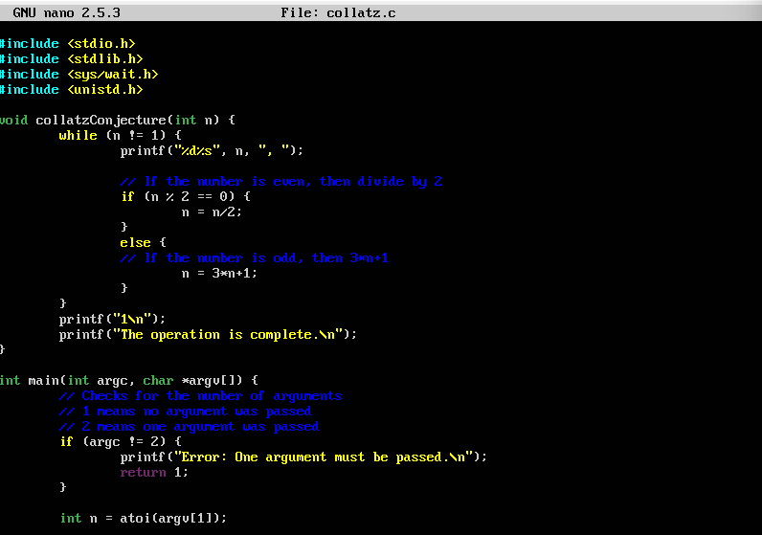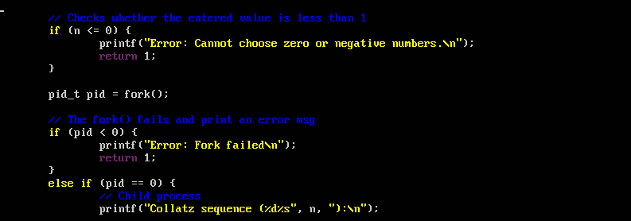
Outputs: -
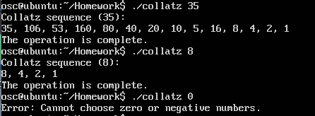

2.
Codes: -
main.c: -
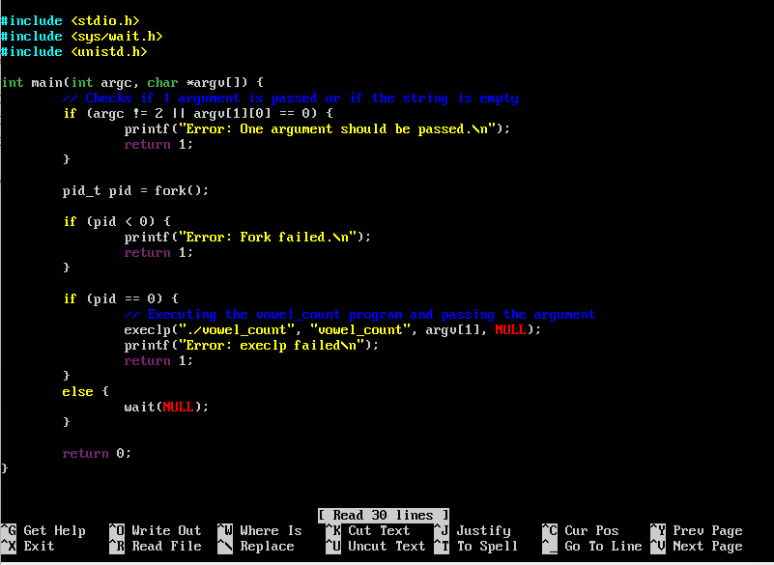
vowel_count.c: -
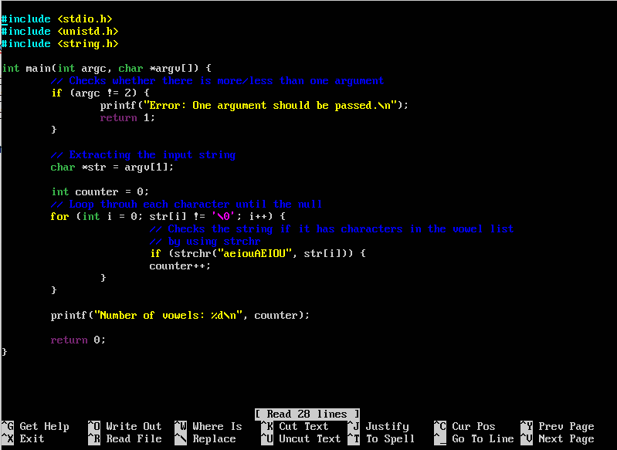

Outputs: -
