**Homework 10**

Zero Crossing Edge Detection

R09922063 鄭筠庭 資工所碩一

**Code explanation:**

Extend all the border by 1 pixel. Calculate input pixel gradient magnitude. If the magnitude is larger than threshold, Laplacian output pixel is set to 1. If the magnitude is smaller than negative number of the threshold, Laplacian output pixel is set to -1. In other conditions, Laplacian output pixel is set to 0.

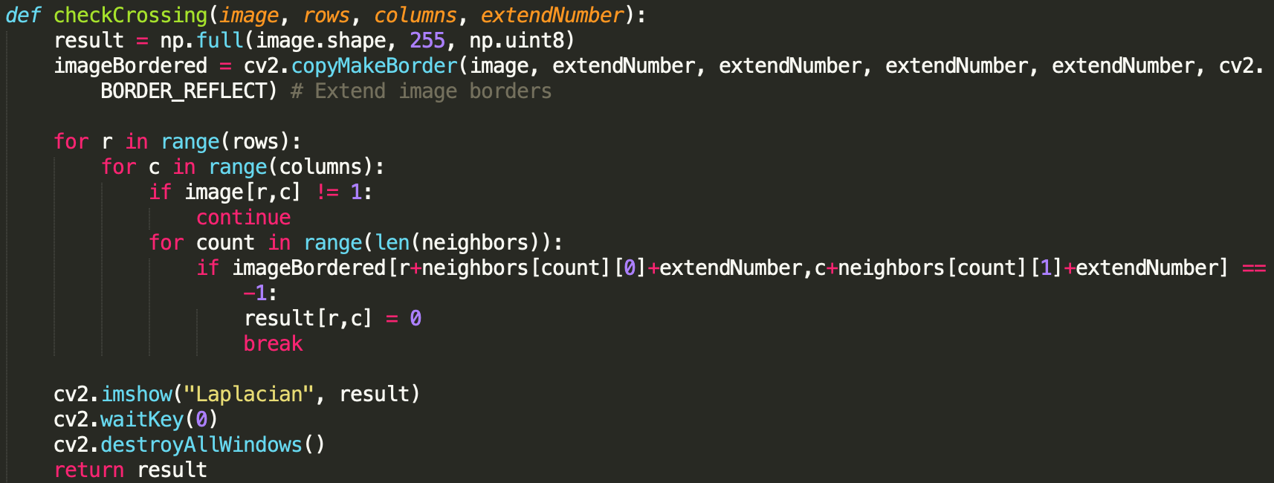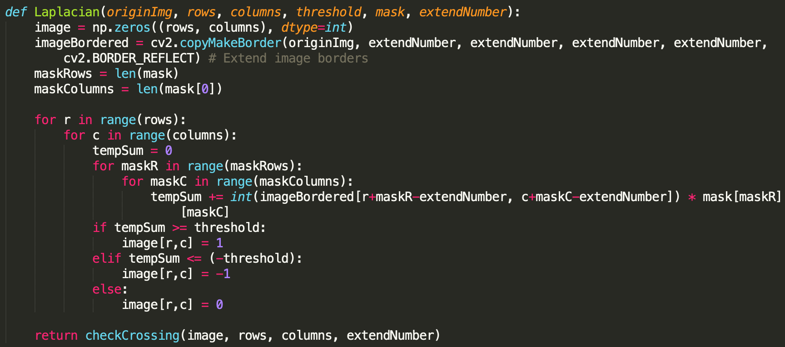I wrote two functions for all the kernel and threshold. One is to calculate the Laplacian output pixel. The other one is to find the zero-crossing edge.

A pixel is declared to have a zero crossing if it is less than –t and one of its eight neighbors is greater than t, or if it is greater than t and one of its eight neighbors is less than –t for some fixed threshold t.

Mask:

1. **Laplace Mask 1: threshold 15**

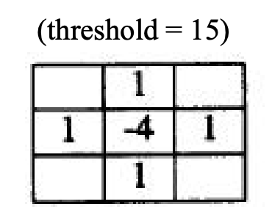

1. **Laplace Mask 2: threshold 15**

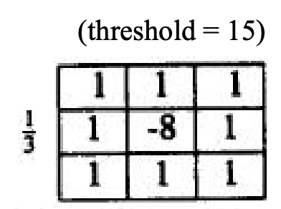

1. **Minimum variance Laplacian: 20**

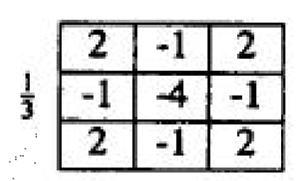

1. **Laplace of Gaussian: 3000**

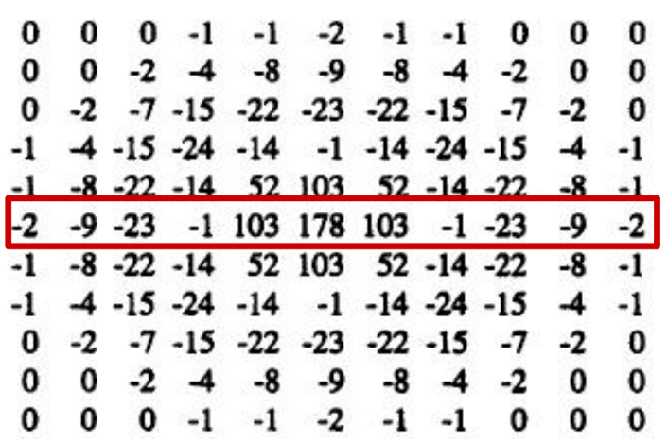

1. **Difference of Gaussian: 1**

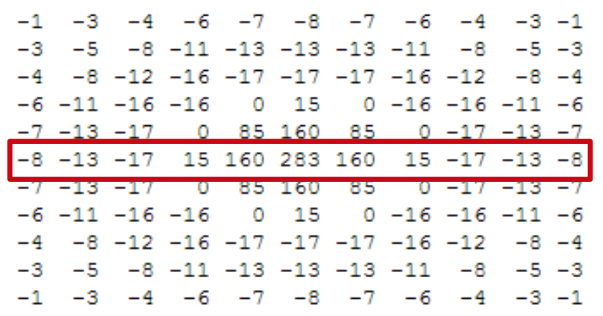

**Result:**

|  |  |
| --- | --- |
| 1. Laplace Mask1: 15 | 1. Laplace Mask2: 15 |
| 1. Minimum variance Laplacian: 20 | 1. Laplace of Gaussian: 3000 |
| 1. Kirsch's Compass Operator: 135 |  |