**Homework 1**

Basic Image Manipulation

Programming language: Python 3.7.3

Library used for this homework:

* Numpy
* OpenCv: to read and write the image file

Image info: lena.bmp [512(width),512(height),3(RGB)]

**Part 1:**

**[Code explanation]**

lena = cv2.imread('lena.bmp')

Read in the lena.bmp image file using opencv. The type of the variable “lena” is “numpy.ndarray”.

rows,columns = lena.shape[:2]

Get the row number and column number of the image.

For each section in part 1, a function is created to do the work.

lenaCopy = np.zeros(lena.shape,np.uint8)

lenaCopy = lena.copy()

All of the function has these two lines of code. Their purpose is to create a copy of the original image. The copied image will store the new data.

for c in range(columns):

for r in range(rows):

lenaCopy[r,c] = lena[rows-r-1,c]

In the function upsideDown(), we took the pixel information of lena from the bottom, and stored it to a new image from the top. We ran through each column to complete the flip.

for r in range(rows):

for c in range(columns):

lenaCopy[r,c] = lena[r,columns-c-1]

As for right-side-left flip, the leftmost pixel was swapped to the rightmost pixel. It kept swapping till the whole row was flipped. We went through the image pixels from top to bottom.

for r in range(rows):

for c in range(columns):

lenaCopy[r,c] = lena[c,r]

To flip diagonally, the pixel at [a,b] needs to switch with the pixel at [b,a].

**[Here are the results]**

1. **upside-down lena.bmp**

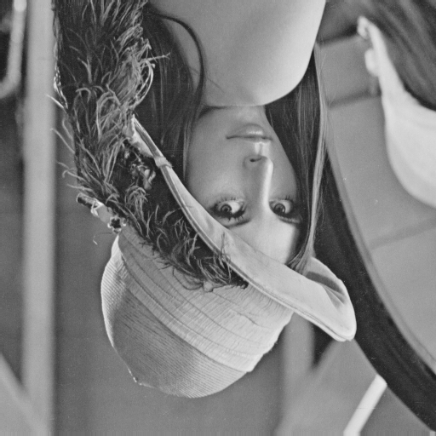

1. **right-side-left lena.bmp**

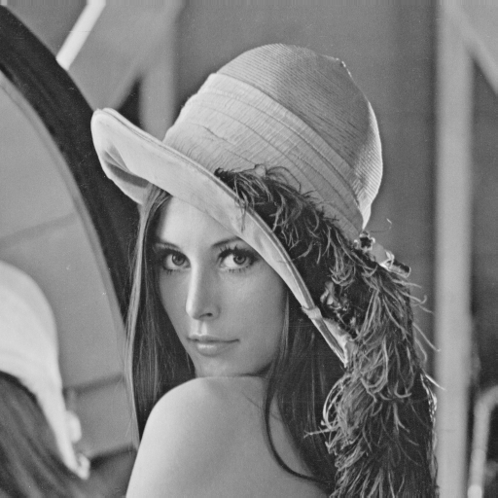

1. **diagonally flip lena.bmp**

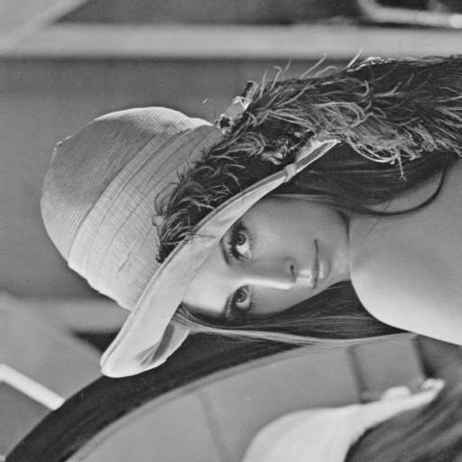

**Part 2:**

1. **rotate lena.bmp 45 degrees clockwise**

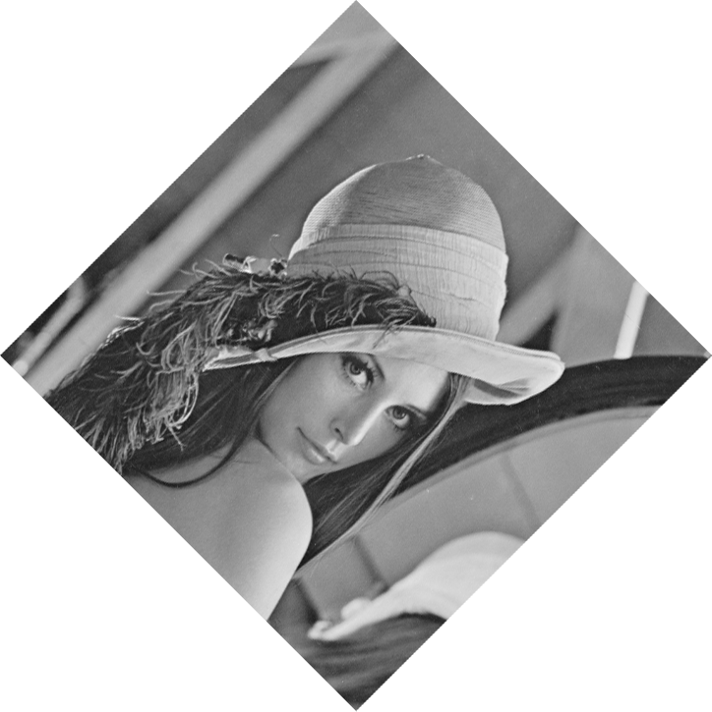

1. **shrink lena.bmp in half**

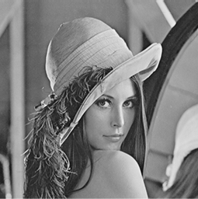

1. **binarize lena.bmp at 128 to get a binary image**

