**Homework 3**

Histogram Equalization

Programming language: Python 3.7.3

Library used for this homework:

* Numpy
* OpenCv: to read and write the image file

Image info: lena.bmp [512(width),512(height),3(RGB)]

**Code explanation:**

Draw a histogram with the brightness value of all pixel.

Use matplotlib.pyplot to draw the histogram.

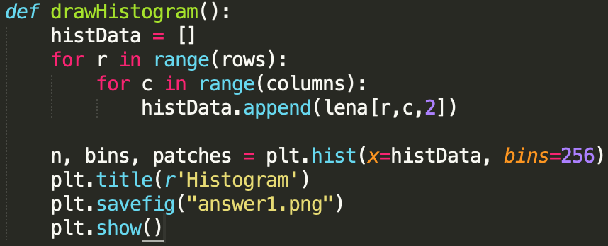

(b)

Divided all the pixels’ brightness value by 3. Save the result into each RGB channel. Use a list “histDivided” to save all the value, and draw the histogram using this list.

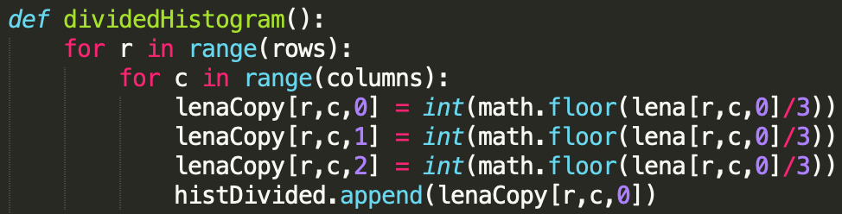

(C)

Calculate the PMF and CDF (cumulative distribution function) value of the darken image from part b. PMF was calculated from the hisDivided list from part B.

Histogram Equalization: <https://en.wikipedia.org/wiki/Histogram_equalization>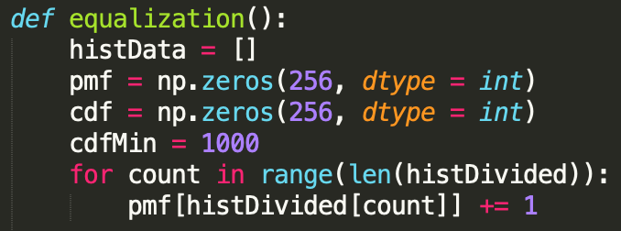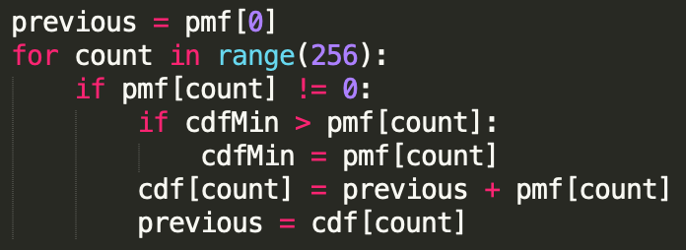

Calculate the normalized value of each pixel using the CDF values.

The general histogram equalization formula:

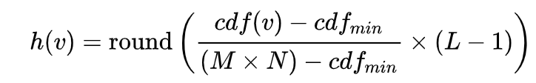

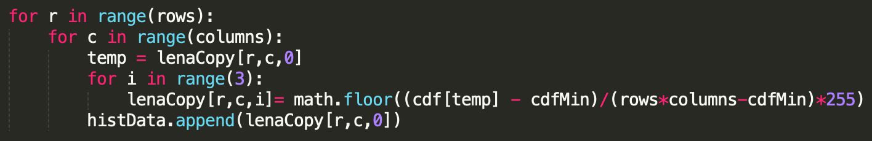

**Result:**

(a-1)

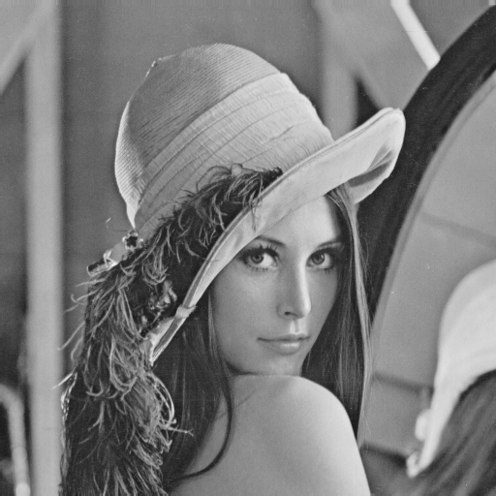

(a-2)

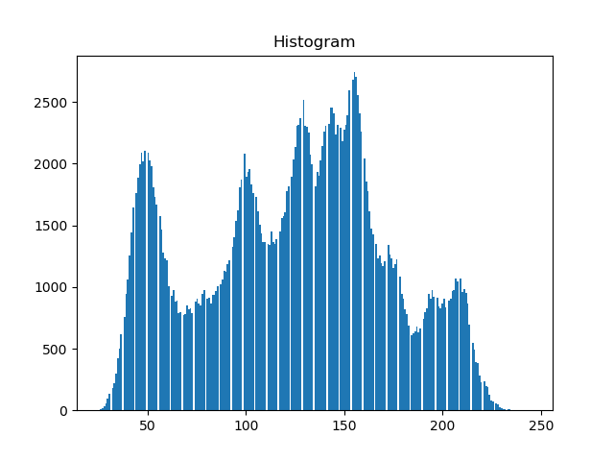

(b-1)

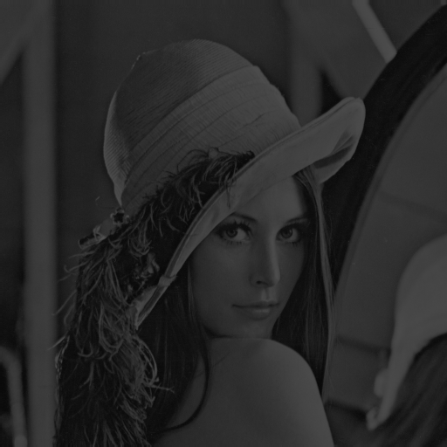

(b-2)

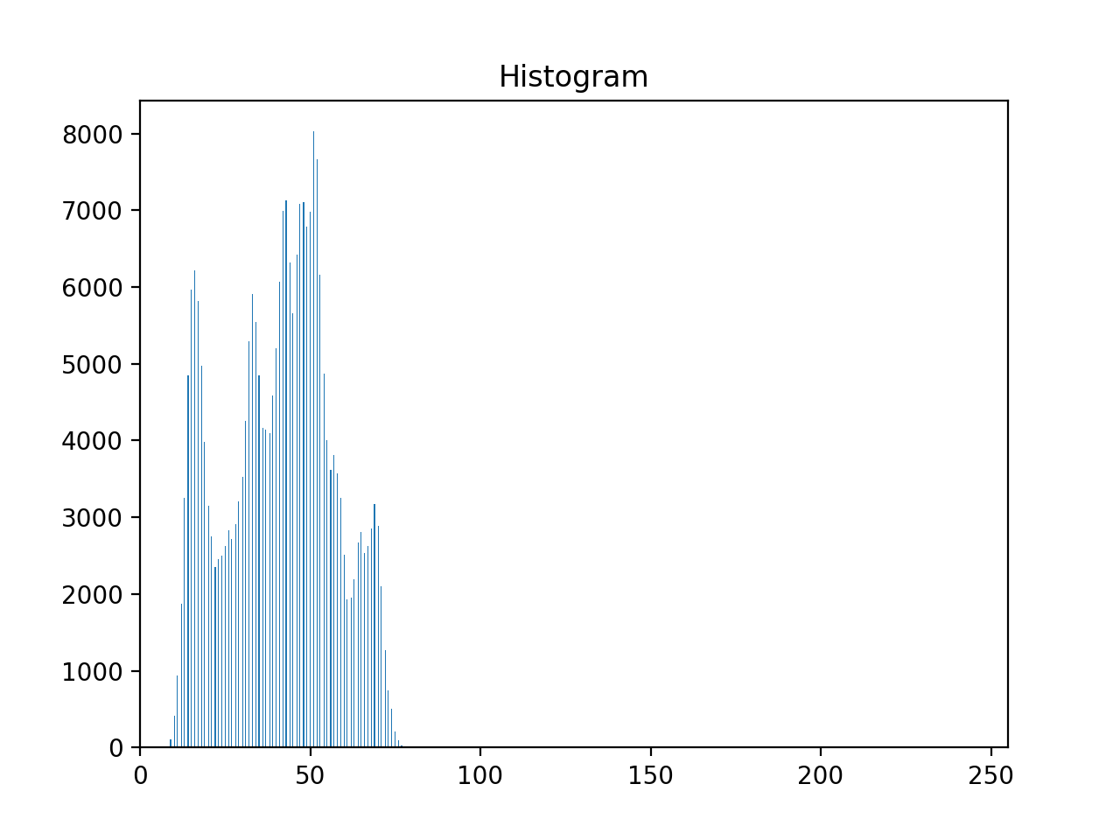

(c-1)

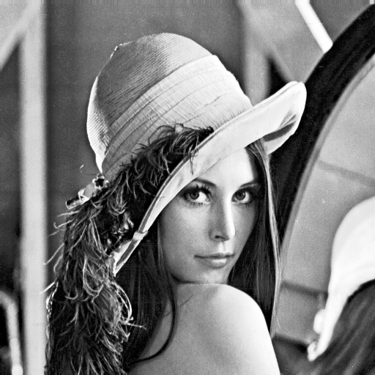

(c-2)

