**Homework 6**

Yokoi Connectivity Number

R09922063 鄭筠庭 資工所碩一

Programming language: Python 3.7.3

Library used for this homework:

* Numpy: for array usage
* Opencv: to read and write the image file

Image info: lena.bmp [512(width),512(height),1(Grayscale)]

**Code explanation:**

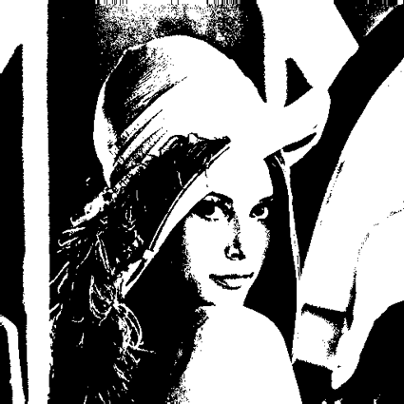First, binarize the benchmark image lena as in HW2.

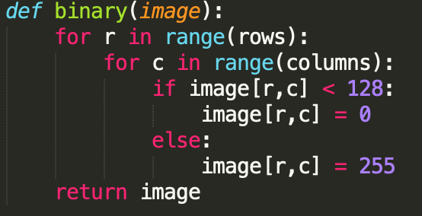

Second step is to down sampling the binary image from a 512x512 to 64x64. The row and column value are divided by 8, so the parameter “divide” is set to 8. Take the topmost-left pixel in each 8x8 region as the down sampled data.

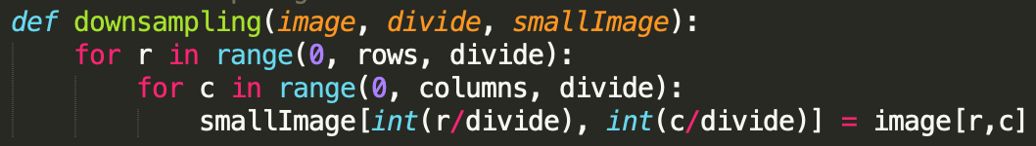

Call the Yokoi function to classify the way a pixel is connected to its like neighbors.

Go through every pixel and check its value. If the pixel is white (255), keep go down the function.

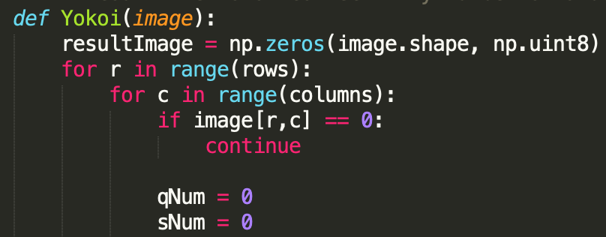

Skip the special cases where the mask is out of image border (<0 or >255).

Check the corner neighborhood with the following conditions, and record how many “q” and “s” this pixel gets.

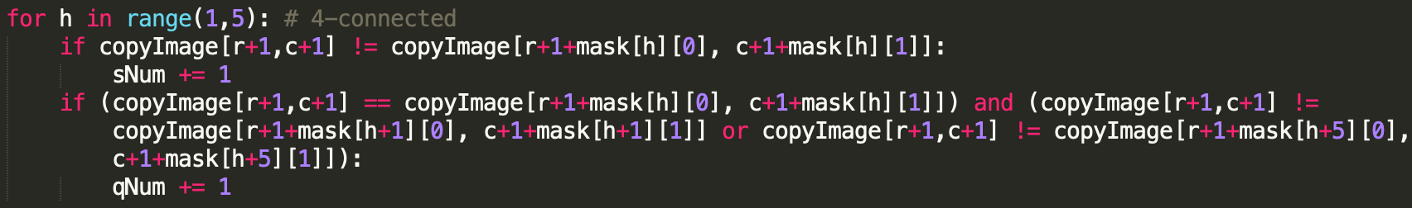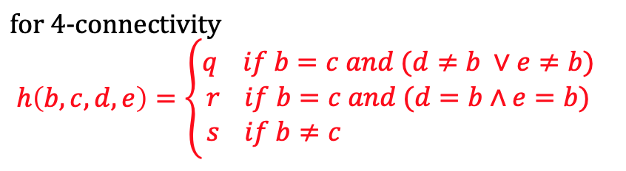

Label the image pixels with this formula. Finally, output the number-labeled image to a text file.

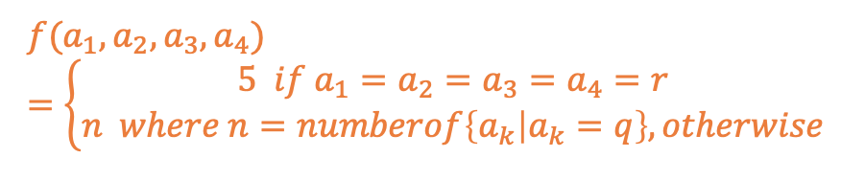

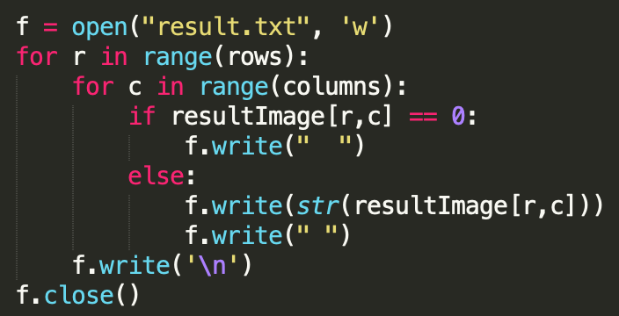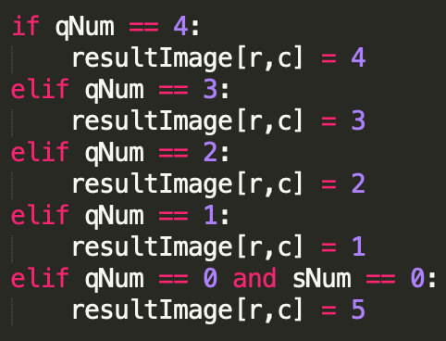

**Result:**

