**Part I (MongoDB)**

Task 1

mongoimport -d DB_class -c students --type csv --file hw6_student_data.csv –headerline

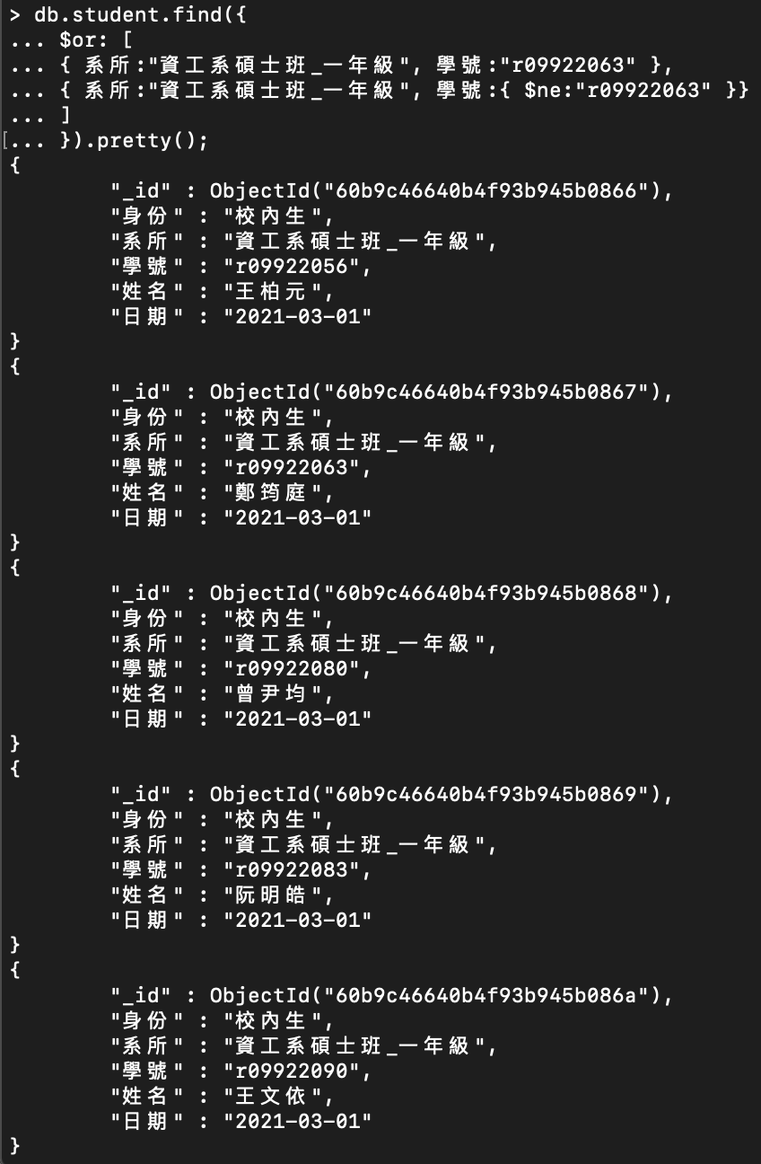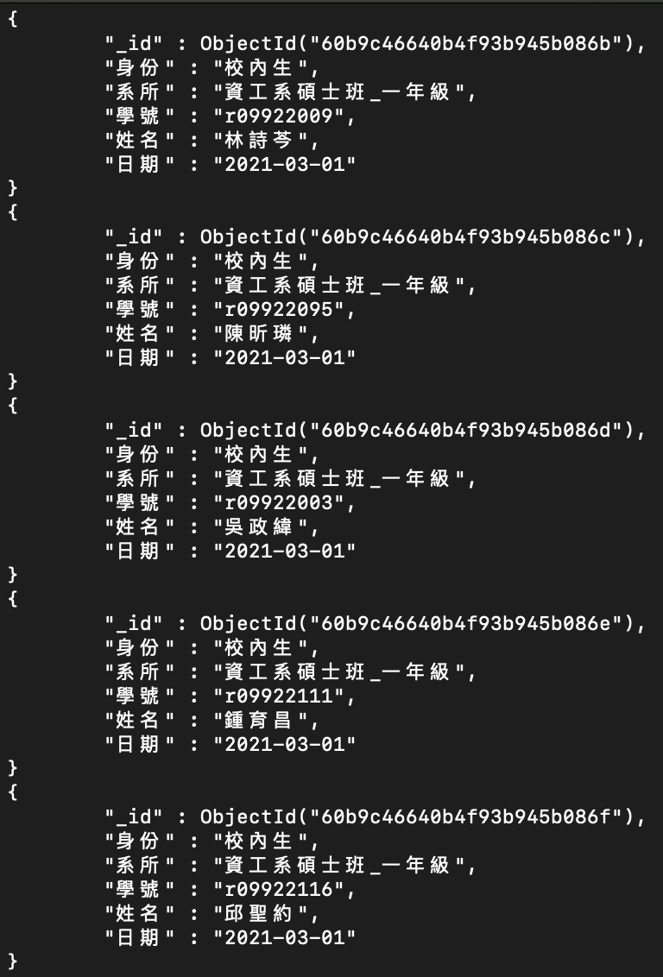Task 2

db.students.find({

$or: [

{ 系所:"資工系碩士班_一年級", 學號:"r09922063" },

{ 系所:"資工系碩士班_一年級", 學號:{ $ne:"r09922063" }}

]

}).pretty();

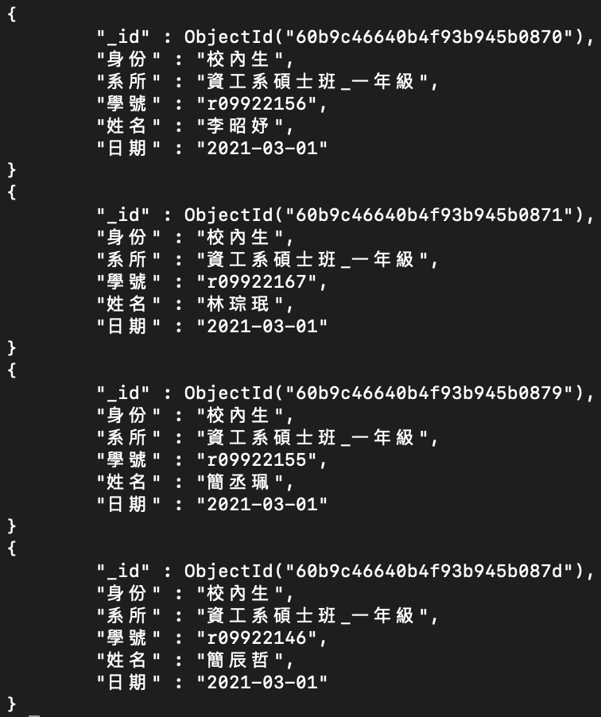

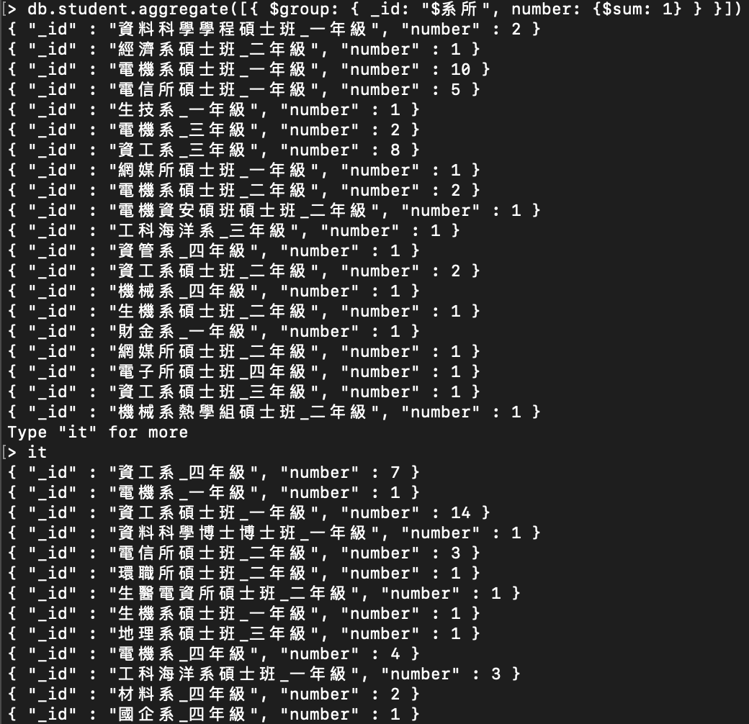Task 3

db.students.aggregate([{ $group: { _id: "$系所", number: { $sum : 1 } } }])

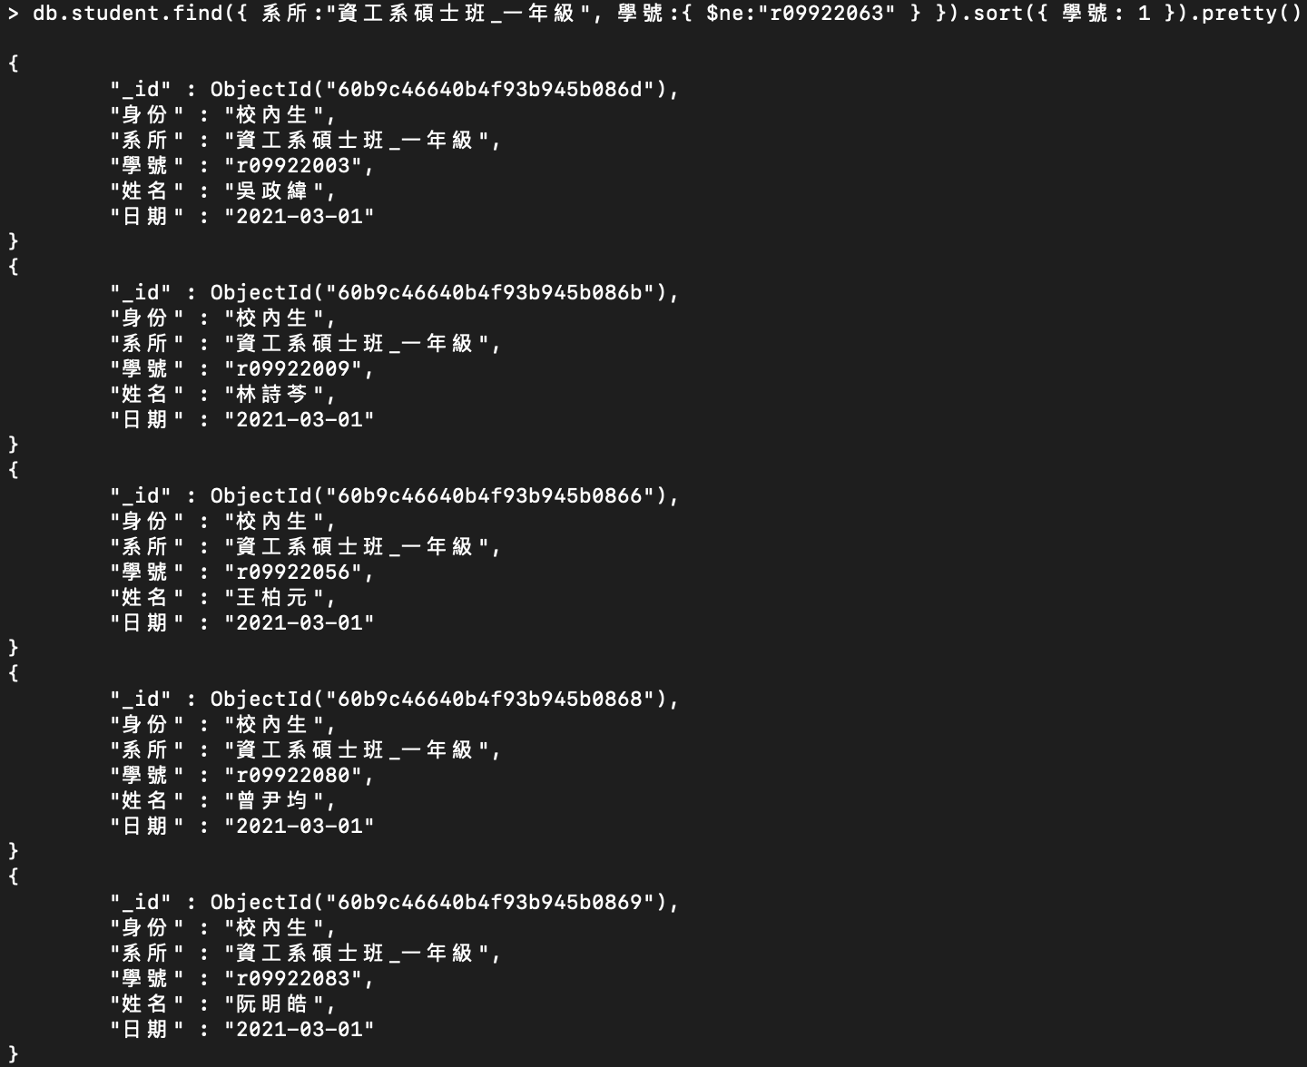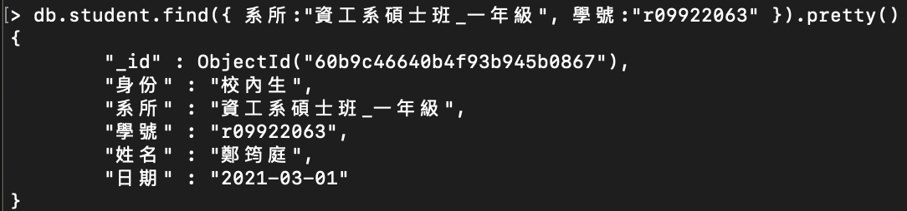Task 4

db.students.updateMany( {}, { $set: { 日期: "2021-03-01" } }, false, true )

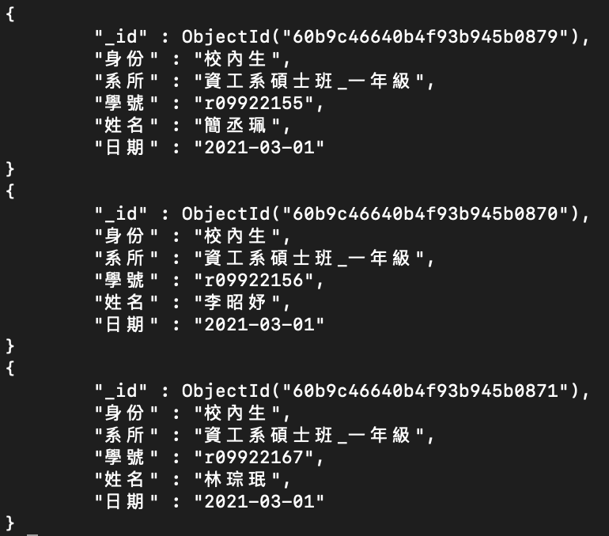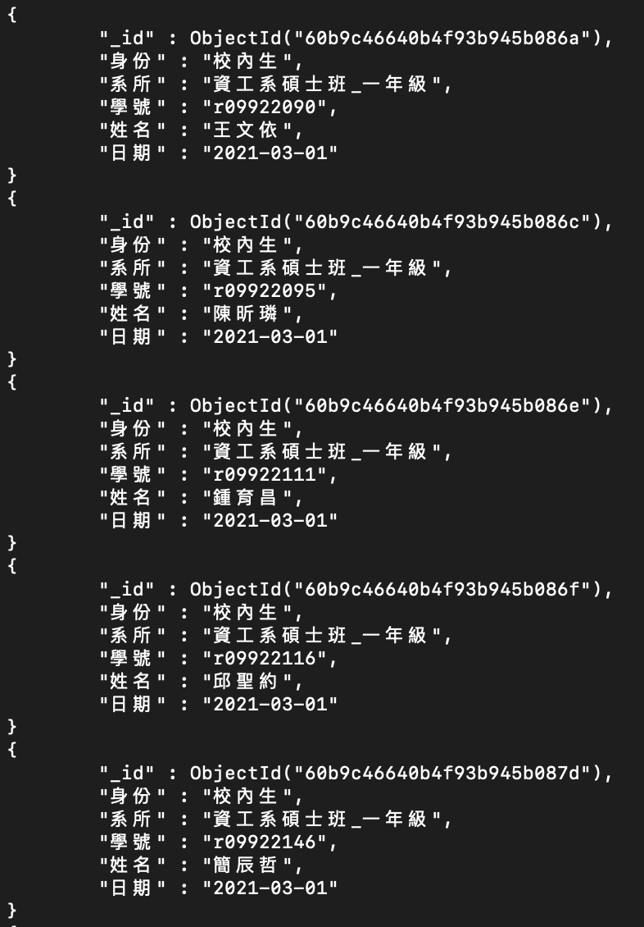

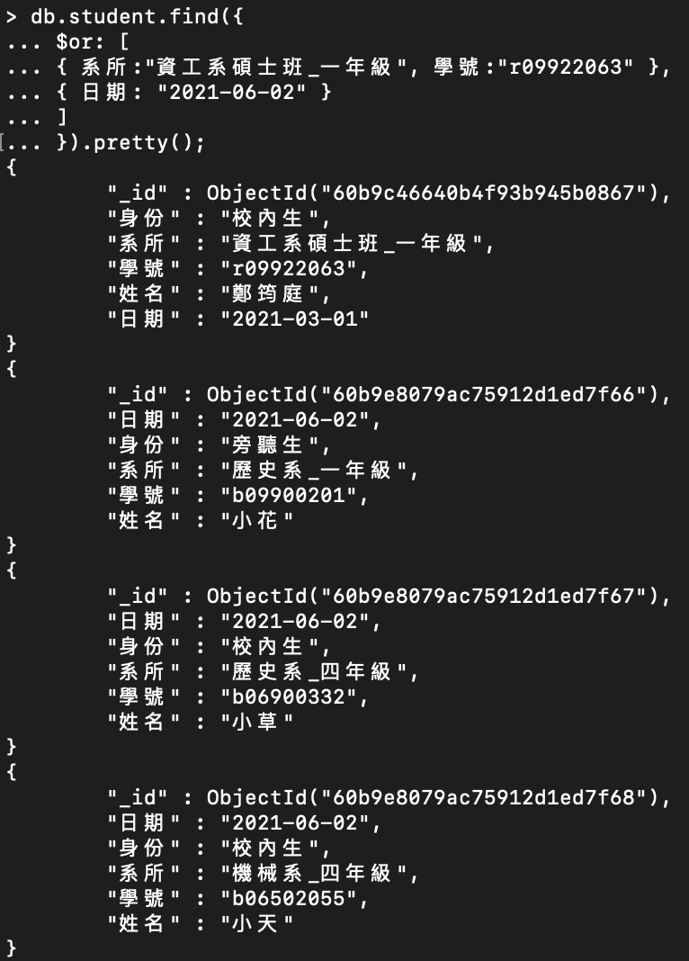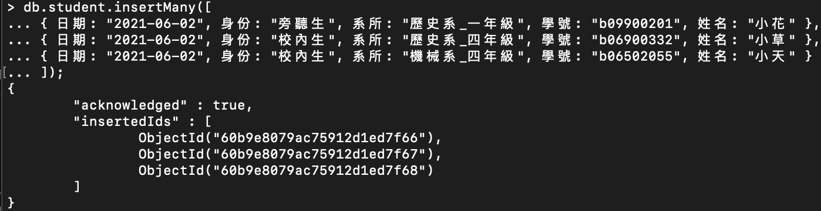Task 5

db.students.insertMany([

{ 日期: "2021-06-02", 身份: "旁聽生", 系所: "歷史系_一年級", 學號: "b09900201", 姓名: "小花" },

{ 日期: "2021-06-02", 身份: "校內生", 系所: "歷史系_四年級", 學號: "b06900332", 姓名: "小草" },

{ 日期: "2021-06-02", 身份: "校內生", 系所: "機械系_四年級", 學號: "b06502055", 姓名: "小天" }

]);

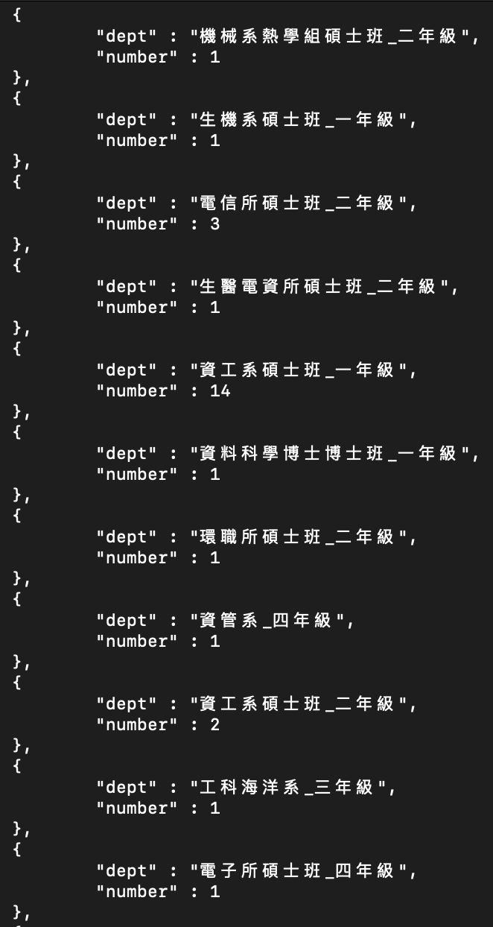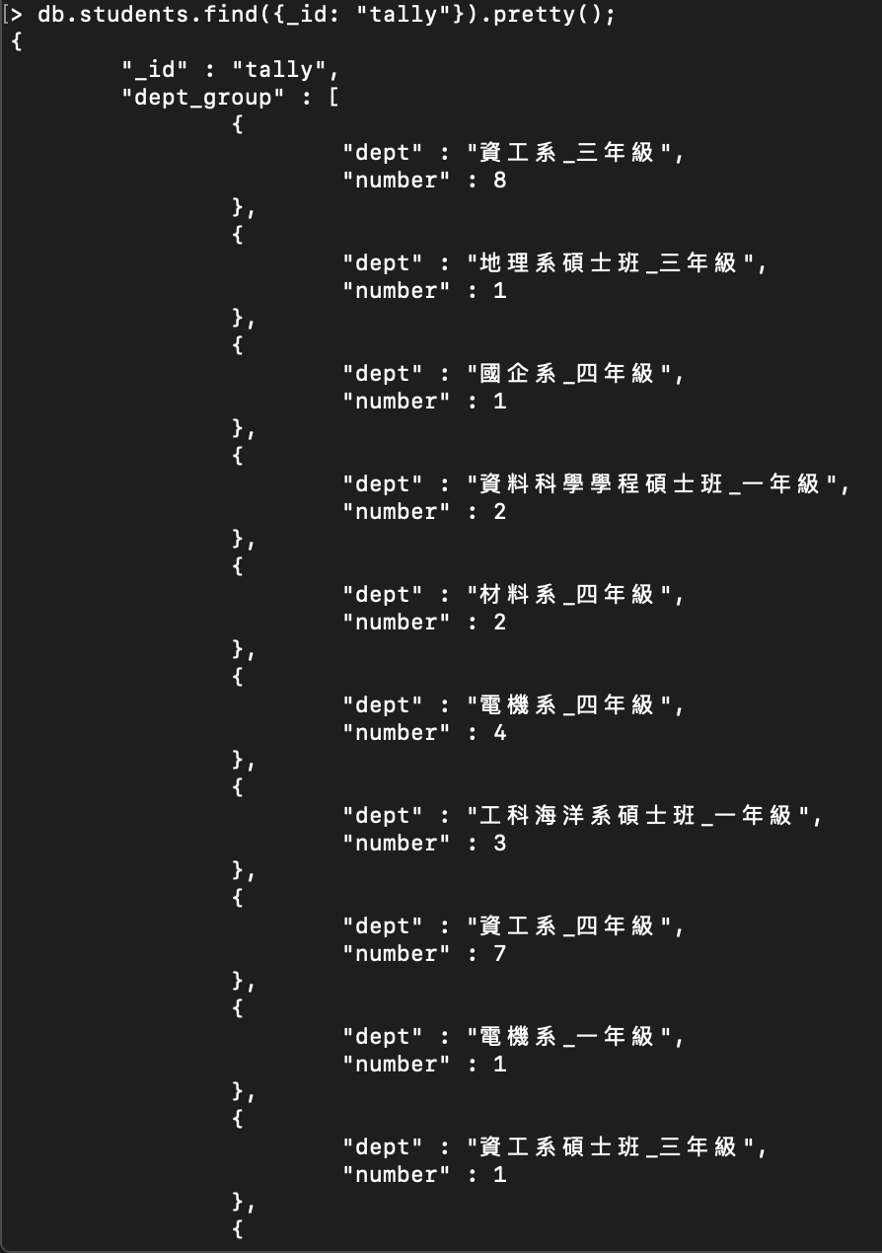Task 6

studentNumber = function(startDate) {

db.students.aggregate([

{ $match: { 日期: { $lte: startDate } } },

{ $group: { _id: {系所:"$系所"}, count: { $sum: 1 } } },

{ $group: { _id: null, DEPT_GROUP: { $push: { dept: "$_id.系所", number: "$count" } } } },

{ $project: { _id: "tally", dept_group: "$DEPT_GROUP" } },

{ $merge: {

into: "students",

whenMatched: "replace",

whenNotMatched: "insert"

}}

]);

};

studentNumber("2021-03-31");

studentNumber("2021-06-10");

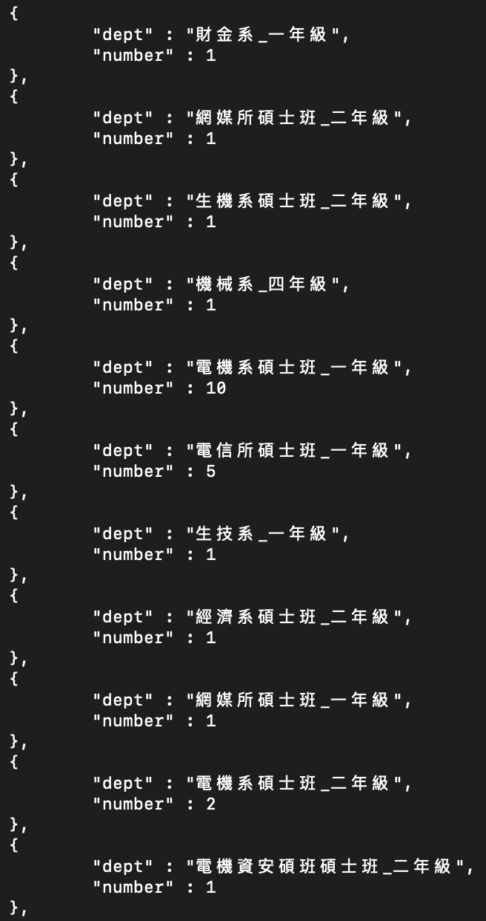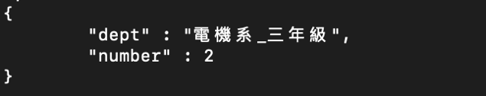

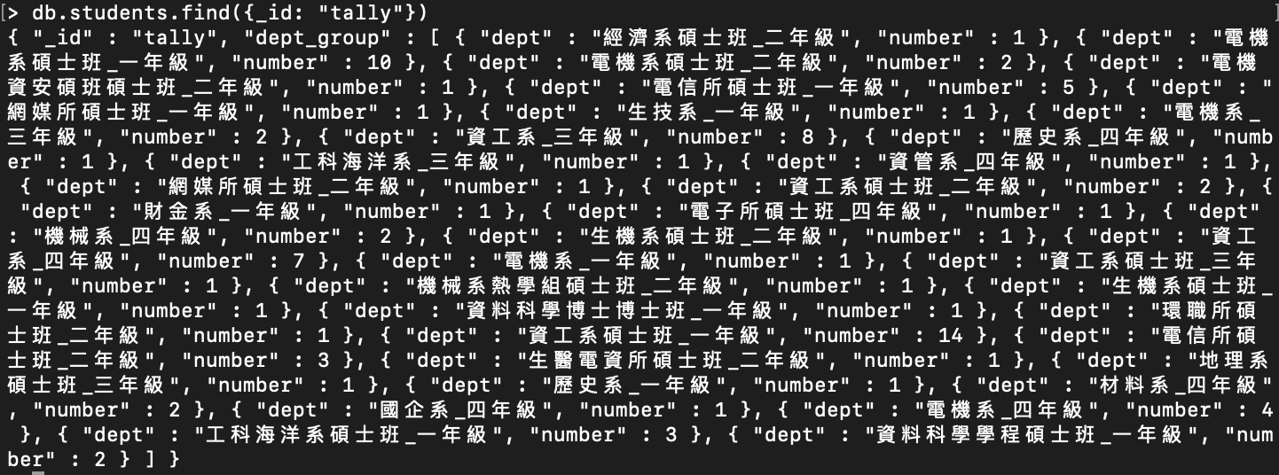

**Part II (Graph DB Basic)**

Task 1

LOAD CSV WITH HEADERS FROM "file:///hw6_student_data.csv" AS csvLine

CREATE (s:Student {身份: csvLine.身份, 系所: csvLine.系所, 學號: csvLine.學號, 姓名: csvLine.姓名})

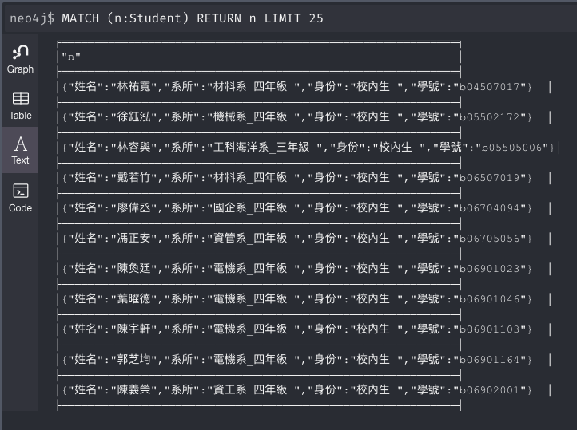

Task 2

MATCH (a:Student {學號: 'r09922063'}),(b:Student {系所: '資工系碩士班_一年級 '})

WHERE b.學號 <> 'r09922063'

CREATE (a)-[r:peer]->(b) RETURN type(r), r.name

