**UROP**

**Juran Zhang, Haiyang Han, Rong Chen**

**Introduction**

There are several open source softwares that provide captive portal service and among them we think CoovaChilli is the most mature one which is a feature rich software access controller that provides a captive portal / walled-garden environment and uses FreeRADIUS for access provisioning and accounting.

**Objective**

Our objective is to work out a functional captive portal which can interact with social networks like Facebook or WeChat. When users send request for Wi-Fi access at hotspots supported by our captive portal, their browser should simply display a login page for them to login to their social network account and “like” hotspot provider’s home page in order to obtain access to the Internet.

**Requirements**

-Ubuntu 14.04 LTS

-2 NICs eth0 connected to Internet on either static or dhcp,

eth1 connect to clients with no IP address

-LAMP(Linux+Apache+Mysql/MariaDB+Perl/PHP/Python)

-SSH Server

-BIND(implements the Domain Name System )

-CoovaChilli and FreeRadius

**Proposal Statement**

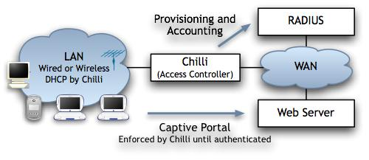

[CoovaChilli](http://www.coova.org/CoovaChilli) - is a feature rich software access controller that provides a captive portal / walled-garden environment

[Freeradius](http://freeradius.org/) - handles authentication and accounting

[MySQL](http://www.mysql.com/) - backing the Radius server

We aim to design the captive portal based on the structure provided by Coovachilli, with the radius server supported by FreeRadius.

The software should take control of one of the two network interface cards (in our case, eth1),

which passes and receives packets to and from the user via a dd-wrt router. The other NIC( eth0), is used to connect the server to the Internet.

A client connecting to this interface is limited to a "walled garden" until authorized. The client is only able to resolve DNS and web browser web sites specifically added to the walled garden (in our case, Facebook or other social network). Authentication happens by using "Universal Access Method" (UAM). This method uses a captive portal that initiates authentication. When a non-authenticated client tries to connect to a web-page (on port 80) the request is intercepted by our software and redirected to the captive portal. In our case, we'll use a perl-script cgi (served by apache).0

The cgi page contains steps to gain access to Internet and link of the specified Facebook page. Whenever the user logins and “likes” the specified webpage, the Facebook API will send these authentication data (which might include the user’s Facebook ID and the device ID of his MAC address) to our server which will then forward to the FreeRADIUS server, which matches them with information in it’s back-end database based on mysql.

A user is then either rejected or authenticated by FreeRADIUS, prompting the cgi(login page) to present either a rejection message or a page with a success message and a logout link to the user.

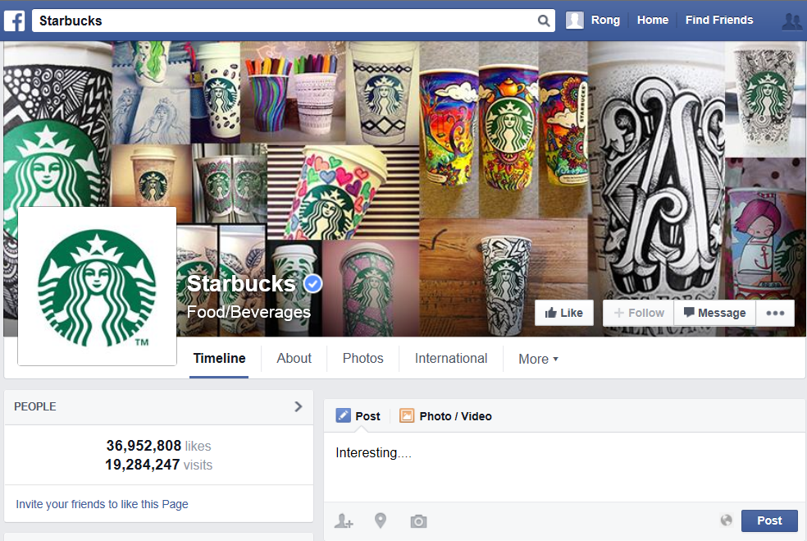

**Work Schedule**

**Phase1: 6/23/2014 - 6/30/2014**

Get acquainted with all the necessary softwares and techniques.

Download, install and configure Ubuntu 14.04 + Freeradius + Coova-Chill + daloRADIUS respectively as separate modules.

**Phase2: 7/1/2014 - 7/15/2014**

Setup mySQL database

Combine Freeradius with mySQL database.

Test for Access-Request and Access-Accept packages.

Equip Freeradius with Daloradius web management application.

**Phase3: 7/16/2014 - 8/1/2014**

Setup authentication page embedded with Facebook API.

Set Freeradius and CoovaChilli to work together.

Change CoovaChilli's iptables configurations to install firewalls.

Integrate softwares with DD-WRT router and test for captive portal.

**Conclusion**

It can become quite a challenge when integrating with other systems. Once captive portal is built, plenty of features can be added to it. E.g. Location Based Service. Different business may customize their own captive portal pages and these pages will be displayed to the customers based on their locations in the shopping mall.

**Reference**

[Building a Captive Portal - controlling access to the internet from your network](https://blog.trifork.com/2013/01/15/building-a-captive-portal-controlling-access-to-the-internet-from-your-network/)

<https://blog.trifork.com/2013/01/15/building-a-captive-portal-controlling-access-to-the-internet-from-your-network/>

[WifiDocs](https://help.ubuntu.com/community/WifiDocs)/[CoovaChilli](https://help.ubuntu.com/community/WifiDocs/CoovaChilli?action=fullsearch&value=linkto%3A%22WifiDocs%2FCoovaChilli%22&context=180)

<https://help.ubuntu.com/community/WifiDocs/CoovaChilli>

Creating a Capture Portal using CoovaChilli, FreeRadius, and MySQL

<http://emandeguzman.wordpress.com/2012/10/24/creating-a-capture-portal-using-coovachilli-freeradius-and-mysql/>

Ubuntu Server + Freeradius 2.0.x + coovachilli + Daloradius

<http://network-scratch.blogspot.hk/2011/09/ubuntu-server-freeradius-20x.html>

Install CoovaChilli + FreeRadius on Ubuntu 12.04.2 LTS i386

<http://servernetworktech.com/2013/03/install-coovachilli-freeradius-on-ubuntu-12-04-2-lts-i386/>