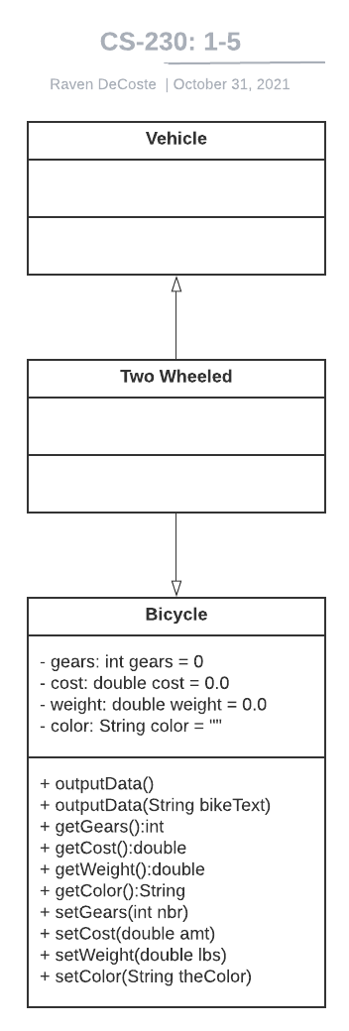

The above UML class diagram illustrates the inheritance relationships between the class vehicle, and its sub-class two wheeled, and two wheeled and its subclass bicycle. The bicycle program has only public methods. Its variables are all private, as they need only be accessed by the class methods. This is an example of encapsulation, allowing only the objects own classes to use its variables. The creation of the classes themselves are abstractions representing a set of functions and variables.