DSS Grading System Project

Изготвено от: Димитър Любомиров Бояджиев

No: 121221014

e-mail: [dimitar.boyadzhiev02@gmail.com](mailto:dimitar.boyadzhiev02@gmail.com)

Presenting:

*The Grading System*

*The Grading System* shown below is a state of the art ReactTM single page application featuring a great UI/UX design that keeps the user engaged! With its bright colors to catch the attention of the user it will keep, in this case teachers, entertained! With a working section that is not too straining on the eyes it is the best design for the users! Truly a top tier design combining the best of dark and light themes!

***The incredible design:***

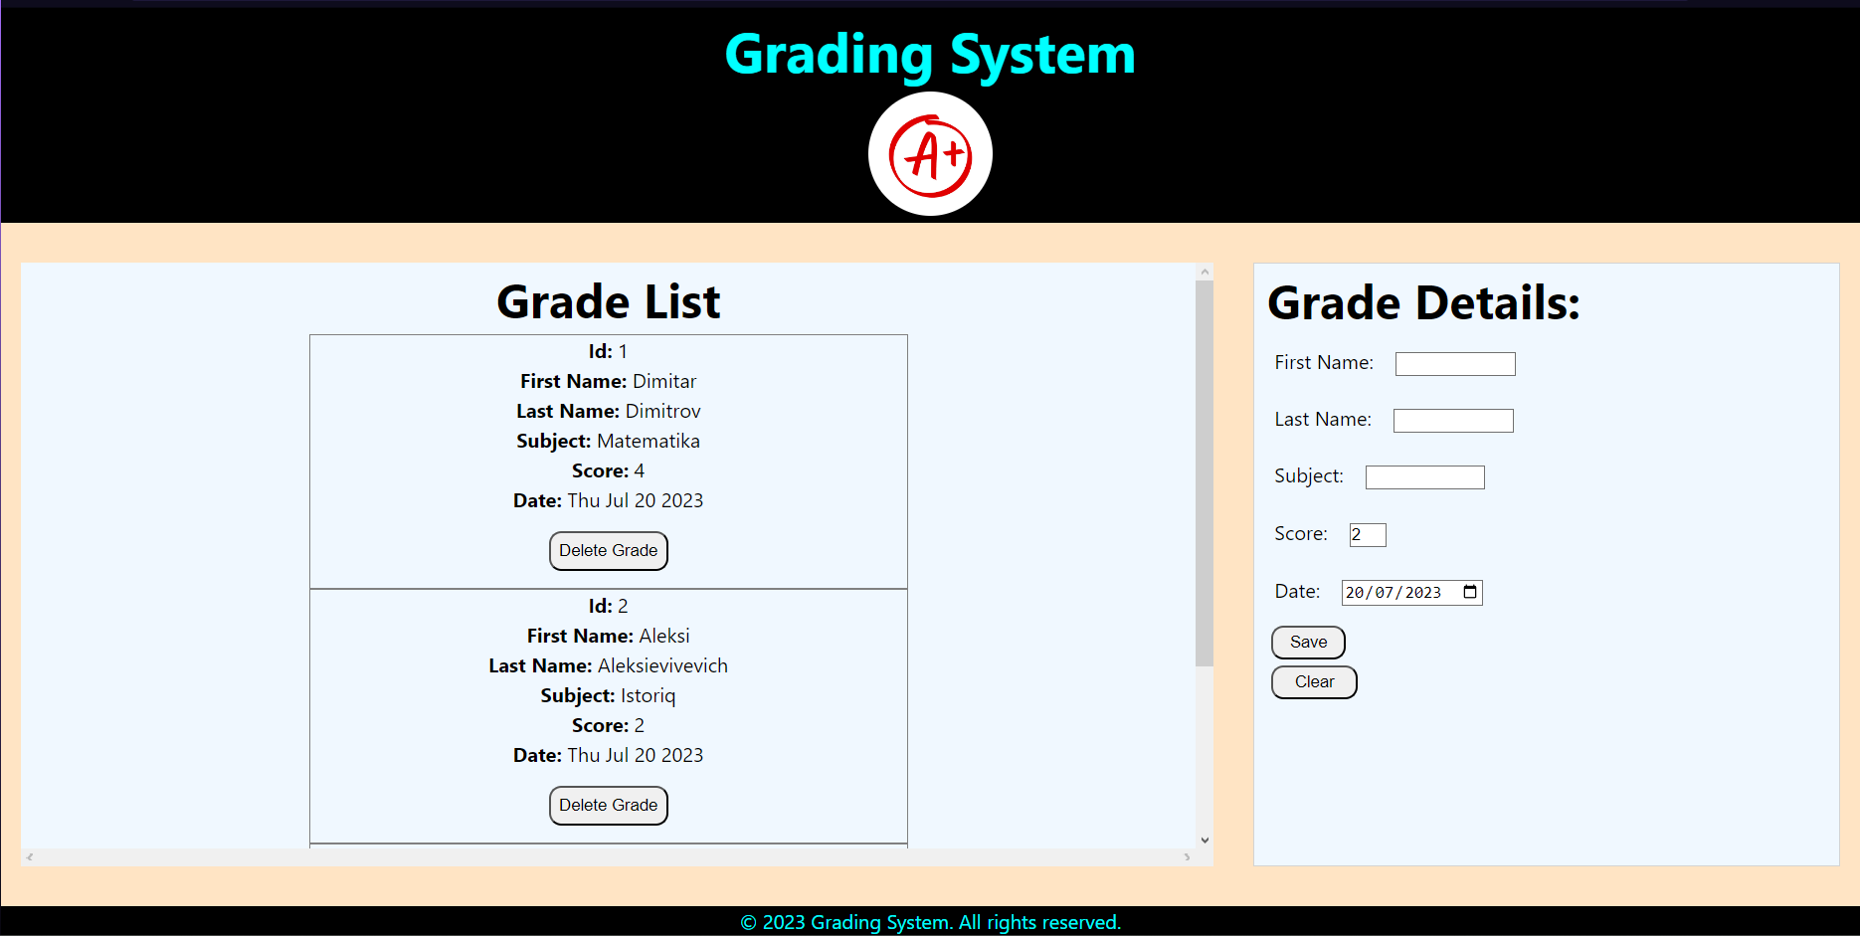

And let’s not forget the amazing logo design that is definitely not stolen from the web!

While there is no additional logic added, the application is simple and efficient! Just as a good grading system should be!

**Adding item:**

(It is also an amazing decision to make the Save and Clear buttons green! Adds attention to detail for the user!)



**Deleting an item:**

(It also clears the details section! Turn your attention to the red color of the delete button when you hover it as well!)



**Updating an item:**



**Selecting and clearing items:**

(Please, note that the grade returns to 2(lowest possible) by default! As well as on initialisation! *That was intentional!*)

