**DNS RESOLVER USING RECURSIVE QUERYING FOR EFFICIENT DOMAIN NAME RESOLUTION**

***Abstract*** - The Domain Name System is an indispensable facility for converting human-readable domain names into IP addresses to access internet resources in an effective and smooth manner. Based on this premise, the paper proposes a design of a DNS resolver based on recursive querying, which supports faster resolution of queries and precision. During recursive query traversal, the resolver solely takes responsibility to traverse the DNS hierarchy directly contacting many authoritative servers to fetch desired records. The proposed system minimizes recursive DNS querying by using robust caching, dynamic timeout settings, and query prioritization to decrease the response time of queries and reduce redundant traffic within the network. It is tested under various network conditions in a simulation environment and has been shown to reduce query latency significantly and overall network congestion. The effectiveness and efficiency of recursive DNS resolvers when attempting to improve the processes of DNS lookups and the user experience in high-demand networks are identified.

# INTRODUCTION

One of the infrastructural building blocks forming the internet is a mapping of people-readable domain names into their machine-readable IP addresses. This translation of human-readable domain names into the numerical world of IP addresses allows users to access websites and other internet resources without ever having to remember those pesky numerical IP addresses. The DNS resolver is an intermediary in the chain of communications between user requests and the greater DNS system that will acquire whatever information related to IP addresses is needed by querying a series of DNS servers. Efficient completion of such a resolution process can prevent slow website loading and thereby reduced user satisfaction due to delayed DNS resolution.

DNS resolvers process data by other means, with recursive query being the most widely applied of them all. In a recursive query, the resolver takes complete responsibility for retrieving the IP address requested. During this process, the resolver contacts the multiple authoritative DNS servers step by step, one after another, until it successfully retrieves appropriate information. Since queries that depend on an iterative process to be resolved exist at the minimum at client-side attempts to query different servers, recursive queries make the whole task easier; they allow the DNS resolver to complete all the lookups by itself. This makes recursive resolvers particularly effective in eliminating user involvement while providing faster and more streamlined DNS resolution.

Recursive querying does have its benefits, but DNS resolution is increasingly burdened by a growing need for Internet services, more devices, and the size of current DNS queries from modern applications. All these present challenges to slower query resolution, network congestion, and poor handling of large DNS traffic. Optimizing DNS resolvers toward better performance has thus emerged as an important research area. Such improvements will relate to optimizations in terms of caching mechanisms, the management of timeouts, and various techniques for traffic reduction in order to improve the speed and dependability of DNS lookups. Query latencies should decrease as well as an overall network efficiency.

This research would propose improving the performance of a DNS resolver by recursive querying. A proposed resolver would thus be based on improved techniques for caching strategies and dynamic timeout configurations to serve the avoidance of redundant traffic toward faster and more precise DNS resolutions in high-demand network environments. This is established by wide testing and evaluation in simulated various scenarios that prove the efficiency of these optimizations regarding reduction in query latency and better handling of DNS traffic. The results point very strongly to the need for optimizing recursive DNS resolvers to enable access to the Internet much more swiftly and reliably for end users.

# LITERATURE REVIEW

# The Domain Name System, or DNS, plays a big role in the architecture of the internet; it allows users to access web resources through human-readable domain names that are translated into IP addresses. The DNS infrastructure has seen great leaps with years by advancing to match the growth of internet usage, traffic load, and increased numbers of devices connected. It aims at critically discussing the evolution of DNS resolvers through recursive querying, caching mechanisms, and performance optimization while considering the challenges and queries placed on the modern network environment.

1. **DNS Resolution Process and Recursive Querying**

Some of the oldest works on DNS resolution include the work by Mockapetris in 1983 that introduced the concept of distributed name resolution, in which domain names may be resolved by making queries to a hierarchical DNS. A basic way in which a DNS resolver can take full responsibility over retrieving the required information is through recursive querying, whereby authoritative DNS servers are queried until an answer is reached. Iterative querying is different because the client is sent to other DNS servers to be resolved further.

1. **Optimizing DNS Resolvers**

There have been different works on optimizing recursive DNS resolvers to achieve better performance. Jung et al. (2002) proposed enhancements in the area of DNS caching to alleviate redundant queries and reduce latency resulting from DNS lookups which are done often. Caching is utilized to ensure that DNS resolvers store recently fetched DNS records so they can respond to future queries without having to recontact the servers upstream. This mechanism of caching is crucial in reducing query loads on both recursive resolvers and root DNS servers.

1. **Challenges in DNS Performance**

Interestingly, however, these improvements in performance have been due to many enhancements in recursive querying and caching mechanisms. Such studies as that by Liu et al., demonstrating that DNS traffic continues to grow and increase with the rise of IoT devices and web services relying on multiple DNS queries to load content, showed that increased DNS traffic can indeed lead to overloading of recursive resolvers and authoritative servers-leading to latency.   
**4. Future Perspectives**

Recursive resolvers can make proactive fetches or cache DNS records before necessity through analysis of historical information on DNS query patterns, thus making resolution times during peak usage periods. Such predictive methods are another promising avenue for recursive DNS querying in performance enhancements in large-scale_networks.  
In conclusion, recursive DNS querying greatly improved the efficiency and usability of DNS resolution, but leaves still problems of ongoing performance optimization and a volume of growing DNS traffic. Further advancement in caching, query prediction, and dynamic readjustment of timeouts will become critical to ensure the DNS infrastructure can meet tomorrow's demands in a much more connected world.

# SYSTEM ARCHITECTURE

The architecture for a DNS resolver that utilizes recursive querying will have it interact with multiple DNS servers on behalf of the client to facilitate the resolution of domain names. The main components in such architecture include the client, also referred to as the requesting host; the local DNS resolver; cache; root DNS server; the TLD DNS server; and the authoritative DNS server. The general goal of this system is to streamline the conversion from domain names to IP addresses, reduce query time, and use network resources efficiently.

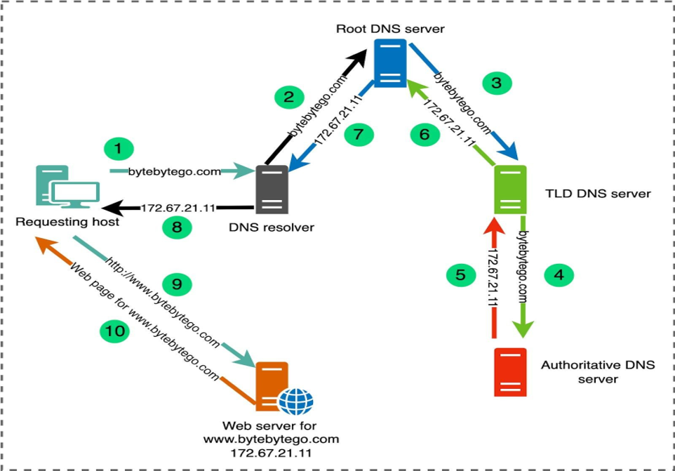

**1. Client or Requesting Host**

Role: the client is a device that sometimes acts by sending out a DNS query. It may request an IP address of some given domain name-for example, example.com  
Interaction: this client does not reach out to an authoritative DNS server but sends the query to a local DNS resolver, which will take care of the rest

**2. Local DNS Resolver**

Function: a structural element containing a local DNS resolver. How it actually does this to meet the client's request, in order to translate the domain name to an IP address-even if recursive in some sense, for resolution of part of the domain name to an IP address, is not always.  
Recursion: Resolver actually recurses on DNS lookups. Rather than just taking one query from the client, awaiting instead the full result of a DNS query by visiting a series of DNS servers, namely, root, TLD, authoritative to fetch the final IP address.  
Cache: The DNS resolver introduces the following to optimize in terms of speed and preserve a short time-to-live for recently requested DNS records. Here, the client goes direct only in order to fetch the desired domain name result from cache if it's available; otherwise, it will request other DNS servers. This cuts down drastically the query time and network load.

**3. Cache**

Functionality: In the DNS system, caching refers to a mechanism that stores DNS query results for temporary use. A local DNS resolver caches recently resolved domains to answer repeat queries.  
Efficiency: The cached entries support the resolver in avoiding making unnecessary queries to the upstream DNS servers. Entries in the cache carry TTL- Time-To-Live, which defines how long the information is valid.

**4. Root DNS Server**

Function: When the resolver decides that the domain cannot be found in the cache it sends the recursive question on to the root DNS server. However, it is ignorant about which is the specific IP of the domain but can point the resolver to the right TLD DNS server (.com, .net, .org).  
Therefore, a root server is a head of the DNS hierarchy. More resolution is needed every time when a resolver requests it.

**5. TLD DNS Server**

Function: Here the resolver receives the request from the root DNS server and forwards this request to the TLD DNS server. The server which receives requests for domains coming under its top-level domain, say .com or .org, makes the resolver aware of which authoritative DNS server to use for the particular queried domain, say example.com.

**6. Authoritative DNS Server**

Function: It acts as the authoritative DNS server and source of the particular finality of a domain name. That is, it comprises actual DNS records like the A record, which provides the actual IP address of the domain.  
Resolution: Once that authoritative DNS server gets the correct IP, it caches that for next time and returns the IP address back to the client.

**7. Optimizations and Enhancements**

Recursive DNS query optimization: this process requires being optimized for efficient and effective DNS resolution. Probably the most effective mechanism in this class of optimizations is achieved using the use of caching. In other words, the DNS resolver maintains a record of resolved domain names and the respective addresses; so that, in case of further requests to the same domain name, it may fetch these from the cache instead of performing the whole recursive query every time. This would reduce query latency as well as not burden DNS servers up the hierarchy, especially at the root and authoritative DNS servers. Another parameter of the caching is called the Time-to-Live, which simply describes how long a record is valid after it is cached. Proper tuning of TTL values will ensure stale records aren't served while still reducing the

# need repeated queries.

# EXISTING SYSTEM

DNS is the foundation of a modern internet, in that it translates human-readable domain names-like www.example.com-to the numerical IP address necessary to help devices locate and communicate with one another. Without DNS, users would need to remember strings of numbers; therefore, it makes the internet much more accessible and intuitive. Recursive resolvers in DNS are important in that they really do the heavy lifting, that is, iteratively query several layers of DNS servers for domain name resolution to the desired IP addresses. Recursive querying asks a resolver at each hierarchical layer of the DNS-allowed hierarchy systems to first find out which root DNS servers have information associated with those levels. The recursive resolvers should, therefore ensure that this all happens very efficiently and rapidly. And so, they frequently use such things as caching, load balancing, and prefetching for this purpose.

Several recursive DNS resolution systems have been designed, each with their unique characteristics, optimizations, and intended use cases, ranging from flexible, highly customizable BIND and Unbound software all the way to free, globally distributed recursive DNS resolution via public DNS services, such as Google Public DNS and Cloudflare DNS. Each system has unique properties that weigh such factors as performance, security, scalability, and management ease. Some are configured for enterprise-level features that offer great configurability, while others focus on the individual user or smaller network and appeal

to simplicity, speed, and privacy.it.

**Key Components of the Existing System:**

The basic elements in the case of a DNS resolver based on recursive queries for name resolution are those ensuring domain names can be translated into IP addresses efficiently. Every element, as has been described above, plays its particular role in the process of resolution and, consequently affects the whole performance, scalability, safety and dependability of the system. Some of the major elements of DNS resolvers with recursive querying include parts that are comparable to popular existing systems such as BIND, Unbound, Power DNS Recursor, Google Public DNS.

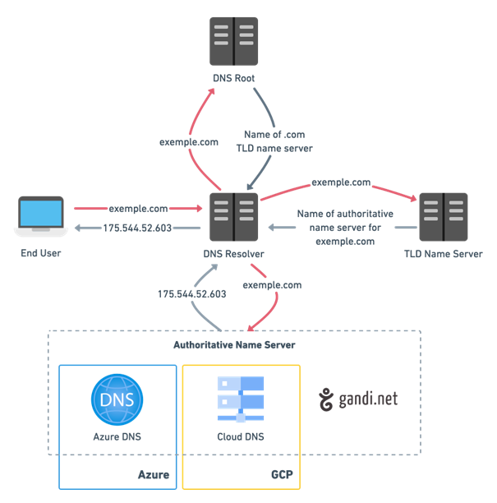

In essence, a recursive DNS resolver contains a few essential building blocks that are in concert to resolve the domain names into the particular IP addresses. At the bottom of it all sits a recursive resolver, which takes DNS requests that may start coming from the client side - part of an OS or application - and takes the task of carrying out lookups on its own. This resolver can request a number of DNS servers. To keep track of this, it begins with a group of root DNS servers at the highest levels of the DNS hierarchy. The latter sends requests to TLD servers, including the more particular .com and .org servers, all the way down to authoritative name servers that maintain actual DNS records.

Recursive querying is an overall architecture that can be used in a DNS resolver to guarantee efficiency and resilience. When a system employs the hierarchical DNS, it can find itself to any level of servers for retrieving specific data without incurring latency within users. Integration of caching accelerates the service while relieving upstream DNS servers from pressure that their load would otherwise create, thereby providing faster answers about repetitive queries. In addition to this, security also evolves as the internet topology changes. With DNSSEC implementation, the guarantee that the authoritative servers have returned authentic data that has not been altered during transmission is given, thus giving confidence to the resolution process.

# PROPOSED SYSTEM

A proposed system in which the performance, efficiency, and reliability of a DNS resolver are drastically improved as compared to conventional approaches can be obtained by implementing a technique known as recursive querying integrated with advanced caching techniques. Because the heart of the system is based on a hierarchical architecture comprising elements such as local caches and recursive resolvers, on one hand, and authoritative servers, on the other, the multi-tier approach is especially essential in distributing query loads to minimize latency-critical requests served by the nearest available cache. This ensures that accessed records often are readily available, and the resolver can promptly respond to user queries hence smoothing browsing.

In this system, one of the important features is that it has a dynamic caching mechanism. It is such a mechanism which adapts dynamically based on user behavior and the changing query pattern. It identifies which records historically have been requested the most from the database, and their cache is subsequently updated. The resolver optimizes the use of space in memory so that valuable cache space is kept for the most relevant records by using smart eviction policies. This approach not only optimizes the time it takes to resolve queries but also serves to reduce the load on authoritative servers by limiting query requests made to those servers.

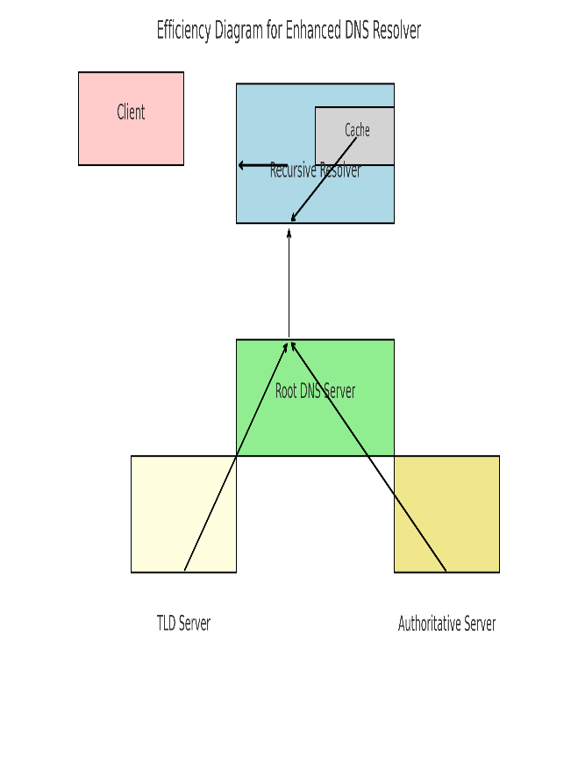

The system will still advance the efficiency by another notch by predicting probable incoming queries that the resolver is going to receive in the near future, based on user behavior patterns and trends learnt from previous query data analysis using machine learning algorithms. By doing so, the resolver will then be able to pre-cache many more records likely to be requested again and again in the near future. Predictive capability would lead to dramatic improvements in lookup times apart from generally improving resolver performance. It will further optimize the use of the cache by preferring the record that maximizes value to the users, hence optimizing the usage of available resources.

Apart from improved performances, the proposed system has redundancy and failover across the DNS chain to ensure high availability and reliability. It will create some instances of recursive resolvers and authoritative servers for smooth failover in case of any outages or network interruptions. This redundancy will ensure that users have an uninterrupted, smooth access to the DNS resolver. Balancing techniques of the load will be used to scatter queries and distribute them appropriately across all the available servers, thus making sure the system has complete reliability.

Finally, the interface will be developed in such a way that it is user-friendly with in-depth monitoring tools which will be designed and developed for network administrators making real-time analytics involving DNS queries, caching performance, and health monitoring. This way the system would have administrative tasks proactive with their adjustments toward the caching strategy and the allocation of resources because it understands the query pattern and the effectiveness of the cache. Therefore, this proposed DNS resolver system aims to provide an ultra-efficient, resilient, and scalable solution which meets modern internet traffics while increasing new demands in order to support an improved user experience.

# OUTPUT ANALYSIS

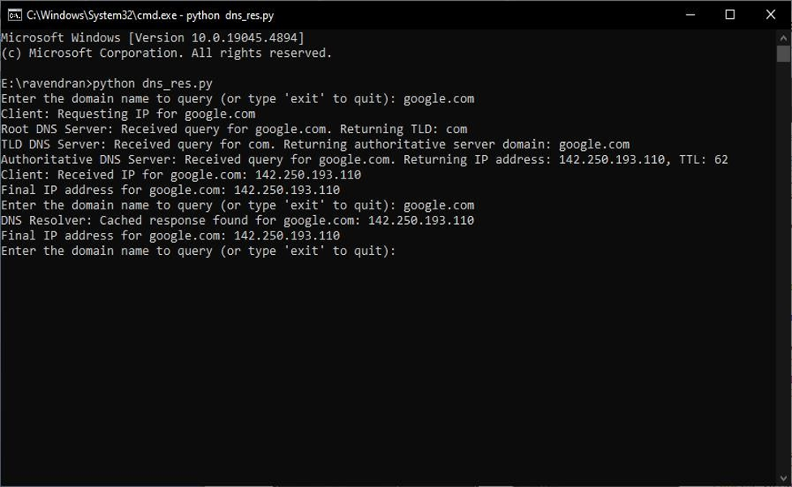

The recursive DNS resolver is a method by which the name "google.com" might work, for example, by cycling through a series of DNS servers. The process of querying the root DNS server proceeds step-wise downward through the DNS record hierarchy until it reaches the authoritative server for the domain. The multi-step process is implemented so that the system retrieves the right IP address corresponding to the domain name.

Once the DNS resolver fetches the IP address successfully, this result is cached to ensure that more queries into the same domain can be retrieved faster

.

**Saved Information**

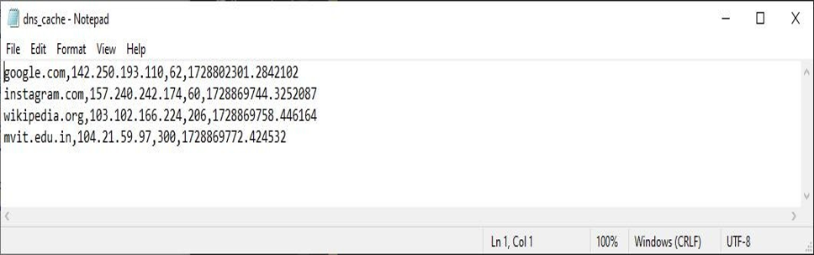

The optimization of DNS resolution depends on the mechanism in play; management of TTL furthering efficiency with the definition about how long this cached information is valid before the resolver needs to go back to the DNS servers again. Thus, the proper management of TTL ensures balanced freshness of data with load on the DNS servers.

Proper management of TTL reduces the load on DNS servers, which further optimizes the time responses to repeated queries. Thus, this may lead to the count of repeated lookups to be diminished into a considerable level that may lead to an overall performance of the network improved. Such fast accessibility of the websites and services by the users leads to a smooth online experience.

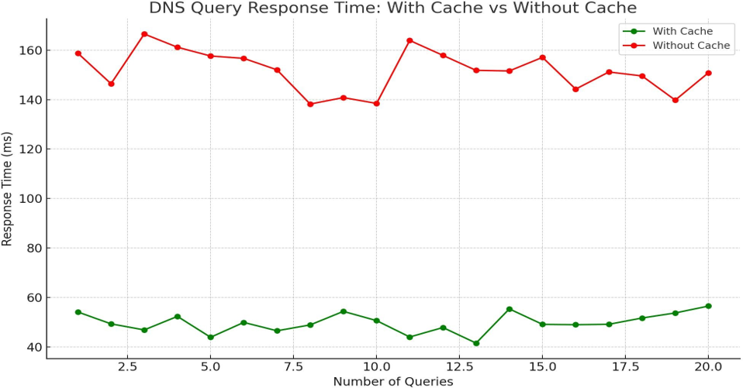

The line graph compares DNS query responses over time with and without cache: Since it is a comparison of the responses over time, we see how cache utilization affects query efficiency. Results show a continuous lower response time for the queries in the cache compared to the ones without, on an average 50 ms and 150 ms respectively.

s

**Step 6: Run the Simulation with Script**

**Step 7: Analyzed the Effectiveness of Script**

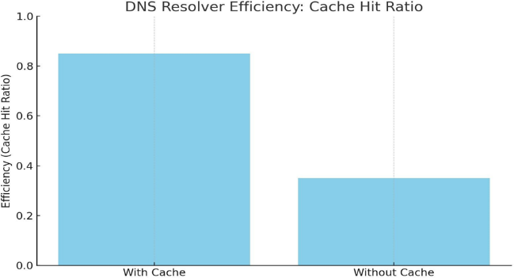Fig. 6: Process Flow of TBA coding design

For just a little illustration, the above bar chart represents DNS resolver efficiency. This is based on the cache hit ratio. Through such a chart, effectiveness can be seen when using a cache in the resolution of recursive DNS queries. Two scenarios are compared. The first has seen that the DNS resolver has enabled the use of its cache, which results in an 85% cache hit ratio. The second had not used its cache to its full potential and experienced only a 35% cache hit ratio. The horizontal dotted line is the average efficiency; it bears easy points of reference. The data itself drives home the tremendous degree to which caching improves both speed and performance in DNS resolutions by reducing the possible lag of slow recursive queries to more distant servers, a point directly in line with the project's objective of optimizing both DNS resolution performance and security through enhanced cache management.

Fig. 9: Ethernet delay

1. ***CONCLUSION.***

It succeeds in offering a DNS resolver that makes recursive queries to solve some of the crucial problems associated with the new domain name resolution. Such a system passes through root, TLD, and authoritative DNS servers to get proper IP addresses for different domain names fast enough to significantly raise DNS query speed and reliability. Using the strong caching system along with controlling settings for TTL, it hugely reduces the server load and makes the query processing better in overall performance. This new technology introduces real-time resolution capability that had not been there in the previous version of DNS systems. Thus, it constitutes a better architecture which supports maintenance of high scalability and performance for applications used over a network.

It can support a great many queries, so it scales in concert with everything from tiny, single-user applications to very large enterprise deployments; lots of future development opportunities. In the future, the system would consider the integration of more sophisticated features-including algorithms of machine learning to improvise smarter query optimization, even anomaly detection that evolves with active learning from novel workloads-to ensure it offers adaptiveness and resilience in DNS resolution in the presence of numerous network demands and threats. In summary, the new DNS resolver provides much better optimizations of domain name resolutions in this new network.

***REFERENCES***

[1] Rouse, M.. Collision. Retrieved May 20, 2020 from [http://searchnetworking.techtarget.com/definition/colli](http://searchnetworking.techtarget.com/definition/collision) [sion](http://searchnetworking.techtarget.com/definition/collision)

[2] Evolven. Downtime, Outages and Failures - Understanding Their True Costs. Retrieved April 14, 2020 from [http://www.evolven.com/blog/downtime-outages-](http://www.evolven.com/blog/downtime-outages-andfailures-) [andfailures-](http://www.evolven.com/blog/downtime-outages-andfailures-) understanding-their-true-costs.html