Predicting Gait Cycle Phases Based on Angular Kinematics in Normal, Knee Brace and Ankle Brace Gait.
Raven Huiberts
GitHub:https://github.com/Ravenprojects1999/assignment_machinelearning_course.git
Introduction:
Accurately identifying the phases of the gait cycle from kinematic data is relevant for applications in movement analysis, rehabilitation and bioelectronics. However, when gait is perturbed by external factors such as knee or ankle braces, it becomes more difficult to predict. Consequently, a robust model that can reliably predict gait phase independent of such conditions is highly valuable for improving detection accuracy and robustness.
Therefore, this project aims to predict gait cycle percentage from right-leg angular kinematics. During which we will first apply a baseline regression model and then see if we can improve this based on the cyclic nature of bipedal gait.
Methods:
The dataset was obtained from Kaggle (Enhanced Gait Biomechanics Dataset)(Helwig et al., 2016) and loaded into a pandas data frame. This dataset contains 10 strides (99 data points each) for 10 participants. Prior to modelling, the data were filtered to include only right-leg ankle, knee and hip joint angles, angular velocities and angular accelerations, as the brace was applied to the right side. Time values originally ranged from 0–1 and were rescaled to 0–100% of the gait cycle.
The target variable was gait cycle percentage, while joint kinematics, repetition number, participant ID and condition were used as predictor variables. The data were split into training (70%) and testing (30%) sets by participant, ensuring that no subject appeared in both sets.
A random forest regressor was trained using this split. To assess model stability given the relatively small sample size, the random participant split was repeated three times using different random seeds. While more repetitions would be preferable, this number was chosen to because of computational demands.
To account for gait cyclicity, gait cycle percentage was transformed into an angular values ranging from 0 to 2π. The sine and cosine of this angle were used as target variables. Two separate regression models (together called model 2) were trained to predict these components, which were subsequently converted back into gait cycle percentage using a circular transformation (Equation 1) (Berens, 2009).
Model performance was evaluated using a cyclic-aware root mean error (RME), defined as the shortest distance between predicted and true gait phase on a circular scale (Equation 2).
Formula 1: ${phase_{pred}}_{i}=\left(\arg\left(\cos_{i}+{i sin}_{i}\right)*\frac{100}{2π}\right)mod 100$
Formula 2: RME$=\left(phase-phase_{pred}+50\right) mod 100-50$
Results:
The baseline model exhibited considerable variability across runs, with average RME values of 13.37, 30.47 and 40.23. When analysed per condition, normal gait showed the lowest error (36.95), followed by ankle brace (37.29), while knee brace gait resulted in the highest error (46.46).
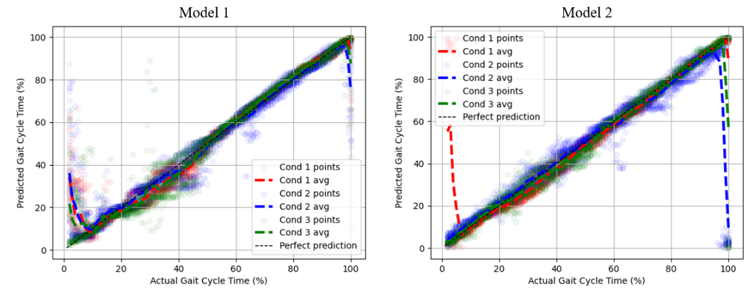
The adjusting the time to be cyclic-aware, improved performance, with lower and more stable RME values of 15.32, 11.68 and 9.38 across runs. Performance across conditions followed the same trend as the baseline model, with normal gait demonstrating the lowest error (6.61), followed by ankle brace (7.79) and knee brace gait (13.74). Predicted versus actual gait cycle percentages for each condition are shown in Figure 1.
Figure 2. Predicted versus actual gait cycle percentage for the baseline model (Model 1, left) and the cyclic-aware model (Model 2, right). These are displayed for the three gait conditions: unbraced (Cond 1), knee brace (Cond 2) and ankle brace (Cond 3).
The distribution of prediction errors revealed that the cyclic-aware model produced a stronger concentration of errors around zero, while the baseline model exhibited a broader error range (Figure 2).
Figure 2. Distribution of cyclic prediction errors (%) for the baseline regression model (Model 1, left) and the cyclic-aware regression model (Model 2, right).
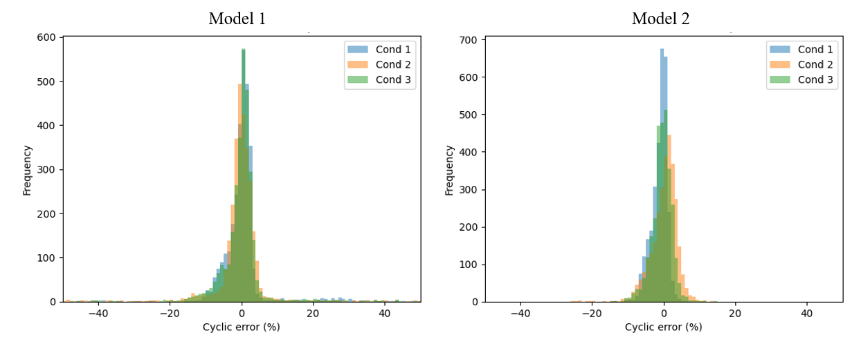
Summary:
Both models demonstrated that joint angles, angular velocities and angular accelerations are good predictors of gait phase. However, explicitly modelling gait as a cyclic process substantially improved prediction accuracy and reduced the range of the errors. These findings highlight the importance of accounting for cyclic structure when modelling kinematic data. Future work could further improve performance by applying dedicated circular regression techniques and more advanced methods from circular statistics
References:
Berens, P. (2009). Toolbox for Circular Statistics. Journal of Statistical Software, 31(10). https://doi.org/10.18637/jss.v031.i10
Helwig, N. E., Shorter, K. A., Ma, P., & Hsiao-Wecksler, E. T. (2016). Smoothing spline analysis of variance models: A new tool for the analysis of cyclic biomechanical data. Journal of Biomechanics, 49(14), 3216–3222. https://doi.org/10.1016/j.jbiomech.2016.07.035
Kaggle dataset: Enhanced Gait Biomechanics Dataset

