React Native Developer — Practical Assessment

Company: Acolyte Living
Role: React Native Developer (Mid–Senior)
Estimated time: 4–6 hours
Format: Solo coding mini project

————————————————————————————————————————

Overview

Build a Student Housing Explorer mobile app using the mock property dataset below. Implement browse, filter, detail, and favorites flows.

————————————————————————————————————————

Submission

Deliverables

- **Git repository** (GitHub / GitLab / Bitbucket — public or invite us)
- **`README.md`** with:
- Setup and run instructions (iOS and/or Android)
- Architecture decisions (2–5 bullets)
- Known limitations and what you would do with more time
- Total time spent
- **Working app** on at least one platform (simulator or device)

Allowed

- Expo or bare React Native (Expo recommended)
- Any open-source libraries (document why you chose them)
- AI tools for boilerplate or lookup — you must understand every line you submit

Not allowed

- Copy-pasting a full tutorial project with minimal changes
- Private npm packages or starter kits we cannot run
- A live backend (use the provided mock API only)

Deadline

Agree on a deadline with your recruiter. Recommended: 5 calendar days from receipt of this document.

————————————————————————————————————————

Tech Requirements

Requirement | Details
Framework | React Native **0.76+** or Expo SDK **52+**
Language | **TypeScript** (strict mode preferred)
Navigation | React Navigation v6+
Screens | 4 (see below)
Data | Use the provided mock API — no live backend

Optional libraries: @tanstack/react-query, zustand, react-native-mmkv, @shopify/flash-list, expo-image.

————————————————————————————————————————

UI Reference

Use the mockups below as a visual guide. Exact styling is not required — focus on layout, flows, and functionality.

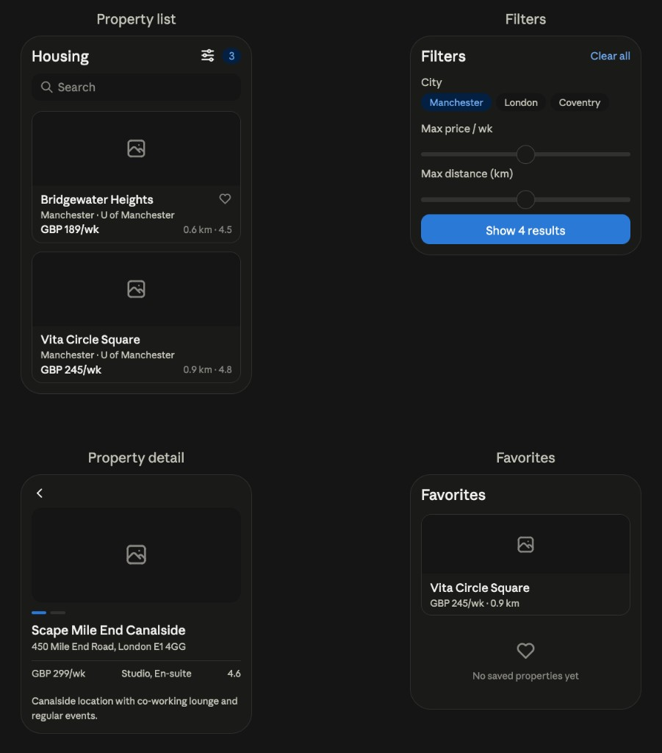
Student Housing Explorer — UI reference

Screen | What to build
**Housing** | Property list with search, filter badge, and property cards
**Filters** | City chips, max price slider, max distance slider, result count CTA
**Property Detail** | Image gallery, price/room type/rating bar, description, favorite toggle
**Favorites** | Saved properties list with empty state

————————————————————————————————————————

Build: Student Housing Explorer

Students search for accommodation near universities. Build a lightweight property marketplace app with these flows:

- Browse a list of properties
- Filter and search
- Open a property detail page
- Save favorites locally (persist across app restarts)

Screen 1 — Property List (`/`)

- Scrollable list (`FlatList` or `FlashList`)
- Each card shows:
- Thumbnail image
- Property name
- City and university
- Price per week (formatted with currency)
- Distance to university (e.g. 0.8 km)
- Star rating (if present)
- Pull-to-refresh (re-fetch from mock API)
- Loading spinner or skeleton on first load
- Empty state when filters match nothing

Screen 2 — Filters (modal, bottom sheet, or dedicated screen)

- **Search** by property name or address (case-insensitive)
- **City** dropdown or chips (derive unique cities from data)
- **Max price** slider or numeric input
- **Max distance** (km) filter
- Show **active filter count** on the list screen
- **Clear all filters** action
- Filters work **together** (AND logic)

Screen 3 — Property Detail (`/property/:id`)

- Hero image (first image, or placeholder if none)
- Image gallery swipe if multiple images (horizontal scroll is fine)
- Name, address, about text
- Price, currency, beds, room types
- University and distance
- Operator name (if present)
- **Favorite** toggle (heart icon) synced with local storage
- Back navigation to list **preserving scroll position and filters**

Screen 4 — Favorites (`/favorites`)

- List only favorited properties
- Same card UI as main list
- Empty state: “No saved properties yet”
- Unfavoriting from this screen removes the item

————————————————————————————————————————

Mock API

Create src/api/properties.ts (or equivalent).
Simulate network delay (400–800 ms) and a 5% random failure rate on fetchProperties.

Types

export interface Property {
id: string;
name: string;
lat: number;
lng: number;
price: number; // price per week
currency: string; // e.g. "GBP", "USD"
address: string;
university: string;
distance: number; // km from university
rating: number | null;
about: string;
images: string[];
houseUrl: string;
operator?: string;
beds?: number;
roomTypes?: string;
country?: string;
city?: string;
}
export interface FetchPropertiesResult {
data: Property[];
fetchedAt: string; // ISO timestamp
}

API contract

/** Returns all properties. Throws on simulated network error. */
export async function fetchProperties(): Promise<FetchPropertiesResult>;
/** Returns one property or null if not found. */
export async function fetchPropertyById(id: string): Promise<Property | null>;

Seed data

Save as src/data/properties.seed.json:

[
{
"id": "prop-001",
"name": "Bridgewater Heights",
"lat": 53.4808,
"lng": -2.2426,
"price": 189,
"currency": "GBP",
"address": "Whitworth Street, Manchester M1 3WS",
"university": "University of Manchester",
"distance": 0.6,
"rating": 4.5,
"about": "Modern student accommodation with gym, study spaces, and 24/7 security.",
"images": [
"https://picsum.photos/seed/bridgewater/800/600",
"https://picsum.photos/seed/bridgewater2/800/600"
],
"houseUrl": "uk/manchester/apartments-bridgewater-heights",
"operator": "Homes for Students",
"beds": 450,
"roomTypes": "Studio, En-suite, Shared",
"country": "UK",
"city": "Manchester"
},
{
"id": "prop-002",
"name": "Vita Student Circle Square",
"lat": 53.4722,
"lng": -2.2389,
"price": 245,
"currency": "GBP",
"address": "9 Albion Street, Manchester M1 5LN",
"university": "University of Manchester",
"distance": 0.9,
"rating": 4.8,
"about": "Premium studios with rooftop terrace and cinema room.",
"images": [
"https://picsum.photos/seed/vita/800/600"
],
"houseUrl": "uk/manchester/apartments-vita-circle-square",
"operator": "Vita Student",
"beds": 320,
"roomTypes": "Studio",
"country": "UK",
"city": "Manchester"
},
{
"id": "prop-003",
"name": "Scape Mile End Canalside",
"lat": 51.5245,
"lng": -0.0389,
"price": 299,
"currency": "GBP",
"address": "450 Mile End Road, London E1 4GG",
"university": "Queen Mary University of London",
"distance": 0.3,
"rating": 4.6,
"about": "Canalside location with co-working lounge and regular events.",
"images": [
"https://picsum.photos/seed/scape/800/600",
"https://picsum.photos/seed/scape2/800/600",
"https://picsum.photos/seed/scape3/800/600"
],
"houseUrl": "uk/london/apartments-scape-mile-end",
"operator": "Scape",
"beds": 600,
"roomTypes": "Studio, En-suite",
"country": "UK",
"city": "London"
},
{
"id": "prop-004",
"name": "Chapter Highbury",
"lat": 51.5521,
"lng": -0.1023,
"price": 275,
"currency": "GBP",
"address": "309 Holloway Road, London N7 9DS",
"university": "London Metropolitan University",
"distance": 0.4,
"rating": 4.2,
"about": "Large development with courtyard, games room, and laundry.",
"images": [
"https://picsum.photos/seed/chapter/800/600"
],
"houseUrl": "uk/london/apartments-chapter-highbury",
"operator": "Chapter Living",
"beds": 700,
"roomTypes": "En-suite, Shared",
"country": "UK",
"city": "London"
},
{
"id": "prop-005",
"name": "Urbanest Westminster Bridge",
"lat": 51.5007,
"lng": -0.1176,
"price": 399,
"currency": "GBP",
"address": "203 Westminster Bridge Road, London SE1 7FR",
"university": "King's College London",
"distance": 1.2,
"rating": 4.9,
"about": "River views near South Bank with premium amenities.",
"images": [
"https://picsum.photos/seed/urbanest/800/600",
"https://picsum.photos/seed/urbanest2/800/600"
],
"houseUrl": "uk/london/apartments-urbanest-westminster",
"operator": "urbanest",
"beds": 500,
"roomTypes": "Studio, En-suite",
"country": "UK",
"city": "London"
},
{
"id": "prop-006",
"name": "The Standard at College Park",
"lat": 38.9897,
"lng": -76.9374,
"price": 1450,
"currency": "USD",
"address": "4321 Hartwick Road, College Park, MD 20740",
"university": "University of Maryland",
"distance": 0.5,
"rating": 4.4,
"about": "Purpose-built student housing steps from campus.",
"images": [
"https://picsum.photos/seed/standard/800/600"
],
"houseUrl": "us/college-park/apartments-the-standard",
"operator": "The Standard",
"beds": 800,
"roomTypes": "Studio, 2 Bed, 4 Bed",
"country": "US",
"city": "College Park"
},
{
"id": "prop-007",
"name": "Hub on Campus Madison",
"lat": 43.0766,
"lng": -89.4125,
"price": 1299,
"currency": "USD",
"address": "437 N Frances Street, Madison, WI 53703",
"university": "University of Wisconsin-Madison",
"distance": 0.2,
"rating": 4.7,
"about": "Steps from State Street with fitness center and study rooms.",
"images": [
"https://picsum.photos/seed/hub/800/600",
"https://picsum.photos/seed/hub2/800/600"
],
"houseUrl": "us/madison/apartments-hub-on-campus",
"operator": "Hub on Campus",
"beds": 550,
"roomTypes": "Studio, 1 Bed, 2 Bed",
"country": "US",
"city": "Madison"
},
{
"id": "prop-008",
"name": "Nido Aspre Gardens",
"lat": 52.4068,
"lng": -1.5197,
"price": 165,
"currency": "GBP",
"address": "Far Gosford Street, Coventry CV1 5DT",
"university": "Coventry University",
"distance": 0.7,
"rating": null,
"about": "Affordable en-suite rooms with communal kitchen and social spaces.",
"images": [],
"houseUrl": "uk/coventry/apartments-nido-aspre",
"operator": "Nido Living",
"beds": 400,
"roomTypes": "En-suite",
"country": "UK",
"city": "Coventry"
}
]

API starter

import seed from '../data/properties.seed.json';
import type { Property, FetchPropertiesResult } from '../types/property';
const PROPERTIES = seed as Property[];
function delay(ms: number): Promise<void> {
return new Promise((resolve) => setTimeout(resolve, ms));
}
function maybeFail(): void {
if (Math.random() < 0.05) {
throw new Error('Network request failed. Please try again.');
}
}
export async function fetchProperties(): Promise<FetchPropertiesResult> {
await delay(400 + Math.random() * 400);
maybeFail();
return {
data: PROPERTIES,
fetchedAt: new Date().toISOString(),
};
}
export async function fetchPropertyById(id: string): Promise<Property | null> {
await delay(200 + Math.random() * 200);
maybeFail();
return PROPERTIES.find((p) => p.id === id) ?? null;
}

————————————————————————————————————————

Suggested Project Structure

student-housing-explorer/
├── App.tsx
├── README.md
├── src/
│ ├── api/
│ │ └── properties.ts
│ ├── components/
│ │ ├── PropertyCard.tsx
│ │ ├── PropertyList.tsx
│ │ ├── FilterBar.tsx
│ │ ├── EmptyState.tsx
│ │ └── ErrorState.tsx
│ ├── hooks/
│ │ ├── useProperties.ts
│ │ ├── usePropertyFilters.ts
│ │ └── useFavorites.ts
│ ├── navigation/
│ │ └── RootNavigator.tsx
│ ├── screens/
│ │ ├── PropertyListScreen.tsx
│ │ ├── PropertyDetailScreen.tsx
│ │ └── FavoritesScreen.tsx
│ ├── storage/
│ │ └── favorites.ts
│ ├── types/
│ │ └── property.ts
│ ├── utils/
│ │ ├── formatPrice.ts
│ │ └── filterProperties.ts
│ └── data/
│ └── properties.seed.json

————————————————————————————————————————

Requirements Checklist

Required

- [ ] App builds and runs without errors
- [ ] Property list loads from mock API with loading state
- [ ] Network error shows retry UI (not a crash)
- [ ] Search + city + max price + max distance filters work together
- [ ] Property detail screen shows all required fields
- [ ] Favorites persist after app restart (AsyncStorage, MMKV, or SecureStore)
- [ ] TypeScript with no `any` in core business logic
- [ ] README with setup instructions

Bonus (optional)

- [ ] Clean separation: screens / components / hooks / api
- [ ] Memoized list items or FlashList
- [ ] Currency-aware price formatting (`GBP 189/wk`, `USD 1,450/wk`)
- [ ] Handles missing images and null ratings gracefully
- [ ] Filter state preserved when navigating back from detail
- [ ] React Query (or similar) for cache + retry
- [ ] Unit tests for `filterProperties` and `formatPrice`
- [ ] Sort options (price, distance, rating)
- [ ] Dark mode support

————————————————————————————————————————

UX Guidelines

- Mobile-first layout (375×812 baseline)
- Consistent spacing and typography
- Touch targets at least **44×44 pt**
- Placeholder image when `images` array is empty
- Focus on structure and polish over branding

————————————————————————————————————————

Quick Start

npx create-expo-app@latest student-housing-explorer -t expo-template-blank-typescript
cd student-housing-explorer
npx expo install @react-navigation/native @react-navigation/native-stack
npx expo install react-native-screens react-native-safe-area-context
npx expo install @react-native-async-storage/async-storage
npm run ios
# or: npm run android

————————————————————————————————————————

*Acolyte Living Engineering*

