**ONLINE BANKING MANAGEMENT SYSTEM**



|  |  |  |
| --- | --- | --- |
| **ROLL No** | **NAME** | **Registration number** |
| **53** | **RAVI RANJAN SINGH** | **11908563** |
| **51** | **VINEET SINGH RANA** | **11918820** |
| **50** | **MD ASIF IQBAL** | **11918584** |

**SUBJECT CODE-** CSE 326

**TOPIC:** ONLINE BANKING MANAGEMENT

**SUBMITTED TO**- **Ms MANU BALI**



***OBJECTIVE OF PROJECT***

The BANK has been working for Accounts information, Withdrawal, Deposit amount. In this webpage you can keep record for daily Banking transactions. THE OBJECTIVE is to prepare a webpage, which could maintain data & provide a user friendly interface for retrieving customer related details just in few seconds, with 100% accuracy. Webpage is completely computerized, so it is not time consuming process. No paper work required & can be implemented further. The application should also facilitate the addition of new Customer A/c, deletion of A/c& modification of existing customer A/C. Block transactions for any A/c by Freeze/Unfreeze facility. Show all or required transaction. Any account can be opened with Zero(0) balance.services like personal internet banking ,corporate banking,Merchant business,online tax. Payments/transfer services like International transfer,National transfer,Bill payments from anywhere.people can also do Fixed Deposit for their account.people can also access to various E-services benifts like gift vouchers,cashback etc.



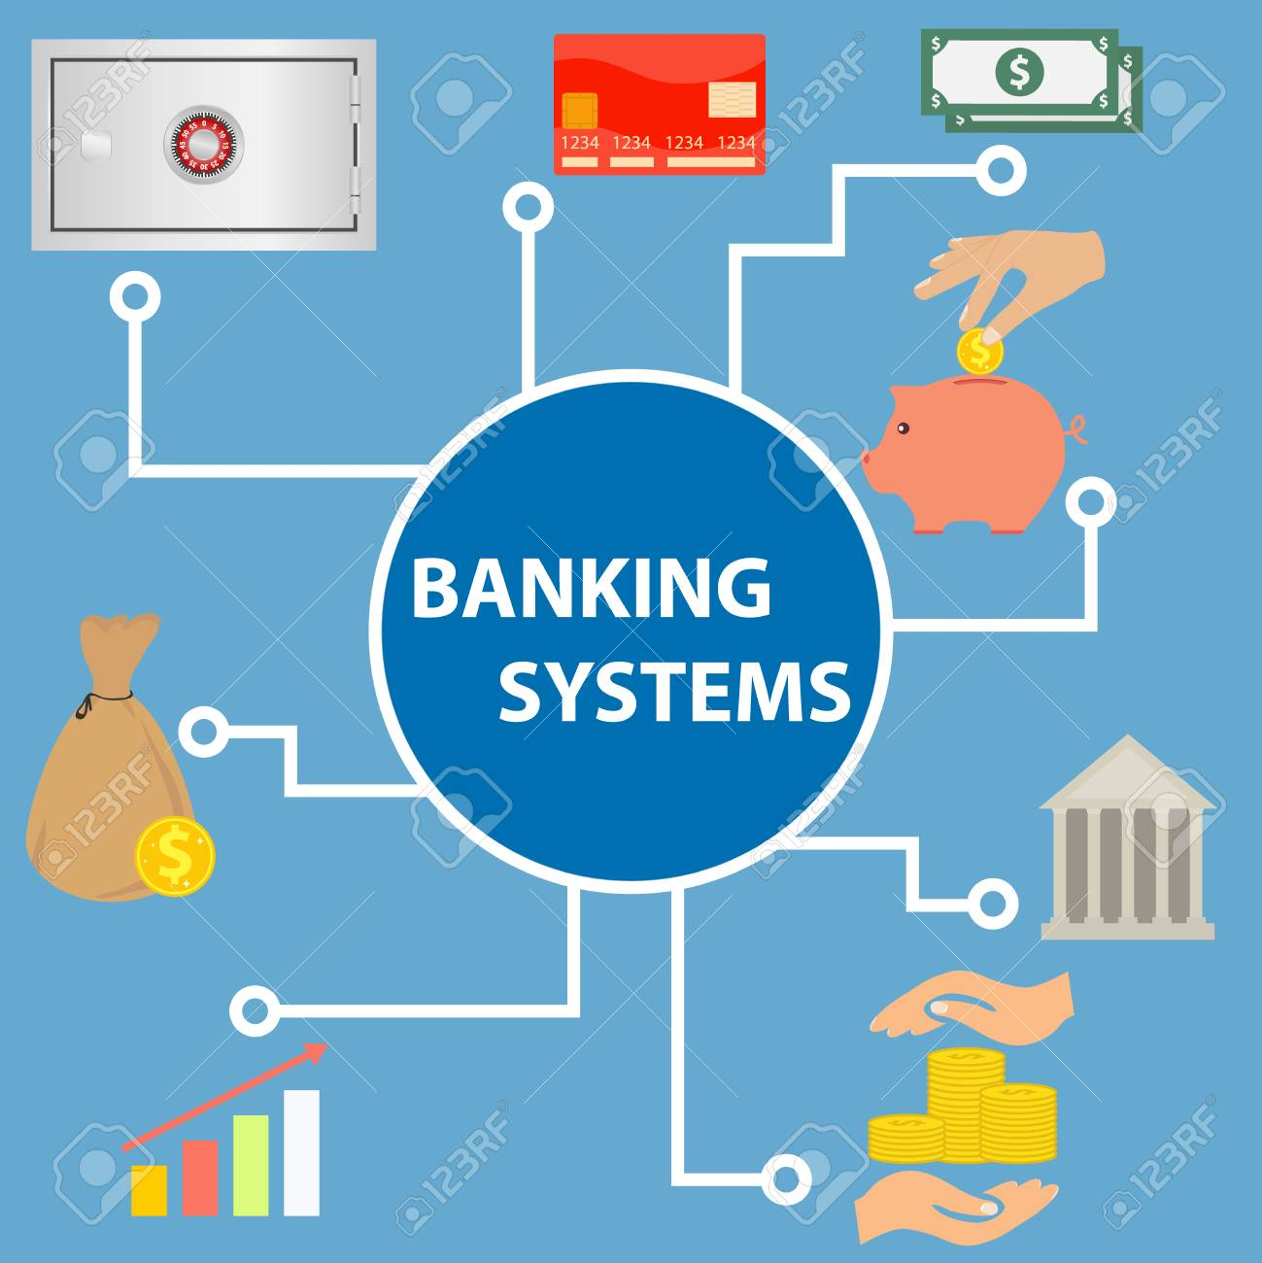

**About the BANK**

VRA Bank Ltd. is a Universal Bank with its operations driven by a cutting edge core Banking IT platform. The Bank offers personalized banking and financial solutions to its clients in the retail and corporate banking arena through its large network of Branches and ATMs, spread across length and breadth of India. We have also set up an overseas branch at Dubai and have plans to open representative offices in various other parts of the Globe, for encashing emerging global opportunities. Our experience of financial markets will help us to effectively cope with challenges and capitalize on the emerging opportunities by participating effectively in our country™s growth process.  
VRA Bank is the youngest, new generation, public sector universal bank that rides on a cutting edge core banking Information Technology platform. This enables the Bank to offer personalized banking and financial solutions to its clients. The Bank had an aggregate balance sheet size of Rs. 3,22,769 crore and total business of Rs 4,23,423 crore as on March 31, 2013. VRA Bank's operations during the financial year ended March 31, 2013 resulted in a net profit of Rs. 1882 crore.

Our vision for the Bank is "TO BE THE MOST PREFERRED AND TRUSTED BANK ENHANCING VALUE FOR ALL STAKEHOLDERS".

**PROJECT BASIC IDEA**

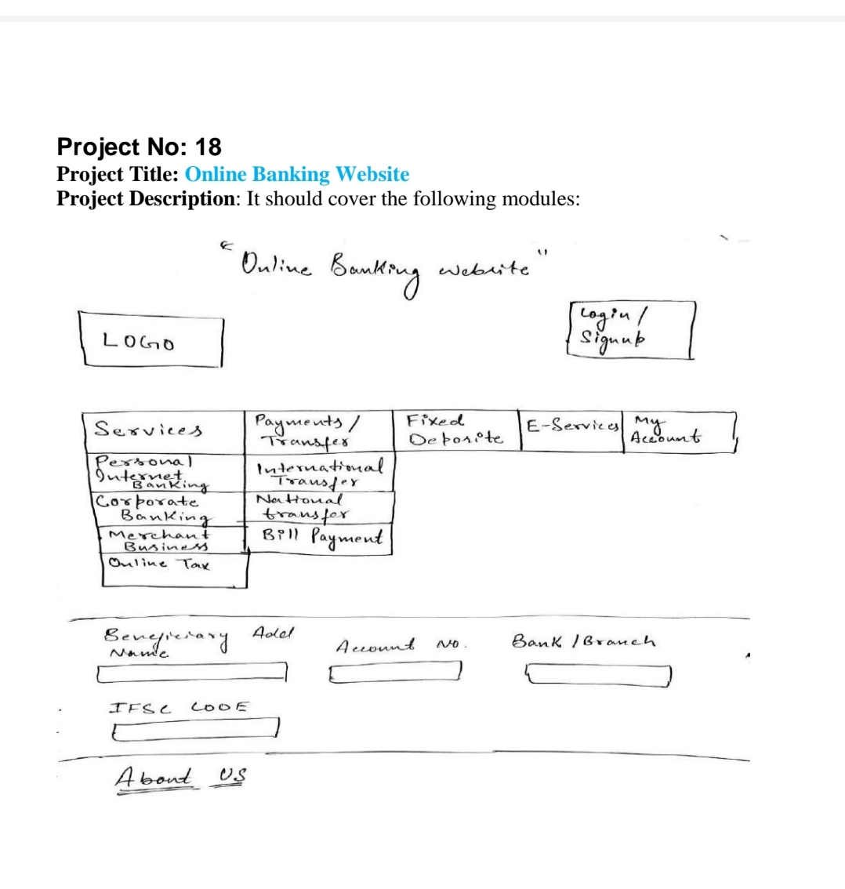 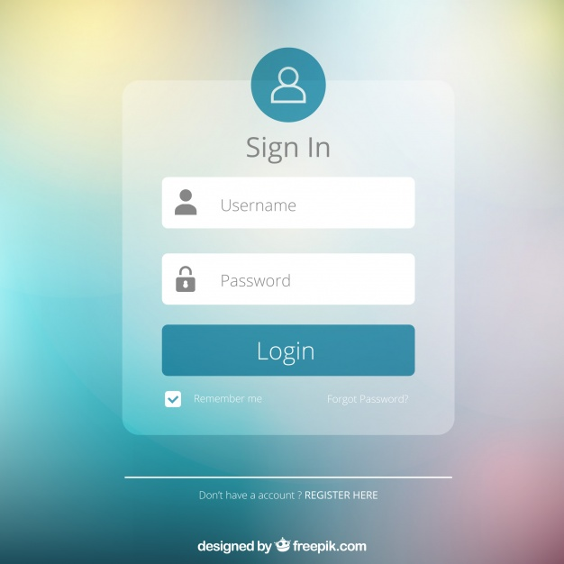

First of all,the user has to login at the main webpage of the bank at login menu to access the various services

* Using his personalized username and password given by the bank
* if the person forgets username ,He/She can opt for forgot username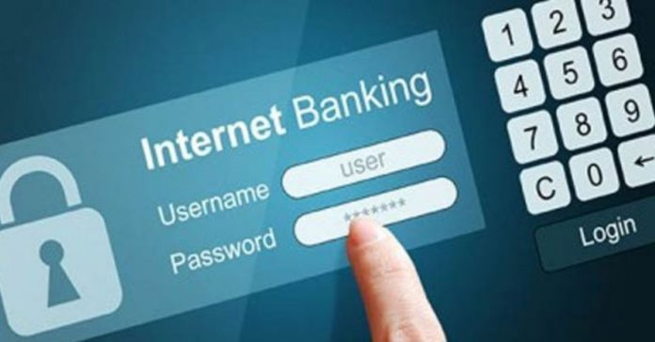

***Modules***

1. Services **– person can opt for services required by him/her**
2. **Personal internet banking**
3. It provides you with exclusive eservices for you only
4. It keeps you updated with your account services
5. **Corporate banking**
6. If you run your own business,it makes money sanctions easy and less hefty
7. **Merchant business**
8. If you are a merchant,you can accept online cash &
9. **Online tax**
10. You can have a check on your income tax return services and pay it with ease



***Module for payments/Transfer money***

1. International transfer
2. You can transfer money to nay country with ease & send money to dear ones
3. National transfer
   1. You can transfer money to any registered account with any bank throughout nation
4. Bill payments
   1. You acan pay your essential bills with comfort and with a click only

**Fixed deposit**



**Fixed Deposit** (FD) Designed for risk-averse investors, **fixed deposit** accounts let you earn interest on the deposited amount over a **fixed** period of time. The interest rate usually varies from 4.50% p.a. to 8% p.a. depending on the tenure, which is usually up to 10 years.

**E-SERVICES**

* **Online banking**
* **E-mini statements(account balance)**
* **Mobile wallet(for prepaid payments)**
* **Mobile apps(Tablet and Phone){accessibility ease}**
* **Billpay{electricty,insurance,rent,loan}**
* **Popmoney{premium service}**

**Money transfer**

**Any person can transfer to account of any other person by providing following details:**

* **By adding beneficiary’s name**
* **Account number**
* **Bank/branch**
* **IFSC code**
* **Monet transfer is essential for trade services**
* **It makes trade and money handling easy with security and double check**

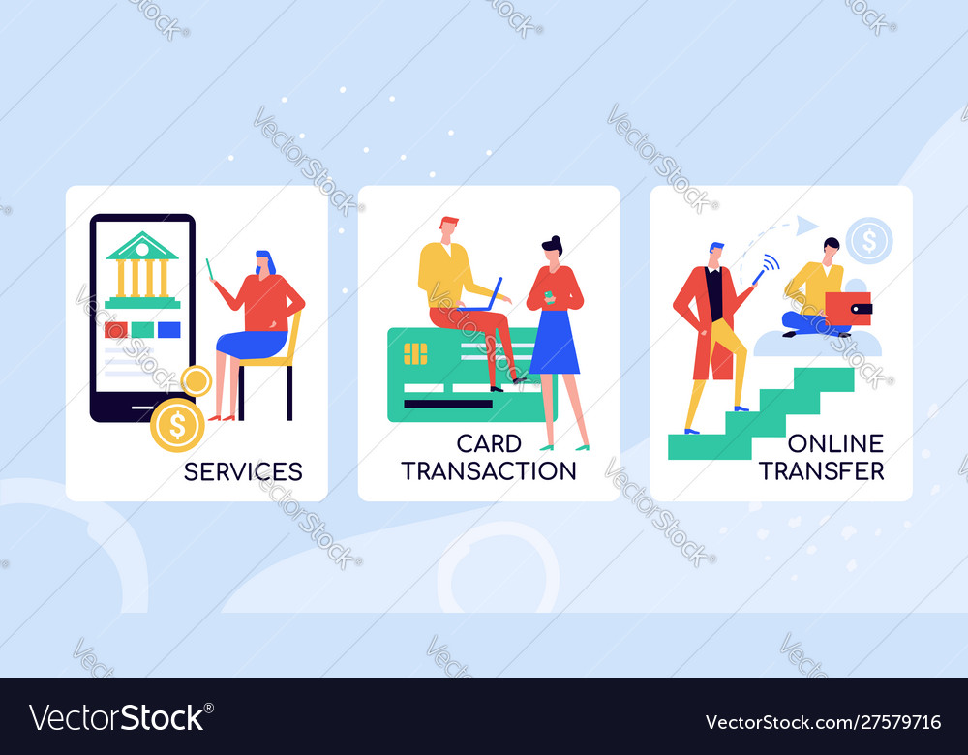

B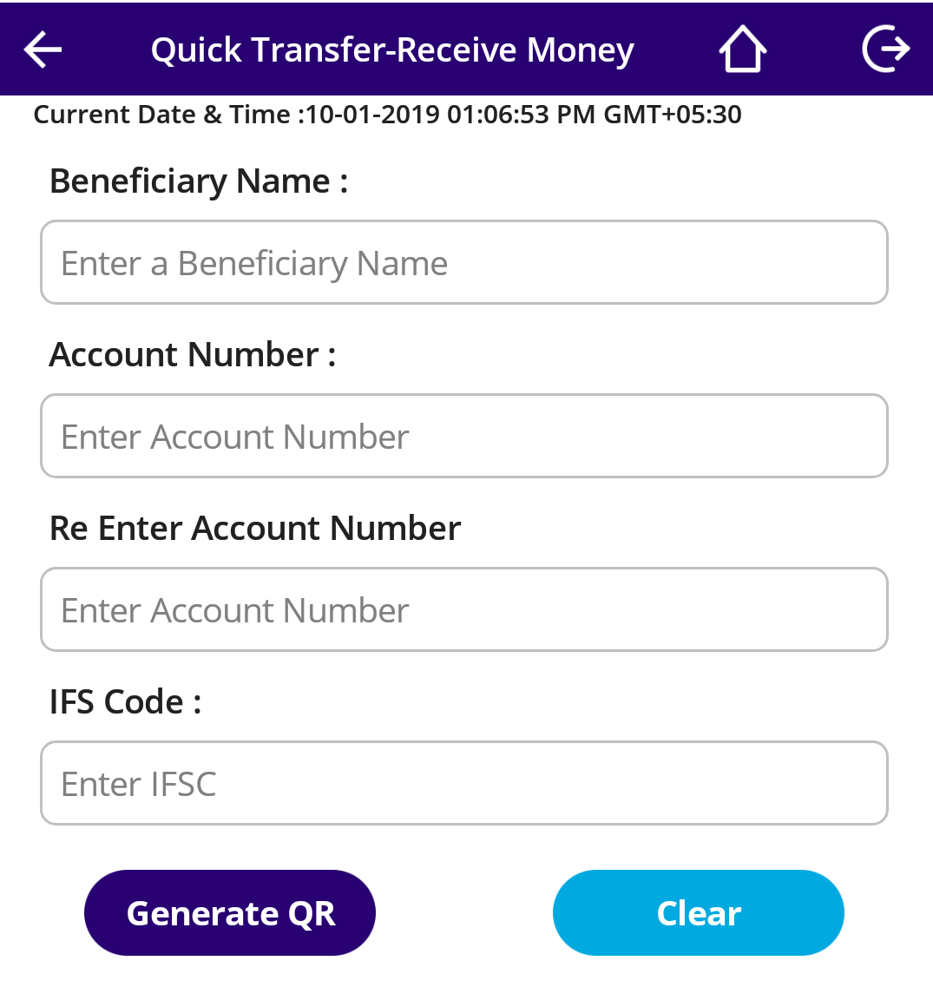

**ROLE AND RESPONSIBILITY**

***Ravi Ranjan Singh***

* ***Login/signup***
* **Drop down modules**
* **Report making**
* **Background tables**
* **coding**

***Vineet Singh Rana***

* **web page homepage**
* ***Drop down modules***
* **synopsis**
* **report making**
* **coding**
* **about us**

***Asif Iqbal***

* **synopsis**
* **logo**
* **picture collection**
* **coding**

**Language used**

* **HTML**
* **CSS**