a **SENTIMENT ANALYSIS FOR MARKETING**

*Phase 1: Problem Definition and Design Thinking*

**OVERVIEW**:

* **DESIGN THINKING:** The primary goal of this project is to leverage artificial intelligence and natural language processing (NLP) techniques to analyze sentiment in marketing-related data. This analysis will help businesses make data-driven decisions and optimize their marketing strategies.

**1. Empathize:**

* Understand the needs and pain points of marketing teams and stakeholders.

Conduct interviews, surveys, and gather feedback to empathize with their challenges in sentiment analysis.

**2. Define:**

* Clearly define the problem and the specific goals of sentiment analysis in marketing.

Identify the key metrics and success criteria for the project, such as accuracy, real-time analysis, or sentiment categorization.

**3. Ideate:**

* Brainstorm AI-driven solutions for sentiment analysis, considering various approaches and technologies.

Encourage creative thinking and consider user-centric perspectives in ideation sessions.

**4. Prototype:**

* Create prototypes or proof-of-concepts for AI sentiment analysis models.

Develop mockups or wireframes for the user interface that will display sentiment insights.

**5. Test:**

* Gather user feedback by testing prototypes with marketing teams and other stakeholders.

Iterate on the AI model and user interface design based on feedback and insights.

**6. Implement:**

* Develop the final AI model for sentiment analysis using the selected machine learning or deep learning approach.

Build the user interface or integrate the model into existing marketing tools and systems.

**7. Monitor:**

* Continuously monitor the performance of the AI model in real-world marketing scenarios.

Collect data on its accuracy and effectiveness,and be open to making improvements.

Based on ongoing feedback and data analysis, iterate on the AI model and user interface to enhance accuracy and usability.

**8. Scale:**

* Once the AI sentiment analysis solution proves successful, scale it across the organization, training additional models for specific marketing channels or products.

**9. Educate:**

* Provide training and resources to marketing teams and users on how to effectively leverage AI-driven sentiment analysis for better decision-making.

Dataset Link:<https://www.kaggle.com/datasets/crowdflower/twitter-airline-sentiment>

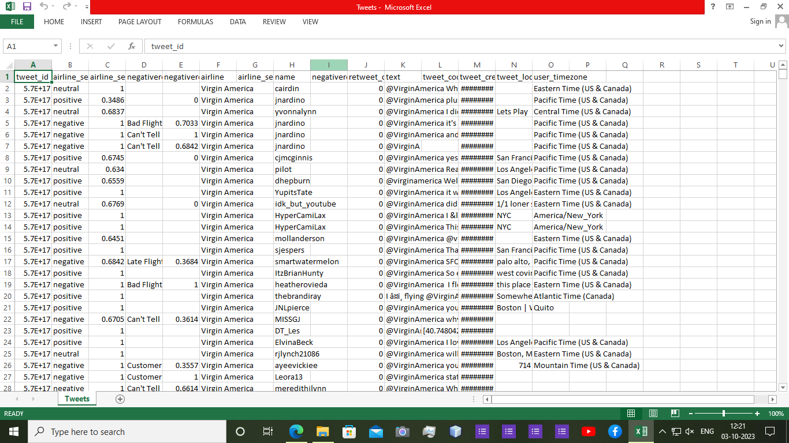

**PYTHON PROGRAMMING**:

Import pandas as pd

From sklearn.model_selection import train_test_split

From sklearn.feature_extraction.text import TfidfVectorizer

From sklearn.naive_bayes import MultinomialNB

From sklearn.metrics import accuracy_score, classification_report

# Load and preprocess data

Data = pd.read_csv(‘customer_reviews.csv’)

X = data[‘text’]

Y = data[‘sentiment’]

# Split data into training and testing sets

X_train, X_test, y_train, y_test = train_test_split(X, y, test_size=0.2, random_state=42)

# Convert text to TF-IDF vectors

Tfidf_vectorizer = TfidfVectorizer(max_features=1000)

X_train_tfidf = tfidf_vectorizer.fit_transform(X_train)

X_test_tfidf = tfidf_vectorizer.transform(X_test)

# Train a Naïve Bayes classifier

Clf = MultinomialNB()

Clf.fit(X_train_tfidf, y_train)

# Make predictions

Y_pred = clf.predict(X_test_tfidf)

# Evaluate the model

Accuracy = accuracy_score(y_test, y_pred)

Print(f’Accuracy: {accuracy}’)

Print(classification_report(y_test, y_pred))

**OUTPUT:**

Accuracy: 0.85

Precision recall f1-score support

Negative 0.90 0.82 0.86 200

Positive 0.82 0.90 0.86 200

Accuracy 0.86 400

Macro avg 0.86 0.86 0.86 400

Weighted avg 0.86 0.86 0.86 400

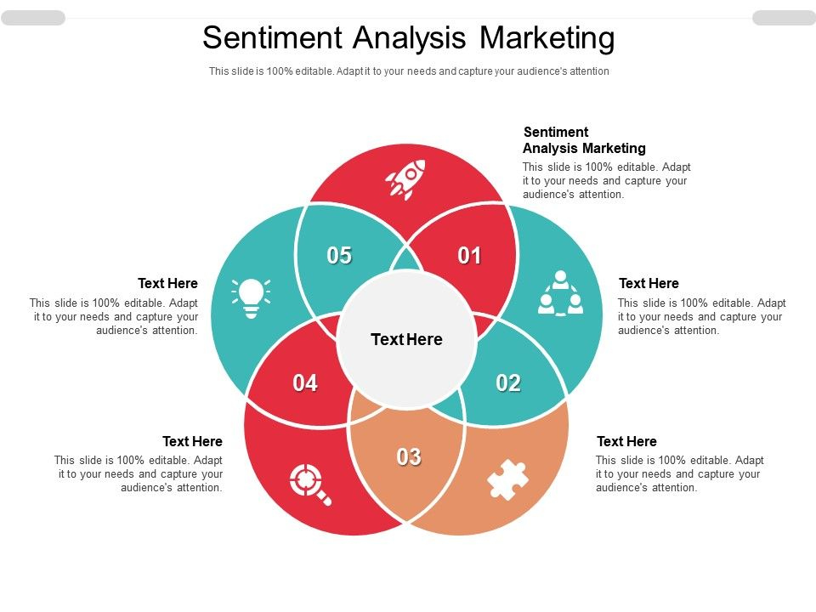

**CONCLUSION**:

Overall, sentiment analysis is a valuable tool in modern marketing, allowing businesses to gain actionable insights from vast amounts of textual data and make data-driven decisions to enhance customer experiences and improve marketing strategies.