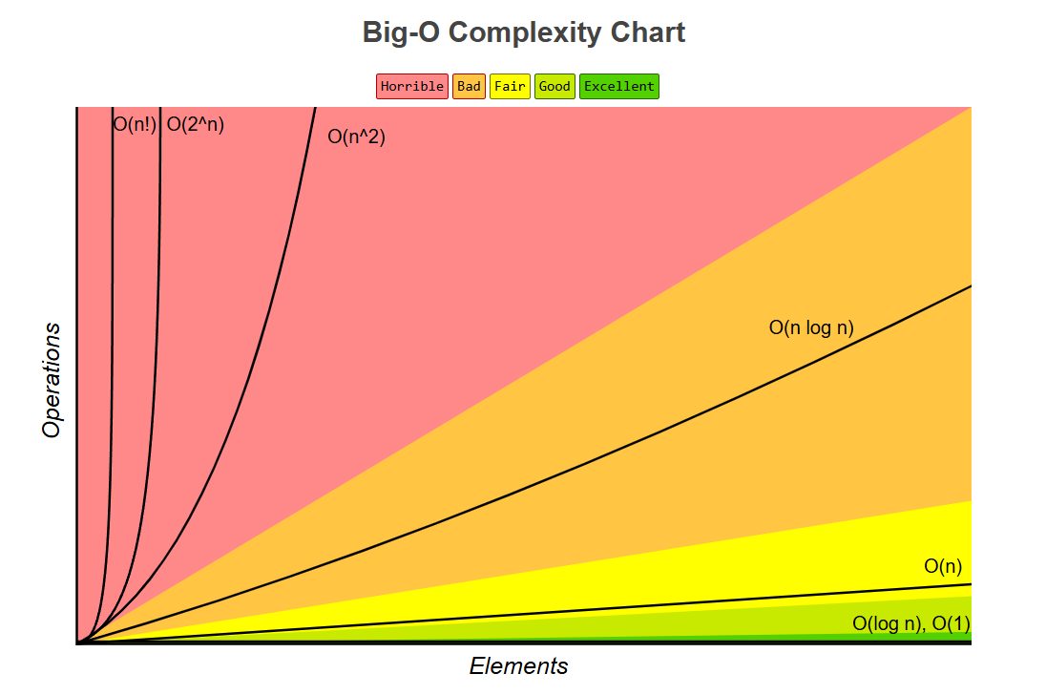
Big O Time Complexity
Constant Time: O(1)
When your algorithm is not dependent on the input size n, it is said to have a constant time complexity with order O(1). This means that the run time will always be the same regardless of the input size.
For example, if an algorithm is to return the first element of an array. Even if the array has 1 million elements, the time complexity will be constant if you use this approach:
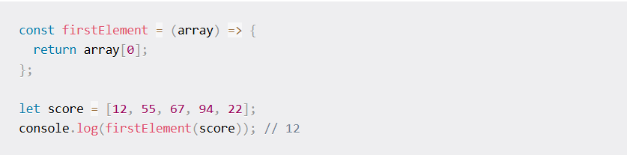
The function above will require only one execution step, meaning the function is in constant time with time complexity O(1).
Linear Time: O(n)
You get linear time complexity when the running time of an algorithm increases linearly with the size of the input. This means that when a function has an iteration that iterates over an input size of n, it is said to have a time complexity of order O(n).
For example, if an algorithm is to return the factorial of any inputted number. This means if you input 5 then you are to loop through and multiply 1 by 2 by 3 by 4 and by 5 and then output 120:
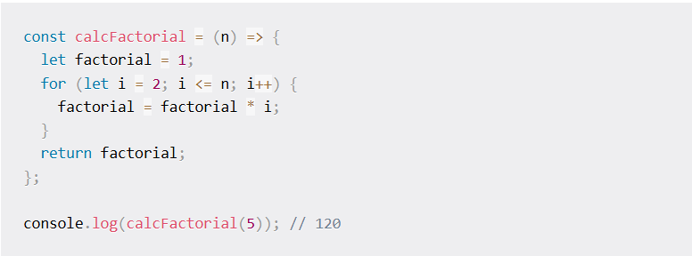
The fact that the runtime depends on the input size means that the time complexity is linear with the order O(n).

Logarithm Time: O(log n)
This is similar to linear time complexity, except that the runtime does not depend on the input size but rather on half the input size. When the input size decreases on each iteration or step, an algorithm is said to have logarithmic time complexity.
This method is the second best because your program runs for half the input size rather than the full size. After all, the input size decreases with each iteration.
A great example is binary search functions, which divide your sorted array based on the target value.

Quadratic Time: O(n^2)
When you perform nested iteration, meaning having a loop in a loop, the time complexity is quadratic, which is horrible.
A perfect way to explain this would be if you have an array with n items. The outer loop will run n times, and the inner loop will run n times for each iteration of the outer loop, which will give total n^2 prints. If the array has ten items, ten will print 100 times (10^2).
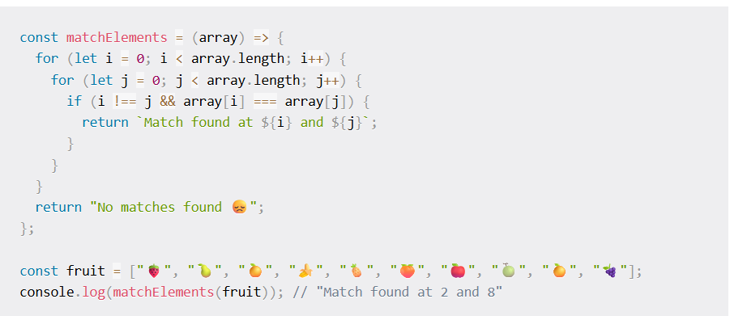

Exponential Time: O(2^n)
You get exponential time complexity when the growth rate doubles with each addition to the input (n), often iterating through all subsets of the input elements. Any time an input unit increases by 1, the number of operations executed is doubled.
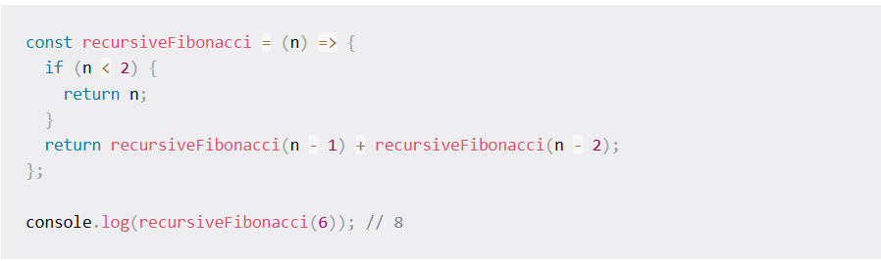
In the code above, the algorithm specifies a growth rate that doubles every time the input data set is added. This means the time complexity is exponential with an order O(2^n).
Queue
A Queue is a linear data structure that follows the FIFO (First In, First Out) principle. Elements are inserted at the rear and removed from the front.
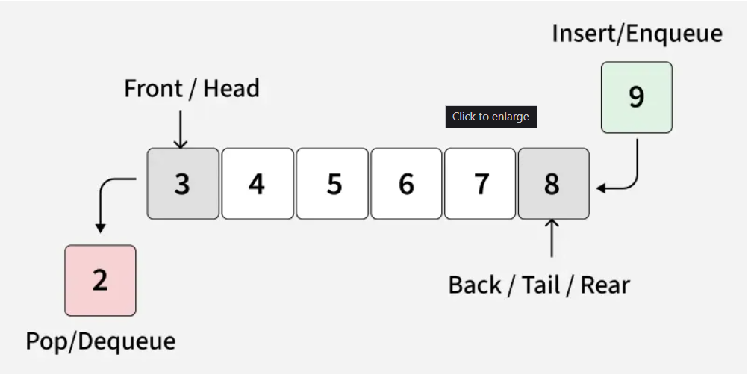
Queue Operations
- enqueue(item) - Adds an element to the end of the queue.
- dequeue() - Removes and returns the first element from the queue.
- peek() - Returns the first element without removing it.
- isEmpty() - Checks if the queue is empty.
- size() - Returns the number of elements in the queue.
- clear() - Removes all elements from the queue.
- print() - Prints the elements of the queue.

