Strings
1.IndexOf()
When u do
Let str=”ravi”;
Str.indexof(“avi”); // this will give u 1 because the value starts from the index 1 in the str.
indexOf() returns the first index if the value in the bracket is present in the string.

2. Slice()
When u do
Prefix=prefix.slice(0,prefix.length-1) then it removes one letter at the end and give back only remaining word
For example: ravi
If u do ravi.slice(0,ravi.length-1) then It will give rav

3.substring()
String.prototype.substring() is a built-in JavaScript method that extracts a portion of a string between two index positions and returns it as a new string, without modifying the original.
- startIndex (required) — The position where extraction begins (zero-based)
- endIndex (optional) — The position where extraction ends, but this character is NOT included in the result
How Indexing Works
Think of a string like a row of numbered boxes starting from 0:


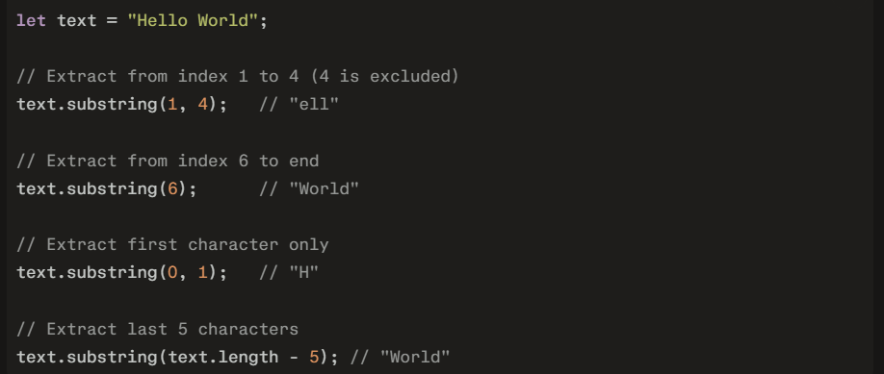
Special Behaviors
These edge cases make substring() unique:
- Start > End → Arguments are swapped automatically
- Negative index → Treated as 0
- Start equals End → Returns empty string
substring() vs slice()
Both methods are similar, but handle edge cases differently:
