Whats the difference between schema and tables

Why cant we get all the errors inside the query at just one query
This is a fundamental PostgreSQL behavior — it stops and throws an error at the first violation it finds and does not continue checking the rest. You cannot change this for standard INSERT statements.
Option 1 — Test Each Column Separately First
Before inserting, validate your values manually:
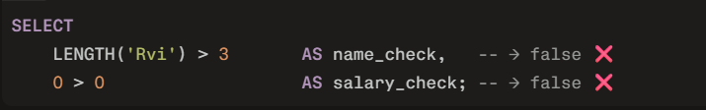
This shows all failures at once before you even attempt the insert.
Option 2 — Use a Validation Query with CASE
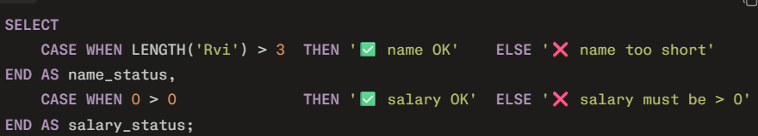
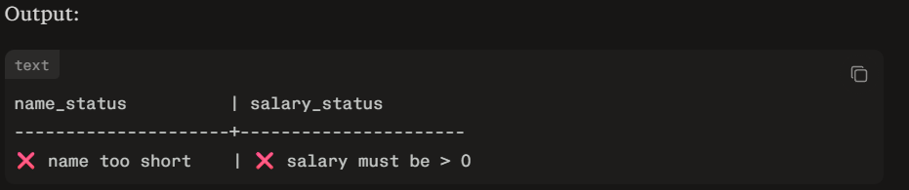
Option 3 — Write Separate INSERT Per Row with Exception Handling
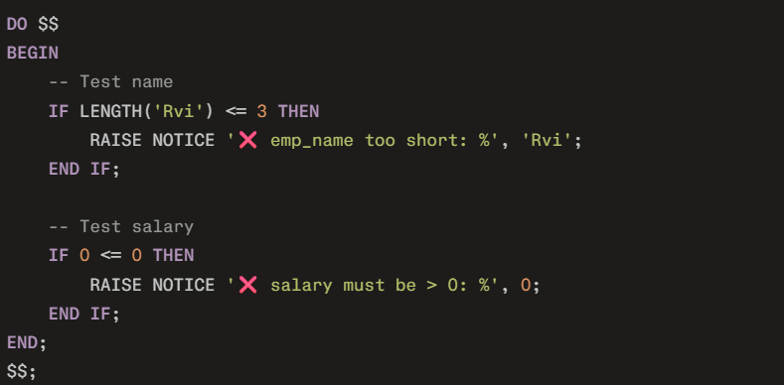
This prints all errors as notices without stopping.
The Honest Truth for Production
In real production systems, you never rely on the database to report all validation errors to the user. That job belongs to your application layer (Node.js, Python, Java, etc.), which validates all fields before sending the query to the database.

