What is sql
SQL (Structured Query Language) is the standard language used with relational DBMSs to define schemas (DDL), manipulate and query data (DML/DQL), and optimize access.
what is data?

What is a database?
A database is an organized collection of data stored and accessed electronically. It provides a way to store, organize, and retrieve large amounts of data efficiently.

What is DBMS
Database Management System is the software layer that sits between your application and your raw data, giving you structured, reliable, and concurrent access to that data without you having to manage files, memory, or consistency yourself.

Difference between the Database and DBMS
A database, at its most fundamental level, is just stored data — it could theoretically even exist as a physical ledger or spreadsheet. The DBMS is what turns that raw data into something useful at scale — it handles querying, concurrency, security, indexing, and recovery automatically, so your application doesn't have to.
SQL is not a DBMS
- MySQL — Relational DBMS (uses SQL)
- PostgreSQL — Relational DBMS (uses SQL)
- MongoDB — NoSQL DBMS (uses documents/JSON instead of tables)
- Oracle DB — Relational DBMS (enterprise-level)
- Microsoft SQL Server — Relational DBMS (built by Microsoft)
SQL is a language, not a DBMS. It stands for Structured Query Language and it's simply the language you use to talk to a relational DBMS

What the RDBMS Does "Internally"
This is the interesting part — when the RDBMS receives your SQL, it doesn't just go fetch data immediately. It does 4 things behind the scenes:​
- Parsing — Checks if your SQL has correct syntax (like a grammar check). If you made a typo, it rejects it here​
- Optimization — Figures out the fastest way to get your data. For example, should it scan the whole table or use an index? It picks the cheapest path​
- Execution Plan — Creates a step-by-step internal plan of exactly how to retrieve the data​
- Execution — Actually goes to disk/memory, fetches the rows, applies your filters (WHERE, JOIN, etc.), and assembles the result

What is RDBMS
At its core, an RDBMS stores data in structured tables that are connected to each other through relationships. What makes it powerful is that it keeps the data accurate and consistent by enforcing rules inside the database itself, not just in the application.
Each piece of data has a specific place and must follow rules like primary keys, foreign keys, and unique constraints. Because of this, the database can automatically prevent incorrect or duplicate data instead of relying only on application code.

What is ACID
Explain the ACID properties in database transactions
ACID principles make sure database transactions are reliable and maintain data integrity:
- Atomicity: All operations in a transaction succeed or fail together
- Consistency: Data remains valid according to defined rules
- Isolation: Concurrent transactions don't interfere with each other
- Durability: Committed changes survive system crashes
Example – NEEDED
difference between DBMS & RDBMS
Think of DBMS as the broader category — it's any system that manages data, whether that's a hierarchical file store, a navigational database, or even something like Microsoft Access. RDBMS is a specific, far more evolved subset of that, built on E.F. Codd's relational model, where data lives in structured tables and those tables are explicitly linked through keys.
Relational Model and Table
The relational model is a way of organizing/storing data where data is stored in tables, and those tables can have relationships with each other using keys.

E.F. Codd Rules
Rule 1: Information Rule
The data stored in a database, may it be user data or metadata, must be a value of some table cell. Everything in a database must be stored in a table format.
Rule 2: Guaranteed Access Rule
Every single data element (value) is guaranteed to be accessible logically with a combination of table-name, primary-key (row value), and attribute-name (column value). No other means, such as pointers, can be used to access data.
Rule 3: Systematic Treatment of NULL Values
The NULL values in a database must be given a systematic and uniform treatment. This is a very important rule because a NULL can be interpreted as one the following − data is missing, data is not known, or data is not applicable.
Rule 4: Active Online Catalog
The structure description of the entire database must be stored in an online catalog, known as data dictionary, which can be accessed by authorized users. Users can use the same query language to access the catalog which they use to access the database itself.
Rule 5: Comprehensive Data Sub-Language Rule
A database can only be accessed using a language having linear syntax that supports data definition, data manipulation, and transaction management operations. This language can be used directly or by means of some application. If the database allows access to data without any help of this language, then it is considered as a violation.
Rule 6: View Updating Rule
All the views of a database, which can theoretically be updated, must also be updatable by the system.
Rule 7: High-Level Insert, Update, and Delete Rule
A database must support high-level insertion, updation, and deletion. This must not be limited to a single row, that is, it must also support union, intersection and minus operations to yield sets of data records.
Rule 8: Physical Data Independence
The data stored in a database must be independent of the applications that access the database. Any change in the physical structure of a database must not have any impact on how the data is being accessed by external applications.
Rule 9: Logical Data Independence
The logical data in a database must be independent of its users view (application). Any change in logical data must not affect the applications using it. For example, if two tables are merged or one is split into two different tables, there should be no impact or change on the user application. This is one of the most difficult rule to apply.
Rule 10: Integrity Independence
A database must be independent of the application that uses it. All its integrity constraints can be independently modified without the need of any change in the application. This rule makes a database independent of the front-end application and its interface.
Rule 11: Distribution Independence
The end-user must not be able to see that the data is distributed over various locations. Users should always get the impression that the data is located at one site only. This rule has been regarded as the foundation of distributed database systems.
Rule 12: Non-Subversion Rule
If a system has an interface that provides access to low-level records, then the interface must not be able to subvert the system and bypass security and integrity constraints.

What is datatype & it's Types
A data type defines what kind of data a variable or database field can store and how that data is interpreted by the system.
1. Numeric Data Types
Used to store numbers.
Examples:
Data Type | Description
INT | Whole numbers (Stores integers without decimal points, round off if <=0.5).
FLOAT | Decimal numbers (Stores decimal numbers with floating precision.  Float uses the 4 bytes i.e. 32 bits to store the values. So it has a wide range of values. But it is not always precise.)
DOUBLE | Large decimal numbers (Stores **decimal numbers with higher precision than FLOAT**.  Double uses the 8 bytes i.e. 64 bits to store the values. So it has a wide range of values. Double is more precise than the Float.)
DECIMAL | Exact decimal values
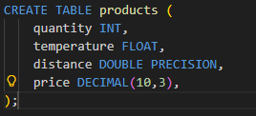

2. Character / String Data Types
Used to store text or characters.
Examples:
Data Type | Description
CHAR | Fixed-length string (Reserves exactly 10 spaces always. Stores "Hi " (pads 8 empty spaces) — wasteful if text varies in size)
VARCHAR | Variable-length string (Reserves only what's needed. Stores "Hi" using just 2 spaces — flexible and efficient)
TEXT | Large text data ( No size limit at all. Stores anything from 1 word to an entire book)

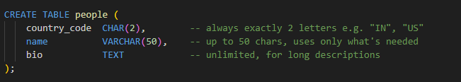

3. Date and Time Data Types
Used to store dates and time values.
Type | Stores | Example Value
DATE | Date only | 2026-03-11
TIME | Time only | 14:30:00
TIMESTAMP | Date + Time (no timezone) | 2026-03-11 14:30:00
TIMESTAMPTZ | Date + Time (with timezone, converts to UTC) | 2026-03-11 14:30:00+05:30

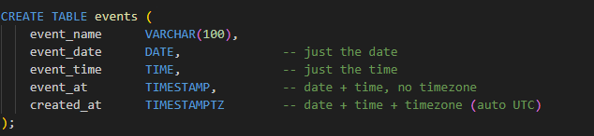

4. Boolean Data Type
Used to store true or false values.
Means TRUE | Means FALSE
TRUE | FALSE
'true' | 'false'
't' | 'f'
'yes' | 'no'
'y' | 'n'
'1' | '0'
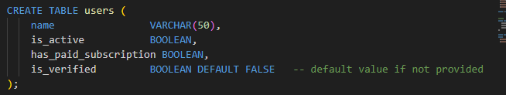

5. Binary Data Types
Used to store binary data like images, files, PDFs, audio, etc.
⚠️ PostgreSQL Note: PostgreSQL does NOT have BLOB or BINARY (those are MySQL types). PostgreSQL uses BYTEA instead.
Data Type | Description | Max Size
BYTEA | Stores raw binary data (PostgreSQL's version of BLOB) | 1 GB
Large Object | For very large files like videos | 4 TB

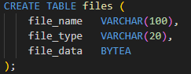
The Simple Rule
Quotes | Used for | Example
' ' Single quotes | Values / Strings | 'IN', 'Ravi', '2026-01-01'
" " Double quotes | Column/Table names | "user_id", "first name"

What is Constraint
Types of constraint

Overview of SQL Statements
- Data Definition Language
- Data Manipulation Language
- Transaction Control Language
- Data Control Language
- Data Query Language

Data Query Language (DQL)
- Select
  - FROM, WHERE, GROUP BY, HAVING, ORDER BY, LIMIT ,OFFSET

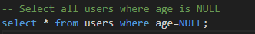
This doesn’t work
The Core Reason
NULL means "unknown" — and you cannot compare something unknown with =.​
Think about it logically:
If someone's age is unknown, can you ask "is this unknown value equal to NULL?"
The answer is also unknown — not TRUE or FALSE!
So = NULL never returns TRUE or FALSE — it always returns UNKNOWN, which SQL treats as FALSE. Your query returns 0 rows as a result
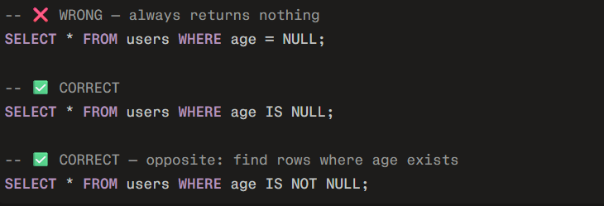

When you use aggregates like SUM() and non-aggregate columns like category, PostgreSQL requires GROUP BY.

Aggregates + non-aggregate columns = Must have GROUP BY
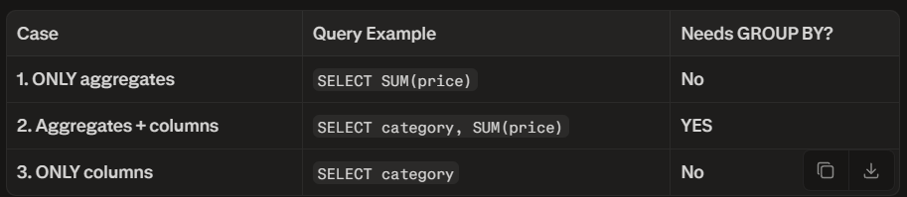

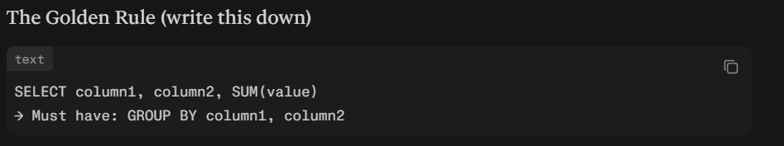
Every non-aggregate column in SELECT → must appear in GROUP BY.

Projection in PostgreSQL
Projection refers to selecting specific columns from a table or query result. In PostgreSQL, this is done using the SELECT clause in a query. It reduces the number of columns returned, making results narrower and often more efficient by avoiding unnecessary data transfer and processing.
​
Core Concept
A relation (table) has rows and columns. Projection takes a subset of columns while keeping all qualifying rows.
PostgreSQL implements this directly in SQL via SELECT column1, column2 FROM table. The result is a new relation with only those columns; duplicates are not automatically removed unless DISTINCT is used.

How PostgreSQL Processes Projection
- FROM clause builds base rows.
- WHERE filters rows.
- GROUP BY/HAVING groups and filters groups.
- SELECT computes output columns (projections) for surviving rows.
- DISTINCT removes duplicates if specified.
- ORDER BY, LIMIT applied last.
This order allows projections to use aggregates or filtered data. Projection early in execution plan reduces data volume for later steps, enabling optimizations like index-only scans if covering indexes exist

Selection in PostgreSQL
Selection filters rows based on a condition. In PostgreSQL, this is the WHERE clause. It acts as horizontal partitioning, keeping only rows where the condition evaluates to true.
Core Concept
From relational algebra, selection is σ_condition(relation), where condition is a boolean predicate like salary > 50000. PostgreSQL WHERE clause implements this: rows not satisfying condition are discarded. It operates after FROM (including joins) but before GROUP BY/HAVING.
How PostgreSQL Processes Selection
- FROM builds Cartesian product/joins.
- WHERE applies filter: for each row, evaluate condition; discard if false/null.
- Surviving rows to GROUP BY.
Indexes speed selection (e.g., B-tree for =/>). Bitmap scans combine multiple conditions. Pushdown: conditions on subquery tables pushed if safe.

Keys
Beginner Level Keys
Primary Key
- A primary key in PostgreSQL is a column (or a set of columns) that uniquely identifies each row in a table. It is an important component for ensuring data integrity and plays an important role in database normalization.
- When we define a primary key in PostgreSQL, the database automatically creates a unique B-tree index on the key column(s), which helps improve query performance.

What is Primary Key in PostgreSQL ?
Technically, a primary key constraint combines two aspects: a NOT NULL constraint (which means the key cannot be left empty) and a UNIQUE constraint (which ensures no two rows have the same key value).

Important Points About PostgreSQL Primary Key
- When WE define a primary key, PostgreSQL automatically creates a unique B-tree index on the column(s) used.
- Use SERIAL or BIGSERIAL for auto-incrementing primary keys. These types automatically generate unique sequential values.
- Each table can have only one primary key, but that key can consist of multiple columns (composite key).
- In tables that use inheritance, primary keys are not automatically inherited. You must explicitly define primary keys in each child table.

Foreign Key
A foreign key is a column (or a group of columns) in one table that references the primary key of another table, establishing a link between the two tables. The table containing the foreign key is known as the "child table" and the table to which it refers is known as the "parent table."
A foreign key creates a link between two tables by ensuring that any data entered into the foreign key column must already exist in the parent table. This helps maintain data integrity by preventing orphan records and ensuring that relationships between data remain consistent.
Referential Integrity: It ensures that the relationship between two tables remains consistent.

Foreign Key Constraints
In PostgreSQL, foreign keys come with several constraints that govern how changes in the parent table affect the child table. These constraints can be set when creating or altering a table.
- ON DELETE CASCADE: It Automatically deletes any rows in the child table when the corresponding row in the parent table is deleted.
- ON DELETE SET NULL: It Sets the foreign key value in the child table to NULL when the corresponding row in the parent table is deleted.
- ON UPDATE CASCADE: It Updates the foreign key in the child table when the corresponding primary key in the parent table is updated.
Important Points About Foreign Key Constraints in PostgreSQL
- Foreign key constraints enforce referential integrity between tables by ensuring that a column or a group of columns in the child table matches values in the parent table.
- A single table can have multiple foreign keys, each establishing a relationship with different parent tables.
- PostgreSQL supports several actions that can be taken when the referenced row in the parent table is deleted or updated such as CASCADE, SET NULL, SET DEFAULT, RESTRICT, NO ACTION.
- You can specify a name for the foreign key constraint using the CONSTRAINT keyword. If omitted, PostgreSQL assigns an auto-generated name.
- If ON DELETE or ON UPDATE actions are not specified, the default behavior is NO ACTION.

Unique Key.

OT NULL Constraint

Intermediate Level Keys
- Composite Primary Key
- Composite Unique Key
- Partial Unique Index
- Exclusion Constraint
Advanced Level Keys
- Multi-Column Foreign Key
- Deferred Constraints
- Partial Foreign Key
- Expression Indexes (Functional Keys)

Expert Level Keys
- BRIN Indexes
- GIN/GiST/SP-GiST Indexes
- Hash Indexes
- Generated Columns as Keys

- Joins
  - A JOIN clause is used to combine rows from two or more tables, based on a related column between them.
- INNER JOIN: Returns records that have matching values in both tables
- LEFT JOIN: Returns all records from the left table, and the matched records from the right table
  - LEFT JOIN keeps the FROM table completely
  - FROM [KEEP_ALL_TABLE] LEFT JOIN [OPTIONAL_TABLE] ON
- RIGHT JOIN: Returns all records from the right table, and the matched records from the left table
- FULL JOIN: Returns all records when there is a match in either left or right table
- CROSS JOIN: Returns the Cartesian product of two or more tables (combines every row from the first table with every row from the second table)

- Aggregation (Summaries)
  - An aggregate function takes many rows of a column and returns one summarized value
  - Functions: COUNT, SUM, AVG, MIN, MAX
  - Usually used with GROUP BY and sometimes HAVING.
  - SUM, AVG, MIN, MAX ignore NULL values.
  - COUNT(*) counts all rows, including rows where some columns are NULL
1. What is Conditional Aggregation?
- Conditional aggregation means applying an aggregate function (COUNT, SUM, AVG, MIN, MAX) to only specific rows that match a condition, all within a single query and a single GROUP BY.
- Without conditional aggregation, if you want three different counts from the same table, you need three separate queries. With conditional aggregation, you get all three in one query.
Without conditional aggregation (wrong approach):
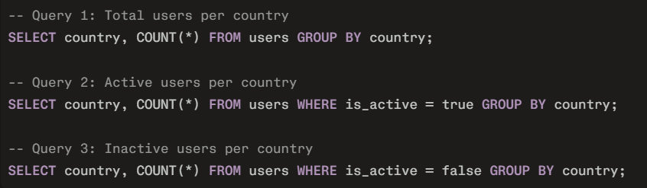

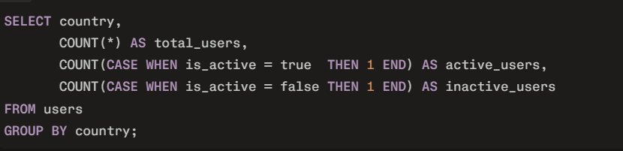

Pattern to remember:
SELECT ... FROM ... WHERE ... GROUP BY ... HAVING ... ORDER BY column_or_expression [ASC|DESC];
2. How it Works — Core Mechanics
The idea is to place a CASE WHEN expression inside an aggregate function.
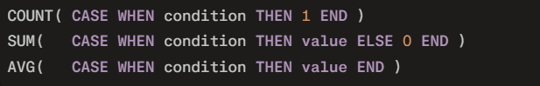

COUNT with CASE WHEN
Used when you want to count rows that match a specific condition within a group.

- Why THEN 1? You just need something non-NULL to count. 1 is the convention. You can use any value.
- Why no ELSE? When no ELSE is written, the default return is NULL. COUNT ignores NULL, so non-matching rows are skipped automatically.
SUM with CASE WHEN
Used when you want to add values that match a specific condition within a group.
Why ELSE 0? For SUM, if you skip ELSE, non-matching rows return NULL. SUM ignores NULL which gives the correct answer, but ELSE 0 makes the intention clearer. Both work.
AVG with CASE WHEN
Used when you want to average values only for rows matching a condition.
Important: Do NOT use ELSE 0 with AVG. If you write ELSE 0, the zeros will be included in the average calculation and pull the result down incorrectly. Let non-matching rows return NULL so AVG ignores them.

The ELSE 0 vs No ELSE Rule
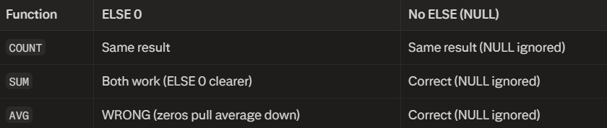

Multiple Conditions in One CASE WHEN
You can combine AND / OR inside a single CASE WHEN.
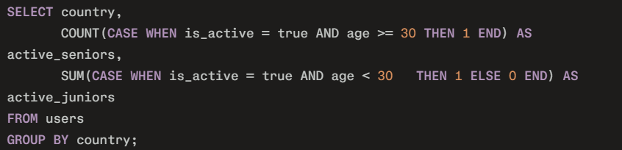
Conditional Aggregation vs WHERE
WHERE removes rows before grouping — it applies to the entire query.
Conditional aggregation keeps all rows but selects which rows each column counts/sums.
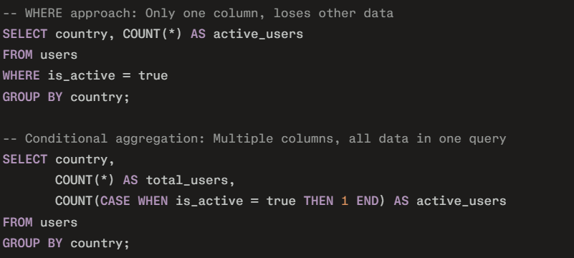
Use WHERE when you want to filter the whole query.
Use conditional aggregation when you want multiple different filters as separate columns.

Why THEN 1 and Why No ELSE — Properly Explained
This is the most important concept to understand before writing any conditional aggregation.
First, understand how COUNT works
COUNT(column) counts only non-NULL values. It completely ignores any row where the column value is NULL.
Now, why THEN 1?
When you write:
Why 1 and not some other number?
You can use THEN 1, THEN 5, THEN 999 — the result is always the same because COUNT only cares whether the value is NULL or not NULL. 1 is just the universal convention because it is clean and obvious.


Now, why no ELSE?
When you do NOT write ELSE, the CASE WHEN returns NULL by default for rows that do not match

What You Should Learn Next (in order)
- Window Functions — asked in every mid-level interview
- CTEs — cleaner alternative to nested subqueries
- EXPLAIN ANALYZE — shows you can optimize, not just write
- Indexes — shows you understand performance
- Transactions — shows you understand data integrity
- Partitioned Tables
- Schema Design — shows senior-level thinking
- B-tree Index , Predicate Pushdown , Bitmap Index Scan

Operator
- 1. Concatenation Operator ( || )
What It Is
  - The || operator is used to join two or more strings or column values together into one single output string. It does not change any data in the table. It only changes how the result looks when you display it.
  - Think of it like this: you have the name "Ravi" in one column and "Kumar" in another column. The || operator lets you combine them to display "Ravi Kumar" as a single value.
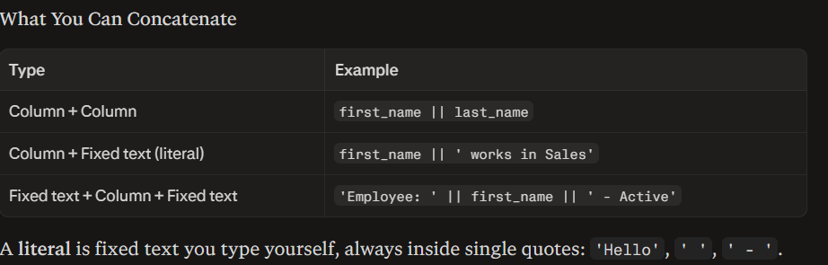
A literal is fixed text you type yourself, always inside single quotes: 'Hello', ' ', ' - '.

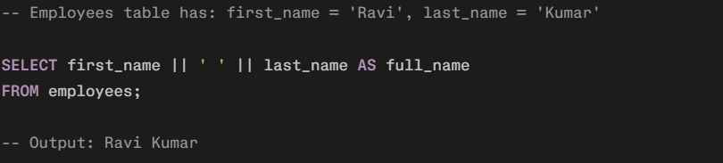
NULL Behavior — Critical Rule
If any part of a concatenation chain is NULL, the entire result becomes NULL.
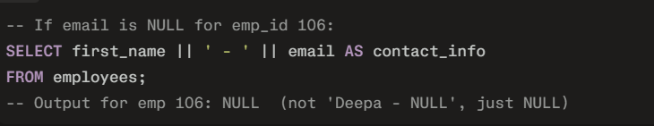
Fix using COALESCE: COALESCE returns the first non-NULL value from a list.
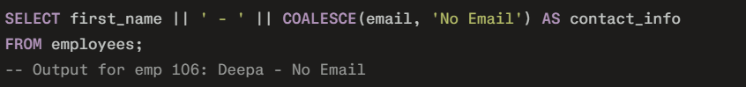
Key Rules to Remember
- The result of || is always a string/text type.
- You can chain as many || as you need in one query.
- Always add spaces manually if needed: first_name || ' ' || last_name — that ' ' is the space character.

2. Logical Operators (AND, OR, NOT)
Logical operators are used inside the WHERE clause to combine or modify conditions. They decide which rows get included in the result.​

AND Operator
What it is: AND means all conditions must be true at the same time. If even one condition is false, that row is excluded.
Real-world analogy: You want an employee who is in Sales AND earns more than 50000. Both must be true simultaneously.

OR Operator
What it is: OR means at least one condition must be true. If any one condition is true, the row is included.​
Real-world analogy: You want employees who are in Sales OR in Marketing. Being in either one is enough.

NOT Operator
What it is: NOT reverses the result of a condition. TRUE becomes FALSE. FALSE becomes TRUE.​
Real-world analogy: "Give me everyone who is NOT in HR."

Operator Precedence — How AND, OR, NOT Interact
When you mix these three, SQL follows a strict order:
- NOT is evaluated first
- AND is evaluated second
- OR is evaluated last
3. Special Operators — IN and NOT IN
IN Operator
What it is: IN checks whether a column's value matches any value in a given list. It is a cleaner, shorter replacement for multiple OR conditions. 
-- Exactly the same as:
-- WHERE department = 'Sales' OR department = 'IT' OR department = 'HR'
-- Returns employees belonging to any one of these three departments

Key Points:
- Values in the list are comma-separated inside parentheses
- Text values must be in single quotes; numbers do not need quotes
- The order of values inside IN() does not matter
- NULL values inside the IN list are ignored (they never cause a match)
- IN can also work with a subquery (a nested SELECT statement)

NOT IN Operator
What it is: NOT IN returns rows where the column value does not match any value in the list.​

-- Returns employees who are NOT in Sales and NOT in IT
-- Returns: HR, Finance, Marketing employees
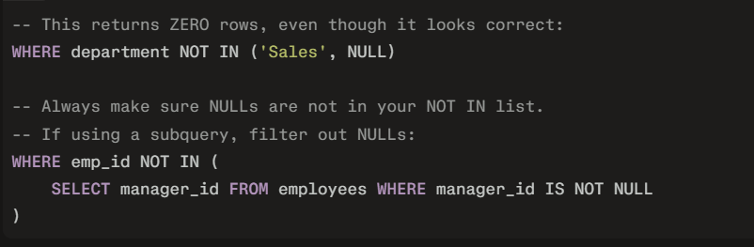

Special Operators — BETWEEN and NOT BETWEEN
BETWEEN Operator
What it is: BETWEEN checks whether a value falls within a range from a lower value to an upper value. Both the lower and upper values are included in the result (this is called inclusive on both ends).

Works with Three Data Types:
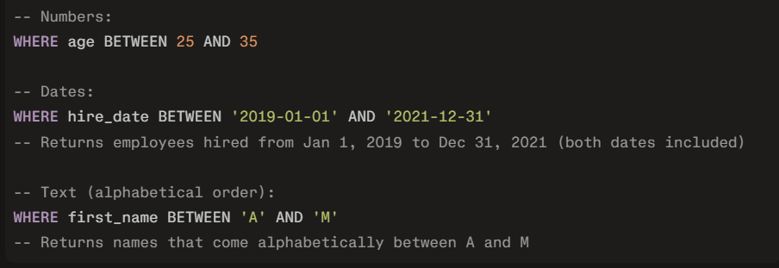

Key Points:
- Always write the smaller value first, then the larger value
- If you reverse them (BETWEEN 80000 AND 40000), you get zero results because no number can be >= 80000 AND <= 40000 at the same time
- Both boundary values are always included
- BETWEEN with dates: make sure your date format matches the database's expected format

NOT BETWEEN Operator
What it is: NOT BETWEEN returns rows where the value falls outside the range — either below the lower boundary or above the upper boundary
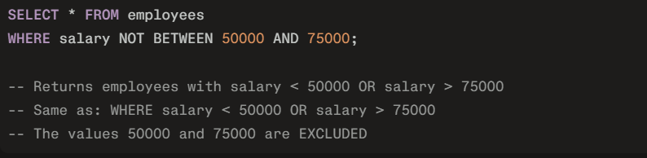

5. Special Operators — IS NULL and IS NOT NULL
IS NULL Operator
What it is: IS NULL checks whether a column contains no value at all. NULL in SQL means the value is absent, missing, or unknown. It is not the number zero, it is not an empty string '', it is not a space ' '. NULL literally means "nothing is stored here."
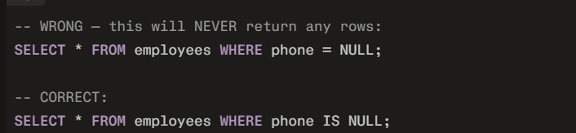
The reason = NULL does not work: NULL means "unknown." You cannot ask "is this unknown value equal to unknown?" — SQL treats such a comparison as UNKNOWN, which is neither TRUE nor FALSE. So no rows pass the filter. Only IS NULL properly detects missing values.

NULL Behavior in Arithmetic and Concatenation:
Any operation involving NULL produces NULL:
- 50000 + NULL = NULL
- 'Hello' || NULL = NULL
- NULL = NULL gives UNKNOWN (not TRUE)
- NULL != NULL gives UNKNOWN (not TRUE)
This is why IS NULL exists as a special check.

IS NOT NULL Operator
What it is: IS NOT NULL returns rows where a column has a value — it is not empty.
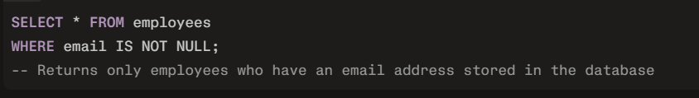

6. Special Operators — LIKE and NOT LIKE
LIKE Operator
What it is: LIKE searches for rows where a column's value matches a pattern you define. Instead of looking for an exact match (like = 'Ravi'), you describe what the value should look like using wildcard characters.
The Two Wildcards:
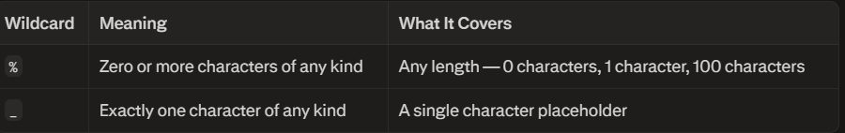

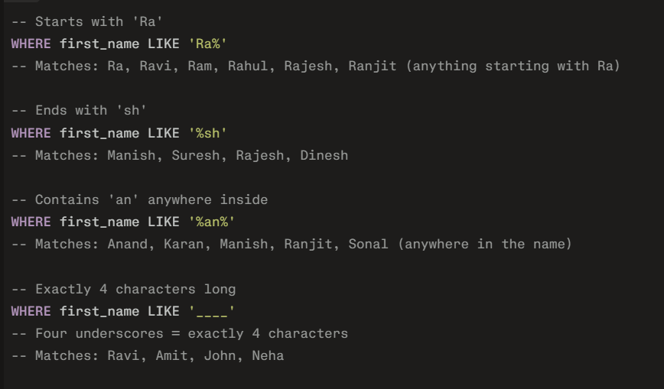
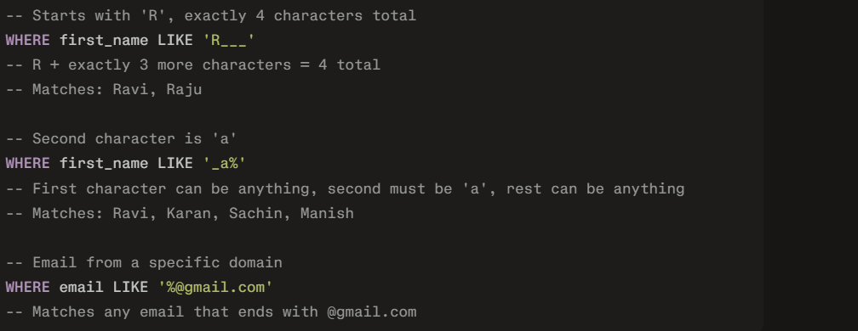

Key Points:
- The pattern must always be in single quotes
- Wildcards only work inside LIKE — they have no special meaning with =
- LIKE is case-insensitive in Oracle and SQL Server by default; case-sensitive in PostgreSQL by default​
- LIKE '%' matches everything (even empty strings)
- LIKE '%text%' is slow on large tables because the database must scan every row — it cannot use indexes efficiently

NOT LIKE Operator
What it is: NOT LIKE returns rows where the column value does not match the pattern.
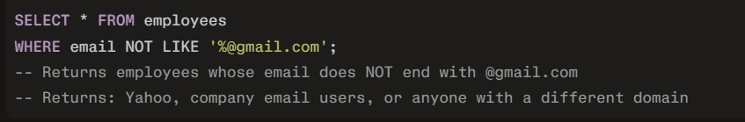

Union (UNION) - ∪ - combine relations
Difference (EXCEPT) - - rows in first only
Intersection (INTERSECT) - ∩ - common rows
Function
- What is Function & Types
- Multi-Row Function
- Single-Row Functions

Grouping
- Group By clause
- Having clause
  - HAVING is like a WHERE for groups, not for individual rows.
  - WHERE filters rows before grouping.
  - HAVING filters groups after GROUP BY + aggregates (SUM, COUNT, etc.).

Sorting
- Order By clause
  - The ORDER BY keyword is used to sort the result in ascending or descending order.
  - The ORDER BY keyword sorts the records in ascending order by default. To sort the records in descending order, use the DESC keyword.
  - You cannot use two ORDER BY clauses.

WHERE always comes before ORDER BY.
- Offset
  - the OFFSET clause allows you to skip a certain number of rows before returning the result set.
- LIMIT and OFFSET allow you to retrieve just a portion of the rows produced by a query... The two clauses can appear in either order.

Subquery
- What is Subquery & Explain
  - A subquery is a SELECT statement written inside another SELECT statement. The inner query runs first, produces a result, and the outer query uses that result.
  - It is also called a nested query or inner query.
  - 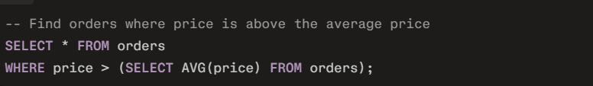

Subquery is always written inside parentheses ()
Inner query runs first, outer query runs second
A subquery can be placed in WHERE, SELECT, FROM, or HAVING

2. When and Why to Use a Subquery
Use a subquery when you need a value that does not exist yet and must be calculated first before the outer query can use it.
Common situations:
- Compare rows against a calculated value (average, max, min)
- Filter rows based on data from another table
- Create a temporary table from a complex query
- Check if a value exists in another table

- Max & Min
  - MAX per user — most expensive order each user placed:
  - 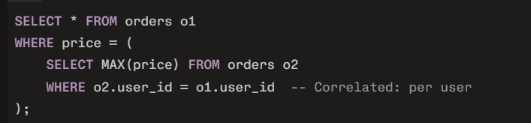
  - Important: MAX() and MIN() always return one single value, so they work perfectly with = in a subquery. Never use > or < with them directly unless intentional.

Types of Subqueries
Type 1: Scalar Subquery
Returns exactly one value (one row, one column)
Used with: =, >, <, >=, <=

Type 2: Multi-Row Subquery
Returns multiple rows (list of values).
Used with: IN, NOT IN, ANY, ALL
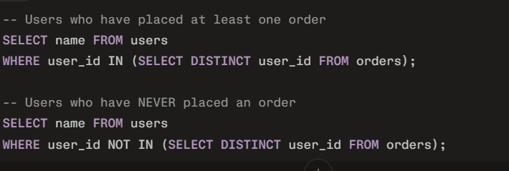
Rule: You cannot use = here because there are multiple rows. Must use IN or NOT IN.

Type 3: Correlated Subquery
Inner query references a column from the outer query. Runs once per row of the outer query.
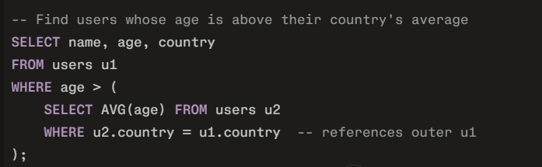
Use when: You need to compare each row against a group it belongs to.

Type 4: Derived Table (Subquery in FROM)
Subquery acts as a temporary table
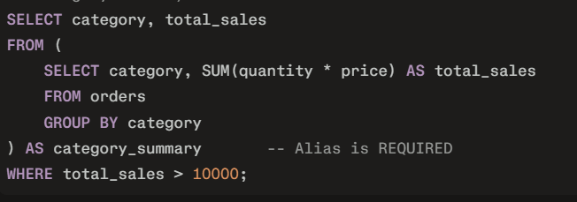
Rule: Always give the subquery an alias (AS category_summary). PostgreSQL requires it.

Type 5: EXISTS / NOT EXISTS Subquery
Checks if the subquery returns any rows at all. Returns TRUE or FALSE.
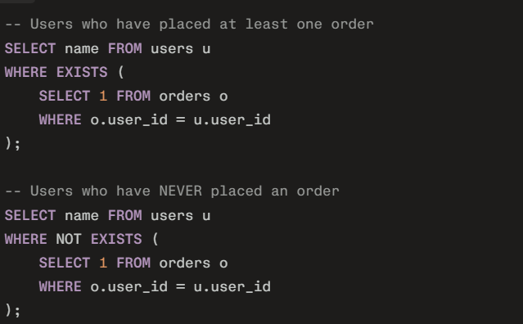
Why SELECT 1? EXISTS only checks if rows exist, not what values they have. SELECT 1 is a convention — it's fast and clear.

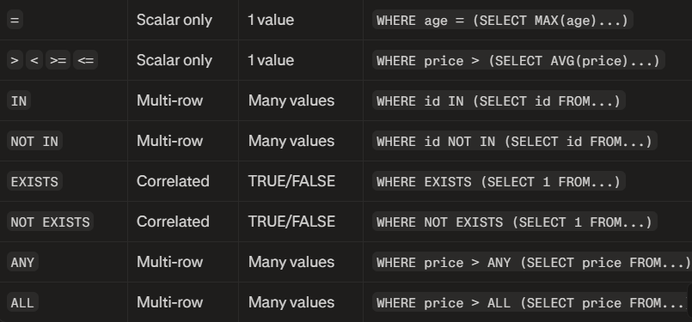

- Subquery Operator
- Nested Subqueries (Subquery inside Subquery)
- A subquery can contain another subquery inside it. No hard limit on depth, but keep it readable.
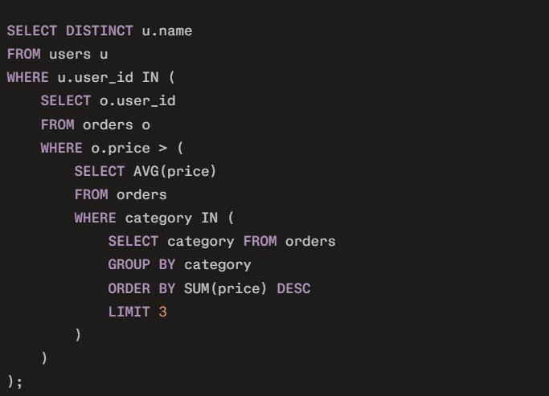
- 7. WHERE to Place Subqueries — Summary
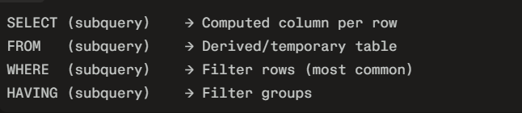
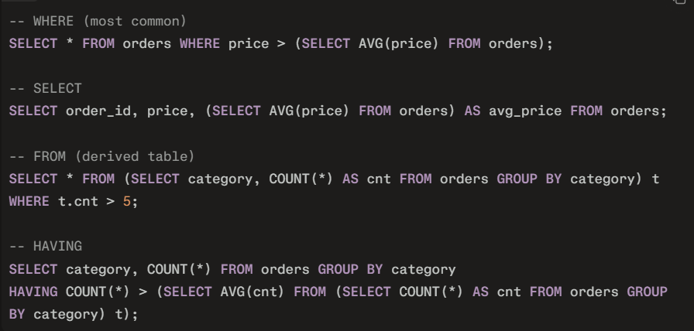

Joins
- Inner joins
- Left joins
- Right joins
- Full joins
- Cartesian Join / Cross Join
- Natural Join
- Outer Join
- Self-Join
- Multiple conditions on joins

Co-Related Subquery
- What is Corelated Subquery?
- Example on Corelated Subquery
- Exists & not exists operators
- Identifying nth max Value & min Value

Data Definition Language (DDL)
- Create
- Rename
- Alter
- Truncate
- Drop

Data Manipulation Language
- Insert
- Update
- Delete

Transaction Control Language
- Commit
- Rollback
- Save point

Data Control Language
- Grant
- Revoke

Normalization
- Functional Dependencies & It's types
- Types of Functional Dependencies
- Normalization
- 1st normal form
- 2nd normal form
- 3rd normal form & BCNF

Here’s a notes-ready summary you can paste and reuse later.

SQL NULL – Core Idea
- NULL means “no value stored here”.
- Reasons a column might be NULL:
  - Value is not known yet (will be filled later).
  - Value is not available (user skipped it).
  - Value does not apply (e.g., middle_name for someone without one).
- NULL is not:
  - 0
  - empty string ''
  - the text 'unknown'

Why = NULL Does Not Work
- Comparisons (=, !=, <, >, etc.) do not work with NULL.
- Any comparison with NULL gives UNKNOWN, not TRUE or FALSE:
  - 28 = NULL → UNKNOWN
  - NULL = NULL → UNKNOWN
- In a WHERE clause, only rows where the condition is TRUE are kept.
  - FALSE and UNKNOWN both get filtered out.
- That’s why this returns 0 rows, even if some ages are NULL:
sql
SELECT * FROM users WHERE age = NULL; -- wrong

Correct Way to Work with NULL
Use special operators:
sql
-- rows where age is missing
SELECT * FROM users WHERE age IS NULL;

-- rows where age is present
SELECT * FROM users WHERE age IS NOT NULL;
- Use IS NULL to find missing values.
- Use IS NOT NULL to find filled values.

Simple Mental Model
- Value present → you can compare: age = 25, age > 18, etc.
- Value missing (NULL) → you cannot compare; you must ask if it’s missing:
  - ❌ age = NULL
  - ✅ age IS NULL
So for your notes, remember this one line:
NULL = “no value stored”. You never compare it with =; you always check it with IS NULL / IS NOT NULL.

