EDA DETAILS OF data_specifications_01262026.xlsx - fa.csv

SHAPE: (244, 12)

COLUMN DEFAULTS & DYPES:
# int64
FILE_NAME object
COLUMN_NAME object
IS_ID object
ORDINAL_POSITION int64
DATA_TYPE object
CHAR_MAX_LENGTH float64
NUM_PRECISION float64
NUM_SCALE float64
IS_NULLABLE object
DESCRIPTION object
NOTES float64
dtype: object

BASIC INFO:
<class 'pandas.core.frame.DataFrame'>
RangeIndex: 244 entries, 0 to 243
Data columns (total 12 columns):
# Column Non-Null Count Dtype
--- ------ -------------- -----
0 # 244 non-null int64
1 FILE_NAME 244 non-null object
2 COLUMN_NAME 244 non-null object
3 IS_ID 244 non-null object
4 ORDINAL_POSITION 244 non-null int64
5 DATA_TYPE 244 non-null object
6 CHAR_MAX_LENGTH 86 non-null float64
7 NUM_PRECISION 96 non-null float64
8 NUM_SCALE 96 non-null float64
9 IS_NULLABLE 244 non-null object
10 DESCRIPTION 244 non-null object
11 NOTES 0 non-null float64
dtypes: float64(4), int64(2), object(6)
memory usage: 23.0+ KB

ABLES & COLUMN COUNTS:

 | Column_Count | ID_Columns | Nullable_Count
FILE_NAME
beacon_client_fixed_Rates | 83 | 12 | 67
beacon_client_fixed_Contract_Contributions | 49 | 3 | 32
beacon_client_fixed_Waivers | 27 | 3 | 15
beacon_client_fixed_gmwb | 25 | 3 | 22
beacon_client_fixed_products | 15 | 2 | 11
beacon_client_fixed_age | 13 | 3 | 12
beacon_client_fixed_gmab | 10 | 3 | 7
beacon_client_fixed_bonuses | 7 | 3 | 5
beacon_client_fixed_death_benefits | 7 | 3 | 5
beacon_client_fixed_Withdrawals | 5 | 3 | 4
beacon_client_fixed_companies | 3 | 2 | 1

VARIABLES BY TABLE:

📁 beacon_client_fixed_age (13 columns)
PRODUCTID, MINANQ, MINAQ, MINONQ, MINOQ, MXANQ, MXAQ, MXAZNQ...
... and 5 more

📁 beacon_client_fixed_bonuses (7 columns)
productid, bonus_id, name, sequence, inception_date, closed_date, UNIQUEID

📁 beacon_client_fixed_companies (3 columns)
company_name, COMPANYID, UNIQUEID

📁 beacon_client_fixed_death_benefits (7 columns)
productid, name, sequence, benefit_id, sub_sequent_premium, partial_withdrawals, UNIQUEID

📁 beacon_client_fixed_gmab (10 columns)
name, sequence, closed_date, product_id, gmab_id, introduction_date, avail_when_added, target_anniversery_years...
... and 2 more

📁 beacon_client_fixed_gmwb (25 columns)
productid, name, sequence, closed_date, partial_withdrawals, introduction_date, gmwb_type, reqd_min_distributions...
... and 17 more

📁 beacon_client_fixed_products (15 columns)
PRODUCTID, name, closed_date, Company name, EXPDATE, INCDATE, PREMIUM_TYPE, WINAFTSURR...
... and 7 more

📁 beacon_client_fixed_Rates (83 columns)
PRODUCTID, company_name, urn_code, bandid, blockid, varid, schedid, product_name...
... and 75 more

📁 beacon_client_fixed_Waivers (27 columns)
productid, EXPDATE, ANN, BAIL, DEATH, DES_ANN, DES_BAIL, DES_DEATH...
... and 19 more

📁 beacon_client_fixed_Withdrawals (5 columns)
PRODUCTID, ANNFREEPCT, DES_MVA, UNIQUEID, WITHID

📁 beacon_client_fixed_Contract_Contributions (49 columns)
FOUR57, PENSION, PROFSH, DESCR, SEPIRA, FOUR01A, KEOGH, IRATR...
... and 41 more

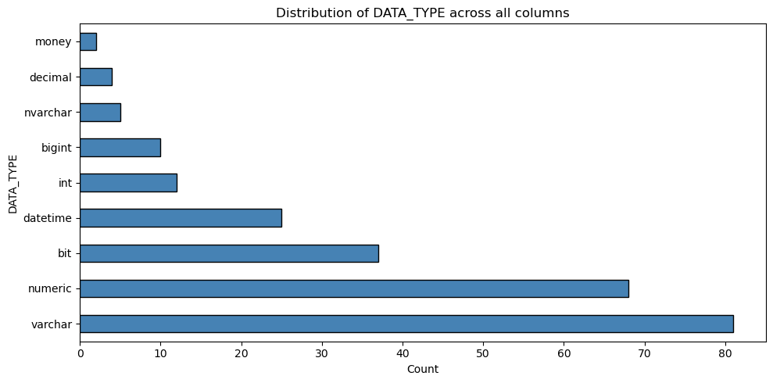

IS_NULLABLE distribution:
IS_NULLABLE
YES 181
NO 63
Name: count, dtype: int64

ID columns (IS_ID = Yes): 40

ID columns by table:
 | ID_Columns
FILE_NAME
beacon_client_fixed_Contract_Contributions | [PRODUCTID, CONTRIBID, UNIQUEID]
beacon_client_fixed_Rates | [PRODUCTID, bandid, blockid, varid, schedid, U...
beacon_client_fixed_Waivers | [productid, UNIQUEID, WAIVERID]
beacon_client_fixed_Withdrawals | [PRODUCTID, UNIQUEID, WITHID]
beacon_client_fixed_age | [PRODUCTID, UNIQUEID, AGEID]
beacon_client_fixed_bonuses | [productid, bonus_id, UNIQUEID]
beacon_client_fixed_companies | [COMPANYID, UNIQUEID]
beacon_client_fixed_death_benefits | [productid, benefit_id, UNIQUEID]
beacon_client_fixed_gmab | [product_id, gmab_id, UNIQUEID]
beacon_client_fixed_gmwb | [productid, gmwb_id, UNIQUEID]
beacon_client_fixed_products | [PRODUCTID, UNIQUEID]
Descriptive stats for numeric specification fields:

 | ORDINAL_POSITION | CHAR_MAX_LENGTH | NUM_PRECISION | NUM_SCALE
count | 244.000000 | 86.000000 | 96.000000 | 96.000000
mean | 23.594262 | 4214.453488 | 14.479167 | 1.093750
std | 21.649550 | 3990.364255 | 5.688361 | 1.414795
min | 1.000000 | -1.000000 | 1.000000 | 0.000000
25% | 6.000000 | 3.000000 | 10.000000 | 0.000000
50% | 16.000000 | 8000.000000 | 18.000000 | 0.000000
75% | 36.000000 | 8000.000000 | 18.000000 | 2.000000
max | 83.000000 | 8000.000000 | 19.000000 | 4.000000

Missing values in key columns:
FILE_NAME 0
COLUMN_NAME 0
DATA_TYPE 0
DESCRIPTION 0
dtype: int64

