Princy Patel

Michele Castaldo

COM088-012

29 November 2024

Revised: Descriptive Paragraph

MY FAVORITE PLACE: AN ART STUDIO

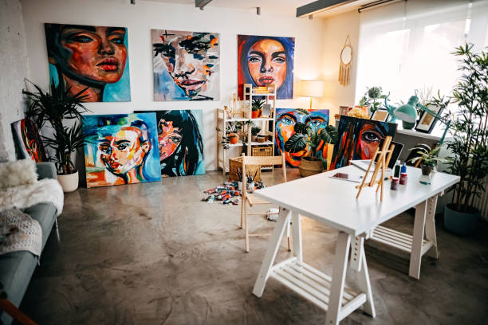

An art studio is something more than a place to work; it is a sanctuary where creativity thrives, a place where imagination bursts to life on canvas, in sculpture, or through countless other forms of artistic expression. For me, the ideal art studio is one that combines functionality with an inspirational atmosphere. Not just a workplace, but a haven where ideas flow like air and the spirit of creation permeates everywhere. The studio in my head is one I crave being lost into-the perfect manifestation of love for art.

The soul of my favorite studio is the huge, airy windows. These windows run all the way from the floor to the ceiling and let in soft, gentle natural light. As sunshine bursts through, it dances across the room and accentuates the many vivid colors of the artworks while bringing an extra layer of warmth. Indeed, the view outside the windows themselves is just as important. I envision trees with green leaves that are gently swaying to the breeze, a hilltop outlines far away, and the sound of a river meandering through the landsacpe. This view is one of constant inspiration, ever-changing in its scene to encourage the artist to capture the beauty of the world on the canvas. As the day wears on, the light changes, shadows change, and new perspectives on the artwork come out. This eternal change is one big muse that inspires me to work with light color.

Inside, it is spacious and free from any clutter, yet everything essential an artist would want to work with can be found here; huge easels in every corner, covered with paintings or sketches, or partly finished. The floor is littered with palettes of oil paints, brushes of all sizes, and sketchpads full of ideas just waiting to be brought to life. There is an undeniable feeling of organized chaos in the air. Each object has its place, yet there is a certain freedom that comes with the scattered material, a feeling that anything is possible. A big workbench in one corner is reserved for sculpting or experimenting with mixed media. The smell of wood, clay, and paint fills the air, mingling together in a sensory experience unique to any artist’s workplace.

The walls are a gallery unto themselves: work-in-progress, abstract paintings, charcoal sketces, and even sculptures in various stages of completion adorn them. These unfinished pieces tell something about the creative process-sketches of how this work moved from the head to the board. Accomplished pieces proudly hang on the wall, standing testimony to an artist’s vision and effort. Every piece has something to say, one moment frozen in time highlighting skill and talking also about how the technique and style of an artist is evolving.

One comfortable corner is occupied by a comfortable chair, accompanied by a pile of art books or magazines, which waits for the relaxing and reflective moments of your work. This could be a perfect spot to retreat from the physicality of creation: to rest and accumulate new ideas. Maybe here I would sit with a cup of tea, turning the pages of a book about famous artists or going through the latest trends in art magazines. This quiet solitude is just what is needed to balance the often-overwhelming energy of creation; it is a place to recharge and refresh one’s mind.

This studio is not only a place of solitude where one works alone but also one meant for shared experiences and collaboration. It would be a place where ideas can be shared with fellow artists or any other visitor who may show interest in one’s work. The balance between solitude and community is crucial for the foresting of creativity. There is room for introspection, where an artist can retreat into his thoughts and express the deepest of emotions, yet the studio also offers an open environment for dialogue and feedback. This communal aspect creates a vibrant atmosphere, filled with conversations, laughter, and the sharing of ideas, all contributing to the artistic growth of everyone involved.

My ideal studio is almost like a living, organic entity that evolves with the artist. It grows as the artist’s abilities grow, and it continuously adapts to the changing needs of the creative process. It provides a nourishing space where artistic boundaries are pushed, and new ideas are born. Every day, the studio offers something new, encouraging the artist to try new techniques, media, and to push the boundaries of their imagination.

The conclusion would be that my favorite place is not a place but a space that symbolizes creativity, freedom, and inspiration. It is a place where light, nature, and art come together, creating an ideal environment for artistic expression. An art studio is more than just a place; it’s a sanctum that nurtures both personal growth for the artist and skill building. This is a place where creativity knows no bounds, and possibilities are endless.