Texas College of Management and IT

**Web Technology**

Explore, Learn and Excel

**Mid Terminal Exam**

Submitted By:

Name: Ravi Timsina

LCID: LC00017002747

Program: BIT

Section: B

Date: 2025/03/08

Submitted To:

Department of IT





Contents

**Abstract** 2

**Introduction** 3

**Objective** 4

**Design & Implementation** 6

**1.** **HTML** 6

**A.** **HomePage** 6

**B.** **Skills Page** 7

**C.** **Contact Page** 9

2. CSS 11

**3. JavaScript** 18

**OutPut** 20

**Future Improvements** 22

**Conclusion** 23

# **Abstract**

The **Personal Portfolio Website** project aims to create a visually appealing and responsive web platform that provides individuals with an online space to display their skills, experience, projects, and achievements. As the demand for online portfolios increases, this project focuses on delivering an interactive, professional, and user-friendly solution for individuals seeking to showcase their expertise in various fields, such as web development, graphic design, or digital marketing. The website features a variety of sections, such as an introductory landing page, a detailed skills section, and a contact form, which collectively work to present the individual’s professional persona in the best possible light.

The website's development utilizes **HTML**, **CSS**, and **JavaScript**, making it compatible with most modern web browsers. The site is built to be fully responsive, adapting seamlessly to different screen sizes, ranging from desktops to mobile devices. This ensures a positive user experience regardless of the device being used. By implementing a straightforward yet effective design, this website allows visitors to interact with the individual’s portfolio efficiently, learn more about their skills, and contact them directly for potential collaboration or job opportunities. This project also provides valuable experience in front-end development, showcasing how basic web technologies can be used to create a professional and functional online presence.

# 

# **Introduction**

The advent of the digital age has significantly transformed the way professionals present themselves to potential employers, clients, and collaborators. One of the most effective ways to showcase one’s skills and projects is through a personal portfolio website. This website serves as a central hub where users can learn about the individual’s background, skills, achievements, and previous work. It also provides a platform for easy communication through contact forms and social media links.

The Personal Portfolio Website project has been designed to reflect the fundamental aspects of web development while allowing room for future improvements and integrations. By using HTML for structuring the content, CSS for styling, and JavaScript for interactive elements, the project offers a comprehensive yet beginner-friendly solution for anyone looking to establish an online presence. The website’s focus is on usability and aesthetic appeal, ensuring that it caters to both potential employers and clients while also being easy to navigate.

With the increasing trend of hiring and collaborating online, professionals across various industries are now seeking to build personal websites that not only highlight their work but also make it easier for them to be contacted. This project is an excellent demonstration of how essential web development skills can be utilized to design and deploy a well-rounded personal website. It leverages the power of front-end technologies and basic design principles to create a fully functional and responsive portfolio.

# **Objective**

The core objectives of the Personal Portfolio Website project are as follows:

1. **Create an Accessible and User-Friendly Website**: The website is designed with the goal of being intuitive and easy to navigate. All sections are well-structured and clearly labeled, ensuring users can easily find the information they are looking for.
2. **Showcase Professional Skills and Achievements**: A key objective is to effectively present the individual's skills, projects, and accomplishments. This is accomplished by creating a dedicated section for skills, where the user can highlight expertise in various areas such as web development, graphic design, or software development.
3. **Enable Efficient Communication**: The website includes a contact form that allows visitors to get in touch with the individual for job opportunities, collaborations, or inquiries. This feature enhances user engagement and promotes easy communication between the individual and website visitors.
4. **Implement a Responsive Design**: The website is built with a responsive layout, ensuring that it adapts seamlessly to different screen sizes, from large desktop monitors to small mobile devices. This is essential for providing a good user experience across a wide range of devices.
5. **Enhance Web Development Skills**: This project serves as an opportunity to strengthen the developer’s skills in front-end web development. By working with HTML, CSS, and JavaScript, the developer can refine their understanding of these technologies and implement best practices in building a professional portfolio website.
6. **Future Expansion and Scalability**: The website is designed with scalability in mind. While the initial version focuses on the front-end, future improvements such as database integration, server-side functionality, and more complex user interactions can be incorporated to enhance the site’s functionality.

**Technologies**

The **Personal Portfolio Website** is built using a combination of essential web technologies that ensure functionality, usability, and responsiveness. The technologies employed in the development of this project include:

1. **HTML (HyperText Markup Language)**: HTML is the backbone of the website’s structure. It defines the overall layout and organizes content into readable and navigable sections. HTML provides the tags for headings, paragraphs, images, and forms that make up the website’s content. Semantic HTML tags help improve accessibility and SEO, ensuring that search engines can properly index and rank the website.
2. **CSS (Cascading Style Sheets)**: CSS is used to style the website and define its appearance. This includes setting colors, fonts, layouts, margins, and padding. CSS also plays a critical role in the website’s responsiveness. Using **media queries**, the website adjusts its layout to fit different screen sizes, ensuring an optimal user experience on any device.
3. **JavaScript**: JavaScript is used to add interactivity to the website. In this project, JavaScript is employed to validate form submissions, ensuring that the user enters the required information in the contact form. Additionally, JavaScript allows for dynamic changes to the website, such as animations or content updates without the need for page reloads.
4. **Responsive Design**: The website is designed using **CSS Flexbox** and **CSS Grid Layout** to ensure that the layout adapts seamlessly to various screen sizes. Media queries are incorporated to change the styles based on the viewport width, ensuring the website is responsive across desktops, tablets, and mobile devices.
5. **Version Control (GitHub)**: GitHub is used to manage the codebase and track changes made to the project. It ensures that the developer can maintain version control, collaborate with others, and revert to previous versions of the website if necessary. GitHub also serves as the repository for hosting the project and making it available for publicviewing.

# **Design & Implementation**

## **HTML**

### **HomePage**

<!DOCTYPE html>

<html lang="en">

<head>

<meta charset="UTF-8">

<meta name="viewport" content="width=device-width, initial-scale=1.0">

<title>Ravi's Portfolio</title>

<link rel="stylesheet" href="style.css">

</head>

<body>

<header>

<nav>

<div class="left">Ravi's Portfolio</div>

<div class="right">

<ul>

<li><a href="index.html">Home</a></li>

<li><a href="skills.html">Skills</a></li>

<li><a href="contact.html">Contact</a></li>

</ul>

</div>

</nav>

</header>

<main>

<section class="firstSection">

<div class="leftSection">

<h1>Ravi Timsina - Web Developer</h1>

<p>Hello, I'm Ravi Timsina, a passionate Web Developer with expertise in HTML, CSS, and JavaScript. I

specialize in crafting clean, modern, and responsive websites that deliver seamless experiences

across all devices. My goal is to continually grow my skills and stay updated with the latest web

development trends to create high-quality websites that meet both user needs and business

objectives.</p>

</div>

<div class="rightSection">

<img src="images/ravi.jpg" alt="Ravi's photo">

</div>

</section>

</main>

<footer>

<p>&copy; 2025 Ravi. All rights reserved.</p>

</footer>

</body>

</html>

### **Skills Page**

<!DOCTYPE html>

<html lang="en">

<head>

<meta charset="UTF-8">

<meta name="viewport" content="width=device-width, initial-scale=1.0">

<title>Skills - Ravi's Portfolio</title>

<link rel="stylesheet" href="style.css">

</head>

<body>

<header>

<nav>

<div class="left">Ravi's Portfolio</div>

<div class="right">

<ul>

<li><a href="index.html">Home</a></li>

<li><a href="skills.html">Skills</a></li>

<li><a href="contact.html">Contact</a></li>

</ul>

</div>

</nav>

</header>

<main>

<section class="skillsSection">

<h2>My Skills</h2>

<div class="skillsContainer">

<div class="skillBox">

<img src="images/java.jpg" alt="Java">

<h3>Java</h3>

<p>

I am proficient in Java, with a strong foundation in Basics, object-oriented programming (OOP),

and collections. I am comfortable working with core Java concepts to

develop efficient and scalable applications."

</p>

</div>

<div class="skillBox">

<img src="images/html.jpg" alt="HTML">

<h3>HTML</h3>

<p>I have a solid understanding of HTML5, using semantic elements to structure content for

accessibility and SEO. I ensure that web pages are well-organized and provide a strong

foundation for any website</p>

</div>

<div class="skillBox">

<img src="images/css.jpg" alt="CSS">

<h3>CSS</h3>

<p>I am proficient in CSS3, with experience in creating responsive layouts using techniques like

flexbox and grid. I focus on styling websites to be visually appealing, user-friendly, and

adaptable to various screen sizes.</p>

</div>

<div class="skillBox">

<img src="images/js.jpg" alt="JavaScript">

<h3>JavaScript</h3>

<p>I have hands-on experience in JavaScript, particularly in

DOM manipulation and creating dynamic, interactive web pages.

I enjoy working with JavaScript to add functionality and enhance user experiences</p>

</div>

</div>

</section>

</main>

<footer>

<p>&copy; 2025 Ravi. All rights reserved.</p>

</footer>

</body>

</html>

### **Contact Page**

<!DOCTYPE html>

<html lang="en">

<head>

<meta charset="UTF-8">

<meta name="viewport" content="width=device-width, initial-scale=1.0">

<title>Contact - Ravi's Portfolio</title>

<link rel="stylesheet" href="style.css">

</head>

<body>

<header>

<nav>

<div class="left">Ravi's Portfolio</div>

<div class="right">

<ul>

<li><a href="index.html">Home</a></li>

<li><a href="skills.html">Skills</a></li>

<li><a href="contact.html">Contact</a></li>

</ul>

</div>

</nav>

</header>

<main>

<section class="contactSection">

<h2>CONTACT ME</h2>

<p>I'll be glad to answer your questions!</p>

<form id="contactForm" class="contactForm">

<input type="text" id="name" name="name" placeholder="Name" required>

<input type="email" id="email" name="email" placeholder="Email address" required>

<input type="text" id="subject" name="subject" placeholder="Subject" required>

<textarea id="message" name="message" placeholder="Your message" required></textarea>

<button type="submit">Send Message</button>

</form>

<h3>SOCIAL MEDIA</h3>

<div class="socialIcons">

<a href="https://www.linkedin.com/in/ravi-timsina-6048472b2/"><img src="images/linkedin.jpg" alt="Linkedin"></a>

<a href="https://www.facebook.com/Timsinaraviashish"><img src="images/facebook.jpg" alt="Facebook"></a>

<a href="https://www.instagram.com/ravitimsina/"><img src="images/instagram.jpg" alt="Instagram"></a>

</div>

</section>

</main>

<footer>

<p>&copy; 2025 Ravi. All rights reserved.</p>

</footer>

<script src="script.js"></script>

</body>

</html>

## 2. CSS

* {

*margin*: 0;

*padding*: 0;

*box-sizing*: border-box;

}

body {

*background-color*: #f5f5f5;

*color*: #333;

*font-family*: 'Arial', sans-serif;

*display*: flex;

*flex-direction*: column;

*min-height*: 100vh;

}

header {

*flex-shrink*: 0;

*background-color*: #2C3E50;

*color*: white;

}

main {

*flex-grow*: 1;

}

footer {

*text-align*: center;

*padding*: 20px;

*background-color*: #2C3E50;

*color*: white;

*margin-top*: auto;

}

nav {

*display*: flex;

*justify-content*: space-between;

*align-items*: center;

*height*: 80px;

*background-color*: #2C3E50;

*padding*: 0 20px;

}

nav ul {

*display*: flex;

*list-style*: none;

}

nav ul li {

*margin*: 0 15px;

}

nav ul li a {

*text-decoration*: none;

*color*: white;

*font-size*: 1.1rem;

}

nav ul li a:hover {

*color*: #3498db;

}

.left {

*font-size*: 1.7rem;

}

.firstSection {

*display*: flex;

*justify-content*: space-between;

*align-items*: center;

*margin*: 100px 20px;

}

.firstSection > div {

*width*: 45%;

}

.leftSection {

*font-size*: 1.3rem;

*font-weight*: bold;

*color*: #333;

*line-height*: 1.5;

}

.rightSection img {

*width*: 90%;

*border-radius*: 10px;

*box-shadow*: 0px 4px 8px rgba(0, 0, 0, 0.1);

}

.firstSection .rightSection img {

*width*: 100%;

*max-width*: 400px;

*height*: auto;

*border-radius*: 10px;

*box-shadow*: 0px 4px 8px rgba(0, 0, 0, 0.1);

}

button {

*padding*: 10px 20px;

*background-color*: #3498db;

*color*: white;

*border*: none;

*cursor*: pointer;

*font-size*: 1.1rem;

*border-radius*: 5px;

*margin-top*: 20px;

}

button:hover {

*background-color*: #2980b9;

}

.skillsSection {

*text-align*: center;

*margin*: 50px 0;

}

.skillsSection h2 {

*font-size*: 2.5rem;

*margin-bottom*: 20px;

*position*: relative;

}

.skillsSection h2::after {

*content*: "";

*display*: block;

*width*: 60px;

*height*: 4px;

*background-color*: #3498db;

*margin*: 10px auto;

}

.skillsContainer {

*display*: flex;

*flex-wrap*: wrap;

*justify-content*: center;

*gap*: 40px;

}

.skillBox {

*width*: 250px;

*text-align*: center;

}

.skillBox img {

*width*: 80px;

*height*: 80px;

*border-radius*: 50%;

*background-color*: white;

*padding*: 10px;

*margin-bottom*: 10px;

}

.skillBox h3 {

*font-size*: 1.5rem;

*margin-bottom*: 10px;

}

/* Contact Form Specific Styles */

.contactSection {

*text-align*: center;

*padding*: 50px 0;

}

.contactSection h2 {

*font-size*: 3rem;

*font-weight*: bold;

*text-transform*: uppercase;

*margin-bottom*: 10px;

}

.contactSection p {

*font-size*: 1.2rem;

*margin-bottom*: 20px;

}

/* Updated Contact Form */

#contactForm {

*width*: 50%;

*margin*: auto;

*text-align*: left;

}

#contactForm input,

#contactForm textarea {

*width*: 100%;

*padding*: 15px;

*margin*: 10px 0;

*font-size*: 1.1rem;

*background*: #fff;

*border*: 1px solid #ddd;

*outline*: none;

*border-radius*: 5px;

}

#contactForm input:focus,

#contactForm textarea:focus {

*border-color*: #3498db;

}

#contactForm textarea {

*height*: 150px;

*resize*: none;

}

#contactForm button {

*width*: 100%;

*padding*: 15px;

*background*: #3498db;

*color*: white;

*font-size*: 1.2rem;

*border*: none;

*cursor*: pointer;

*border-radius*: 5px;

}

#contactForm button:hover {

*background*: #2980b9;

}

.socialIcons {

*display*: flex;

*justify-content*: center;

*gap*: 20px;

*margin-top*: 20px;

}

.socialIcons a {

*display*: inline-block;

*transition*: transform 0.3s ease, box-shadow 0.3s ease;

}

.socialIcons img {

*width*: 50px;

*height*: 50px;

*border-radius*: 50%;

*background-color*: #fff;

*padding*: 10px;

*box-shadow*: 0 4px 8px rgba(0, 0, 0, 0.1);

*object-fit*: contain;

}

.socialIcons a:hover img {

*transform*: scale(1.1);

*box-shadow*: 0 8px 16px rgba(0, 0, 0, 0.2);

}

/* Responsive styles */

@media (*max-width*: 768px) {

    .firstSection {

*flex-direction*: column;

*align-items*: center;

*margin*: 50px 0;

    }

    .firstSection > div {

*width*: 80%;

*margin-bottom*: 20px;

    }

    .leftSection {

*font-size*: 2rem;

*text-align*: center;

    }

    .rightSection img {

*width*: 80%;

    }

    .skillsContainer {

*flex-direction*: column;

*gap*: 30px;

    }

    .contactForm {

*width*: 80%;

    }

    .contactForm button {

*width*: 100%;

    }

    nav ul {

*flex-direction*: column;

*align-items*: center;

*margin-top*: 20px;

    }

    nav ul li {

*margin*: 10px 0;

    }

}

@media (*max-width*: 480px) {

    body {

*font-size*: 14px;

    }

    .leftSection {

*font-size*: 1.7rem;

    }

    .skillsSection h2 {

*font-size*: 2rem;

    }

    .contactSection h2 {

*font-size*: 2.5rem;

    }

    .socialIcons img {

*width*: 40px;

*height*: 40px;

    }

    .socialIcons a:hover img {

*transform*: scale(1);

    }

}

## **3. JavaScript**

document.getElementById("contactForm").addEventListener("submit", *function*(*event*) {

*event*.preventDefault(); // Prevent the form from submitting

// Get form values

*const* name = document.getElementById("name").value;

*const* email = document.getElementById("email").value;

*const* subject = document.getElementById("subject").value;

*const* message = document.getElementById("message").value;

// Validate name

if (name.trim() === "") {

alert("Name is required.");

return;

}

// Validate email (simple regex for example)

*const* emailPattern = /^[a-zA-Z0-9._%+-]+@[a-zA-Z0-9.-]+\.[a-zA-Z]{2,}$/;

if (!emailPattern.test(email)) {

alert("Please enter a valid email address.");

return;

}

// Validate subject

if (subject.trim() === "") {

alert("Subject is required.");

return;

}

// Validate message

if (message.trim() === "") {

alert("Message cannot be empty.");

return;

}

// If everything is valid, submit the form

alert("Form submitted successfully!");

// You can also clear the form fields if needed

document.getElementById("contactForm").reset();

});

## 

## **OutPut**

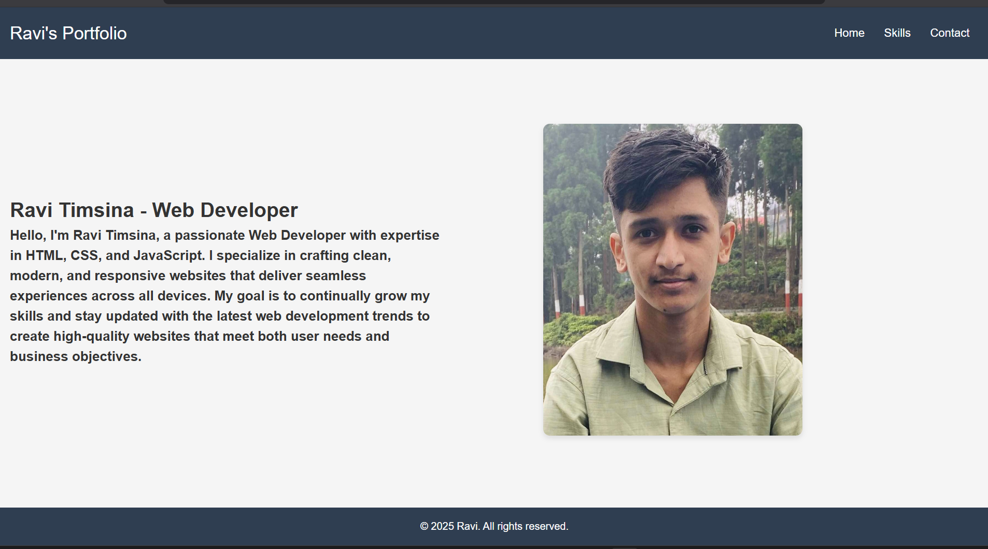

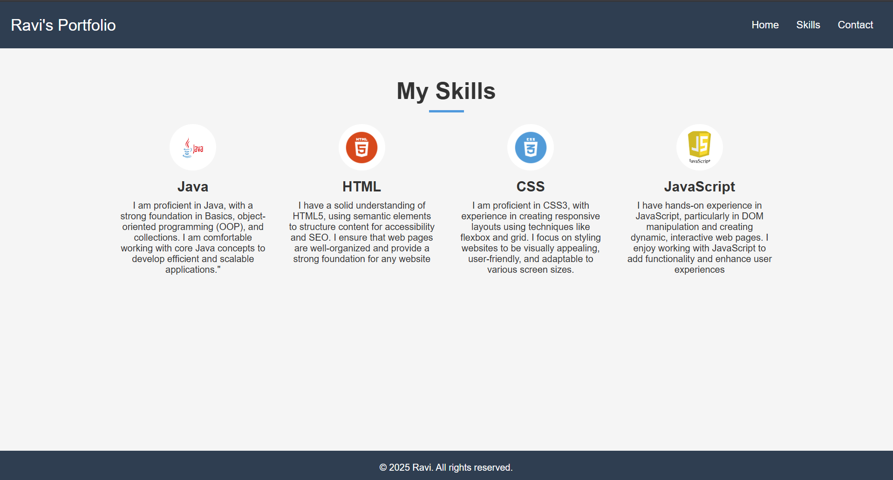

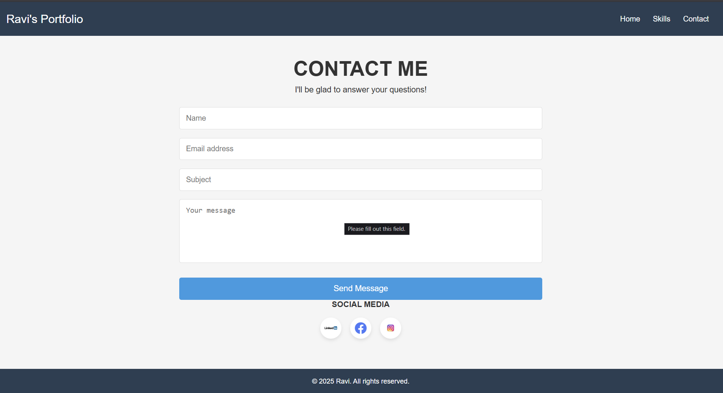

# 

# **Future Improvements**

While the current version of the Personal Portfolio Website offers a solid foundation, there are several key areas where the project can be improved or expanded in the future:

1. **Backend Integration**: To improve the contact form functionality and provide additional features, a backend system could be integrated to handle form submissions. Technologies such as Node.js, Java, or Python could be used to process user input and send emails or store data in a database.
2. **Database Integration**: Adding a database like MySQL or MongoDB could allow the website to dynamically fetch and display content, such as projects, client testimonials, and blog posts. This would enhance the site’s scalability and interactivity.
3. **Enhanced Form Validation**: While JavaScript is used to validate the form fields on the client-side, integrating server-side validation is essential for improved security and preventing malicious submissions.
4. **User Authentication**: Implementing user authentication (login/logout functionality) could allow visitors to interact with the website in more dynamic ways. For example, users could leave comments on projects or save their favorite work samples.

# **Conclusion**

The Personal Portfolio Website project is an essential demonstration of how fundamental web technologies can be leveraged to create a professional, responsive, and interactive online presence. By focusing on HTML, CSS, and JavaScript, the project ensures that the website is accessible, user-friendly, and adaptable across different devices. It serves as a comprehensive portfolio that showcases the individual’s skills, experience, and achievements, while also providing a means for visitors to get in touch.

Although the website is currently a simple, static front-end application, the possibilities for future enhancements are vast. By integrating back-end functionality, improving form validation, and adding advanced interactivity, the project could evolve into a fully-featured platform for personal branding. This project also provides valuable hands-on experience in web development, helping to reinforce core skills and lay the groundwork for more complex projects in the future.

**References**

**HTML**

[**https://www.w3schools.com/html/default.asp**](https://www.w3schools.com/html/default.asp)

**CSS**

[**https://www.w3schools.com/css/default.asp**](https://www.w3schools.com/css/default.asp)

**JavaScript**[**https://www.w3schools.com/css/default.asp**](https://www.w3schools.com/css/default.asp)

**Declaration of Originality**

I declare that this mini-project is my original work and that all references have been appropriately cited.

Signature: Ravi

Date: 2025/03/08