A Project Report On

**EduMatrix**

Submitted in partial fulfillment of the requirement for the award of the degree

Bachelor of Computer Application

BCA

Academic Year 2025 – 26

**Jenish Gohel Yuvrajsinh Zala Ravi Sav**

**92300527156 92300527141 92300527257**

|  |
| --- |
| **Internal Guide** |
| Prof. Dipak Thanki |



Rajkot-Morbi Road, At & PO : Gauridad, Rajkot 360 003. Gujarat. India.



**Faculty of Computer Applications (FCA)**



**This is to certify that the project work entitled**

**EduMatrix**

**submitted in partial fulfillment of the requirement for**

**the award of the degree of**

**Bachelor of Computer Application**

BCA

**of the**

**Marwadi University**

**is a result of the bonafide work carried out by**

**Jenish Gohel (92300527156)**

**Yuvrajsinh Zala (92300527141)**

**Ravi Sav (92300527257)**

**during the academic year 2025-26**

*Prof . Dipak Thanki Dr. Sunil Bajeja Dr. R . Sridaran*

|  |  |  |  |  |
| --- | --- | --- | --- | --- |
| **Faculty Guide** |  | **HOD** |  | **Dean** |

**DECLARATION**

Wehereby declare that this project work entitled **EduMatrix** is a record done by us.

We also declare that the matter embodied in this project is genuine work done by us and has not been submitted whether to this University or to any other University / Institute for the fulfillment of the requirement of any course of study.

Place : Marwadi University , Rajkot

Date : 6th June, 2025

**Jenish Gohel (92300527156) Signature : Jenish Gohel**

**Yuvrajsinh Zala (92300527141) Signature : Yuvrajsinh zala**

**Ravi sav (92300527257) Signature : Ravi Sav**

**CONTENTS**

|  |  |  |
| --- | --- | --- |
| **Chapters** | **Particulars** | **Page No.** |
| **1** | **SYNOPSIS** | 6 |
| **2** | **PREAMBLE**  General Introduction  Module description | 7 |
| **3** | **TECHNICAL DESCRIPTION**  Hardware Requirement  Software Requirement | 8 |
| **4** | **SYSTEM DESIGN AND DEVELOPMENT**   * Flowchart * Activity Diagram * Use Case Diagram * Database Design * Screen Design & Coding | 9  10  11  12  14 |
| **5** | **CONCLUSION** | 24 |
| **6** | **LEARNING DURING SIP** | 25 |
| **7** | **BIBLIOGRAPHY**  Online References  Offline References | 26 |

**TABLE INDEX**

|  |  |  |
| --- | --- | --- |
| **Table No.** | **Title** | **Page No.** |
| Table 3.1 | Hardware Configuration | 8 |
| Table 3.2 | Software Configuration | 8 |

**FIGURE INDEX**

|  |  |  |
| --- | --- | --- |
| **Figure No.** | **Title** | **Page No.** |
| Figure 4.1 | Flowchart | 9 |
| Figure 4.2 | Activity Diagram | 10 |
| Figure 4.3 | Use Case Diagram | 11 |
| Figure 4.5.1 | Main Page | 14 |
| Figure 4.5.2 | Quiz Page | 15 |
| Figure 4.5.3 | Quiz Start Page | 16 |
| Figure 4.5.4 | Review Answers Page | 16 |
| Figure 4.5.5 | Quiz Complete Page | 17 |
| Figure 4.5.6 | Dashboard Page | 17 |
| Figure 4.5.7 | Game Page | 18 |
| Figure 4.5.8 | Flashcard | 18 |
| Figure 4.5.9 | Hangman | 19 |
| Figure 4.5.10 | Puzzle Game | 19 |
| Figure 4.5.11 | Memory Game | 20 |
| Figure 4.5.12 | Word Search | 20 |
| Figure 4.5.13 | Typing Challenge | 21 |
| Figure 4.5.14 | Common Subject Selection Page for all Games | 21 |
| Figure 4.5.15 | Language Tool Syntax References | 22 |
| Figure 4.5.16 | Language Tool Code Snippet | 22 |
| Figure 4.5.17 | Language Tool Keyword Lookup | 23 |
| Figure 4.5.18 | Language Tool Error Explainations | 23 |

**1. SYNOPSIS**

* **EduMatrix** is an all-in-one interactive desktop application designed to help students and learners master essential programming concepts through quizzes, games, and instant reference tools. Built with Python and Tkinter, EduMatrix provides a seamless experience for practicing multiple-choice questions (MCQs), playing subject-oriented educational games, and accessing a rich language tool that includes syntax references, keyword explanations, error guides, and reusable code snippets.
* EduMatrix supports the following core programming disciplines:
* Python
* Java
* C
* Web Technologies
* Operating System Concepts
* With a focus on engagement and effective learning, EduMatrix combines self-testing, game-based exercises, and handy code resources under a single, user-friendly platform. All progress and results are stored locally, ensuring privacy and offline accessibility.

**2.PREAMBLE**

**2.1 General Introduction:**

* **EduMatrix** is a desktop application developed in Python using Tkinter, designed to help students learn programming concepts interactively. It supports five key subjects: Python, Java, C, Web Technologies, and Operating Systems. EduMatrix combines quizzes, educational games, and a language reference tool in a single offline platform. Quiz history will be saved for Every time attempt of Quiz.

**2.2 Module Description:**

* EduMatrix is organized into four main modules, each serving a unique purpose within the application:

**1.Quiz Module**:

> The Quiz Module offers timed, randomized multiple-choice quizzes for Python, Java, C, Web, and Operating System subjects. Users receive immediate feedback and explanations for each answer, can review and change their responses before submission, and get a detailed result summary. All quiz attempts are logged for progress tracking.

**2.Game Center:**

> The Game Center features eight interactive games—including Flashcards, Hangman, Puzzle, Memory, Word Search, Typing Challenge, and more—tailored to reinforce programming concepts in a fun and engaging way. Each game adapts its content to the selected subject, promoting active recall and long-term retention.

**3.Dashboard:**

> The Dashboard provides users with a clear overview of their learning journey. It displays best scores, average performance, and a comprehensive quiz history for each subject, helping users identify strengths and areas for improvement

**4.Language Tool :**

> The Language Tool is a multi-tabbed reference window offering instant access to syntax guides, keyword definitions, error explanations, and a curated library of code snippets for all supported languages. It serves as a quick reference for study, revision, and practical coding assistance.

**3. TECHNICAL DESCRIPTION**

| **Component** | **Minimum Requirement** | **Recommended Requirement** |
| --- | --- | --- |
| Computer/Laptop | Standard personal computer or laptop | – |
| RAM | 2 GB | 4 GB or more |
| Disk Space | 200 MB free | – |
| Display | 1024x768 resolution support | Higher resolution |
| Input Devices | Keyboard and mouse (or equivalent) | – |

**TABLE 3.1 Hardware Configurations**

| **Component** | **Requirements** |
| --- | --- |
| Operating System | Windows, Linux, or macOS |
| Python | Python 3.x (3.7 or higher recommended) |
| Tkinter | Pre-installed with most Python distributions |
| SQLite | Included with Python standard library |
| Internet Connection | Not required after installation |

**TABLE 3.2 Software Configurations**

**4. SYSTEM DESIGN AND DEVELOPMENT**

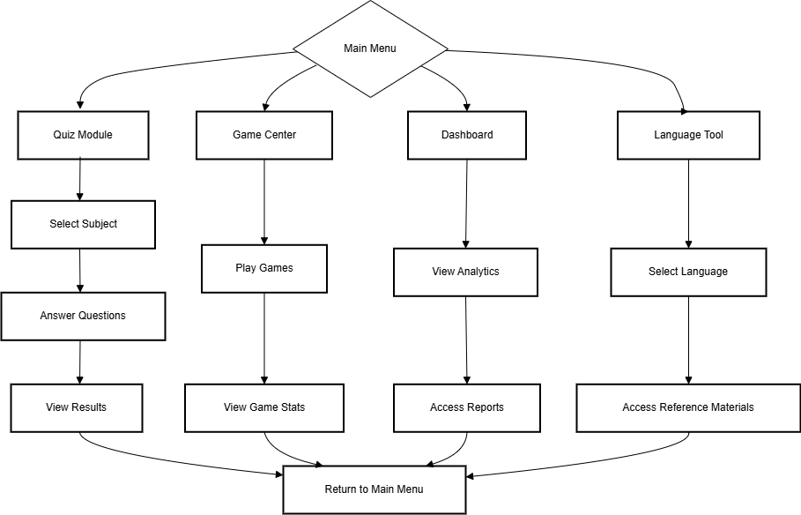

**Figure 4.1 Flow chart**

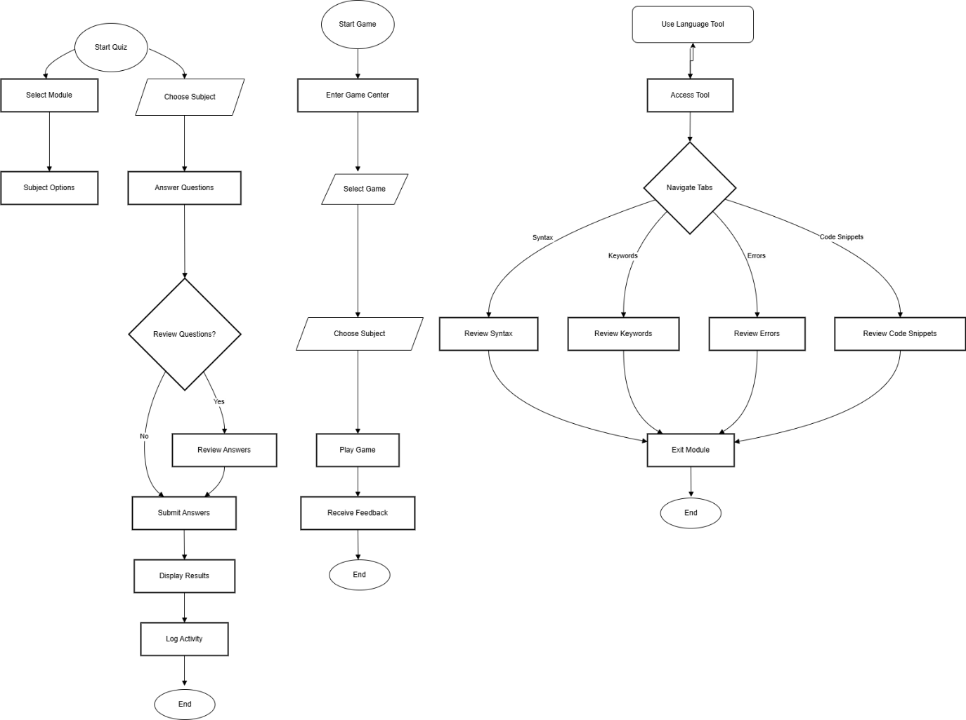

**Figure 4.2 Activity Diagram**

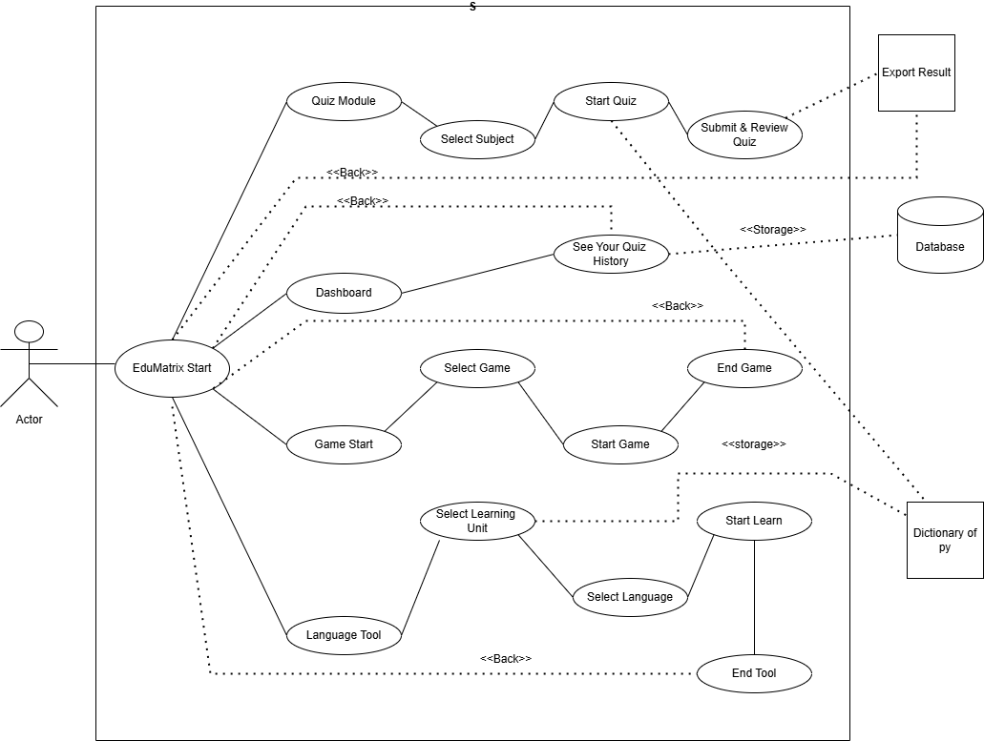

**Figure 4.3 Use Case Diagram**

**4.4 Database Design :**

* **Database Information:**

The EduMatrix application uses an SQLite database, but this database is dedicated exclusively to the Quiz module. All other modules (such as games and reference tools) operate without persistent data storage.

* **Purpose :**

The database securely stores quiz-related data locally on the user's device. It keeps a record of each quiz attempt, enabling users to track their progress and review past results.

* **Main Table stores UserHistory :**
* Stores information about every quiz attempt.

Fields:

* + `id` (primary key)
  + `subject` (the topic of the quiz)
  + `date` (when the quiz was taken)
  + `score` (user’s score)
  + `time_taken` (duration of the attempt)
  + `answers` (user’s responses, stored as text or JSON)
* **Key Characteristics :**
* **Local Only:** Data is stored locally; no internet connection or external database is required.
* **Privacy:** All quiz history remains on the user's device.

Simplicity:Only quiz attempts are tracked—no user profiles, game scores, or other features require database storage.

* **Example Table Schema (SQLite):**

```sql

CREATE TABLE UserHistory (

id INTEGER PRIMARY KEY AUTOINCREMENT,

subject TEXT NOT NULL,

date TEXT NOT NULL,

score INTEGER NOT NULL,

time_taken TEXT,

answers TEXT

);

```

* **Data Flow:**
  + When a user completes a quiz, their attempt is saved in the `UserHistory` table.
  + The Dashboard or results screen can retrieve and display this data to help users monitor their learning progress.
* **Note:** No other modules of EduMatrix (such as games or language tools) use the database. All database operations are confined to the Quiz module.
* **4.5 Screen Design & Coding :**

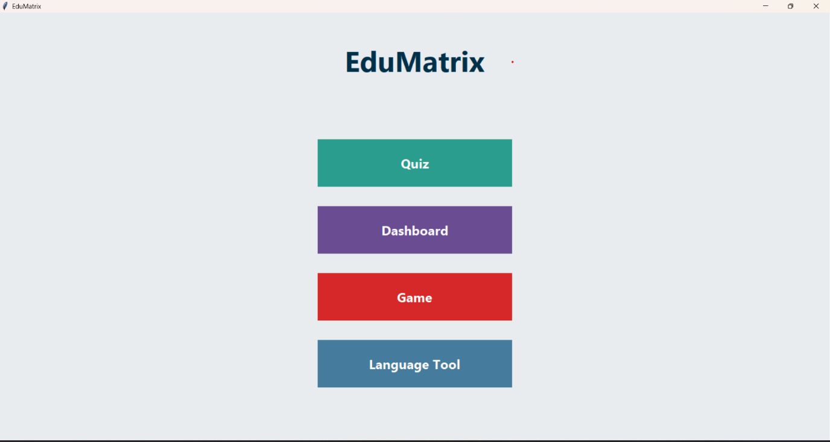

**Figure 4.5.1 Main Page**

**Code :**

import tkinter as tk

from tkinter import messagebox, font

import sqlite3

from datetime import datetime

# ... (other imports and subject/question data skipped for brevity)

class EduMatrixApp(tk.Tk):

def __init__(self):

super().__init__()

self.title("EduMatrix")

self.state('zoomed')

self.configure(bg="#e9ecef")

self.custom_font = font.Font(family="Segoe UI", size=18)

self.title_font = font.Font(family="Segoe UI", size=40, weight="bold")

self.button_font = font.Font(family="Segoe UI", size=18, weight="bold")

self.subjects = list(SUBJECTS.keys())

self.protocol("WM_DELETE_WINDOW", self.on_quit)

init_db()

self.show_main_menu()

def clear(self):

for widget in self.winfo_children():

widget.destroy()

def show_main_menu(self):

self.clear()

tk.Label(self, text="EduMatrix", font=self.title_font, bg="#e9ecef", fg="#003049").pack(pady=50)

menu = tk.Frame(self, bg="#e9ecef")

menu.pack(pady=40)

tk.Button(menu, text="Quiz", width=25, height=2, font=self.button_font, bg="#2a9d8f", fg="white",

activebackground="#52b788", relief="flat", command=self.show_subject_menu).pack(pady=18)

tk.Button(menu, text="Dashboard", width=25, height=2, font=self.button_font, bg="#6a4c93", fg="white",

activebackground="#b983ff", relief="flat", command=self.show_dashboard).pack(pady=18)

tk.Button(menu, text="Game", width=25, height=2, font=self.button_font, bg="#d62828", fg="white",

activebackground="#f77f00", relief="flat", command=self.show_game_menu).pack(pady=18)

tk.Button(menu, text="Language Tool", width=25, height=2, font=self.button_font, bg="#457b9d", fg="white",

activebackground="#a8dadc", relief="flat", command=self.show_language_tool).pack(pady=18)

def on_quit(self):

if messagebox.askyesno("Exit", "Do you really want to quit EduMatrix?"):

self.destroy()

# The rest of your code for the other classes and logic...

if __name__ == "__main__":

app = EduMatrixApp()

app.mainloop()

Note : Rest of the code will Have been submited as edumatrix_main.py file which contains entire code file

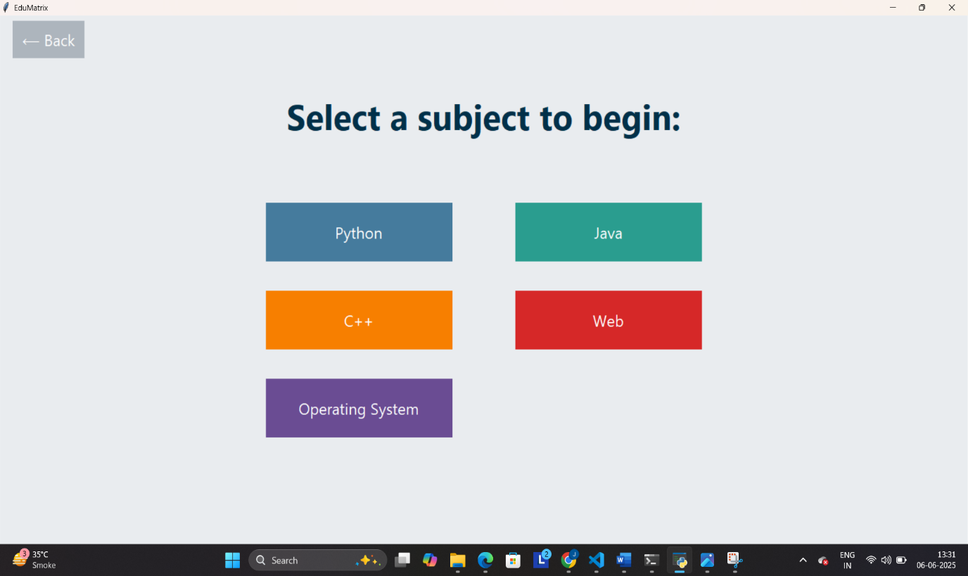

**Figure 4.5.2 Quiz Page**

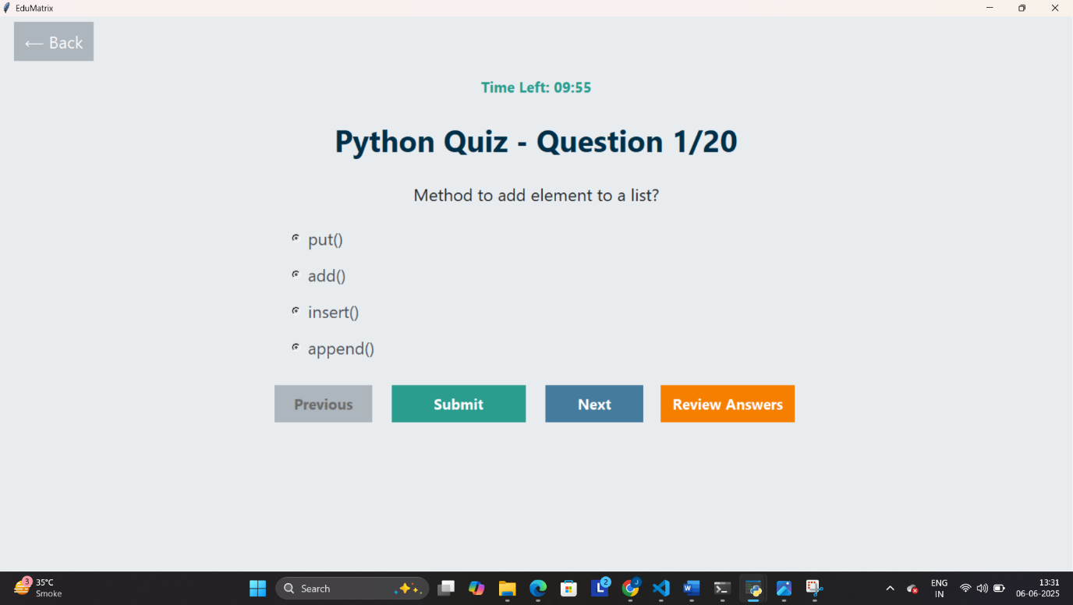

**Figure 4.5.3 Quiz Start Page**

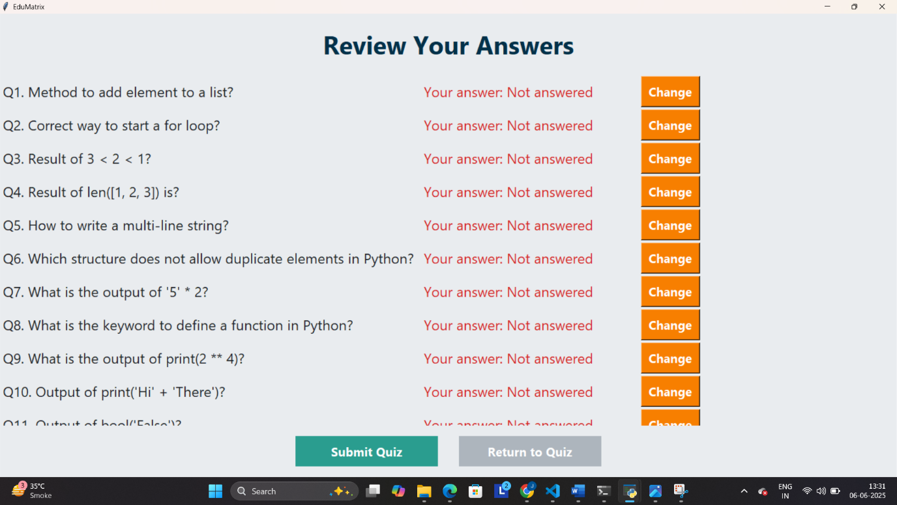

**Figure 4.5.4 Review Answer Page**

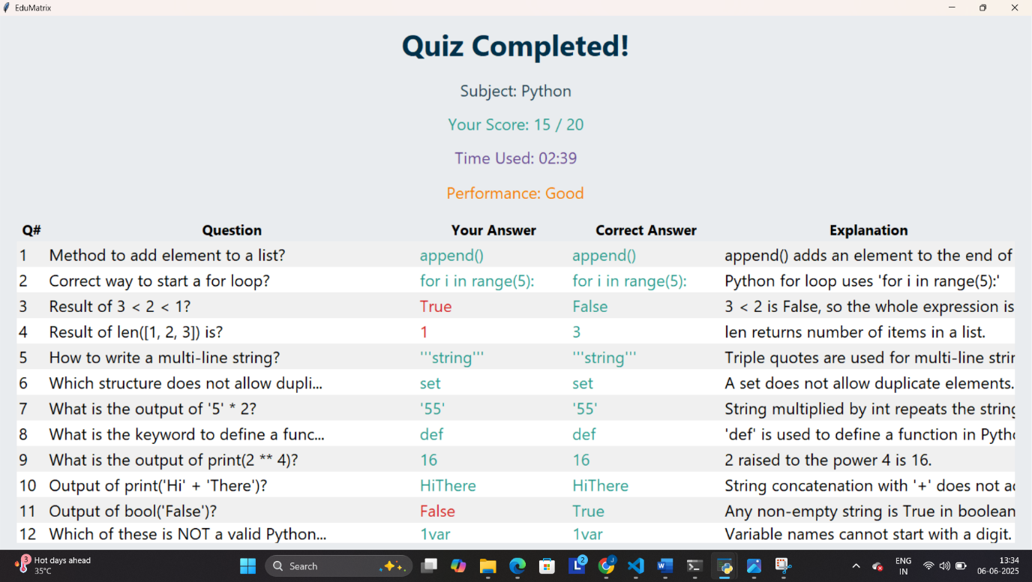

**Figure 4.5.5 Quiz Completed Page**

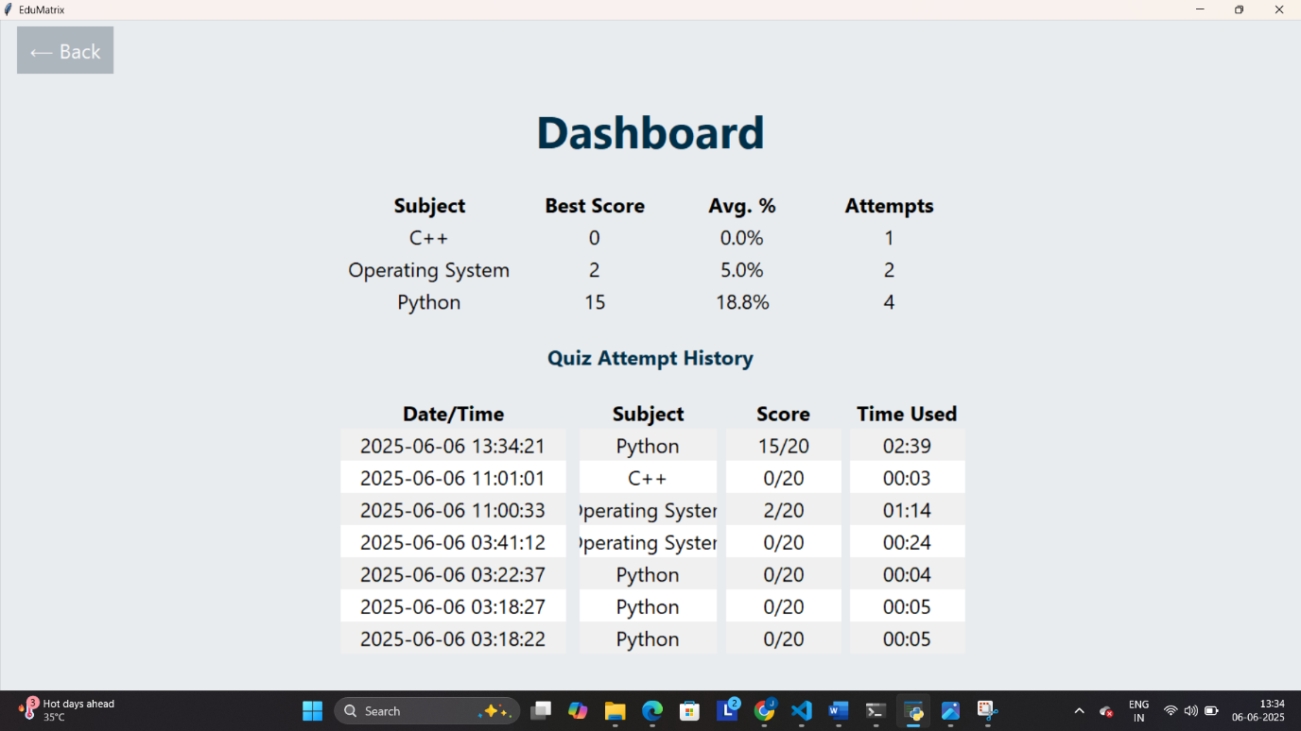

**Figure 4.5.6 Dashboard Page**

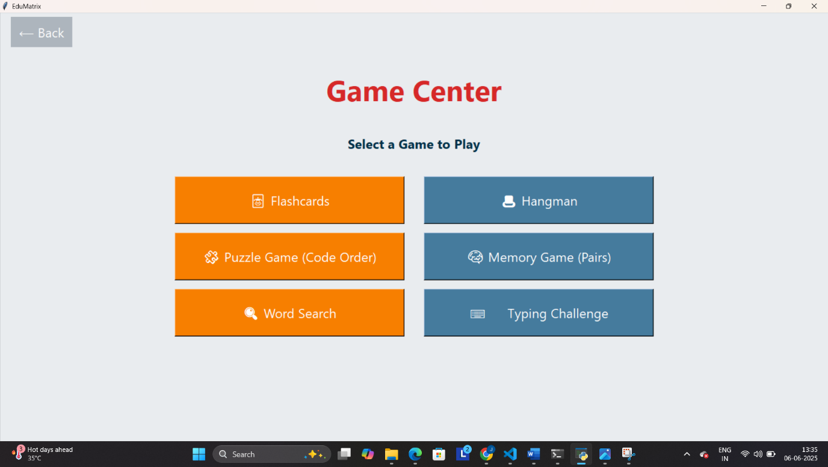

**Figure 4.5.7 Game Page**

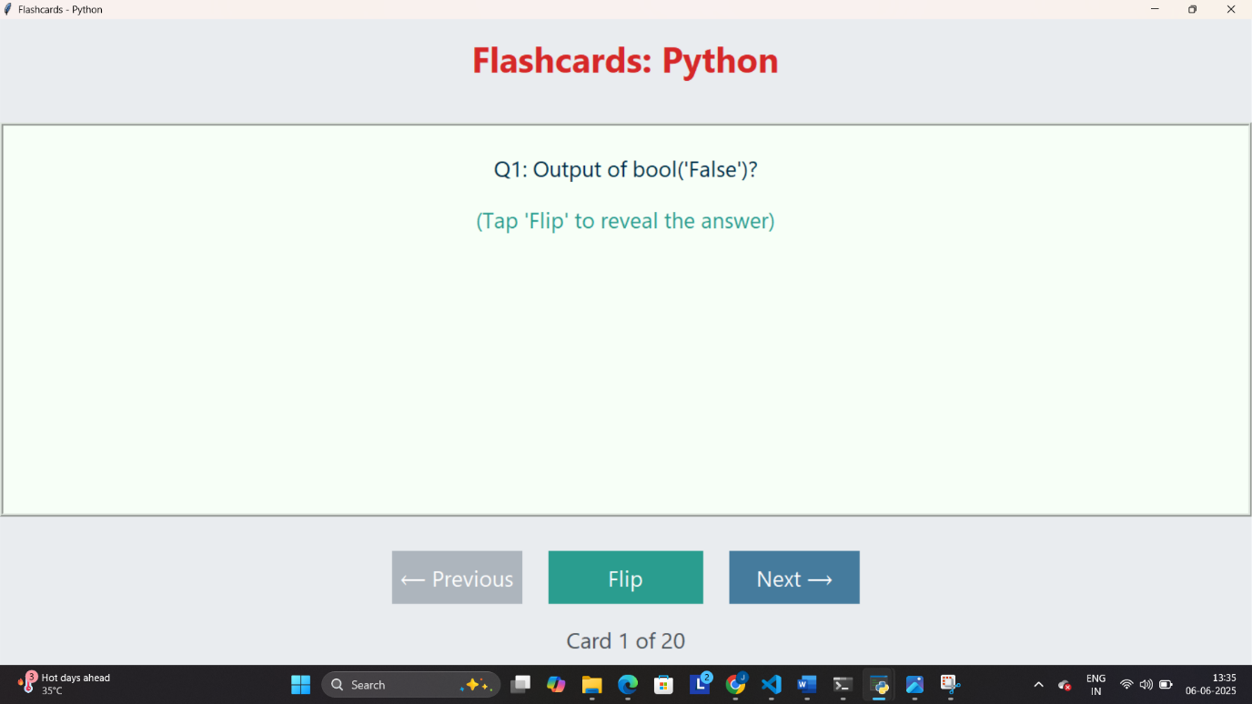

**Figure 4.5.8 Flashcard**

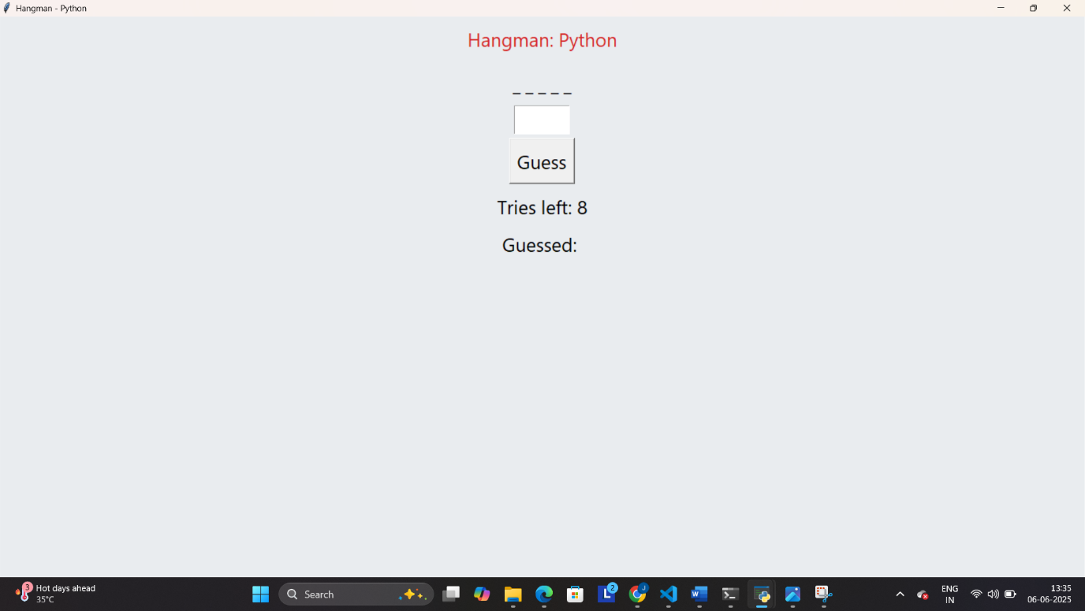

**Figure 4.5.9 Hangman**

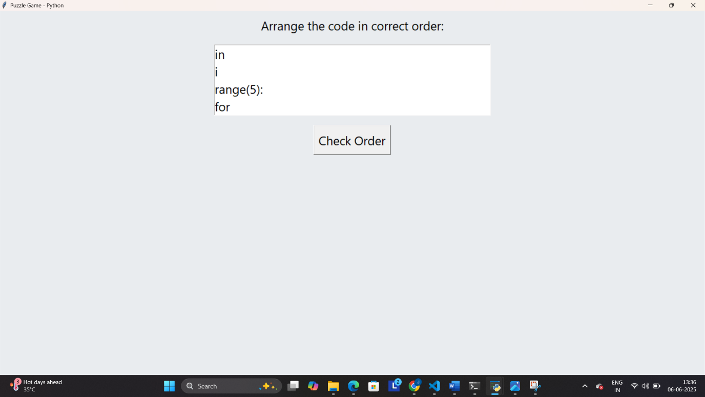

**Figure 4.5.10 Puzzle Game**

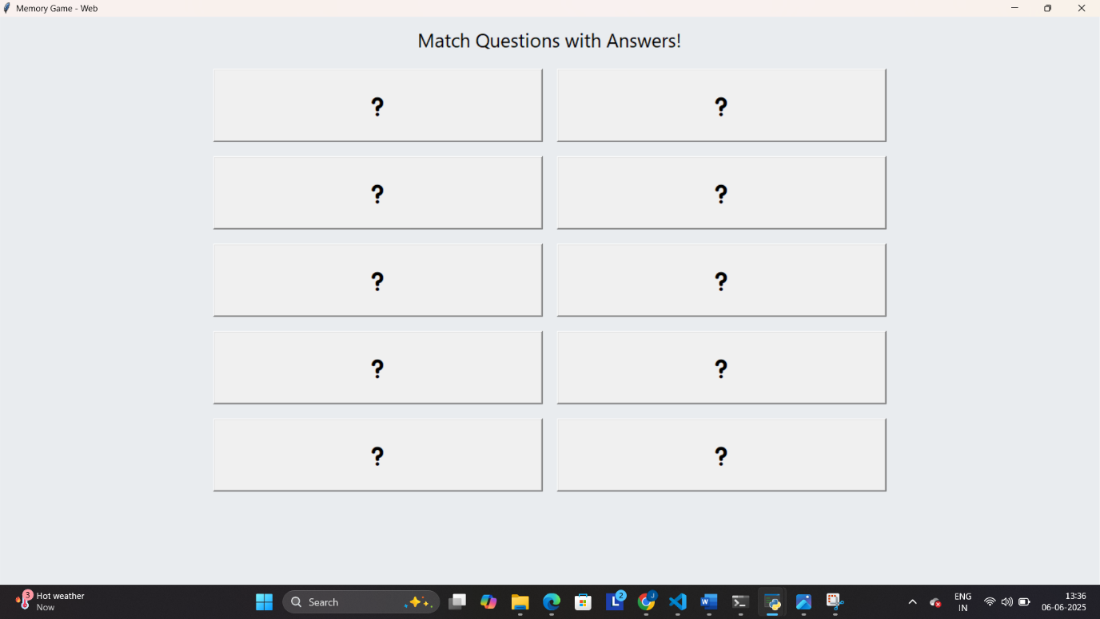

**Figure 4.5.11 Memory Game**

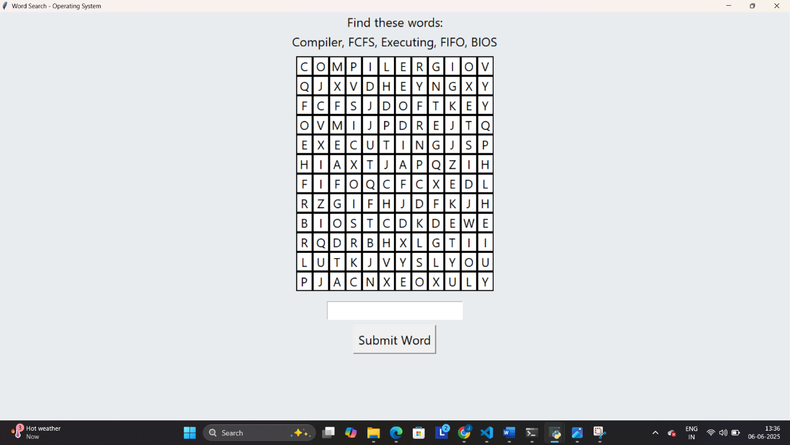

**Figure 4.5.12 Word Search**

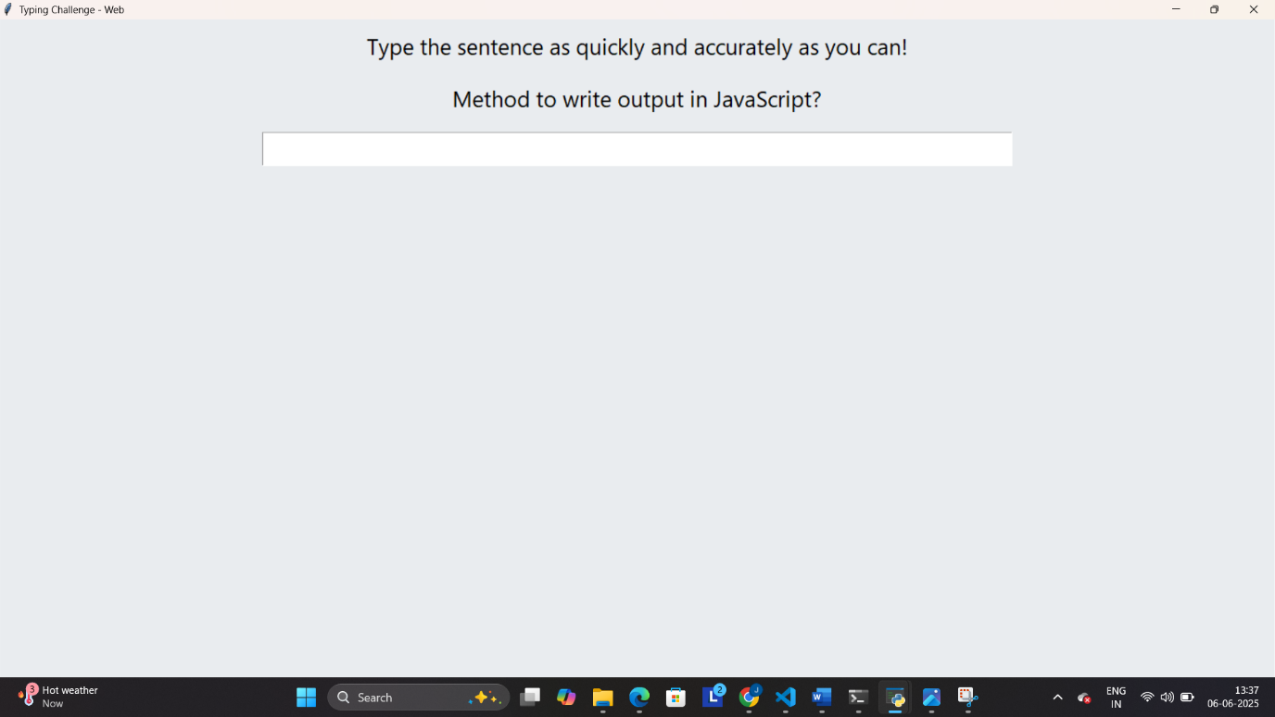

**Figure 4.5.13 Typing Challenge**

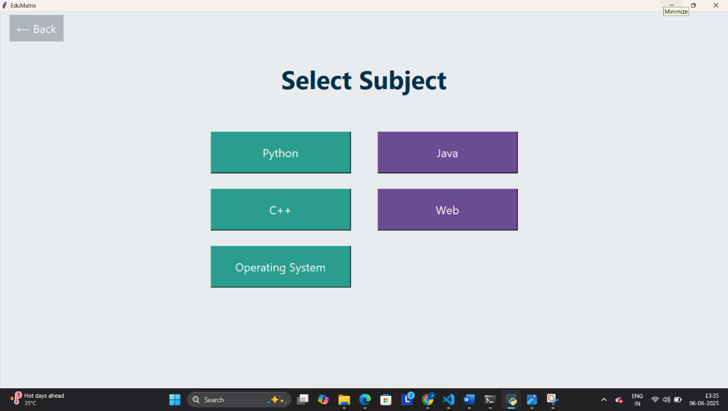

**Figure 4.5.14 Common Subject Selection Page for all Games**

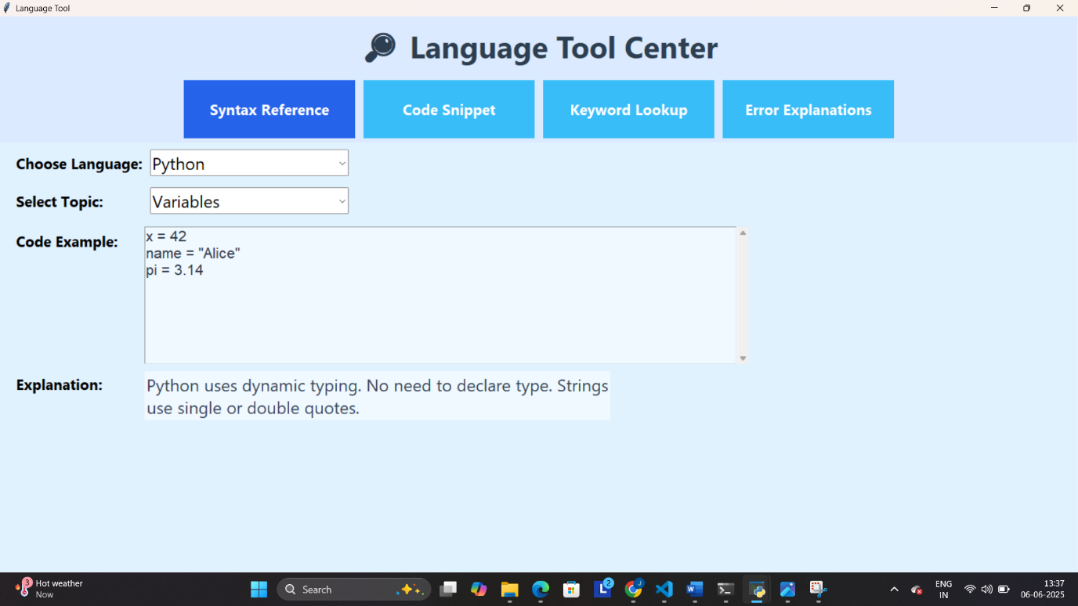

**Figure 4.5.15 Language Tool Syntax References**

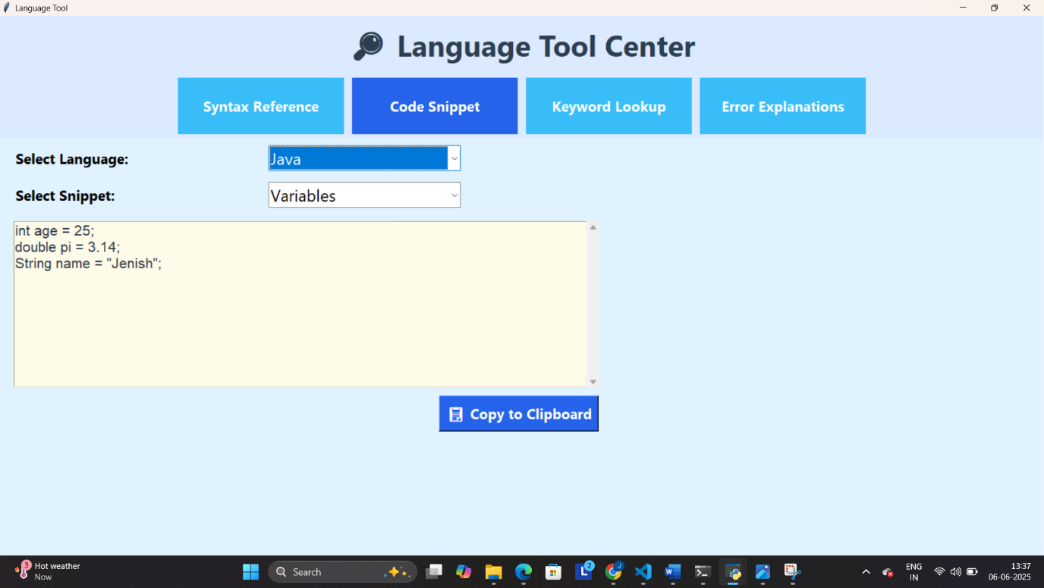

**Figure 4.5.16 Language Tool Code Snippet**

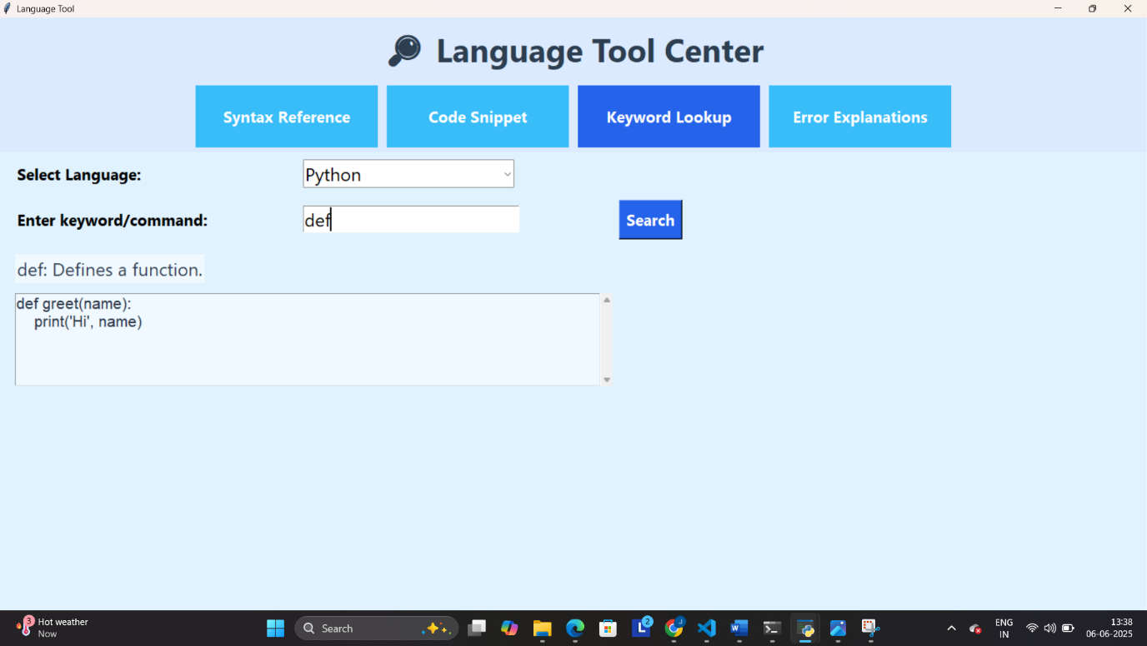

**Figure 4.5.17 Language Tool Keyword Lookup**

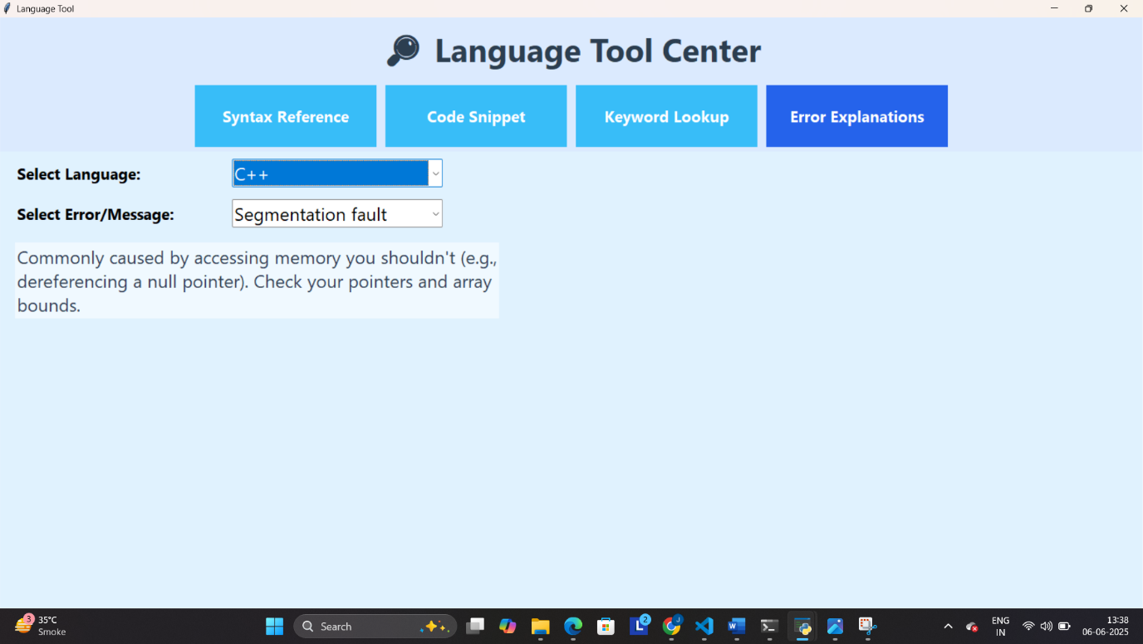

**Figure 4.5.18 Language Tool Error Explainations**

**5 . CONCLUSION**

* The **EduMatrix** project provides an integrated, user-friendly educational platform focused on multi-disciplinary quizzes, interactive games, a comprehensive dashboard, and a robust language reference tool.
* Through careful system design featuring clear activity diagrams, database structuring (with a focus on quiz data), and intuitive screen layouts the application ensures both ease of use and effective learning outcomes.
* The use of Python's Tkinter for GUI development and SQLite for data persistence in the Quiz module allows for seamless offline operation, ensuring accessibility and privacy. The modular architecture supports easy maintenance and future enhancements.
* By combining assessment, gamification, and reference resources, EduMatrix delivers a holistic learning experience for users, fostering both knowledge retention and practical skills in a supportive, engaging environment.

**6. LEARNING DURING SIP**

**1. Python GUI Development**

> Working extensively with Tkinter improved understanding of graphical user interface design, event-driven programming, widget management, custom fonts, and application state handling.

**2. Database Integration**

> Implementing SQLite for quiz result storage provided hands-on experience with database schema design, CRUD operations (Create, Read, Update, Delete), and integrating persistent data storage within a desktop application.

**3. Modular Programming Structure**

> The project required designing and organizing code into logical classes and functions, enhancing the ability to write modular, maintainable, and reusable code.

**4. User Experience (UX) Principles**

> Attention to layout, navigation, color schemes, and user feedback (such as warnings, confirmations, and result displays) deepened the appreciation for user-centric application design.

**5. Educational Content Structuring**

> Curating and formatting multi-subject quiz questions and educational resources improved skills in information organization and content validation.

**6. Debugging and Error Handling**

> Encountering and resolving various bugs developed stronger debugging techniques, especially in the context of GUI and database-related errors.

**7. Version Control and Documentation**

> Maintaining clear documentation and managing project files instilled good practices for collaboration, code readability, and future scalability.

**8. Gamification and Engagement**

> Designing interactive games and dashboards provided insight into making educational software more engaging and effective for learners.

* Overall, this project fostered a comprehensive, practical understanding of desktop application development, from back-end logic to front-end user experience, equipping me with valuable skills for future projects.

**7. BIBLIOGRAPHY**

**7.1 Online References :**

[1] “Tkinter — Python interface to Tcl/Tk,” *Python Standard Library Documentation*.[Online].Available:<https://docs.python.org/3/library/tkinter.html>. [Accessed: Sep. 8, 2025].

[2]“SQLite Documentation,” *SQLite.org*. [Online]. Available: <https://sqlite.org/docs.html>. [Accessed: Sep. 8, 2025].

[3] “Python Documentation,” *Python.org*. [Online]. Available: <https://docs.python.org/3/>. [Accessed: Sep. 8, 2025].

[4] “Python Programming Examples,” *GeeksforGeeks*. [Online]. Available: <https://www.geeksforgeeks.org/python-programming-examples/>. [Accessed: Sep. 8, 2025].

[5] “Stack Overflow,” *StackExchange Inc.* [Online]. Available: <https://stackoverflow.com/questions>. [Accessed: Sep. 8, 2025].

[6] “SQLite Python,” *TutorialsPoint*. [Online]. Available: <https://www.tutorialspoint.com/sqlite/sqlite_python.htm>. [Accessed: Sep. 8, 2025].

**7.2 Offline References :**

[7] E. Balagurusamy, *Programming in Python*. New Delhi, India: McGraw Hill Education, 2017.

[8] J. Zelle, *Python Programming: An Introduction to Computer Science*. Franklin, Beedle & Associates Inc., 2010.

[9] H. Schildt, *Java: The Complete Reference*. New Delhi, India: McGraw Hill, 2018.

[10] Y. Kanetkar, *Let Us C*. New Delhi, India: BPB Publications, 2018.